Doping strategy of BSe/WSe₂ heterostructures to realize the adsorption and sensing of harmful NH₃ and NO₂ gas molecules: A density functional theory study

Amirali Abbasi ^{a*}
ª. Department of Chemistry Education, Farhangian University, P.O. Box 14665-889, Tehran, Iran
*Corresponding Author: a_abasi@cfu.ac.ir

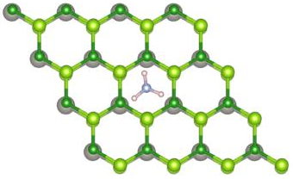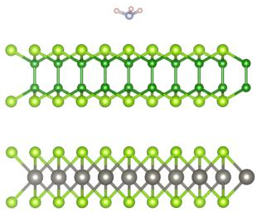
BSe/WSe₂/NH₃

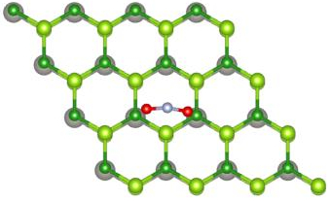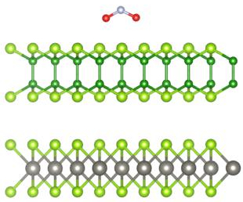
BSe/WSe/NO₂

Figure S1. Top and side views of the optimized structures of the pristine BSe/WSe₂ heterostructures with adsorbed NH₃ and NO₂ gas molecules.

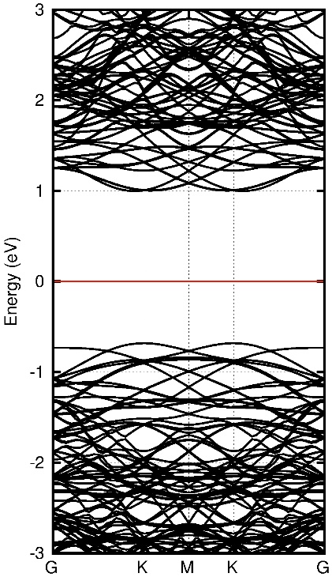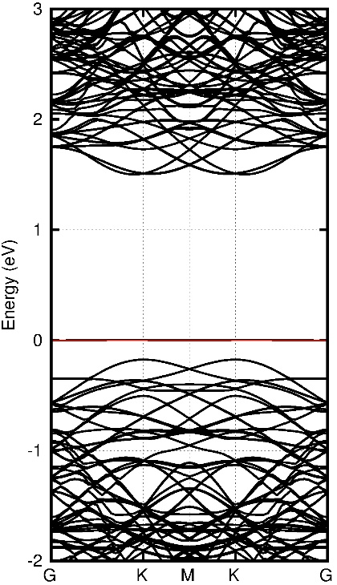
b
a

Figure S2. Band structure plots of the pristine BSe/WSe₂ heterostructures with adsorbed NH₃ (a) and NO₂ (b) gas molecules.

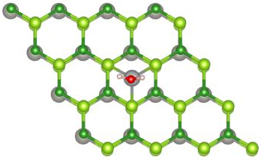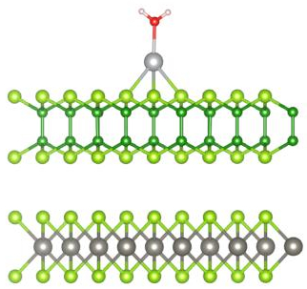
BSe/WSe₂-Ag/H₂O
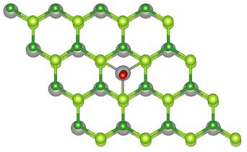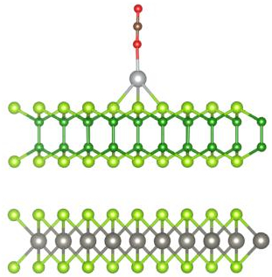
BSe/WSe₂-Ag/CO₂

Figure S3. Top and side views of the optimized structures of the pristine BSe/WSe₂ heterostructures with adsorbed H₂O and CO₂ gas molecules.

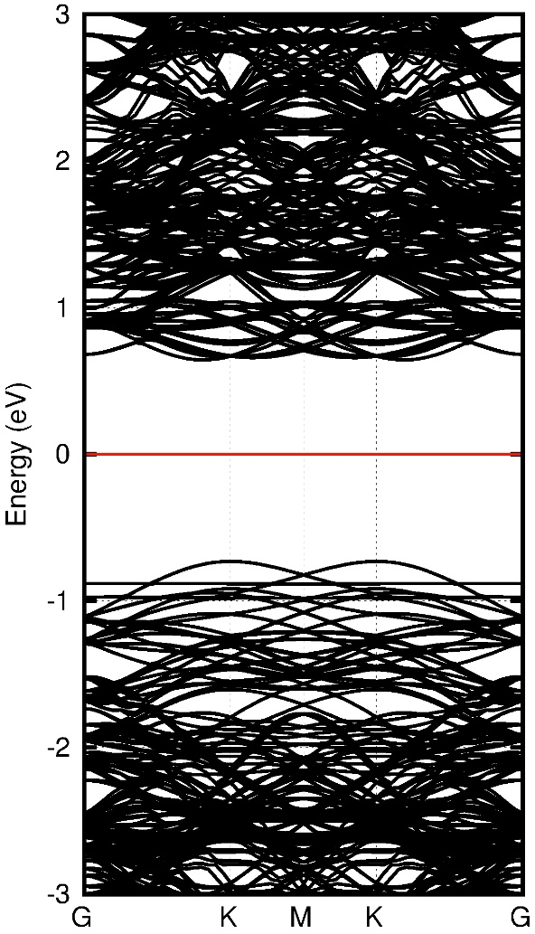
Figure S4. Band structure plot of the NO₂ adsorption Ag-BSe/WSe₂ heterostructures with the inclusion of spin-orbit coupling (SOC).

