Supplementary Material
Supplementary Table 1. Model-fit indices and classification diagnostics for candidate RAR trajectory models with one to seven groups
Metric | Group 1 | Group 2 | Group 3 | Group 4 | Group 5 | Group 6 | Group 7
AIC | 89925.22 | 75882.32 | 70065.13 | 67941.25 | 66633.20 | 66122.06 | 65478.76
BIC | 89949.16 | 75954.12 | 70176.83 | 68092.85 | 66824.69 | 66353.45 | 65750.04
CAIC | 89952.16 | 75963.12 | 70190.83 | 68111.85 | 66848.69 | 66382.45 | 65784.04
SSBIC | 89939.63 | 75925.52 | 70132.34 | 68032.46 | 66748.42 | 66261.29 | 65641.99
HQIC | 89933.03 | 75905.72 | 70101.54 | 67990.67 | 66695.62 | 66197.49 | 65567.19
AvePP_1 | 1 | 0.9914 | 0.9883 | 0.9876 | 0.9811 | 0.9821 | 0.9849
AvePP_2 |  | 0.9861 | 0.9803 | 0.9681 | 0.9575 | 0.9604 | 0.9368
AvePP_3 |  |  | 0.9775 | 0.9732 | 0.9628 | 0.9624 | 0.9652
AvePP_4 |  |  |  | 0.9585 | 0.9595 | 0.9489 | 0.9223
AvePP_5 |  |  |  |  | 0.9824 | 0.9774 | 0.9536
AvePP_6 |  |  |  |  |  | 0.9276 | 0.9436
AvePP_7 |  |  |  |  |  |  | 0.9425
OCC_1 |  | 70.2946 | 99.2126 | 120.2808 | 110.7739 | 112.9686 | 158.4475
OCC_2 |  | 116.1994 | 236.7075 | 299.5837 | 233.7483 | 227.0521 | 139.5982
OCC_3 |  |  | 74.6152 | 71.6093 | 60.7264 | 70.2771 | 72.6729
OCC_4 |  |  |  | 110.5774 | 84.5127 | 104.0738 | 116.7218
OCC_5 |  |  |  |  | 689.5695 | 680.8946 | 877.9225
OCC_6 |  |  |  |  |  | 117.2036 | 81.9203
OCC_7 |  |  |  |  |  |  | 301.1911
Prop.Class 1 | 100.00% | 62.18% | 45.94% | 39.90% | 31.94% | 32.81% | 29.11%
Prop.Class 2 |  | 37.82% | 17.34% | 8.64% | 8.85% | 9.64% | 9.74%
Prop.Class 3 |  |  | 36.72% | 34.14% | 29.84% | 26.75% | 27.69%
Prop.Class 4 |  |  |  | 17.32% | 22.00% | 15.21% | 9.24%
Prop.Class 5 |  |  |  |  | 7.37% | 5.99% | 2.27%
Prop.Class 6 |  |  |  |  |  | 9.60% | 16.94%
Prop.Class 7 |  |  |  |  |  |  | 5.01%
Abbreviations: AIC, Akaike information criterion; BIC, Bayesian information criterion; CAIC, consistent Akaike information criterion; SSBIC, sample-size-adjusted Bayesian information criterion; HQIC, Hannan-Quinn information criterion; AvePP, average posterior probability; OCC, odds of correct classification; Prop.Class, estimated class proportion.

Supplementary Table 2. Associations of RAR trajectory classes with ICU and in-hospital mortality in MIMIC-IV, MIMIC-III CareVue, and eICU
Variable | Model 1 |  | Model 2 |  | Model 3
Variable | OR (95% CI) | P value | OR (95% CI) | P value | OR (95% CI) | P value
MIMIC-IV ICU Mortality
Class 2 vs Class 1 | 2.52 (1.87–3.39) | < 0.001 | 2.57 (1.90–3.47) | < 0.001 | 2.43 (1.75–3.38) | < 0.001
Class 3 vs Class 1 | 1.70 (1.37–2.10) | < 0.001 | 1.69 (1.36–2.10) | < 0.001 | 1.64 (1.30–2.06) | < 0.001
Class 4 vs Class 1 | 2.06 (1.61–2.64) | < 0.001 | 2.06 (1.61–2.64) | < 0.001 | 2.07 (1.57–2.72) | < 0.001
MIMIC-IV Hospital Mortality
Class 2 vs Class 1 | 3.41 (2.66–4.36) | < 0.001 | 3.62 (2.81–4.67) | < 0.001 | 2.98 (2.27–3.91) | < 0.001
Class 3 vs Class 1 | 1.73 (1.45–2.06) | < 0.001 | 1.73 (1.45–2.07) | < 0.001 | 1.56 (1.28–1.88) | < 0.001
Class 4 vs Class 1 | 2.65 (2.17–3.24) | < 0.001 | 2.70 (2.20–3.32) | < 0.001 | 2.37 (1.90–2.97) | < 0.001
MIMIC III ICU Mortality
Class 2 vs Class 1 | 5.26 (3.27–8.46) | < 0.001 | 5.22 (3.23–8.43) | < 0.001 | 4.54 (2.62–7.84) | < 0.001
Class 3 vs Class 1 | 2.47 (1.68–3.63) | < 0.001 | 2.43 (1.65–3.57) | < 0.001 | 2.02 (1.32–3.08) | 0.001
Class 4 vs Class 1 | 3.40 (2.28–5.08) | < 0.001 | 3.35 (2.24–5.01) | < 0.001 | 2.84 (1.81–4.46) | < 0.001
MIMIC III Hospital Mortality
Class 2 vs Class 1 | 7.67 (4.90–11.99) | < 0.001 | 8.02 (5.09–12.65) | < 0.001 | 7.33 (4.40–12.21) | < 0.001
Class 3 vs Class 1 | 2.67 (1.92–3.73) | < 0.001 | 2.66 (1.90–3.72) | < 0.001 | 2.37 (1.64–3.43) | < 0.001
Class 4 vs Class 1 | 3.91 (2.74–5.57) | < 0.001 | 3.86 (2.70–5.52) | < 0.001 | 3.54 (2.37–5.29) | < 0.001
eICU ICU Mortality
Class 2 vs Class 1 | 2.28 (1.67–3.11) | < 0.001 | 2.30 (1.68–3.14) | < 0.001 | 2.21 (1.55–3.15) | < 0.001
Class 3 vs Class 1 | 1.27 (0.94–1.71) | 0.118 | 1.26 (0.94–1.70) | 0.127 | 1.18 (0.85–1.63) | 0.328
Class 4 vs Class 1 | 1.78 (1.32–2.41) | < 0.001 | 1.78 (1.32–2.41) | < 0.001 | 1.58 (1.13–2.21) | 0.008
eICU Hospital Mortality
Class 2 vs Class 1 | 2.82 (2.14–3.71) | < 0.001 | 2.78 (2.11–3.66) | < 0.001 | 2.85 (2.09–3.90) | < 0.001
Class 3 vs Class 1 | 1.32 (1.01–1.71) | 0.04 | 1.28 (0.98–1.67) | 0.067 | 1.23 (0.92–1.64) | 0.154
Class 4 vs Class 1 | 1.92 (1.47–2.51) | < 0.001 | 1.88 (1.44–2.46) | < 0.001 | 1.77 (1.31–2.38) | < 0.001
Notes: Values are odds ratios (ORs) with 95% confidence intervals (CIs). Class 1 was the reference group. Model 1 was unadjusted. Model 2 was adjusted for age, sex, and race. Model 3 was additionally adjusted for ICU type; stroke, hypertension, diabetes, chronic obstructive pulmonary disease, and heart failure; infection site; SOFA score; minimum mean arterial pressure; maximum body temperature; hemoglobin; white blood cell count; international normalized ratio; lactate; pH; mechanical ventilation; renal replacement therapy; vasopressor use; albumin infusion within 24 h; and red blood cell/whole-blood transfusion within 24 h.

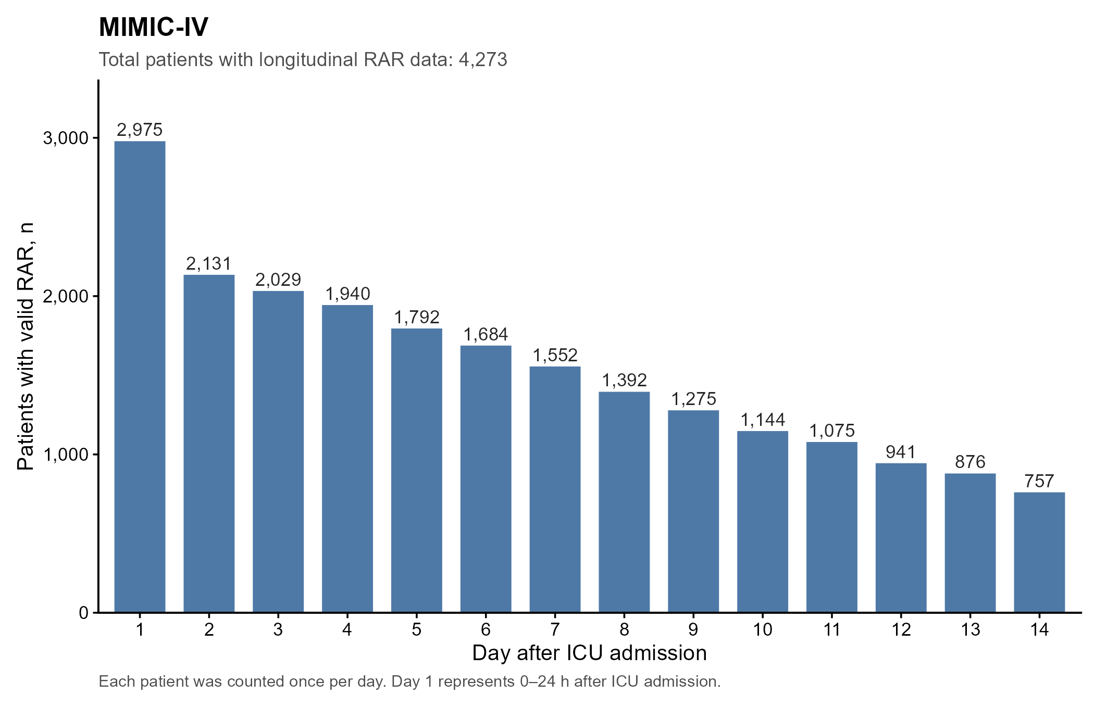
Supplementary Figure 1. Daily availability of valid RAR measurements during days 1-14 after ICU admission in MIMIC-IV. Bars show the number of unique patients with a valid daily RAR value; each patient was counted once per day, and day 1 represents 0-24 h after ICU admission.

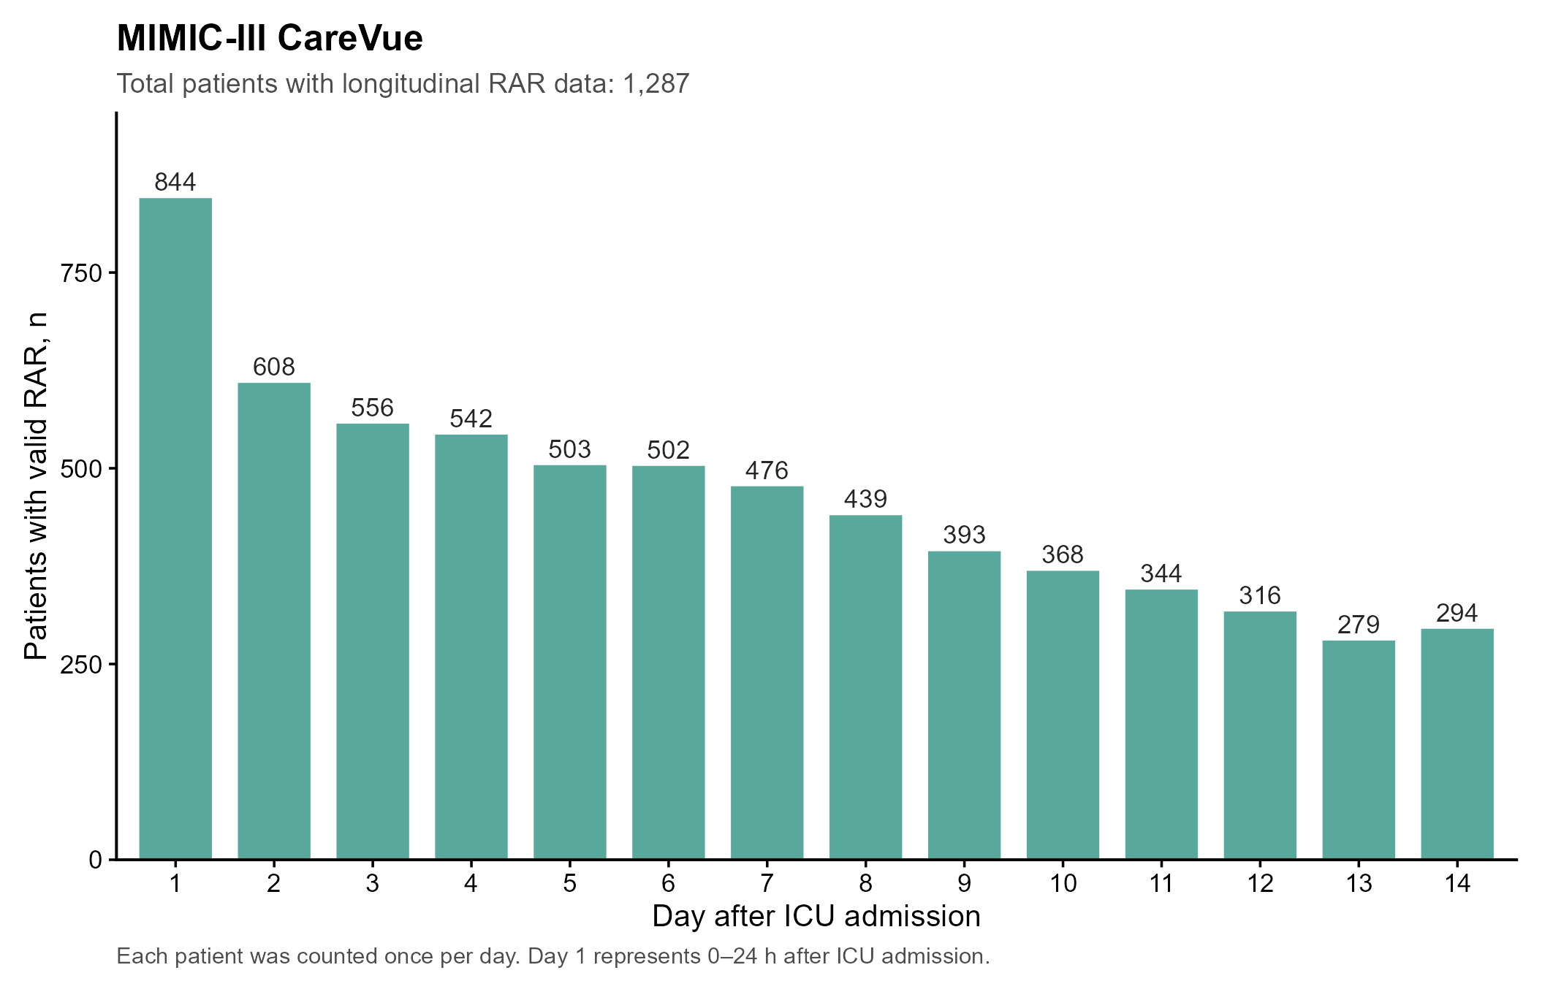
Supplementary Figure 2. Daily availability of valid RAR measurements during days 1-14 after ICU admission in MIMIC-III CareVue. Bars show the number of unique patients with a valid daily RAR value; each patient was counted once per day, and day 1 represents 0-24 h after ICU admission.

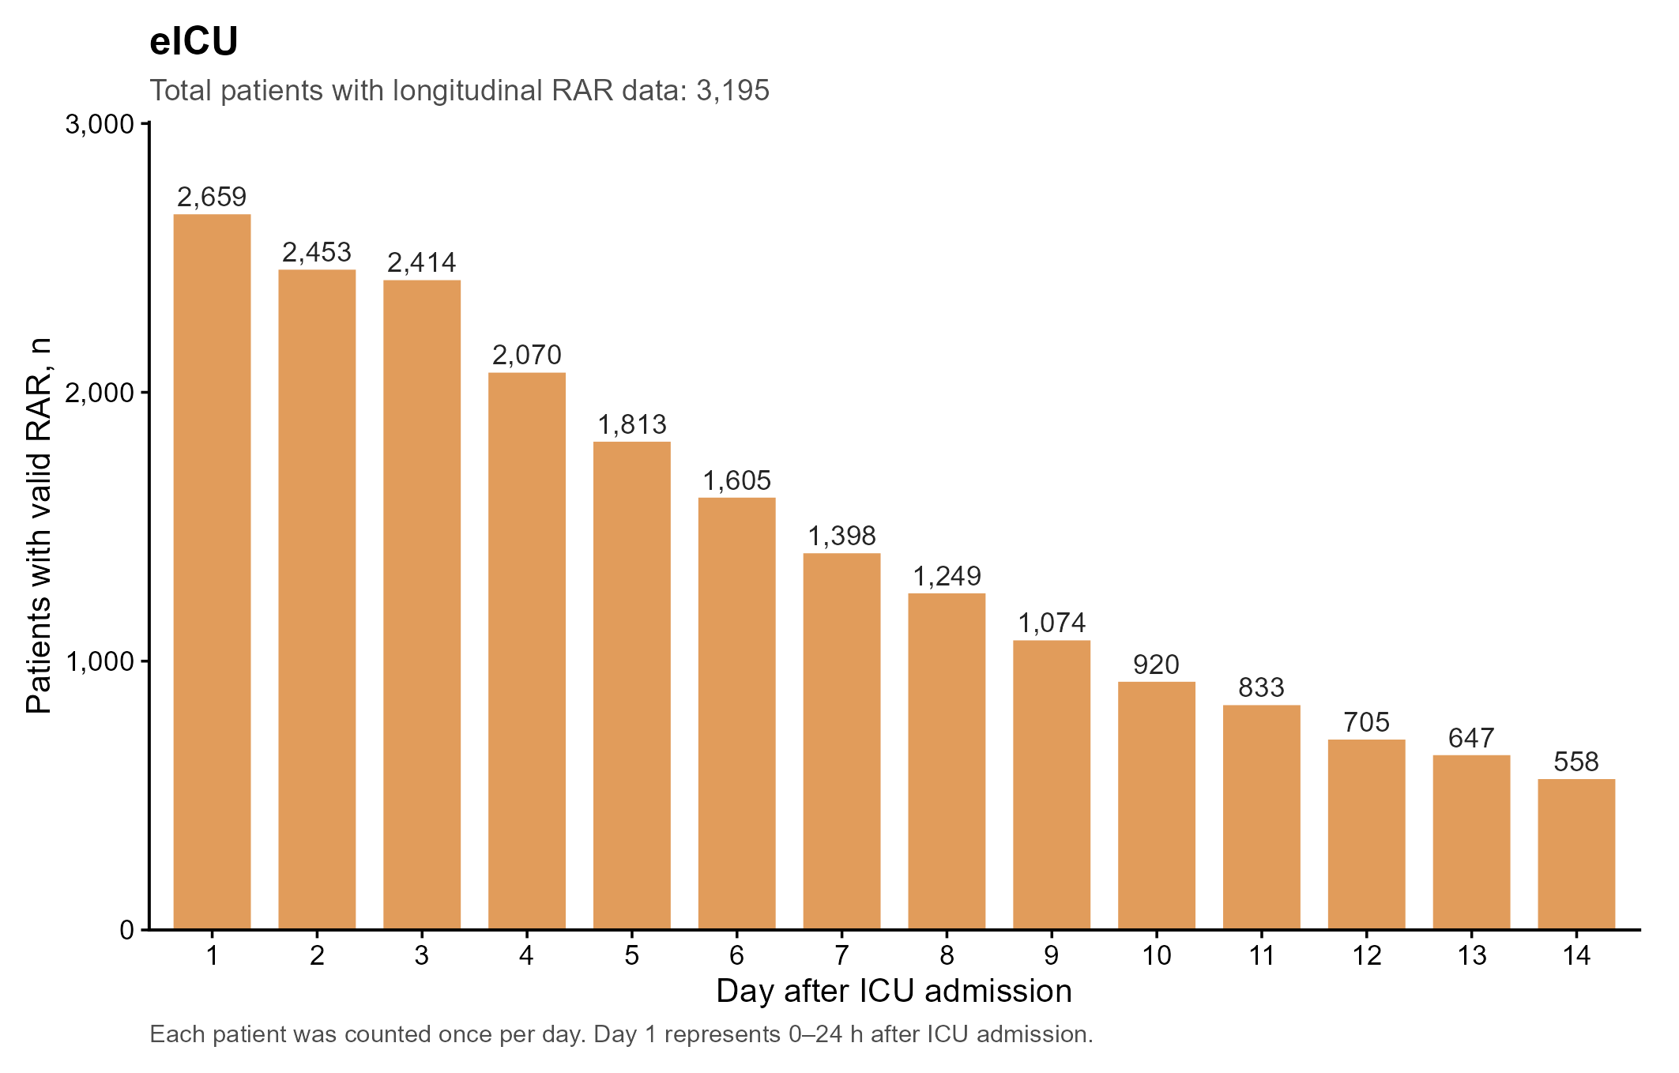
Supplementary Figure 3. Daily availability of valid RAR measurements during days 1-14 after ICU admission in eICU. Bars show the number of unique patients with a valid daily RAR value; each patient was counted once per day, and day 1 represents 0-24 h after ICU admission.

