Supporting Information
A Non-enzymatic Ag/CuS-MWCNT-Chitosan/SPCE Sensor for Simultaneous Detection of Paraoxon-ethyl and Carbaryl
Orapan Pechtesª, Chiravoot Pechyen^{a,d,*}, Natthapon Nakpathomkun^{b,d}, Itsarapong Chuasontia^{c}, Benchamaporn Tangnorawich^{b,d,*}
ªDepartment of Material and Textile Technology, Faculty of Science and Technology, Thammasat University, Pathum Thani, 12120, Thailand
^{b}Department of Physics, Faculty of Science and Technology, Thammasat University, Pathum Thani, 12120, Thailand
^{c}Faculty of Learning Sciences and Education, Thammasat University, Pathum Thani, 12120, Thailand
^{d}Thammasat University Center of Excellence in Modern Technology and Advanced Manufacturing for Medical innovation, Thammasat University, Pathum Thani, 12120, Thailand

*Corresponding author. Department of Material and Textile Technology, Faculty of Science and Technology, Thammasat University, Pathum Thani, 12120, Thailand
E-mail address: chiravoot.p@gmail.com (C.Pechyen)

Table S1 Results of the Ag/CuS-modified electrode at different Ag concentrations
Concentrations of Ag (M) | I_{pa} (µA) | I_{pc} (µA) | I_{pa}/I_{pc} | ΔE_{p} (V)
0.10 | 821.047 | -726.856 | 1.130 | 0.369
0.25 | 854.670 | -786.155 | 1.087 | 0.343
0.50 | 893.366 | -829.467 | 1.077 | 0.382
0.75 | 957.036 | -831.553 | 1.151 | 0.395
1.00 | 908.287 | -773.430 | 1.174 | 0.401

Table S2 Results of nano-ink-modified SPCE recorded at different scan rates
Scan rate (V/s) | I_{pa} (µA) | I_{pc}(µA) | I_{pa}/I_{pc} | ΔE_{p} (V)
0.025 | 510.210 | -355.295 | 1.436 | 0.247
0.050 | 733.853 | -506.897 | 1.448 | 0.333
0.100 | 1014.549 | -726.578 | 1.396 | 0.438
0.200 | 1408.930 | -1135.720 | 1.241 | 0.605
0.300 | 1530.221 | -1298.666 | 1.178 | 0.715

Table S3 Results of the nano-ink SPCE in phosphate-buffered saline (PBS) at different pH values
pH | I_{pa} (µA) | I_{pc}(µA) | I_{pa}/I_{pc} | ΔE_{p} (V)
5 | 153.306 | -57.036 | 1.436 | 0.251
7 | 203.015 | -131.261 | 1.448 | 0.247
8 | 90.308 | -15.341 | 1.396 | 0.237
9 | 55.619 | -10.028 | 1.241 | 0.251

Concentration of Pesticides (ppm) | Paraoxon-ethyl |  | Carbaryl
Concentration of Pesticides (ppm) | I_{pa} (µA) | E_{pa} (V) | I_{pa} (µA) | E_{pa} (V)
5 | 74.313 | 0.078 | 42.806 | 0.068
10 | 76.937 | 0.078 | 47.934 | 0.068
15 | 84.869 | 0.078 | 49.743 | 0.068
20 | 85.985 | 0.078 | 51.413 | 0.068
25 | 88.880 | 0.078 | 59.494 | 0.073
30 | 90.145 | 0.078 | 61.646 | 0.073
Table S4 Results of nano-ink-modified SPCE for the detection of paraoxon-ethyl and carbaryl (5–30 ppm)

Table S5 Results of Ag with ICP technique Ag/CuS Nanocomposite and nano-ink
Sample name | Ag Quant Average (mg/L) | Ag RSD
Ag/CuS | 1740 | 2.53
Nano-ink | 1570 | 0.85

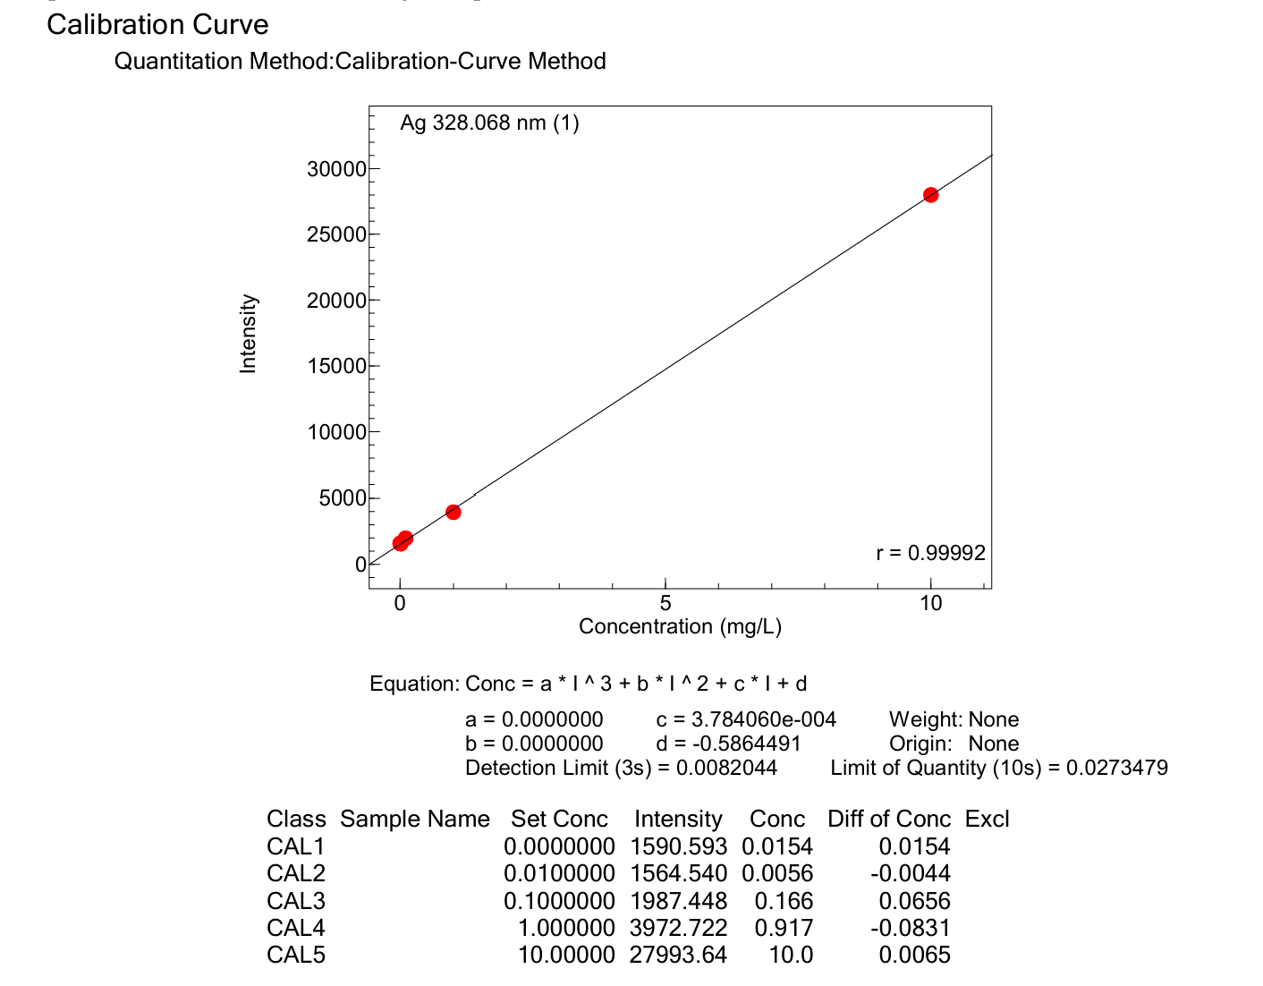
S1. Calibration curve of Ag Standard by ICP technique

Table S6 Fitting results of the Nyquist plots obtained for the nano-ink-modified SPCEs.
Element | Fitted Value | Min Value | Max Value | Unit
R_{s} | 109.2 | 1.00$×$10⁻⁶ | 1.00$×$10¹² | Ω
R_{ct} | 0.002 | 1.00$×$10⁻⁶ | 1.00$×$10¹² | Ω
W1 | 294.2 | 1.00$×$10⁻⁶ | 1.00$×$10¹² | σ
C1 | 2.994$×$10⁻⁴ | 1.00$×$10⁻¹² | 1.00$×$10⁻³ | F
Chi-Squared (χ²): | 0.0003

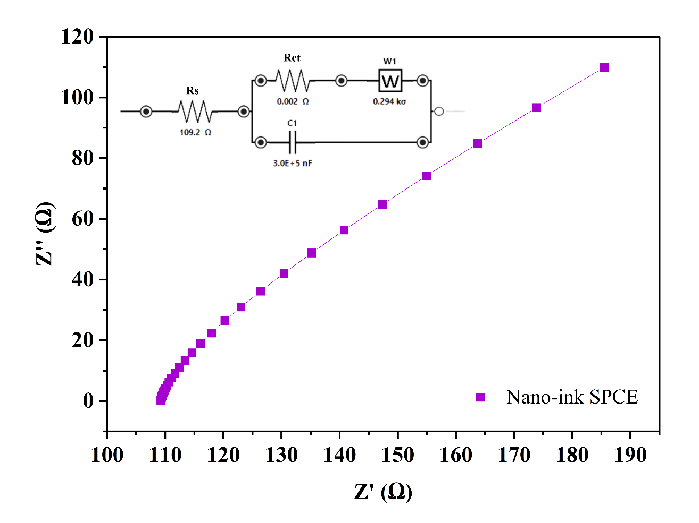
S2. Nyquist plots of the nano-ink-modified SPCE were obtained from a repeated experiment, showing results comparable to the previous measurement.
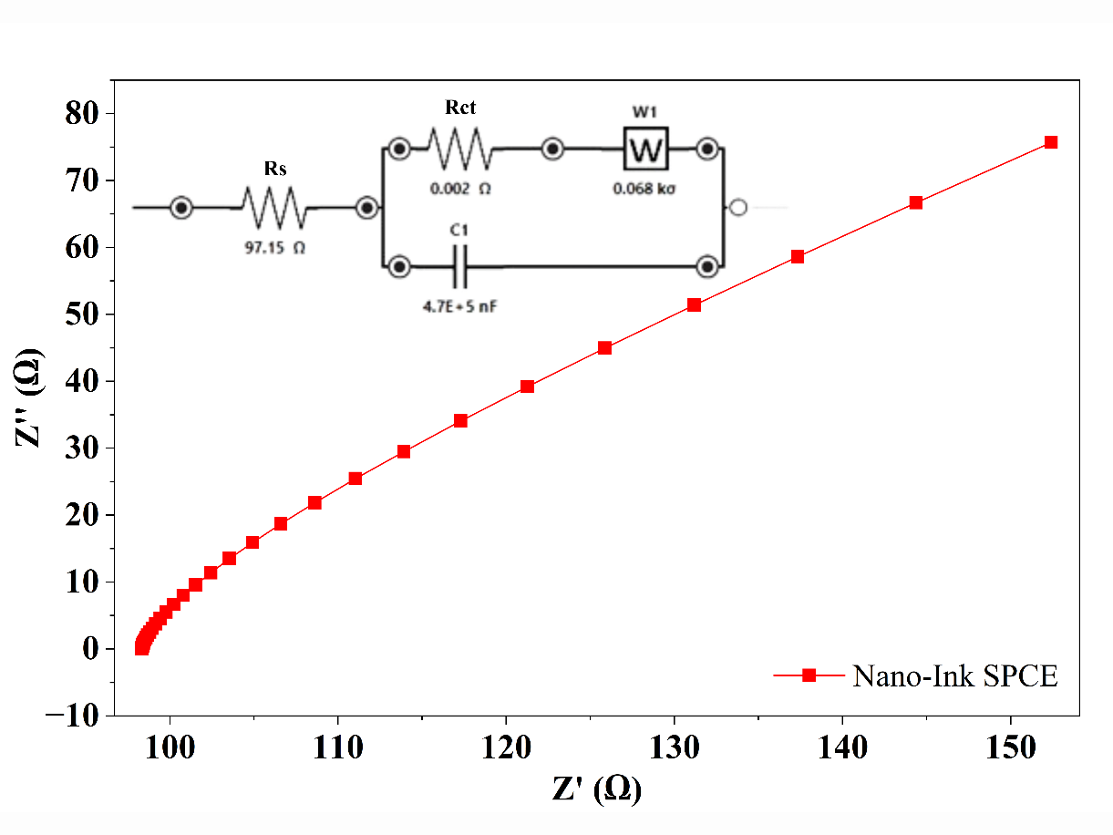
S3. Nyquist plot of the nano-ink-modified SPCE from the previous experiment.

S4. linear relation plot of logarithm of I_{pa} versus logarithm of scan rate (v)
