Supplementary Information

First genomic evidence of inbreeding in South American pumas and the role of Andean climate history in shaping genetic diversity
Daniel E. Chavez*¹, Chiara Correa-Zanotti^{2,3}, Nicole Ormaza⁴, David Mora⁴, María B. Cabezas⁴, Carolina Sáenz⁵, Ernesto Arbelaez⁶, Lauren Ong⁷, Alexander Medina⁸, Robert K. Wayne⁹†, Tuyen Ong¹⁰, & Rebecca Zug¹¹

Supplementary Figures

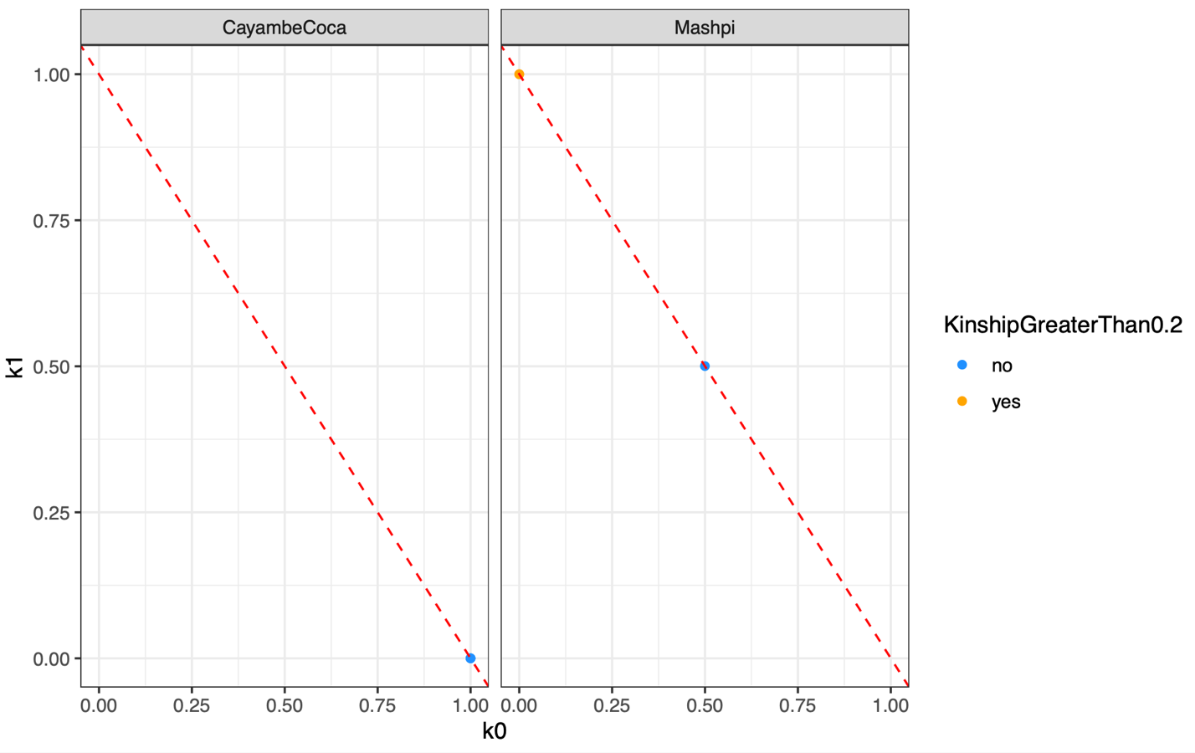
Figure S1. Pairwise identity-by-descent relationships among puma individuals from Cayambe-Coca and Mashpi. Pairwise relatedness was estimated using the method-of-moments identity-by-descent (IBD) estimator implemented in SNPRelate snpgdsIBDMoM() from an LD-pruned SNP dataset. Two closely related pairs were identified within Mashpi, Copal–Capu and Copal–Mila, each with k₀ = 0, k₁ = 1, and an estimated kinship coefficient of 0.25. Because the complete three-individual pattern did not correspond unambiguously to a simple pedigree configuration, we report the degree of pairwise relatedness without assigning specific pedigree relationships.
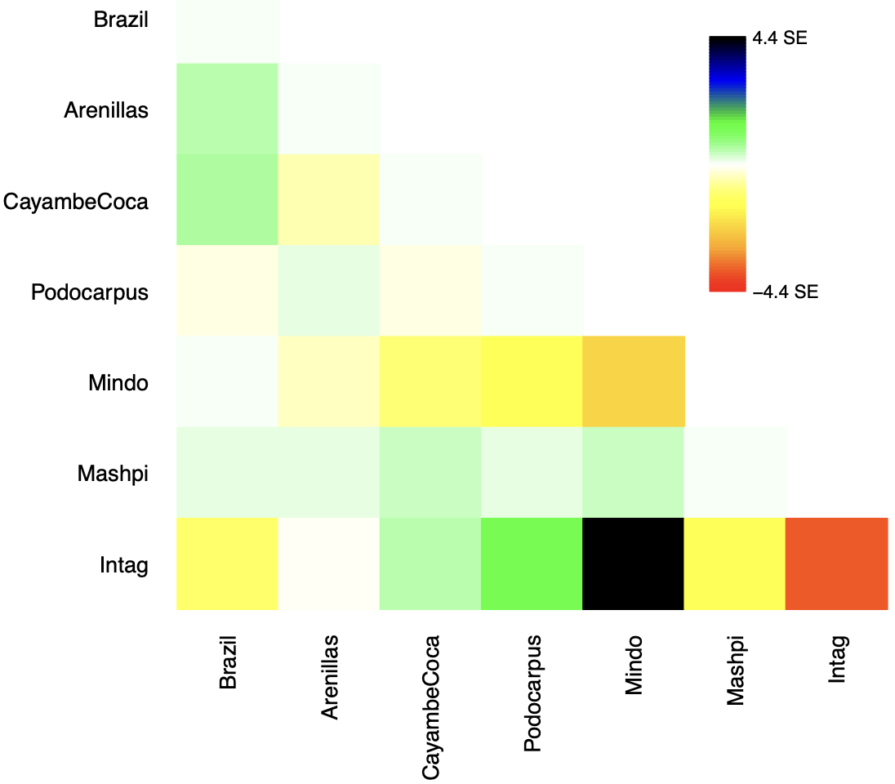
Figure S2. TreeMix residual covariance plot for the five-migration-edge model of South American pumas.
Residuals show the difference between observed and model-predicted allele-frequency covariance among populations, expressed in units of standard errors. Pale colors indicate population pairs that are well explained by the fitted tree plus five migration edges, whereas stronger positive or negative residuals indicate excess or reduced covariance not fully captured by the model. Most residuals were low, suggesting that the m = 5 model captured the major structure among puma populations. The strongest residual occurred between Intag and Mindo, consistent with close genetic affinity among northwestern Andean foothill populations.

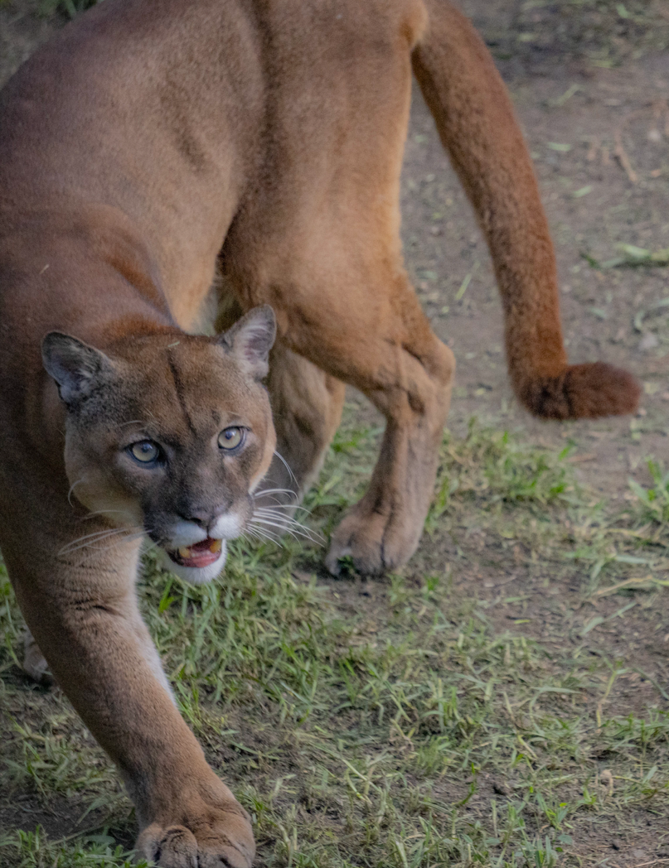
Figure S3. Julio, a puma from the northeastern Cayambe-Coca region of Ecuador.
Photograph of Julio, one of the Cayambe-Coca individuals analyzed in this study. Genomic analyses showed that Julio carried relatively long runs of homozygosity and an elevated proportion of putatively deleterious genotypes compared with several other sampled pumas, suggesting possible recent inbreeding. Photo by Andrés Reinoso M, used with permission of the author.

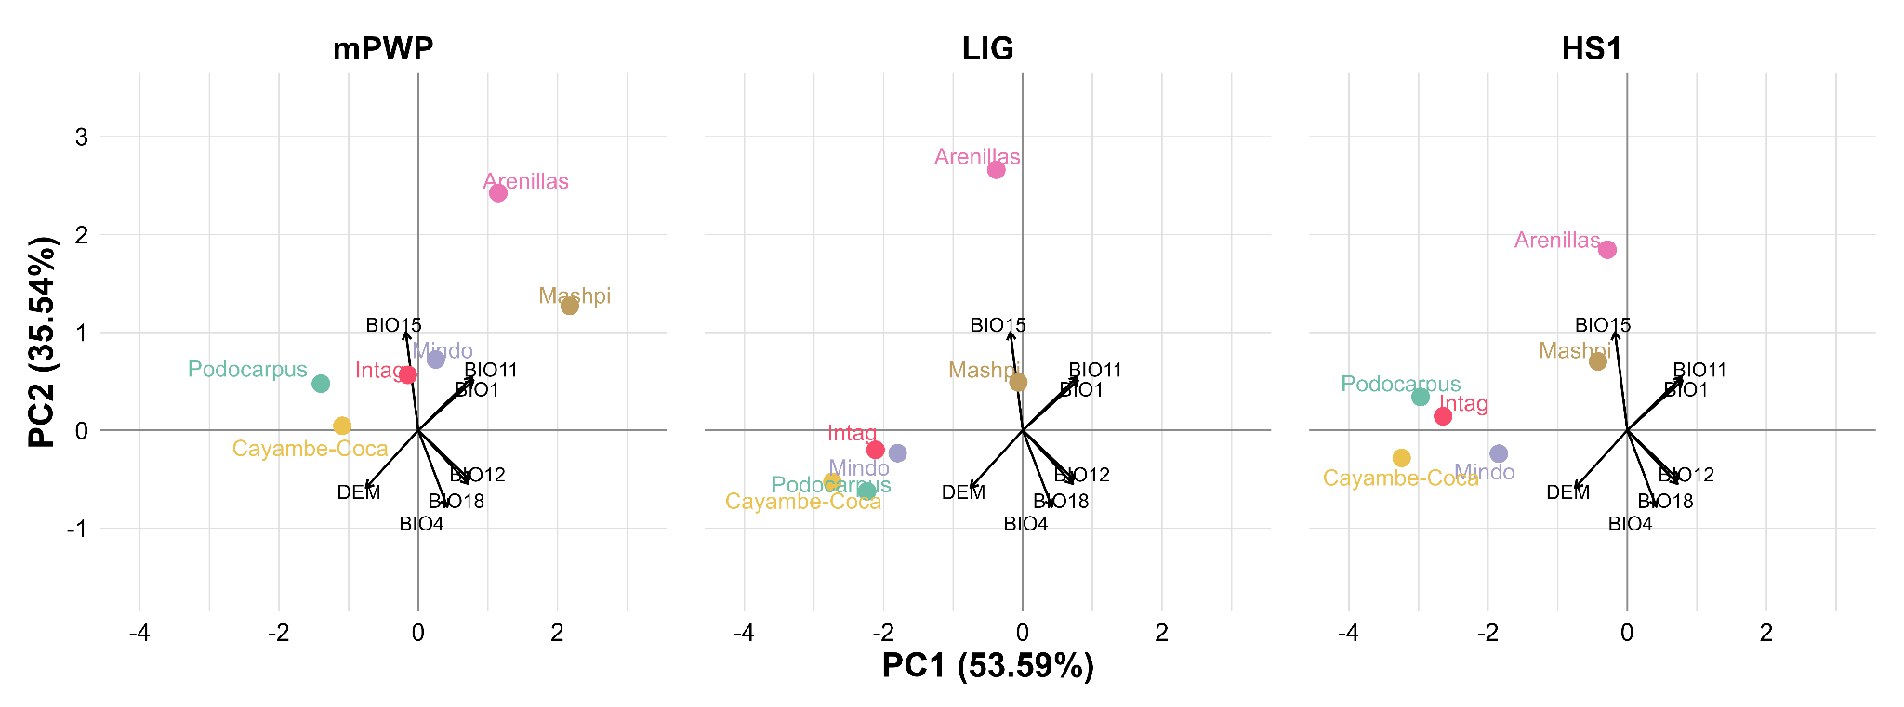
Figure S4. Paleoclimatic environmental similarity among Ecuadorian puma populations. Population centroids for the mid-Pliocene Warm Period (mPWP), Last Interglacial (LIG), and Heinrich Stadial 1 (HS1) were projected into a common MIS19-calibrated PCA environmental space. Arrows represent MIS19 environmental loadings. PC1 and PC2 explain 53.59% and 35.54% of the environmental variance, respectively.

Supplementary Tables

Table S1. Marginal likelihood values for fastSTRUCTURE models across K = 1–9.
K values | marginal likelihood
K =1 | -1.233909517
K = 2 | -1.235582504
K = 3 | -1.235582896
K = 4 | -1.243715965
K = 5 | -1.235583228
K = 6 | -1.249534322
K = 7 | -1.243716247
K = 8 | -1.233911464
K = 9 | -1.233911505

Table S2 Genome-wide average heterozygosity and total length of short/medium/long runs of homozygosity (ROH) of Ecuadorian pumas.
Sample ID | Population ID | Hetero(kb*) | Short(MB*) | Medium(MB*) | Long(MB*)
Ili | Arenillas | 1.5325154 | 169.564581 | 147.890888 | 21.868942
Spumi | Podocoarpus | 1.6608978 | 152.515161 | 209.806468 | 181.42973
Copal | Mashpi | 1.81610943 | 100.061856 | 85.514568 | 37.293325
Mila | Mashpi | 1.82593067 | 107.002943 | 181.64907 | 126.07981
Capu | Mashpi | 1.9375866 | 119.992998 | 59.281208 | 26.857093
Verus | Mindo | 1.87692586 | 112.010514 | 143.725841 | 27.751426
Nacho | Intag | 2.02281614 | 107.893269 | 92.150217 | 15.898817
Julio | Cayambe-Coca | 2.0583292 | 83.114927 | 117.909431 | 58.257049
Mao | Cayambe-Coca | 2.08499694 | 73.212966 | 74.812335 | 14.259035
Note - ROH were categorized as short (<1Mb), medium (1-10Mb), and long (>10Mb).
* KB stands for kilobases, and MB stands for megabases

Table S3 Genotype counts in Andean puma populations
SampleId | HomRefCount | HomAltCount | HetCount | MutType
Mao.CayambeCoca | 1719 | 822 | 873 | LOF
Copal.Mashpi | 1833 | 717 | 900 | LOF
Capu.Mashpi | 1875 | 765 | 786 | LOF
Ili.Arenillas | 1839 | 819 | 537 | LOF
Julio.CayambeCoca | 1818 | 843 | 786 | LOF
Nacho.CayambeCoca | 1794 | 777 | 831 | LOF
Mao.CayambeCoca | 39850 | 12013 | 18545 | Synon
Copal.Mashpi | 40810 | 11441 | 18487 | Synon
Capu.Mashpi | 40795 | 11420 | 18594 | Synon
Ili.Arenillas | 40756 | 12283 | 14442 | Synon
Julio.CayambeCoca | 40013 | 12032 | 18321 | Synon
Nacho.CayambeCoca | 40226 | 11945 | 18560 | Synon
Mao.CayambeCoca | 27288 | 8457 | 12261 | Missen
Copal.Mashpi | 27924 | 8136 | 12500 | Missen
Capu.Mashpi | 28005 | 8108 | 12336 | Missen
Ili.Arenillas | 27963 | 8279 | 10090 | Missen
Julio.CayambeCoca | 27452 | 8662 | 11995 | Missen
Nacho.CayambeCoca | 27357 | 8579 | 12376 | Missen
Note – Homozygote-derived genotypes in the damaging category are higher in populations with smaller effective population sizes, such as the Arenillas population, shown in bold, due to increased drift. In contrast, damaging mutations are less frequent in species with large effective population sizes such as the Cayambe-Coca population. This difference is less evident in the benign category. The counts of benign and damaging alleles in the genome were 17,647 and 2,838, respectively.

Table S4. Software, scripts, versions, and analytical workflow used in the Puma concolor genomic analyses.
Analysis | Script(s) | Software | Version
Raw read quality assessment | Fastqc | FastQC | 0.12.1
FASTQ → unmapped BAM | 02_FastqToSam/run_FastqToSam.sh | Picard FastqToSam | 3.1.1
Adapter detection | 03_MarkIlluminaAdapters/run_MarkIlluminaAdapters.sh | Picard MarkIlluminaAdapters | 3.1.1
Read alignment | 04_AlignCleanBam/run_AlignCleanBam.sh | BWA-MEM | 0.7.17
Duplicate marking | 05_MarkDuplicates/run_MarkDuplicates.sh | Picard MarkDuplicates | 3.1.1
BAM filtering | 06_RemoveBadReads/run_RemoveBadReads.sh | SAMtools | 1.2
Variant calling | 08_HaplotypeCaller/run_GATK_HC_bottleneck_Pumas.sh | GATK HaplotypeCaller | 4.x.x
Joint genotyping | 09_Genotype_gVCFs/* | GATK GenotypeGVCFs | 4.x.x
Variant filtering | 11_FilterVCF/Mask_Filter_bottleneck.Pumas.sh | GATK / Python | 4.x.x
PCA | snprelate_PCA_cluster_Pumas.R | SNPRelate | 3.18
Population structure | fastStructure_Step_2_runFASTSTRUCTURE.Pumas.sh | fastSTRUCTURE | 1
Population tree | TreeMix script | TreeMix | 1.13
Relatedness | ComparingRelatedness.relatedness.plinkMoM.Pumas.Ecuador.R | PLINK | 2.00a5
Genome-wide heterozygosity | HetPerInd.py | Python | 3.x
Sliding-window heterozygosity | SlidingWindowHet.Puma.py | Python | 3.x
Runs of homozygosity | Step0–3_ROH* | PLINK | 2.00a5
Predicted deleterious variation | run_SubsetVCF_getAlleleGenotCounts.PumaUCSC.sh | SIFT | v.2.1
Functional variant summarization | getAlleleGenotCounts.py | Python | 3.x
Historical demography | submit_Step_2_runMSMC.Pumas.sh | MSMC | 2.1.2
Recent demography | GONE workflow | GONE2 | v1.0.2
Paleoclimate PCA | R scripts | R | 4.4.1
Climatic distances | R scripts | R | 4.4.1

Table S5. Reclassification of MapBiomas Ecuador Collection 3.0 land-cover classes used to construct the anthropogenic landscape-fragmentation index.
MapBiomas code | Official land-cover class | Cover origin | Relative anthropogenic transformation score | Classification rationale
3 | Forest | Natural | 0 | Natural forest cover; does not represent landscape fragmentation caused by human land use.
4 | Open forest | Natural | 0 | Natural forest formation; does not represent anthropogenic transformation.
5 | Mangrove | Natural | 0 | Natural coastal vegetation; retained as zero anthropogenic transformation.
6 | Flooded forest | Natural | 0 | Natural forest formation associated with periodic or permanent flooding.
9 | Silviculture | Anthropogenic | 5 | Managed tree cover representing human modification but retaining partial woody structure and vegetation cover.
11 | Non-forest wetland | Natural | 0 | Natural wetland formation; does not represent anthropogenic fragmentation.
12 | Grassland | Natural | 0 | Natural non-forest vegetation; retained as zero anthropogenic transformation.
13 | Other non-forest natural formation | Natural | 0 | Natural vegetation formation; does not represent human-induced landscape transformation.
21 | Mosaic of uses | Anthropogenic | 10 | Heterogeneous agricultural and pasture-dominated land use representing an intermediate level of human transformation.
23 | Beach, dune and sand spot | Natural | 0 | Natural non-vegetated surface; not considered a source of anthropogenic fragmentation.
24 | Urban infrastructure | Anthropogenic | 20 | Built-up and predominantly impervious land cover representing very high human transformation.
25 | Other anthropic non-vegetated area | Anthropogenic | 20 | Human-modified surface with substantial vegetation removal or soil alteration.
27 | Not observed | Unclassified | NoData | Excluded because the original land-cover class could not be reliably determined.
29 | Rocky outcrop | Natural | 0 | Natural non-vegetated surface; not interpreted as fragmentation caused by human activity.
30 | Mining | Anthropogenic | 20 | Extractive land use involving extensive vegetation removal and surface disturbance.
31 | Aquaculture | Anthropogenic | 20 | Artificial conversion and intensive modification of terrestrial or wetland cover.
33 | River, lake and ocean | Natural | 0 | Natural aquatic cover; retained as zero anthropogenic transformation and not interpreted as human-induced fragmentation.
34 | Glacier | Natural | 0 | Natural land-cover class; not considered a source of anthropogenic fragmentation.
68 | Other natural non-vegetated area | Natural | 0 | Natural non-vegetated surface; retained as zero anthropogenic transformation.
74 | Banana | Anthropogenic | 15 | Intensively managed perennial monoculture representing a high level of agricultural transformation.
81 | Andean herbaceous and shrubby vegetation | Natural | 0 | Natural Andean vegetation; not considered evidence of anthropogenic fragmentation.
82 | Flooded Andean herbaceous | Natural | 0 | Natural flooded Andean vegetation; retained as zero anthropogenic transformation.

