Supplementary Materials
Supplementary Table 1. Coded and actual levels of factors used for Plackett-Burman design and CCRD-based RSM
Response | Factor code | Factors | Levels
Response | Factor code | Factors | –α | –1 | 0 | +1 | +α
Plackett-Burman design  Starch yield (g/100 g corm dry weight) | I | Sample concentration (g/mL) | - | 0.2 | - | 1 | -
 | II | Corm size (cm³) | - | 0.5 | - | 2 | -
 | III | Concentration of NaCl (%) | - | 5 | - | 30 | -
 | IV | Soaking time in NaCl (h) | - | 6 | - | 36 | -
 | V | Soaking temperature (°C) | - | 25 | - | 60 | -
 | VI | Milling time (min) | - | 5 | - | 15 | -
 | VII | Proportion of water for milling (× times) | - | 1 | - | 5 | -
 | VIII | Incubation time (h) | - | 6 | - | 36 | -
 | IX | Incubation temperature (°C) | - | 25 | - | 60 | -
 | X | Centrifugation speed (RPM) | - | 3000 | - | 8000 | -
 | XI | Drying temperature (°C) | - | 40 | - | 80 | -
RSM model  Starch yield (g/100 g corm dry weight) | A | Corm size (cm³) | 1 | 1.5 | 2 | 2.5 | 3
RSM model  Starch yield (g/100 g corm dry weight) | B | Soaking temperature (°C) | 10 | 20 | 30 | 40 | 50
RSM model  Starch yield (g/100 g corm dry weight) | C | Sample concentration (g/mL) | 0.5 | 1 | 1.5 | 2 | 2.5
RSM model  Starch yield (g/100 g corm dry weight) | D | Proportion of water for milling (× times) | 0.5 | 1 | 1.5 | 2 | 2.5

Supplementary Table 2. Analysis of variance of the variables used in the CCRD model (RSM design) for the optimization of starch extraction
Source | Sum of Squares | df | Mean Square | F-value | p-value
Cubic Model | 1470.47 | 22 | 66.84 | 663.09 | < 0.0001 | Significant
A-Corm Size | 80.77 | 1 | 80.77 | 801.31 | < 0.0001
B-Soaking Temperature | 0.7938 | 1 | 0.7938 | 7.87 | 0.0263
C-Sample Conc. | 0.0338 | 1 | 0.0338 | 0.3353 | 0.5807
D-Proportion of water for milling | 113.60 | 1 | 113.60 | 1126.96 | < 0.0001
AB | 181.52 | 1 | 181.52 | 1800.81 | < 0.0001
AC | 3.81 | 1 | 3.81 | 37.80 | 0.0005
AD | 15.48 | 1 | 15.48 | 153.57 | < 0.0001
BC | 2.82 | 1 | 2.82 | 28.02 | 0.0011
BD | 61.03 | 1 | 61.03 | 605.43 | < 0.0001
CD | 109.27 | 1 | 109.27 | 1083.98 | < 0.0001
A² | 2.04 | 1 | 2.04 | 20.26 | 0.0028
B² | 1.91 | 1 | 1.91 | 18.98 | 0.0033
C² | 174.33 | 1 | 174.33 | 1729.48 | < 0.0001
D² | 75.92 | 1 | 75.92 | 753.18 | < 0.0001
ABC | 110.13 | 1 | 110.13 | 1092.60 | < 0.0001
ABD | 30.61 | 1 | 30.61 | 303.71 | < 0.0001
ACD | 129.46 | 1 | 129.46 | 1284.31 | < 0.0001
BCD | 7.07 | 1 | 7.07 | 70.17 | < 0.0001
A²B | 64.57 | 1 | 64.57 | 640.58 | < 0.0001
A²C | 13.12 | 1 | 13.12 | 130.13 | < 0.0001
A²D | 72.84 | 1 | 72.84 | 722.63 | < 0.0001
AB² | 0.7656 | 1 | 0.7656 | 7.60 | 0.0283
Residual | 0.7056 | 7 | 0.1008
Lack of Fit | 0.7056 | 2 | 0.3528
Pure Error | 0.0000 | 5 | 0.0000
Cor Total | 1471.18 | 29

R² = 0.9995, Adjusted R² = 0.9980, Predicted R² = 0.9309, Adequate Precision = 108.6718
p < 0.05 implies the significance of model terms.

Supplementary Table 3. Report of Plackett-Burman analysis
Run Order | Starch yield (g/100 g dry weight corm) |  | Residual | Leverage | Internally Studentized Residuals | Externally Studentized Residuals | Cook's Distance | Influence on Fitted Value DFFITS | Standard Order
Run Order | Actual Value | Predicted Value
1 | 40.15 | 41.27 | -1.12 | 0.750 | -1.128 | -1.213 | 0.424 | -2.101 | 3
2 | 42.03 | 41.00 | 1.04 | 0.750 | 1.047 | 1.073 | 0.365 | 1.859 | 11
3 | 36.64 | 37.50 | -0.8562 | 0.750 | -0.862 | -0.812 | 0.248 | -1.406 | 2
4 | 42.35 | 43.29 | -0.9362 | 0.750 | -0.943 | -0.918 | 0.296 | -1.589 | 6
5 | 41.04 | 40.11 | 0.9362 | 0.750 | 0.943 | 0.918 | 0.296 | 1.589 | 12
6 | 49.53 | 50.65 | -1.12 | 0.750 | -1.128 | -1.213 | 0.424 | -2.101 | 1
7 | 52.84 | 51.81 | 1.04 | 0.750 | 1.047 | 1.073 | 0.365 | 1.859 | 10
8 | 42.63 | 41.51 | 1.12 | 0.750 | 1.128 | 1.213 | 0.424 | 2.101 | 7
9 | 41.34 | 42.38 | -1.04 | 0.750 | -1.047 | -1.073 | 0.365 | -1.859 | 5
10 | 59.45 | 60.31 | -0.8562 | 0.750 | -0.862 | -0.812 | 0.248 | -1.406 | 8
11 | 48.24 | 47.38 | 0.8562 | 0.750 | 0.862 | 0.812 | 0.248 | 1.406 | 4
12 | 54.54 | 53.60 | 0.9362 | 0.750 | 0.943 | 0.918 | 0.296 | 1.589 | 9

Supplementary Table 4. Analysis of variance of the variables used in the Plackett-Burman design for the selection of factors for starch extraction
Source | Sum of Squares | df | Mean Square | F-value | p-value
Model | 514.70 | 8 | 64.34 | 16.31 | 0.0212 | Significant
Factor I | 55.78 | 1 | 55.78 | 14.14 | 0.0329
Factor II | 222.78 | 1 | 222.78 | 56.47 | 0.0049
Factor III | 20.51 | 1 | 20.51 | 5.20 | 0.1069
Factor V | 74.84 | 1 | 74.84 | 18.97 | 0.0224
Factor VII | 39.20 | 1 | 39.20 | 9.94 | 0.0512
Factor VIII | 28.54 | 1 | 28.54 | 7.23 | 0.0744
Factor X | 52.58 | 1 | 52.58 | 13.33 | 0.0355
Factor XI | 20.47 | 1 | 20.47 | 5.19 | 0.1071
Residual | 11.83 | 3 | 3.94
Cor Total | 526.53 | 11
R2 = 0.9775, Adjusted R2 = 0.9176, Predicted R2 = 0.6404, Adequate Precision = 13.2596
p < 0.05 implies the significance of model terms.

Supplementary Table 5. Report of RSM
Run Order | Starch yield (g/100 g dry weight corm) |  | Residual | Leverage | Internally Studentized Residuals | Externally Studentized Residuals | Cook's Distance | Influence on Fitted Value DFFITS | Standard Order
Run Order | Actual Value | Predicted Value
1 | 66.63 | 66.86 | -0.2337 | 0.917 | -2.550 | -8.832⁽¹⁾ | 3.109⁽²⁾ | -29.292⁽²⁾ | 19
2 | 56.59 | 56.42 | 0.1730 | 0.917 | 1.887 | 2.493 | 1.703⁽²⁾ | 8.267⁽²⁾ | 1
3 | 69.59 | 69.42 | 0.1730 | 0.917 | 1.887 | 2.493 | 1.703⁽²⁾ | 8.267⁽²⁾ | 6
4 | 60.87 | 61.10 | -0.2337 | 0.917 | -2.550 | -8.832⁽¹⁾ | 3.109⁽²⁾ | -29.292⁽²⁾ | 17
5 | 51.23 | 51.17 | 0.0607 | 0.917 | 0.662 | 0.633 | 0.210 | 2.101 | 12
6 | 64.27 | 64.10 | 0.1730 | 0.917 | 1.887 | 2.493 | 1.703⁽²⁾ | 8.267⁽²⁾ | 4
7 | 54.77 | 54.60 | 0.1730 | 0.917 | 1.887 | 2.493 | 1.703⁽²⁾ | 8.267⁽²⁾ | 7
8 | 68.34 | 68.28 | 0.0607 | 0.917 | 0.662 | 0.633 | 0.210 | 2.101 | 5
9 | 64.31 | 64.25 | 0.0607 | 0.917 | 0.662 | 0.633 | 0.210 | 2.101 | 15
10 | 81.44 | 81.38 | 0.0607 | 0.917 | 0.662 | 0.633 | 0.210 | 2.101 | 2
11 | 58.35 | 58.29 | 0.0607 | 0.917 | 0.662 | 0.633 | 0.210 | 2.101 | 8
12 | 68.55 | 68.55 | 0.0000 | 0.167 | 0.000 | 0.000 | 0.000 | 0.000 | 27
13 | 76.10 | 76.04 | 0.0607 | 0.917 | 0.662 | 0.633 | 0.210 | 2.101 | 14
14 | 57.63 | 57.57 | 0.0607 | 0.917 | 0.662 | 0.633 | 0.210 | 2.101 | 3
15 | 62.10 | 61.93 | 0.1730 | 0.917 | 1.887 | 2.493 | 1.703⁽²⁾ | 8.267⁽²⁾ | 13
16 | 69.20 | 69.43 | -0.2337 | 0.917 | -2.550 | -8.832⁽¹⁾ | 3.109⁽²⁾ | -29.292⁽²⁾ | 24
17 | 69.00 | 68.83 | 0.1730 | 0.917 | 1.887 | 2.493 | 1.703⁽²⁾ | 8.267⁽²⁾ | 10
18 | 68.55 | 68.55 | 0.0000 | 0.167 | 0.000 | 0.000 | 0.000 | 0.000 | 26
19 | 58.10 | 58.34 | -0.2337 | 0.917 | -2.550 | -8.832⁽¹⁾ | 3.109⁽²⁾ | -29.292⁽²⁾ | 22
20 | 58.36 | 58.60 | -0.2337 | 0.917 | -2.550 | -8.832⁽¹⁾ | 3.109⁽²⁾ | -29.292⁽²⁾ | 21
21 | 68.55 | 68.55 | 0.0000 | 0.167 | 0.000 | 0.000 | 0.000 | 0.000 | 28
22 | 53.71 | 53.65 | 0.0607 | 0.917 | 0.662 | 0.633 | 0.210 | 2.101 | 9
23 | 73.58 | 73.81 | -0.2337 | 0.917 | -2.550 | -8.832⁽¹⁾ | 3.109⁽²⁾ | -29.292⁽²⁾ | 18
24 | 68.55 | 68.55 | 0.0000 | 0.167 | 0.000 | 0.000 | 0.000 | 0.000 | 30
25 | 67.89 | 68.12 | -0.2337 | 0.917 | -2.550 | -8.832⁽¹⁾ | 3.109⁽²⁾ | -29.292⁽²⁾ | 20
26 | 65.66 | 65.49 | 0.1730 | 0.917 | 1.887 | 2.493 | 1.703⁽²⁾ | 8.267⁽²⁾ | 11
27 | 68.55 | 68.55 | 0.0000 | 0.167 | 0.000 | 0.000 | 0.000 | 0.000 | 25
28 | 70.03 | 69.85 | 0.1730 | 0.917 | 1.887 | 2.493 | 1.703⁽²⁾ | 8.267⁽²⁾ | 16
29 | 68.55 | 68.55 | 0.0000 | 0.167 | 0.000 | 0.000 | 0.000 | 0.000 | 29
30 | 54.13 | 54.36 | -0.2337 | 0.917 | -2.550 | -8.832⁽¹⁾ | 3.109⁽²⁾ | -29.292⁽²⁾ | 23

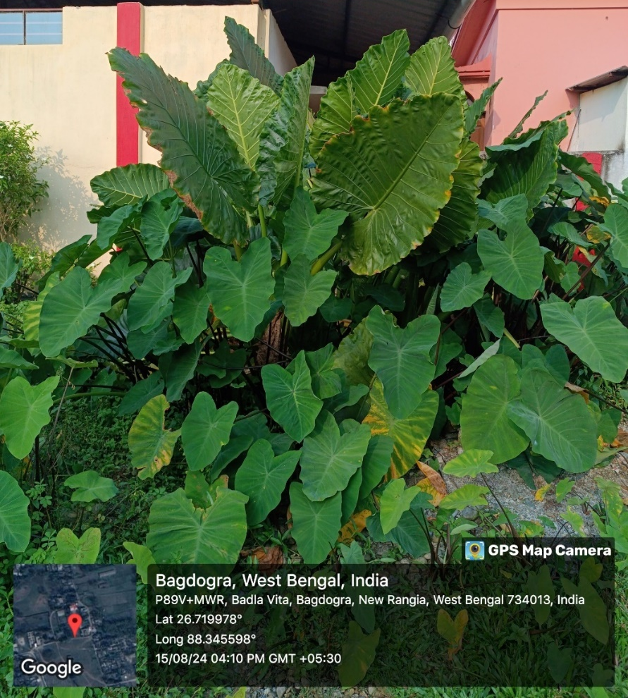
Supplementary Figure 1. Sample collection area showing the geographical location of the study site.

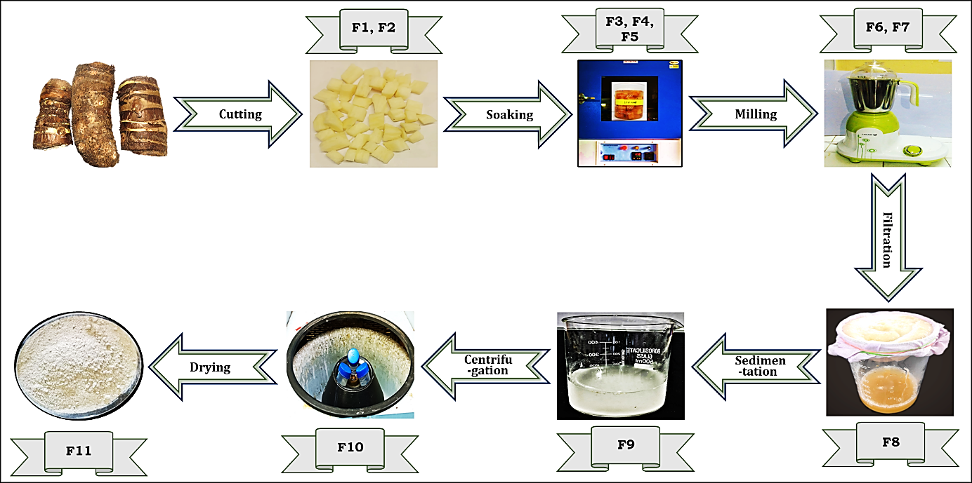
Supplementary Figure 2. Stepwise extraction procedure of starch from the corms of Alocasia macrorrhizos along with the eleven factors (F) used for Plackett-Burman design - Factor 1: Sample concentration (0.2 & 1 g/mL); Factor 2: Corm size (0.5 & 2 cm³); Factor 3: NaCl concentration (5% & 30%); Factor 4: Soaking time (6 & 36 h); Factor 5: Soaking temperature (25 & 60 ℃); Factor 6: Milling time (5 & 6 min); Factor 7: Proportion of water for milling (0.5 & 6.5 times); Factor 8: Incubation time (6 & 36 h); Factor 9: Incubation temperature (25 & 60 ℃); Factor 10: Centrifugation (3000 & 8000 rpm); Factor 11: Drying temperature (40 & 80 ℃).

