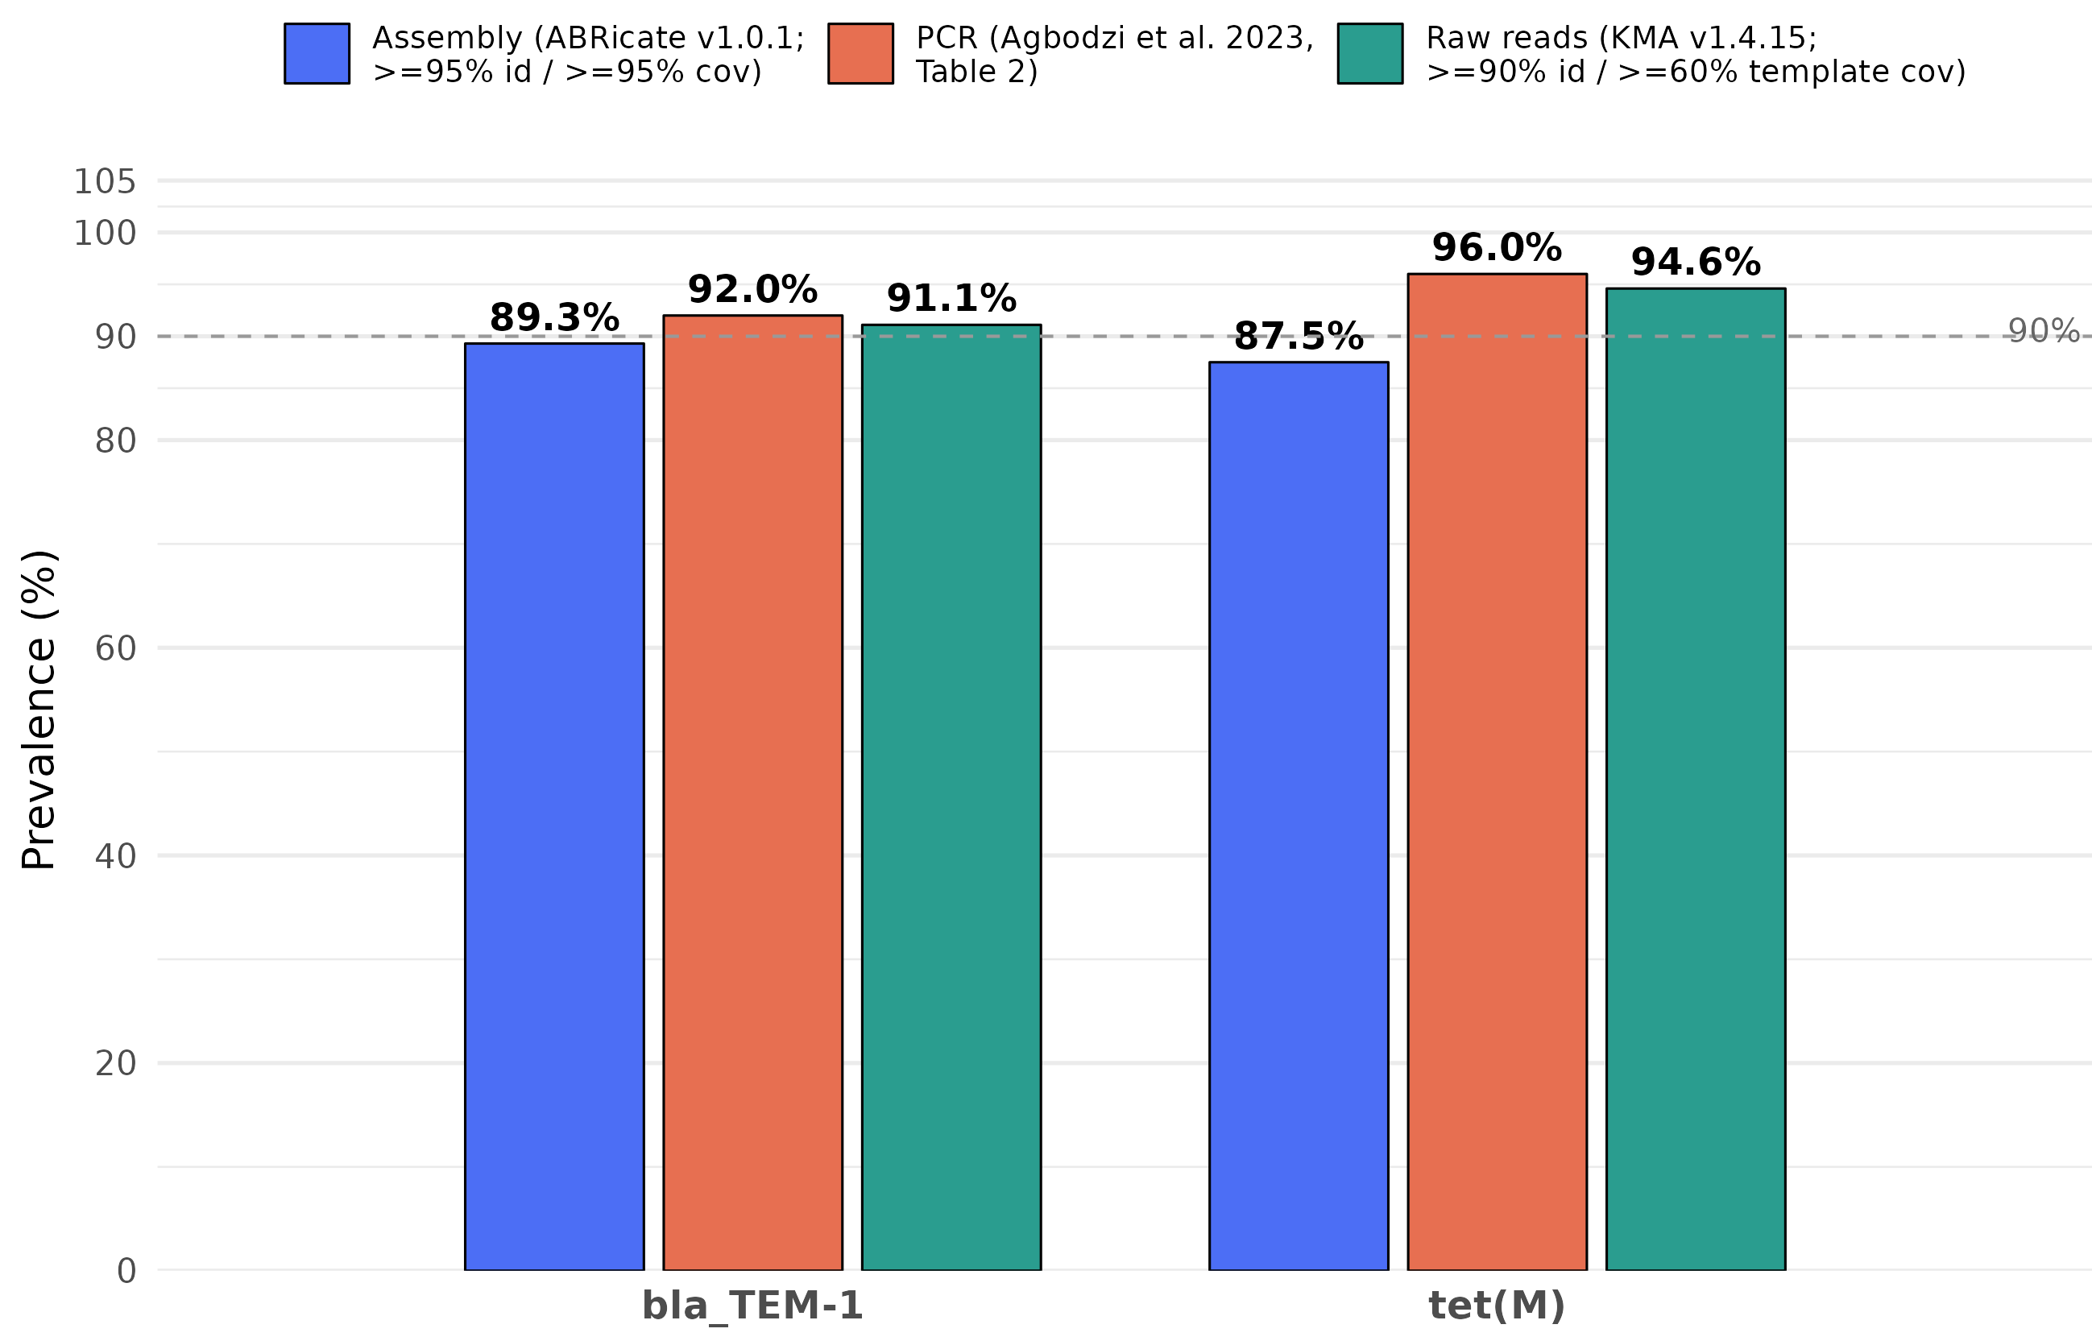
Supplementary Figure S4. Plasmid-Mediated Resistance Prevalence by Method. Grouped bar chart comparing the observed prevalence of plasmid-mediated penicillin (bla_TEM-1) and tetracycline (tet(M)) resistance determinants across three orthogonal detection methodologies: assembly-based screening (ABRicate v1.0.1 against AMRFinderPlus + ResFinder; ≥95% identity, ≥95% coverage), raw-read k-mer alignment (KMA v1.4.15 against ResFinder; ≥90% identity, ≥60% template coverage), and wet-lab targeted PCR results published by Agbodzi et al. (2023). Dashed line represents a 90% prevalence reference threshold.

