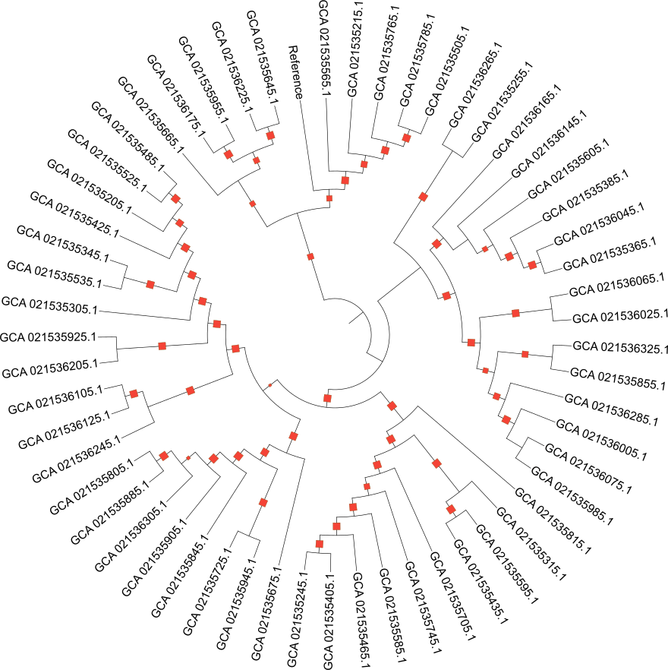
Supplementary Figure S1. Unannotated core-genome maximum-likelihood phylogeny of 56 N. gonorrhoeae clinical isolates from Ghana. The tree was inferred using IQ-TREE v2.2.6 from a recombination-filtered core-SNP alignment (Snippy v4.6.0 against reference FA1090, GenBank GCA_000006845.1; recombination masked with Gubbins v3.2.1) under the GTR + ASC substitution model with 1,000 ultrafast bootstrap replicates. Tip labels are GenBank assembly accessions; bootstrap support values ≥ 70 are shown at internal nodes. This unannotated tree displays the raw branching topology without the metadata overlays presented in main-text Figure 1B.

