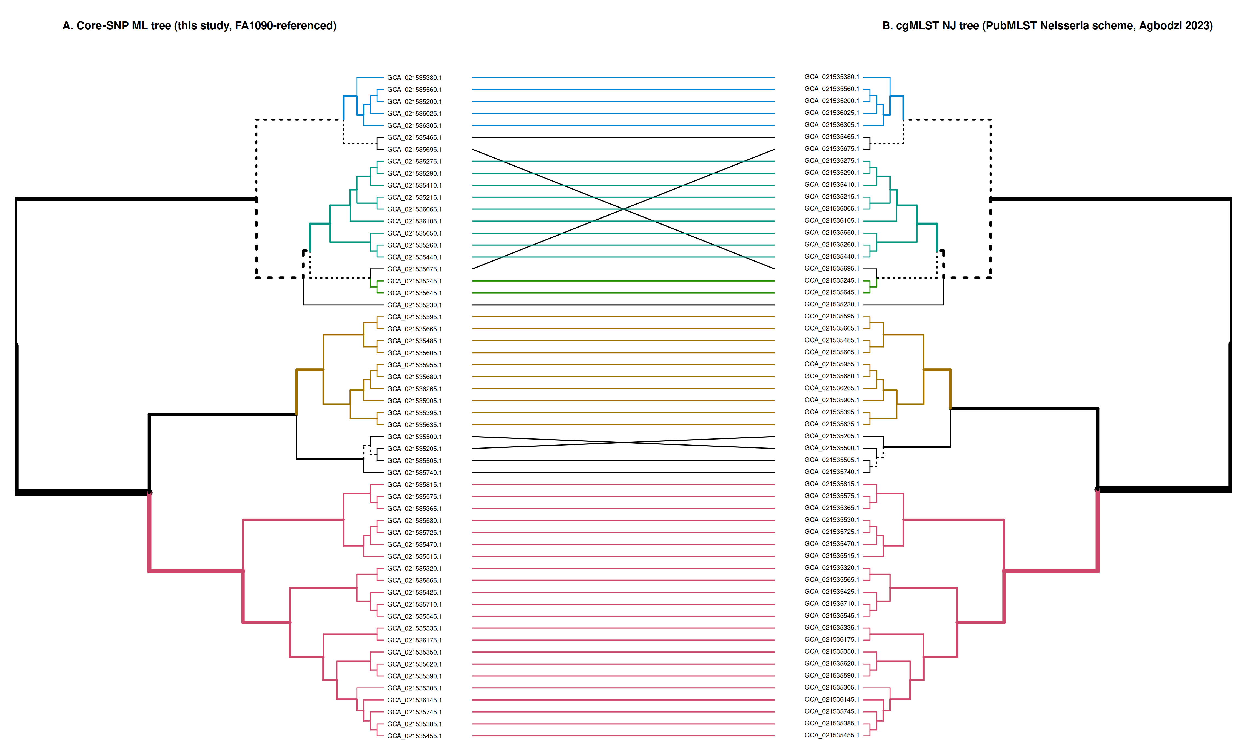
Supplementary Figure S2. Tanglegram Comparison of Core-SNP and cgMLST Topologies. High-resolution tanglegram comparing the reference-based core-genome SNP maximum-likelihood tree (left, mapped to FA1090 reference) and the reference-free core-genome multilocus sequence typing (cgMLST) neighbor-joining tree (right, PubMLST Neisseria scheme) for the 56 Ghanaian isolates. Connector lines are colored by major MLST sequence types (clades), illustrating congruent branch partitioning. Quantitative concordance metrics (Baker's Gamma, Cophenetic correlation, Entanglement, and Normalised Robinson-Foulds distance) are annotated at the bottom.

