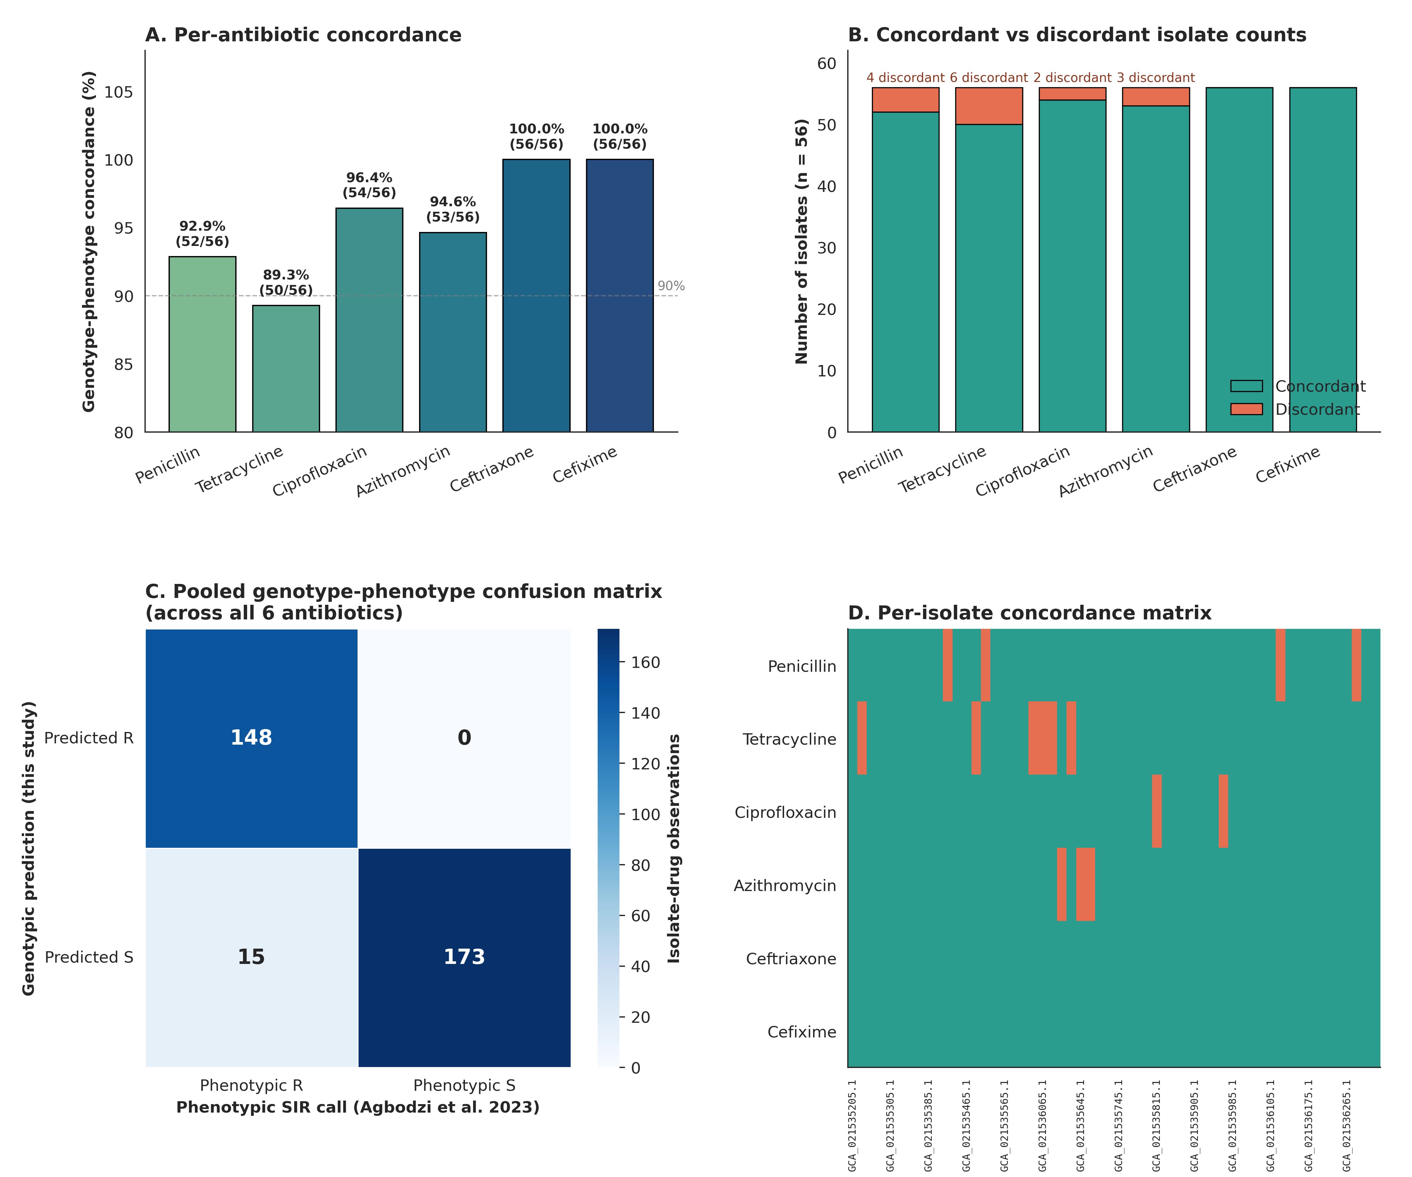
Supplementary Figure S3. Genotype-Phenotype Susceptibility Concordance Analysis. Comprehensive concordance mapping between in silico genotypic AMR predictions (this study) and qualitative categorical (S/I/R) phenotypic antimicrobial susceptibility testing (AST) results published by Agbodzi et al. (2023). (A) Per-antibiotic percentage concordance across six clinical drugs (penicillin, tetracycline, ciprofloxacin, azithromycin, ceftriaxone, and cefixime). (B) Stacked counts of concordant (teal) and discordant (orange) isolates per drug. (C) Pooled genotype-phenotype confusion matrix (336 total isolate-drug observations). (D) Heatmap of isolate-level categorical concordance mapped against standard GCA accessions.

