Dengue virus serotype classification from complete genomes using a Transformer with chunk-based sequence modeling and explainability analysis
SUPPLEMENTARY APPENDIX
- Supplementary Methods
- Supplementary Results
- Figure S1
- Figure S2
- Figure S3
- Figure S4
- Figure S5
- Table S1
- Table S2
- Table S3
- References

Supplementary Methods
CD-HIT clustering and MSA
We performed a CD-HIT-based sequence reduction using CD-HIT-EST [1], followed by multiple sequence alignment (MSA) analysis. CD-HIT-EST v4.8.1 and MAFFT v7.505 were installed through Bioconda in Python and used for sequence clustering and MSA, respectively. Complete DENV genome sequences were first clustered separately for each serotype using CD-HIT-EST at a 95% sequence identity threshold. The representative sequences retained by CD-HIT-EST were used for the downstream MSA analysis, reducing the contribution of overrepresented groups of highly similar genomes. The CD-HIT-EST clustering output was also used independently to define the CD-HIT cluster-aware validation strategy.
For the MSA-based variability analysis, each CD-HIT-EST representative genome was mapped to the corresponding serotype-specific RefSeq genome. This mapping was used to extract annotated DENV genomic regions, including untranslated regions and structural and non-structural protein-coding regions. Region-specific FASTA files were then generated and aligned at the nucleotide level using MAFFT [2]. Variability metrics were therefore computed from region-specific MSAs derived from CD-HIT-EST representative genomes.
The resulting region-level summaries were used to compare two complementary measures across DENV genomic regions and serotypes: within-serotype variability, quantified by normalized Shannon entropy [3], and serotype-vs-others divergence, quantified by Jensen–Shannon divergence (JSD). At each aligned nucleotide position, entropy was computed from the nucleotide frequency distribution within that serotype and normalized to the interval from 0 to 1, with higher values indicating greater intra-serotype nucleotide variability.
Region-level values were obtained by averaging normalized entropy across aligned positions within each region-specific MSA. To quantify serotype-specific divergence, JSD was computed between nucleotide distributions for all pairwise serotype comparisons at each aligned position within each region-specific MSA.
Pairwise JSD values were then averaged across aligned positions within each genomic region. For the serotype-vs-others summary, each serotype-specific value was obtained by averaging the pairwise JSD values between that serotype and each of the other three serotypes. Higher values therefore indicate regions where nucleotide distributions show stronger serotype-specific separation.
Across the four serotypes, the 29,091 genomes formed 2,392 serotype-specific CD-HIT clusters. Representative-sequence reduction was used only for the MSA analysis, whereas all 29,091 genomes were retained in the classification and validation analyses.
Implementation details for reproducibility
CD-HIT-EST was run separately for each serotype using the following command-line parameters:
cd-hit-est -i <input_fasta> -o <output_fasta> -c 0.95 -n 9 -T 4 -M 16000 -d 0
The resulting clusters were grouped by serotype and sorted in descending order of cluster size. Each cluster was then assigned in its entirety to the fold containing the smallest current number of genomes from the same serotype. Ties were resolved according to fold order. This deterministic greedy procedure produced five outer folds while preventing members of the same CD-HIT cluster from being divided between outer training and test subsets.
For CD-HIT cluster-aware validation, the internal validation split was performed at sequence level and used only for checkpoint selection, whereas CD-HIT cluster integrity was enforced for the outer training–test separation. Encoded inputs followed the preprocessing described in the main manuscript; no separate padding or ambiguity mask was applied.
Class imbalance was handled only in the training loader using PyTorch WeightedRandomSampler. Class-specific sampling weights were calculated independently within the training subset of each partition. For a class $c$ containing $n_{c}$ genomes in a training subset of size $N_{train}$, the sampling weight was defined as:
$$w_{c}= 1 -\frac{n_{c}}{N_{train}}$$
Each training genome received the weight associated with its class. The sampler drew $N_{train}$ samples per epoch with replacement. The internal validation and held-out-test loaders were not resampled.
Partition-level accuracy and per-serotype F1-scores were calculated independently for each held-out continent, collection period, or CD-HIT fold.
For protocol-level pooled summaries and paired model comparisons, the held-out predictions from the mutually exclusive outer partitions of the same validation protocol were concatenated using the original global dataset indices. Each of the 29,091 genomes therefore contributed exactly one held-out prediction to each protocol-level analysis. Predicted probabilities and partition-level metric values were not averaged across outer partitions.
Classification confusion matrices
Confusion matrices were computed separately for each geographical, temporal, and CD-HIT cluster-aware held-out partition using ground-truth and predicted serotype labels.
Sequence-level baseline analysis
To quantify the serotype information contained in global sequence properties, we evaluated classifiers that did not use nucleotide order, local sequence motifs, one-hot encoded position-level inputs, learned embeddings, or Transformer representations. The analysis included all 29,091 genomes and used the same ground-truth targets and geographical, temporal, and CD-HIT cluster-aware validation partitions adopted in the primary experiments.
The evaluated predictors included sequence length, N fraction, GC fraction, and combinations of these variables. A broader sequence-quality feature set additionally comprised the fractions of non-N IUPAC ambiguity symbols, gap characters, and other non-ACGT symbols. Sequence length also directly determined the amount of terminal zero-padding because all genomes were padded to the common maximum sequence length. GC fraction was calculated relative to the total number of unambiguous A, C, G, and T positions.
A majority-class classifier was included as a reference. Linear associations were evaluated using multinomial Logistic Regression, whereas possible nonlinear relationships among the complete set of global sequence properties were assessed using histogram gradient boosting. All models were fitted and evaluated independently within the original training and held-out test subsets. Accuracy, balanced accuracy, and macro-averaged F1-score were calculated from the pooled held-out predictions across all partitions of each validation protocol.
Statistical comparison of model performance
Formal model comparisons were performed at the prediction level using aligned held-out predictions from the same genomes. Inferential tests were not applied to the small number of structured outer-partition scores. The primary endpoint was the paired difference in accuracy between models.
Confidence intervals were estimated using a paired nonparametric bootstrap that resampled complete serotype-specific CD-HIT clusters with replacement, stratified by true serotype. A total of 10,000 bootstrap replicates were used. Statistical significance was assessed using a two-sided paired sign-flip permutation test at the same serotype-specific CD-HIT-cluster level, using 100,000 permutation replicates. This cluster-aware approach preserved the pairing between model predictions while reducing the risk of treating highly similar genomes as statistically independent observations.
Holm correction was applied separately to the prespecified benchmark comparison family and the DENFormer pooling-ablation comparison family. The benchmark family included comparisons of DENFormer-mean with Longformer, Performer, FFNN, and Logistic Regression under each validation protocol. The ablation family included all pairwise comparisons among DENFormer-first, DENFormer-mean, and DENFormer-max under each protocol.
Exact two-sided McNemar tests based on genome-level correctness indicators were additionally reported as a sensitivity analysis. Differences in macro-averaged F1-score and per-serotype F1-score were examined as secondary endpoints using paired cluster-bootstrap confidence intervals. Complete numerical results, including primary accuracy comparisons, cluster-bootstrap confidence intervals, Holm-adjusted permutation p-values, exact McNemar sensitivity analyses, and macro-F1 and per-serotype F1 comparisons, are provided in Supplementary File S3.
Inferential conclusions were based on the Holm-adjusted cluster-level permutation p-values. Cluster-bootstrap confidence intervals were not adjusted for multiple comparisons and were reported to quantify the magnitude and uncertainty of the observed differences.
Computational efficiency benchmark
A controlled computational efficiency benchmark was performed for Logistic Regression, FFNN, DENFormer-first, DENFormer-mean, DENFormer-max, Longformer, and Performer using the first CD-HIT cluster-aware fold. The benchmark included 16,021 training genomes, 1,780 validation genomes, and 11,290 test genomes. All models used one-hot encoded inputs, a batch size of 32, a fixed random seed of 0, float32 precision, and the same software environment. Measurements were obtained on an NVIDIA H200 NVL GPU under a fixed MPS allocation of 50%.
For the training benchmark, each model was initialized from scratch and run for one complete warm-up epoch, followed by three measured epochs. Each epoch consisted of a complete training pass followed by validation. The reported training time refers to the training pass only, while peak allocated GPU memory was measured over the complete training and validation epoch using PyTorch CUDA peak-memory statistics.
For the inference benchmark, the original checkpoints trained for 100 epochs were loaded. After ten warm-up batches, three complete inference passes were performed on the same held-out test subset. Timing included host-to-device transfer, the forward pass, softmax computation, class prediction, and accuracy accumulation. CUDA synchronization was applied before and after each timed pass. Training time, inference time, and throughput are reported as medians across the three measurements, whereas GPU memory corresponds to the maximum peak allocated memory observed across the measured runs.
Mathematical XAI
Principal Component Analysis (PCA) and Uniform Manifold Approximation and Projection (UMAP) were used as complementary dimensionality reduction techniques to the t-SNE analysis.
PCA was applied as a linear dimensionality reduction method to transform correlated features into an orthogonal set of linearly uncorrelated components, maximizing the variance captured by the leading components. This analysis provided a preliminary overview of the global structure and variance distribution within the learned feature space.
UMAP was applied as a nonlinear manifold learning technique to complement t-SNE visualization. UMAP preserves both local and broader topological relationships by constructing a weighted k-nearest neighbor graph and optimizing a cross-entropy–based objective function [4].
Statistical analysis
Effect sizes were computed to complement statistical significance testing and to describe the magnitude of regional differences in model-derived XAI signals [5].
For Kruskal–Wallis analyses, both ordinal eta-squared and ordinal epsilon-squared estimates were reported, with epsilon-squared used as the primary omnibus effect-size summary in the regional analyses.
For pairwise Mann–Whitney U comparisons, Vargha–Delaney A, folded Vargha–Delaney A, rank-biserial correlation, and Cliff’s delta were computed. Rank-biserial correlation was used as the primary signed pairwise effect-size measure, where positive values indicate higher signal values for the first serotype in the pair and negative values indicate higher signal values for the second serotype.

Supplementary Results
CD-HIT clustering and MSA
Figure S1 reports the multiple sequence alignment-based regional variability analysis performed after CD-HIT-EST sequence reduction. The analysis summarizes two complementary sequence-level measures across annotated DENV genomic regions: normalized within-serotype entropy and serotype-vs-others divergence based on Jensen–Shannon divergence. The entropy analysis showed that within-serotype nucleotide variability was not uniform along the genome, with higher values observed particularly in prM and NS4B, and intermediate values in regions such as E and NS2B. DENV4 generally showed higher entropy in several regions, including prM, E, NS1, NS2B, NS4B, and NS5, suggesting greater intra-serotype variability in these genomic segments.
The serotype-vs-others divergence analysis showed a partially distinct pattern. The strongest serotype-specific separation was observed in prM, NS4B, NS2B, 5′UTR, and 3′UTR, whereas the C region showed consistently low divergence across serotypes. Some regions showed serotype-specific differences in divergence, such as higher 5′UTR divergence for DENV3 and lower 3′UTR divergence for DENV3 compared with the other serotypes. Together, these results indicate that regional sequence variability and serotype-specific nucleotide separation are unevenly distributed across the DENV genome. This provides an independent alignment-based context for interpreting the regional model-derived XAI patterns.
Classification confusion matrices
Figure S2 reports the confusion matrices obtained with DENFormer-mean across geographical, temporal, and CD-HIT cluster-aware validation settings. Across most held-out subsets, predictions were strongly concentrated along the diagonal, indicating that the majority of genomes were assigned to the correct serotype. This pattern was particularly evident in several CD-HIT cluster-aware folds and in smaller geographical subsets such as Europe and Oceania, where only limited off-diagonal entries were observed.
Residual misclassifications were more visible in specific held-out partitions, particularly in the South America geographical subset and in the 2021–2025 temporal subset. In these cases, off-diagonal entries mainly involved confusion among DENV1, DENV2, and DENV3, while DENV4 was generally classified with fewer errors across most partitions. Overall, the confusion matrices confirm that DENFormer-mean maintained strong class-wise discrimination under the three validation protocols, while also showing that the remaining errors were concentrated in specific geographical or temporal subsets rather than uniformly distributed across all partitions.
Sequence-level baseline analysis
Complete results are reported in Supplementary Table S1. For sequence length, balanced accuracy ranged from 19.9% to 24.4% and macro-F1 from 16.4% to 21.3% across the three validation protocols. For N fraction, balanced accuracy ranged from 21.8% to 22.9% and macro-F1 from 16.6% to 20.4%. GC fraction was more informative, although balanced accuracy remained approximately 70% and macro-F1 approximately 67%, indicating uneven discrimination among serotypes. Adding sequence length and/or N fraction to GC fraction did not consistently improve performance, while the additional IUPAC, gap, and other non-ACGT fractions produced negligible changes in the linear classifier. The nonlinear classifier based on the complete sequence-quality feature set achieved macro-F1 values of 74.7%, 83.6%, and 81.8% under geographical, temporal, and CD-HIT cluster-aware validation, respectively.
Statistical comparison of model performance
The primary accuracy comparisons and pooling-ablation results are reported in the main manuscript. Complete numerical results, including cluster-bootstrap confidence intervals, Holm-adjusted permutation p-values, exact McNemar sensitivity analyses, and macro-F1 and per-serotype F1 comparisons, are provided in Supplementary File S3.
Computational efficiency
The controlled benchmark confirmed substantial computational differences among the evaluated architectures, with complete absolute measurements reported in Supplementary Table S2 and the principal comparisons summarized in the main manuscript. Relative to Performer and Longformer, DENFormer-mean reduced training time by 16.5% and 75.5%, respectively, while peak training memory was reduced by 63.9% and 79.5%. During inference, DENFormer-mean achieved 1.21-fold and 2.20-fold higher throughput than Performer and Longformer, respectively, while reducing peak inference memory by approximately 95% and 97%. DENFormer-max achieved the highest inference throughput among the Transformer models, whereas DENFormer-mean was retained as the reference configuration for the principal comparative and XAI analyses.
Mathematical XAI
The PCA and UMAP projections, reported in Figures S3 and S4, provide complementary views of the same embedding space. PCA provides a linear projection of the embeddings and showed broad serotype-associated separation across several validation subsets, although with partial overlap in some partitions. UMAP provides a nonlinear representation and generally preserved compact local groupings of genomes belonging to the same serotype, with variable inter-cluster distances across validation settings.
Across t-SNE, PCA, and UMAP, the held-out embeddings showed broadly consistent serotype-associated organization across geographical, temporal, and CD-HIT cluster-aware evaluations.
Perceptive XAI
The G×I regional analysis, reported in Figure S5, showed a stronger and more localized attribution pattern. As observed for attention, all 13 genomic regions passed the Kruskal–Wallis consensus criterion. Pairwise testing identified consensus-significant differences in 67 of 78 serotype-region comparisons. Regions showing significant differences for all six pairwise comparisons included C, NS1, NS2B, NS4A, NS4B, and 3′UTR, while E, NS2A, NS5, and 2K showed significant differences in five of six comparisons. G×I also produced larger and more consistent effect sizes than attention, with the strongest Kruskal–Wallis effects observed for NS4A, E, NS1, NS2B, prM, 2K, and NS4B.
For Transformer attention, effect-size analysis indicated that many statistically significant regional differences had small or negligible magnitude across validation strategies. In the Kruskal–Wallis effect-size analysis, the largest median epsilon-squared values were observed for NS4B, NS4A, NS1, 2K, E, NS2B, NS2A, and NS3. Pairwise attention effect sizes were generally limited, and no pairwise comparison showed consistent medium or large effect-size support across validation strategies. These results indicate that attention captured reproducible serotype-associated regional differences, while the magnitude of many pairwise differences remained modest. Full p-values, sample counts, and effect-size estimates are provided in Supplementary File S1. The analogous complete statistical results for G×I attribution, including corrected p-values, sample counts, and effect-size estimates, are provided in Supplementary File S2.

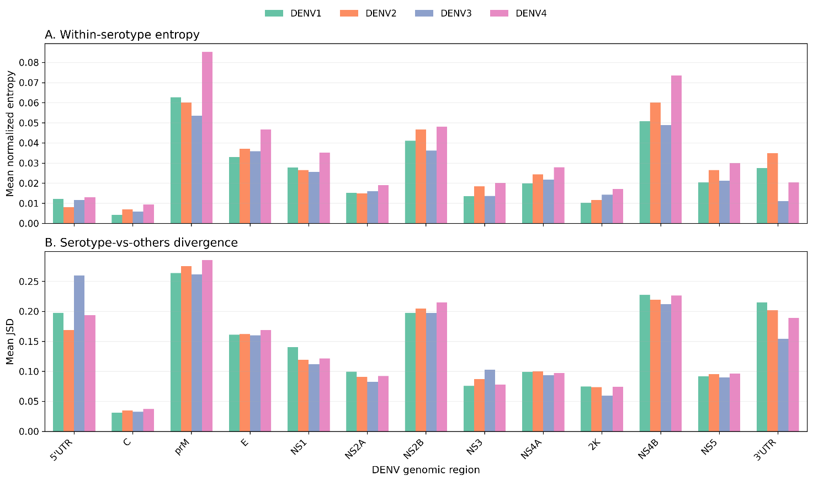
Figure S1. Multiple sequence alignment (MSA)-based regional variability across DENV serotypes after CD-HIT-EST sequence reduction. (A) Mean normalized within-serotype entropy computed from nucleotide-level region-specific MSAs of CD-HIT-EST representative genomes and averaged across annotated DENV genomic regions. Higher values indicate greater intra-serotype nucleotide variability. (B) Mean serotype-vs-others divergence computed using Jensen–Shannon divergence (JSD). For each genomic region, pairwise JSD values were computed between serotype-specific nucleotide distributions, and each serotype-vs-others value was obtained by averaging the JSD values between that serotype and each of the other three serotypes. Higher values indicate stronger serotype-specific separation in nucleotide distributions. Genomic regions are ordered according to their position along the DENV genome.
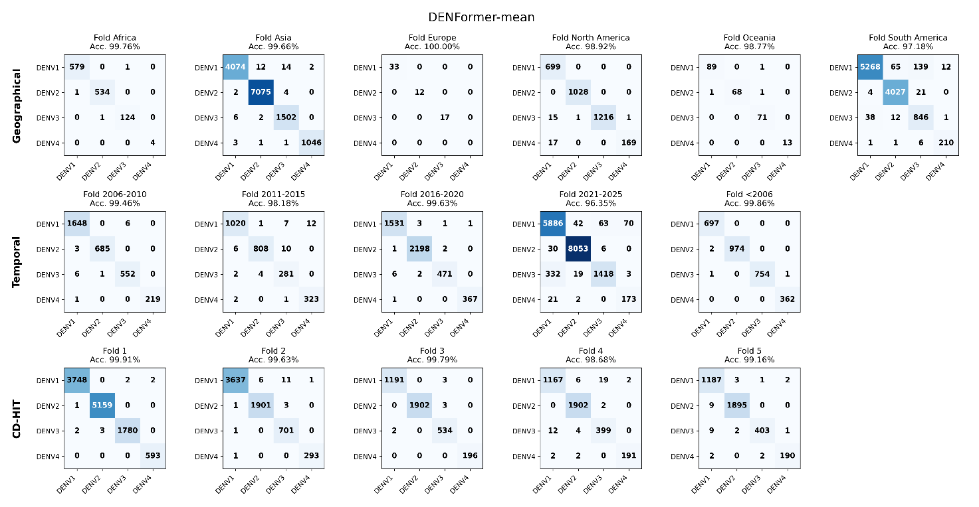
Figure S2. Confusion matrices for DENFormer-mean across geographical, temporal, and CD-HIT cluster-aware evaluation settings. Each matrix compares the predicted and true DENV serotype labels for the held-out test subset of the corresponding validation partition. The first row shows continent-specific test subsets, the second row temporal test subsets defined by collection period, and the third row the five CD-HIT cluster-aware folds. Matrix rows indicate the true serotype labels, whereas columns indicate the predicted serotype labels. Diagonal entries represent correct classifications, while off-diagonal entries represent misclassifications.

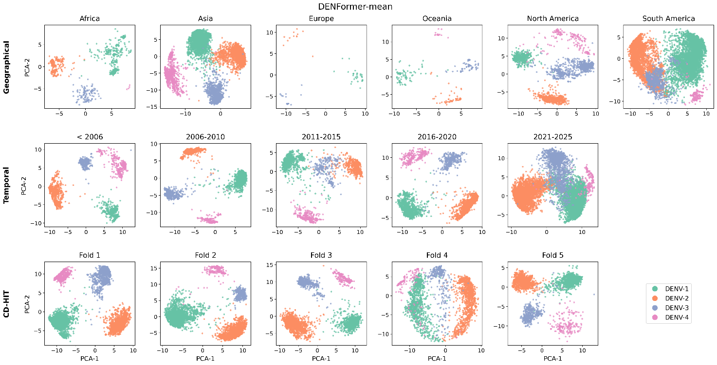
Figure S3. Principal component analysis (PCA) of DENFormer-mean embeddings across geographical, temporal, and CD-HIT cluster-aware evaluation settings. Each point represents a DENV genome from the held-out test subset, projected into two dimensions using PCA and colored according to serotype. The first row shows continent-specific test subsets, the second row temporal test subsets defined by collection period, and the third row the five CD-HIT cluster-aware folds. Overall, the projections provide a linear view of the learned embedding space and indicate broad serotype-associated organization across the three validation protocols.
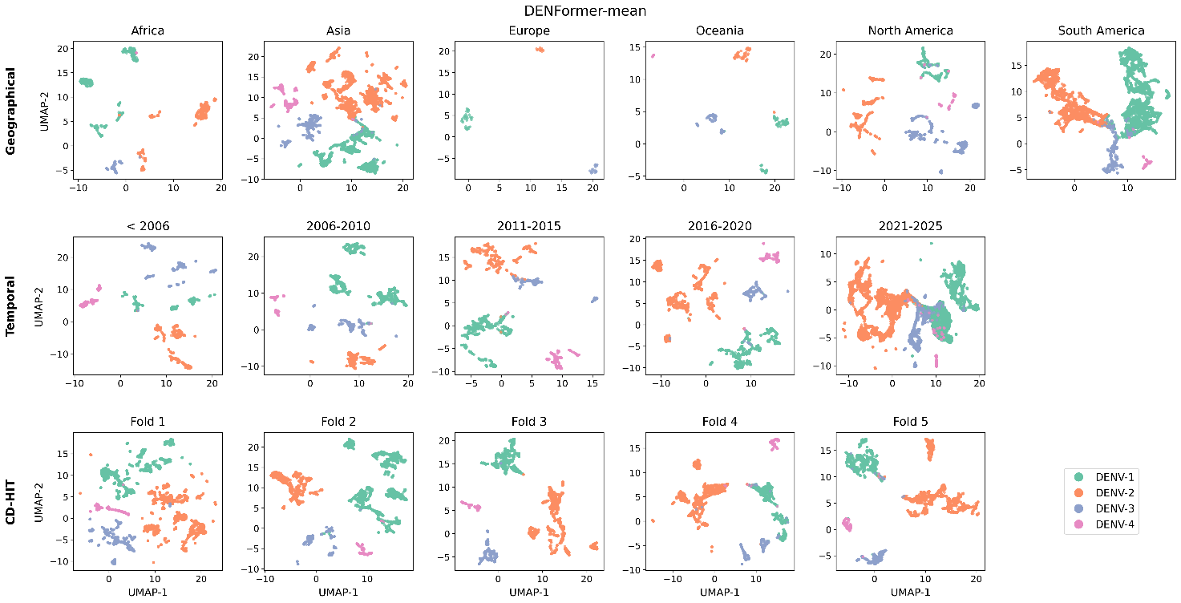
Figure S4. Uniform Manifold Approximation and Projection (UMAP) of DENFormer-mean embeddings across geographical, temporal, and CD-HIT cluster-aware evaluation settings. Each point represents a DENV genome from the held-out test subset, projected into two dimensions using UMAP and colored according to serotype. The first row shows continent-specific test subsets, the second row temporal test subsets defined by collection period, and the third row the five CD-HIT cluster-aware folds. Overall, the projections provide a nonlinear view of the learned embedding space and indicate compact local serotype-associated groupings across the three validation protocols.
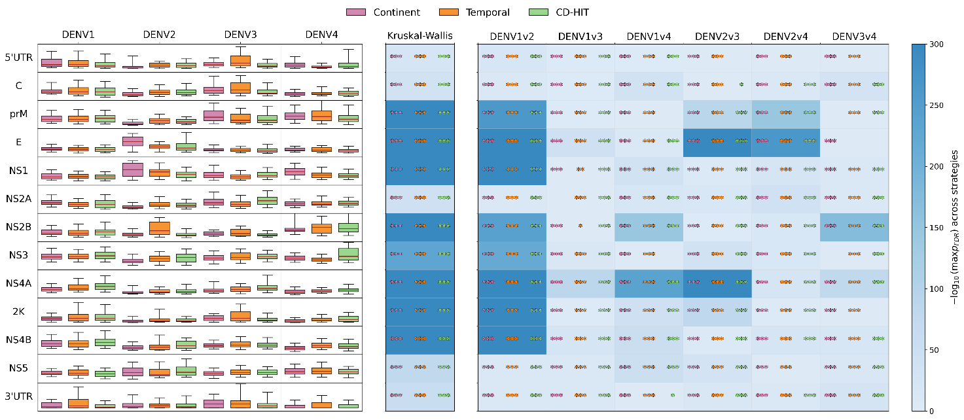
Figure S5. Regional Gradient × Input (G×I) attribution distributions and cross-strategy statistical consistency. Regional G×I attribution scores are shown for each annotated DENV genomic region across DENV1–DENV4 and the three validation protocols: geographical split by continent, temporal split, and CD-HIT cluster-aware split. Left panel: boxplots summarize sample-level regional G×I distributions after reduction of nucleotide-level input-gradient products to regional signal values; colors indicate the validation protocol. Middle panel: Kruskal–Wallis tests evaluate serotype-dependent differences within each genomic region. Right panel: pairwise Mann–Whitney U tests compare all six serotype pairs. Heatmap intensity encodes −log₁₀ of the maximum false discovery rate (FDR)-corrected p-value across the three validation protocols, providing a conservative summary of cross-strategy statistical consistency; non-consensus cells are displayed with minimal intensity. Colored asterisks report the significance level obtained within each individual validation protocol, matching the strategy colors used in the boxplots. Significance levels are denoted as *, **, *** for pFDR < 0.05, pFDR < 0.01, and pFDR < 0.001, respectively. Pairwise comparisons are shown in the context of regions satisfying the Kruskal–Wallis consensus criterion.

Table S1. Performance of classifiers based exclusively on global sequence properties. Accuracy, balanced accuracy, and macro-F1 are reported as percentages in separate rows and were calculated from pooled held-out predictions across all partitions of each validation protocol. LR, multinomial Logistic Regression; HGB, histogram gradient boosting. The complete sequence-quality feature set comprised sequence length and the fractions of N, non-N IUPAC ambiguity symbols, gaps, other non-ACGT symbols, and GC among unambiguous A, C, G, and T positions.

Baseline | Metric | Geographical | Temporal | CD-HIT
Majority class | Accuracy | 33.7 | 37.0 | 43.9
Majority class | Balanced accuracy | 20.5 | 23.0 | 25.0
Majority class | Macro-F1 | 18.4 | 20.3 | 15.3
Length (LR) | Accuracy | 34.0 | 41.0 | 36.6
Length (LR) | Balanced accuracy | 19.9 | 24.4 | 21.5
Length (LR) | Macro-F1 | 16.4 | 21.3 | 18.2
N fraction (LR) | Accuracy | 35.3 | 33.9 | 37.1
N fraction (LR) | Balanced accuracy | 21.8 | 21.9 | 22.9
N fraction (LR) | Macro-F1 | 19.5 | 16.6 | 20.4
GC fraction (LR) | Accuracy | 84.4 | 84.6 | 84.5
GC fraction (LR) | Balanced accuracy | 69.9 | 70.4 | 70.2
GC fraction (LR) | Macro-F1 | 66.7 | 66.9 | 67.0
Length + GC (LR) | Accuracy | 77.2 | 83.9 | 81.0
Length + GC (LR) | Balanced accuracy | 65.2 | 70.9 | 67.9
Length + GC (LR) | Macro-F1 | 62.4 | 65.2 | 66.2
Length + N + GC (LR) | Accuracy | 77.4 | 83.9 | 81.0
Length + N + GC (LR) | Balanced accuracy | 66.3 | 71.3 | 68.6
Length + N + GC (LR) | Macro-F1 | 63.5 | 65.5 | 67.2
All quality features (LR) | Accuracy | 77.8 | 83.9 | 81.0
All quality features (LR) | Balanced accuracy | 66.6 | 71.3 | 68.6
All quality features (LR) | Macro-F1 | 63.6 | 65.6 | 67.2
All quality features (HGB) | Accuracy | 78.6 | 88.1 | 85.9
All quality features (HGB) | Balanced accuracy | 75.6 | 83.1 | 81.5
All quality features (HGB) | Macro-F1 | 74.7 | 83.6 | 81.8

Table S2. Controlled computational efficiency benchmark of DENFormer and competing models. Training time, peak allocated GPU memory, inference time, inference throughput, and trainable parameter count are reported for LR (Logistic Regression), FFNN, DENFormer-first, DENFormer-mean, DENFormer-max, Longformer, and Performer. All measurements were obtained using the same CD-HIT cluster-aware fold, batch size of 32, software environment, random seed, and NVIDIA H200 NVL GPU under a fixed MPS allocation of 50%. Training times are medians from three measured training passes following one complete warm-up epoch. Inference values are medians from three complete passes over 11,290 held-out genomes following ten warm-up batches. GPU memory corresponds to the maximum peak allocated CUDA memory observed across the measured runs.
Model | Trainable parameters | Training time per epoch (s) | Peak training GPU memory (GB) | Inference time (s) | Inference throughput (genomes/s) | Peak inference GPU memory (GB)
LR | 192,004 | 0.97 | 0.08 | 0.38 | 29786.96 | 0.08
FFNN | 24,841,220 | 0.96 | 0.53 | 0.40 | 28052.24 | 0.26
DENFormer-first | 397,956 | 55.37 | 6.77 | 16.54 | 682.69 | 0.46
DENFormer-mean | 397,956 | 55.27 | 6.61 | 15.12 | 746.55 | 0.31
DENFormer-max | 397,956 | 55.55 | 6.61 | 12.42 | 909.37 | 0.31
Longformer | 2,087,300 | 225.85 | 32.22 | 33.25 | 339.50 | 12.07
Performer | 397,956 | 66.15 | 18.28 | 18.23 | 619.42 | 6.58

Table S3. Cross-method summary of regional evidence from Transformer attention, G×I attribution, and alignment-based sequence analyses. All 13 annotated DENV genomic regions are represented individually or in groups with similar evidence profiles. Attention and Gradient × Input (G×I) summaries integrate cross-strategy omnibus effect-size rankings and pairwise consensus across geographical, temporal, and CD-HIT cluster-aware validation, whereas the MSA context summarizes within-serotype entropy and serotype-vs-others Jensen–Shannon divergence. Interpretation is limited to regional concordance among model-derived and sequence-level analyses; causal, mutation-level, and experimentally validated biological determinants were not assessed.
Region | Transformer attention | G×I attribution | MSA context | Interpretation
NS2B, NS4B | NS4B had the largest median omnibus attention effect size; NS2B was also among the more prominent regions. Pairwise consensus was broader for NS2B than for NS4B. | Both were among the strongest omnibus G×I effect-size regions and each showed consensus differences in all six serotype comparisons. | Both were among the regions with the strongest serotype-vs-others divergence; NS4B also showed high within-serotype entropy. | Clearest overall cross-method regional convergence.
E | Among the regions with larger attention effect sizes, with consensus differences in five of six serotype comparisons. | One of the strongest G×I effect-size regions, with consensus differences in five of six comparisons. | Intermediate within-serotype variability, but not among the strongest Jensen–Shannon divergence regions. | Concordant model-derived evidence with established antigenic context.
NS1, NS4A, 2K | All three ranked among the larger attention effect-size regions. Pairwise consensus was strongest for NS1 and 2K and more limited for NS4A. | All three were among the strongest G×I effect-size regions; NS1 and NS4A showed six-of-six pairwise support and 2K five-of-six. | Not among the strongest regions in the overall MSA summaries, although DENV4 showed relatively high entropy in NS1. | Strong cross-XAI concordance without equally strong sequence-summary concordance. The short length of 2K requires particular caution.
prM | Less prominent in the attention effect-size ranking and supported in two of six pairwise comparisons. | Among the strongest G×I omnibus effect-size regions, with consensus support in four of six pairwise comparisons. | High within-serotype entropy and strong serotype-vs-others divergence. | Concordance between output sensitivity and sequence-level variation despite limited attention support.
5′UTR, 3′UTR | Both showed recurrent attention differences, with five-of-six pairwise comparisons supported for each region. | The 3′UTR showed six-of-six pairwise support despite a low omnibus effect-size ranking; the 5′UTR showed three-of-six pairwise support. | Both were among the regions with the strongest serotype-vs-others divergence. | Partial cross-method concordance, consistent with regional sequence divergence.
C, NS2A, NS3, NS5 | NS2A and NS3 were moderately prominent in the attention effect-size ranking; NS5 showed recurrent pairwise differences, whereas C had weak omnibus support. | C showed six-of-six pairwise support; NS2A and NS5 showed five-of-six and NS3 four-of-six, with variable omnibus effect-size rankings. | These regions were not among the strongest overall MSA summaries; C showed consistently low divergence. | Primarily method-specific or secondary evidence.

References
1. Li, W. & Godzik, A. Cd-hit: a fast program for clustering and comparing large sets of protein or nucleotide sequences. Bioinformatics 22, 1658–1659 (2006).
2. Katoh, K. & Standley, D. M. MAFFT Multiple Sequence Alignment Software Version 7: Improvements in Performance and Usability. Mol. Biol. Evol. 30, 772–780 (2013).
3. Tharanga, S. et al. DiMA: sequence diversity dynamics analyser for viruses. Brief. Bioinform. 26, bbae607 (2024).
4. McInnes, L., Healy, J. & Melville, J. UMAP: Uniform Manifold Approximation and Projection for Dimension Reduction. Preprint at https://doi.org/10.48550/arXiv.1802.03426 (2020).
5. Peres, F. F. Effect sizes for nonparametric tests. Biochem. Medica 36, 5–16 (2026).

