Phytochemical Characterization and In Vitro Evaluation of Antibacterial and Cytotoxic Activities of Indigenous Iranian Nigella sativa L. Seeds

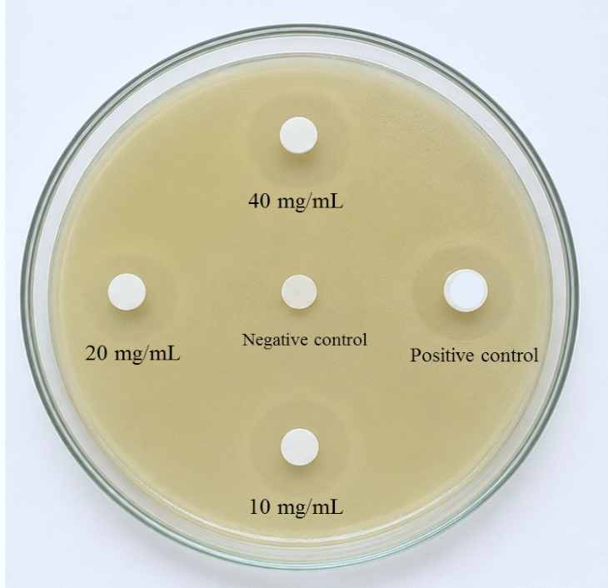

Figure S1. Representative disk diffusion assay showing the antibacterial activity of Nigella sativa essential oil against Escherichia coli. Disks contained essential oil at concentrations of 10, 20, and 40 mg/mL. The central disk represents the negative control, and the antibiotic disk represents the positive control (Tetracycline). Images are representative of three independent experiments.

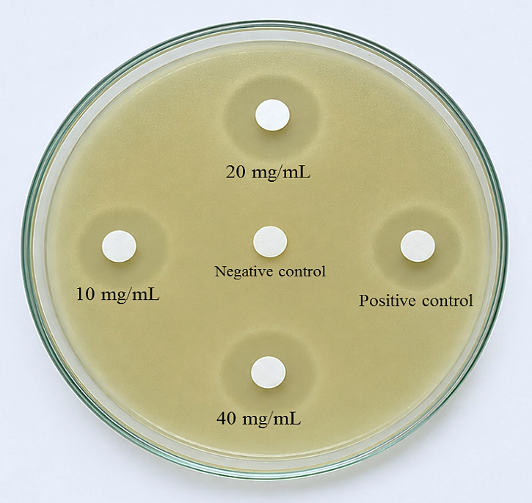

Figure S2. Representative disk diffusion assay showing the antibacterial activity of Nigella sativa essential oil against Staphylococcus aureus. Disks contained essential oil at concentrations of 10, 20, and 40 µg/mL. The central disk represents the negative control, and the antibiotic disk represents the positive control (Tetracycline). Images are representative of three independent experiments.

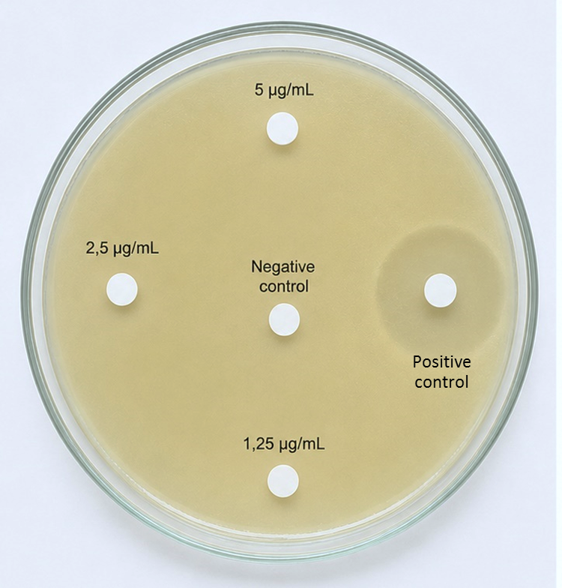

Figure S3. Representative disk diffusion assay showing the antibacterial activity of the protein buffer (protein suspension) isolated from Nigella sativa against Escherichia coli. Disks contained protein buffer at concentrations of 1.25, 2.5, and 5 µg/mL. The central disk represents the negative control (buffer), and the antibiotic disk represents the positive control (Tetracycline). Images are representative of three independent experiments.

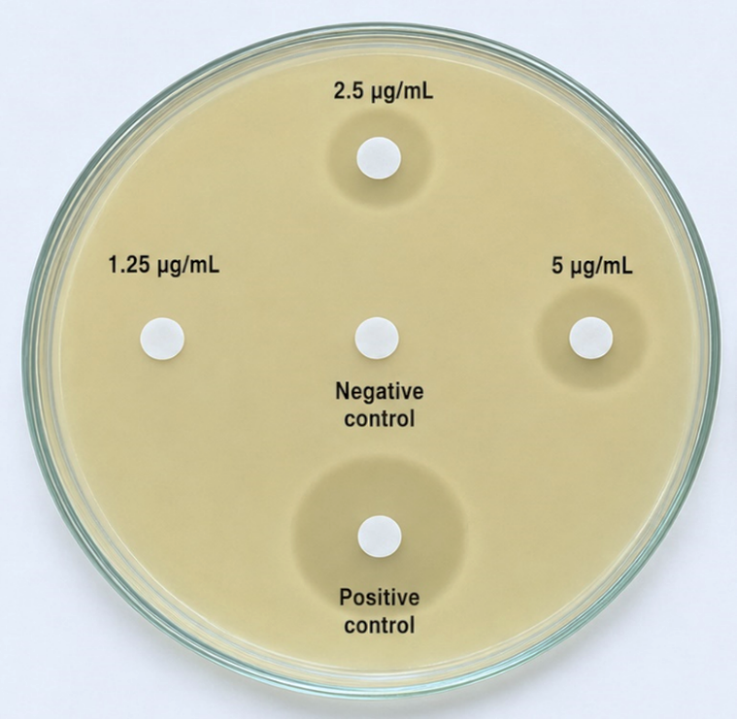

Figure S4. Representative disk diffusion assay showing the antibacterial activity of the protein buffer (protein suspension) isolated from Nigella sativa against Staphylococcus aureus. Disks contained protein buffer at concentrations of 1.25, 2.5, and 5 µg/mL. The central disk represents the negative control (buffer), and the antibiotic disk represents the positive control (Tetracycline). Images are representative of three independent experiments.

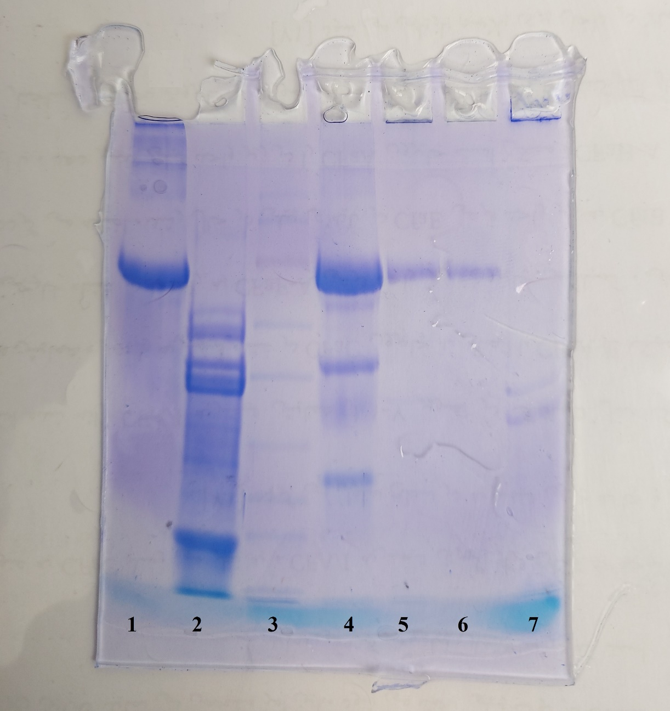
Figure S5. SDS-PAGE analysis of the protein suspension extracted from Nigella sativa L. seeds. Multiple protein bands with different molecular weights were detected. Lanes 2 and 3 represent the protein samples analyzed in the present study. The other lanes correspond to samples from an independent experiment and are not included in the present analysis. The uncropped gel image is shown to preserve the integrity of the original experimental record.

