Supplementary Information
Synchrotron X-ray-informed machine learning for local hardness mapping in a Cu–Ni–Ti–Hf–Zr high-entropy shape-memory alloy

Ming-Yi Chen^{1,†*}, Mao-Yuan Luo^{2,3†}, Tu-Ngoc Lam^{2,4†*}, Chia-Lin Li^{5†}, Ching-Yu Chiang⁶, Wan-Zhen Hsieh⁶, Chia-Yung Jui⁷, Phuoc Huu Le⁵, Cheng-Yu Chiu⁸, Soo Yeol Lee⁹, Jayant Jain¹⁰, Che-Wei Tsai^{3,11}, Wen-Jay Lee⁷, and E-Wen Huang^{2,3*}

¹ Department of Materials Science, National University of Tainan, Tainan City, 70005, Taiwan
² Department of Materials Science and Engineering, National Yang Ming Chiao Tung University, 1001 University Road, Hsinchu 300093, Taiwan
³ High Entropy Materials Center, National Tsing Hua University, Hsinchu 300044, Taiwan
⁴ Cuu Long University, Vinh Long Province, 890000, Viet Nam
⁵ Center for Plasma and Thin Film Technologies, Ming Chi University of Technology, New Taipei City 243303, Taiwan
⁶ National Synchrotron Radiation Research Center, Hsinchu 300092, Taiwan
⁷ National Center for High-Performance Computing, Taichung City, 40763, Taiwan
⁸ Master Program in Semiconductor Materials and Optoelectronic Characterization, Chung Yuan Christian University, Taoyuan City 320314, Taiwan
⁹ Department of Materials Science and Engineering, Chungnam National University, Daejeon 34134, Republic of Korea
¹⁰ Department of Materials Science and Engineering, Indian Institute of Technology, New Delhi 110016, India
¹¹ Department of Materials Science and Engineering, National Tsing Hua University, Hsinchu 300044, Taiwan

* Correspondence: neoone0321@mail.nutn.edu.tw, neoone0321@nycu.edu.tw, EwenHUANG@nycu.edu.tw, and lamtungoc1310@nycu.edu.tw
† These authors contributed equally: Ming-Yi Chen, Mao-Yuan Luo, Tu-Ngoc Lam, and Chia-Lin Li

Supplementary experimental information
Representative nanoindentation load–depth curves
Nanoindentation measurements were performed using a TI-950 TriboIndenter (Bruker, USA) equipped with a Berkovich diamond indenter in XPM (Hysitron Accelerated Property Mapping) mode. Measurements were conducted under load control with a 2 μN pre-load, loading to 1500 μN over 0.4 s, a 0.1 s hold, and unloading over 0.5 s. Load–displacement data were acquired at 100 Hz, and hardness and elastic modulus were determined using the Oliver–Pharr method. Representative curves from six indentation sites are shown in Supplementary Fig. S1.
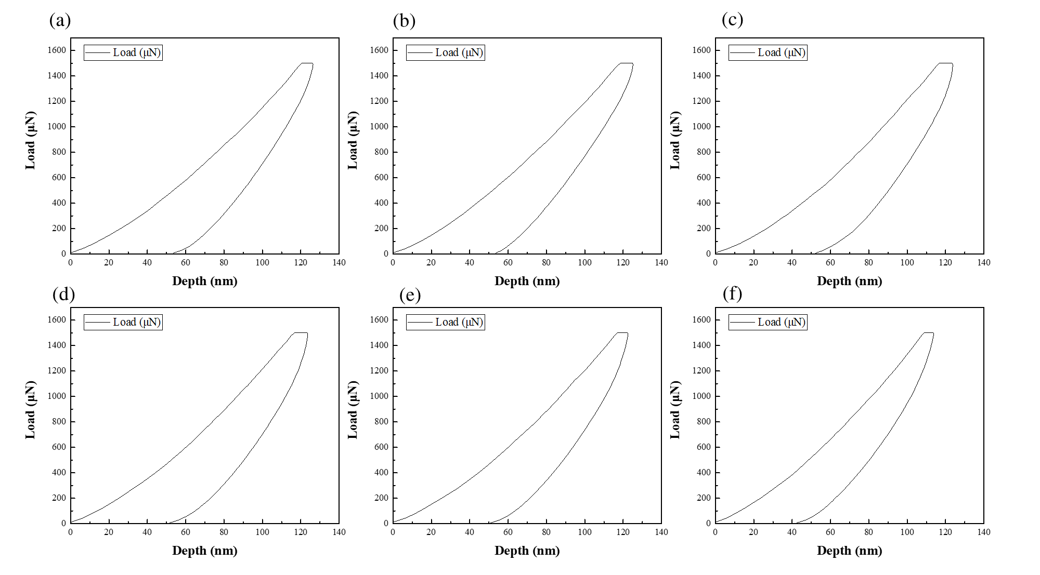
Supplementary Fig. S1. Representative load–depth curves obtained from six indentation sites in the mapped region.
Representative diffraction profiles
At each TPS 21A scanning position, a complete Laue diffraction pattern was recorded. Representative diffraction profiles from six scanning points in the mapped region are shown in Supplementary Fig. S2.
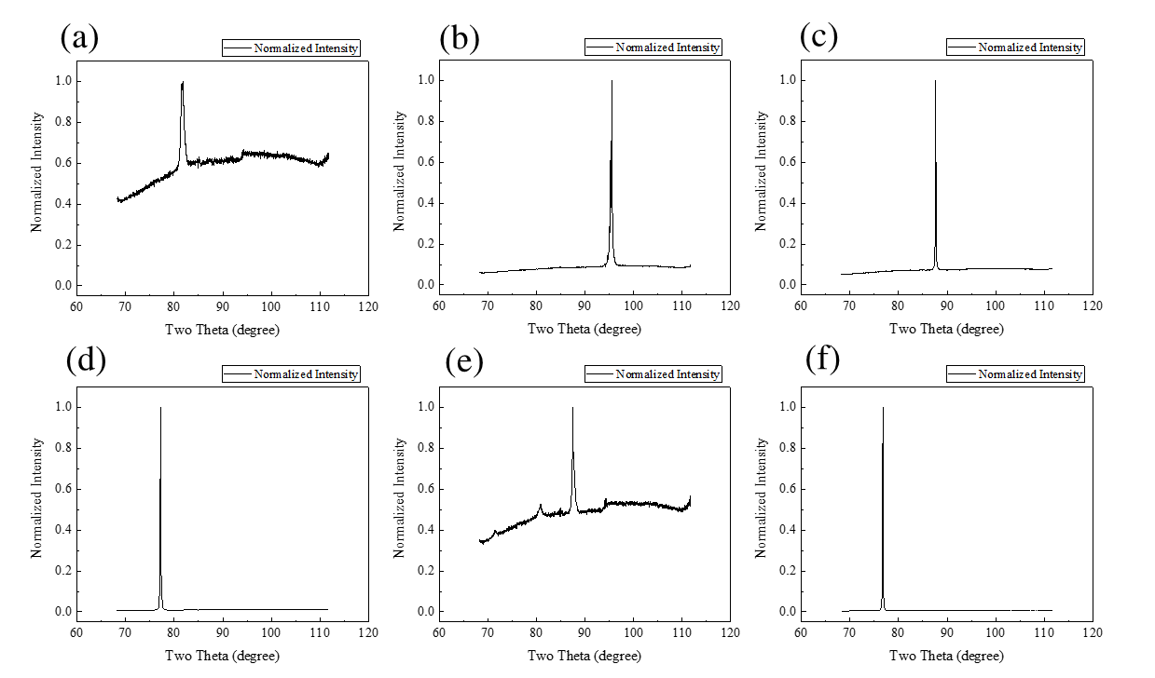
Supplementary Fig. S2. Representative XRD profiles obtained at six scanning points in the mapped region.
Supplementary Methods
Multilayer perceptron evaluation and full-data feature attribution
The analysis used all 516 observations in the merged dataset without hardness-based cutoff, IQR filtering, model-residual screening, or retrospective manual row deletion. The prediction target was log-transformed hardness, log(HV + ε), with ε = 10⁻⁵ used only as a numerical safeguard; predictions were back-transformed to HV for the primary performance metrics. The synchrotron XRF measurements were quantitatively calibrated against reference standards to obtain spatially resolved local elemental composition values. For machine-learning analysis, the five measured elemental channels were normalized pointwise over the measured elemental set. Three feature families were evaluated: (A) normalized local XRF composition, containing the pointwise-normalized Ni Kα, Hf Lβ, Cu Kα, Ti Kα, and Zr Kα values; (B) XRF/XND without E, adding d-spacing, FWHM, Schmid factor, mixing entropy, mixing enthalpy, Ω, and atomic-size mismatch δ; and (C) multimodal with E, additionally including nanoindentation-derived E and the fold-aware interaction terms E × Ω and E × d.
The multilayer perceptron (MLP) used hidden layers of 128, 64, and 32 neurons with rectified-linear activation and the Adam optimizer. The initial learning rate was 0.001 with adaptive learning-rate scheduling, L2 regularization alpha = 0.005, batch size = 32, tolerance = 0.0001, a maximum of 2000 iterations, an early-stopping validation fraction of 0.10, and 50 iterations without improvement as the stopping criterion. The random state was fixed at 160. Standardization was fitted within each training fold. For LOOCV, the early-stopping subset was drawn only from the training portion of each fold; the held-out observation was not used for scaling, early stopping, or model fitting. All 516 MLP fits converged without recorded exceptions in each of the three LOOCV feature-family analyses. The four Grain-LOGO fits in each feature family also converged without recorded exceptions.
MLP feature attribution was performed only for the 15-feature multimodal family (family C) and was explicitly separated from validation. The MLP was fitted to the full 516-point dataset after full-data standardization, and SHapley Additive exPlanations (SHAP) values were calculated with KernelExplainer. The background set contained 100 samples selected with the fixed random state, and all 516 observations were included in the explanation set. Feature-importance percentages were calculated from mean absolute SHAP values. Two hundred bootstrap resamples of the already-computed SHAP values were used only to characterize SHAP sampling variability; this procedure was not treated as model uncertainty. Because this interpretation is based on a full-data fitted model, it is not an out-of-fold validation result.
Grain-domain coverage diagnostic
To examine whether the loss of unseen-grain performance was specific to one model configuration or was also associated with limited coverage of independent grain domains, the same 516-point dataset and model settings were used to compare pointwise LOOCV with Grain LOGO across MLP, KNN, RF, and CatBoost; no model was retuned on the basis of the held-out grain results. For the multimodal feature family, additional held-out-group diagnostics were calculated using training-only statistics. For each held-out group, the diagnostics were: (i) the percentage of held-out observations with at least one feature outside the corresponding training minimum-maximum range; (ii) the largest absolute shift in the held-out-group feature mean, expressed in training-set standard-deviation units; and (iii) the ratio between the median nearest-neighbor distance from held-out observations to the training set and the median within-training nearest-neighbor distance. A nearest-neighbor ratio above 1 indicates that the held-out observations are, on average, farther from their training support than training observations are from one another. These quantities describe domain coverage within the present dataset and are not presented as independent external validation.
Supplementary Table S1. MLP validation performance across the three fixed feature families.
Feature family | LOOCV R² | LOOCV MAE (HV) | LOOCV RMSE (HV) | LOOCV r | Grain LOGO R²
Normalized local XRF composition | -0.045 | 67.7 | 90.5 | 0.199 | -0.159
XRF/XND/thermodynamic without E | -0.987 | 84.3 | 124.8 | 0.125 | -5.863
Multimodal with E | -1.771 | 95.4 | 147.3 | 0.213 | -10.521

All metrics were calculated in the HV domain from complete out-of-fold predictions (n = 516 for each model-family combination). Negative R² values indicate performance below the corresponding mean baseline.

Supplementary Fig. S3
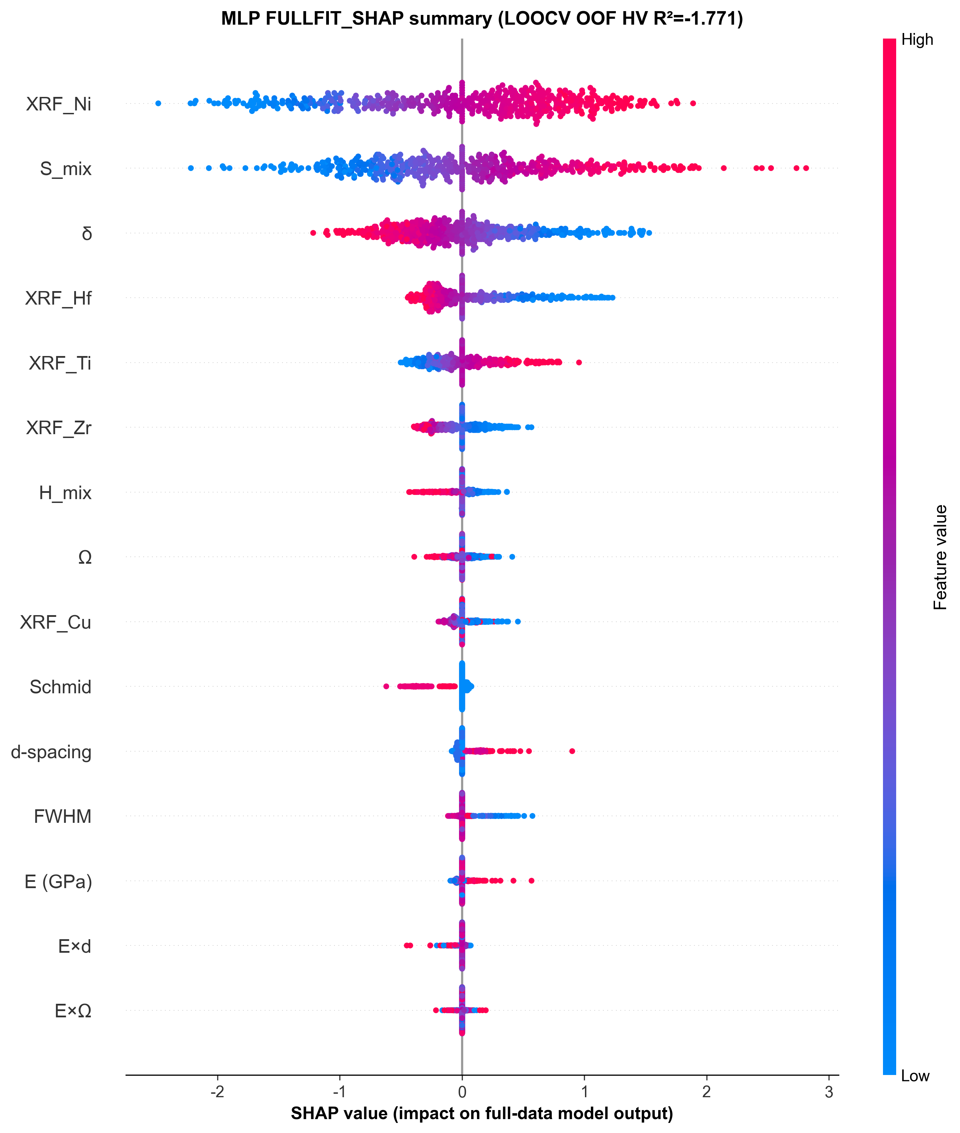
Supplementary Fig. S3. Full-data-fit MLP SHAP summary for the multimodal 15-feature family. Each point is one of the 516 observations; horizontal position gives the SHAP value for the fitted log-hardness model and color indicates the corresponding feature value. The title reports the independent pointwise LOOCV OOF HV R² (-1.771) only as a validation warning. Because the MLP OOF performance was negative, this figure is interpreted only as an exploratory description of how the full-data fitted MLP used the available features; it is not evidence of predictive reliability, transferability, or a causal materials mechanism.
Supplementary Table S2. Full-data-fit MLP SHAP importance for the multimodal feature family.
Feature | Mean |SHAP| contribution (%)
XRF_Ni | 25.491
S_mix | 22.743
δ | 14.511
XRF_Hf | 9.489
XRF_Ti | 7.522
XRF_Zr | 5.628
H_mix | 2.568
Ω | 2.379
Schmid | 2.330
XRF_Cu | 2.328
d-spacing | 1.725
FWHM | 1.408
E (GPa) | 0.944
E×d | 0.511
E×Ω | 0.423

The percentages sum to 100% after normalization of mean absolute SHAP values. XRF_Ni, S_mix, and δ have the largest attributions in the full-data fitted MLP, whereas E and the E-derived interaction terms have small MLP attributions. Because the MLP OOF R² values are negative (Supplementary Table S1), these full-data-fit attributions are retained only as an exploratory description of the fitted model and should not be used to support predictive reliability, mechanistic inference, or transferable feature-importance claims.

Supplementary Table S3. Validation-scale dependence across model classes and feature families.
Feature family | Model | LOOCV R² | Grain LOGO R² | R² decrease
Normalized local XRF composition | CatBoost | 0.065 | -0.069 | 0.134
Normalized local XRF composition | RF | 0.059 | -0.096 | 0.154
Normalized local XRF composition | KNN | -0.015 | -0.172 | 0.156
Normalized local XRF composition | MLP | -0.045 | -0.159 | 0.115
XRF/XND/thermodynamic without E | CatBoost | 0.214 | -0.224 | 0.438
XRF/XND/thermodynamic without E | RF | 0.210 | -0.353 | 0.563
XRF/XND/thermodynamic without E | KNN | 0.029 | -0.611 | 0.641
XRF/XND/thermodynamic without E | MLP | -0.987 | -5.863 | 4.875
Multimodal with E | CatBoost | 0.342 | -0.002 | 0.345
Multimodal with E | RF | 0.336 | -0.059 | 0.395
Multimodal with E | KNN | 0.209 | -0.142 | 0.352
Multimodal with E | MLP | -1.771 | -10.521 | 8.749

The reduction in R² at the grain-group validation scale occurs across multiple model classes. For the E-free and multimodal families, RF and CatBoost show similar scale dependence despite their different ensemble constructions. MLP is already unstable under pointwise LOOCV and deteriorates further under Grain LOGO.

Supplementary Table S4. Held-out-group diagnostics for the multimodal feature family.
Held-out group | n | CatBoost R² | RF R² | Any feature outside training range (%) | Largest mean shift (training SD) | NN-distance ratio
A | 131 | 0.129 | 0.087 | 6.9 | 0.726 (FWHM) | 0.928
B | 193 | 0.080 | 0.100 | 33.2 | 0.407 (FWHM) | 1.160
C | 165 | -0.540 | -0.743 | 6.7 | 1.827 (FWHM) | 1.409
GB | 27 | 0.333 | 0.282 | 7.4 | 0.520 (Schmid factor) | 0.918

The held-out C group shows the largest multivariate separation by the nearest-neighbor diagnostic (ratio = 1.409) and the largest single-feature mean shift (FWHM = 1.827 training SD), and it also gives the poorest held-out R² for CatBoost (-0.540) and RF (-0.743). The B group has a larger fraction of observations with at least one univariate range exceedance, showing that simple minimum-maximum exceedance alone does not determine prediction failure. Together, these diagnostics are consistent with limited grain-domain coverage as an important contributor to the observed transfer loss, while not establishing it as the sole cause.

