A Novel Sensitive and Validated Spectrofluorimetric Framework for Betrixaban Determination in Different Matrices Using Erythrosine B–Based Fluorescence Quenching

Amal A. El-Masry¹, Omar A. El-Khouly*², Eman A. Al-Harbi³, Eman Said^{2,4}, Heba Elmansi⁵, Nahed El-Enany^{2,5}
¹Department of Medicinal Chemistry, Faculty of Pharmacy, Mansoura University, 35516 Mansoura, Egypt
² Department of Pharmaceutical Chemistry, Faculty of Pharmacy, New Mansoura University, New Mansoura 7723730, Egypt
³Department of Chemistry, College of Science, Taibah University, Al-Madinah Al-Minawara 42353, Kingdom of Saudi Arabia
⁴ Department of Pharmacology and Toxicology, Faculty of Pharmacy, Mansoura University, Mansoura 35516, Egypt
⁵ Department of Pharmaceutical Analytical Chemistry, Faculty of Pharmacy, Mansoura University, Mansoura 35516, Egypt

* Corresponding author: Omar A. El-Khouly
Tel.: +201090675149 e-mail: omarelkhouly99@gmail.com ; omar.elkhouly@nmu.edu.eg

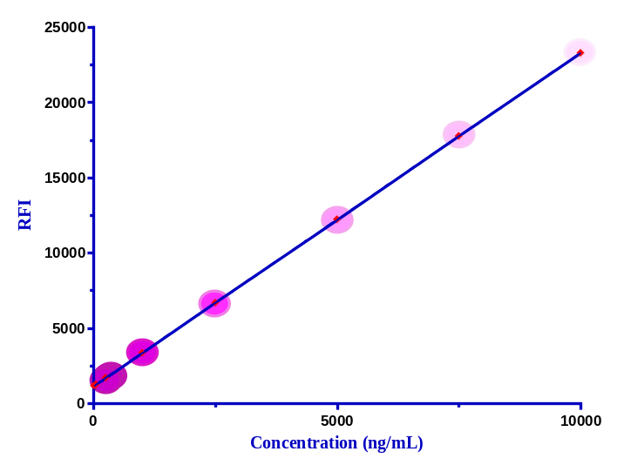

Figure S1: Calibration curve for the fluorescence quenching of Erythrosine B upon addition of increasing concentrations of BTX.

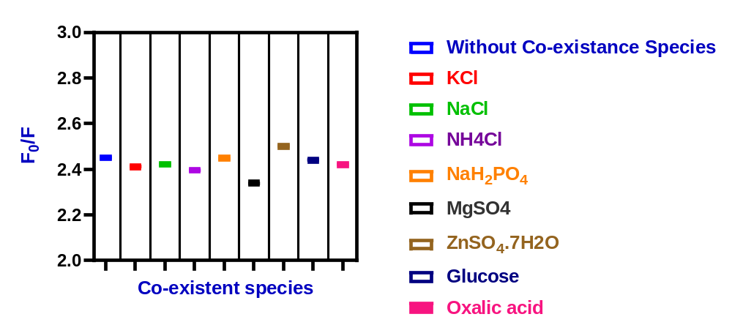
Figure S2: Determination of BTX in presence of Co-existing species.

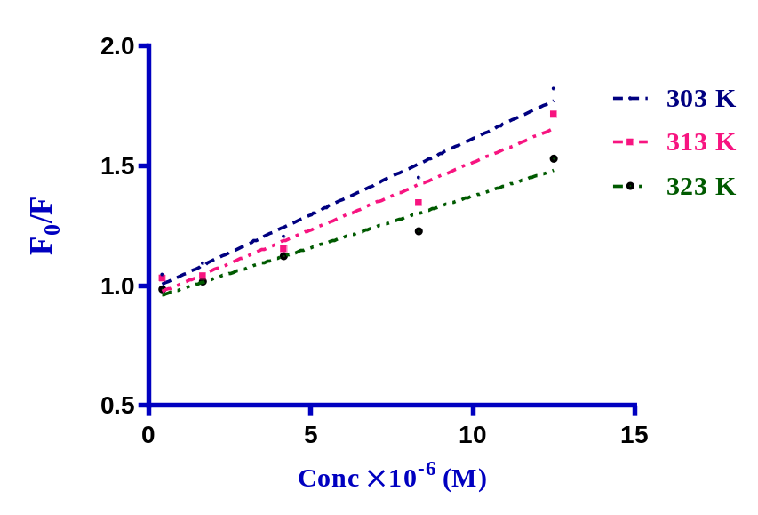
Figure S3: Stern Volmer plot for the interaction between Erythrosine B and BTX at three different temperatures.

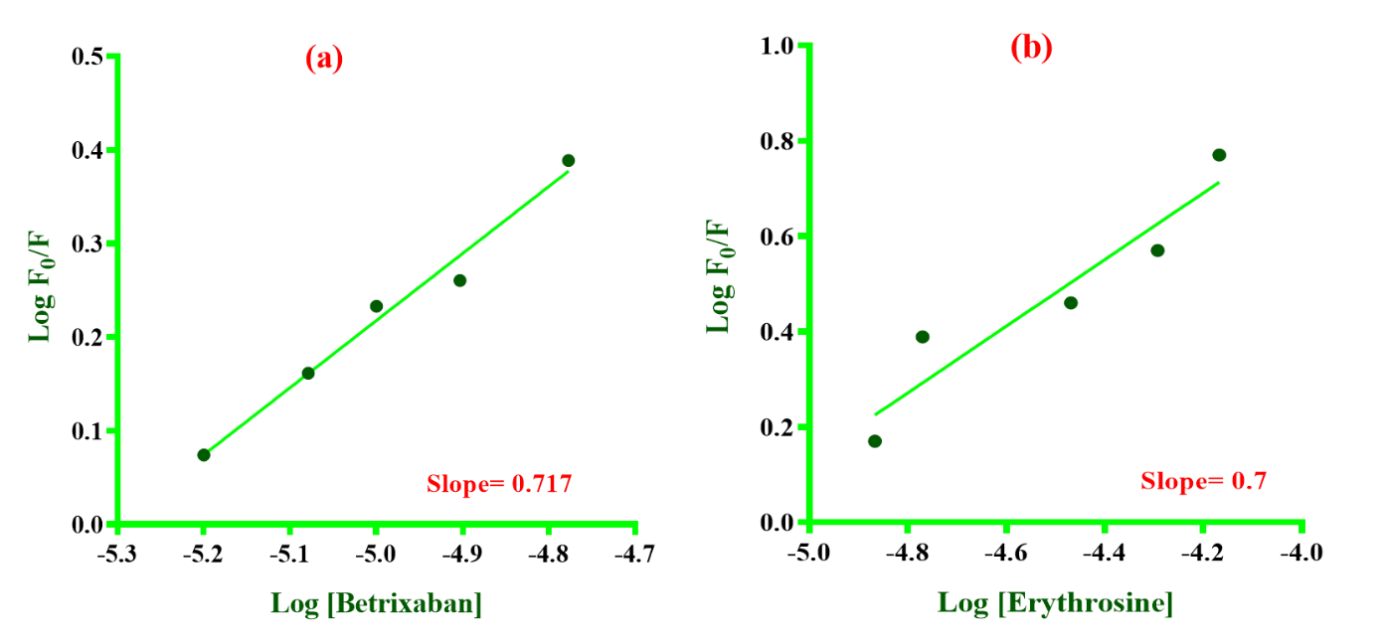
Figure S4: Limiting logarithmic plots for the interaction between Erythrosine B and BTX.

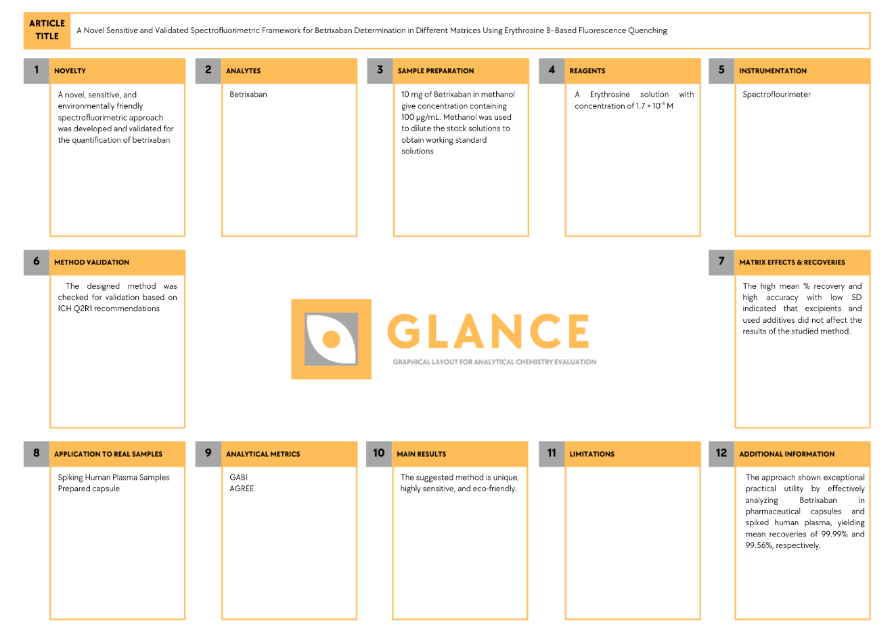
Figure S5: Glance aided overview of the proposed method.

Table S1: Precision data for the spectrofluorometric determination of Betrixaban using the Erythrosine (fluorescent probe).
Parameters |  | Betrixaban concentration (ng/mL)
 |  | 1000.0 | 2500.0 | 5000.0
Intra-day | % Recoveryª | 99.98 | 99.99 | 100.07
Intra-day | % Recoveryª | 100.89 | 99.38 | 99.75
Intra-day | % Recoveryª | 101.07 | 98.81 | 98.56
Intra-day | Mean recovery ± SD | 100.64 ± 0.58 | 99.39 ± 0.59 | 99.46 ± 0.8
Intra-day | % Error | 0.33 | 0.34 | 0.46
Inter-day | % Recoveryª | 99.98 | 99.99 | 100.07
Inter-day | % Recoveryª | 98.62 | 98.76 | 97.86
Inter-day | % Recoveryª | 100.67 | 98.25 | 97.99
Inter-day | Mean recovery ± SD | 99.76 ± 1.05 | 99.0 ± 0.9 | 98.64 ± 1.25
Inter-day | % Error | 0.60 | 0.52 | 0.73
ªMean value of three individual determinations.
- All measurements were performed after excitation at 528 nm.

Table S2: Robustness data of Betrixaban
Parameters | Volume of buffer (mL) |  |  | pH of buffer |  |  | Time of the reaction
Parameters | 0.8 | 1.0 | 1.2 | 3.8 | 4 | 4.2 | 3.8 | 4 | 4.2
% Recovery | 98.83 | 99.98 | 100.76 | 99.33 | 99.98 | 100.21 | 98.11 | 99.98 | 99.99
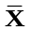± SD | 99.86 ± 0.97 |  |  | 99.89 ± 0.46 |  |  | 99.36 ± 1.08
% Error | 0.56 |  |  | 0.26 |  |  | 0.63

Table S3: Comprehensive Comparison of reported methods for BTX determination with the proposed method.
Methods | Conditions | Linearity range (μg/mL) | LOD (μg/mL) | Applications | Remarks | Reference
Spectrofluorimetry | Using Erythrosine B as a fluorescent agent, quenching occurs in the presence of BTX and is measured at 556 nm. | 0.01 – 10.0 | 0.003 | Pharmaceutical formulations and spiked plasma | - Simple and rapid analysis within seconds.  - relatively straightforward  data interpretation  - Green method  - High sensitivity, suitable for routine analysis and high-throughput testing. | This method
Spectrophotometry | First derivative amplitude measured at 304 nm using methanol. | 1.0 – 20.0 | 0.23 | Pharmaceutical formulations | - Simple and rapid analysis.  - relatively straightforward  data interpretation.  - Low sensitivity | ¹
Spectrophotometry | Difference absorbance measured at 335 nm using 0.1 M NaOH versus 0.1 M HCL. | 8.0 – 80.0 | 0.91 | Pharmaceutical formulations |  | ¹
RP-HPLC | C₁₈ column, mobile phase consists of water: acetonitrile (88: 12 v/v) using UV detection at λ= 272 nm. | 70.0 – 210.0 | 4.96 | Pharmaceutical formulations | - Expensive instrumentation,  - Requires trained personnel  - High amounts of hazardous organic solvents are required.  - Slower analysis and preparation time.  - Low sensitivity | ²
RP-HPLC | Cyano column, mobile phase consists of acetonitrile: methanol: water (35:35:30, v/v/v, pH 3.2) with UV detection at 240 nm. | 0.20 – 20.0 | 0.04 | Pharmaceutical formulations and spiked plasma | - Expensive instrumentation  -Requires trained personnel  - High amounts of hazardous organic solvents are required.  - Slower analysis and preparation time.  - Moderate sensitivity | ³
LC-MS/MS | C₁₈ column, mobile phase A consists of (95% of 5 mM ammonium formate in water with 5% acetonitrile), mobile phase B consists of (100% acetonitrile). | 0.004 – 1.0 | 0.0003 | Environmental samples | - Expensive instrumentation.  -Requires trained personnel  - High amounts of hazardous organic solvents are required.  - Slower analysis and preparation time.  - High sensitivity | ⁴
Quantitative ¹H-NMR | The quantitative determination was based on the selective proton BTX signal at 3.87 ppm using DMSO-d₆ as deuterated solvent and phloroglucinol as internal standard | 100 - 8000 | 19.0 | Pharmaceutical formulations | - Very expensive instrumentation.  -Requires trained personnel  - hazardous organic solvents are required.  - Very low sensitivity | ⁵

References:

1- A.A. El-Masry, D.R. El-Wasseef, M. Eid, I.A. Shehata, A.M. Zeid, Development of three ecological spectroscopic methods for analysis of betrixaban either alone or in mixture with lercanidipine: Greenness assessment, R. Soc. Open Sci. 9 (2022). https://doi.org/10.1098/RSOS.211457.
2- P. Harshalatha, K. Chandrasekhar, M. V. Chandrasekhar, Stability indicating RP-HPLC method development and validation for the estimation of Betrixaban (BET) in bulk and its pharmaceutical formulations, Inter. J. Res. Pharm. Sci., 9 (2018) 1572-1578.
3- A.A. El-Masry, D.R. El-Wasseef, M. Eid, I.A. Shehata, A.M. Zeid, Optimization and validation of a facile RP-HPLC method for determination of betrixaban and lercanidipine in pharmaceutical and biological matrices, J. Chromatogr. Sci. 59 (2021) 785–794. https://doi.org/10.1093/CHROMSCI/BMAB088.
4- T. Jasemizad, L.P. Padhye, Simultaneous analysis of betrixaban and hexazinone using liquid chromatography/tandem mass spectrometry in aqueous solutions, MethodsX 6 (2019) 1863–1870. https://doi.org/10.1016/J.MEX.2019.07.028.
5- A.A. El-Masry, A.M. Zeid, D.R. El-Wasseef, M. Eid, I.A. Shehata, A Validated Quantitative 1H Nuclear Magnetic Resonance (1H-qNMR) Method for Quantification of a Novel Anti-Coagulant Drug (Betrixaban Maleate) with Assessing Its Stability by Application to Degradation Study, Analytical Chemistry Letters 10 (2020) 768–783. https://doi.org/10.1080/22297928.2021.1875873;ISSUE:ISSUE:DOI.

