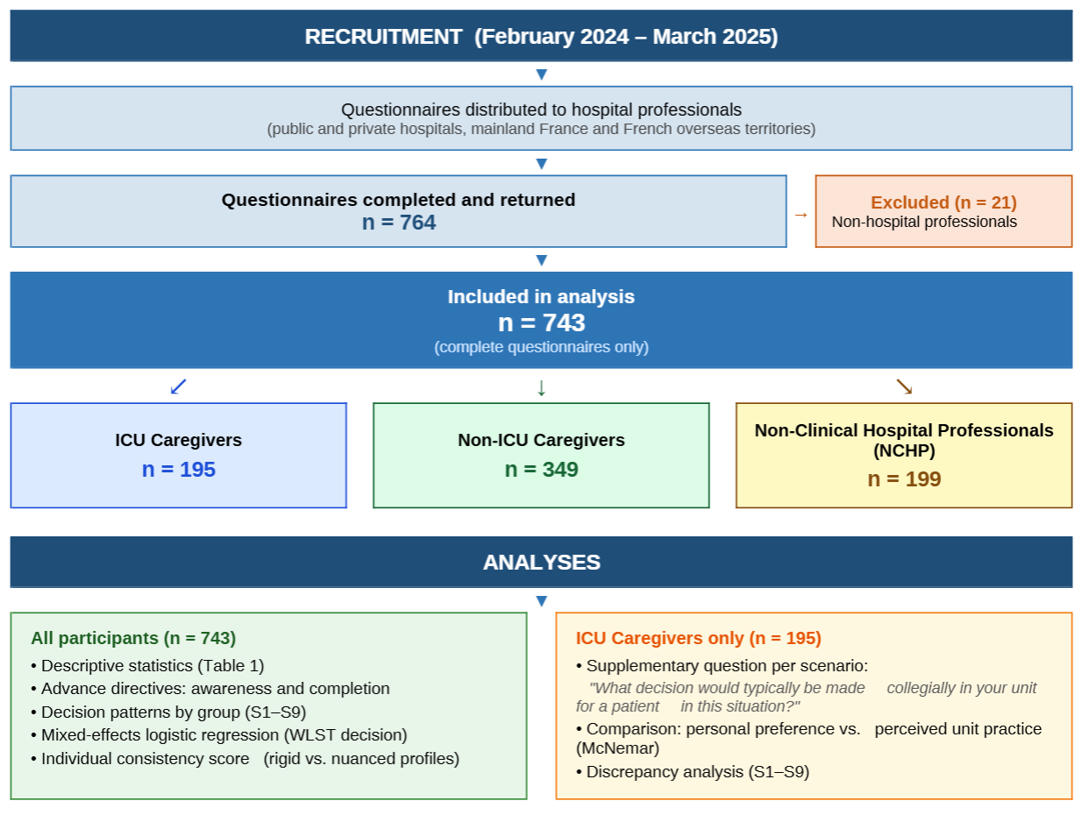
Figure S1: Flowchart. ICU: Intensive care unit; NCHP: Non-Clinical Hospital Professionals; S1–S9: Nine clinical scenarios; WLST: Withdrawal of Life-Sustaining Treatment.

