A comprehensive assessment of soil degradation linked to treated wastewater irrigation in the cultivated semi-arid region
Salar Rezapour ^{1*}, Hassan Jodat², and Parisa Alamdari³
^{1, 2} Soil Science Department, Urmia University, P.O. Box 165, Urmia, 57134, I.R. Iran
³ Soil Science Department, Faculty of Agriculture, University of Zanjan, Zanjan, Iran

Corresponding Author: Salar Rezapour
E-mail:
S.Rezapour@urmia.ac.ir, and
S_Rezapour2000@yahoo.com
Address:
Salar Rezapour, Soil Science Department, Urmia University, P.O. Box 165, Urmia, 57134, I.R. Iran

Co-authors’ email list:
² H-jodat@urmia.ac.ir
³ p_alamdari@znu.ac.ir

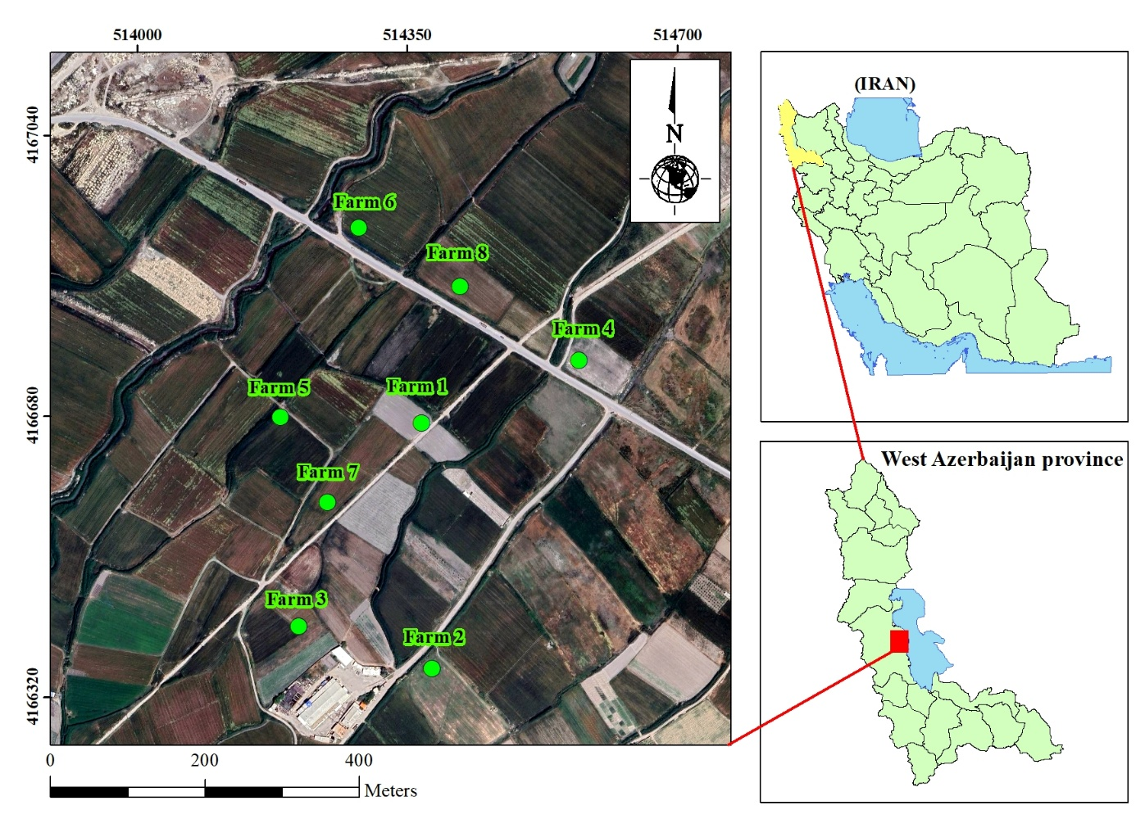

Figure S1. The geographical map of the study area.

Table S1. The chemical properties and concentrations of heavy metals in the FW and TWW.

پارامتر | FW | TW | Safe limit (WHO, 2013)
پارامتر | Mean ± SD | Mean ± SD | Safe limit (WHO, 2013)
pH | 7.5 ª ± 0.05 | 7.6 ª ± 0.25 | 6.5 – 8.4
EC (dS m⁻¹) | 0.45 ^{b} ± 0.08 | 1.25 ª ± 0.28 | 0 – 3.0
TDS | 310 ^{b} ± 52.5 | 856.0 ª ± 18.2 | 0 – 2000
Zn (mg L⁻¹) | 0.61ª ± 0.18 | 0.58 ª ± 0.07 | 2
Cu (mg L⁻¹) | 0.3 ª ± 0.10 | 0.33 ª ± 0.07 | 0.2
Cd (mg L⁻¹) | 0.012 ª ± 0.06 | 0.015 ª ± 0.03 | 0.01
Pb (mg L⁻¹) | 0.33 ª ± 0.07 | 0.28 ª ± 0.05 | 2
FW, Fresh wastewater; TWW, Treated wastewater.
EC, Electrical conductivity; TDS, Total dissolved salt.
Different letters in each row indicates statistically significant differences between FW and TWW at P < 0.05 based on the t-test.

Table S2. Lower and upper limits of the TDS approach, their associations with soil degradation, and corresponding indicator weightings across TWW- and FW-Irrigated Farms
Soil indicators | TWW-irrigated farm |  |  |  | FW-irrigated farm
Soil indicators | Relationship with soil degradation | a | b | Weight | Relationship with soil degradation | a | b | Weight
BD | P | 1.31 | 1.43 | 0.0356 | P | 1.33 | 1.44 | 0.0354
SCI | P | 0.24 | 1.32 | 0.0572 | P | 0.24 | 1.36 | 0.0549
SSI | N | 1.72 | 2.42 | 0.0640 | N | 1.62 | 2.27 | 0.0586
MCR | P | 0.68 | 3.64 | 0.0588 | P | 0.72 | 3.87 | 0.0487
CROSS | P | 1.29 | 3.01 | 0.0496 | P | 1.26 | 2.56 | 0.0523
K-factor | P | 0.03 | 0.03 | 0.0569 | P | 0.03 | 0.03 | 0.0607
pH | P | 7.46 | 7.96 | 0.0349 | P | 7.35 | 7.86 | 0.0430
EC | P | 0.93 | 1.28 | 0.0623 | P | 0.52 | 0.80 | 0.0593
SOC | N | 2.32 | 5.30 | 0.0628 | N | 1.53 | 2.80 | 0.0514
SAR | P | 3.70 | 5.90 | 0.0439 | P | 2.70 | 4.90 | 0.0500
ESP | P | 5.87 | 6.60 | 0.0556 | P | 3.92 | 4.60 | 0.0552
Zn | P | 53.20 | 91.50 | 0.0551 | P | 40.00 | 52.00 | 0.0606
Cu | P | 30.10 | 42.40 | 0.0479 | P | 28.40 | 38.36 | 0.0540
Cd | P | 3.88 | 9.85 | 0.0651 | P | 2.43 | 6.83 | 0.0634
Pb | P | 30.10 | 63.60 | 0.0520 | P | 30.60 | 46.80 | 0.0575
Ni | P | 25.50 | 38.60 | 0.0621 | P | 22.40 | 35.70 | 0.0604
mC_{d} | P | 2.07 | 3.47 | 0.0678 | P | 1.66 | 2.39 | 0.0670
SSI, soil stability index; SCI, soil crust index; MCR, modified compaction ratio; EC, electrical conductivity; SOC, soil organic matter; SOM, soil organic matter; SAR, sodium adsorption ratio; ESP, exchangeable sodium percentage, K-factor, K factor of soil erodibility; mCd, modified degree of contamination; PLI, pollution load index. a and b; lower and upper limits of each soil indicator, respectively.

Table S3. Lower and upper limits of the MDS approach, their associations with soil degradation, and corresponding indicator weightings across TWW- and FW-Irrigated Farms
Soil indicators | TWW-irrigated farm |  |  |  | FW-irrigated farm
Soil indicators | Relationship with soil degradation | a | b | Weight | Relationship with soil degradation | a | b | Weight
SSI | N | 1.72 | 2.42 | 0.1360 | N | 1.62 | 2.27 | 0.1431
MCR | P | 0.68 | 3.64 | 0.1251 | P | 0.72 | 3.87 | 0.1247
CROSS | P | 1.29 | 3.01 | 0.1056 | P | 1.26 | 2.56 | 0.1099
EC | P | 0.93 | 1.28 | 0.1335 | P | 0.52 | 0.80 | 0.1181
SOC | N | 2.32 | 5.30 | 0.1325 | N | 1.53 | 2.80 | 0.1181
ESP | P | 5.87 | 6.60 | 0.1183 | P | 3.92 | 4.60 | 0.1161
Cd | P | 3.88 | 9.85 | 0.1384 | P | 2.43 | 6.83 | 0.1240
Pb | P | 30.10 | 63.60 | 0.1105 | P | 30.60 | 46.80 | 0.1300
SSI, soil stability index; MCR, modified compaction ratio; EC, electrical conductivity; SOC, soil organic carbon. a and b; lower and upper limits of each soil indicator, respectively.

Table S4. The allowable concentration (mg kg⁻¹) of heavy metal in agricultural soils.
Soil heavy metal | Zn | Cu | Cd | Pb | Ni
permissible limit | 0-500 | 0-200 | 0-5 | 0-75 | 0-110
Source: Environmental Organization of Iran. 2024. Quality standards of soil resources and its guidelines (https://www.doe.ir/portal/file/?692345/1395-standards.pdf).

Table S5. Pearson correlation coefficients between selected soil health indicators in the TWW-irrigated soils.
 | BD | SCI | SSI | MCR | CROSS | K-factor | pH | SOC | EC | SAR | ESP | Zn | Cu | Cd | Pb | Ni | mCd | PLI
BD | 1.00 | 0.30 | 0.01 | 0.12 | 0.41⁎ | -0.13 | 0.12 | 0.09 | 0.39⁎ | 0.11 | 0.10 | -0.42⁎ | -0.01 | 0.04 | -0.11 | -0.01 | -0.07 | -0.13
SCI | 0.30⁎ | 1.00 | -0.02 | 0.68⁎⁎ | 0.45⁎ | 0.08 | 0.19 | 0.13 | 0.56⁎ | 0.23 | 0.06 | -0.52⁎ | 0.20 | 0.10 | -0.01 | -0.08 | -0.01 | -0.09
SSI | 0.01 | -0.02 | 1.00 | 0.06 | 0.04 | -0.74⁎⁎ | 0.15 | 0.94⁎⁎ | 0.31⁎ | 0.01 | 0.01 | 0.40⁎ | -0.03 | 0.51⁎ | 0.09 | 0.54⁎ | 0.56⁎ | 0.56⁎
MCR | 0.12 | 0.68⁎⁎ | 0.06 | 1.00 | 0.20 | -0.03 | 0.11 | 0.17 | 0.41⁎ | 0.02 | -0.22 | -0.32⁎ | 0.24 | 0.14 | 0.00 | -0.06 | 0.07 | 0.01
CROSS | 0.41⁎ | 0.45⁎ | 0.04 | 0.20 | 1.00 | 0.19 | 0.15 | 0.14 | 0.69⁎⁎ | 0.01 | 0.19 | -0.51⁎ | 0.00 | 0.17 | -0.03 | 0.17 | 0.06 | 0.00
K-factor | -0.13 | 0.08 | -0.74⁎⁎ | -0.03 | 0.19 | 1.00 | -0.03 | -0.67⁎⁎ | -0.11 | -0.09 | 0.00 | -0.38⁎ | -0.20 | -0.24 | 0.00 | -0.20 | -0.31⁎ | -0.33⁎
pH | 0.12 | 0.19 | 0.15 | 0.11 | 0.15 | -0.03 | 1.00 | 0.20 | 0.40⁎ | -0.19 | -0.36⁎ | -0.09 | -0.30⁎ | 0.45⁎ | -0.03 | 0.47⁎ | 0.37⁎ | 0.28⁎
SOC | 0.09 | 0.13 | 0.94⁎⁎ | 0.17 | 0.14 | -0.67⁎⁎ | 0.20 | 1.00 | 0.50⁎ | 0.01 | -0.01 | 0.21 | -0.10 | 0.59⁎ | 0.11 | 0.61⁎ | 0.59⁎ | 0.56⁎
EC | 0.39⁎ | 0.56⁎ | 0.31⁎ | 0.41⁎ | 0.69⁎⁎ | -0.11 | 0.40⁎ | 0.50⁎ | 1.00 | -0.11 | -0.12 | -0.41⁎ | -0.09 | 0.63⁎⁎ | 0.23 | 0.52⁎ | 0.52⁎ | 0.42⁎
SAR | 0.11 | 0.23 | 0.01 | 0.02 | 0.01 | -0.09 | -0.19 | 0.01 | -0.11 | 1.00 | 0.64⁎⁎ | -0.06 | 0.41⁎ | -0.26 | -0.01 | -0.24 | -0.21 | -0.15
ESP | 0.10 | 0.06 | 0.01 | -0.22 | 0.19 | 0.00 | -0.36⁎ | -0.01 | -0.12 | 0.64⁎⁎ | 1.00 | -0.10 | 0.25 | -0.27 | -0.08 | -0.23 | -0.25 | -0.20
Zn | -0.42⁎ | -0.52⁎ | 0.40⁎ | -0.32⁎ | -0.51⁎ | -0.38⁎ | -0.09 | 0.21 | -0.41⁎ | -0.06 | -0.10 | 1.00 | 0.08 | 0.11 | 0.16 | 0.18 | 0.33⁎ | 0.46⁎
Cu | -0.01 | 0.20 | -0.03 | 0.24 | 0.00 | -0.20 | -0.30⁎ | -0.10 | -0.09 | 0.41⁎ | 0.25 | 0.08 | 1.00 | -0.36⁎ | -0.16 | -0.50⁎ | -0.27 | -0.18
Cd | 0.04 | 0.10 | 0.51⁎ | 0.14 | 0.17 | -0.24 | 0.45⁎ | 0.59⁎ | 0.63⁎⁎ | -0.26 | -0.27 | 0.11 | -0.36⁎ | 1.00 | 0.42⁎ | 0.89⁎⁎ | 0.96⁎⁎ | 0.88⁎⁎
Pb | -0.11 | -0.01 | 0.09 | 0.00 | -0.03 | 0.00 | -0.03 | 0.11 | 0.23 | -0.01 | -0.08 | 0.16 | -0.16 | 0.42⁎ | 1.00 | 0.25 | 0.61⁎⁎ | 0.63⁎⁎
Ni | -0.01 | -0.08 | 0.54⁎ | -0.06 | 0.17 | -0.20 | 0.47⁎ | 0.61⁎⁎ | 0.52⁎ | -0.24 | -0.23 | 0.18 | -0.50⁎ | 0.89⁎⁎ | 0.25 | 1.00 | 0.86⁎⁎ | 0.79⁎⁎
mCd | -0.07 | -0.01 | 0.56⁎ | 0.07 | 0.06 | -0.31⁎ | 0.37⁎ | 0.59⁎ | 0.52⁎ | -0.21 | -0.25 | 0.33⁎ | -0.27 | 0.96⁎⁎ | 0.61⁎⁎ | 0.86⁎⁎ | 1.00 | 0.97⁎⁎
PLI | -0.13 | -0.09 | 0.56⁎ | 0.01 | 0.00 | -0.33⁎ | 0.28 | 0.56⁎ | 0.42⁎ | -0.15 | -0.20 | 0.46⁎ | -0.18 | 0.88⁎⁎ | 0.63⁎⁎ | 0.79⁎⁎ | 0.97⁎⁎ | 1.00
SSI, soil stability index; SCI, soil crust index; MCR, modified compaction ratio; EC, electrical conductivity; SOC, soil organic carbon; SOM, soil organic matter; SAR, sodium adsorption ratio; ESP, exchangeable sodium percentage, K-factor, K factor of soil erodibility; mCd, modified degree of contamination; PLI, pollution load index.
* and **indicate significant level at 0.05 and 0.01, respectively

Table 6. Pearson correlation coefficients between selected soil health indicators in the FW-irrigated soils.
 | BD | SCI | SSI | MCR | CROSS | K-factor | pH | SOC | EC | SAR | ESP | Zn | Cu | Cd | Pb | Ni | mCd | PLI
BD | 1.00 | 0.36⁎ | -0.05 | 0.18 | 0.44⁎ | 0.26 | -0.04 | 0.06 | 0.24 | 0.11 | -0.08 | -0.06 | 0.06 | 0.00 | 0.14 | 0.02 | 0.03 | 0.04
SCI | 0.36⁎ | 1.00 | -0.01 | 0.68⁎⁎ | 0.61⁎⁎ | 0.22 | 0.20 | 0.02 | 0.40 | 0.26 | -0.18 | -0.21 | 0.18 | -0.10 | 0.13 | -0.08 | -0.08 | -0.06
SSI | -0.05 | -0.01 | 1.00 | 0.07 | 0.11 | -0.77⁎⁎ | 0.09 | 0.23 | 0.48⁎ | -0.10 | 0.02 | 0.17 | 0.35⁎ | 0.16 | 0.65⁎⁎ | 0.55⁎ | 0.40⁎ | 0.55⁎
MCR | 0.18 | 0.68⁎⁎ | 0.07 | 1.00 | 0.21 | 0.15 | 0.12 | 0.12 | 0.33⁎ | 0.07 | -0.14 | -0.37⁎ | 0.12 | -0.13 | 0.19 | -0.06 | -0.12 | -0.11
CROSS | 0.44⁎ | 0.61⁎⁎ | 0.11 | 0.21 | 1.00 | 0.04 | 0.17 | 0.01 | 0.40⁎ | -0.04 | -0.27 | 0.27 | 0.09 | -0.01 | 0.32⁎ | 0.25 | 0.13 | 0.23
K-factor | 0.26 | 0.22 | -0.77⁎⁎ | 0.15 | 0.04 | 1.00 | 0.13 | -0.28 | -0.13 | -0.13 | -0.07 | -0.41⁎ | -0.24 | -0.14 | -0.59⁎ | -0.42⁎ | -0.36⁎ | -0.51⁎
pH | -0.04 | 0.20 | 0.09 | 0.12 | 0.17 | 0.13 | 1.00 | -0.14 | 0.24 | -0.25 | -0.13 | 0.13 | -0.13 | -0.26 | 0.04 | 0.43⁎ | -0.12 | 0.02
SOC | 0.06 | 0.02 | 0.23 | 0.12 | 0.01 | -0.28 | -0.14 | 1.00 | 0.06 | 0.23 | -0.04 | 0.12 | 0.25 | 0.11 | 0.30⁎ | -0.08 | 0.16 | 0.19
EC | 0.24 | 0.40⁎ | 0.48⁎ | 0.33⁎ | 0.40⁎ | -0.13 | 0.24 | 0.06 | 1.00 | 0.02 | 0.08 | -0.14 | 0.32⁎ | 0.22 | 0.42⁎ | 0.38⁎ | 0.35⁎ | 0.41⁎
SAR | 0.11 | 0.26 | -0.10 | 0.07 | -0.04 | -0.13 | -0.25 | 0.23 | 0.02 | 1.00 | 0.27 | 0.03 | -0.09 | 0.23 | 0.10 | -0.28 | 0.13 | 0.05
ESP | -0.08 | -0.18 | 0.02 | -0.14 | -0.27 | -0.07 | -0.13 | -0.04 | 0.08 | 0.27 | 1.00 | -0.20 | -0.24 | 0.32⁎ | 0.30⁎ | 0.17 | 0.30⁎ | 0.22
Zn | -0.06 | -0.21 | 0.17 | -0.37⁎ | 0.27 | -0.41⁎ | 0.13 | 0.12 | -0.14 | 0.03 | -0.20 | 1.00 | -0.01 | 0.13 | 0.22 | 0.45⁎ | 0.33⁎ | 0.47⁎
Cu | 0.06 | 0.18 | 0.35⁎ | 0.12 | 0.09 | -0.24 | -0.13 | 0.25 | 0.32⁎ | -0.09 | -0.24 | -0.01 | 1.00 | 0.12 | 0.08 | 0.05 | 0.24 | 0.31⁎
Cd | 0.00 | -0.10 | 0.16 | -0.13 | -0.01 | -0.14 | -0.26 | 0.11 | 0.22 | 0.23 | 0.32⁎ | 0.13 | 0.12 | 1.00 | 0.34⁎ | 0.10 | 0.92⁎⁎ | 0.75⁎⁎
Pb | 0.14 | 0.13 | 0.65⁎⁎ | 0.19 | 0.32⁎ | -0.59⁎ | 0.04 | 0.30⁎ | 0.42⁎ | 0.10 | 0.30⁎ | 0.22 | 0.08 | 0.34 | 1.00 | 0.60⁎⁎ | 0.59⁎ | 0.72⁎⁎
Ni | 0.02 | -0.08 | 0.55⁎ | -0.06 | 0.25 | -0.42⁎ | 0.43⁎ | -0.08 | 0.38⁎ | -0.28 | 0.17 | 0.45⁎ | 0.05 | 0.10 | 0.60⁎⁎ | 1.00 | 0.44⁎ | 0.65⁎⁎
mCd | 0.03 | -0.08 | 0.40⁎ | -0.12 | 0.13 | -0.36⁎ | -0.12 | 0.16 | 0.35⁎ | 0.13 | 0.30⁎ | 0.33⁎ | 0.24 | 0.92⁎⁎ | 0.59⁎ | 0.44⁎ | 1.00 | 0.95⁎⁎
PLI | 0.04 | -0.06 | 0.55⁎ | -0.11 | 0.23 | -0.51⁎ | 0.02 | 0.19 | 0.41⁎ | 0.05 | 0.22 | 0.47⁎ | 0.31⁎ | 0.75⁎⁎ | 0.72⁎⁎ | 0.65⁎⁎ | 0.95⁎⁎ | 1.00
SSI, soil stability index; SCI, soil crust index; MCR, modified compaction ratio; EC, electrical conductivity; SOC, soil organic carbon; SOM, soil organic matter; SAR, sodium adsorption ratio; ESP, exchangeable sodium percentage, K-factor, K factor of soil erodibility; mCd, modified degree of contamination; PLI, pollution load index.
* and **indicate significant level at 0.05 and 0.01, respectively.

