Effect of the BOPPPS-PBL teaching model on clinical pharmacotherapeutics education for pharmacy undergraduates in Central China: a non-randomized Fangying Si, Xue Ying, Xiaojing Lu, Kelei Guan
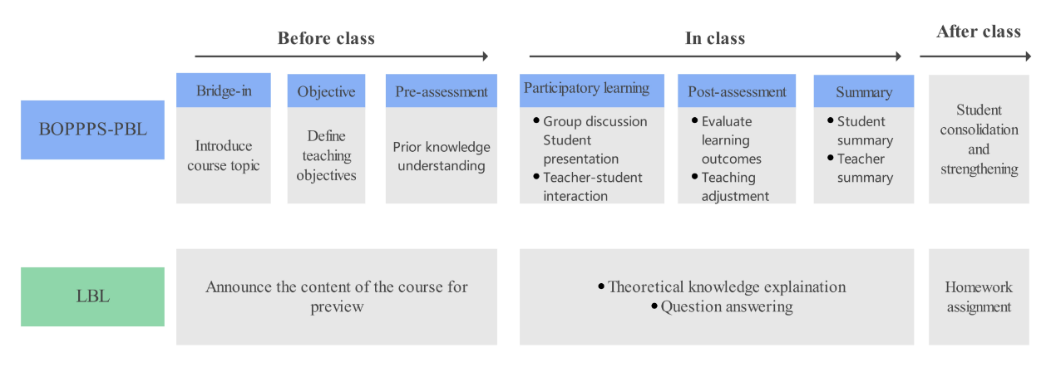
Supplemental Fig.1 Schematic illustration of the teaching design for the BOPPPS-PBL and LBL groups.

