Sorting for Identity: Dielectrophoresis Enriches GABAergic-Fated Neural Stem Cells
Supplemental Material
Jazmine S. Moore^{1, 2,} ; Lauren M. Nishitani²; Nicole S. Lav²; Kirsten Ha²; Lisa A. Flanagan;^{1, 2, 3, 4} and Tayloria N.G. Adams^{1, 2, 5, a)}
¹Department of Anatomy & Neurobiology, University of California, Irvine, Irvine, California 92697-4291, USA
²Sue & Bill Gross Stem Cell Research Center, University of California, Irvine, Irvine, California 92697-1705, USA
³Department of Neurology, University of California, Irvine, Irvine, California 92697-6750, USA
⁴Department of Biomedical Engineering, University of California, Irvine, Irvine, California 92697
⁵Department of Chemical and Biomolecular Engineering, University of California, Irvine, Irvine, California 92697-2580, USA
ªAuthor to whom correspondence should be addressed: tayloria@uci.edu

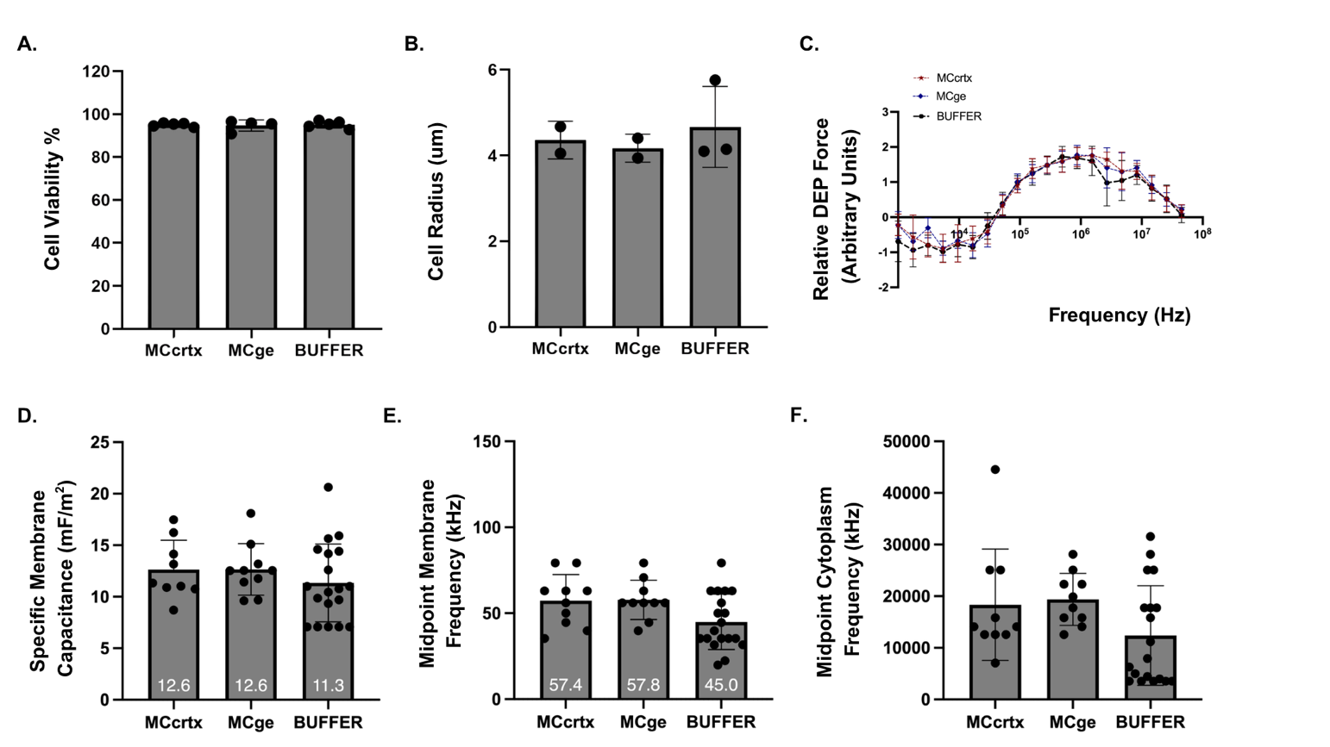
Supplemental Figure 1. Validation of control conditions for DEP sorting of mNSPCs. (A) Cell viability of controls assessed by Trypan Blue exclusion (MCcrtx n=5, MCge n=4, and BUFFER n=5). All groups maintained high cell viability. (B) Cell radius measurements obtained using ImageJ revealed no significant differences among control conditions (MCcrtx n=2, MCge n=2, and BUFFER n=3). (C) DEP spectra of control populations demonstrating comparable electrophysiological responses across the tested frequency range (MCcrtx n=2, MCge n=2, and BUFFER n=3). (D) Specific membrane capacitance, (E) midpoint membrane frequency, and (F) midpoint cytoplasm frequency of control conditions. No statistically significant differences were observed among control conditions for any of the assessed electrophysiological parameters (MCcrtx n = 2, MCge n = 2, BUFFER n = 3).

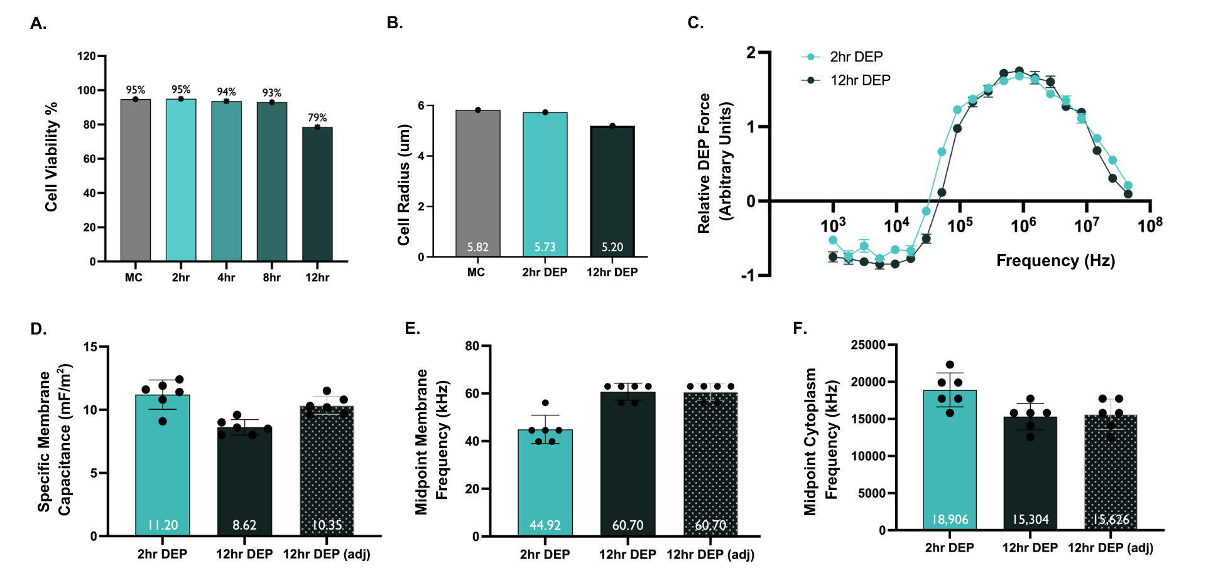
Supplementary Figure 2. Validation of DEP buffer stability for GE-derived mNSPCs over time. (A) GE-derived mNSPCs maintained >90% viability for up to 8 hours in DEP buffer, with viability decreasing to approximately 79% after 12 hours. (B) Cell radius of GE-derived mNSPCs maintained in growth medium (media control; MC) or DEP buffer. (C) DEP spectra demonstrating preservation of the frequency-dependent electrophysiological response following incubation in DEP buffer. (D) Specific membrane capacitance, (E) midpoint membrane frequency, and (F) midpoint cytoplasm frequency of GE-derived mNSPCs following incubation in DEP buffer. For panels D–F, "12 hr DEP (adj)" denotes values adjusted to account for changes in DEP buffer conductivity over time. Electrophysiological properties remained largely stable throughout the experimental period, supporting the suitability of the DEP buffer for maintaining cellular electrophysiological integrity during the typical duration of DEP experiments (8–12 hours). Data represents one biological replicate with multiple technical measurements (n=1).

Supplementary Table 1. Cell recovery across independent DEP sorting experiments. The number of cells collected from O1, O2, and O3 for each independent biological experiment are shown. The BUFFER column indicates the standard number of cells allocated as the unsorted control prior to sorting, while the total cell recovery across outlet fractions and the average values across experiments are also reported. These values document representative sorting yields used for downstream expansion and analyses.

 | BUFFER | O1 (%) | O2 (%) | O3 (%) | Total Collection Across Outlets
Biological  n=1 | 100,000 | 147,000 (66.7%) | 40,250  (18.3%) | 33,125  (15.0%) | 220,375
Biological  n=2 | 100,000 | 105,400 (23.1%) | 188,800  (41.4%) | 162,400  (35.6%) | 456,600
Biological  n=3 | 100,000 | 99,060  (17.4%) | 234,980 (41.2%) | 236,440  (41.5%) | 570,480
Average Across Experiments | 100,000 | 117,153  (28.2%) | 154,677  (37.2%) | 143,988  (34.6%) | 415,818
Supplementary Video 1. Representative Video of DEP Sorting of mNSPCs. This video illustrates the sequential hydrodynamic focusing and DEP sorting of mNSPCs within the HOAPES microfluidic device. In the first segment, cells enter the hydrophoretic module, where passive hydrodynamic forces direct them toward the microchannel walls, producing two well-defined cell streams before they enter the DEP sorting region. The second segment demonstrates DEP sorting with the electrode array actuated at 400 kHz at 3.3 V_{pp}. Cells exhibiting positive DEP behavior are observed migrating along the chevron-patterned electrodes as they move through the sorting channel. These cells are progressively focused toward the center of the channel and collected through the center outlet (O1), whereas the remaining cell populations exit through the adjacent outlet channels (O2 and O3). Cells collected from each outlet were subsequently used for electrophysiological, molecular, and ICC analyses.

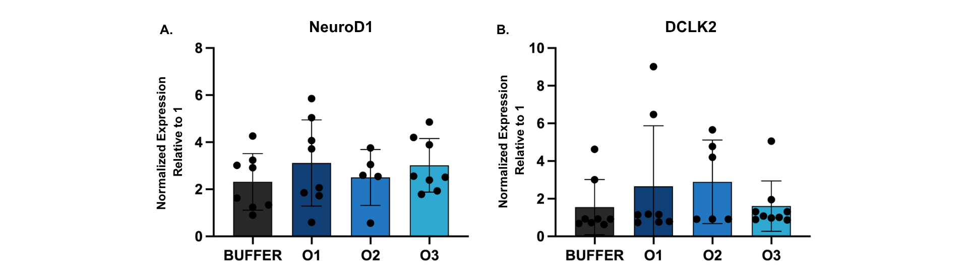
Supplementary Figure 3. Expression of neuronal differentiation-associated genes in DEP-sorted undifferentiated mNSPCs. Relative expression of (A) NeuroD1 and (B) Dclk2 in BUFFER and DEP-sorted undifferentiated mNSPC populations (O1, O2, and O3). One-way ANOVA revealed no statistically significant differences among groups. Relative gene expression was calculated using the 2⁻ΔΔCt method, with GAPDH used as the housekeeping gene and MCcrtx used as the calibrator sample (relative expression = 1; not shown). BUFFER is shown as the experimental control for comparison with the DEP-sorted undifferentiated mNSPC populations (O1, O2, and O3). Biological replicates consisted of n=3 independent experiments, with technical qPCR replicates averaged for each biological sample. Dclk2 analysis for O2 was performed using n=2 biological replicates due to limited sample availability.

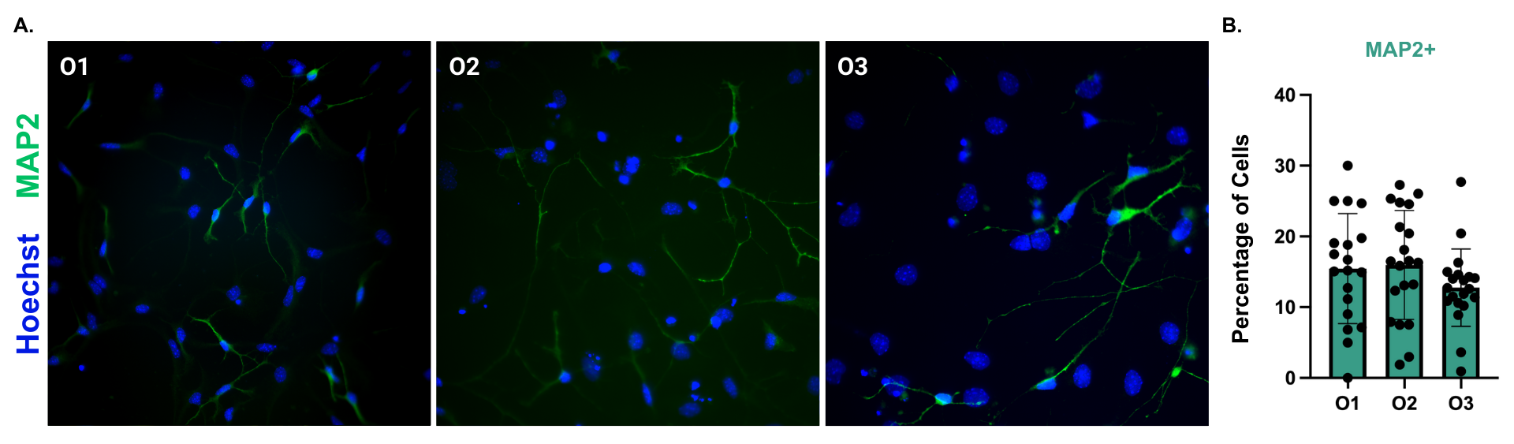
Supplementary Figure 4. MAP2 ICC analysis of DEP-sorted differentiated mNSPC populations. (A) Representative immunofluorescence images of differentiated DEP-sorted populations stained with Hoechst (blue) and MAP2 (green). (B) Quantification of MAP2+ cells revealed no statistically significant differences among DEP-sorted populations, suggesting that MAP2 expression was maintained across all sorting conditions (n=3). Statistical analysis was performed using one-way ANOVA, which revealed no significant differences among groups (p > 0.05).

Supplementary Table 2. Mean percentages of double-positive GABA+/TUJ1+ cells and fold enrichment across independent biological DEP sorting experiments. Mean percentages of double-positive GABA+/TUJ1+ cells are shown for BUFFER, O1, O2, and O3 across independent biological sorting experiments. Values represent the mean percentage calculated from five technical replicates within each biological experiment. Fold enrichment was calculated by dividing the percentage of double-positive GABA+/TUJ1+ cells in O2 by the corresponding percentage observed in the comparison population (BUFFER, O1, or O3) within the same biological experiment. BUFFER data were available for biological experiments 2 and 3. Fold enrichment values are reported as N/A when the comparison population contained 0% GABA+/TUJ1+ cells or when a BUFFER control was not included. The final row reports the mean fold enrichment calculated from biological experiments with valid comparison groups (n=2 and n=3). These data demonstrate consistent enrichment of GABA+/TUJ1+ cells within O2.
 | BUFFER | O1 (%) | O2 (%) | O3 (%) | O2 vs. BUFFER (Fold) | O2 vs. O1 (Fold) | O2 vs. O3 (Fold)
Biological  n=1 | n/a | 0.46 | 0.63 | 0 | n/a | 1.38x | n/a
Biological  n=2 | 5.60 | 1.27 | 13.69 | 1.97 | 2.45x | 10.80x | 6.95x
Biological  n=3 | 0.69 | 1.71 | 12.09 | 0.97 | 17.53x | 7.08x | 12.47x
Mean Fold Enrichment † | - | - | - | - | 9.99x | 8.94x | 9.71x
† Mean fold enrichment was calculated using biological experiments 2 and 3 only. Biological experiment 1 was excluded from the summary because no BUFFER control was included and GABA+/TUJ1+ frequencies were negligible across all DEP outlet fractions, precluding meaningful fold-enrichment comparisons.

Supplementary Table 3. Primer information for qRT-PCR analysis of DEP-sorted undifferentiated mNSPCs. Primer sequences used for GAPDH, NeuroD1, and Dclk2. GAPDH was used as the housekeeping gene for normalization, while NeuroD1 and Dclk2 were selected as targeted molecular markers associated with neuronal differentiation. Primer sequences, annealing temperatures (T_{a}), and expected amplicon lengths are shown.
Gene | Primer sequence (5’→3’) | Tₐ (°C) | Expected length (bp)
GAPDH | Sense: ATACGGCTACAGCAACAGGG  Antisense: GCCTCTCTTGCTCAGTGTCC | 65 | 105
NeuroD1 | Sense: GAATTCGCCCACGCAGAAGG  Antisense: GCCCGCTCTCGCTGTATGAT | 65 | 120
Dclk2 | Sense: TGAACTTGACCGTTGCCTGAGC  Antisense: ACGCACTCCTTAACTACCGCGA | 65 | 132

