Supplementary Information

Morphology of the Devonian Mandibulate Arthropod Rhyniognatha and Its Implications for the Timing of Insect Evolution

Emma J. Long^{1,2,3}, Gregory D. Edgecombe², Markus Koch⁴ & Xiaoya Ma¹

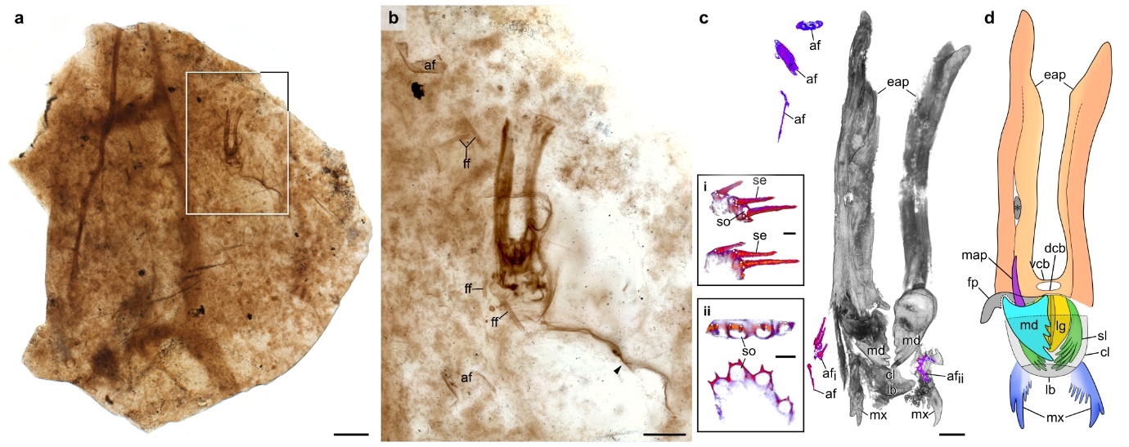

Fig. S1 | Contextual overview of Rhyniognatha hirsti. a,b, Light micrographs showing the mulm-like texture of the surrounding chert matrix and associated fungal and arthropod fragments. Inset in (a) indicates the region enlarged in (b). b, Black arrowhead marks extreme anterolateral unravelling of the exoskeleton. c, Rotated three-dimensional model showing Rhyniognatha in situ with nearby arthropod fragments. i,ii, Close-ups of adjacent arthropod fragments bearing four setae and/or setal sockets, each flanked by two spines (white circles). d, Diagrammatic illustration of Rhyniognatha in dorsal view. Asterisk denotes miscellaneous cuticular element. Abbreviations: af, arthropod fragment; cl, clypeus; dcb, dorsal cuticular bridge; eap, elongate apodeme; ff, fungal fragment; lb, labrum; lg, lingua; map, mandibular apodeme; md, mandible; mx, first maxilla; se, seta; sl, superlingua; so, setal socket; vcb, ventral cuticular bridge. Scale bars: 500 µm (a,c,d); 200 µm (b), 10 µm (ci,cii).

Table S1 | Confocal laser scanning microscopy (CLSM) acquisition parameters for imaging Rhyniognatha hirsti. All scans were conducted using a Plan Fluor 40x Oil DIC H N2 objective, with excitation at 640.4 nm, a z-step size of 0.25 μm, and a confocal pinhole aperture of 30.7 μm.
Figure(s) | Digital zoom | XY pixel dimensions (pixels/µm) | No. Z steps | XY tile scan size (pixels) | Scan depth (µm) | Line avg. | Pixel dwell time (µs) |  | XY scan area (tiles) | XY tile overlap (%) | Morphosource doi
Figs. 1b,c, 2 g–i, 3b & S1c | X 1 | 0.31 | 549 | 1024  x 1024 | 137.00 | 8X |  | 6.1 | 4 x 2 | 10 | https://doi.org/10.17602/M2/M699255
Figs. 1d–f & 2a,b,e,f,j,k | X 1 | 0.16 | 340 | 2048  x 2048 | 84.75 | 16X |  | 13.7 | 1 x 1 | n/a | https://doi.org/10.17602/M2/M699258
Fig. 2c,d | X 4.44 | 0.03 | 96 | 2048  x 2048 | 23.75 | 16X |  | 6.9 | 1 x 1 | n/a | https://doi.org/10.17602/M2/M699261

