Supplementary Information
Timing of oral beta-blocker initiation and 90-day mortality in critically ill patients with acute myocardial infarction: a target trial emulation

Figure S1. Clone–censor–weight strategy and artificial-censoring timeline
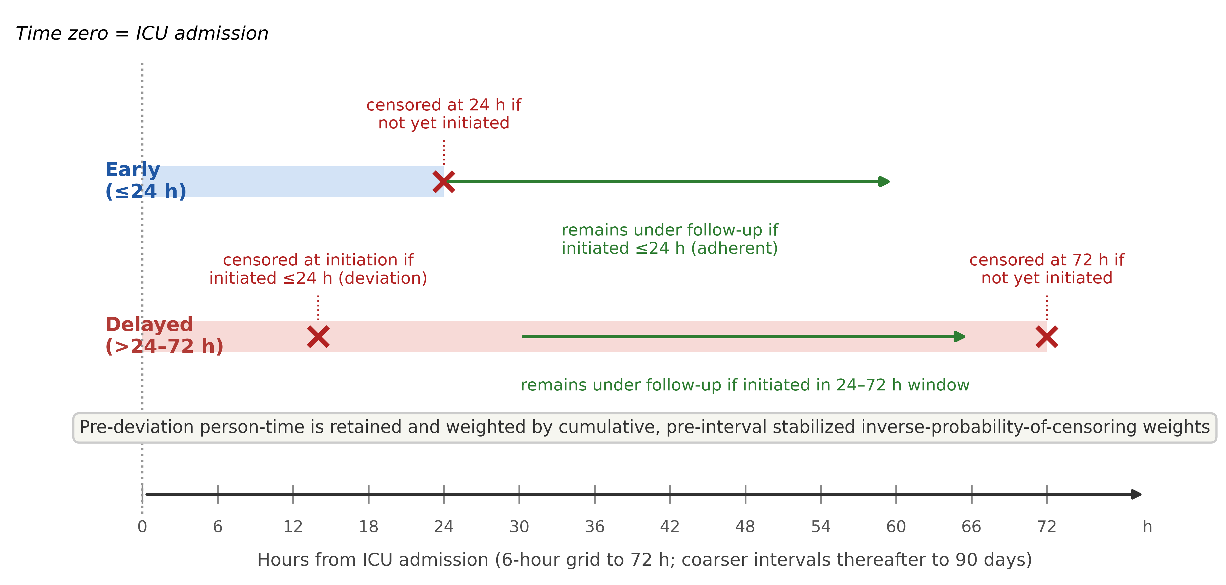
Time zero = ICU admission. The schematic depicts the corrected artificial-censoring rules: in the early arm a clone is censored at 24 h if it has not initiated; in the delayed arm a clone is censored at initiation if initiation occurs at ≤24 h (deviation) and at 72 h if it has not initiated. Pre-deviation person-time is retained and weighted by cumulative, pre-interval stabilized inverse-probability-of-censoring weights over a 6-hour grid to 72 h (then coarser intervals to 90 days).

Table S1. Baseline characteristics by observed initiation timing
Characteristic | Overall  (n=5899) | Early ≤24 h  (n=2334) | Delayed >24–72 h  (n=1033) | >72 h  (n=940) | Never  (n=1592) | Missing
Age, years | 72.6 (62.5–81.9) | 71.6 (61.6–81.2) | 72.9 (63.8–82.6) | 72.5 (63.7–81.3) | 73.7 (62.3–82.9) | 0.0%
Charlson index | 7.0 (5.0–9.0) | 6.0 (4.0–8.0) | 7.0 (5.0–9.0) | 7.0 (5.0–9.0) | 7.0 (5.0–9.0) | 0.0%
SAPS II | 37.0 (29.0–48.0) | 32.0 (25.0–40.0) | 37.0 (29.0–45.0) | 43.0 (34.0–53.0) | 45.0 (35.0–57.0) | 0.0%
SOFA | 4.0 (2.0–8.0) | 2.0 (1.0–5.0) | 4.0 (2.0–7.0) | 6.0 (4.0–9.0) | 7.0 (4.0–10.0) | 0.0%
Heart rate, bpm | 81.6 (71.7–93.2) | 79.6 (71.2–89.9) | 80.7 (70.5–91.4) | 84.5 (73.1–95.9) | 83.9 (73.1–97.8) | 0.1%
Mean arterial pressure, mmHg | 77.2 (70.9–84.9) | 79.9 (73.5–87.9) | 76.6 (71.1–83.3) | 75.1 (69.8–81.3) | 74.9 (68.7–82.7) | 0.2%
Creatinine, mg/dL | 1.4 (1.0–2.3) | 1.2 (0.9–1.8) | 1.2 (0.9–1.9) | 1.6 (1.1–2.6) | 1.9 (1.1–3.0) | 0.4%
WBC, ×10⁹/L | 13.0 (9.6–17.9) | 11.7 (9.0–15.1) | 12.9 (10.1–17.6) | 15.0 (10.9–20.8) | 14.6 (10.1–20.4) | 0.5%
Lactate, mmol/L | 2.4 (1.6–4.4) | 2.1 (1.4–3.1) | 2.2 (1.5–3.5) | 2.5 (1.6–4.4) | 3.3 (1.8–7.0) | 40.5%
Male | 61.5% | 63.4% | 63.8% | 60.5% | 57.9% | 0.0%
Concomitant heart failure | 53.8% | 52.5% | 55.1% | 65.9% | 47.9% | 0.0%
Vasoactive support (≤24 h) | 32.6% | 12.6% | 38.1% | 50.4% | 48.0% | 0.0%
Invasive ventilation (≤24 h) | 34.2% | 18.0% | 34.8% | 53.9% | 45.9% | 0.0%
Values are median (IQR) or %. Groups are defined by observed initiation timing (descriptive) and do not define the clone–censor–weight strategy contrast; the Overall column covers all 5,899 analytic patients. Vasoactive support and invasive ventilation within 24 h are post-baseline (treatment-window) descriptors.

Table S2. Weighting, positivity, and balance diagnostics
Panel A. Primary analysis (Scheme C, unstratified censoring weights; 90-day)
Diagnostic | Value
Raw stabilized weight range | 0.547–8.468
Truncated (1st/99th) maximum weight | 3.115
Person-period effective sample size | 93,703 (92.2%)
Risk-set ESS at 24 h (early / delayed) | 1,746 / 3,365
Risk-set ESS at 72 h (early / delayed) | 1,736 / 1,000
Patients with conditional (single-interval) uncensoring probability <0.05 | 19/5492 (0.3%)
Patients with cumulative uncensoring probability <0.05 | 19/5492 (0.3%); min 0.0325
Max baseline SMD in risk set at 24 h / 72 h | 0.049 / 0.132
Risk-set N at 24 h / 72 h | 5,708 / 3,318
Risk-set N are below the cohort size because clones are censored at protocol deviation; weighting corrects for this informative censoring. Baseline covariates: age, sex, heart failure, Charlson index.
Panel B. Exploratory effect-modification identification checks
Check | Value
Baseline vasoactive support (vaso at admission), n | 116
Adherent clones, early / delayed | 13 / 23
Patients with cumulative uncensoring <0.05 (modifier+) | 35/116
Max baseline SMD, 72 h risk set (modifier+) | 0.20
Interaction under stratified vs pooled weights | 1.05 vs 1.55 (≈48% difference)
First-24-hour vasopressor definition | post-baseline (treatment-window); descriptive only
Because of limited strategy support, poor positivity, and sensitivity to the weight specification, the baseline effect-modification contrast is reported as not reliably estimable.

Table S3. Secondary and sensitivity analyses
Analysis | Estimate
Primary 90-day RD (1st/99th truncation) | +0.53 pp (95% CI −2.13 to +3.43)
7-day RD (exploratory) | −2.13 pp (unadjusted 95% CI −3.64 to −0.21; Holm P≈0.08)
30-day RD | −0.28 pp (95% CI −2.68 to +2.33)
90-day RD, no weight truncation | +2.0 pp
90-day RD, 2.5th/97.5th truncation | −1.6 pp
90-day RD, principal-diagnosis AMI (n=2,439) | −2.0 pp
90-day RD, excluding first-24-hour deaths (non-causal diagnostic) | +2.0 pp
Pooled incidence-rate ratio (secondary, time-averaged) | 0.90
Exploratory vaso_24h interaction (post-baseline; 90-day / 7-day) | ~1.08 / ~1.35 (specification-sensitive; not causal)
Point estimates unless a CI is shown. The 90-day RD was specification-dependent (range ≈ −2.0 to +2.0 pp), indicating no robust overall association. The first-24-hour-death exclusion conditions on post-treatment survival and is a diagnostic, not a primary causal analysis.

