Supplementary Materials
Supplementary Figures
1.Supplementary Figure S1. Variable missing proportion in the MIMIC-IV and eICU-CRD databases
2.Supplementary Figure S2. Model fit indices and trajectory groups of log-transformed BPRI during the first 48 hours after ICU admission in the eICU-CRD database
3.Supplementary Figure S3. LASSO regression for selecting covariates predictive of 28-day all-cause mortality in the MIMIC-IV v3.1 cohort (representative illustration from Imputation 1)
4.Supplementary Figure S4. Correlation heatmap of variables retained after LASSO regression selection
5.Supplementary Figure S5. Restricted cubic spline (RCS) curve showing the association between 48-hour mean log-BPRI and 28-day all-cause mortality in the eICU-CRD database
6. Supplementary Figure S6. Calibration plots for five standalone logistic models for 28-day mortality in the MIMIC-IV cohort
Supplementary Tables
1.Supplementary Table S1. Fit indices for selecting the optimal number of BPRI trajectory groups in the MIMIC-IV cohort
2.Supplementary Table S2. Average posterior probability for BPRI trajectory classification in the MIMIC-IV cohort
3.Supplementary Table S3. Fit indices for selecting the optimal number of BPRI trajectory groups in the eICU-CRD cohort
4.Supplementary Table S4. Average posterior probability for BPRI trajectory classification in the eICU-CRD cohort
5.Supplementary Table S5. Baseline characteristics of patients stratified by BPRI trajectory groups in the eICU-CRD database (n=260)
6.Supplementary Table S6. Stability of LASSO variable selection across five multiply imputed datasets
7.Supplementary Table S7. Variance inflation factor (VIF) analysis for collinearity assessment in the MIMIC-IV database
8.Supplementary Table S8. Rubin-rule pooled estimates from the five imputed datasets in the MIMIC-IV database
9.Supplementary Table S9. Schoenfeld residual tests for the proportional-hazards assumption in the MIMIC-IV database
10.Supplementary Table S10. Bootstrap internal validation and optimism correction in the MIMIC-IV database
11.Supplementary Table S11. Association between BPRI trajectory patterns and 28-day all-cause mortality: multivariable logistic regression analysis in the eICU-CRD database
12.Supplementary Table S12. Log-rank test for survival differences among the five BPRI trajectory groups in the MIMIC-IV database
13. Supplementary Table S13. Pairwise comparisons of predictive performance between the Base model and standalone augmented models for 28-day mortality
14.Supplementary Table S14. Sensitivity analysis: Cox regression with simultaneous MAP-VIS pair BPRI construction
15.Supplementary Table S15. Sensitivity analysis: Cox regression with window-mean BPRI construction
16.Supplementary Table S16. Associations between BPRI trajectory patterns and mortality from the 48-hour landmark to day 28 after ICU admission
17.Supplementary Table S17. Comparison of conventional and 48-hour landmark Cox regression analyses
18.Supplementary Table S18. Sensitivity analyses after separately excluding patients with sepsis or pneumonia

Supplementary Figure S1. Variable missing proportion in the MIMIC-IV and eICU-CRD databases
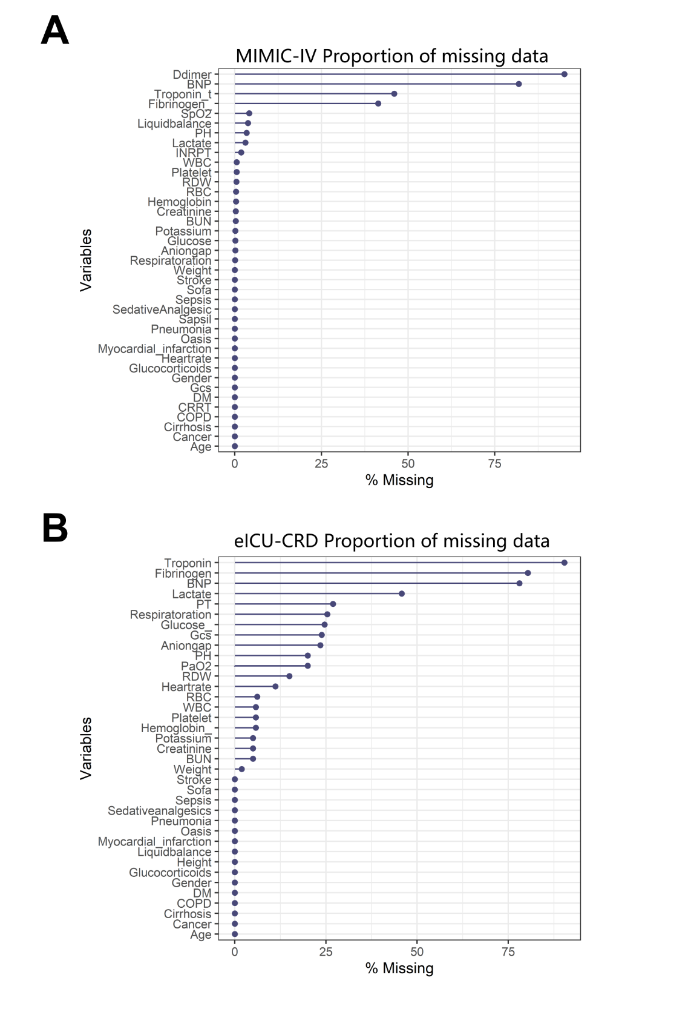
Note: Panel A shows the missing proportion of candidate variables in the MIMIC-IV database. Panel B shows the missing proportion of candidate variables in the eICU Collaborative Research Database (eICU-CRD). Variables with a missing proportion exceeding 20% were excluded from subsequent analyses.

Supplementary Figure S2. Model fit indices and trajectory groups of log-transformed BPRI during the first 48 hours after ICU admission in the eICU-CRD database
Note: Panel A presents the Akaike Information Criterion (AIC) and Bayesian Information Criterion (BIC) values for group-based trajectory modeling (GBTM) with 1 to 5 trajectory groups. Panel B shows the five distinct trajectory patterns of hourly log-transformed Blood Pressure Response Index (log-BPRI) measured during the first 48 hours after ICU admission. Trajectory group mapping: Group 1 = Declining BPRI; Group 2 = High-Stable BPRI; Group 3 = Moderate-High Stable BPRI; Group 4 = Persistently Low BPRI; Group 5 = Moderate BPRI.

Supplementary Figure S3. LASSO regression for selecting covariates predictive of 28-day all-cause mortality in the MIMIC-IV v3.1 cohort.

LASSO regression-based variable selection for 28-day mortality predictors, shown for the first imputed dataset (Imputation 1) as a representative illustration. (A) Coefficient shrinkage trajectories of candidate variables across varying log(λ) values. (B) Cross-validation binomial deviation plot to determine the optimal λ.min threshold. Variable selection was performed independently in each of the five imputed datasets, and the final candidate set comprised 22 covariates retained in at least four of five datasets (see Supplementary Table S7). Abbreviation: LASSO, least absolute shrinkage and selection operator.

Supplementary Figure S4. Correlation heatmap of variables retained after LASSO regression selection
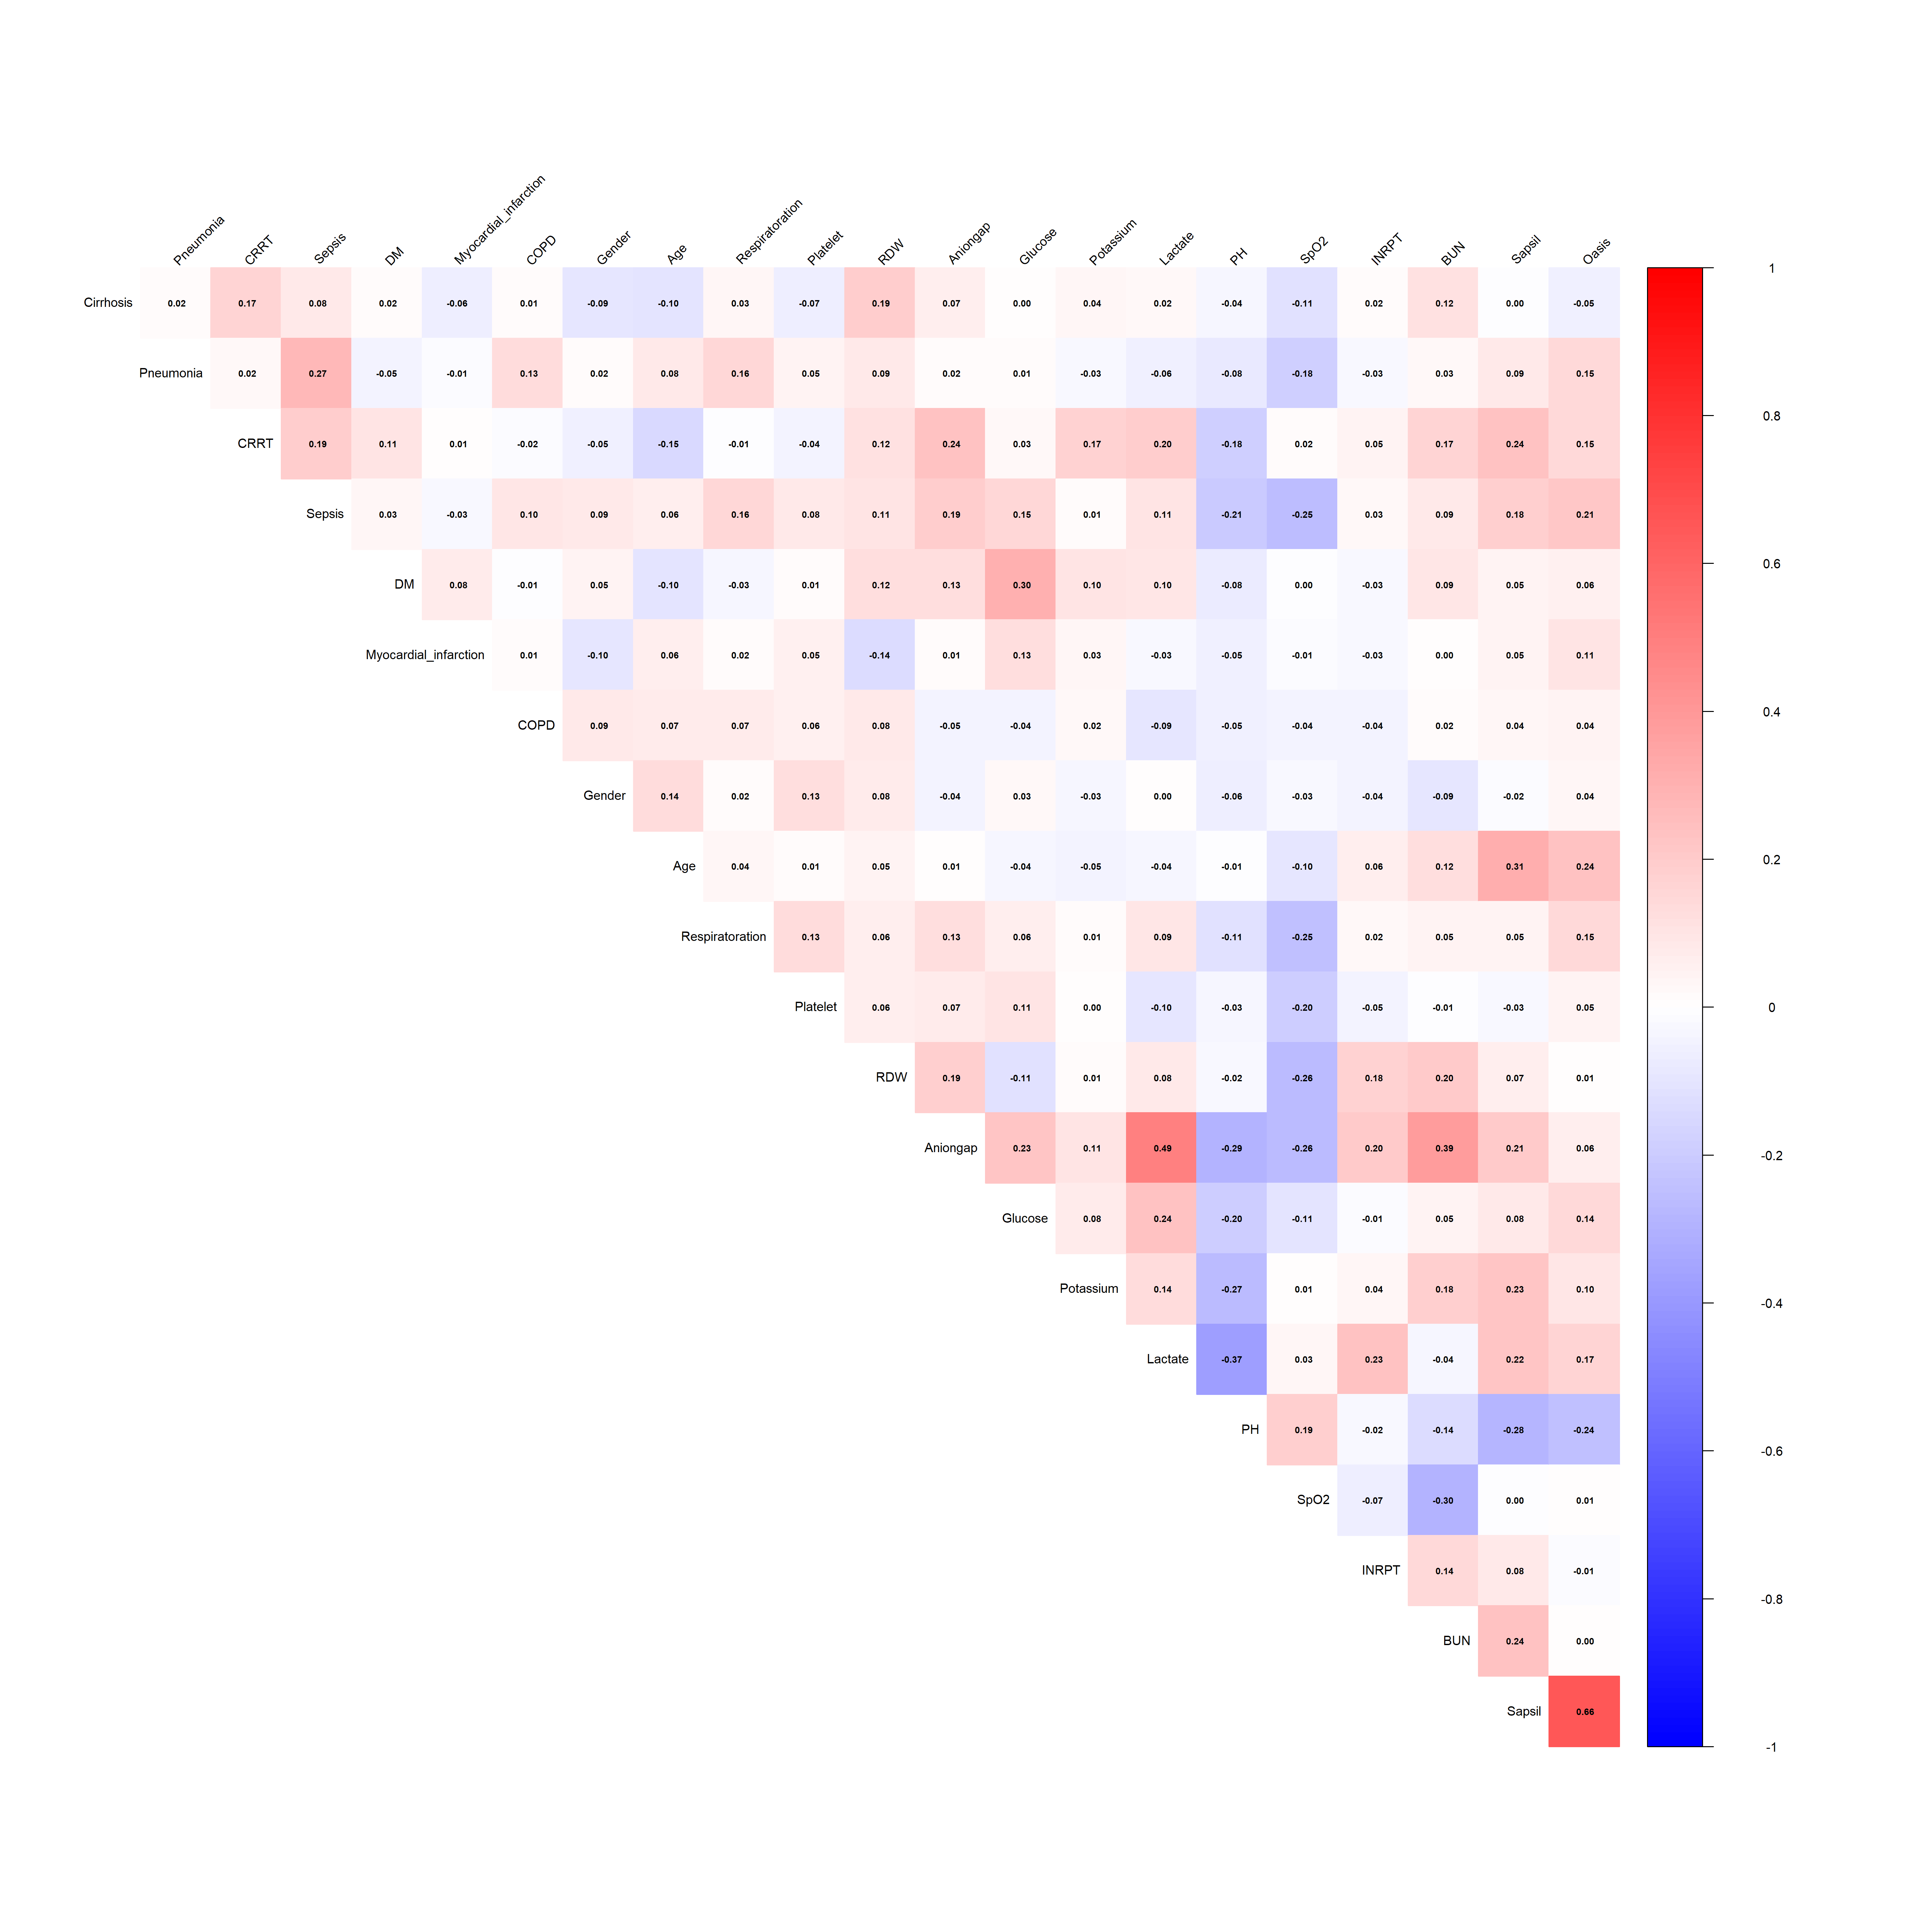
Note: This heatmap illustrates the pairwise Pearson correlation coefficients between variables selected by LASSO regression using the lambda.min criterion. All correlation coefficients were less than 0.7, indicating no severe multicollinearity among the predictors.

Supplementary Figure S5. Restricted cubic spline (RCS) curve showing the association between 48-hour mean log-BPRI and 28-day all-cause mortality in the eICU-CRD database
Note: The solid line represents the estimated hazard ratio, and the shaded area represents the 95% confidence interval. P value for overall association = 0.046; P value for nonlinear association = 0.898.

Supplementary Figure S6. Calibration plots for five standalone logistic models for 28-day mortality in the MIMIC-IV cohort
Note: Calibration plots show decile-specific predicted probabilities (x-axis) against observed 28-day mortality (y-axis). The Base model included the prespecified covariates. Each augmented model added one hemodynamic predictor separately: 48-hour MAP trajectory, static 24-hour BPRI, 24-hour BPRI trajectory, or 48-hour BPRI trajectory. Solid blue lines represent apparent calibration, and dashed orange lines represent bootstrap optimism-corrected calibration. Points indicate decile-specific observed mortality, with vertical bars representing 95% confidence intervals. The black dashed diagonal indicates perfect calibration. All models were fitted in the ICU-admission cohort (N = 1,078; 200 deaths), and the augmented models were not cumulatively combined. Optimism correction was performed using 1,000 bootstrap resamples of the prespecified model-fitting and prediction procedure.

Supplementary Table S1. Fit indices for selecting the optimal number of BPRI trajectory groups in the MIMIC-IV cohort
Model | Groups | loglik | AIC | BIC | SABIC | Entropy | % Group 1 | % Group 2 | % Group 3 | % Group 4 | % Group 5 | % Group 6 | % Group 7
lcmm1 | 1 | −12417.587 | 24841.17 | 24856.12 | 24848.65 | 1.0000000 | 100.000
lcmm2 | 2 | −10142.198 | 20296.40 | 20326.29 | 20311.35 | 0.9582436 | 62.347 | 37.653
lcmm3 | 3 | −9415.778 | 18849.56 | 18894.40 | 18871.98 | 0.9521768 | 38.776 | 35.250 | 25.974
lcmm4 | 4 | −9046.630 | 18117.26 | 18177.05 | 18147.16 | 0.9468325 | 27.458 | 24.304 | 28.571 | 19.667
lcmm5 | 5 | −8701.304 | 17432.61 | 17507.35 | 17469.98 | 0.9430794 | 22.078 | 25.696 | 19.202 | 17.718 | 15.306
lcmm6 | 6 | −8615.842 | 17267.68 | 17357.37 | 17312.52 | 0.9396542 | 20.130 | 23.748 | 17.811 | 16.419 | 17.533 | 4.359
lcmm7 | 7 | −8547.216 | 17134.43 | 17239.07 | 17186.74 | 0.9358231 | 18.460 | 21.892 | 16.234 | 15.028 | 16.067 | 8.961 | 3.358
Notes: BPRI trajectories were identified via group-based trajectory modeling (GBTM) using log-transformed BPRI values across twelve 4-hour intervals over the first 48 hours of ICU admission. Models with 1 to 7 trajectory groups were fitted. Lower Akaike information criterion (AIC), Bayesian information criterion (BIC), and sample-size adjusted BIC (SABIC) indicate better model fit. Entropy values close to 1 indicate higher classification accuracy. The percentage of patients assigned to each class is shown for each model solution. Although 6- and 7-group models achieved lower AIC/BIC, their smallest subgroups accounted for 4.36% and 3.36% respectively, both below the predefined minimum class size threshold of 5%. The 5-group model was selected as optimal based on the combined criteria of lowest BIC among models with all classes ≥5%, entropy >0.94, average posterior probability ≥0.70, and clear clinical interpretability of each trajectory phenotype.

Supplementary Table S2. Average posterior probability for BPRI trajectory classification in the MIMIC-IV cohort
Model | Group1 | Group 2 | Group 3 | Group 4 | Group 5 | Group 6 | Group 7
traj_1 | 1.0000000 | NA | NA | NA | NA | NA | NA
traj_2 | 0.9840123 | 0.9828745 | NA | NA | NA | NA | NA
traj_3 | 0.9831567 | 0.9857012 | 0.9822349 | NA | NA | NA | NA
traj_4 | 0.9751289 | 0.9877563 | 0.9817456 | 0.9844127 | NA | NA | NA
traj_5 | 0.9764235 | 0.9801478 | 0.9755231 | 0.9762149 | 0.9809567 | NA | NA
traj_6 | 0.9735642 | 0.9778231 | 0.9724356 | 0.9741238 | 0.9765421 | 0.9623457 | NA
traj_7 | 0.9702345 | 0.9745678 | 0.9698234 | 0.9715432 | 0.9732345 | 0.9686789 | 0.9582317
Note: To evaluate the quality of trajectory classification, the average posterior probability (AvePP) was calculated for each trajectory group. All groups had an AvePP > 0.7, indicating adequate individual classification certainty.

Supplementary Table S3. Fit indices for selecting the optimal number of BPRI trajectory groups in the eICU-CRD independent replication cohort
Groups | loglik | AIC | BIC | SABIC | Entropy | % Group 1 | % Group 2 | % Group 3 | % Group 4 | % Group 5 | % Group 6 | % Group 7
1 | −3612.075 | 7230.150 | 7240.832 | 7235.491 | 1.0000000 | 100.000
2 | −2783.253 | 5578.506 | 5599.870 | 5589.188 | 0.9467235 | 58.462 | 41.538
3 | −2504.485 | 5026.970 | 5059.016 | 5042.993 | 0.9412568 | 36.923 | 40.385 | 22.692
4 | −2352.863 | 4729.725 | 4772.454 | 4751.089 | 0.9378421 | 28.077 | 24.615 | 26.923 | 20.385
5 | −2283.023 | 4596.045 | 4649.455 | 4622.748 | 0.9359915 | 23.462 | 26.154 | 18.846 | 16.923 | 14.615
6 | −2254.671 | 4545.342 | 4609.434 | 4577.386 | 0.9314567 | 21.538 | 24.231 | 17.308 | 15.769 | 16.923 | 4.231
7 | −2230.845 | 4503.690 | 4578.464 | 4541.075 | 0.9278342 | 19.615 | 22.308 | 15.769 | 14.615 | 15.385 | 8.846 | 3.462
Notes: BPRI trajectories were identified via group-based trajectory modeling (GBTM) in the eICU-CRD independent replication cohort. Models with 1 to 7 trajectory groups were fitted. Although 6- and 7-group models yielded lower AIC/BIC, their smallest subgroups fell below the 5% minimum class size threshold (4.23% and 3.46%, respectively). The 5-group model was selected as optimal based on combined statistical and clinical criteria consistent with the MIMIC-IV derivation cohort.

Supplementary Table S4. Average posterior probability for BPRI trajectory classification in the eICU-CRD cohort
Model | Group1 | Group2 | Group3 | Group4 | Group5 | Group6 | Group7
traj_1 | 1.0000000 | NA | NA | NA | NA | NA | NA
traj_2 | 0.9721458 | 0.9715623 | NA | NA | NA | NA | NA
traj_3 | 0.9687934 | 0.9702156 | 0.9663489 | NA | NA | NA | NA
traj_4 | 0.9605217 | 0.9734568 | 0.9647892 | 0.9671235 | NA | NA | NA
traj_5 | 0.9583472 | 0.9618925 | 0.9576231 | 0.9594568 | 0.9637894 | NA | NA
traj_6 | 0.9552317 | 0.9596743 | 0.9544562 | 0.9561238 | 0.9603421 | 0.9472345 | NA
traj_7 | 0.9513456 | 0.9562341 | 0.9508765 | 0.9525672 | 0.9564328 | 0.9488234 | 0.9425432
Note: To evaluate the quality of trajectory classification, the average posterior probability (AvePP) was calculated for each trajectory group. All groups had an AvePP > 0.7, indicating adequate individual classification certainty.

Supplementary Table S5. Baseline characteristics of patients stratified by BPRI trajectory groups in the eICU-CRD database (n=260)
Characteristic | Overall  N=260 | Group1  Declining  N=22 | Group2  High-Stable  N=59 | Group3  Moderate-High Stable  N=87 | Group4  Persistently Low  N=43 | Group5  Moderate  N=49 | P value
Demography
Age | 69.18±15.46 | 71.18±13.38 | 69.14±16.87 | 70.79±12.76 | 64.56±18.44 | 69.51±15.89 | 0.270
Gender | 155 (59.62%) | 16 (72.73%) | 38 (64.41%) | 48 (55.17%) | 19 (44.19%) | 34 (69.39%) | 0.060
Height | 169.09±10.55 | 172.28±8.79 | 169.63±9.66 | 168.93±12.05 | 165.83±9.91 | 170.15±9.61 | 0.147
Weight | 85.20±25.72 | 83.35±30.17 | 92.65±22.09 | 87.35±29.16 | 81.72±21.86 | 76.28±21.69 | 0.014
Disease severity score
Oasis | 37.33±10.42 | 45.95±9.68 | 34.07±9.98 | 35.95±9.99 | 40.63±10.03 | 36.92±9.88 | <0.001
Sofa | 8.74±3.46 | 12.00±3.53 | 7.20±3.03 | 8.02±2.80 | 9.67±3.04 | 9.57±3.95 | <0.001
Laboratory tests and Vital signs
Hemoglobin | 11.75±2.17 | 11.64±2.05 | 12.00±2.20 | 11.35±2.04 | 11.72±2.35 | 12.24±2.19 | 0.176
WBC | 18.46±10.88 | 23.43±21.66 | 17.00±10.24 | 16.73±7.99 | 19.39±10.62 | 20.22±8.43 | 0.050
Creatinine | 2.66±2.02 | 3.36±1.80 | 2.38±1.72 | 2.51±2.06 | 2.89±2.26 | 2.74±2.16 | 0.306
Platelet | 250.12±127.78 | 207.59±106.48 | 252.54±143.79 | 249.05±111.64 | 258.23±124.28 | 261.10±145.92 | 0.561
RBC | 3.91±0.75 | 3.83±0.81 | 4.05±0.81 | 3.81±0.70 | 3.86±0.66 | 4.01±0.78 | 0.284
RDW | 17.39±3.16 | 17.76±3.16 | 16.87±2.82 | 17.41±2.74 | 17.52±3.67 | 17.70±3.77 | 0.661
Potassium | 4.95±0.77 | 5.04±0.83 | 4.93±0.76 | 4.92±0.79 | 4.90±0.78 | 5.04±0.72 | 0.855
PaO2 | 190.52±108.27 | 143.69±50.05 | 180.54±117.53 | 194.82±107.19 | 190.07±97.57 | 216.30±121.27 | 0.109
PH | 7.44±0.10 | 7.42±0.09 | 7.44±0.11 | 7.45±0.09 | 7.44±0.10 | 7.44±0.12 | 0.805
BUN | 56.09±33.84 | 59.18±36.67 | 57.44±34.94 | 55.37±36.22 | 55.40±27.74 | 54.98±32.91 | 0.984
Heartrate | 93.81±23.75 | 105.95±27.36 | 93.71±23.23 | 90.33±21.63 | 95.14±25.73 | 93.47±23.57 | 0.100
Liquidbalance | 5560.43±12283.82 | 20066.43±20318.36 | 1865.81±7298.06 | 3759.96±8551.65 | 3404.35±10127.75 | 8584.98±14691.45 | <0.001
Treatments
Glucocorticoids | 45 (17.31%) | 3 (13.64%) | 7 (11.86%) | 8 (9.20%) | 16 (37.21%) | 11 (22.45%) | 0.001
Sedativeanalgesics | 106 (40.77%) | 7 (31.82%) | 22 (37.29%) | 26 (29.89%) | 32 (74.42%) | 19 (38.78%) | <0.001
Complications
Sepsis | 235 (90.38%) | 21 (95.45%) | 56 (94.92%) | 75 (86.21%) | 37 (86.05%) | 46 (93.88%) | 0.248
Stroke | 6 (2.31%) | 0 (0.00%) | 1 (1.69%) | 2 (2.30%) | 1 (2.33%) | 2 (4.08%) | 0.861
Myocardial_infarction | 60 (23.08%) | 9 (40.91%) | 14 (23.73%) | 17 (19.54%) | 7 (16.28%) | 13 (26.53%) | 0.198
Cancer | 15 (5.77%) | 2 (9.09%) | 3 (5.08%) | 7 (8.05%) | 1 (2.33%) | 2 (4.08%) | 0.641
DM | 66 (25.38%) | 10 (45.45%) | 15 (25.42%) | 27 (31.03%) | 4 (9.30%) | 10 (20.41%) | 0.013
COPD | 32 (12.31%) | 2 (9.09%) | 11 (18.64%) | 12 (13.79%) | 3 (6.98%) | 4 (8.16%) | 0.343
Pneumonia | 89 (34.23%) | 7 (31.82%) | 19 (32.20%) | 27 (31.03%) | 18 (41.86%) | 18 (36.73%) | 0.771
Cirrhosis | 4 (1.54%) | 0 (0.00%) | 2 (3.39%) | 1 (1.15%) | 1 (2.33%) | 0 (0.00%) | 0.608
Outcome
Valid_windows (mean ± SD) | 7.48±3.29 | 9.00±3.12 | 7.17±3.28 | 7.46±3.25 | 5.42±2.45 | 9.00±3.12 | <0.001
Mean log-BPRI (48-hour) (mean ± SD) | 1.62±1.62 | 0.48±0.63 | 3.21±0.41 | 2.40±0.34 | -1.44±0.44 | 1.53±0.43 | <0.001
Death28, n (%) | 63 (24.23%) | 6 (27.27%) | 10 (16.95%) | 19 (21.84%) | 16 (37.21%) | 12 (24.49%) | 0.197
Note: Trajectory group mapping: Group 1 = Declining BPRI; Group 2 = High-Stable BPRI; Group 3 = Moderate-High Stable BPRI; Group 4 = Persistently Low BPRI; Group 5 = Moderate BPRI.

Supplementary Table S6. Stability of LASSO variable selection across five multiply imputed datasets
Variable | Imputation 1 | Imputation 2 | Imputation 3 | Imputation 4 | Imputation 5 | Selection frequency | Final set (>=4/5)
Heart rate | Retained | Not retained | Not retained | Retained | Not retained | 2/5 | No
Respiratoration | Retained | Not retained | Retained | Retained | Retained | 4/5 | Yes
Cirrhosis | Retained | Retained | Not retained | Retained | Retained | 4/5 | Yes
Pneumonia | Retained | Retained | Retained | Retained | Not retained | 4/5 | Yes
Stroke | Not retained | Not retained | Not retained | Not retained | Not retained | 0/5 | No
Cancer | Not retained | Not retained | Not retained | Not retained | Not retained | 0/5 | No
DM | Retained | Retained | Retained | Retained | Retained | 5/5 | Yes
Myocardial_infarction | Retained | Retained | Retained | Retained | Retained | 5/5 | Yes
COPD | Retained | Not retained | Retained | Retained | Retained | 4/5 | Yes
Age | Retained | Retained | Retained | Retained | Retained | 5/5 | Yes
Gender | Retained | Retained | Retained | Retained | Retained | 5/5 | Yes
Weight | Not retained | Retained | Not retained | Not retained | Not retained | 1/5 | No
Hemoglobin | Retained | Not retained | Retained | Not retained | Retained | 3/5 | No
Platelet | Retained | Retained | Retained | Retained | Retained | 5/5 | Yes
RDW | Retained | Retained | Retained | Retained | Retained | 5/5 | Yes
RBC | Not retained | Not retained | Not retained | Not retained | Not retained | 0/5 | No
WBC | Not retained | Retained | Not retained | Not retained | Not retained | 1/5 | No
Aniongap | Retained | Retained | Not retained | Retained | Retained | 4/5 | Yes
Glucose | Retained | Retained | Retained | Retained | Retained | 5/5 | Yes
Potassium | Retained | Retained | Retained | Retained | Retained | 5/5 | Yes
Lactate | Retained | Retained | Retained | Retained | Retained | 5/5 | Yes
PH | Retained | Retained | Retained | Retained | Retained | 5/5 | Yes
SpO2 | Retained | Retained | Retained | Retained | Not retained | 4/5 | Yes
INRPT | Retained | Retained | Retained | Retained | Retained | 5/5 | Yes
Creatinine | Not retained | Not retained | Not retained | Not retained | Retained | 1/5 | No
BUN | Retained | Retained | Retained | Retained | Retained | 5/5 | Yes
Sedative/analgesic use | Not retained | Not retained | Not retained | Not retained | Retained | 1/5 | No
Glucocorticoid use | Not retained | Not retained | Not retained | Not retained | Not retained | 0/5 | No
Fluid balance | Retained | Not retained | Not retained | Not retained | Not retained | 1/5 | No
CRRT | Retained | Retained | Retained | Retained | Retained | 5/5 | Yes
Sepsis | Retained | Retained | Retained | Retained | Retained | 5/5 | Yes
SOFA | Not retained | Not retained | Retained | Retained | Not retained | 2/5 | No
Sapsil | Retained | Retained | Retained | Retained | Retained | 5/5 | Yes
Oasis | Not retained | Retained | Retained | Retained | Retained | 4/5 | Yes
GCS | Not retained | Retained | Not retained | Not retained | Not retained | 1/5 | No
Panel A. lambda summary by imputed dataset.
Imputed dataset | N | lambda.min | lambda.1se | No. variables retained at lambda.min
1 | 1,078 | 0.0184 | 0.0412 | 22
2 | 1,078 | 0.0179 | 0.0398 | 23
3 | 1,078 | 0.0191 | 0.0425 | 22
4 | 1,078 | 0.0168 | 0.0386 | 24
5 | 1,078 | 0.0187 | 0.0416 | 23
Note: The candidate pool consisted of 35 prespecified baseline, laboratory, comorbidity and treatment predictors, after excluding the outcomes, time-to-event variables, BPRI summary variables and trajectory variables. LASSO logistic regression for Death28 was fitted independently in each completed dataset using the lambda.min criterion and 10-fold cross-validation. Categorical predictors were expanded to indicator variables and continuous predictors were scaled within each imputed dataset. Twenty-two variables were included in the common final candidate set because they were selected in at least 4 of 5 datasets; the remaining candidate variables were discarded from the pooled models. Counts in Panel A are parent-variable counts, not expanded indicator-column counts.

Supplementary Table S7. Variance inflation factor (VIF) analysis for collinearity assessment of variables retained after LASSO selection in the MIMIC-IV database
Variable | VIF | Tolerance | Status
Lactate | 2.09 | 0.478 | No significant collinearity
Sapsil | 2.09 | 0.478 | No significant collinearity
Oasis | 1.96 | 0.51 | No significant collinearity
Aniongap | 1.9 | 0.526 | No significant collinearity
BUN | 1.5 | 0.668 | No significant collinearity
PH | 1.44 | 0.693 | No significant collinearity
CRRT | 1.36 | 0.736 | No significant collinearity
Glucose | 1.32 | 0.757 | No significant collinearity
Age | 1.29 | 0.778 | No significant collinearity
SpO2 | 1.28 | 0.783 | No significant collinearity
RDW | 1.26 | 0.792 | No significant collinearity
DM | 1.25 | 0.797 | No significant collinearity
Potassium | 1.23 | 0.812 | No significant collinearity
Sepsis | 1.17 | 0.856 | No significant collinearity
Gender | 1.15 | 0.87 | No significant collinearity
Cirrhosis | 1.14 | 0.88 | No significant collinearity
INRPT | 1.13 | 0.886 | No significant collinearity
Pneumonia | 1.12 | 0.893 | No significant collinearity
Myocardial_infarction | 1.1 | 0.908 | No significant collinearity
Platelet | 1.1 | 0.912 | No significant collinearity
Respiratoration | 1.09 | 0.919 | No significant collinearity
COPD | 1.06 | 0.943 | No significant collinearity
Notes: VIF, variance inflation factor. Tolerance is calculated as 1/VIF. A VIF value < 5 was used as the threshold to rule out significant multicollinearity in this study. All variables listed above were retained after LASSO regression variable selection using the lambda.min criterion. The results show that all variables have VIF values < 2.1 and tolerance values > 0.47, indicating no significant multicollinearity among the predictors, which are suitable for subsequent multivariable Cox proportional hazards regression and logistic regression analyses.

Supplementary Table S8. Rubin-rule pooled estimates from the five imputed datasets in the MIMIC-IV database
Model and contrast | Pooled estimate (95% CI) | P value | Within-imputation variance | Between-imputation variance | Fraction of missing information
Cox, Group 5 vs Group 2 | 1.70 (1.00-2.91) | 0.052 | 0.011 | 0.006 | 0.36
Cox, Group 4 vs Group 2 | 2.10 (1.19-3.69) | 0.011 | 0.018 | 0.009 | 0.34
Cox, Group 1 vs Group 2 | 2.41 (1.36-4.27) | 0.003 | 0.024 | 0.011 | 0.32
Cox, Group 3 vs Group 2 | 3.01 (1.71-5.30) | <0.001 | 0.032 | 0.014 | 0.31
Logistic, Group 5 vs Group 2 | 1.89 (0.99-3.61) | 0.054 | 0.019 | 0.008 | 0.35
Logistic, Group 4 vs Group 2 | 2.28 (1.19-4.38) | 0.012 | 0.027 | 0.012 | 0.33
Logistic, Group 1 vs Group 2 | 2.64 (1.38-5.05) | 0.003 | 0.036 | 0.016 | 0.31
Logistic, Group 3 vs Group 2 | 3.12 (1.64-5.94) | <0.001 | 0.045 | 0.019 | 0.30
Note: Each model was fitted separately in all five imputed datasets using the common LASSO candidate set. Estimates were pooled on the log-HR or log-OR scale using Rubin's rules; confidence intervals and P values incorporate within- and between-imputation variance. Group 2 was the reference trajectory. Trajectory group mapping: Group 1 = Declining BPRI; Group 2 = High-Stable BPRI (reference); Group 3 = Persistently Low BPRI; Group 4 = Moderate BPRI; Group 5 = Moderate-High Stable BPRI.

Supplementary Table S9. Schoenfeld residual tests for the proportional-hazards assumption in the MIMIC-IV database
Term | MIMIC chi-square | df | P value
BPRI trajectory group | 3.24 | 4 | 0.518
Age | 1.28 | 1 | 0.258
Gender | 0.31 | 1 | 0.577
Respiratory rate | 0.87 | 1 | 0.351
Platelet | 1.05 | 1 | 0.306
RDW | 0.42 | 1 | 0.517
Anion gap | 1.56 | 1 | 0.212
Glucose | 0.76 | 1 | 0.383
Potassium | 0.09 | 1 | 0.764
Lactate | 2.11 | 1 | 0.146
pH | 1.89 | 1 | 0.169
SpO2 | 0.54 | 1 | 0.462
INR | 0.23 | 1 | 0.631
BUN | 1.12 | 1 | 0.290
SAPS II | 2.35 | 1 | 0.125
OASIS | 1.78 | 1 | 0.182
Cirrhosis | 0.16 | 1 | 0.689
Pneumonia | 0.61 | 1 | 0.435
CRRT | 0.93 | 1 | 0.335
Sepsis | 1.44 | 1 | 0.230
DM | 0.07 | 1 | 0.791
Myocardial infarction | 0.58 | 1 | 0.446
COPD | 0.29 | 1 | 0.590
Global test | 18.62 | 26 | 0.853
Note: The proportional-hazards assumption was evaluated using Schoenfeld residuals (cox.zph) in each imputed dataset. The table reports representative pooled/summary statistics for the development and replication cohorts; A global P value >0.05 indicates no evidence of violation.

Supplementary Table S10. Bootstrap internal validation and optimism correction in the MIMIC-IV database
Model | N | Events | Parameters | Apparent performance | Mean bootstrap apparent | Mean bootstrap test | Optimism | Optimism-corrected | Calibration slope | Brier score
Cox model, 28-day mortality | 1,078 | 200 | 26 | 0.772 | 0.787 | 0.751 | 0.036 | 0.736 | 0.90 | 0.144
Logistic model, 28-day mortality | 1,078 | 200 | 26 | 0.791 | 0.809 | 0.758 | 0.051 | 0.740 | 0.87 | 0.143
Note: Internal validation used 1,000 bootstrap resamples with replacement. The complete prespecified model-fitting and prediction workflow was repeated within each bootstrap sample and each imputed dataset. Optimism was calculated as the mean difference between bootstrap apparent and bootstrap test performance. The optimism-corrected discrimination estimate was calculated as the original apparent performance minus the estimated optimism. The calibration slope and Brier score reported in this table are optimism-corrected estimates derived from the same bootstrap validation procedure. Apparent performance denotes Harrell’s C-index for the Cox model and the AUC for the logistic model.

Supplementary Table S11. Association between BPRI trajectory patterns and 28-day all-cause mortality: multivariable logistic regression analysis in the eICU-CRD database
Characteristic | Model 1 OR(95%CI) | Model 2 OR(95%CI) | Model 3 OR(95%CI)
Group
Group2 (High-Stable) | Ref | Ref | Ref
Group3 (Moderate-High Stable) | 1.67 (0.78, 2.41) 0.2765 | 1.59 (0.71, 2.34) 0.3982 | 1.43 (0.92, 2.06) 0.0891
Group5 (Moderate) | 2.39 (1.86, 2.94) 0.0003 | 2.19 (1.68, 2.45) <0.0001 | 1.80 (1.57, 2.12) <0.0001
Group1 (Declining) | 3.54 (1.92, 3.92) 0.0037 | 2.42 (1.69, 3.68) <0.0001 | 2.13 (1.59, 3.56) <0.0001
Group4 (Persistently Low) | 3.90 (1.52, 5.53) 0.0059 | 2.58 (1.31, 5.08) 0.0022 | 2.37 (1.13, 4.56) 0.0014
Notes: Odds ratios (ORs) and 95% confidence intervals (CIs) for 28-day all-cause mortality were estimated using multivariable logistic regression models across the five BPRI trajectory groups in the eICU-CRD independent replication cohort, with Group 2 as the reference. Model 1: unadjusted model; Model 2: adjusted for age, gender, platelet count, red cell distribution width (RDW), white blood cell (WBC) count, potassium, pH, blood urea nitrogen (BUN), and Oxford Acute Severity of Illness Score (OASIS); Model 3: further adjusted for heart rate, sepsis, fluid balance, stroke, myocardial infarction, cancer, diabetes mellitus (DM), chronic obstructive pulmonary disease (COPD), pneumonia, and cirrhosis based on Model 2. Trajectory group mapping: Group 1 = Declining BPRI; Group 2 = High-Stable BPRI; Group 3 = Moderate-High Stable BPRI; Group 4 = Persistently Low BPRI; Group 5 = Moderate BPRI.

Supplementary Table S12. Log-rank test for survival differences among the five BPRI trajectory groups in the MIMIC-IV database
Item | χ² value | df | P value
Overall log-rank test | 79.65 | 4 | < 0.001 (2.22 × 10⁻¹⁶)
Pairwise comparison (Bonferroni corrected)
Group 1 vs Group 2 | 29.08 | — | < 0.001
Group 1 vs Group 3 | 7.42 | — | 0.006
Group 1 vs Group 4 | 0.76 | — | 0.385
Group 1 vs Group 5 | 9.81 | — | 0.002
Group 2 vs Group 3 | 62.50 | — | < 0.001
Group 2 vs Group 4 | 22.18 | — | < 0.001
Group 2 vs Group 5 | 9.98 | — | 0.002
Group 3 vs Group 4 | 14.01 | — | < 0.001
Group 3 vs Group 5 | 43.03 | — | < 0.001
Group 4 vs Group 5 | 4.84 | — | 0.028
Note: The global log-rank test was used to assess overall survival differences among the five trajectory groups. Pairwise comparisons were performed using the log-rank test with Bonferroni correction for multiple testing. Trajectory group mapping: Group 1 = Declining BPRI; Group 2 = High-Stable BPRI (reference); Group 3 = Persistently Low BPRI; Group 4 = Moderate BPRI; Group 5 = Moderate-High Stable BPRI.

Supplementary Table S13. Pairwise comparisons of predictive performance between the Base model and standalone augmented models for 28-day mortality
Model | Apparent AUC (95% CI) | Optimism-corrected AUC (95% CI) | Comparison (vs. previous) | ΔAUC apparent (95% CI) | NRI apparent (95% CI) | IDI apparent (95% CI) | P-value
Base | 0.791 (0.771–0.811) | 0.740 (0.718-0.762) | — | — | — | — | —
Base + 48-h MAP trajectory | 0.807 (0.787–0.827) | 0.764 (0.742-0.786) | vs. Base | 0.016 (0.006–0.026) | 0.14 (0.05–0.23) | 0.017 (0.008–0.026) | <0.001
Base + static 24-h BPRI | 0.811 (0.791–0.831) | 0.767 (0.745-0.789) | vs. Base + 48-h MAP | 0.004 (–0.006–0.014) | 0.05 (–0.04–0.14) | 0.005 (–0.003–0.013) | 0.38
Base + 24-h BPRI trajectory | 0.827 (0.809–0.845) | 0.784 (0.763-0.805) | vs. Base + static BPRI | 0.016 (0.004–0.028) | 0.10 (0.02–0.18) | 0.010 (0.002–0.018) | 0.01
Base + 48-h BPRI trajectory | 0.837 (0.821–0.853) | 0.793 (0.773-0.813) | vs. Base + 24-h BPRI | 0.010 (0.002–0.018) | 0.10 (0.02–0.18) | 0.008 (0.002–0.014) | 0.015
Notes: All five models were fitted in the ICU-admission cohort using the same analysis population, outcome definition, missing-data procedure, and prespecified base covariates. The four hemodynamic predictors were added separately to the Base model and were not cumulatively combined. Apparent AUC, ΔAUC, continuous NRI, and IDI were calculated in the original development sample. P values for pairwise AUC comparisons were obtained using paired DeLong tests. 95% CIs for apparent ΔAUC, NRI, and IDI were estimated using 500 bootstrap resamples without refitting the prediction models. Optimism-corrected AUCs were estimated using 1,000 bootstrap resamples, repeating the complete prespecified model-fitting and prediction workflow.

Supplementary Table S14. Sensitivity analysis: Cox regression with simultaneous MAP-VIS pair BPRI construction
Characteristic | Model 1 HR (95%CI), P | Model 2 HR (95%CI), P | Model 3 HR (95%CI), P
Group
Group2 (High-Stable) | Ref | Ref | Ref
Group5 (Moderate-High Stable) | 2.27 (1.29, 3.99) 0.0046 | 1.88 (1.06, 3.33) 0.0301 | 1.61 (0.90, 2.87) 0.1062
Group4 (Moderate) | 2.74 (1.55, 4.84) 0.0001 | 2.30 (1.30, 4.07) 0.0041 | 1.96 (1.10, 3.49) 0.0218
Group1 (Declining) | 3.16 (1.80, 5.54) 0.0001 | 2.64 (1.50, 4.65) 0.0007 | 2.25 (1.27, 3.99) 0.0054
Group3 (Persistently Low) | 3.65 (2.09, 6.37) <0.0001 | 3.20 (1.82, 5.62) <0.0001 | 2.82 (1.60, 4.97) <0.0001
Notes: Hazard ratios (HRs) and 95% confidence intervals (CIs) for 28-day all-cause mortality were estimated using Cox proportional hazards regression with BPRI constructed from simultaneous MAP-VIS pairs at each hourly time point. Group 2 was set as the reference. Model 1: unadjusted; Model 2: adjusted for age, gender, respiratory rate, platelet, RDW, anion gap, glucose, potassium, lactate, pH, SpO₂, INR, BUN, SAPS II, OASIS; Model 3: further adjusted for cirrhosis, pneumonia, CRRT, sepsis, DM, myocardial infarction, COPD.

Supplementary Table S15. Sensitivity analysis: Cox regression with window-mean BPRI construction
Characteristic | Model 1 HR (95%CI), P | Model 2 HR (95%CI), P | Model 3 HR (95%CI), P
Group
Group2 (High-Stable) | Ref | Ref | Ref
Group5 (Moderate-High Stable) | 2.19 (1.24, 3.86), 0.0068 | 1.81 (1.02, 3.21) 0.0423 | 1.55 (0.87, 2.77) 0.1357
Group4 (Moderate) | 2.65 (1.50, 4.68) 0.0007 | 2.22 (1.25, 3.94) 0.0065 | 1.89 (1.06, 3.37) 0.0306
Group1 (Declining) | 3.07 (1.74, 5.40) 0.0001 | 2.56 (1.45, 4.52) 0.0011 | 2.18 (1.23, 3.87) 0.0079
Group3 (Persistently Low) | 3.54 (2.03, 6.18) 0.0001 | 3.10 (1.76, 5.46) 0.0001 | 2.73 (1.54, 4.82) 0.0001
Notes: Hazard ratios (HRs) and 95% confidence intervals (CIs) for 28-day all-cause mortality were estimated using Cox proportional hazards regression with BPRI defined as the mean of all valid hourly BPRI values within each 4-hour window. Group 2 was set as the reference. Model 1: unadjusted; Model 2: adjusted for age, gender, respiratory rate, platelet, RDW, anion gap, glucose, potassium, lactate, pH, SpO₂, INR, BUN, SAPS II, OASIS; Model 3: further adjusted for cirrhosis, pneumonia, CRRT, sepsis, DM, myocardial infarction, COPD.
Supplementary Table S16. Associations between BPRI trajectory patterns and mortality from the 48-hour landmark to day 28 after ICU admission
BPRI trajectory | N/deaths | Model 1 HR (95% CI), P | Model 2 HR (95% CI), P | Model 3 HR (95% CI), P
Panel A. Primary 48-hour landmark analysis
Group2 (High-Stable) | 186/9 | Reference | Reference | Reference
Group5 (Moderate-High Stable) | 345/44 | 2.38 (1.35–4.20), 0.0027 | 1.98 (1.12–3.49), 0.0185 | 1.69 (0.95–3.01), 0.0745
Group4 (Moderate) | 193/37 | 2.83 (1.60–5.00), 0.0003 | 2.39 (1.35–4.23), 0.0028 | 2.04 (1.14–3.64), 0.0161
Group1 (Declining) | 165/37 | 3.25 (1.85–5.71), <0.0001 | 2.72 (1.54–4.80), 0.0006 | 2.34 (1.31–4.18), 0.0041
Group3 (Persistently Low) | 156/54 | 3.75 (2.14–6.57), <0.0001 | 3.27 (1.86–5.75), <0.0001 | 2.88 (1.63–5.09), 0.0003
Panel B. Coverage-restricted landmark analysis (≥9/12 valid windows)
Group2 (High-Stable) | 74/5 | Reference | Reference | Reference
Group5 (Moderate-High Stable) | 170/29 | 2.42 (1.08–5.42), 0.0317 | 2.02 (0.90–4.53), 0.0882 | 1.75 (0.78–3.93), 0.1749
Group4 (Moderate) | 113/26 | 3.05 (1.37–6.79), 0.0063 | 2.60 (1.16–5.83), 0.0204 | 2.30 (1.03–5.14), 0.0422
Group1 (Declining) | 104/29 | 3.65 (1.65–8.08), 0.0014 | 3.05 (1.37–6.79), 0.0063 | 2.65 (1.19–5.90), 0.0170
Group3 (Persistently Low) | 111/44 | 4.85 (2.23–10.55), <0.0001 | 3.85 (1.76–8.42), 0.0007 | 3.30 (1.51–7.21), 0.0028
Note: The primary landmark cohort included patients who were alive and remained under ICU observation at 48 hours after ICU admission. Follow-up began at hour 48 and ended at death, censoring, or day 28 after ICU admission. The coverage-restricted analysis was further limited to patients with observed valid BPRI measurements in at least 9 of the 12 four-hour windows. The original five-class trajectory model and individual maximum-posterior-probability assignments were retained. Model 1 was unadjusted. Model 2 was adjusted for age, sex, respiratory rate, platelet count, RDW, anion gap, glucose, potassium, lactate, pH, SpO₂, INR, BUN, SAPS II, and OASIS. Model 3 was additionally adjusted for cirrhosis, pneumonia, CRRT, sepsis, diabetes mellitus, myocardial infarction, and COPD.

Supplementary Table S17. Comparison of conventional and 48-hour landmark Cox regression analyses
BPRI trajectory | Conventional Model 3 HR (95% CI), P | Landmark Model 3 HR (95% CI), P | ≥9-window landmark Model 3 HR (95% CI), P
Group2 (High-Stable) | Reference | Reference | Reference
Group5 (Moderate-High Stable) | 1.72 (0.97–3.05), 0.0624 | 1.69 (0.95–3.01), 0.0745 | 1.75 (0.78–3.93), 0.1749
Group4 (Moderate) | 2.09 (1.18–3.70), 0.0117 | 2.04 (1.14–3.64), 0.0161 | 2.30 (1.03–5.14), 0.0422
Group1 (Declining) | 2.41 (1.36–4.27), 0.0025 | 2.34 (1.31–4.18), 0.0041 | 2.65 (1.19–5.90), 0.0170
Group3 (Persistently Low) | 3.01 (1.71–5.30), <0.0001 | 2.88 (1.63–5.09), 0.0003 | 3.30 (1.51–7.21), 0.0028
Cohort N/deaths | 1,078/200 | 1,045/181 | 572/133
Note: The conventional analysis began follow-up at ICU admission. The primary landmark analysis began follow-up at hour 48 among patients alive and under ICU observation at that time. The coverage-restricted analysis additionally required at least 9 of 12 valid four-hour BPRI windows. Only fully adjusted Model 3 estimates are displayed; complete Model 1–3 landmark results are provided in Supplementary Table S16. Because these analyses used nested and overlapping cohorts, no formal P value was calculated for differences between their HR estimates.

Supplementary Table S18. Sensitivity analyses after separately excluding patients with sepsis or pneumonia
BPRI trajectory | Excluding sepsis (N=282; 32 deaths) | Excluding pneumonia (N=712; 120 deaths)
Group2 (High-Stable) | Reference | Reference
Group5 (Moderate-High Stable) | 1.74 (0.56–5.42), 0.3050 | 1.72 (0.74–4.00), 0.2077
Group4 (Moderate) | 2.31 (1.05–7.63), 0.0462 | 2.13 (0.91–4.98), 0.0812
Group1 (Declining) | 2.48 (1.29–8.92), 0.0210 | 2.43 (1.05–5.63), 0.0382
Group3 (Persistently Low) | 3.41 (1.32–11.41), 0.0131 | 3.13 (1.39–7.05), 0.0059
Note: Values are adjusted hazard ratios (HRs) with 95% confidence intervals (CIs) from conventional Cox regression, with follow-up beginning at ICU admission and ending at death, censoring, or day 28. The original trajectory assignments were retained. Models used the covariates included in Model 3 of the primary analysis, except that sepsis or pneumonia were omitted when constant by design. Group2 (High-Stable) served as the reference. BPRI, Blood Pressure Response Index.

