Assumptions

Assumptions of the repeated measure ANOVA
Number of assumptions | Answers to the assumptions | Results
Assumption #1: dependent variable should be measured at the continuous level | The dependent variables CPR test score before and after the training are continuous variables | -
Assumption #2: Your independent variable should consist of at least two categorical, "related groups" or "matched pairs". "Related groups" indicates that the same subjects are present in both groups | The independent variable is the position and department (categorical variables) and were measured at two different time | -
Assumption #3: The distribution of the dependent variable in the two or more related groups should be approximately normally distributed | 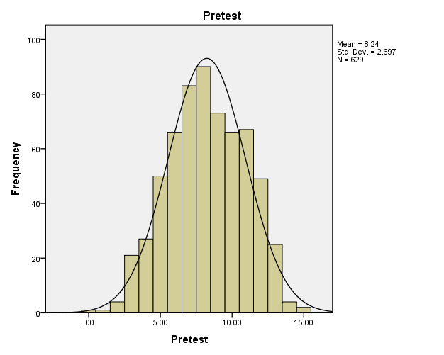 | 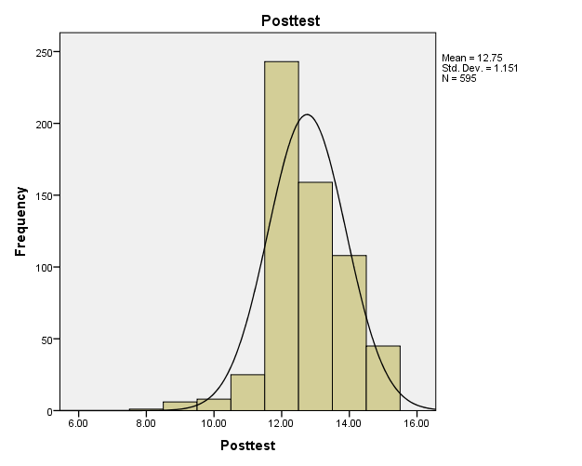

Assumptions of the Linear regression analysis
Number of assumptions | Answers to the assumptions
Assumption #1: dependent variable should be measured at the continuous level | The dependent variables overall confidence and difference between pre- and post-training performance are continuous variables
Assumption #2: independent variable should also be measured at the continuous level. | The independent variables are considered as a continuous level
 | Dependent variable: overall confidence | Dependent variable: difference between pre and post
Assumption #3: There needs to be a linear relationship between the dependent variable and independent variables.
   |  | Overall_confidence
  Standardized Predicted Value DV overall confidence | Pearson Correlation |  | .531**
  Standardized Predicted Value DV overall confidence | Sig. (2-tailed) |  | .000
  Standardized Predicted Value DV overall confidence | N |  | 339
   |  | Diff_pre_post
  Standardized Predicted Value DV diff pre post | Pearson Correlation | .294**
  Standardized Predicted Value DV diff pre post | Sig. (2-tailed) | .000
  Standardized Predicted Value DV diff pre post | N | 334
Assumption #4: There should be no significant outliers. An outlier is an observed data point that has a dependent variable value that is very different to the value predicted by the regression equation | 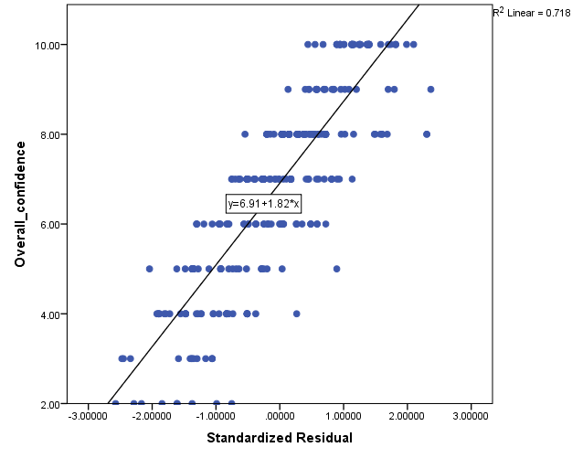 | 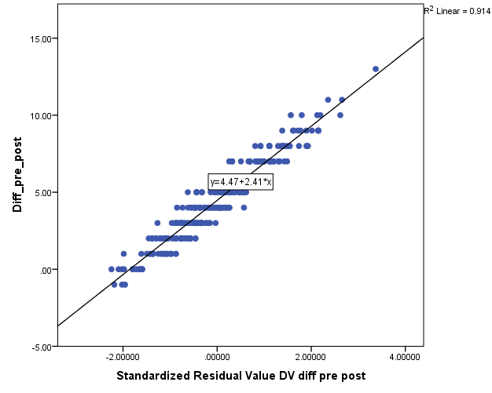
Assumption #5: There should be independence of observations, which can be checked using the Durbin-Watson statistic.  The Durbin-Watson value should be between 1.5 to 2.5 (not consider autocorrelation)
  Model Summary^{b}
  Model | R | R Square | Adjusted R Square | Std. Error of the Estimate | Durbin-Watson
  1 | .531ª | .282 | .244 | 1.82228 | 1.566
  Model Summary^{b}
  Model | R | R Square | Adjusted R Square | Std. Error of the Estimate | Durbin-Watson
  1 | .300ª | .090 | .039 | 2.38689 | 1.827
Assumption #6: Data needs to show homoscedasticity, which is where the variances along the line of best fit remain similar as you move along the line. | 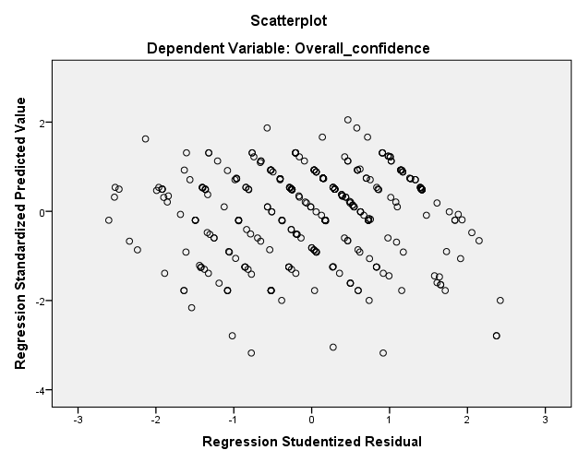 | 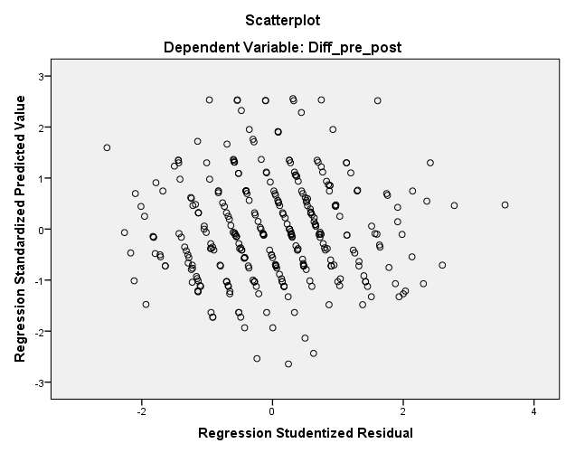
Assumption #7: Finally, check that the residuals (errors) of the regression line are approximately normally distributed | 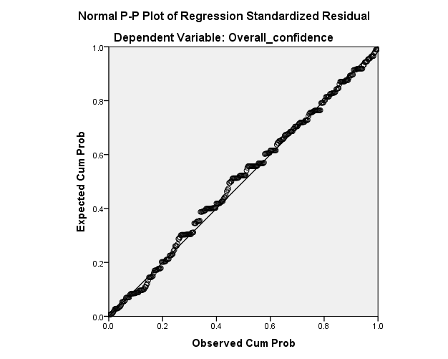 | 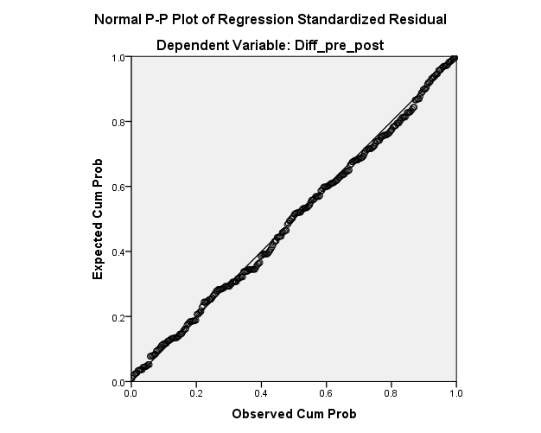

Assumptions of the Linear Mixed Model
Number of assumptions | Answers to the assumptions | Results
Assumption #1: The dependent variable is normally distributed | 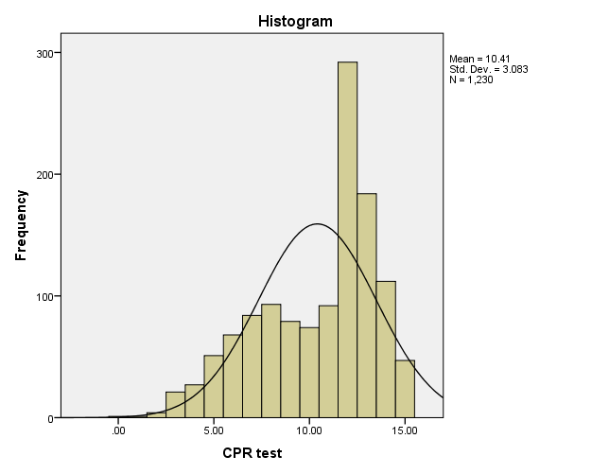
  Statistics
  trans1
  N | Valid | 1230
  N | Missing | 34
  Skewness |  | -.688
  Std. Error of Skewness |  | .070
  Kurtosis |  | -.450
  Std. Error of Kurtosis |  | .139
Assumption #2: The relationship between the dependent variable and independent variables is linear | 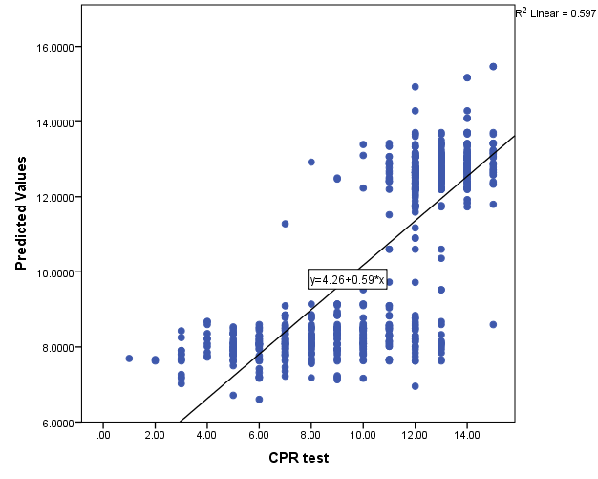
   |  | CPR test
  Predicted Values | Pearson Correlation | .773**
  Predicted Values | Sig. (2-tailed) | .000
  Predicted Values | N | 743
Assumption #3: The random effects are normally distributed. | 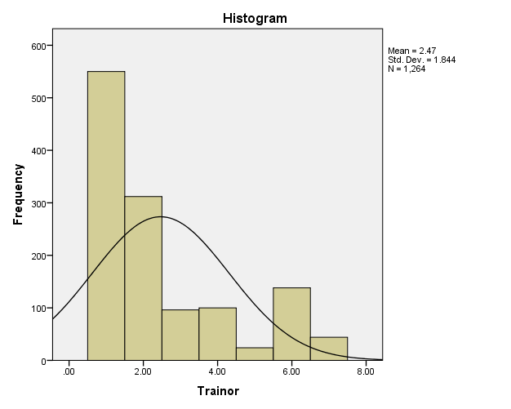
  Statistics
  Trainor
  N | Valid | 1264
  N | Missing | 0
  Skewness |  | 1.162
  Std. Error of Skewness |  | .069
  Kurtosis |  | .034
  Std. Error of Kurtosis |  | .138
Assumption #4: The model does not exhibit multicollinearity among fixed effects
  Model |  | Collinearity Statistics
   |  | Tolerance | VIF
  1 | (Constant)
  1 | Pre – Post time | 1.000 | 1.000
  1 | Trainor | .966 | 1.035
  1 | Gender | .940 | 1.064
  1 | Position_code_cat | .919 | 1.089
  1 | Department_code_cat | .948 | 1.054
  1 | Level of confidence | .914 | 1.094
  1 | Did you receive a CPR training | .894 | 1.118

