Enhanced Hydrogen Generation from NaBH₄ Hydrolysis over Green-Synthesized Co₃O₄ Catalysts through Control of Parsley Ratio and Calcination Temperature
Simon W. Samouel¹, Hatem A. Mahmoud ^{1,*}, Bahaa M. Abu-Zied ², Tarek T. Ali ¹
¹Chemistry Department, Sohag University, 82524 Sohag, Egypt
²Chemistry Department, Assiut University, 71516 Assiut, Egypt
Corresponding author: Hatem A. Mahmoud
Email address: hatem.elnakeeb@science.sohag.edu.eg

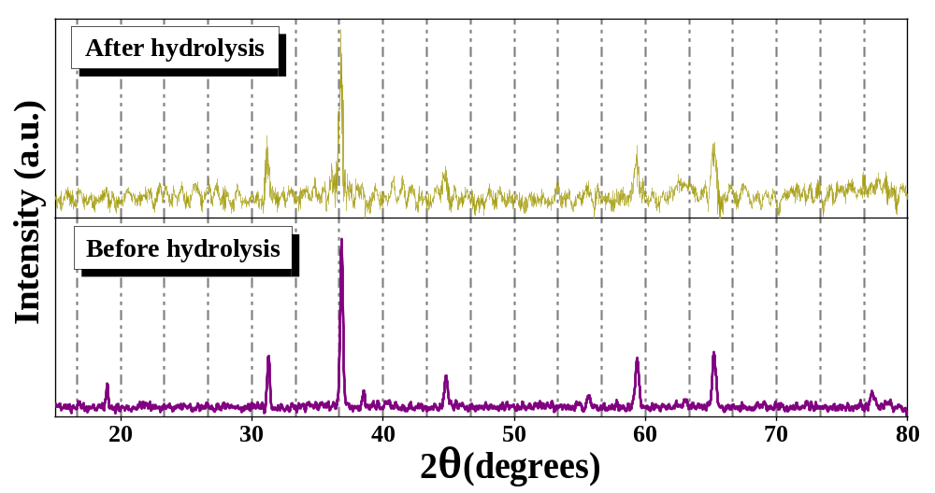
Fig. S1. X-ray diffraction patterns of PWB600 before and after hydrolysis of NaBH₄.
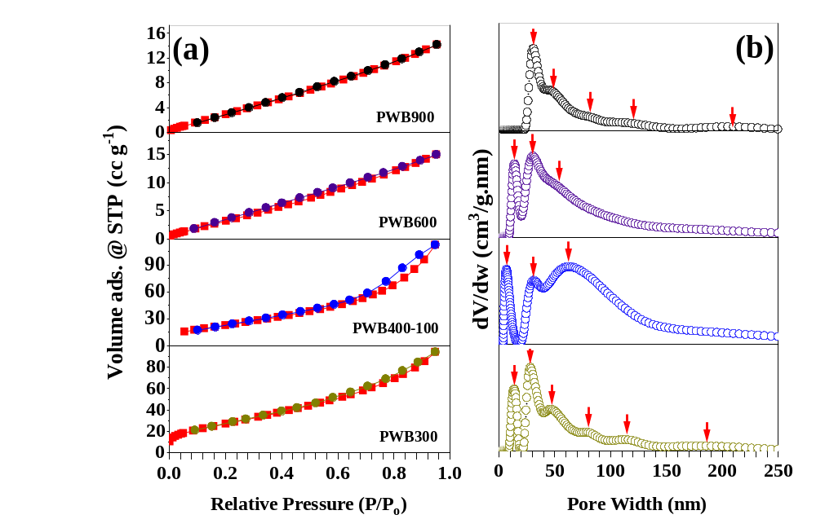
Fig. S2. N₂ adsorption isotherms (a) and distribution particle sizes (b) for green-synthesized catalysts.
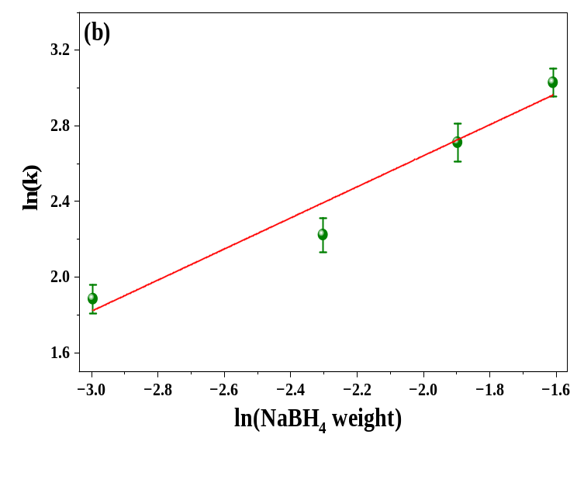
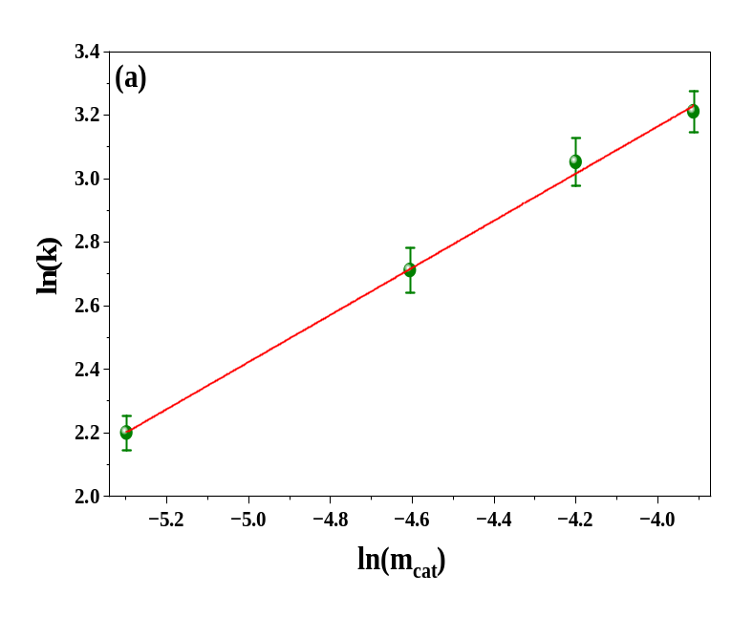
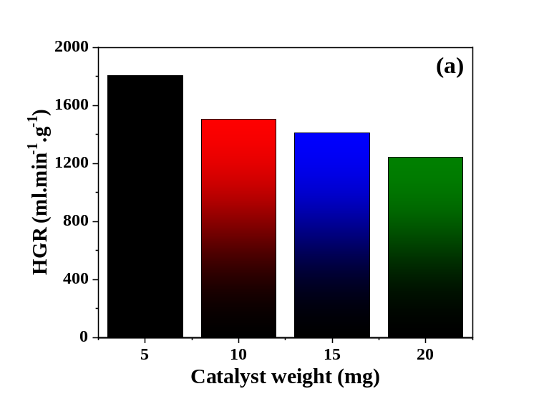
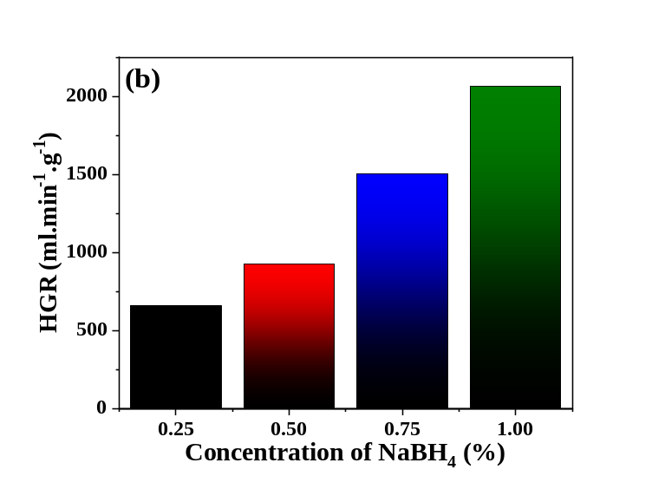
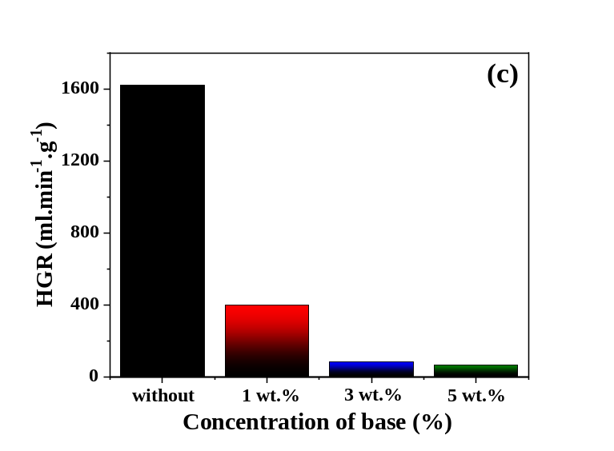
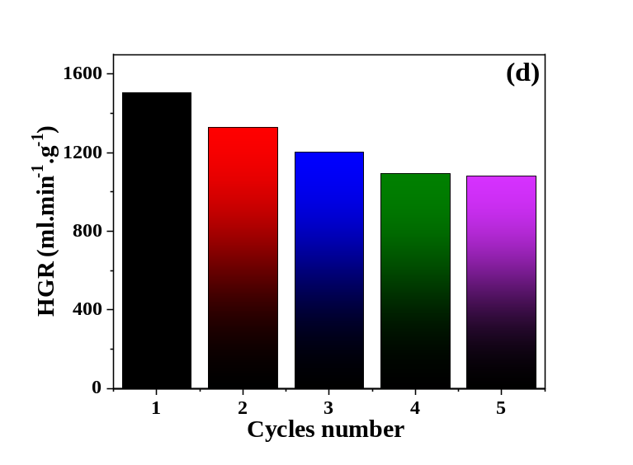
Fig. S3. HGR values versus different parameters effect during NaBH₄ hydrolysis over Co₃O₄ NPs: catalyst weight (a), concentration of NaBH₄ (b), concentration of base (c), and cycles number (d).
Fig. S4. The linear relationship plots of PWB400-100 between ln (k) and ln (m_{cat}) (a) and ln (k) and ln (NaBH₄ weight) (b).
Table S1. XPS binding energy and atomic percentage of Co2p, O1s, and C1s for the prepared catalysts PWB400-15, PWB400-100, and PWB400-150.
Catalyst | PWB400-15 |  | PWB400-100 |  | PWB400-150
Catalyst | BE (eV) | Atomic (%) | BE (eV) | Atomic (%) | BE (eV) | Atomic (%)
Co³⁺ (2p_{3/2})  (2p_{1/2}) | 779.95  794.93 | 22.22  7.44 | 781.38  796.62 | 29.79  13.37 | 780.88  796.14 | 30.78  14.8
Co²⁺ (2p_{3/2})  (2p_{1/2}) | 781.45  796.53 | 32.35  16.63 | 783.31  798.73 | 27.82  10.53 | 782.95  798.46 | 24.07  9.39
Ratio of Co²⁺/Co³⁺ (2p_{3/2}) | 1.46 |  | 0.93 |  | 0.78
O 1s (lattice oxygen) | 529.92 | 35.61 | 531.01 | 32.78 | 530.68 | 52.34
O 1s (oxygen defect) | 531.19 | 64.39 | 532.46 | 59.82 | 532.36 | 47.66
O 1s (surface oxygen (H₂O)) | ------- | ------- | 534.37 | 7.39 | ------- | -------
Ratio of O_{lattice} / O_{defect} | 0.553 |  | 0.548 |  | 1.098
C 1s (C-C/C-H) | 284.57 | 50.73 | 285.63 | 56.89 | 284.82 | 38.19
C 1s (C-O/C=O) | 286.1 | 32.08 | 287.36 | 30.73 | 286.18 | 39.05
C 1s (O-C=O) | 288.38 | 17.18 | 289.92 | 12.39 | 288.75 | 22.76

Table S2. XPS binding energy and atomic percentage of Co2p, O1s, and C1s for the pre-treatment catalysts PWB300, PWB600, and PWB900.
Catalyst | PWB300 |  | PWB600 |  | PWB900
Catalyst | BE (eV) | Atomic (%) | BE (eV) | Atomic (%) | BE (eV) | Atomic (%)
Co³⁺ (2p_{3/2})  (2p_{1/2}) | 780.29  795.37 | 23.93  9.01 | 780.14  795.17 | 16.14  6.36 | 779.74  794.91 | 11.44  5.11
Co²⁺ (2p_{3/2})  (2p_{1/2}) | 781.85  797.08 | 31.18  14.71 | 781.55  797.04 | 39.05  16.76 | 781.05  796.83 | 39  17.33
Ratio of Co²⁺/Co³⁺ (2p_{3/2}) | 1.3 |  | 2.42 |  | 3.41
O 1s (lattice oxygen) | 530.25 | 35.2 | 530.34 | 39.76 | 530.2 | 37.33
O 1s (oxygen defect) | 531.55 | 64.8 | 531.7 | 60.24 | 531.74 | 62.67
Ratio of O_{lattice} / O_{defect} | 0.54 |  | 0.66 |  | 0.60
C 1s (C-C/C-H) | 284.86 | 50.87 | 284.81 | 74.41 | 284.83 | 64.12
C 1s (C-O/C=O) | 286.35 | 26.13 | 286.25 | 12.4 | 286.18 | 29.16
C 1s (O-C=O) | 288.23 | 22.99 | 287.72 | 13.19 | 288.64 | 6.71

