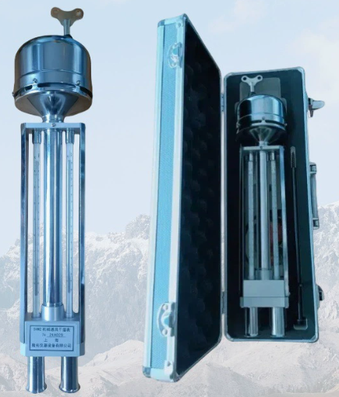 | 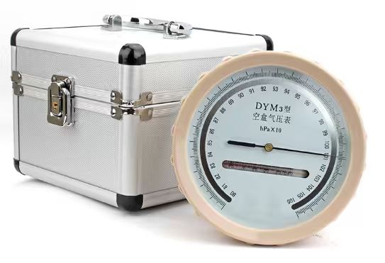
Figure S1 Assmann ventilated psychrometer | Figure S2 DYM aneroid barometer
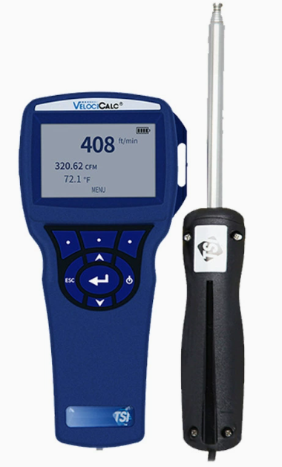 | 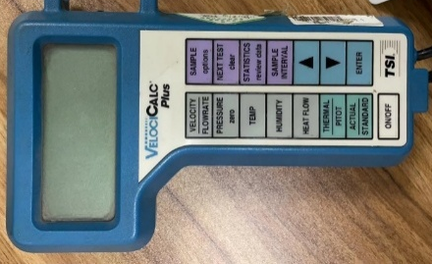
Figure S3 TSI-8386 hot-wire anemometer | Figure S4 Micromanometer

