Supplementary information
for
Plasma Membrane Vesicles Preserve Cell Type Specific Physicochemical Signatures
Katarzyna Pogoda^{1*}, Karolina Chrabąszcz¹, Piotr Deptuła², Robert Bucki^{2,3}, Natalia Piergies¹

1. Institute of Nuclear Physics, Polish Academy of Sciences, Radzikowskiego 152, 31-342 Krakow, Poland
2. Independent Laboratory of Nanomedicine, Medical University of Bialystok, 15-222 Białystok, Poland
3. Department of Medical Microbiology and Nanobiomedical Engineering, Medical University of Bialystok, 15-222 Białystok, Poland

*corresponding author: katarzyna.pogoda@ifj.edu.pl

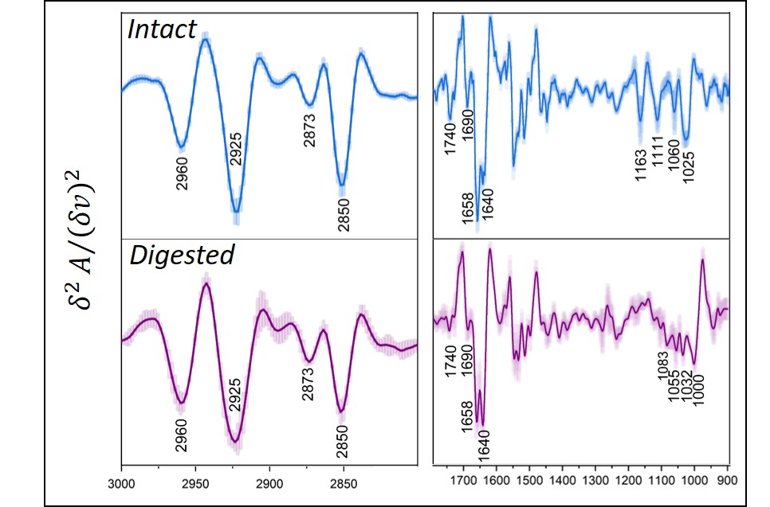
Figure S1. Second derivative FT-IR spectra of GPMVs isolated from intact (blue) and glycocalyx-digested (purple) LN229 cells. Digestion was performed using chondroitinase ABC and hyaluronidase. Alterations in the spectral features associated with carbohydrate region (~1200–1000 cm⁻¹), confirming the contribution of glycosylated surface structures to the GPMV spectral profile can be observed. Shaded areas represent standard deviation.

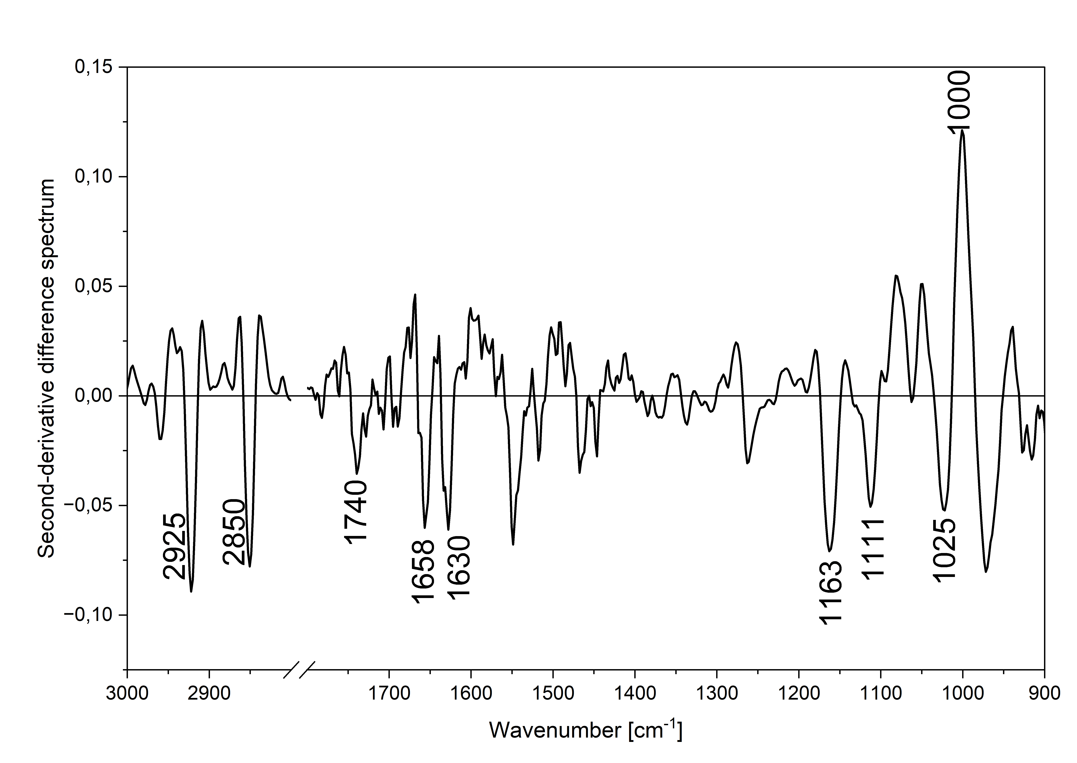
Figure S2. Difference second-derivative FT-IR spectrum calculated as “Non-digested” – “Digested” following partial glycocalyx digestion with chondroitinase ABC and hyaluronidase. The spectrum emphasizes spectral differences induced by glycocalyx digestion, particularly within the carbohydrate-associated region (1200–950 cm⁻¹).

Table S1. Pearson correlation coefficients between the average FT-IR spectra of each cell line and its corresponding GPMVs. Correlations were calculated using the lipid- and protein-dominated spectral regions (1360–1800 and 2850–3050 cm⁻¹) and after inclusion of the carbohydrate-rich spectral region (1000–1360 cm⁻¹). Lower correlation coefficients obtained after inclusion of the carbohydrate-rich spectral region indicate that carbohydrate-associated spectral features contribute substantially to the spectral differences between intact cells and their corresponding GPMVs. All correlations were statistically significant (p < 0.0001).
Cell line | Pearson's r
Cell line | Spectral range | Spectral range
Cell line | 1360–1800 + 2850–3050 cm⁻¹ | 1000–1800 + 2850–3050 cm⁻¹
HMC3 | 0.94854 | 0.82386
LN18 | 0.96845 | 0.84245
LN229 | 0.96401 | 0.92301
A172 | 0,95031 | 0.83998
T98G | 0.97950 | 0.86527

