Supplementary Material

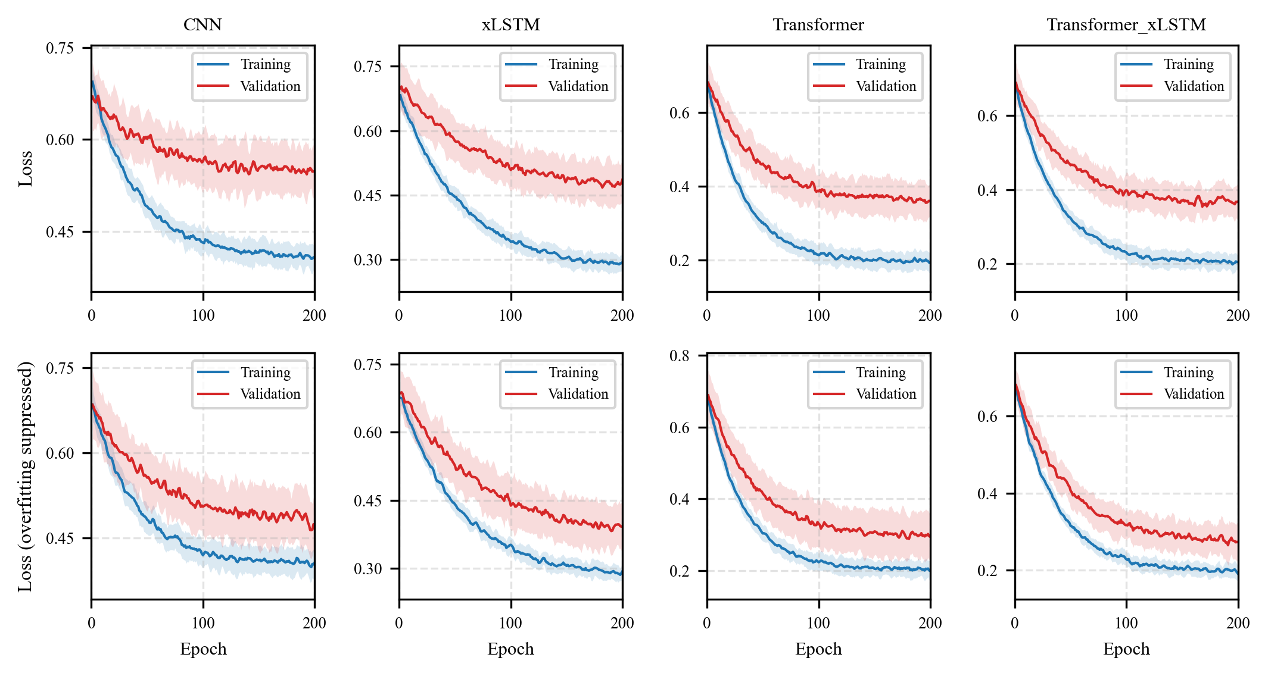
Figure S1. Training and validation cross-entropy losses across 200 training epochs for the four deep-learning models (mean ± SD across 15 repeated runs). Top row: regularization-ablated configuration without weight decay or label smoothing; bottom row: regularized configuration with weight decay (1 × 10⁻²) and label smoothing (0.1).

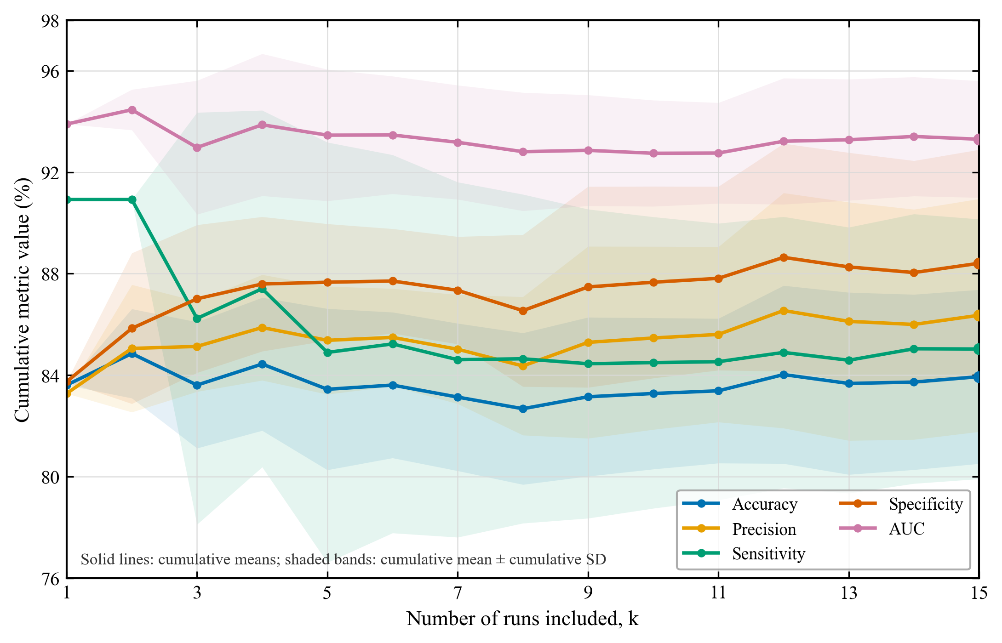
Figure S2. Run-count stability of the Transformer-based cross-attention model under model-level fusion across 15 independent runs. (a) Cumulative mean and (b) cumulative sample standard deviation (SD) of accuracy, precision, sensitivity, specificity, and AUC as a function of the number of included runs (k = 1, …, 15). All metrics are expressed as percentages; because a sample SD is undefined for one observation, the SD curves begin at k = 2. By k = 15, the cumulative means were 83.94%, 86.36%, 85.03%, 88.41%, and 0.933 respectively.

