Metagenomic Insights into Viral Community Restructuring and Microbial Interactions in Waste Stabilization Ponds

Neveen M. Rizk¹, Mohamed A. Marouf², Nehal Ismail Ahmed¹, Mona H. El-Gayar³, Marwa A. Kamel¹, Mohamad A. El-Khateeb², Rehab Sedhom², Esmat M. S. Elfeky⁴, Mohamed Azab El-Liethy⁵, Mahmoud Gad¹*

¹Environmental Virology Laboratory, Water Pollution Research Department, Environment and Climate Change Research Institute, National Research Centre, Giza, 12622, Egypt
²Water Pollution Research Department, National Research Centre, Giza 12622, Egypt
³Department of Microbiology and Immunology, Faculty of Pharmacy, Ain Shams University, Organization of African Unity Street, Cairo, 11566, Egypt
⁴Holding Company for Water and Wastewater (HCWW), Cairo, Egypt
⁵Environmental Microbiology Laboratory, Water Pollution Research Department, National Research Centre, Giza 12622, Egypt
*Correspondence: Mahmoud Gad; email: mahmoudafw@gmail.com & mi.saleh@nrc.sci.eg; Tel: +201061132911

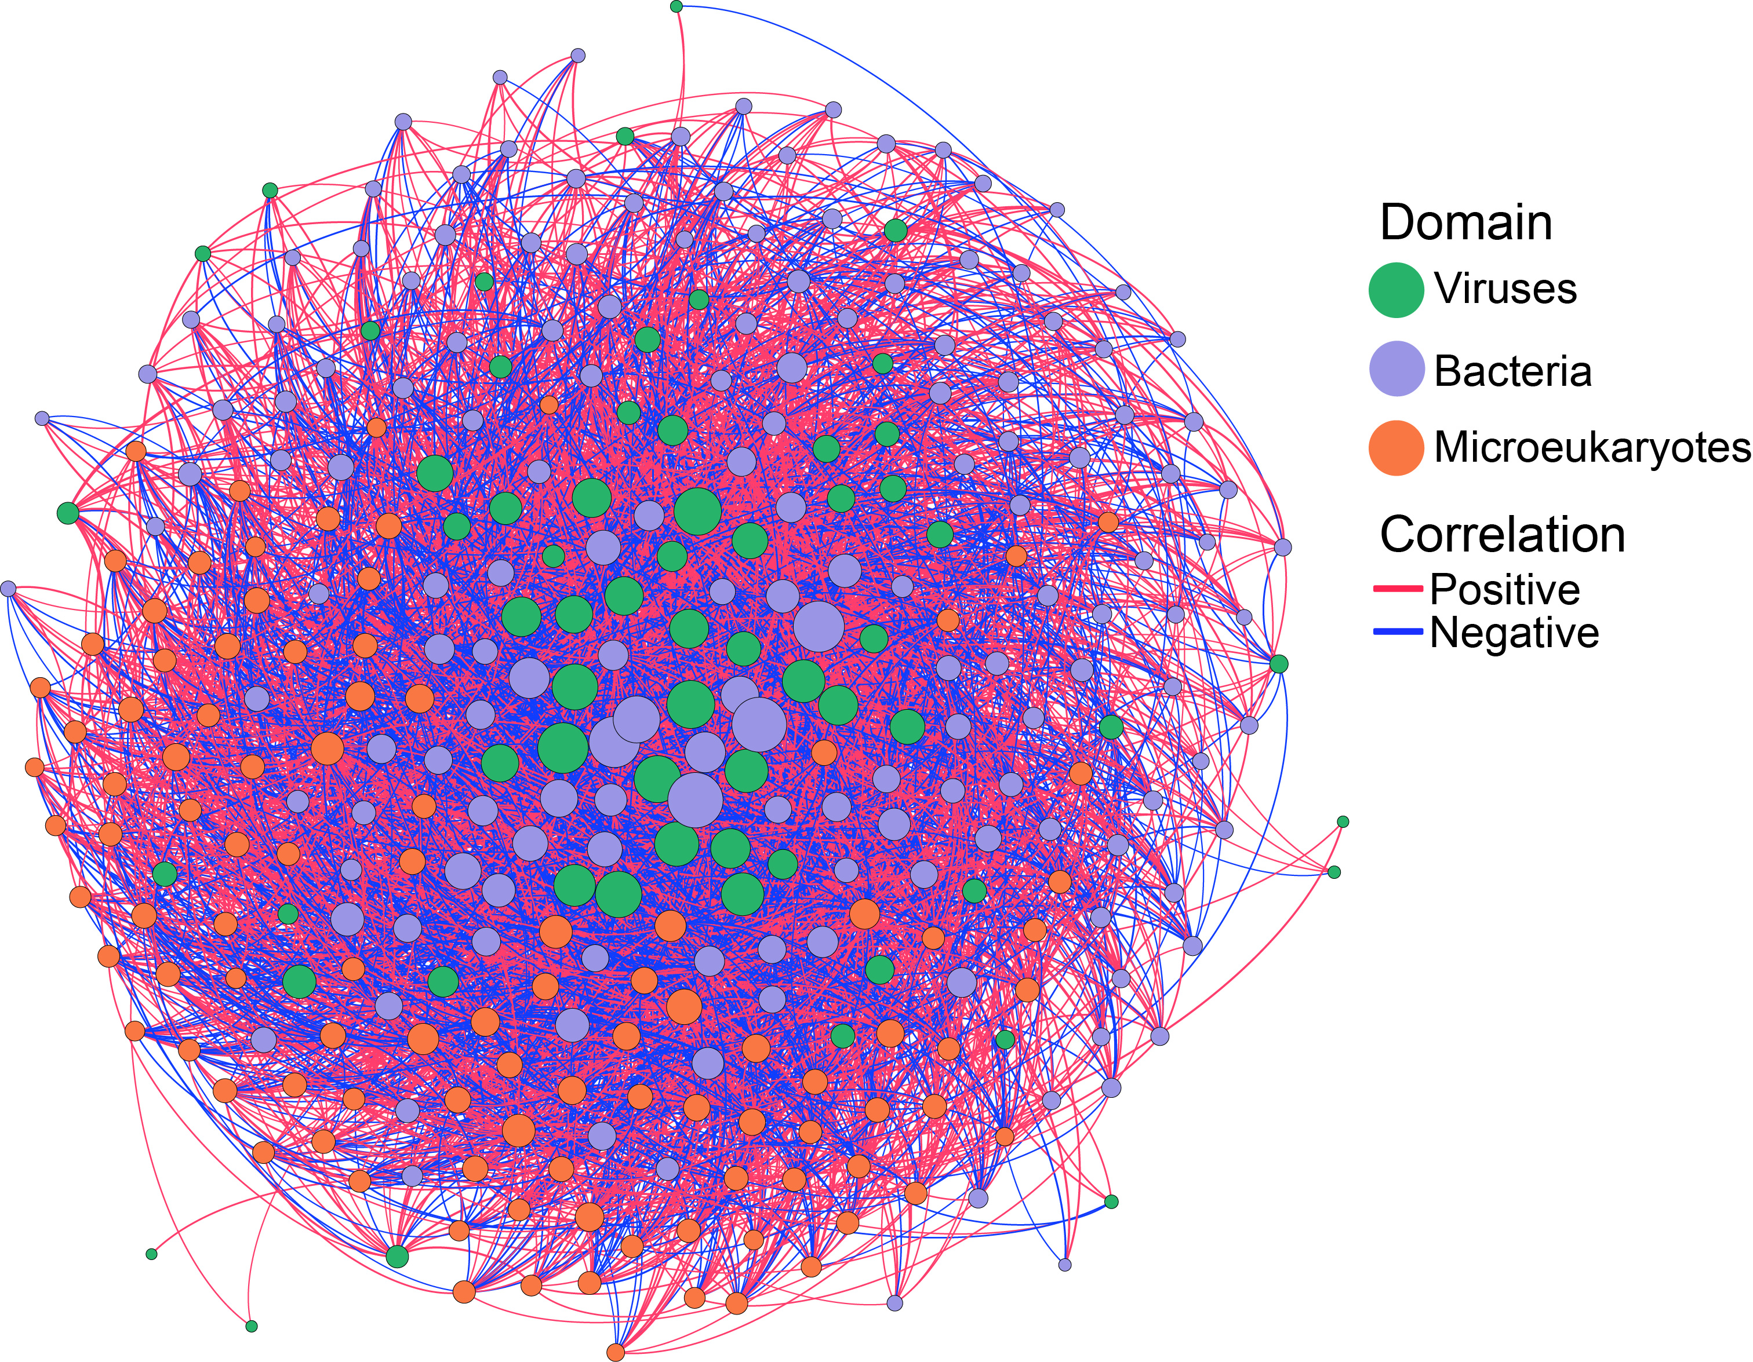
Figure S1. Cross-domain microbial association network in the waste stabilization pond (WSP) system inferred using a compositional data-aware SPIEC-EASI framework. Nodes represent taxa from viruses, bacteria, and microeukaryotes, shown in green, purple, and orange, respectively. Node size is proportional to node degree, indicating the number of statistically inferred associations connected to each taxon. Edges represent SPIEC-EASI-inferred conditional associations among microbial taxa, with red edges indicating positive associations and blue edges indicating negative associations

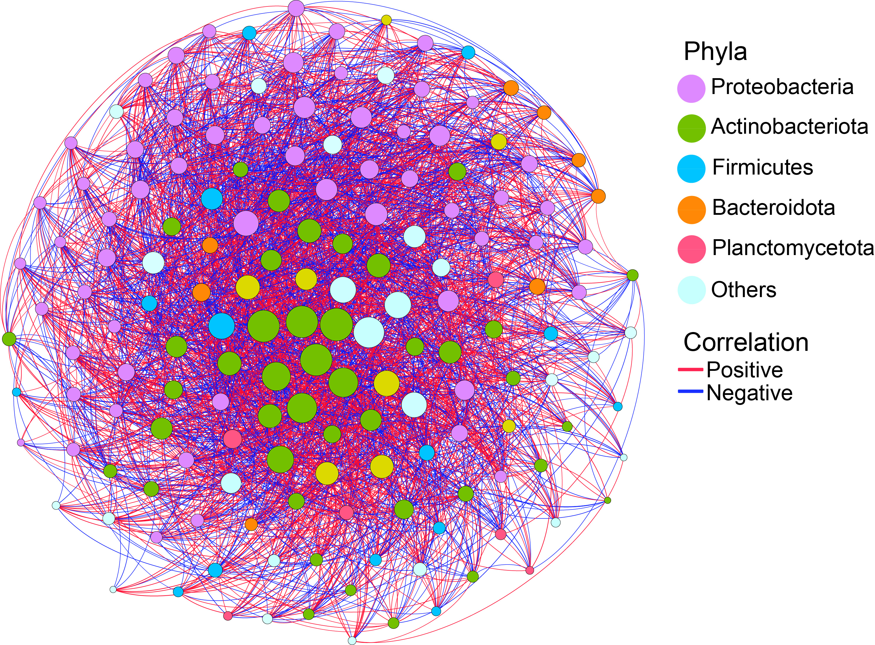
Figure S2. Bacteria association network in the waste stabilization pond (WSP) system inferred using a compositional data analysis (CoDA) framework based on the SPIEC-EASI workflow. Nodes represent bacterial taxa, with node size proportional to node degree, indicating the number of statistically inferred associations connected to each taxon. Node colors indicate major bacterial taxonomic groups. Edges represent SPIEC-EASI-inferred conditional associations among viral taxa, with red edges indicating positive associations and blue edges indicating negative associations. Others represent less contributed and unclassified taxa.

