Supplementary Information
Microbial Strains Isolation
Discarded waste PCB samples were collected from a local electronic waste recycling facility and transported to the laboratory under sterile conditions. To preserve the indigenous microbial population associated with the PCB surfaces, no thermal or chemical pretreatment was applied prior to microbial isolation. The PCB samples were aseptically transferred into sterile nutrient broth and incubated under appropriate culture conditions to enrich the associated bacterial community. Serial dilutions of the enrichment culture were spread on nutrient agar plates, and morphologically distinct colonies were isolated by repeated streaking to obtain pure cultures. Fig. S1 describe step by step isolation process of bacterial strains.
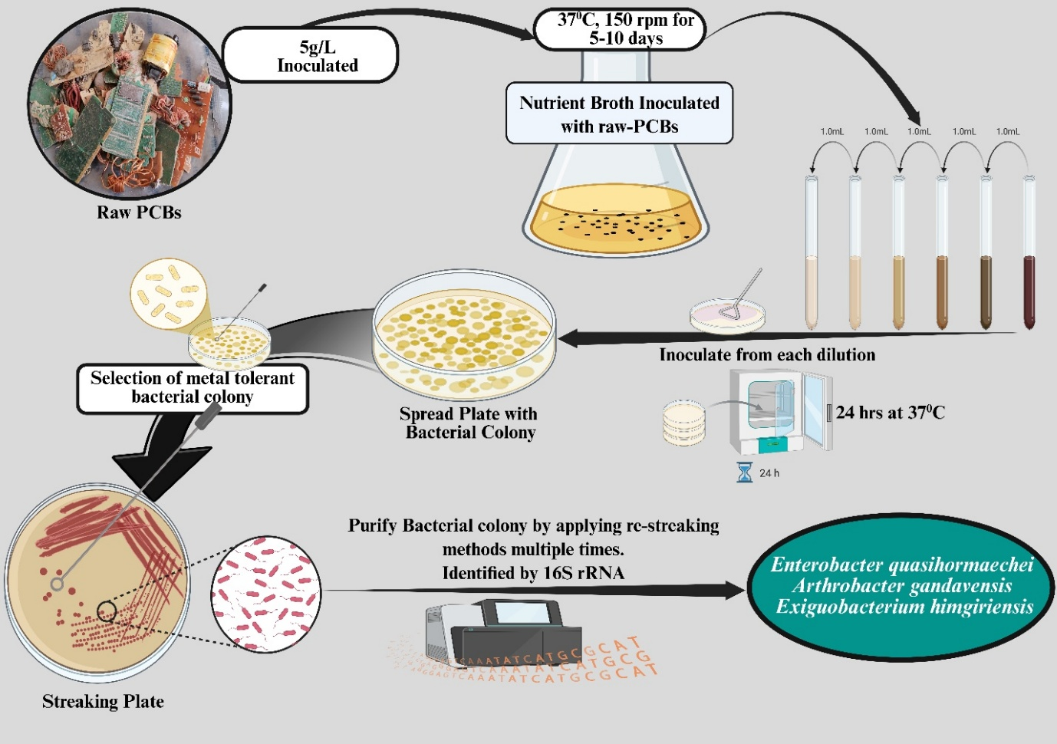
Fig.S1: Step-by-step bacterial strains isolation process from raw-PCB
Supplementary Table S1. Initial elemental composition of untreated waste printed circuit board (PCB) feedstock determined by ICP-OES prior to bioleaching (n = 3).
Target Metal | Sample 1 | Sample 2 | Sample 3 | Mean | SD
Copper (Cu) | 288.41 | 290.98 | 293.79 | 291.06 | 2.690892045
Silver (Ag) | 1.66 | 1.71 | 1.73 | 1.7 | 0.036055513
Calcium (Ca) | 57.96 | 58.83 | 59.64 | 58.81 | 0.840178552
Iron (Fe) | 6.09 | 6.28 | 6.41 | 6.26 | 0.160934769
Manganese (Mn) | 4.79 | 4.95 | 5.05 | 4.93 | 0.13114877
Zinc (Zn) | 4.55 | 4.71 | 4.81 | 4.69 | 0.13114877

