Supplementary Figure 1. ROC curves for the 70/30 random split validation: training set and test set.
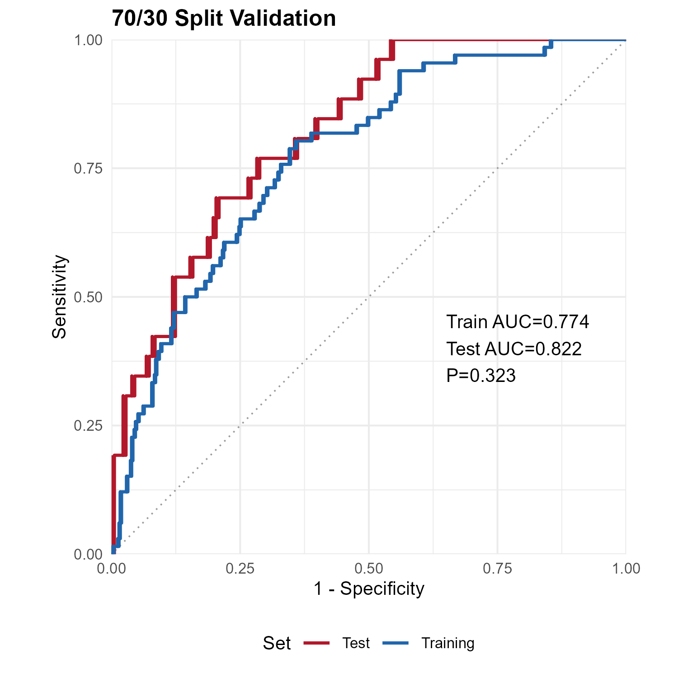

Supplementary Figure 2. Calibration curve of the CAMP Score.
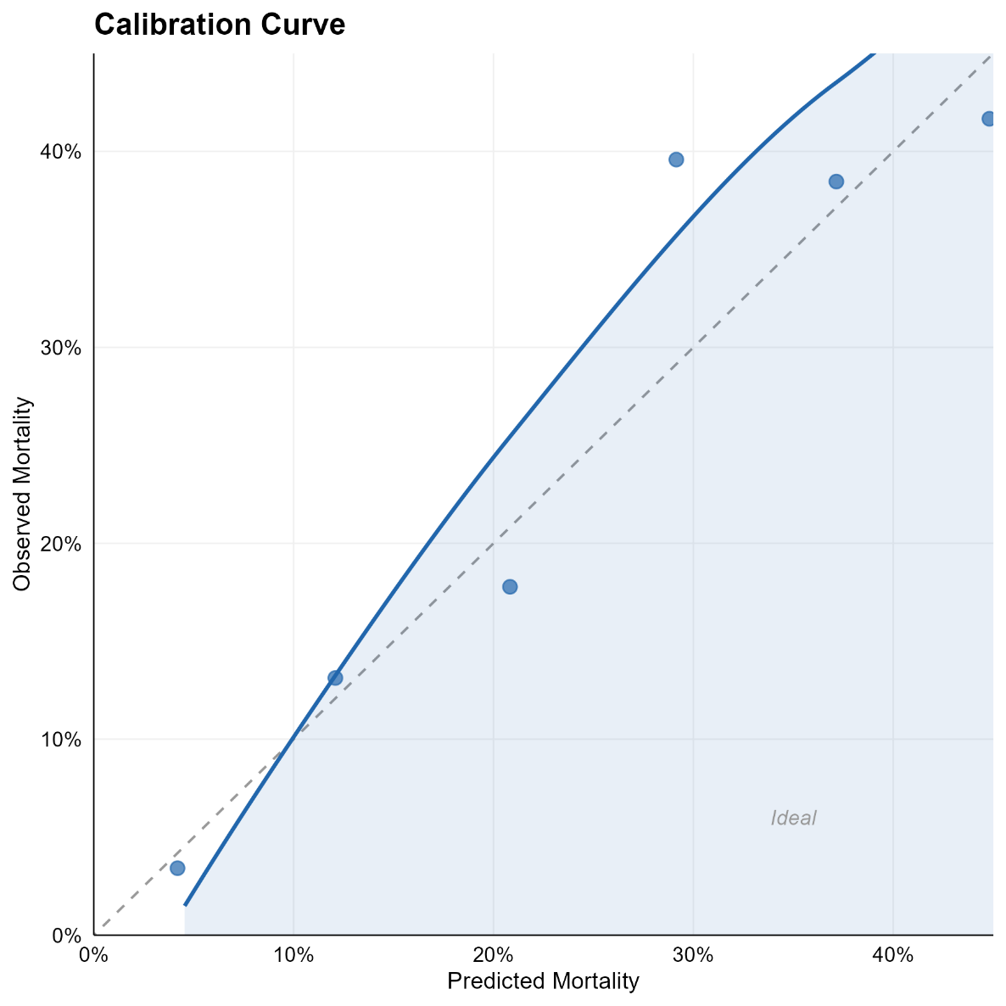

Supplementary Figure 3. Decision curve analysis.
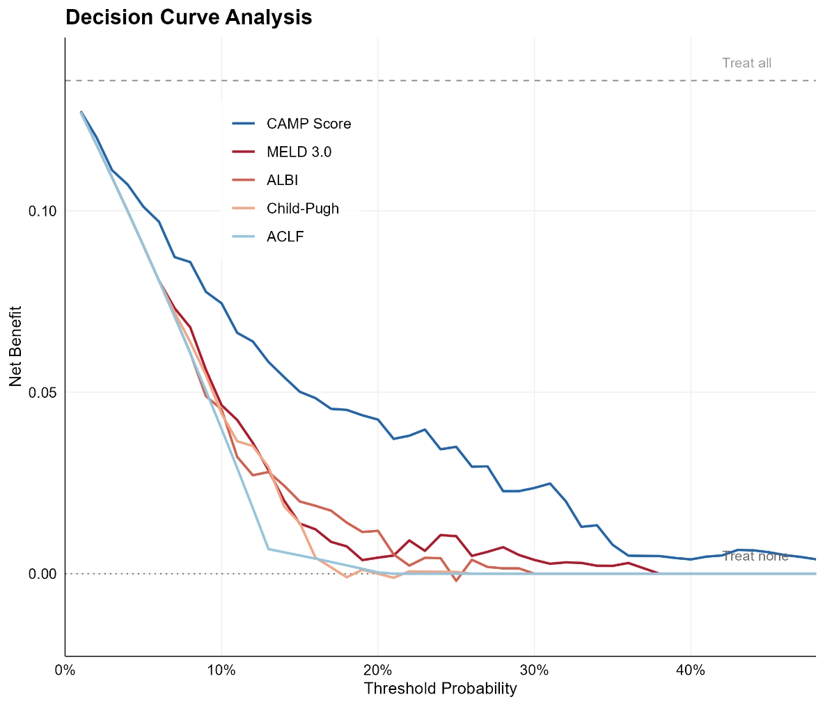

Supplementary Figure 4. Risk stratification according to the CAMP Score.
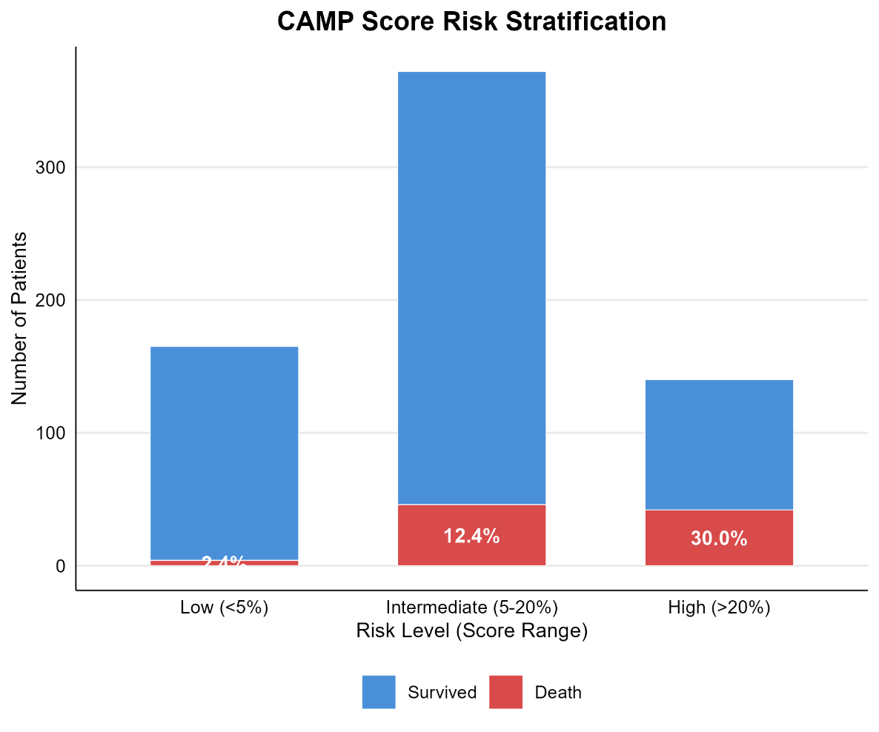

Supplementary Figure 5. Score-to-mortality relationship.
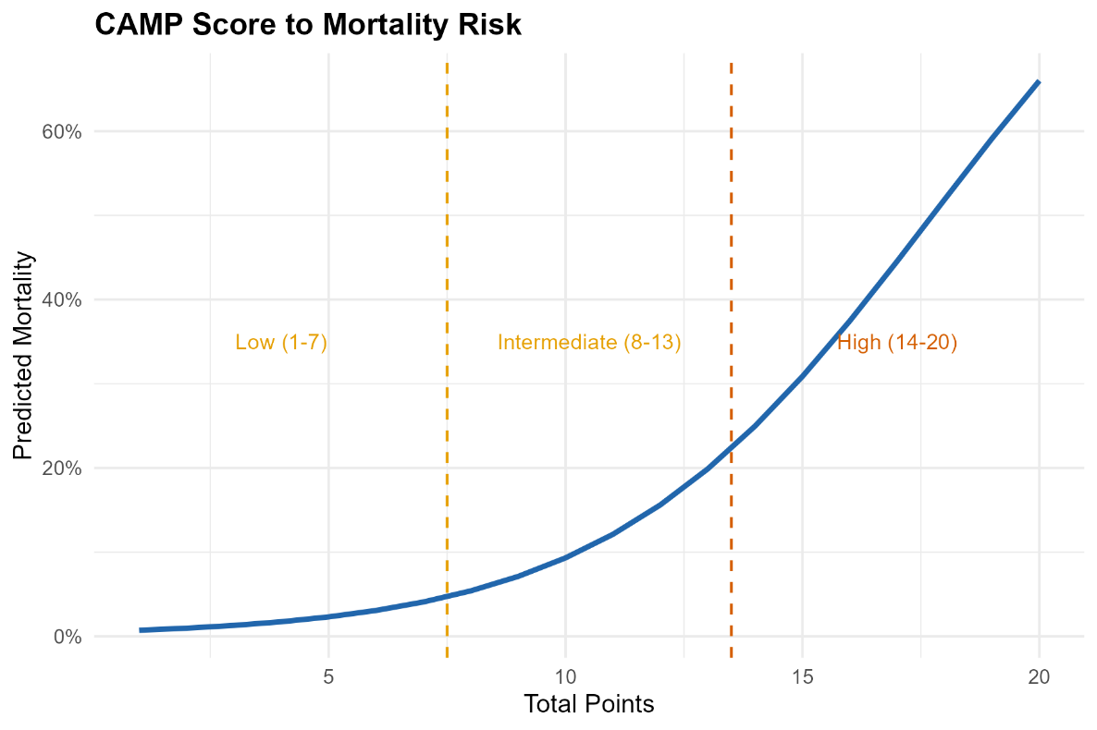

Supplementary Figure 6. Restricted cubic spline analysis. Non-linear effects of (A) albumin and (B) age on predicted in-hospital mortality. (C) Comparison of predicted probabilities from the linear versus the RCS model.
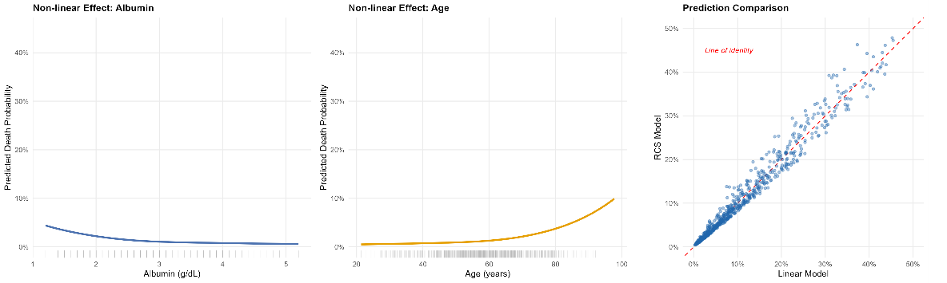

Supplementary Table 1. ICD-9-CM and ICD-10-CM Codes
Category | ICD-9-CM codes | ICD-10-CM codes
Liver cirrhosis | 5712, 5715, 5716 | K703, K7030, K7031, K717, K74, K743, K744, K745, K746, K7460, K7469, P7881
HCC | 2308 | C220,C227
Ascites | 78951, 78959 | K7011, K7031, K7151, R18
Hepatic encephalopathy | 5722 | K7291
Gastrointestinal bleeding | 53082,5310,5312,5314,5316,5320,5322,5324,5326,5330,5332,5334,5336,5340,5342,5344,5346,5350,5351,5352,5353,53541, | K226,K250,K252,K254,K256,K260,K262,K264,K266,K270,K272,K274,K276,K280,K282,K284,K286
Hepatorenal syndrome | 5724 | K767
Viral hepatitis | 070 | B15,B16,B17,B18,B19
Alcohol hepatitis | 5711 | K70
Autoimmune hepatitis | 57142 | K754
NAFLD | 5718 | K7581
CKD | 585 | N18
Diabetes | 250 | E08,E10,E11,E13
Hypertension | 401 | I10
Malnutrition (protein-calorie) | 260-263.9 | E40-E46
Severe malnutrition | 262 | E43
Unspecified malnutrition | 263.9 | E46
Sepsis / bacteremia | 038, 78550, 78551, 78552, 78559, 7907, 7908, 99591, 99592 | A40, A41, A49, R652
Pneumonia | 480, 481, 482, 483, 484, 485, 486, 4870, 4871, 4878, 488 | J09, J10, J11, J12, J13, J14, J15, J16, J17, J18
Urinary tract infection | 590, 5990, 5997 | N10, N11, N12, N136, N151, N300, N39, N390
Peritonitis / SBP | 5672, 5678, 5679 | K65
Skin / soft tissue infection | 680, 681, 682, 683, 684, 685, 686 | L00, L01, L02, L03, L04, L05, L08
Endocarditis / myocarditis | 421, 4220, 42490, 42491, 42499 | I30, I32, I33, I38, I39, I40, I41
Central nervous system infection | 320, 321, 322, 323, 324, 325, 326 | G00, G01, G02, G03, G04, G05, G06, G07, G08, G09
Osteomyelitis / septic arthritis | 711, 730 | M00, M01, M02, M86
Clostridioides difficile | 00845, 00846, 00847, 00849 | A047
Candidiasis / fungal | 112, 116, 117 | B35, B36, B37, B38, B39, B40, B41, B42, B43, B44, B45, B46, B47, B48, B49
Herpes / varicella | 052, 053, 054, 055, 056, 057, 058, 059 | B00, B01, B02, B05, B06, B08, B09
HIV / AIDS | 042, 043, 044 | B20, B21, B22, B23, B24
Tuberculosis | 010, 011, 012, 013, 014, 015, 016, 017, 018 | A15, A16, A17, A18, A19
Syphilis | 090, 091, 092, 093, 094, 095, 096, 097 | A50, A51, A52, A53
Empyema / lung abscess | 510, 5111, 513, 5186 | J85, J86
Infectious pathogen codes | 041 | B95, B96, B97
Other bacterial / viral infections | 006, 007, 034, 035, 036, 037, 039, 040, 045, 046, 047, 048, 049, 0490, 079, 101, 102, 103, 104, 105, 106, 107, 108, 109, 110, 111, 114, 115, 118, 130, 131, 132, 133, 134, 135, 136, 460, 461, 462, 463, 464, 465, 466, 472, 473, 474, 475, 476, 522, 523, 524, 525, 526, 527, 540, 541, 542, 5621, 566, 5695, 5696, 5750, 5761, 5770, 5771, 580, 581, 582, 583, 595, 597, 598, 601, 604, 6071, 6080, 614, 615, 616, 771, 9966, 9967, 9976, 9985, 9986, 9993 | A00, A01, A02, A03, A04, A047, A05, A06, A07, A08, A09, A20, A21, A22, A23, A24, A25, A26, A27, A28, A30, A31, A32, A36, A38, A39, A42, A43, A44, A46, A48, A54, A55, A56, A57, A58, A59, A60, A63, A64, A65, A66, A67, A68, A69, A70, A71, A74, A75, A77, A78, A79, B50, B51, B52, B53, B54, B55, B56, B57, B58, B59, B60, B64, B65, B66, B67, B68, B69, B70, B71, B72, B73, B74, B75, B76, B77, B78, B79, B80, B81, B82, B83, H10, H160, H161, H162, H163, H164, H170, H180, H190, H200, H440, H601, H660, H661, H662, H663, H664, H670, H671, H680, H700, H701, H702, H703, H704, H710, H711, H720, H721, H722, H723, H724, H730, H731, H732, H733, H734, H738, H739, H740, H741, H742, H743, H744, H748, H749, H750, J010, J011, J012, J013, J014, J015, J016, J017, J018, J019, J320, J322, J325, J329, J340, J36, J37, J380, J390, J391, J398, K110, K112, K113, K114, K120, K122, K130, K230, K250, K251, K252, K253, K254, K255, K256, K257, K258, K259, K35, K36, K37, K38, K39, K57, K61, K630, M60, M65, M68, M711, M726, N30, N300, N31, N340, N341, N342, N343, N344, N41, N42, N431, N432, N45, N490, N491, N492, N493, N494, N495, N496, N497, N498, N499, N70, N71, N72, N73, N74, N75, N76, P36, P37, P38, P39, T802, T814, T82, T83, T84, T85, T86, T87
ACLF | – | K720, K7200, K7201
SBP | 56723 | K652

Supplementary Table 2. Univariable logistic regression analysis of predictors for in-hospital mortality
Variable | OR (95%CI) | P
Age (per year) | 1.01 (1.00–1.03) | 0.0966
Viral hepatitis | 0.66 (0.34–1.19) | 0.1866
Alcohol-related hepatitis | 1.61 (1.02–2.57) | 0.0427
Chronic kidney disease | 1.99 (1.17–3.31) | 0.0090
Ascites | 1.51 (0.92–2.56) | 0.1148
Hepatorenal syndrome | 3.63 (2.20–5.91) | <0.001
Liver failure | 2.09 (1.34–3.26) | 0.0012
WBC (×10⁹/L) | 1.02 (1.00–1.04) | 0.0196
Total bilirubin (mg/dL) | 1.04 (1.02–1.06) | <0.001
Albumin (g/dL) | 0.75 (0.53–1.05) | 0.0966
Creatinine (mg/dL) | 1.23 (1.09–1.38) | <0.001
INR | 1.70 (1.31–2.21) | <0.001
Potassium (mmol/L) | 1.23 (0.96–1.56) | 0.0872
Infection | 3.94 (2.14–7.99) | <0.001
SBP | 1.66 (0.85–3.05) | 0.1144
Mechanical ventilation | 2.59 (1.24–5.12) | 0.0080
Hemodialysis | 3.62 (1.42–8.60) | 0.0045
BMI (kg/m²) | 1.03 (1.00–1.06) | 0.0185
Emergency admission | 2.64 (1.55–4.73) | <0.001
Abbreviations: SBP, spontaneous bacterial peritonitis; WBC, white blood cell; INR, international normalized ratio.

Supplementary Table 3. Subgroup analysis.
Subgroup | Level | N | Events | AUC
Alcohol etiology | Non-alcohol | 302 | 32 | 0.781
Alcohol etiology | Alcohol | 375 | 60 | 0.804
ICU admission | ICU | 325 | 86 | 0.715
Age | <60 | 384 | 44 | 0.809
Age | ≥60 | 293 | 48 | 0.794

Supplementary Table 4. Competing risk (Fine-Gray, discharge alive as competing event)
Variable | sHR (95%CI) | P
Infection | 2.62 (1.35–5.09) | 0.0045
Hepatorenal syndrome | 2.21 (1.26–3.86) | 0.0053
Liver failure | 1.85 (1.20–2.86) | 0.0053
WBC (×10⁹/L) | 1.01 (1.00–1.02) | 0.0029
Total bilirubin (mg/dL) | 1.04 (1.02–1.06) | <0.001
Albumin (g/dL) | 0.59 (0.41–0.85) | 0.0046
Age (per year) | 1.04 (1.02–1.06) | <0.001
Emergency admission | 2.14 (1.25–3.66) | 0.0057

Supplementary Table 5. Sensitivity Analyses
Analysis | N | Events | AUC
Reference (all patients) | 677 | 92 | 0.793
S1: BMI complete cases | 306 | 66 | 0.738
S2: Exclude LOS>90d | 671 | 92 | 0.803

