Supplementary Table 1. Row Percentages of Clinical and Sociodemographic Characteristics of Close Contacts of Tuberculosis Patients and Their Association with IGRA Positivity.
Close contacts characteristics | Total  (n = 1234) | Positive IGRA  (n = 534) | OR (95%CI) | p-value
Age, years | 39.4 [29.3 - 51.5] | 41.9 [31.3 - 54.4] | 1.02 (1.01 - 1.03) | <0.001
Sex
Male | 460 (37.3%) | 182 (39.6%) | Ref. | --
Female | 774 (62.7%) | 352 (45.5%) | 1.23 (0.95 - 1.61) | 0.121
Live in slums
No | 936 (77.2%) | 360 (38.5%) | Ref. | --
Yes | 277 (22.8%) | 159 (57.4%) | 2.24 (1.61 - 3.12) | <0.001
Nonwhite
No | 256 (20.8%) | 88 (34.4%) | Ref. | --
Yes | 977 (79.2%) | 445 (45.5%) | 1.66 (1.18 - 2.34) | 0.004
Illiterate
No | 1206 (98.0%) | 517 (42.9%) | Ref. | --
Yes | 25 (2.03%) | 16 (64.0%) | 2.38 (0.92 - 6.13) | 0.072
Years in education | 11.0 [7.00 - 12.0] | 10.0 [6.00 - 12.0] | 0.93 (0.90 - 0.96) | <0.001
More than one minimum wage
No | 757 (61.6%) | 343 (45.3%) | Ref. | --
Yes | 472 (38.4%) | 189 (40.0%) | 0.86 (0.65 - 1.13) | 0.273
Number of people in residence | 3.00 [2.00 - 4.00] | 3.00 [2.00 - 4.00] | 0.98 (0.93 - 1.05) | 0.614
Health worker
No | 1138 (92.4%) | 492 (43.2%) | Ref. | --
Yes | 93 (7.55%) | 40 (43.0%) | 1.03 (0.61 - 1.75) | 0.909
Vaccinated with BCG
No | 118 (9.6%) | 57 (48.3%) | Ref. | --
Yes | 1112 (90.4%) | 474 (42.6%) | 0.66 (0.37 - 1.19) | 0.167
Smoking history
Never smoked | 791 (64.2%) | 322 (40.7%) | Ref. | --
Currently smokes | 174 (14.1%) | 91 (52.3%) | 1.68 (1.14 - 2.46) | 0.009
Stopped smoking | 268 (21.7%) | 120 (44.8%) | 1.31 (0.94 - 1.82) | 0.108
Alcohol consumption
Never consumed | 339 (27.5%) | 166 (49.0%) | Ref. | --
Currently consumes | 570 (46.2%) | 233 (40.9%) | 0.70 (0.51 - 0.97) | 0.030
Stopped consuming | 324 (26.3%) | 134 (41.4%) | 0.72 (0.50 - 1.03) | 0.072
Drug use
Never used | 1059 (85.9%) | 459 (43.3%) | Ref. | --
Currently uses | 39 (3.16%) | 18 (46.2%) | 1.13 (0.53 - 2.41) | 0.746
Stopped using | 135 (10.9%) | 56 (41.5%) | 0.97 (0.64 - 1.48) | 0.895
Cancer
No | 1223 (99.1%) | 534 (43.7%) | -- | --
Yes | 11 (0.89%) | 0 (0.00%) | -- | --
Diabetes Mellitus
No | 1147 (92.9%) | 489 (42.6%) | Ref. | --
Yes | 87 (7.05%) | 45 (51.7%) | 1.49 (0.90 - 2.48) | 0.12
COPD
No | 1226 (99.4%) | 528 (43.1%) | Ref. | --
Yes | 8 (0.65%) | 6 (75.0%) | 3.99 (0.65 - 24.42) | 0.134
Kidney disease
No | 1233 (99.9%) | 533 (43.2%) | -- | --
Yes | 1 (0.08%) | 1 (100%) | -- | --
Arterial Hypertension
No | 1028 (83.3%) | 427 (41.5%) | Ref. | --
Yes | 206 (16.7%) | 107 (51.9%) | 1.60 (1.12 - 2.27) | 0.009
Others
No | 1098 (89.0%) | 481 (43.8%) | Ref. | --
Yes | 136 (11.0%) | 53 (39.0%) | 0.76 (0.50 - 1.17) | 0.21
HIV
No | 1202 (97.4%) | 524 (43.6%) | Ref. | --
Yes | 32 (2.59%) | 10 (31.2%) | 0.58 (0.24 - 1.43) | 0.239
Body Mass Index, kg/m2 | 26.3 [23.2 - 30.2] | 26.5 [23.4 - 30.5] | 1.01 (0.99 - 1.03) | 0.426
WHO BMI categories
Normal weight | 454 (36.8%) | 191 (42.1%) | Ref. | --
Underweight | 28 (2.27%) | 10 (35.7%) | 0.76 (0.30 - 1.87) | 0.545
Overweight | 425 (34.4%) | 190 (44.7%) | 1.13 (0.83 - 1.53) | 0.451
Obese | 327 (26.5%) | 143 (43.7%) | 1.05 (0.75 - 1.47) | 0.771
Hb, mg/dL | 13.7 [12.8 - 14.7] | 13.6 [12.6 - 14.5] | 0.89 (0.82 - 0.97) | 0.01
Leukocyte, cells/mm³ | 6440 [5310 - 7670] | 6300 [5300 - 7586] | 1.00 (1.00 - 1.00) | 0.148
Neutrophils, cells/mm³ | 3596 [2748 - 4556] | 3448 [2712 - 4420] | 1.00 (1.00 - 1.00) | 0.006
Lymphocytes, cells/mm³ | 2080 [1680 - 2515] | 2088 [1720 - 2532] | 1.00 (1.00 - 1.00) | 0.054
Platelets, cells/mm³ | 255 [216 - 300] | 253 [218 - 296] | 1.00 (1.00 - 1.00) | 0.632
Table legend: Description of the clinical and sociodemographic characteristics of close contacts. Characteristics are reported as absolute and relative values (%) and medians and [interquartile ranges]. The p-values refer to univariable mixed-effects regression modelling. Abbreviations: Chronic Obstructive Pulmonary Disease (COPD), Body Mass Index (BMI), world Health Organization (WHO), and Hemoglobin (Hb).

Supplementary Table 2. Index case characteristics.
Index case characteristics | Index cases N=533
Number of contacts included in the cohort | 2.00 [1.00;3.00]
Symptoms
Cough | 501 (94.0%)
Fever | 420 (78.8%)
Weight loss | 485 (91.2%)
Fatigue | 422 (79.2%)
Night sweats | 359 (67.5%)
Chest pain | 346 (64.9%)
Age, years | 36.0 [25.0;49.0]
Sex, female | 188 (35.3%)
Live in slums | 171 (32.5%)
Marital status
Never married | 183 (34.4%)
Married | 253 (47.6%)
Divorced | 75 (14.1%)
Widowed | 21 (3.95%)
Race, Non-white | 421 (79.0%)
Years in education | 10.0 [6.00;12.0]
More than minimum wage | 179 (33.6%)
People living in residence | 3.00 [2.00;4.00]
Healthcare worker | 20 (3.76%)
Smoking
Currently smokes | 106 (19.9%)
Stopped smoking | 159 (29.8%)
Never smoked | 268 (50.3%)
Alcohol consumption
Currently consumes | 209 (39.2%)
Stopped consuming | 229 (43.0%)
Never consumed | 95 (17.8%)
Drug use
Currently uses | 55 (10.3%)
Stopped using | 113 (21.2%)
Never used | 365 (68.5%)
History of TB disease | 76 (14.3%)
Comorbidities
Cancer | 7 (1.31%)
Diabetes Mellitus | 69 (12.9%)
COPD | 2 (0.38%)
Kidney disease | 3 (0.56%)
Arterial Hypertension | 48 (9.01%)
No comorbidity | 395 (74.1%)
Other | 46 (8.63%)
HIV | 121 (22.7%)
BMI, kg/m2 | 20.3 [18.3;23.1]
WHO BMI categories
Normal weight | 322 (60.4%)
Underweight | 146 (27.4%)
Overweight | 58 (10.9%)
Obese | 7 (1.31%)
Chest radiography results
Cavitations | 265 (49.9%)
Mediastinal adenopathy | 83 (15.7%)
Pleural effusion | 62 (11.7%)
Opacities | 461 (87.0%)
Miliary pattern | 54 (10.2%)
Complete blood count
Hb, mg/dL | 12.1 [10.6;13.4]
WBC, cells/mm³ | 8485 [6585;10400]
Band cells, cells/mm³ | 5986 [4411;7675]
Lymphocytes, cells/mm³ | 1560 [1096;1956]
Platelets, cells/mm³ | 375000 [301000;465500]
Bacilloscopy
Negative | 115 (21.6%)
Scanty | 55 (10.3%)
1+ | 126 (23.6%)
2+ | 113 (21.2%)
3+ | 124 (23.3%)

Table legend: Description of the clinical and sociodemographic characteristics of the index cases responsible for the inclusion of contacts in this study. Characteristics are reported as absolute and relative values (%) and medians and [interquartile ranges]. Abbreviations: Chronic Obstructive Pulmonary Disease (COPD), Body Mass Index (BMI), world Health Organization (WHO), Hemoglobin (Hb), White Blood Cell (WBC).

Supplementary table 3. Characteristics of IGRA converters compared with non-converters.
Characteristics | Total  N=654 | Non-converters  N=576 | Converters  N=78 | OR | p-value
Age, years | 38.3 [29.3;50.0] | 38.1 [29.3;49.9] | 39.8 [29.1;50.6] | 1.06 [0.89;1.26] | 0.500
Sex, female | 398 (60.9%) | 350 (60.8%) | 48 (61.5%) | 1.03 [0.64;1.69] | 0.901
Live in slums | 120 (18.5%) | 101 (17.6%) | 19 (24.7%) | 1.54 [0.86;2.66] | 0.146
Non-white | 501 (76.6%) | 432 (75.0%) | 69 (88.5%) | 2.52 [1.28;5.56] | 0.006
Education, illiterate | 11 (1.68%) | 9 (1.57%) | 2 (2.56%) | 1.75 [0.24;7.10] | 0.519
More than minimum wage | 273 (41.8%) | 241 (41.9%) | 32 (41.0%) | 0.97 [0.59;1.56] | 0.886
Smoking history
Never smoked | 440 (67.3%) | 394 (68.4%) | 46 (59.0%) | Ref.
Currently smokes | 71 (10.9%) | 63 (10.9%) | 8 (10.3%) | 1.10 [0.46;2.34] | 0.812
Stopped smoking | 143 (21.9%) | 119 (20.7%) | 24 (30.8%) | 1.73 [1.00;2.93] | 0.050
Alcohol consumption
Never consumed | 164 (25.1%) | 143 (24.8%) | 21 (26.9%) | Ref.
Currently consumes | 307 (46.9%) | 272 (47.2%) | 35 (44.9%) | 0.87 [0.49;1.58] | 0.651
Stopped consuming | 183 (28.0%) | 161 (28.0%) | 22 (28.2%) | 0.93 [0.49;1.78] | 0.826
Drug use
Never used | 570 (87.2%) | 502 (87.2%) | 68 (87.2%) | Ref.
Currently uses | 18 (2.75%) | 15 (2.60%) | 3 (3.85%) | 1.53 [0.33;4.86] | 0.535
Stopped using | 66 (10.1%) | 59 (10.2%) | 7 (8.97%) | 0.89 [0.36;1.92] | 0.785
Comorbidities
Diabetes mellitus | 42 (6.42%) | 35 (6.08%) | 7 (8.97%) | 1.55 [0.61;3.44] | 0.337
Arterial hypertension | 97 (14.8%) | 83 (14.4%) | 14 (17.9%) | 1.31 [0.68;2.38] | 0.410
HIV | 21 (3.21%) | 19 (3.30%) | 2 (2.56%) | 0.82 [0.12;2.94] | 0.795
WHO BMI categories
Normal weight | 240 (36.7%) | 212 (36.8%) | 28 (35.9%) | Ref.
Underweight | 15 (2.29%) | 12 (2.08%) | 3 (3.85%) | 1.95 [0.41;6.73] | 0.363
Overweight | 227 (34.7%) | 198 (34.4%) | 29 (37.2%) | 1.11 [0.63;1.94] | 0.717
Obese | 172 (26.3%) | 154 (26.7%) | 18 (23.1%) | 0.89 [0.47;1.66] | 0.711
Hb, mg/dL | 13.8 [12.9;14.8] | 13.8 [12.9;14.8] | 14.0 [13.1;14.7] | 1.03 [0.89;1.19] | 0.736
Neutrophils, cells/mm³ | 3.65 [2.80;4.53] | 3.70 [2.81;4.60] | 3.35 [2.71;3.87] | 0.78 [0.66;0.92] | 0.004
Table legend: Description of the clinical and sociodemographic characteristics of IGRA converters compared with non-converters at month six. Characteristics are reported as absolute and relative values (%) and medians and [interquartile ranges]. The p-values refer to univariable mixed-effects regression modelling. Abbreviations: Chronic Obstructive Pulmonary Disease (COPD), Body Mass Index (BMI), world Health Organization (WHO), and Hemoglobin (Hb).

Supplementary table 4. Index cases characteristics of participants evaluated for IGRA conversion.
Index case characteristics | Index cases N=381
Number of contacts included in the cohort | 2.00 [1.00;4.00]
Symptoms
Cough | 352 (92.4%)
Fever | 297 (78.0%)
Weight loss | 345 (90.8%)
Fatigue | 300 (78.7%)
Night sweats | 252 (66.1%)
Chest pain | 242 (63.5%)
Age, years | 35.0 [25.0;49.0]
Sex, female | 140 (36.7%)
Live in slums | 104 (27.3%)
Marital status
Never married | 132 (34.6%)
Married | 181 (47.5%)
Divorced | 53 (13.9%)
Widowed | 14 (3.7%)
Race, Non-white | 304 (79.8%)
More than minimum wage | 122 (32.0%)
People living in residence | 3 (2 - 4)
Healthcare worker | 15 (3.9%)
Smoking
Currently smokes | 67 (17.6%)
Stopped smoking | 114 (29.9%)
Never smoked | 200 (52.5%)
Alcohol consumption
Currently consumes | 154 (40.4%)
Stopped consuming | 165 (43.3%)
Never consumed | 62 (16.3%)
Drug use
Currently uses | 35 (9.19%)
Stopped using | 85 (22.3%)
Never used | 261 (68.5%)
History of TB disease | 43 (11.3%)
Comorbidities
Cancer | 6 (1.57%)
Diabetes Mellitus | 51 (13.4%)
COPD | 1 (0.26%)
Kidney disease | 3 (0.79%)
Arterial Hypertension | 35 (9.19%)
No comorbidity | 281 (73.8%)
HIV | 97 (25.5%)
WHO BMI categories
Normal weight | 234 (61.4%)
Underweight | 101 (26.5%)
Overweight | 40 (10.5%)
Obese | 6 (1.57%)
Chest radiography results
Cavitations | 171 (45.1%)
Mediastinal adenopathy | 65 (17.2%)
Pleural effusion | 49 (12.9%)
Opacities | 320 (84.7%)
Miliary pattern | 39 (10.3%)
Complete blood count
Hb, mg/dL | 12.1 [10.6;13.2]
WBC, cells/mm³ | 8480 [6540;10300]
Neutrophils | 6026 [4443;7632]
Lymphocytes, cells/mm³ | 1525 [1072;1890]
Platelets, cells/mm³ | 371000 [307000;456000]
Bacilloscopy
Negative | 94 (24.7%)
Scanty | 41 (10.8%)
1+ | 83 (21.8%)
2+ | 80 (21.0%)
3+ | 83 (21.8%)
Table legend: Description of the clinical and sociodemographic characteristics of the index cases responsible for contacts that presented negative or indeterminate IGRA at baseline. Characteristics are reported as absolute and relative values (%) and medians and [interquartile ranges]. Abbreviations: Chronic Obstructive Pulmonary Disease (COPD), Body Mass Index (BMI), world Health Organization (WHO), Hemoglobin (Hb), White Blood Cell (WBC).

Supplementary Figure 1. Associations of clinical and sociodemographic characteristics with IGRA conversion among close contacts of tuberculosis patients.
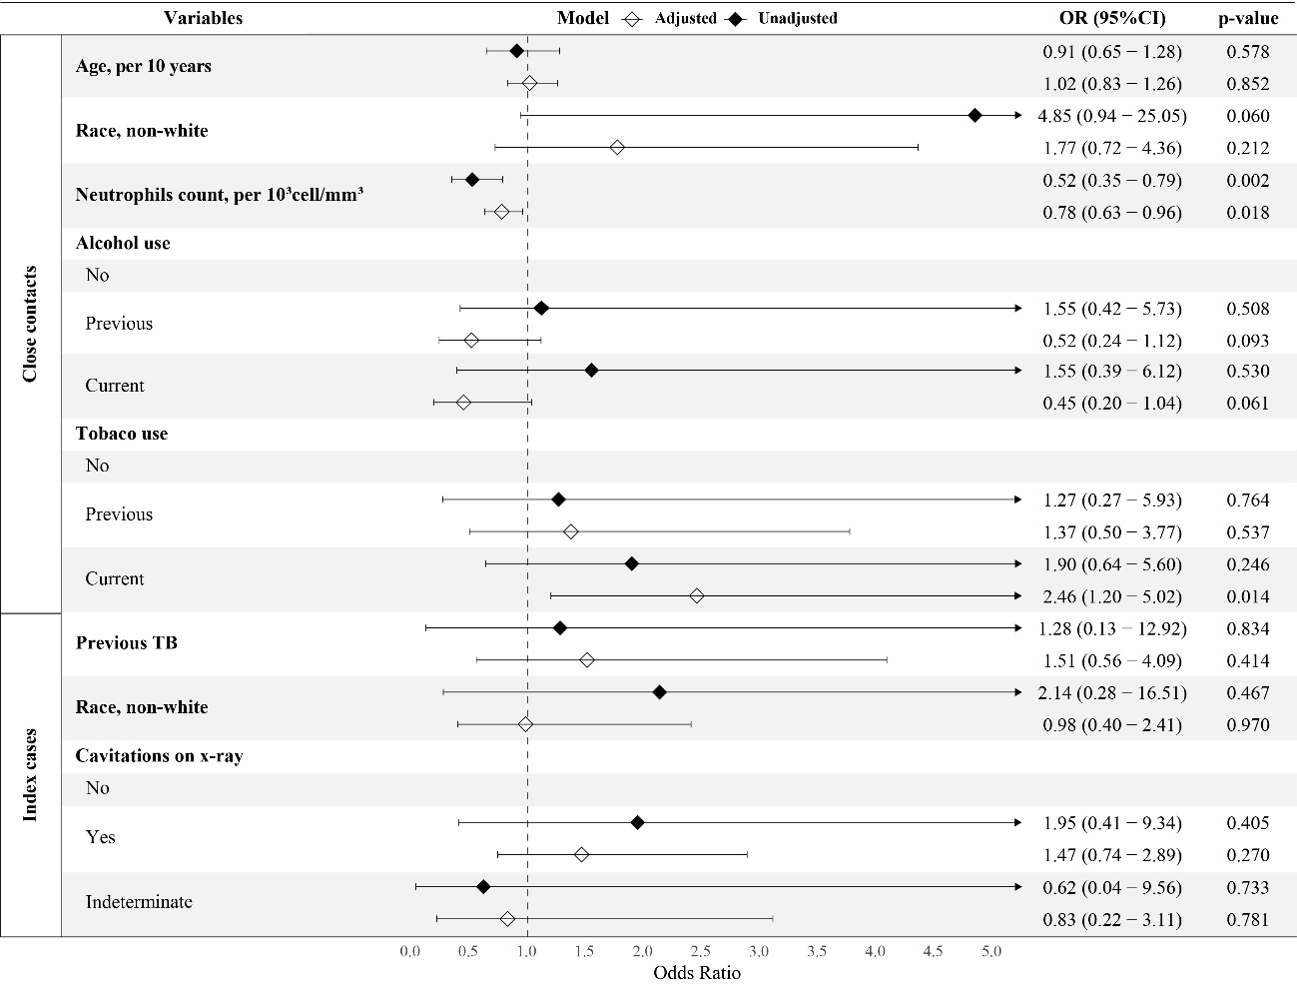
Figure legend: forest plot presenting the odds ratios (ORs) and 95% confidence intervals (CIs) for variables associated with IGRA conversion in close contacts of TB patients. The variables analyzed for close contacts included age, race, neutrophils count, smoking history, alcohol and consumption history. Additionally, variables pertaining to the index cases include history of TB disease, race, and presence of cavitation.

