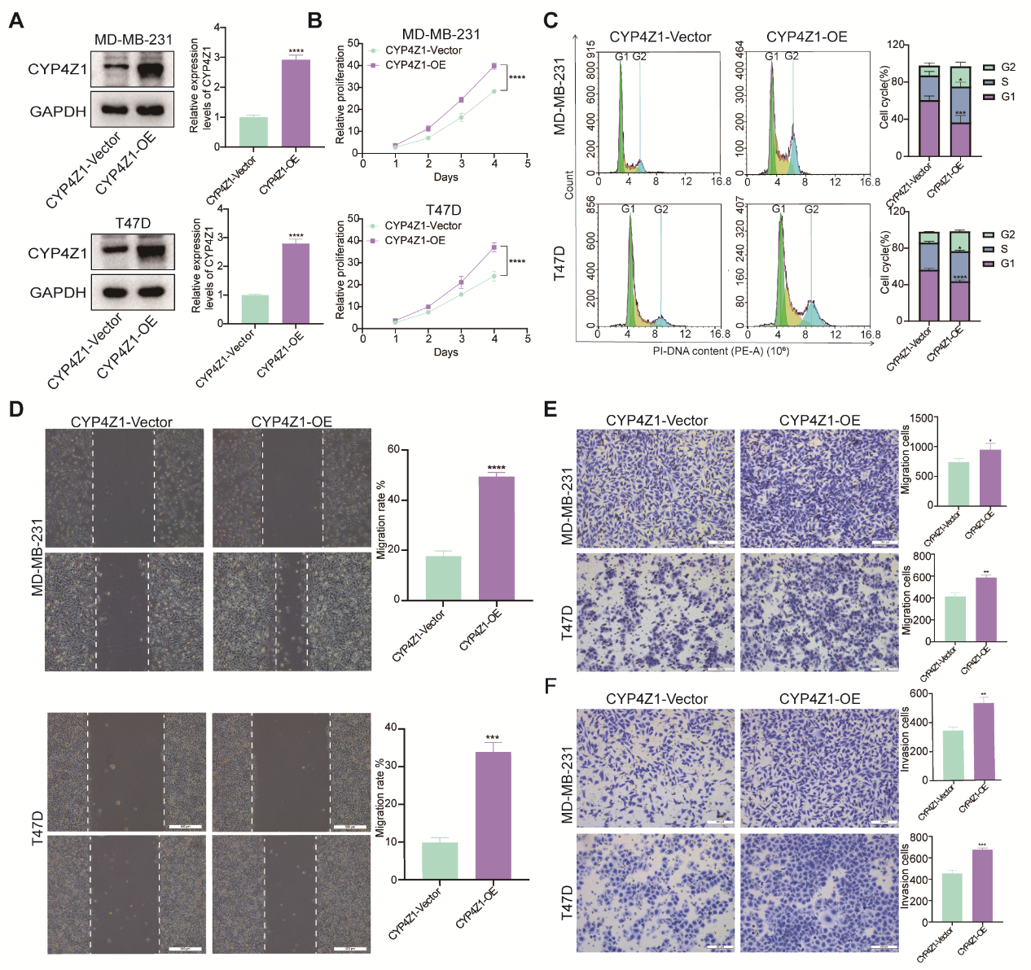
Figure S1. CYP4Z1 regulates breast cancer (BC) cell progression. MDA-MB-231 and T47D cells were stably transfected with plasmids (CYP4Z1-Vector or CYP4Z1-OE). (A) CYP4Z1 expression was analysed by Western blotting. Western blot images were cropped for presentation. Original blots are presented in Figure S2. (B) Cell viability was evaluated via the CCK-8 assay. (C) Cell cycle analysis by flow cytometry. (D) Cell migration capacity was evaluated using a scratch assay. (E–F) Cell migration and invasion were evaluated using a Transwell assay. Statistical significance is denoted as follows: *P<0.05, **P<0.01, ***P<0.001, and ****P<0.0001.
Figure S2. Full blot images. Regions surrounded by red boxes are presented in Figures 1D, 1E, 1G, 2B, 2E, 3B, 5B, and Supplementary Figure S1A.

