Supplementary material

Novel microbiota and the gut-brain axis in ASD individuals
Zehra Muhammed Kirdar¹*, Humada, Yasser Hamad²*, and Ibtesam Ghadban Auda³*
¹*Department of Biology, College of Science, Kirkuk University, Iraq.
²* Department of Biology, College of Science, Kirkuk University, Iraq.
³* Department of Biology, College of Science, Al-Mustansiriyah University, Iraq.

The inclusion and exclusion criteria for sampling

Regarding the study population and sample size, it is essential to highlight the specific demographic and logistical context of Kirkuk City. At the time of the study, the total number of documented ASD cases in the city did not exceed 50 individuals. Recruitment was further constrained by several factors::
Clinical Rigor: All participants were strictly required to have a confirmed diagnosis of ASD according to the DSM-5 criteria to ensure diagnostic homogeneity.

Logistical and Behavioral Challenges: A significant number of potential subjects were excluded because their specialized daily routines for waste management were incompatible with the standardized fecal collection protocols required for high-quality metagenomic analysis.

Parental Consent: Despite our efforts, low participation rates were observed due to a lack of parental consent, a common challenge in regional clinical studies.

These strict inclusion and exclusion criteria were necessary to ensure data integrity and avoid confounding results, even at the expense of a larger sample size. To minimize environmental confounding factors, we restricted the study population to residents of Kirkuk City.

Individuals with ASD living outside this geographical area were strictly excluded to ensure uniformity in environmental exposures, particularly regarding the source of drinking water and local dietary patterns. Such geographical standardization is crucial in microbiota studies.
as variations in water mineral content and regional environmental factors can significantly shift microbial profiles independently of the host's clinical phenotype. "The inclusion of a broad age range (6–18 years) was a deliberate methodological choice intended to identify persistent microbial signatures of ASD that transcend specific developmental stages. Given that ASD is a lifelong neurodevelopmental condition, capturing data across childhood and adolescence allowed us to observe the stability of the microbial dysbiosis independent of age-related fluctuations.
This approach enhances the generalizability of our findings, suggesting that the identified biomarkers are intrinsic to the ASD phenotype rather than being transient age-specific variations. Our data analysis revealed that the microbial distribution remained remarkably consistent across the investigated age range (6–18 years). Critically, no significant age-related variations were observed in the taxonomic profiles, nor were there substantial disparities between the ASD group and the Neurotypical (NT) controls in this regard. These findings suggest a stable microbial signature that is independent of chronological age, further validating the robustness of our study design and the generalizability of the identified biomarkers across childhood and adolescence.

Materials and Methods for NGS-based Amplicon sequencing

2.2.1 DNA Extraction
The CANVAX Higher Purity™ Stool DNA Isolation Kit was applied for the extraction of both ASD and neurotypical controls. The concentration of the DNA was measured by the Promega Quntiflour dsDNA system. DNA concentration for NGS-Amplicon and for NGS-Metagenome should be ≥ 1 ng/µL. All samples were above the range and were sent to Biomarker Technologies (Hong Kong) for sequencing.
2. 2.2 DNA Quality Control

The nucleic acid concentration is measured using an enzyme-linked immunosorbent assay (ELISA) reader (GeneCompany Limited, Synergy HTX) with 1X dsDNA HS Working Solution (Yeasen Biotechnology (Shanghai) Co., Ltd.). Based on the concentration and amplification region, detection and amplification are performed on the BL1000 automated PCR system (Revvity Co., Ltd.). After amplification, the PCR products are analyzed by gel electrophoresis using a 1.8 % agarose gel (Beijing Bomei Fuxin Technology Co., Ltd.) or LabChip GX Touch (PerkinElmer, cls137031/E) for fragment analysis and assessment of their integrity.

Target band size | Target band  brightness | Note 1 | Note 2 | Amount (μL) | Level
The target band size is correct, and the detected fragment is <550 bp. The non-specific bands are weaker compared to the  target band. | The target band is brighter than or close to 500 bp marker | Forecast can construct library one-time success | The total amount meets the construction of 3 or more libraries | ≥0.3 | A
The target band size is correct, and the detected fragment is <550 bp. The non-specific bands are weaker compared to the  target band. | The brightness of the target band is around 400 bp marker | Forecast that 2-3 tubes need to be expanded to construct the  library. | The total amount meets the construction of 1 library | <0.3 | B

2.2.3 Library Construction

2.3.1. Amplicon sequencing standard primer (NGS) list

Type | Target Region | Primers | Primer Sequences
Bacteria | 16S \' 3 + \' 4 | 338F | 5' - ACTCCTACGGGAGGCAGCA -3 '
Bacteria | 16S \' 3 + \' 4 | 806R | 5'- GGACTACHVGGGTWTCTAAT -3'

2.3.2. Reagents for library construction

Reagents | Manufacturers | Number
KOD FX Neo (TOYOBO) | Beijing Biolink Biotechnology Co., Ltd. | KFX-201S
VnF (10 μM) | Suzhou SYNBIO Technology Co., Ltd. | -
VnR (10 μM) | Suzhou SYNBIO Technology Co., Ltd. | -
Phusion HF MM | Beijing Biolink Biotechnology Co., Ltd. | M0544L
Mpp1-n1 (10 μM) | Suzhou SYNBIO Technology Co., Ltd. | -
Mpp1-n2 (10 μM) | Suzhou SYNBIO Technology Co., Ltd. | -
e.Z.N.A.TM Cycle-Pure Kit (omega) | Beijing Hongyue Innovation Technology Co., Ltd. | D6492-02
1X dsDNA HS Working Solution | Yeasen Biotechnology (Shanghai) Co., Ltd. | 12642ES76
Monarch DNA Gel Extraction | Beijing Hongyue Innovation Technology Co., Ltd. | T1020L
TE Buffer (pH 8.0) | Beijing Bomei Fuxin Technology Co., Ltd. | T1120
Agarose | Beijing Bomei Fuxin Technology Co., Ltd. | -
Ethidium Bromide (EB) | Qingdao Tuobang Biotechnology Co., Ltd. | E1020-100 mL
Tris base | Beijing Bomei Fuxin Technology Co., Ltd. | -
EDTA-2Na | Beijing Bomei Fuxin Technology Co., Ltd. | -
Acetic Acid | Beijing Bomei Fuxin Technology Co., Ltd. | -
100 bp DNA Ladder Marker | Beijing Liuhetong Economic and Trade Co.,Ltd. | 3422A
Anhydrous ethanol | Qingdao Tuobang Biotechnology Co., Ltd.
Deionized water | TianGen Biotech (Beijing) Co., Ltd. | RT120-02
VAHTSTM DNA Clean Beads | Nanjing Vazyme Biotechnology Co., Ltd. | N411-03

PCR enzymes: KOD FX Neo (TOYOBO), TransStart FastPfu Fly DNA Polymerase, Phusio (NEB)
PCR products purification: OMEGA DNA Purification Kit
Purification after gel extraction: Monarch DNA Gel Extraction Kit

2.3.3. Instruments list

Instruments | Manufacturers | Type
Instantaneous centrifuge | TianGen Biotech (Beijing) Co., Ltd. | OSE-MC8
-20 ℃ refrigerator | Qingdao Haier Special electric freezer Co.,  Ltd. | BC/BD-629HK
4 ℃ refrigerator | Haier | HYC-360
Vortex oscillator | SCIENTIFICINDUSTRIES.INC | vortex-2G560E
Gradient PCR | Appliedbiosystems | veriti96well9902
24-well centrifuge | Sartorius | 3-16P
Four-dimensional rotational | HaimenKylin-BellLabInstrumentsCo., Ltd. | BE-1100

Mixer
BL1000 | Revvity Co., Ltd. | -
Magnetic rack | Thermo Fisher Scientific Inc. | DynaMag96Side skirted

1. Experimental workflow

(1) Target region amplification (Reaction system: 10 μL)

Reagent | Volume (μL)
Genomic DNA | 3 ng
VnF (10 μM) | 0.3
VnR (10 μM) | 0.3
KOD FX Neo Buffer | 5
dNTP (2 mM each) | 2
KOD FX Neo | 0.2
ddH2O | Fill to 10 µL
Note: Vn F and Vn R are selected based on the target amplification region.

(2) PCR reaction parameters:

95 ℃ | 5 min
95 ℃ | 30 s | 25 cycles
50 ℃ | 30 s | 25 cycles
72 ℃ | 40 s | 25 cycles
72 ℃ | 7 min
Hold at 4℃ (Do not place for a long time to avoid unnecessary damage to the PCR instrument)

(2) PCR products purification

The target region PCR products (10 μL system) were mixed with magnetic beads in a 10:8 ratio, followed by magnetic bead-based purification to select the desired fragments. The elution volume was 8-10 μL. For the target region PCR products (10 μL system), 8 μL of VAHTSTM DNA clean magnetic beads were added, mixed for 5 minutes at room temperature, and then placed on a magnetic rack for 5 minutes to remove the supernatant.
Next, 200 μL of 80% ethanol wash beads were added, incubated at room temperature for 30 seconds, and the supernatant was discarded. This step was repeated once. The beads were then air-dried on the magnetic rack for 3 minutes. Finally, the beads were resuspended in 8-10 μL of ddH₂O, incubated at room temperature for 5 minutes, placed on the magnetic rack for 5 minutes, and 8-10 μL of the supernatant was transferred to a new
PCR tube.

(3) Solexa PCR (Reaction system: 20 µL)

Reagent | Concentration (μM) | Volume (μL)
Purified PCR products | - | 5
★MPPI-a | 2 | 2.5
★MPPI-b | 2 | 2.5
2×Q5 HF MM |  | 10
Total |  | 20

PCR reaction parameters:

98 ℃ | 30 s
98 ℃ | 10 s | 10 cycles
65 ℃ | 30 s | 10 cycles
72 ℃ | 30 s | 10 cycles
72 ℃ | 5 min
Hold at 4℃ (Do not place for a long time to avoid unnecessary damage to the PCR instrument)

2. Electrophoresis detection
- Preparation of a 1.8% agarose gel.
- Loading: 3.5 μL of 100 bp marker and 2 μL of ethidium bromide for every 3.5 μL of PCR product. Prepare a new buffer and gel (do not let the gel sit for too long). Apply a voltage of 120 V for 40-45 minutes.
(3) Gel imaging: After electrophoresis, place the gel block in a staining solution and stain for 20 minutes. Observe the electrophoresis results under a gel imaging system.
(4) Gel documentation requirements: Staining time should be 10-20 minutes. Clean the staining solution with water before gel documentation.
3. Electrophoresis quantification and sample mixing
(1) Quantification using ImageJ software
Pre-edit the gel image with gel imaging software, assign experiment numbers, and adjust the image. Perform quantification of the electrophoresis results using ImageJ software.
The window display is as follows:

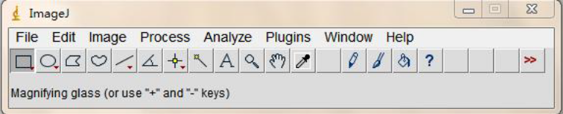

Calculation of sample concentration is based on the peak area of the marker, as the total amount of the marker is known. By using the peak area value of the sample, the total amount of the sample can be calculated. Divide the total amount by the volume of the sample spot to obtain the quantitative concentration of the sample.
The specific algorithm is as follows: Total amount of the reference (marker band) = marker concentration × volume. Concentration of the target band in the sample = (peak area of the sample band/peak area of the reference) × total amount of the reference/volume of the sample spot.
(2) Sample mixing

Take 150 ng of each sample for mixing. After mixing, thoroughly mix the samples. For samples with high concentrations, if the volume to be aspirated is less than 1.5 µL, in order to avoid aspiration errors, adjust the volume to 300 ng or 600 ng for each sample. The adjustment principle for the aspirated volume is as follows: The minimum volume aspirated from the mixed sample should be greater than 1.5 µL, and the maximum volume should not exceed 14 µL (based on the elution volume).
4. Sample mixing column purification
Use the e.Z.N.A.TM Cycle-Pure Kit (omega) columns to purify the mixed samples before gel extraction.

5. Gel extraction
- Preparations: Prepare a 1.8% agarose gel (BIOWEST) and set up the gel block (use a thin comb with 13 wells and 0.15 mm thickness). Each gel block can accommodate two rows of combs. For gel electrophoresis, a gel size of 12 cm (horizontal) * 6 cm (vertical) is sufficient, and there is no need for excessively long electrophoresis time.
- Prepare fresh 1×TAE buffer and pour it into a clean electrophoresis tank. Place the prepared gel block in the tank.
(3) Add 1 µL of loading buffer (xylene cyanol) to every 5 µL of the mixed sample from the previous step. Mix well and add the mixture to the sample wells in the gel block (if the volume after mixing is large, you can add the mixture to 2-3 wells for extraction). Add 3.5 µL of 100 bp DNA Ladder Marker to one side of the sample wells adjacent to the samples. Perform electrophoresis at 100 V for 90 minutes.
(4) Use the Monarch DNA Gel Extraction Kit for gel extraction.

4. Library Sequencing
For sequencing of the constructed library, the Illumina NovaSeq 6000 sequencing platform is used, employing a paired-end (PE) 250 sequencing strategy. Figure 1. Summarizes the experimental workflow.

Software and database tables
The tables below summarize all software, databases, and packages/modules that were used in the study.

Software table (3)

Software | Version | Analysis_module | Main parameter | Website
FASTX Toolkit | 0.0.14 | Data process | [-i INFILE] [-o OUTFILE] | https://anaconda.org/bioconda/fastx_toolkit
flash | 1.2.11 | Data process | --min-overlap NUM --max-mismatch-density num | http://ccb.jhu.edu/software/FLASH/index.shtml
fastp | 0.23.1 | Data process | [-i INFILE] [-o OUTFILE] | https://github.com/OpenGene/fastp
QIIME2 | 2020.6.0 | -- | default | https://qiime2.org
dada2 | 1.20.0 | Denoise | default | https://benjjneb.github.io/dada2/
KronaTools | 2.6 | Krona analysis | default | https://github.com/marbl/Krona/releases
blastn | 2.9.0 | Taxonomy anotation | -evalue 1e-5 -outfmt 5 -num_threads 2 | https://blast.ncbi.nlm.nih.gov/Blast.cgi?CMD=Web&PAGE_TYPE=BlastDocs&DOC_TYPE=Download
lefse | 1.1.1 | Difference analysis | default | https://github.com/SegataLab/lefse/tree/master/lefse
picrust2 | 2.3.0 | Function prediction | -s study_seqs.fna -i study_seqs.biom -o picrust2_out_pipeline -p 1 | https://huttenhower.sph.harvard.edu/picrust
bugbase | 0.1.0 | Function prediction | default | https://github.com/knights-lab/BugBase
FAPROTAX | 1.2.6 | Function prediction | default | http://www.loucalab.com/archive/FAPROTAX/lib/php/

database table (4)
Database | Version | Analysis module | Main parameter | Website
FunGene | 9.9.11 | Taxonomy anotation | - | http://fungene.cme.msu.edu/index.spr
Silva138 | 2019-12-16 | Taxonomy anotation | - | https://www.arb-silva.de/documentation/release-138/
NCBI | - | Taxonomy anotation | - | https://www.ncbi.nlm.nih.gov/

package/module table (5)
Package | Version | Analysis_module | Main parameter | Website
vegan | 2.3-0 | RDA/CCA | - | https://cran.r-project.org/web/packages/
ggplot | 3.1.1 | Boxplot et. | - | https://cran.r-project.org/web/packages/
pheatmap | 1.0.12 | Heatmap | - | https://cran.r-project.org/web/packages/
randomForest | 4.6-10 | Random forest | - | https://cran.r-project.org/web/packages/
scipy | 0.14.1 | rank sum test | - | https://scipy.org/

Materials and Methods for NGS-based Metagenomics
1. DNA extraction was previously done. The same procedure was applied.
2. DNA Quality Control
QC Methods: The extracted nucleic acids are quantified using Qubit (Invitrogen, QubitTM3 Fluorometer). The integrity of the nucleic acids is assessed using agarose gel electrophoresis (Electrophoresis System: Tanon, EPS600; Electrophoresis Tank: Tiangen, HE-120).
3. Library Construction
1. DNA fragmentation (enzymatic digestion) and end repair
1.1 Sample dilution and packaging
1) 10ng DNA (qubit quantification) was used for library construction.
2) Add the following reagents to the above DNA and immediately place them in the PCR instrument for reaction.
The required reagents are as follows:

Reagent | Volume (μL)
Input DNA | 10 ng
FEA Buffer | 2
FEA Enzyme Mix | 4
Total | 20

1.2 Enzymatic fragmentation
Setting procedure: 75 ℃ hot lid

a | 4 ℃ for 15s
b | 37 ℃ for 8 min
c | 65 ℃ for 30 min
d | Hold at 4 ℃ (Do not place for a long time to avoid unnecessary damage to the PCR instrument)

2. Adapter ligation
2.1 Required reagents

Reagent | Volume (μL)
Fragmented DNA (Have the end repaired, add A') | 20
Rapid Ligation Buffer 3 | 10
DNA Adapter | 2
Rapid DNA Ligase | 2
ddH2O | 6
Total Volume | 40

2.2 Experimental workflow
1) Add the above reagents and DNA adapter to the fragmented DNA, which has the end repaired, and add A'.
2) Reaction on the PCR instrument according to the following procedure:

a | Turn off the hot lid
b | 20 ℃ for 15 min

Hold at 4 ℃ (Do not place for a long time to avoid unnecessary damage to the PCR instrument)

c

2.3 Product purification
The PCR products generated in the above steps were purified with Vazyme DNA Clean magnetic beads at 0.8 × concentration. 2.4 Fragment size screening and purification
Perform fragment selection using Vazyme DNA. Clean magnetic beads with the following steps:
1) Add magnetic (0.485×) beads to the above product, mix well, and incubate at room temperature for 5 minutes. Then, place the tube on a magnetic rack and remove all the supernatant into a new 96-well plate.
2) Add magnetic (0.1×) beads, mix well, and incubate at room temperature for 5 minutes. Then place the tube on a magnetic rack and discard the supernatant.
3) Wash the magnetic beads twice with 80% ethanol and discard the supernatant.
4) Add 10 μL of nuclease-free water, mix well, and let it stand at room temperature for 5 minutes. Then place the tube on a magnetic rack and collect 8 μL of the supernatant for the next PCR amplification step.

3. PCR amplification
(1) Add the following reagents to the above product and perform PCR amplification according to the following procedure:

Reagent |  | Volume (μL)
PCR Primer Mix 3 |  | 2
VAHTS HiFi Amplification Mix |  | 10
Size of the screened product |  | 8
Total volume |  | 20
95 ℃ | 3 min |  | 8 cycles
98 ℃ | 20 s |  | 8 cycles
60 ℃ | 15 s |  | 8 cycles
72 ℃ | 30 s |  | 8 cycles
72 ℃ | 5 min
Hold at 4°C (Do not place for a long time to avoid unnecessary damage to the PCR instrument)

4. Product purification
The PCR products generated in the above steps were purified with Vazyme DNA Clean magnetic beads at 0.6 × concentration.
4. Library Quality Control
The library quality control is performed using Qsep-400, and the library concentration is quantified using Qubit 3.0. The following criteria must be met for the library to be eligible for sequencing:
1. Concentration: ≥ 1 ng/μL
2- Fragment size: The center value of quality-checked fragments should be between 430-530 bp, with an average value between 420-580 bp.
3- Peak shape: The peak shape should follow a normal distribution.
5- Fragment purity: The fragment should be single and free from any additional peaks or
contaminants.

5. Library Sequencing
The libraries were sequenced on the Illumina NovaSeq X Plus platform (Illumina, San Diego, CA) by the NovaSeq™ X Series 25B Rgt Kit, and paired-end 150 bp reads were generated.

Appendix
Adapter sequence:
adpter3="AGATCGGAAGAGCACACGTCTGAACTCCAGTCAC";
adpter5="AGATCGGAAGAGCGTCGTGTAGGGAAAGAGTGT";
Library construction kit: VAHTS Universal Plus DNA Library Prep Kit V4 (ND801, Vazyme) Product purification magnetic beads: VAHTSTM DNA Clean Beads (N411-03, Vazyme)

Instruments:
PCR instrument | Eppendorf 6333
Metal bath | TianGen Biotech (Beijing) Co., Ltd., model OSE-DB-02.
Handheld centrifuge | TianGen Biotech (Beijing) Co., Ltd., model OSE-MC8.
Vortex mixer | SCIENTIFIC INDUSTRIES. INC, model G560E.
Pipette | RAININ
Magnetic rack | Life
Camera | Sony
Refrigerator | Haier
4D rotator | Haimen Kylin-Bell Lab Instruments Co., Ltd, model BE-1100
Consumables
1.5 mL centrifuge tubes | Axygen
0.2 mL PCR tubes | Axygen
10 μL, 200 μL pipette tips | Axygen.

NGS- based metagenomic analysis related tables

Table (S1) Statistics on gene prediction
Sample ID | Gene number | Total length(bp) | Average length(bp) | Max length(bp) | Min length(bp) | Mapped(%)
MARY-7 | 336307 | 2.11E+08 | 627 | 17910 | 102 | 96.44
MMAL-8 | 300631 | 2.06E+08 | 685 | 23646 | 102 | 98.38
MMSA-2 | 197344 | 1.13E+08 | 571 | 18189 | 102 | 97.64
MT-4 | 175440 | 98562480 | 561 | 16482 | 102 | 96.34
MSEZ-3 | 409098 | 2.65E+08 | 646 | 16662 | 102 | 96.93
MMM-10 | 286377 | 1.73E+08 | 602 | 12093 | 102 | 96.96
MAARJ-6 | 262199 | 1.71E+08 | 652 | 13680 | 102 | 97.86
MNE-9 | 440415 | 2.8E+08 | 636 | 15366 | 102 | 97
MMARJ-5 | 388676 | 2.26E+08 | 581 | 20265 | 102 | 96.69
MH-1 | 394860 | 2.39E+08 | 606 | 19764 | 102 | 95.94

Table(S2) Geneset_length_stat_

Type | Geneset number | Total length(bp) | Average length(bp) | Max length(bp) | Min length(bp)
geneset | 1367944 | 876703308 | 640 | 23646 | 102

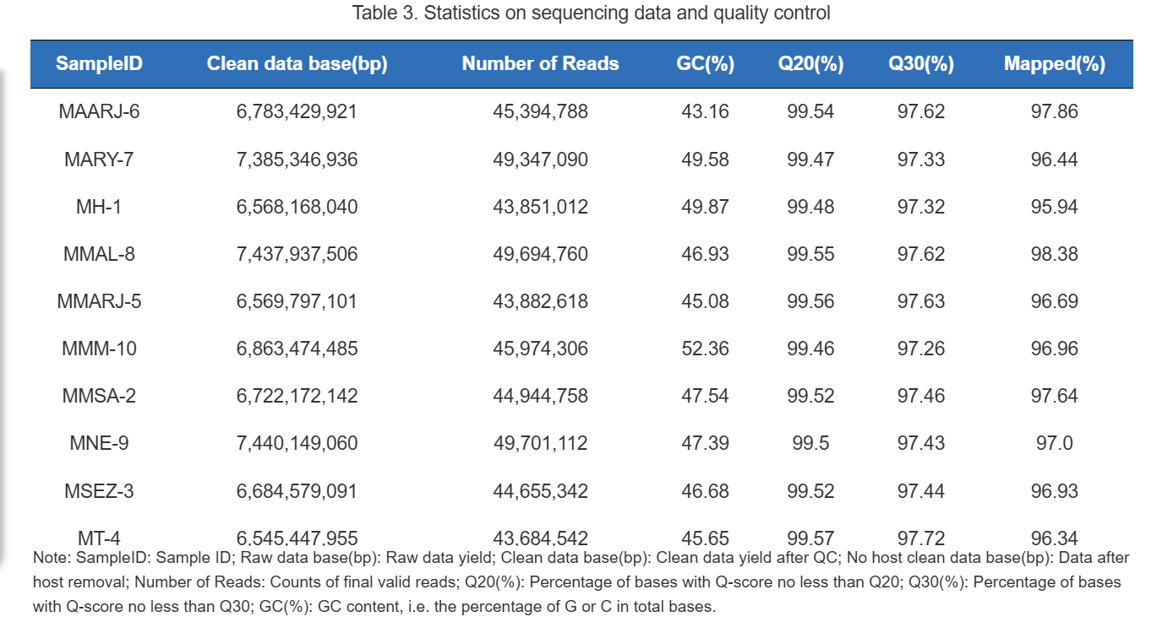

Since we employed the PE150 sequencing mode, the conversion relationship between raw data base (bp)& raw reads, clean data base (bp)& clean reads is as follows: **raw data (bp) / 300 (bp) = raw reads**.
For example, 12,163,829,771 / 300 = 40,546,009, thus the raw reads amount to 40,546,009. Similarly, 12,125,902,246 / 300 = 40,419,674, so the clean reads equal 40,419,674.
The "Number of Reads" listed in the table represents single-ended, not mergered reads, which therefore appear higher.
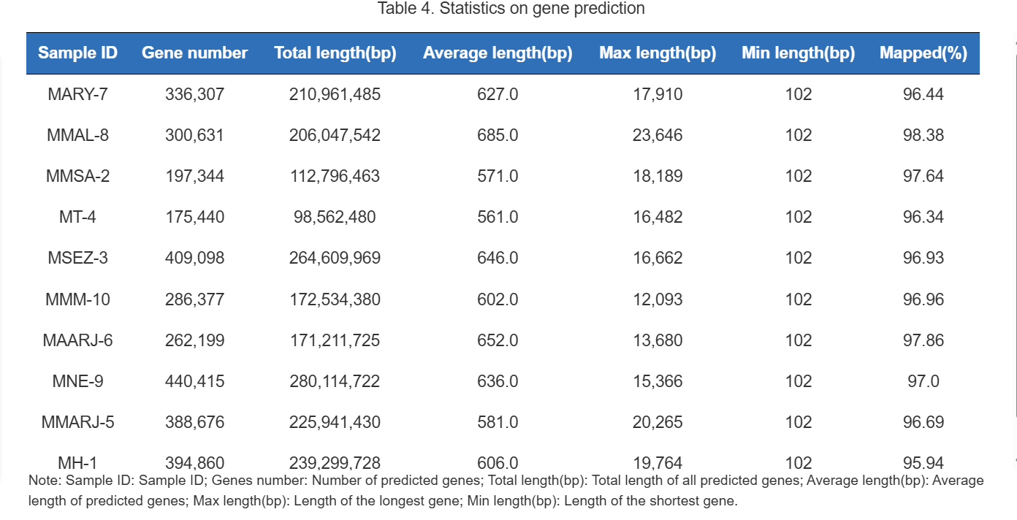

Amplicon sequerncing related tables

Table S5. Summary on raw data processing
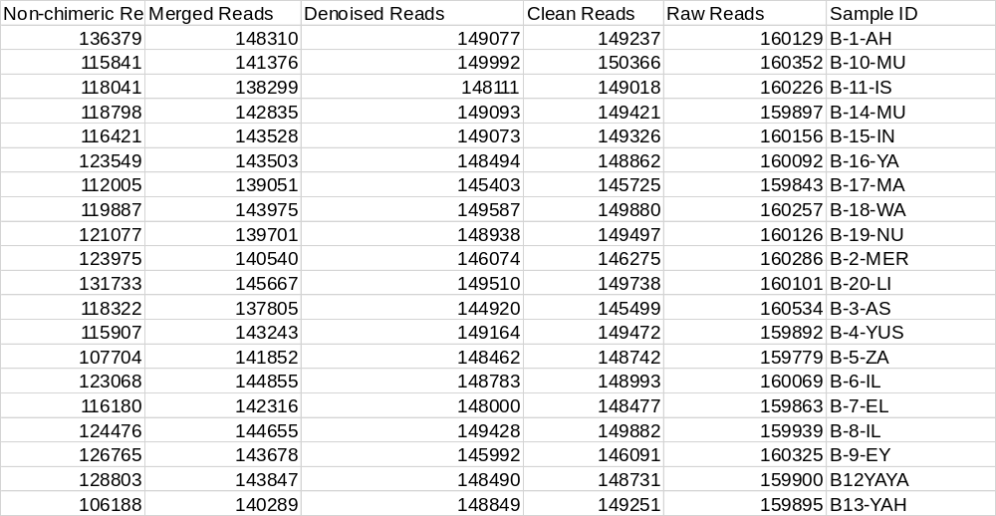

Table S6.All samples ASV _stat
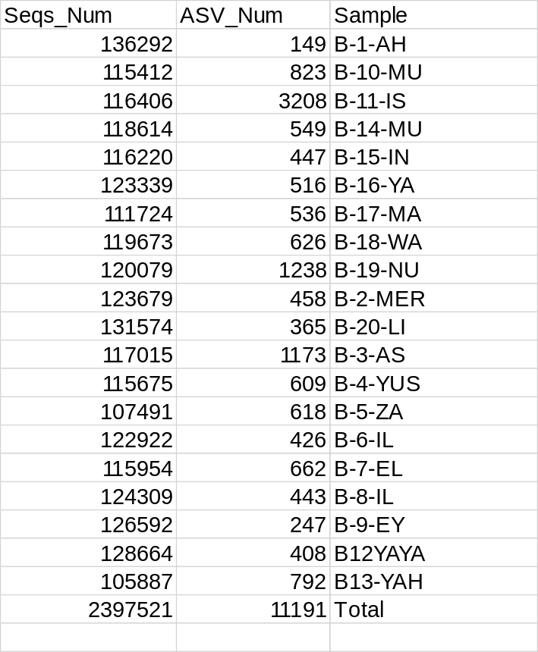

FigureS1 . Flower plot of ASV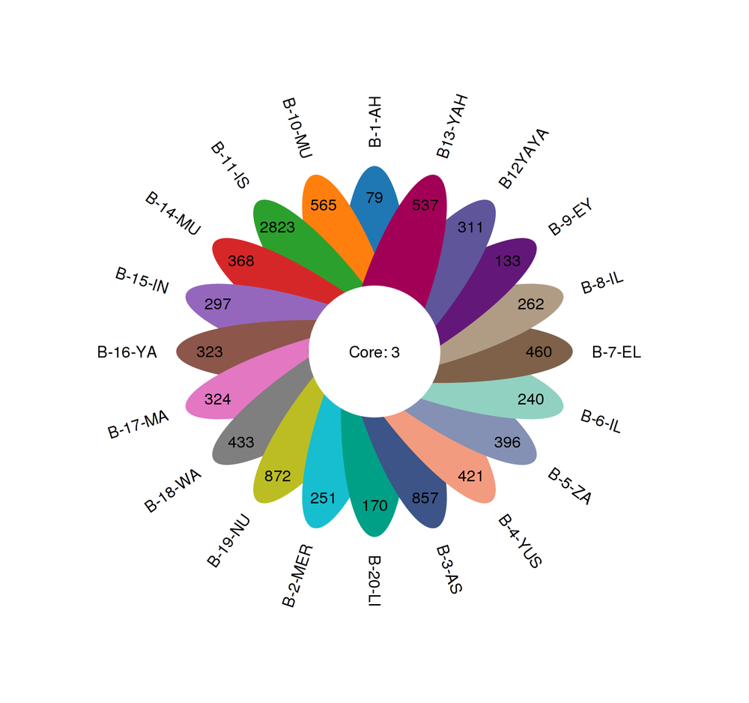
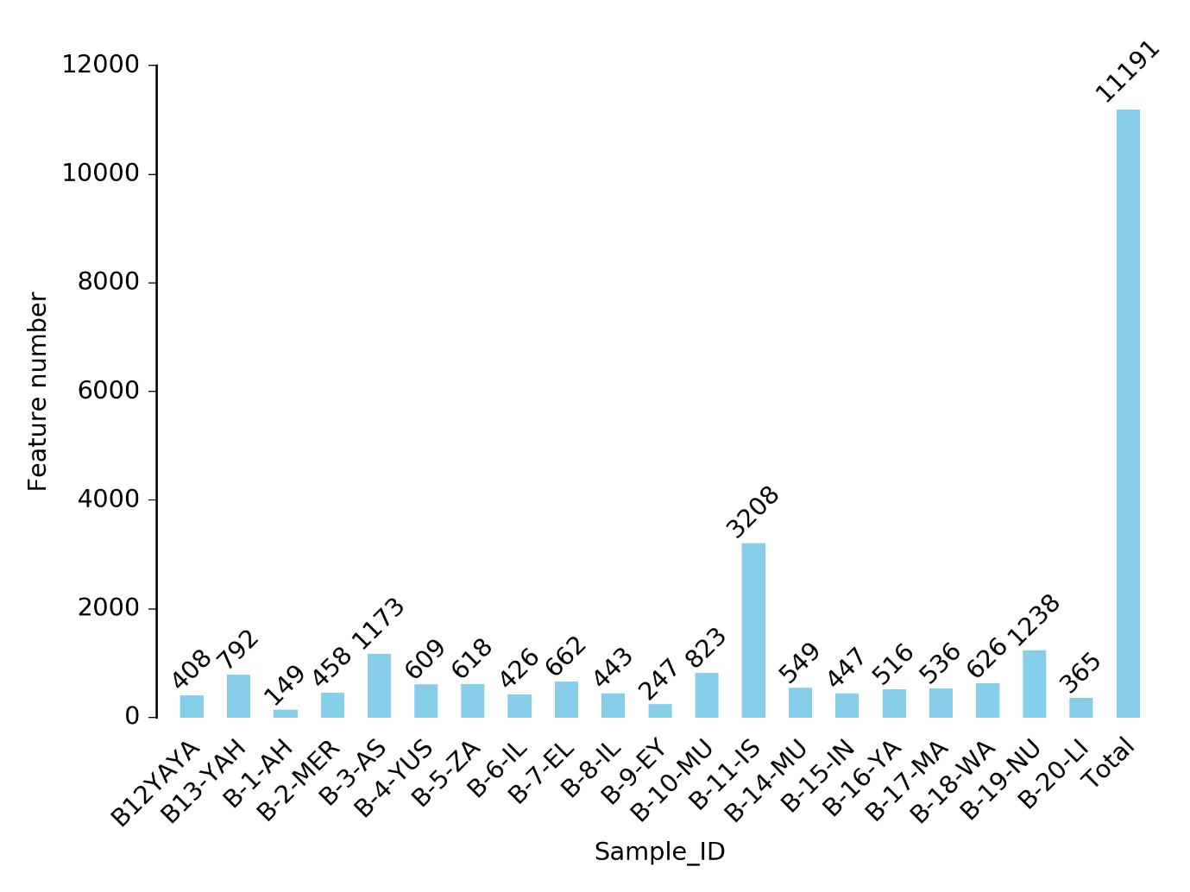
FigureS2 . Statistics on ASV number in each sample

Table S7. Statistics of reads count in each taxomonic level
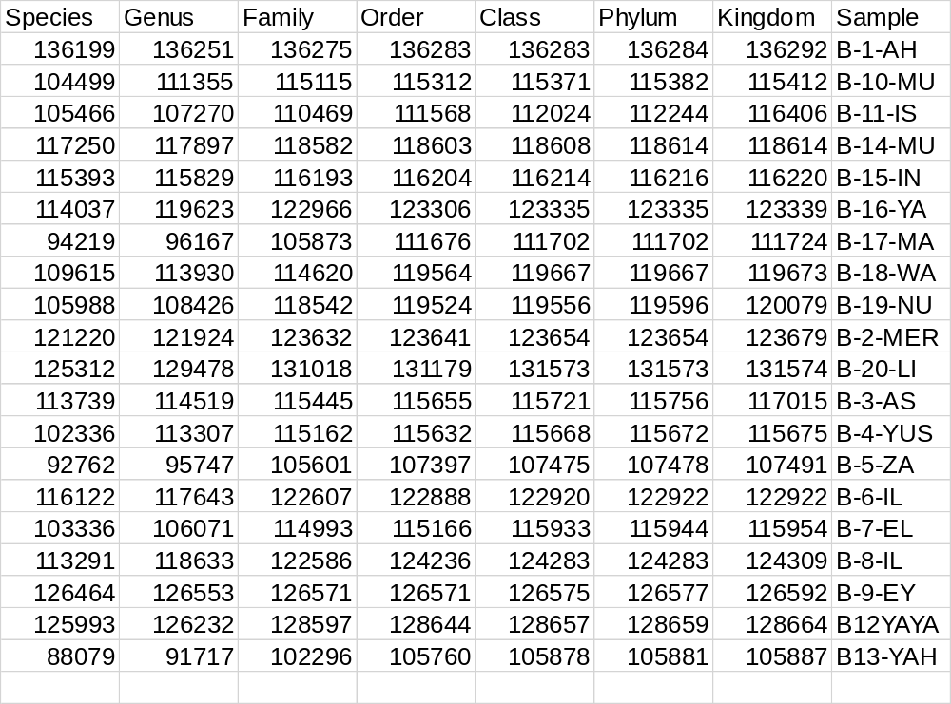

FigureS3 . Sample community distribution map of Phylogenetic tree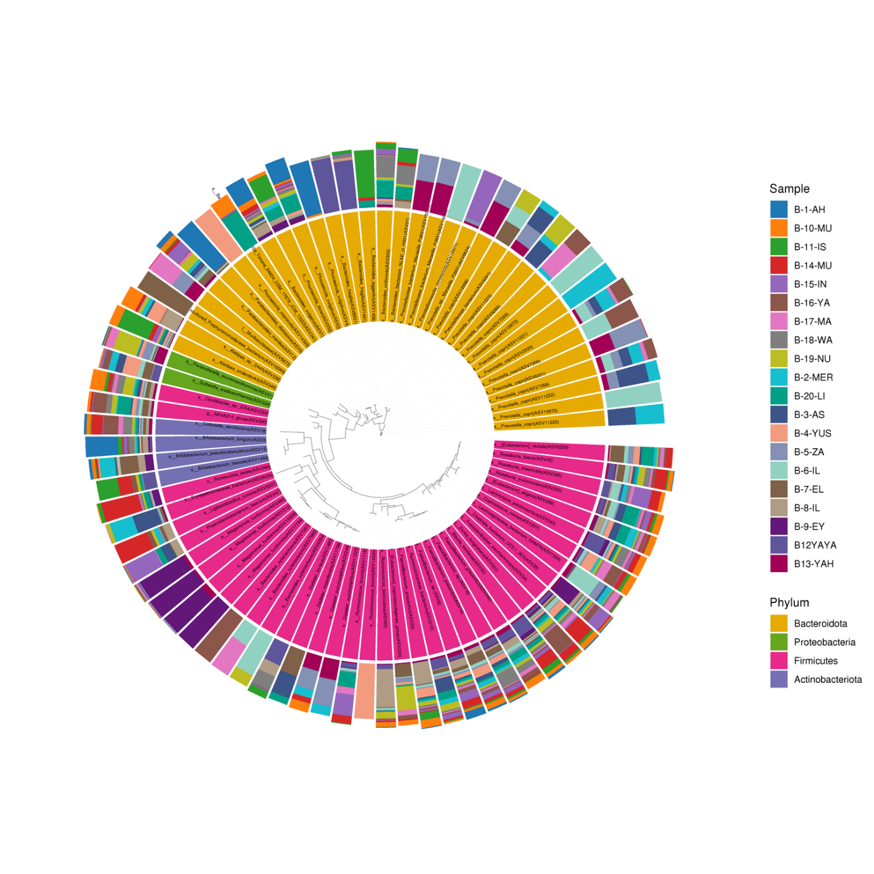

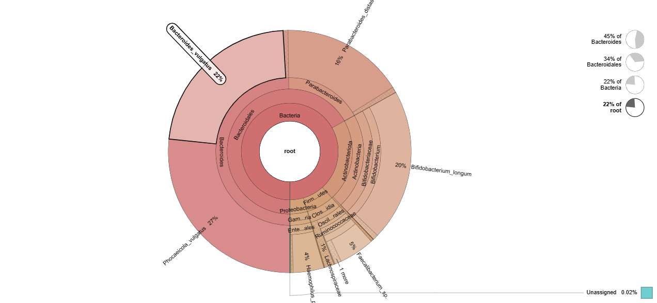

Figure S4 KRONA taxonomic annotation results

create a table or figure showing distribution of MAGs across the samples

