Figure S1. Linear discriminant analysis showing the wing shape variation of the specimens in the left wings (A) and right wings (B), according to mosquito strain.

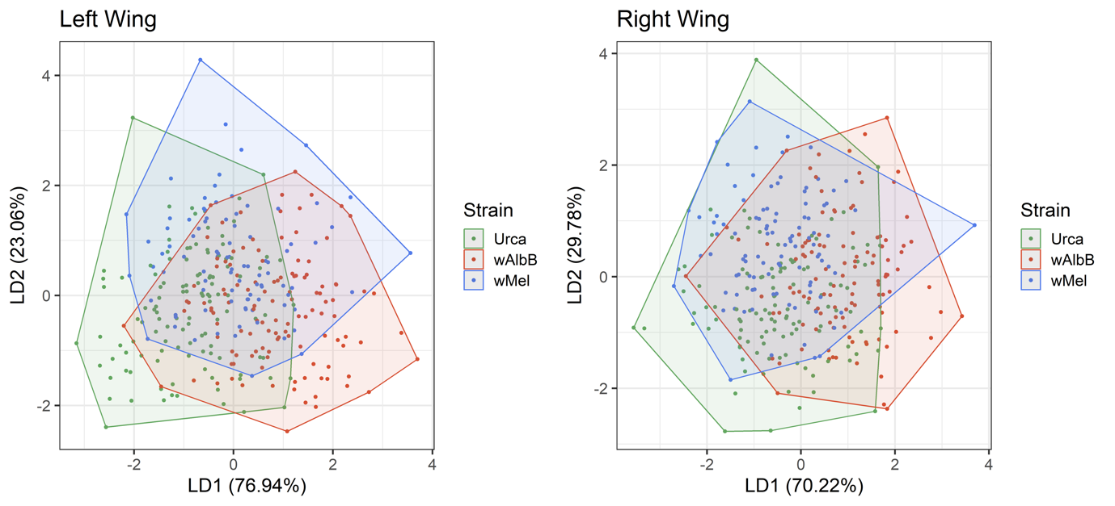

Figure S2. Principal component analysis showing the wing shape variation of the specimens in the left wings (A) and right wings (B), according to the larval density conditions in which larvae were reared.

