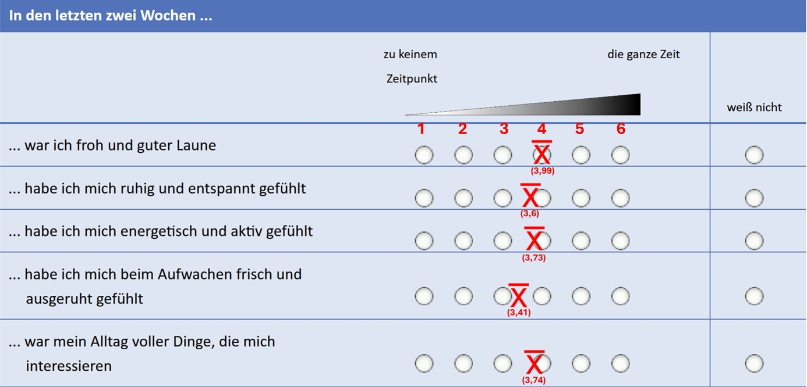

Suppl. Fig. 1: Wellbeing
The WHO 5-point-based tool as used in the survey with mean of answers as given per question. (1) 'I have felt cheerful and in good spirits', (2) 'I have felt calm and relaxed', (3) 'I have felt active and vigorous', (4) 'I woke up feeling fresh and rested' , (5) 'my daily life has been filled with things that interest me'. Scale: ‘at no time’ to ‘all the time’

