Supplementary Table 1: Peak resolution of various analytes separated and detected at different wavelengths
Analytes (Wavelength) | Peak resolution
Levofloxacin (305nm) | 23.44±0.47
Moxifloxacin (305nm) | 5.89±0.09
Linezolid (254nm) | 3.66±0.08
Pretomanid (330nm) | 13.72±0.60
Clofazimine (305nm) | 10.61±0.37
Bedaquiline (330nm) | 3.62±0.16
Delamanid (330nm) | 6.57±0.42

Values are expressed as mean±SD from the data obtained from three standard stock solutions

Supplementary Table 2. Short-term stability assay
 | Standard concentration range (µg/mL) | Stability (%) at 4⁰C for 24 h
 | Standard concentration range (µg/mL) | Extracted sample |  |  | Freshly extracted samples
 | Standard concentration range (µg/mL) | Mean | SD | RSD% | Mean | SD | RSD%
Levofloxacin  (305nm) | 1.0 | 107.8 | 4.1 | 3.83 | 101.3 | 0.6 | 0.62
Levofloxacin  (305nm) | 2.0 | 105.2 | 2.6 | 2.46 | 101.9 | 2.1 | 2.03
Levofloxacin  (305nm) | 4.0 | 106.0 | 0.5 | 0.48 | 103.6 | 4.4 | 4.27
Levofloxacin  (305nm) | 6.0 | 106.7 | 2.6 | 2.39 | 102.3 | 3.7 | 3.62
Levofloxacin  (305nm) | 8.0 | 104.0 | 1.1 | 1.06 | 102.5 | 1.9 | 1.87
Levofloxacin  (305nm) | 10.0 | 106.1 | 4.6 | 4.30 | 103.2 | 3.3 | 3.19
Levofloxacin  (305nm) | 20.0 | 109.6 | 4.8 | 4.34 | 103.5 | 5.0 | 4.78
Moxifloxacin  (305nm) | 1.0 | 110.4 | 5.2 | 4.73 | 101.5 | 0.7 | 0.64
Moxifloxacin  (305nm) | 2.0 | 106.1 | 2.5 | 2.37 | 101.7 | 1.9 | 1.86
Moxifloxacin  (305nm) | 4.0 | 106.3 | 1.1 | 1.01 | 104.3 | 4.8 | 4.59
Moxifloxacin  (305nm) | 6.0 | 106.8 | 2.6 | 2.43 | 102.2 | 3.4 | 3.33
Moxifloxacin  (305nm) | 8.0 | 104.0 | 1.3 | 1.24 | 103.2 | 2.6 | 2.52
Moxifloxacin  (305nm) | 10.0 | 106.1 | 4.5 | 4.28 | 102.6 | 3.3 | 3.17
Moxifloxacin  (305nm) | 20.0 | 109.8 | 4.9 | 4.47 | 102.0 | 6.0 | 5.83
Linezolid  (254nm) | 3.0 | 106.6 | 2.9 | 2.68 | 101.0 | 1.4 | 1.39
Linezolid  (254nm) | 6.0 | 103.5 | 1.3 | 1.22 | 101.3 | 2.2 | 2.19
Linezolid  (254nm) | 12.0 | 105.4 | 0.8 | 0.74 | 102.6 | 4.8 | 4.65
Linezolid  (254nm) | 18.0 | 105.5 | 1.3 | 1.20 | 101.7 | 4.3 | 4.25
Linezolid  (254nm) | 24.0 | 103.3 | 0.5 | 0.47 | 101.8 | 2.8 | 2.76
Linezolid  (254nm) | 30.0 | 105.9 | 5.0 | 4.73 | 102.2 | 3.6 | 3.56
Linezolid  (254nm) | 60.0 | 110.4 | 5.4 | 4.93 | 102.6 | 4.7 | 4.53
Clofazimine  (305nm) | 0.5 | 96.5 | 3.0 | 3.11 | 99.0 | 0.7 | 0.75
Clofazimine  (305nm) | 1.0 | 98.1 | 1.7 | 1.69 | 102.9 | 2.1 | 1.99
Clofazimine  (305nm) | 2.0 | 101.7 | 1.4 | 1.39 | 104.2 | 0.5 | 0.48
Clofazimine  (305nm) | 3.0 | 101.8 | 1.2 | 1.15 | 103.4 | 2.2 | 2.10
Clofazimine  (305nm) | 4.0 | 100.8 | 0.3 | 0.30 | 102.8 | 4.0 | 3.88
Clofazimine  (305nm) | 5.0 | 103.4 | 3.4 | 3.29 | 95.9 | 3.8 | 3.98
Clofazimine  (305nm) | 10.0 | 106.4 | 2.7 | 2.54 | 95.4 | 1.8 | 1.85
Pretomanid  (330nm) | 0.5 | 108.0 | 5.1 | 4.73 | 100.5 | 1.6 | 1.63
Pretomanid  (330nm) | 1.0 | 101.5 | 2.7 | 2.64 | 101.4 | 1.8 | 1.79
Pretomanid  (330nm) | 2.0 | 105.6 | 2.4 | 2.31 | 102.3 | 4.5 | 4.36
Pretomanid  (330nm) | 3.0 | 105.3 | 1.2 | 1.15 | 101.7 | 4.3 | 4.18
Pretomanid  (330nm) | 4.0 | 103.1 | 0.4 | 0.42 | 101.2 | 2.4 | 2.38
Pretomanid  (330nm) | 5.0 | 106.4 | 5.2 | 4.88 | 101.0 | 3.8 | 3.80
Pretomanid  (330nm) | 10.0 | 108.4 | 2.1 | 1.92 | 104.4 | 7.2 | 6.87
Bedaquiline  (330nm) | 0.5 | 107.2 | 4.5 | 4.18 | 96.9 | 2.0 | 2.06
Bedaquiline  (330nm) | 1.0 | 107.8 | 4.3 | 3.98 | 100.9 | 3.2 | 3.17
Bedaquiline  (330nm) | 2.0 | 105.2 | 9.7 | 9.21 | 98.7 | 5.8 | 5.91
Bedaquiline  (330nm) | 3.0 | 101.7 | 2.3 | 2.28 | 100.5 | 1.8 | 1.82
Bedaquiline  (330nm) | 4.0 | 104.3 | 8.1 | 7.75 | 100.6 | 7.1 | 7.04
Bedaquiline  (330nm) | 5.0 | 106.9 | 5.0 | 4.67 | 103.2 | 7.8 | 7.51
Bedaquiline  (330nm) | 10.0 | 106.7 | 3.0 | 2.85 | 100.3 | 9.6 | 9.53
Delamanid  (330nm) | 0.5 | 94.7 | 3.5 | 3.69 | 89.1 | 2.2 | 2.51
Delamanid  (330nm) | 1.0 | 103.2 | 9.6 | 9.27 | 86.3 | 5.1 | 5.86
Delamanid  (330nm) | 2.0 | 105.3 | 4.9 | 4.65 | 91.4 | 5.2 | 5.71
Delamanid  (330nm) | 3.0 | 104.9 | 3.4 | 3.25 | 94.9 | 4.2 | 4.41
Delamanid  (330nm) | 4.0 | 101.8 | 1.9 | 1.87 | 93.3 | 5.6 | 6.01
Delamanid  (330nm) | 5.0 | 101.7 | 4.9 | 4.77 | 90.8 | 3.9 | 4.27
Delamanid  (330nm) | 10.0 | 107.3 | 2.3 | 2.13 | 93.3 | 7.3 | 7.79
The data presented in the table were obtained from assays performed from three standard stock solutions. SD – Standard deviation; RSD – Relative standard deviation.

Supplementary Figure 1. Representative chromatograms of anti-TB and anti-viral drugs tested for specificity
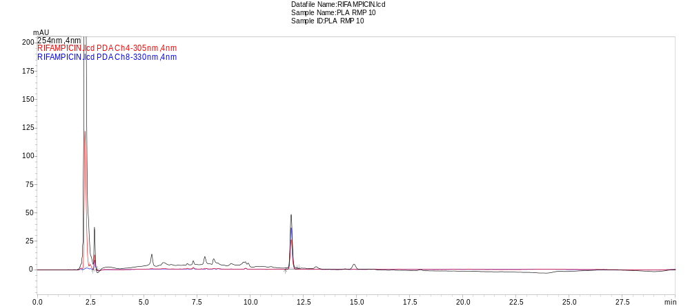
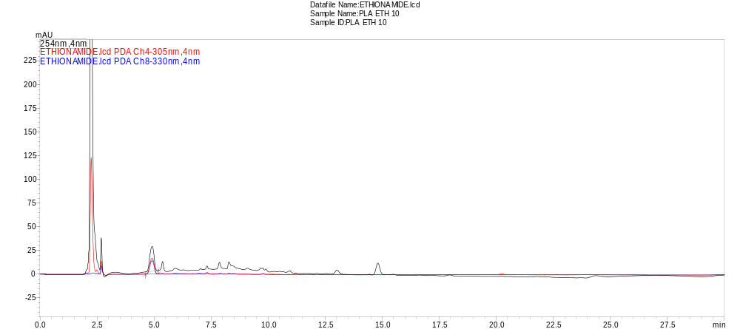
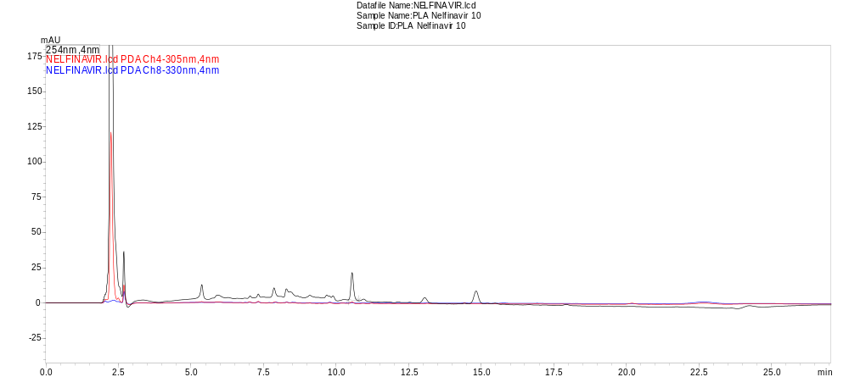
A)

11.93

B)

Response in mAU

4.91

C)

10.54

Minutes
Representative chromatograms of rifampicin (A), ethionamide (B) and nelfinavir (C) in drug-free human plasma eluted at different retention time and detected at 254nm, 305nm and 330nm, analyzed the optimized chromatographic conditions of the method.

