EXECUTIVE FUNCTION SKILLS SCALE
The Executive Function Skills Scale has been developed for use with children aged 60-72 months. The instructions and scale items have been designed to appeal to children in this age group. The scale booklet includes explanations about the scale, scale items, administration instructions, scoring criteria, and a scoring key. Since each child's interests and abilities differ, the administrator must be aware of this when approaching children. To help the child relax, it may be beneficial to start by talking about things they enjoy, beyond the items on the scale. Especially with shy children, the process can be facilitated by initiating conversation using the materials available in the administration room.

EXPLANATIONS AND RULES REGARDING THE SCALE
The practitioner must read the instructions before administering the scale. Furthermore, the practitioner should not change the order of the items, the format of the instructions, or the scoring criteria. Furthermore, the administrator needs to administer the scale items to the child face-to-face and one-on-one, draw the child's attention to the items, make necessary comments to facilitate transitions between items, and support the child when necessary.
The scale measures working memory from item 1 to item 12, cognitive flexibility from item 13 to item 18, and inhibitory control from item 19 to item 23.
Working memory consists of verbal memory (number recall, word recall, nonsense word recall, backward number recall, and first word recall) and visual memory (pattern matrix, block recall, selecting the odd one out, spatial location, pattern formation) items (1-12).
Cognitive flexibility consists of items such as part-whole, reasoning, counting, fast-slow, discrimination, reading graphics, and hand-eye coordination (items 13-18).
Inhibitory control consists of the following components (19-23): impulse control, response inhibition, and deliberate responding.

SCALE SCORING
The scale is scored on a scale of 0, 1, 2, and 3. If the child does not respond to the item or gives an incorrect answer, they receive '0' points; if they answer only one of the options in the item, they receive '1' point; if they answer two, they receive '2' points; if they answer all of them, they receive '3' points. If the child does not respond to the item at all, the item is repeated once, and if the child still does not respond after the repetition, the child is given a score of '0'. However, if the child gives an incorrect response to the item the first time, the item is not repeated, and a score of '0' is given. In addition, the scale is scored separately in the scoring criteria for each item.

SCALE DURATION
The administration of the 23-item scale takes approximately 35 minutes. This may vary depending on the administrator and the child. If the child has conditions such as illness or lack of motivation, the scale items should not be administered to the child. Furthermore, the scale must be completed by the administrator in a single session.

SCALE MATERIALS
The materials used in the scale should be prepared before the application, and a pen and paper must be available in addition to the materials. The materials for each item are in the material file. A stopwatch should also be available for timed items. The materials are listed below.
Item 1: Number sequence cards for the sample application and main application
Item 2: Number sequence cards for the sample application and main application
Item 3: Since this item, prepared for number recall, includes verbal instructions,
there are no material.
Item 4: Since this item, prepared for number recall, contains verbal instructions,
there is no material.
Item 5: Number sequence cards for sample application and main application
Item 6: Number sequence cards for the sample application and the main application
Item 7: Since this item, prepared for word recall, contains verbal instructions,
there is no material.
Item 8: Since this item, which was prepared for word recall, contains verbal instructions,
there is no material.
Item 9: Cards for selecting the same item
Item 10: Cards for selecting the different ones
Item 11: Direction cards
Item 12: Pattern cards
Item 13: Part-whole cards
Item 14: Reasoning cards
Item 15: Reasoning card
Item 16: Counting Cards
Item 17: Discrimination Card
Item 18: Hand-eye coordination card, pencil
Item 19: Summer/Winter Clothing Cards
Item 20: Yellow, red, and green colored papers
Item 21: Object cards starting with A and T
Item 22: In this item, prepare for forming sentences from words and verbal expressions
Therefore, no material has been used.
Item 23: Hot-cold cards

APPLICATION ENVIRONMENT
The application environment at the scale must be free of noise, well ventilated, and well lit so the child can focus on the items. Additionally, the table on which the scale will be administered must be large enough for the child to see the items, and there should be no materials on or around it that could distract the child. Furthermore, no one other than the administrator and the child should be present in the room while the scale items are being administered.

Working Memory Sample Item

Item 5

Material: Number sequence cards for the sample application and the main application
Sample Application
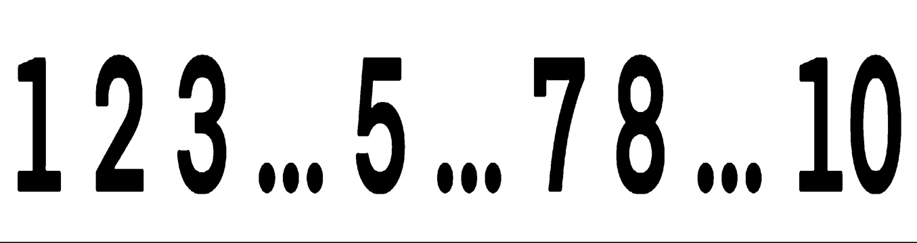
Sample Application and Instructions: The practitioner says, "Let's count backward from 10 together," and counts backward from 10 with the child. Then says, "Now I'm going to show you a card with numbers on it. Some numbers are missing from this card, and I want you to tell me the missing numbers," and shows the card to the child. "Now look at the numbers on the card and tell me the missing numbers from the end to the beginning," and waits for the child to say the numbers 9, 6, 4 in order.
If the child answers correctly, the practitioner says, "Now let's try again," shows the card, and waits for the child to say the numbers from the end to the beginning. They turn the card over and say to the child, "Now repeat the missing numbers in the sequence from the end to the beginning." If the child answers correctly on both attempts, they move on to the main application.
If the child gives the wrong answer and fails the second attempt, the practitioner says, "Now I will say the missing numbers from the end to the beginning. Then you will repeat them," and says the numbers (9, 6, 4). If the child still gives the wrong answer, the practitioner says, "The missing numbers are 9, 6, 4, and you must repeat these numbers in order. Now repeat them." In this case, even if the child gives the wrong answer, no assistance is provided in answering, and the principal application proceeds.
Main Application
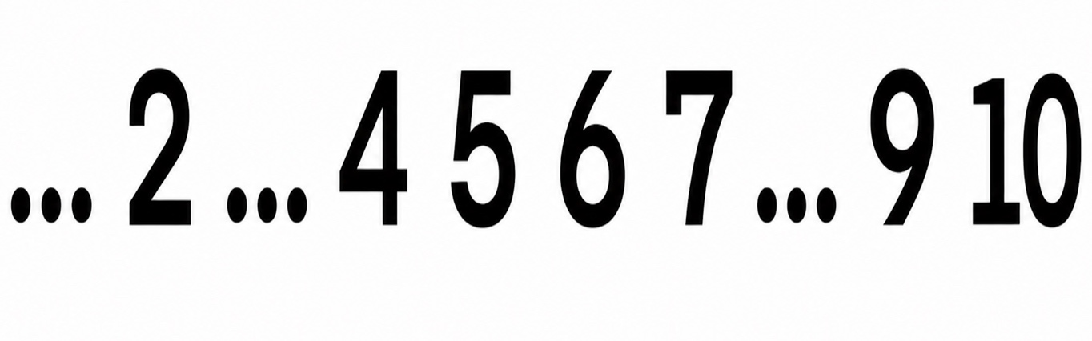
Application and Instructions: The practitioner shows the card to the child. After the child has examined the card for five seconds, the administrator says, "Now say the missing numbers on the card in order from the end to the beginning," and waits for the child to say the numbers in order. Then, turning the card over, the administrator says, "Now repeat the missing numbers in the sequence in order from the end to the beginning," and waits 10 seconds for the child to say the numbers. If the child does not respond within this time, the administrator says, "Now I will say the numbers," and says the numbers "8, 3, 1." The administrator waits another 10 seconds for the child to recite the numbers, then proceeds to the following item.

Item 5 Scoring Criteria
 | Score | Criteria
Correct response | 3 | She/he said the numbers were 8, 3, 1.
Insufficient answer | 2 | She/he correctly identified two of the numbers. For example, "She/he said 8, 3, 4." In this example, she/he only got the orders 8 and 3 correct, so she/he gets 2 points.
Insufficient answer | 1 | She/he correctly identified one of the numbers. For example, "She/he said 8, 1, 3." In this example, only one point is given because she/he said the number 8 in the correct order. Also, if the child says a single number and that number is not in the first position, no points are given. For example, the child said the number 1. Since this number is in the third position, no points are given.
Did not respond | 0 | Did not give the correct answer.

Cognitive Flexibility Example Item
Item 13

Material: Part-whole cards
Application
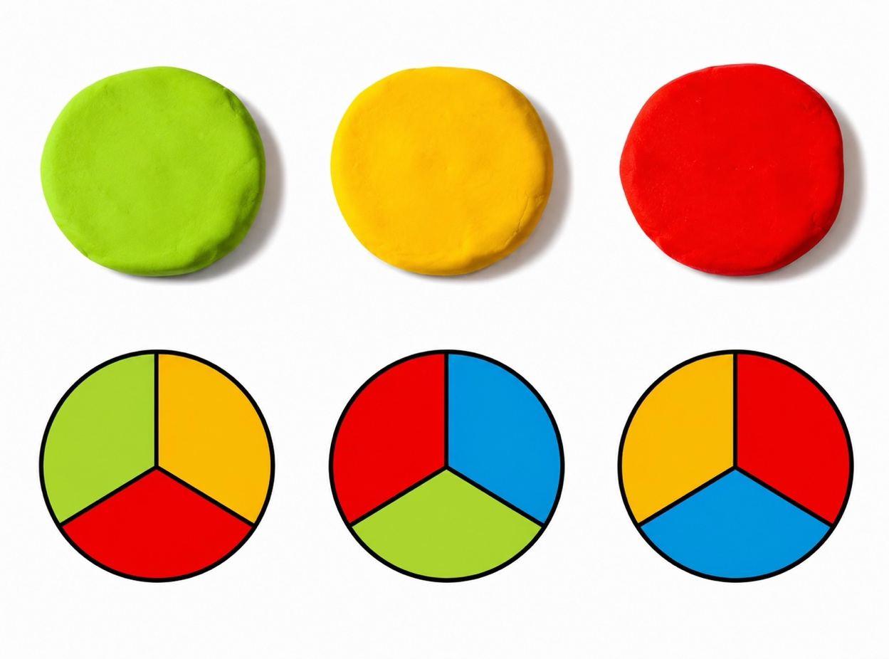
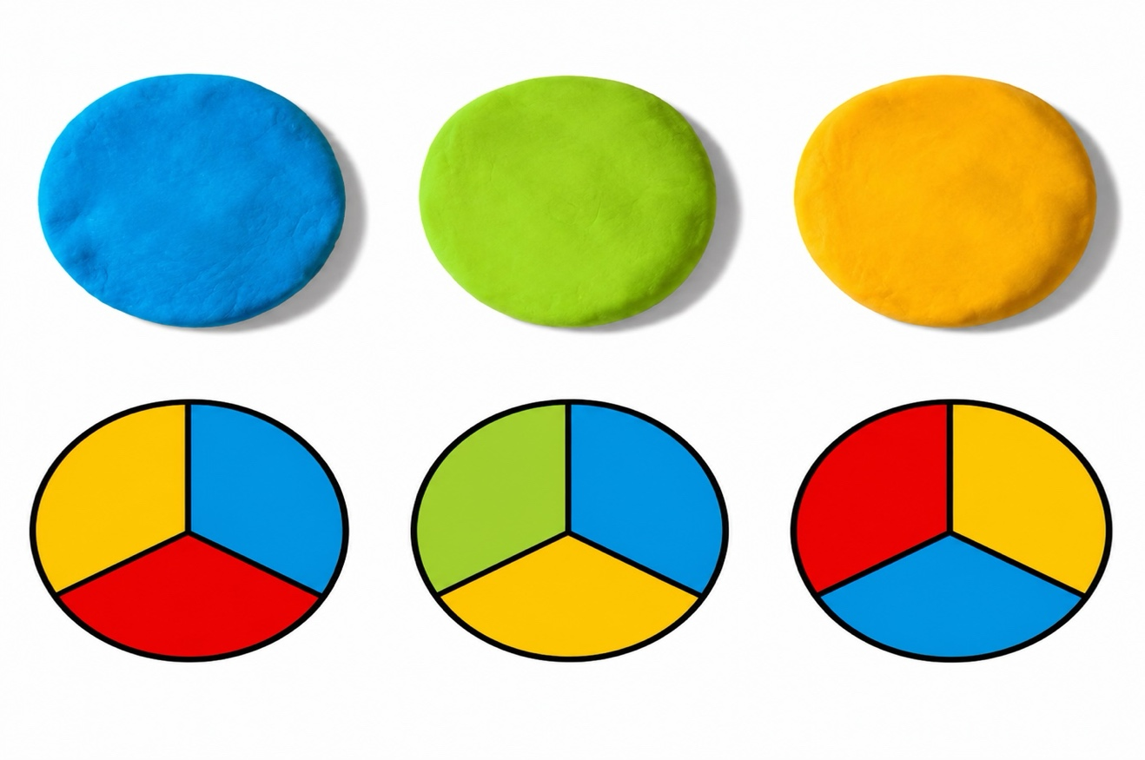
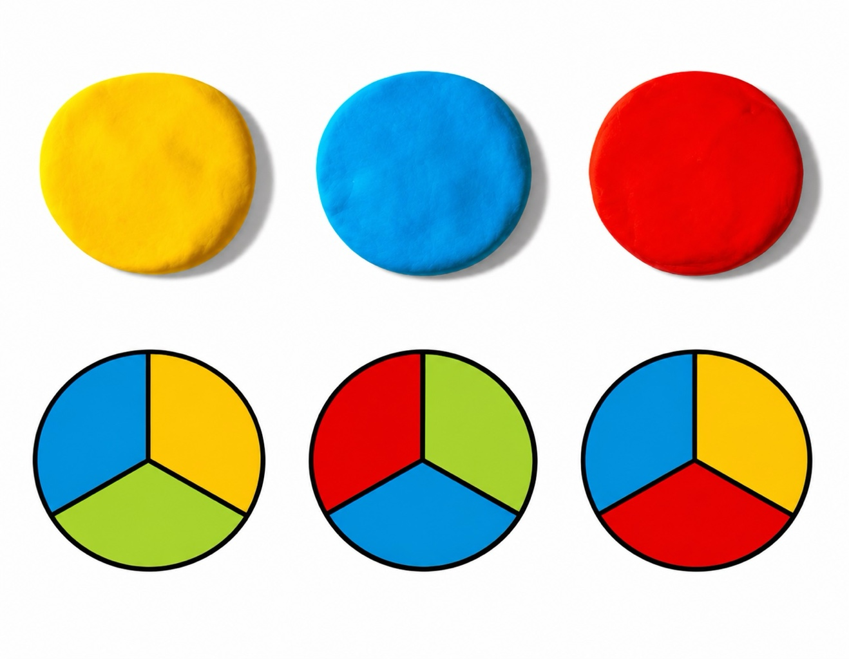
Application and Instructions: The administrator waits for 10 seconds for the child to examine the colors of the play dough, saying, "Carefully examine the colors of the play dough on the card I showed you." The administrator then asks, "In which of the following shapes do you see the colors of the Play-Doh?" If the child does not respond within 10 seconds, the question is repeated once more, and after waiting 10 seconds, the second image is shown. If the child does not respond to the second image within 10 seconds, the question is repeated once more, and after waiting 10 seconds, the third image is shown. If the child does not respond to the third image within 10 seconds, the question is repeated once more, and after waiting 10 seconds, the following item is presented.

Item 13 Scoring Criteria
 | Score | Criteria
Correct answer | 3 | Correctly identified/described three shapes.
Insufficient answer | 2 | Correctly identified/described two shapes.
Insufficient answer | 1 | Correctly identified/described one shapes.
Did not respond | 0 | Did not give the correct answer.

Inhibitory Control Example Item

Item 23
Material: Hot-cold cards
Sample Application

Example Application and Instructions: The practitioner places the cards in front of the child and says, "Now I will choose one of these cards and show it to you. When you see the hot card, I want you to say 'cold,' and when you see the cold card, I want you to say 'hot.' Now let's try it." The practitioner then shows the child one card (for example, the hot card).
If the child gives the correct answer, the practitioner says, "Now let's try again," and shows the second card (cold). If the child gives the correct answer in both trials, the actual application begins.
If the child gives the wrong answer, the practitioner says, "When you see the card related to hot, you will say 'cold'. Now let's try again," and shows the card again. If the child fails the second trial as well, the practitioner says, "There is a sun on this card. This represents hot. You should say 'cold' when you see a card that is hot. Let's try again," and shows the card again. In this case, even if the child gives the wrong answer, no help is provided in answering, and the main application is started.

Main Application
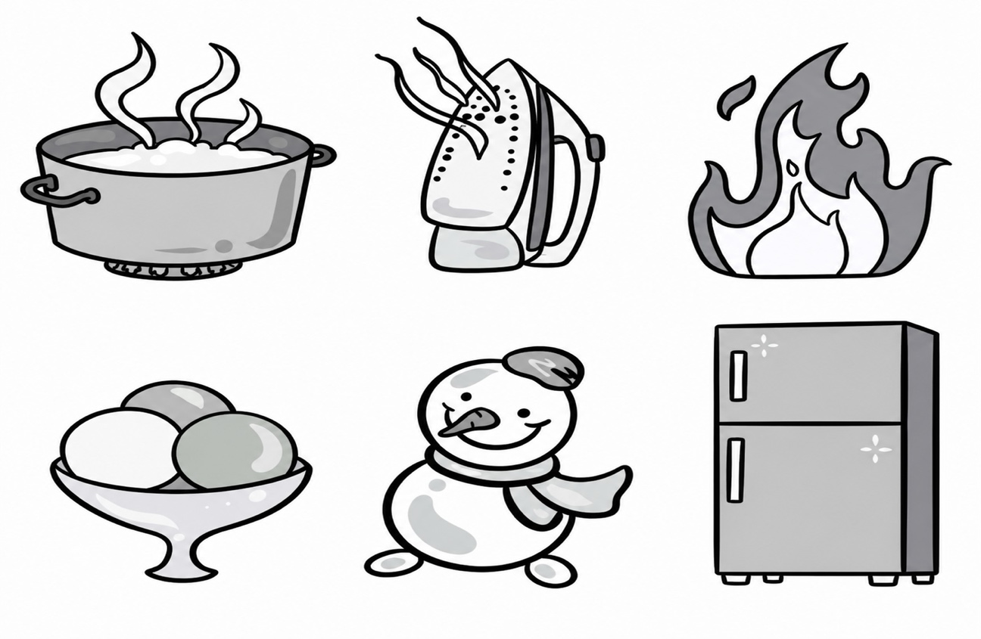
Application and Instructions: The practitioner points to the main application cards and says, "Separate the hot/cold objects on these cards." After the cards are separated (hot/cold) with the child, the practitioner says, "Now I will select one of the cards and show it to you. When you see the card related to hot, I want you to say 'cold,' and when you see the card related to cold, I want you to say 'hot.'" and shows one of the cards to the child. If the child does not respond after 10 seconds, the card is shown again, and then the second card is shown. The application needs to be performed three times.

Item 23 Scoring Criteria

 | Score | Criteria
Correct response | 3 | She/he answered three questions correctly.
Insufficient answer | 2 | She/he answered two applications correctly.
Insufficient answer | 1 | She/he answered one application correctly.
Did not respond | 0 | Did not give the correct answer.

