Supplementary Online Content

Fischer H, Gaisl T, Forrer A, et al. Acclimatization effects on partial pressure of arterial oxygen at high altitude: A systematic review and meta-analysis

eMethods. Literature Search, Risk of Bias Assessment, Statistics
eResults. Study Exclusion and Risk of Bias Assessment
eTable 1. Time Domains and Altitudes of Included Studies
eTable 2. Characteristics of Included Studies
eTable 3. Risk of Bias Assessment
eFigure 1. Galbraith Plot
eFigure 2. Funnel Plot
eFigure 3. Trajectory Plot.
eReferences

eMethods

Literature Search
The following search terms were used to identify eligible studies in the databases of PubMed (Medline, PubMed Central, Bookshelf) and Embase with a cut-off date of 04.10.2025:
In PubMed: (blood OR (arterial blood)) AND (gas OR gases) AND (altitude OR (hypobaric chamber) OR (altitude simulation) OR flight) NOT (review [Publication Type])
+ filter: Human and > 19 (age)
In Embase: (blood OR 'arterial blood') AND (gas OR gases) AND (altitude OR 'hypobaric chamber' OR 'altitude simulation' OR flight).
+ filter: Human and 18-64years, 65+ and 80+ years

Risk of Bias Assessment
As done in Forrer et al. 2023 [1], all included studies were assessed for the risk of bias, using the Quality Assessment Tool for Observational Cohort and Cross-Sectional Studies from the National Heart, Lung and Blood Institute [2]. Two researchers independently applied the tool, which consists of 14 questions, to each study, focusing on our primary outcome (here: PaO₂ at HA). The questions were answered either 'yes', 'no' or 'NR' (not reported) if the study did not provide an answer. Each study was then quality-rated according to a system by Bagias et al 2021 [3]. If the answer was "yes" to > 10 questions, the risk of bias was considered low; 4-10 was considered as moderate risk of bias; and <4 was considered as high risk of bias. Questions 9 “Were the exposure measures (independent variables) clearly defined, valid, reliable, and implemented consistently across all study participants?” and 11 “Were the outcome measures (dependent variables) clearly defined, valid, reliable, and implemented consistently across all study participants?” were of particular importance because exposure (time at HA) and outcome measures (ABG condition and values) were critical for PaO₂. If the values for PaO₂ were not clearly presented, i.e. in graphs rather than numbers, the answer to question 11 was "no".

eResults

Study Exclusion
A Galbraith plot of the TDD group revealed three visual outliers[4-6] (eFigure 1). After careful reconsideration, only one study[6] was excluded, as it presented imprecise data in graphical form without numerical values. The other two studies[4,5] were retained, as no major measurement errors or other inconsistencies could be identified, and they were plausible.
Risk of Bias Assessment
All 39 studies were assessed for risk of bias. 2 studies were rated as "low risk of bias", 20 as "moderate risk of bias" and 17 as "high risk of bias" (eTable 3). Question 3 "Was the participation rate of eligible persons at least 50%?" was usually answered with NR, as no flow chart with study selection criteria was provided. However, two studies[7,8] provided a detailed list of exclusion criteria, so we decided to answer the question with yes. Question 8 “For exposures that can vary in amount or level, did the study examine different levels of the exposure as related to the outcome?” and 10 “Was the exposure(s) assessed more than once over time?” were always answered with yes, because our exposure of interest is time at HA, which was always assessed at least twice, otherwise the study would have been excluded beforehand (see flowchart Figure 1). Question 12 and 14 were always answered negative since blinding at high altitude is only feasible in a hypobaric chamber.

eTable 1. Time domains and altitude of all 39 included studies.
Authors | Freq. | Meters | First measurement (days) | Last measurement (days) | TDD group | DO subgroup
Bailey et al. 2010 | 2 | 4559 | 0.125 | 0.83
Bärtsch et al. 1991 | 4 | 4559 | 0.17 | 2.8
Bender et al. 1988 | 2 | 4300 | 0 | 18
Berger et al. 2009 | 2 | 4559 | 0.167 | 0.83
Bird et al. 2021 | 2 | 3800 | 0.5 | 8
Burgess et al. 2013 | 2 | 5050 | 3 | 13.5
Calbet et al. 2003 | 1 | 5260 | 63 | 63
Dempsey et al. 1972 | 3 | 3100 | 4 | 45
Dempsey et al. 1974 | 3 | 3100 | 0.0417 | 24.5
Eldridge et al. 2006 | 4 | 3810 | 1 | 1.6875
Erba et al. 2004 | 4 | 4559 | 0.25 | 0.8
Frayser et al. 1974 | 2 | 5334 | 3 | 8
Goerre et al. 1995 | 3 | 4559 | 0.8 | 1.8
Hannon et al. 1977 | 3 | 4300 | 2 | 14
Hansen et al. 2003 | 1 | 5260 | 32 | 32
Hartmann et al. 1974 | 2 | 1600 | 0 | 11
Howe et al. 2019 | 2 | 5055 | 1 | 9
Hupperets et al. 2004 | 4 | 3800 | 14 | 56
Hussain et al. 2001 | 2 | 4578 | 1 | 3
Imray et al. 2003 | 2 | 3459 | 0.5 | 0.5083
Kronenberg et al. 1967 | 2 | 4267 | 1 | 3
Leacy et al. 2025 | 2 | 3800 | 1 | 8
Loppkey et al. 2001 | 4 | 4880 | 0.04 | 0.5
Lucas et al. 2011 | 3 | 5050 | 3 | 13.5
Lundby et al. 2018 | 2 | 4100 | 12 | 54
Mairbäurl et al. 2003 | 2 | 4559 | 0.0625 | 0.75
Moncloa et al. 1970 | 3 | 4267 | 0.23 | 0.9
Naughton et al. 1995 | 6 | 2438 | 0.00347 | 0.02778
Reeves et al. 1969 | 6 | 4572 | 0.021 | 0.083
Röggla et al. 2001 | 2 | 2600 | 0 | 0.08
Sevre et al. 2001 | 2 | 4500 | 0 | 3
Skalla et al. 2025 | 2 | 3100 | 1 | 1.833
Spliethoff et al. 2013 | 2 | 4559 | 0.8 | 2.8
Steele et al. 2020 | 2 | 4330 | 0.5 | 7
Sutton et al. 1976 | 3 | 5360 | 0.0417 | 4
Wolfel et al. 1991 | 2 | 4300 | 0.083 | 21
Wolfel et al. 1998 | 2 | 4300 | 0.083 | 21
Xie et al. 2019 | 2 | 4000 | 0.01 | 0.083
Young et al. 1996 | 2 | 4300 | 0.5 | 9
The frequency indicates the number of different time points at which ABGs were taken at the high altitude, and metres indicate the altitude at which the study was carried out.

eTable 2. Characteristics of included studies.
Index | Publication | Altitude [m] | Analyzer | N (max), % male | Demographics (Age and BMI) | Arterial blood gases at HA [kPa], first sample | Time upon arrival [d] | Arterial blood gases at HA [kPa], samples during acclimatization | Time upon arrival [d]
1 | Erba et al.[9], 2004 | 4559¹ | Ciba-Corning Diagnostics | Two groups:  10, 90 %  11, 82 % | First group:  Age, y: 32±12;  BMI, kg/m²: 23.5±2.1  Second group:  Age, y: 39±12;  BMI, kg/m²: 23.4±2.8 | First group:  PaO2, kPa: 6.4±0.67  PaCO2, kPa: 3.47±0.67  SaO2, %: 87±7  pH: 7.56±0.07  Second group:  PaO2, kPa: 6.27±0.93  PaCO2, kPa: 3.2±0.4  SaO2, %: 88±7  pH: 7.58±0.06 | First group:  0.25  Second group:  0.25 | First group:  PaO2, kPa: 6.93±1.73  PaCO2, kPa: 3.4±0.67  SaO2, %: 88±9  pH: 7.54±0.04  Second group:  PaO2, kPa: 6.13±0.93  PaCO2, kPa: 3.2±0.27  SaO2, %: 86±8  pH: 7.55±0.06 | First group:  0.8  Second group:  0.8
2 | Howe et al.[10], 2019 | 5055¹ | ABL90 FLEX, Radiometer | 13, 100% | Age, y: 27±5 ;  BMI, kg/m²: 23.2±2.1 | PaO2, kPa: 5.41±0.63  PaCO2, kPa: 3.95±0.24  SaO2, %:78.3±5.6  pH: 7.47±0.02 | 1 | PaO2, kPa: 6.23±0.56  PaCO2, kPa: 3.15±0.28  SaO2, %:83.3±4.1  pH: 7.5±0.02 | 9
3 | Hussain et al.[11], 2001 | 4578¹ | GEMSTAT blood gas-electrolyte analyser, Mallincrodt Sensor System | 6, 100 % | Age, y: 27.8±1.24,  range 25-35;  BMI, kg/m²: NR | PaO2, kPa: 5.73±0.6  PaCO2, kPa: 4.31±0.4  SaO2, %: 77.08±5.3  pH: NR | 1 | PaO2, kPa: 6.27±0.4  PaCO2, kPa: 4.16±0.2  SaO2, %: 82.27±6.8  pH: NR | 3
4 | Kronenberg et al.[12], 1967 | 4267² | NR | 23, 100% | Age, y: NR;  BMI, kg/m²: NR | PaO2, kPa: 5.48±0.9  PaCO2, kPa: 3.8±0.4  SaO2, %: NR  pH: 7.49±0.05 | 1 | PaO2, kPa: 5.92±1  PaCO2, kPa: 3.64±0.6  SaO2, %: NR  pH: 7.5±0.03 | 3
5 | Loeppkey et al.[13], 2001 | 4880² | Model 520, Radiometer | Two groups:  18, 100 %  32, 0 % | First group:  Age, y: 27.4±3.2;  BMI, kg/m²: NR  Second group:  Age, y: 27.2±4.5;  BMI, kg/m²: NR | First group:  PaO2, kPa: 5.9±0.2  PaCO2, kPa: 4.76±0.3  SaO2, %: 79.5±5.1  pH: 7.44±0.02  Second group:  PaO2, kPa: 5.79±0.5  PaCO2, kPa: 4.28±0.3  SaO2, %: 79.7±4  pH: 7.46±0.02 | First group:  0.04  Second group:  0.04 | First group:  PaO2, kPa: 5.87±0.7  PaCO2, kPa: 4.15±0.3  SaO2, %: 78.7±7.2  pH: 7.47±0.02  Second group:  PaO2, kPa: 5.7±0.5  PaCO2, kPa: 3.81±0.4  SaO2, %: 78.3±4  pH: 7.47±0.02 | First group:  0.5  Second group:  0.5
Index | Publication | Altitude [m] | Analyzer | N (max), % male | Demographics (Age and BMI) | Arterial blood gases at HA [kPa], first sample | Time upon arrival [d] | Arterial blood gases at HA [kPa], samples during acclimatization | Time upon arrival [d]
6 | Röggla et al.[14], 2001 | 2600¹ | NR | 8, 100 % | Age, y: NR  range 24-42;  BMI, kg/m²: NR | PaO2, kPa: 9.17±0.5  PaCO2, kPa: 4.75±0.16  SaO2, %: NR  pH: NR | 0 | PaO2, kPa: 9.3±0.44  PaCO2, kPa: 4.53±0.07  SaO2, %: NR  pH: NR | 0.08
7 | Hupperets et al.[15], 2004 | 3800¹ | Gem 3000 and IL 1735, Instrumentation Laboratories | 5, 80 % | Age, y: 29±4;  BMI, kg/m²: NR | PaO2, kPa: 7.32±0.5  PaCO2, kPa: 3.75±0.2  SaO2, %: 88.1±2.6  pH: 7.43±0.02 | 14 | PaO2, kPa: 7.52±0.6 / 7.73±0.3 / 7.65±0.4  PaCO2, kPa: 3.92±0.2 / 3.93±0.2 / 3.72±0.2  SaO2, %:88.4±2.9 / 89.3±2.2 / 89.5±1.6  pH: 7.43±0.02 / 7.43±0.02 / 7.42±0.02 | 28/42/56
8 | Bailey et al.[16], 2010 | 4559¹ | ABL 5, Radiometer | 26, NR | Age, y: 36±10;  BMI, kg/m²: NR | PaO2, kPa: 5.07±0.4  PaCO2, kPa: 3.87±0.4  SaO2, %: 72±5  pH: 7.48±0.02 | 0.125 | PaO2, kPa: 5.47±0.53  PaCO2, kPa: 3.73±0.27  SaO2, %: 74±5  pH: 7.47±0.08 | 0.83
9 | Bartsch et al.[17], 1991 | 4559¹ | 278 blood gas system, Ciba Corning Diagnostics | 7, 100 % | Age, y: 30,  range 20-64;  BMI, kg/m²: NR | PaO2, kPa: 5.24±0.6  PaCO2, kPa: 4.12±0.2  SaO2, %:70±6.9  pH: NR | 0.17 | PaO2, kPa: 5.68±0.5 / 5.97±0.7 / 6.2±0.7  PaCO2, kPa: 3.93±0.4 / 3.91±0.2 / 3.83±0.4  SaO2, %: 73±10.6 / 80±5.5 / 78±5.3  pH: NR | 0.8/1.8/2.8
10 | Burgess et al.[18], 2013 | 5050¹ | NPT 7 series, Radiometer | 12, 67 % | Age, y: 30±10;  BMI, kg/m²: 23±3 | PaO2, kPa: 5.73±0.4  PaCO2, kPa: 3.87±0.4  SaO2, %: NR  pH: 7.47±0.03 | 3 | PaO2, kPa: 6.4±0.4  PaCO2, kPa: 3.47±0.27  SaO2, %: NR  pH: 7.44±0.03 | 13.5
11 | Frayser et al.[19], 1974 | 5334¹ | Instrumetation Laboratories blood gas analyzer | 8, 100 % | Age, y: NR,  range 19-37;  BMI, kg/m²: NR | PaO2, kPa: 4.81±0.8  PaCO2, kPa: 3.61±0.3  SaO2, %: NR  pH: 7.5±0.03 | 3 | PaO2, kPa: 5.64±0.8  PaCO2, kPa: 3±0.3  SaO2, %: NR  pH: 7.46±0.03 | 8
12 | Goerre et al.[20], 1995 | 4559¹ | 278 blood gas system, Ciba Corning Diagnostics | 10, NR | Age, y: NR,  range 21-54;  BMI, kg/m²: NR | PaO2, kPa: 5.81±0.61  PaCO2, kPa: 3.8±0.31  SaO2, %: NR  pH: 7.5±0.03 | 0.08 | PaO2, kPa: 5.89±0.69 / 5.88±0.59  PaCO2, kPa: 3.84±0.45 / 3.91±0.52  SaO2, %: NR  pH: 7.47±0.03 / 7.46±0.02 | 0.8/1.8
Index | Publication | Altitude [m] | Analyzer | N (max), % male | Demographics (Age and BMI) | Arterial blood gases at HA [kPa], first sample | Time upon arrival [d] | Arterial blood gases at HA [kPa], samples during acclimatization | Time upon arrival [d]
13 | Berger et al.[21], 2009 | 4559¹ | ABL 5, Radiometer | 26, 85 % | Age, y: 36.9±9.9;  BMI, kg/m²: NR | PaO2, kPa: 5.2±0.4  PaCO2, kPa: 3.83±0.46  SaO2, %: NR  pH: 7.48±0.023 | 0.167 | PaO2, kPa: 5.47±0.53  PaCO2, kPa: 3.71±0.3  SaO2, %: NR  pH: 7.465±0.017 | 0.83
14 | Hannon et al.[22], 1977 | 4300¹ | Radiometer electrode system | 6, 100 % | Age, y: NR,  range 20-23;  BMI, kg/m²: NR | PaO2, kPa: 5.73±0.42  PaCO2, kPa: 4.41±0.28  SaO2, %: 77±4  pH: 7.404±0.017 | 2 | PaO2, kPa: 6.41±0.5/ 6.93±0.5  PaCO2, kPa: 4.06±0.51 / 3.58±0.14  SaO2, %: 82±5 / 87±1.5  pH: 7.413±0.023 / 7.438±0.017 | 5/14
15 | Lundby et al.[5], 2018 | 4100¹ | ABL 510, Radiometer | 8, 75 % | Age, y: 25,  range 22-31;  BMI, kg/m²: NR | PaO2, kPa: 6.8±0.17  PaCO2, kPa: 3.47±0.05  SaO2, %:89.7±0.8  pH: 7.46±0.01 | 12 | PaO2, kPa: 7.2±0.16  PaCO2, kPa: 3.33±0.05  SaO2, %:90±0.4  pH: 7.46±0.01 | 54
16 | Mairbäurl et al.[23], 2003 | 4559¹ | model 287, Ciba-Corning Diagnostics Analyzer and Co-oximeter | 12, 67 % | Age, y: 40.5±8.6,  range 24-52;  BMI, kg/m²: NR | PaO2, kPa: 5.29±0.53  PaCO2, kPa: 3.48±0.45  SaO2, %:77.1±5.8  pH: 7.485±0.026 | 0.063 | PaO2, kPa: 5.45±0.64  PaCO2, kPa: 3.25±0.69  SaO2, %:79.2±5.3  pH: 7.5±0.048 | 0.75
17 | Moncloa et al.[24], 1970 | 4267¹ | ph Meter (Radiometer, model 27), Clark electrode, Severinghause electrode | 12, 100 % | Age, y: NR  Range 19-29;  BMI, kg/m²: NR | PaO2, kPa: 6.4±0.9  PaCO2, kPa: 4.79±0.4  SaO2, %: NR  pH: 7.431±0.03 | 0.23 | PaO2, kPa: 6.03±0.5 / 6.03±0.4  PaCO2, kPa: 4.65±0.3 / 4.64±0.4  SaO2, %: NR  pH: 7.438±0.04 / 7.45±0.02 | 0.56/0.9
18 | Reeves et al.[25], 1969 | 4572² | model 113 pH and gas analyzer, Instrumentation Laboratory | Two groups (sometimes more than one BGA sample per subject):  7, 100 %  6 (from the previous 7), 100 % | Age, y: 26,  range 21-36;  BMI, kg/m²: NR | First group:  PaO2, kPa: 5.2±0.53  PaCO2, kPa: 4.27±0.27  SaO2, %: NR  pH: 7.46±0.02  Second group :  PaO2, kPa: 4.27±0.4  PaCO2, kPa: 4±0.4  SaO2, %: NR  pH: 7.46±0.01 | First group:  0.21  Second group:  0.047 | First group:  PaO2, kPa: 4.8±0.4 / 4.8±0.53 / 4.67±0.67  PaCO2, kPa: 4±0.53 / 4±0.27/ 3.6±0.27  SaO2, %: NR  pH: 7.46±0.03 / 7.47±0.02 / 7.49±0.02  Second group:  PaO2, kPa: 4.27±0.4  PaCO2, kPa: 3.47±0.4  SaO2, %: NR  pH: 7.5±0.01 | First group:  0.047/0.073/  00.083  Second group:  0.073
Index | Publication | Altitude [m] | Analyzer | N (max), % male | Demographics (Age and BMI) | Arterial blood gases at HA [kPa], first sample | Time upon arrival [d] | Arterial blood gases at HA [kPa], samples during acclimatization | Time upon arrival [d]
19 | Sevre et al.[4], 2001 | 4500² | IRMA Blood Analyser (Model 400201), Diametrics | 12, 86 % | Age, y: 23.6,  range 20-28  BMI, kg/m²: NR | PaO2, kPa: 4.84±0.9  PaCO2, kPa: 3.42±0.3  SaO2, %: 77.4±6.9  pH: 7.48±0.07 | 0.625 | PaO2, kPa: 5.61±0.6  PaCO2, kPa: 4.19±0.4  SaO2, %: 81.7±3.2  pH: 7.39±0.06 | 3
20 | Imray et al.[26], 2003 | 3459¹ | AVL OPTI 1 Blood Gas/pH Analyser | 10, 100 % | Age, y: NR,  range 24-53;  BMI, kg/m²: NR | PaO2, kPa: 6.5±0.5  PaCO2, kPa: 3.78±0.36  SaO2, %: NR  pH: 7.49±0.02 | 0.5 | PaO2, kPa: 6.6±0.6  PaCO2, kPa: 3.81±0.46  SaO2, %: NR  pH: 7.49±0.02 | 0.0508
21 | Steele et al.[27], 2020 | 4330¹ | point-of-care device i-STAT, Abbott Laboratories | 24, 83 % | Age, y: 28.6±6.4,  range 22-50;  BMI, kg/m²: 24.3±2.4 | PaO2, kPa: 5.53±0.97  PaCO2, kPa: 4.41±0.44  SaO2, %: 78.9±8.4  pH: 7.48±0.034 | 0.5 | PaO2, kPa: 6.76±0.52  PaCO2, kPa: 3.76±0.35  SaO2, %: 87.6±2.1  pH: 7.45±0.031 | 7
22 | Wolfel et al.[28], 1991 | 4300¹ | ABL 300, Radiometer | 7, 100 % | Age, y: 23±5.3;  BMI, kg/m²: NR | PaO2, kPa: 5.47±0.3  PaCO2, kPa: 4±0.3  SaO2, %: 81±2.6  pH: NR | 0.083 | PaO2, kPa: 6.67±0.3  PaCO2, kPa: 3.07±0.3  SaO2, %: 87±2.6  pH: NR | 21
23 | Wolfel et al.[29], 1998 | 4300¹ | ABL 300, Radiometer | 5, 100 % | Age, y: 26.7±3.98;  BMI, kg/m²: NR | PaO2, kPa: 5.33±0.6  PaCO2, kPa: 3.87±0.3  SaO2, %: 79±4.5  pH: 7.49±0.02 | 0.083 | PaO2, kPa: 6.27±0.3  PaCO2, kPa: 3.07±0.3  SaO2, %: 85±2.2  pH: 7.49±0.02 | 21
24 | Young et al.[30], 1996 | 4300¹ | Radiometer ABL 300 blood gas analyzer and OSM3 hemoximeter | 8, 100 % | Age, y: 31±2.8;  BMI, kg/m²: NR | PaO2, kPa: 6.27±0.8  PaCO2, kPa: 3.47±0.4  SaO2, %: 83.2±5.7  pH: 7.49±0.03 | 0.5 | PaO2, kPa: 7.07±0.8  PaCO2, kPa: 2.8±0.4  SaO2, %: 87.6±6.5  pH: 7.49±0.03 | 9
25 | Xie et al.[8], 2019 | 4000² | IL-1304, Instrumentation Laboratory | 25, 56 % | Age, y: 26.6±3.3,  range 21-33;  BMI, kg/m²: NR | PaO2, kPa: 5.87±1  PaCO2, kPa: 4.23±0.51  SaO2, %: 80.98±6.68  pH: 7.42±0.03 | 0.01 | PaO2, kPa: 6.29±1.45  PaCO2, kPa: 4.22±0.43  SaO2, %: 82.6±6.1  pH: 7.41±0.02 | 0.083

Index | Publication | Altitude [m] | Analyzer | N (max), % male | Demographics (Age and BMI) | Arterial blood gases at HA [kPa], first sample | Time upon arrival [d] | Arterial blood gases at HA [kPa], samples during acclimatization | Time upon arrival [d]
26 | Hartmann et al.[31], 1974 | 1600¹ | Gas-Check-AVL-Mikroblutgasanalysator | 15, 27 % | Age, y: 33.4,  range 21-61;  BMI, kg/m²: NR | PaO2, kPa: 9.64±0.78  PaCO2, kPa: 4.87±0.47  SaO2, %: NR  pH: 7.394±0.025 | 0 | PaO2, kPa: 9.74±0.82  PaCO2, kPa: 4.88±0.37  SaO2, %: NR  pH: 7.39±0.033 | 11
27 | Bird et al.[7], 2021 | 3800¹ | Abbott iSTAT, GC4+ and CHEM8+ cartridges | 16, 69 % | Age, y: 31.3±11.7;  BMI, kg/m²: 26±3.8 | PaO2, kPa: 6.73±0.69  PaCO2, kPa: 4.57±0.37  SaO2, %: 85.8±3.8  pH: 7.424±0.017 | 0.5 | PaO2, kPa: 7.17±0.55  PaCO2, kPa: 4.07±0.24  SaO2, %: 88.3±1.9  pH: 7.42±0.013 | 8
28 | Lucas et al.[32], 2011 | 5050¹ | NPT7 series, Radiometer | 17, 65 % | Age, y: 31±9;  BMI, kg/m²: NR | PaO2, kPa: 5.87±0.4  PaCO2, kPa: 3.87±0.4  SaO2, %: 79.9±3.4  pH: 7.47±0.03 | 3 | PaO2, kPa: 6.13±0.4 / 6.4±0.4  PaCO2, kPa: 3.73±0.27 / 3.47±0.27  SaO2, %: 82.9±3.2 / 85.5±1.7  pH: 7.45±0.02 / 7.43±0.03 | 8/13.5
29 | Naughton et al.[33], 1995 | 2438² | ABL500, Radiometer | 6, NR | Age, y: 36±6,  Range 31-44;  BMI, kg/m²: NR | PaO2, kPa: 7.99±0.4  PaCO2, kPa: NR  SaO2, %: NR  pH: NR | 0.00347 | PaO2, kPa: 8.07±0.3 / 8.16±0.7 / 8.16±0.5 / 8.27±0.2 / 8.72±0.7  PaCO2, kPa: NR  SaO2, %: NR  pH: NR | 0.0069/  0.0104/  0.0139/  0.0208/  0.0278
30 | Dempsey et al.[34], 1972 | 3100¹ | arterial PO2: Clark O2 electrode, ph: Astrup micro-equilibration technique (Siggard-Anderson and Engel, 1960) | 10, 100 % | Age, y: 27.8±1.8,  range 21-40;  BMI, kg/m²: NR | PaO2, kPa: 8.05±0.7  PaCO2, kPa: 4.31±0.2  SaO2, %: NR  pH: 7.418±0.04 | 4 | PaO2, kPa: 8.53±0.4 / 7.76±0.4  PaCO2, kPa: 4.2±0.2 / 4.23±0.3  SaO2, %: NR  pH: 7.424±0.28 / 7.42±0.006 | 21/45
31 | Dempsey et al.[35], 1974 | 3100² | Microelectrodes, Radiometer | 6, 100 % | Age, y: 30.6;  BMI, kg/m²: NR | PaO2, kPa: 6.59±0.4  PaCO2, kPa: 5.25±0.3  SaO2, %: NR  pH: 7.398±0.01 | 0.0417 | PaO2, kPa: 6.93±0.3 / 8.04±0.2  PaCO2, kPa: 4.73±0.2 / 4.31±0.2  SaO2, %: NR  pH: 7.418±0.007 / 7.421±0.01 | 0.33/24.5

Index | Publication | Altitude [m] | Analyzer | N (max), % male | Demographics (Age and BMI) | Arterial blood gases at HA [kPa], first sample | Time upon arrival [d] | Arterial blood gases at HA [kPa], samples during acclimatization | Time upon arrival [d]
32 | Sutton et al.[36], 1976 | 5360¹ | Instrumentation Laboratories blood gas analyzer | 7, 100 % | Age, y: NR,  range 18-30;  BMI, kg/m²: NR | PaO2, kPa: 4.73(4.23-5.33)  PaCO2, kPa: 3.55(3.24-3.94)  SaO2, %: NR  pH: 7.509(7.478-7.535) | 0.042 | PaO2, kPa: 4.67(4.05-5.3) / 5.07(3.87-5.65)  PaCO2, kPa: 3.49(3.35-3.64) / 3.61(3.32-4.02)  SaO2, %: NR  pH: 7.51(7.496-7.522) / 7.465-7.521) | 2/4
33 | Spliethoff et al.[37], 2013 | 4559¹ | ABL 5, Radiometer | 11, 73 % | Age, y: 41±10.8,  Range 22-57;  BMI, kg/m²: 23.52±1.82 | PaO2, kPa: 5.31±0.39  PaCO2, kPa: 3.85±0.28  SaO2, %:77.22±4.39  pH: 7.473±0.017 | 0.8 | PaO2, kPa: 5.67±0.54  PaCO2, kPa: 3.94±0.33  SaO2, %: 80.32±5.35  pH: 7.483±0.019 | 2.8
34 | Bender et al.[38], 1988 | 43002² | ABL 300, Radiometer | 7, 100 % | Age, y: 22±1;  BMI, kg/m²: NR | PaO2, kPa: 5.84±0.6  PaCO2, kPa: 4.53±0.3  SaO2, %: 81±5.3  pH: 7.44±0.03 | 0 | PaO2, kPa: 6.66±0.4  PaCO2, kPa: 3.33±0.3  SaO2, %: 86±2.6  pH: 7.46±0.03 | 18
35 | Hansen et al.[39], 2003 | 5260¹ | ABL 510, Radiometer | 8, 50 % | Age, y: 24±2;  BMI, kg/m²: NR | PaO2, kPa: 6.7±0.3  PaCO2, kPa: 3.1±0.3  SaO2, %: 84.8±0.3  pH: 7.47±0.03 | 32
36 | Calbet et al.[40], 2003 | 5260¹ | ABL 5, Radiometer | 9, 56 % | Age, y: 24.3±1.5;  BMI, kg/m²: NR |  |  | PaO2, kPa: 6.53±0.4  PaCO2, kPa: 2.8±0.4  SaO2, %: 85±3.3  pH: 7.48±0.03 | 63
37 | Eldridge et al.[41], 2006 | 3810¹ | ABL 520, Radiometer | 8, 100 % | Age, y: 30.5±5.5,  Range 24-40;  BMI, kg/m²: NR | PaO2, kPa: 6.06±0.9  PaCO2, kPa: 4.53±0.2  SaO2, %: NR  pH: NR | 1 | PaO2, kPa: 6±1.4 /5.33 ±0.5 / 5.99±1  PaCO2, kPa: 4.65±0.3 / 4.32±0.4 / 4.2±0.4  SaO2, %: NR  pH: NR | 1.063/1.104/  1.688
38 | Skalla et al. [42], 2025 | 3100¹ | ABL 80 Flex, Radiometer | 12, 58 % | Age, y: 50,  Range 30-70;  BMI, kg/m²: 23 | PaO2, kPa: 7.93±0.56  PaCO2, kPa: 4.29±0.33  SaO2, %: 91.53±2  pH: 7.46 | 1 | PaO2, kPa: 7.84±0.43  PaCO2, kPa: 4.17±0.24  SaO2, %: 91.58±1.9  pH: 7.45 | 1.83
39 | Leacy et al. [43], 2025 | 3800¹ | Abbott i-STAT, CG4þ  and CHEM8þ cartridges | 12, 58 % | Age, y: 28.7±8.7;  BMI, kg/m2: 24.1±3 | PaO2, kPa: 6.93 (6-8)  PaCO2, kPa: 4.51 (3.87-5)  SaO2, %: NR  pH: 7.42 | 1 | PaO2, kPa: 7.33 (6.26-8.26)  PaCO2, kPa: 4.07 (3.6-4.27)  SaO2, %: NR  pH: 7.42 | 8
Values are presented as mean ± SD. ¹high altitude, ² hypobaric chamber. PaO₂ / CO₂, arterial partial pressure of oxygen and carbon dioxide; SaO₂, arterial oxygen saturation; NR, not reported.
eTable 3. Risk of Bias Assessment
Index | Author | - Was the research question or objective in this paper clearly stated? | - Was the study population clearly specified and defined? | - Was the participation rate of eligible persons at least 50%? | - Were all the subjects selected or recruited from the same or similar populations (including the same time period)? Were inclusion and exclusion criteria for being in the study prespecified and applied uniformly to all participants? | - Was a sample size justification, power description, or variance and effect estimates provided? | - For the analyses in this paper, were the exposure(s) of interest measured prior to the outcome(s) being measured? | - Was the timeframe sufficient so that one could reasonably expect to see an association between exposure and outcome if it existed? | - For exposures that can vary in amount or level, did the study examine different levels of the exposure as related to the outcome? | - Were the exposure measures (independent variables) clearly defined, valid, reliable, and implemented consistently across all study participants? | - Was the exposure(s) assessed more than once over time? | - Were the outcome measures (dependent variables) clearly defined, valid, reliable, and implemented consistently across all study participants? | - Were the outcome assessors blinded to the exposure status of participants? | - Was loss to follow-up after baseline 20% or less? | - Were key potential confounding variables measured and adjusted statistically for their impact on the relationship between exposure(s) and outcome(s)? | Risk of bias
1 | Erba et al.[9], 2004 | 1 | 1 | NR | 1 | 0 | 1 | 1 | 1 | 1 | 1 | 1 | 0 | 1 | 0 | Moderate
2 | Howe et al.[10], 2019 | 1 | 1 | NR | 1 | 0 | 1 | 1 | 1 | 0 | 1 | 1 | 0 | 1 | 0 | High
3 | Hussain et al.[11], 2001 | 1 | 1 | NR | 1 | 0 | 1 | 1 | 1 | 1 | 1 | 1 | 0 | 1 | 0 | Moderate
4 | Kronenberg et al.[12], 1967 | 1 | 0 | NR | 0 | 0 | 1 | 1 | 1 | 1 | 1 | 0 | 0 | NR | 0 | High
5 | Loeppky et al.[13], 2001 | 1 | 1 | NR | 1 | 0 | 1 | 1 | 1 | 0 | 1 | 1 | 0 | 1 | 0 | High
6 | Röggla et al.[14], 2001 | 1 | 0 | NR | NR | 0 | 1 | 1 | 1 | 0 | 1 | 0 | 0 | NR | 0 | High
7 | Hupperets et al.[15], 2004 | 1 | 1 | NR | 0 | 0 | 1 | 1 | 1 | 1 | 1 | 1 | 0 | 1 | 0 | Moderate
8 | Bailey et al.[16], 2010 | 1 | 1 | NR | 0 | 0 | 1 | 1 | 1 | 1 | 1 | 1 | 0 | 1 | 0 | Moderate
9 | Bärtsch et al.[17], 1991 | 1 | 0 | NR | 0 | 0 | 1 | 1 | 1 | 1 | 1 | 1 | 0 | 1 | 0 | Moderate
10 | Burgess et al.[18], 2013 | 1 | 1 | NR | 0 | 0 | 1 | 1 | 1 | 0 | 1 | 1 | 0 | 1 | 0 | High
11 | Frayser et al.[19], 1975 | 0 | 0 | NR | 0 | 0 | 1 | 1 | 1 | 1 | 1 | 0 | 0 | 1 | 0 | High
12 | Goerre et al.[20], 1995 | 1 | 1 | NR | 1 | 0 | 1 | 1 | 1 | 1 | 1 | 1 | 0 | 1/0 | 0 | Moderate
13 | Berger et al.[21], 2009 | 1 | 1 | NR | 0 | 0 | 1 | 1 | 1 | 1 | 1 | 1 | 0 | 1 | 0 | Moderate
14 | Hannon et al.[22], 1977 | 0 | 1 | NR | 1 | 0 | 1 | 1 | 1 | 0 | 1 | 0 | 0 | 1 | 0 | High
15 | Lundby et al.[5], 2018 | 1 | 1 | NR | 1 | 0 | 1 | 1 | 1 | 0 | 1 | 1 | 0 | 1 | 0 | High
16 | Mairbäurl et al.[23], 2003 | 1 | 0 | NR | 1 | 0 | 1 | 1 | 1 | 1 | 1 | 0 | 0 | 1 | 0 | High
17 | Moncloa et al.[24], 1970 | 1 | 1 | NR | 0 | 0 | 1 | 1 | 1 | 1 | 1 | 1 | 0 | 1 | 0 | Moderate
18 | Reeves et al.[25], 1969 | 0 | 0 | NR | 0 | 0 | 1 | 1 | 1 | 1 | 1 | 1 | 0 | 1/0* | 0 | Moderate
19 | Sevre et al.[4], 2001 | 1 | 1 | NR | 1 | 0 | 1 | 1 | 1 | 1 | 1 | 0 | 0 | 1 | 0 | High
20 | Imray et al.[26], 2003 | 1 | 1 | NR | 1 | 0 | 1 | 0 | 1 | 0 | 1 | 0 | 0 | 1 | 0 | High
21 | Steel et al.[27], 2020 | 1 | 1 | NR | 1 | 0 | 1 | 1 | 1 | 1 | 1 | 1 | 0 | 1 | 0 | Moderate
22 | Wolfel et al.[28], 1991 | 1 | 1 | NR | 1 | 0 | 1 | 1 | 1 | 1 | 1 | 1 | 0 | 1 | 0 | Moderate
23 | Wolfel et al.[29], 1998 | 1 | 1 | NR | 1 | 0 | 1 | 1 | 1 | 1 | 1 | 1 | 0 | 1 | 0 | Moderate
24 | Young et al.[30], 1996 | 1 | 1 | NR | 1 | 0 | 1 | 1 | 1 | 1 | 1 | 1 | 0 | 0 | 0 | Moderate
25 | Xie et al.[8], 2019 | 1 | 1 | 1 | 1 | 0 | 1 | 1 | 1 | 1 | 1 | 1 | 0 | 1 | 0 | Low
26 | Hartmann et al.[31], 1974 | 1 | 1 | NR | 0 | 0 | 1 | 1 | 1 | 1 | 1 | 1 | 0 | 1 | 0 | Moderate
27 | Bird et al.[7], 2021 | 1 | 1 | 1 | 1 | 0 | 1 | 1 | 1 | 0 | 1 | 1 | 0 | 1 | 0 | High
28 | Lucas et al.[32], 2011 | 1 | 1 | NR | 1 | 0 | 1 | 1 | 1 | 0 | 1 | 1 | 0 | 1/0/0 | 0 | High
29 | Naughton et al.[33], 1995 | 1 | 1 | NR | 1 | 0 | 1 | 1 | 1 | 1 | 1 | 1 | 0 | 1 | 0 | Moderate
30 | Dempsey et al.[34], 1972 | 1 | 1 | NR | 1 | 0 | 1 | 1 | 1 | 1 | 1 | 0 | 0 | 1 | 0 | High
31 | Dempsey et al.[35], 1974 | 1 | 1 | NR | 1 | 0 | 1 | 1 | 1 | 1 | 1 | 1 | 0 | 1 | 0 | Moderate
32 | Sutton et al.[36], 1976 | 1 | 1 | NR | 1 | 0 | 1 | 1 | 1 | 1 | 1 | 1 | 0 | 1 | 0 | Moderate
33 | Spliethoff et al.[37], 2013 | 1 | 1 | NR | 1 | 1 | 1 | 1 | 1 | 1 | 1 | 1 | 0 | 1 | 0 | Low
34 | Bender et al.[38], 1988 | 1 | 1 | NR | 0 | 0 | 1 | 1 | 1 | 0 | 1 | 0 | 0 | 1 | 0 | High
35 | Hansen et al.[39], 2003 | 1 | 0 | NR | 1 | 0 | 1 | 1 | 1 | 1 | 1 | 1 | 0 | 1 | 0 | Moderate
36 | Calbet et al.[40], 2003 | 1 | 1 | NR | 1 | 0 | 1 | 1 | 1 | 1 | 1 | 1 | 0 | 1 | 0 | Moderate
37 | Eldridge et al.[41], 2006 | 1 | 1 | NR | 1 | 0 | 1 | 0 | 1 | 0 | 1 | 0 | 0 | 1 | 0 | High
38 | Skalla et al.[42], 2025 | 1 | 1 | NR | 1 | 0 | 1 | 1 | 1 | 1 | 1 | 1 | 0 | 1 | 0 | Moderate
39 | Leacy et al.[43], 2025 | 1 | 1 | NR | 1 | 0 | 1 | 1 | 1 | 1 | 1 | 0 | 0 | 1 | 0 | High
1 = yes, 0 = no, NR = not reported. Figures divided by "/" indicate that more than two time points with ABG sampling were present in the study, with loss to follow-up assessed separately for each time point. If more than two time points were used but no loss to follow-up occurred, it was not further labelled. * Two trials separated by 1 month, each evaluated separately.

eFigure 1. Galbraith plot
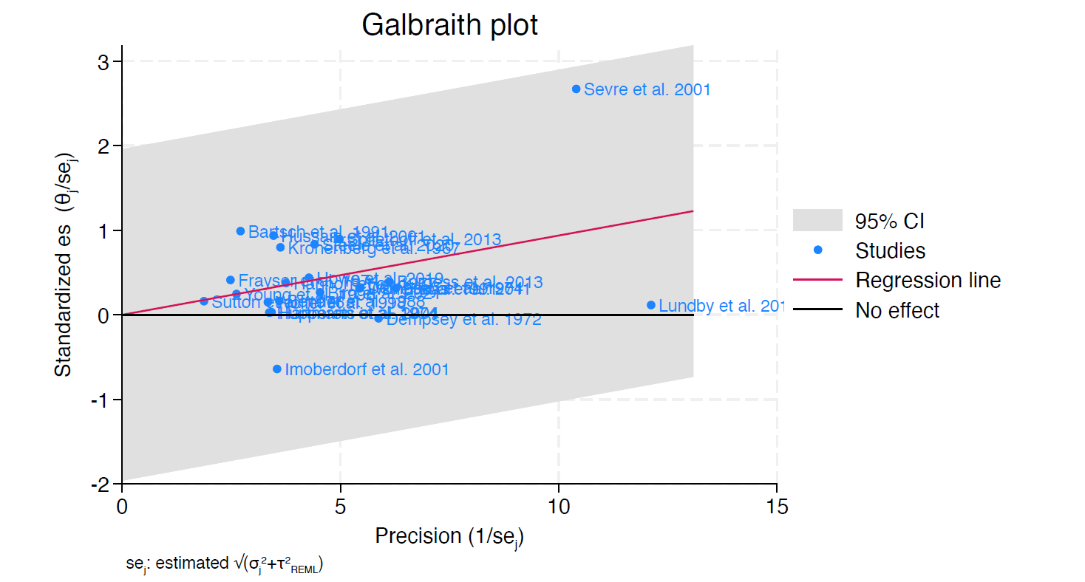
Galbraith plot to test for outliners. Although three visual outliners are present, only Imoberdorf et al. 2001 was excluded after careful reconsideration of the other two. Two studies [42,43] are not displayed in the plot, but they were not identified as outliners.

eFigure 2A. Funnel blot for TDD group
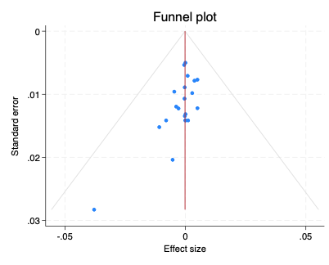

eFigure 2B. Funnel blot for DO subgroup
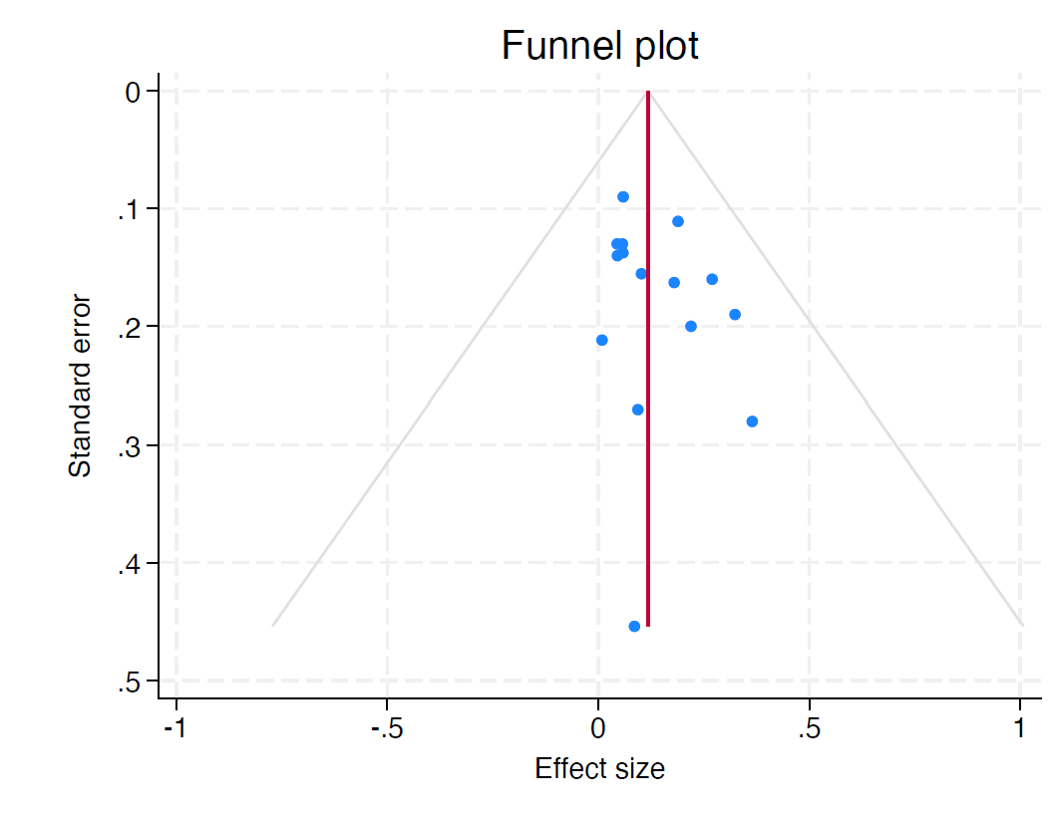

Funnel plots used to assess publication bias revealed no indication of such bias.

eFigure 3. Trajectory Plot of PaO₂ for DO subgroup
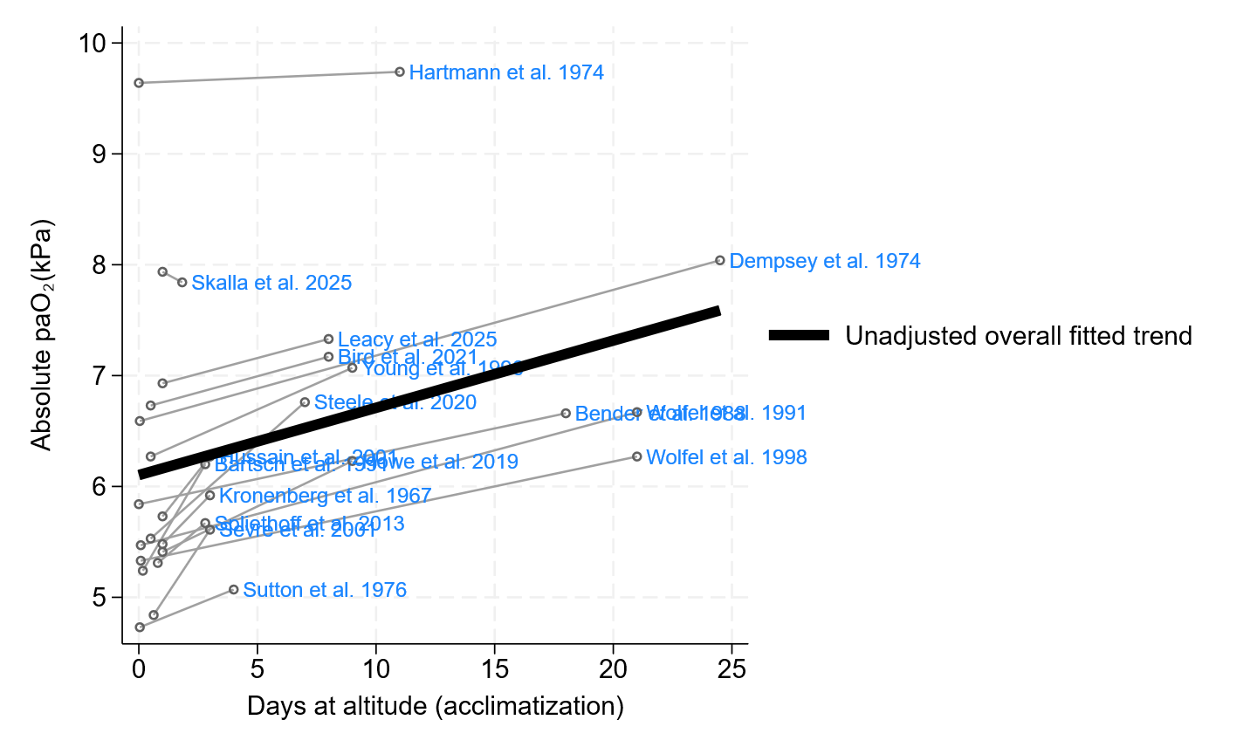
Trajectory plot presenting uncentred absolute PaO₂ trajectories in the DO subgroup. The grey lines connect the final with the first measurement at high altitude. The thick black line represents a pooled estimate derived from study-level effect estimates.

eReferences

1 Forrer, A. et al. Partial Pressure of Arterial Oxygen in Healthy Adults at High Altitudes: A Systematic Review and Meta-Analysis. JAMA Netw Open 6, e2318036, doi:10.1001/jamanetworkopen.2023.18036 (2023).
2 National Heart, Lung, and Blood Institute. Study quality assessment tools. National Institutes of Health; 2014., <https://www.nhlbi.nih.gov/health-topics/study-quality-assessment-tools> (
3 Bagias, C., Sukumar, N., Weldeselassie, Y., Oyebode, O. & Saravanan, P. Cord Blood Adipocytokines and Body Composition in Early Childhood: A Systematic Review and Meta-Analysis. International Journal of Environmental Research and Public Health 18, 1897 (2021).
4 Sevre, K. et al. Reduced autonomic activity during stepwise exposure to high altitude. Acta Physiologica Scandinavica 173, 409-417 (2001).
5 Lundby, C., Calbet, J., Van Hall, G., Saltin, B. & Sander, M. Sustained sympathetic activity in altitude acclimatizing lowlanders and high‐altitude natives. Scandinavian journal of medicine & science in sports 28, 854-861 (2018).
6 Imoberdorf, R. et al. Enhanced synthesis of albumin and fibrinogen at high altitude. Journal of Applied Physiology 90, 528-537 (2001).
7 Bird, J. D. et al. Time course and magnitude of ventilatory and renal acid-base acclimatization following rapid ascent to and residence at 3,800 m over nine days. Journal of Applied Physiology 130, 1705-1715 (2021).
8 Xie, Y. et al. Association Between Arterial Blood Gas Variation and Intraocular Pressure in Healthy Subjects Exposed to Acute Short-Term Hypobaric Hypoxia. Translational Vision Science & Technology 8, 22-22 (2019).
9 Erba, P., Anastasi, S., Senn, O., Maggiorirni, M. & Bloch, K. E. Acute mountain sickness is related to nocturnal hypoxemia but not to hypoventilation. Eur Respir J 24, 303-308, doi:10.1183/09031936.04.00006504 (2004).
10 Howe, C. A. et al. UBC-Nepal Expedition: Haemoconcentration underlies the reductions in cerebral blood flow observed during acclimatization to high altitude. Exp Physiol 104, 1963-1972, doi:10.1113/ep087663 (2019).
11 Hussain, M. M., Aslam, M. & Khan, Z. Acute mountain sickness score and hypoxemia. J Pak Med Assoc 51, 173-179 (2001).
12 R S Kronenberg, S. M. C. Hastening respiratory acclimatization to altitude with benzolamide (CL 11,366). Aerosp Med. 39, 296-300 (1968).
13 Loeppky, J. A. et al. Ventilation is greater in women than men, but the increase during acute altitude hypoxia is the same. Respir Physiol 125, 225-237, doi:10.1016/s0034-5687(00)00221-8 (2001).
14 Röggla, G., Domej, W. & Röggla, M. Does theophylline really improve acute mountain sickness? [2]. European Respiratory Journal 17, 575, doi:10.1183/09031936.01.17305750 (2001).
15 Hupperets, M. D. et al. Increased hypoxic ventilatory response during 8 weeks at 3800 m altitude. Respir Physiol Neurobiol 142, 145-152, doi:10.1016/j.resp.2004.06.011 (2004).
16 Bailey, D. M. et al. High‐altitude pulmonary hypertension is associated with a free radical‐mediated reduction in pulmonary nitric oxide bioavailability. The Journal of physiology 588, 4837-4847 (2010).
17 Bärtsch, P. et al. Prevention of high-altitude pulmonary edema by nifedipine. New England Journal of Medicine 325, 1284-1289 (1991).
18 Burgess, K. R. et al. Worsening of central sleep apnea at high altitude—a role for cerebrovascular function. Journal of Applied Physiology 114, 1021-1028 (2013).
19 Frayser, R., Rennie, I. D., Gray, G. W. & Houston, C. S. Hormonal and electrolyte response to exposure to 17,500 ft. Journal of Applied Physiology 38, 636-642, doi:10.1152/jappl.1975.38.4.636 (1975).
20 Goerre, S. et al. Endothelin-1 in pulmonary hypertension associated with high-altitude exposure. Circulation 91, 359-364 (1995).
21 Berger, M. M. et al. Transpulmonary plasma ET-1 and nitrite differences in high altitude pulmonary hypertension. High altitude medicine & biology 10, 17-24 (2009).
22 Hannon, J. P. & Vogel, J. A. Oxygen transport during early altitude acclimatization: a perspective study. European Journal of Applied Physiology and Occupational Physiology 36, 285-297 (1977).
23 Mairbäurl, H. et al. Nasal Epithelium Potential Difference at High Altitude (4,559 m) Evidence for Secretion. American journal of respiratory and critical care medicine 167, 862-867 (2003).
24 Moncloa, F., Carcelen, A. & Beteta, L. Physical exercise, acid-base balance, and adrenal function in newcomers to high altitude. Journal of Applied Physiology 28, 151-155 (1970).
25 Reeves, J. T., Halpin, J., Cohn, J. E. & Daoud, F. Increased alveolar-arterial oxygen difference during simulated high-altitude exposure. Journal of Applied Physiology 27, 658-661 (1969).
26 Imray, C. et al. Effects of breathing air containing 3% carbon dioxide, 35% oxygen or a mixture of 3% carbon dioxide/35% oxygen on cerebral and peripheral oxygenation at 150 m and 3459 m. Clinical Science 104, 203-210 (2003).
27 Steele, A. R. et al. Global REACH 2018: renal oxygen delivery is maintained during early acclimatization to 4,330 m. American Journal of Physiology-Renal Physiology 319, F1081-F1089 (2020).
28 Wolfel, E. E. et al. Oxygen transport during steady-state submaximal exercise in chronic hypoxia. Journal of Applied Physiology 70, 1129-1136 (1991).
29 Wolfel, E. E. et al. O2 extraction maintains O2 uptake during submaximal exercise with β-adrenergic blockade at 4,300 m. Journal of Applied Physiology 85, 1092-1102 (1998).
30 Young, A. J. et al. Effects of erythrocyte infusion on VO2max at high altitude. Journal of Applied Physiology 81, 252-259 (1996).
31 Hartmann, B., Unger, M., Debelić, M. & Hilpert, P. [Arterial blood gas tensions and airways obstruction in normal subjects and patients with obstructive lung disease before and during adaptation to altitude (author's transl)]. Respiration 31, 7-20, doi:10.1159/000193095 (1974).
32 Lucas, S. J. et al. Alterations in cerebral blood flow and cerebrovascular reactivity during 14 days at 5050 m. The Journal of physiology 589, 741-753 (2011).
33 Naughton, M. T. et al. Is normobaric simulation of hypobaric hypoxia accurate in chronic airflow limitation? American journal of respiratory and critical care medicine 152, 1956-1960 (1995).
34 Dempsey, J. A. et al. Control of exercise hyperpnea under varying durations of exposure to moderate hypoxia. Respir Physiol 16, 213-231, doi:10.1016/0034-5687(72)90052-7 (1972).
35 Dempsey, J., Forster, H. & DoPico, G. Ventilatory acclimatization to moderate hypoxemia in man: the role of spinal fluid [H+]. The Journal of clinical investigation 53, 1091-1100 (1974).
36 Sutton, J. R. et al. Pulmonary gas exchange in acute mountain sickness. Aviat Space Environ Med 47, 1032-1037 (1976).
37 Spliethoff, K. et al. Reduced insulin sensitivity as a marker for acute mountain sickness? High Altitude Medicine & Biology 14, 240-250 (2013).
38 Bender, P. R. et al. Oxygen transport to exercising leg in chronic hypoxia. Journal of Applied Physiology 65, 2592-2597 (1988).
39 Hansen, J. & Sander, M. Sympathetic neural overactivity in healthy humans after prolonged exposure to hypobaric hypoxia. The Journal of physiology 546, 921-929 (2003).
40 Calbet, J. A. Chronic hypoxia increases blood pressure and noradrenaline spillover in healthy humans. The Journal of physiology 551, 379-386 (2003).
41 Eldridge, M. W., Braun, R. K., Yoneda, K. Y. & Walby, W. F. Effects of altitude and exercise on pulmonary capillary integrity: evidence for subclinical high-altitude pulmonary edema. Journal of Applied Physiology 100, 972-980 (2006).
42 Skalla, E. et al. Early acclimatization to high altitude: Acid-base and fluid balance dynamics during the first 2 days at 3100 m. Exp Physiol, doi:10.1113/ep093029 (2025).
43 Leacy, J. K. et al. Characterizing the protective vasodilatory effects of hypobaric hypoxia on the neurovascular coupling response. J Cereb Blood Flow Metab 45, 1293-1309, doi:10.1177/0271678x251322348 (2025).

