Supplementary files
Multiwavelength fluorescence imaging using a CEA-targeted fluorescent agent and indocyanine green to increase surgical precision in patients with colorectal liver metastases

Short title: multiwavelength fluorescence imaging in colorectal liver metastases

Mats I. Warmerdam*, MD¹, Tom H. Dijkhuis, MS^{1,} Okker D. Bijlstra, MD¹, Thomas W. van Ravens, MD¹, Martijn A. van Dam, MD¹, Henk H. Hartgrink, MD, PhD¹, J. Burggraaf, MD, PhD², A. Stijn L.P. Crobach, MD, PhD³, F. Cailler, MS, PhD⁴, Alexander L. Vahrmeijer, MD, PhD¹, J. Sven D. Mieog, MD, PhD¹

1. Department of Surgery, Leiden University Medical Center, Albinusdreef 2, 2333 ZA Leiden, The Netherlands
2. Center for Human Drug Research, Zernikedreef 8, 2333CL, Leiden, The Netherlands
3. Department of Pathology, Leiden University Medical Center, Albinusdreef 2, 2333 ZA Leiden, The Netherlands
4. Surgimab SAS, 10, Parc Club du Millénaire, 1025 Avenue Henri Becquerel 34000, Montpellier, France

Supplementary figure 1: Survey ‘Patient experience’
This questionnaire relates to the additional study drug which was administered to you 4 days prior to surgery (SGM-101). The drug that was given to you 7 days prior to surgery (ICG), is a standard-of-care drug in the Leiden University Medical Center.

- I did not mind coming to the hospital one extra time to get the study drug administered
Totally disagree
Disagree
Neutral
Agree
Totally agree

- I did not experience the extra infusion to be too much of a burden
Totally disagree
Disagree
Neutral
Agree
Totally agree

- If I was able to make the choice again, I would participate in this study again.
Totally disagree
Disagree
Neutral
Agree
Totally agree

Supplementary figure 2: Survey ‘Intra-operative practical workability surgeon’
This questionnaire relates to the addition of SGM-101 on top of the standard of care ICG.

- Using two fluorescent dyes on 2 different channels was workable.
Totally disagree
Disagree
Neutral
Agree
Totally agree

- The time I spent on this technique was acceptable.
Totally disagree
Disagree
Neutral
Agree
Totally agree

- I experienced no discomfort in working with 2 fluorescent dyes.
Totally disagree
Disagree
Neutral
Agree
Totally agree

- The addition of SGM-101 had a positive impact on the surgery (e.g., localization, margin assessment, discriminating malignant/benignant, 'surgical confidence').
Totally disagree
Disagree
Neutral
Agree
Totally agree

Supplementary Table 1. Detailed overview of patient, lesion, intraoperative imaging characteristics, pathological findings, and bread-loaf fluorescence analysis.
Patient and lesion characteristics |  |  |  |  | Intra-operative findings |  |  |  |  |  | Margin assessment, suspected for R1 |  |  | Pathology |  |  |  | Bread loaf
Pt. ID | Inclusion criteria * | Les-ion | Location | Distance to capsula on CT (mm) | WLI | ICG | SGM-101 | SBR ICG | SBR SGM-101 | Resection, ablation or no resection | WLI | ICG | SGM-101 | Histopathology | R0/R1 | CEA | TRG | SBR ICG | TBR SGM-101
1 | 1, 2 | 1 | Seg. 4 local recurrence | 1 | + | + | + | 2,3 | 1,3 | Resection | - | + | + | A.C. | R1 | 11 | 5 | 2,2 | 2,7
 |  | 2 | Diaphragm |  | + | - | - | N.A. | N.A. | Biopsy | N.A. | N.A. | N.A. | Benign | N.A. | 0 | N.A. | N.A. | N.A.
2 | 1, 3 | 1 | Seg. 6 | 1 | + | + | + | 1,8 | 1,7 | Resection | - | - | - | A.C. | R0 | 11 | 2 | 2,0 | 1,2
 |  | 2 | Seg. 7 (dorsal) | 2 | + | - | + | 1,6 | 1,8 | Resection | - | - | - | A.C. | R0 | 11 | 2 | 4,0 | 1,2
 |  | 3 | Seg. 6 lateral | 2 | + | + | + | 1,7 | 1,4 | Resection | - | - | - | A.C. | R0 | 11 | 2 | 2,4 | 1,0
 |  | 4 | Seg. 8 (dorsal) | 17 | - | - | - | N.A. | N.A. | Resection | - | - | - | A.C. | R0 | 11 | 2 | 2,0 | 1,5
 |  | 5 | Seg. 7 (cranial) | 2 | + | + | + | 1,5 | 1,3 | Resection | - | - | - | A.C. | R0 | 11 | 2 | 1,2 | 1,3
 |  | 6 | Seg. 8 | 1 | + | + | + | 2,0 | 1,5 | Resection | - | - | - | A.C. | R0 | 11 | 2 | 4,8 | 1,3
 |  | 7 | Central, near hilus | 17 | - | - | - | N.A. | N.A. | Resection | - | + | + | A.C. | R1 | 11 | 2 | 1,5 | 1,3
 |  | 8 | Peritoneal lesion |  | + | - | - | N.A. | N.A. | Biopsy | N.A. | N.A. | N.A. | Benign | N.A. | 0 | N.A. | N.A. | N.A.
 |  | 9 | Sigmoid |  | + | - | + | N.A. no picture | N.A. no picture | Resection | - | - | - | A.C. | R0 | 10 | 4 | N.A. | 3,5
 |  | 10 | Seg. 3 |  | + | + | + | 1,9 | 1,2 | Resection | - | - | - | A.C. | R0 | 11 | 2 | 2,2 | 1,5
3 | 1, 3 | 1 | Seg. 8 | 1 | - | - | - | N.A. | N.A. | Ablation | N.A. | N.A. | N.A. | N.A. | N.A. | NA | N.A. | N.A. | N.A.
 |  | 2 | Seg. 4b | 12 | - | - | - | N.A. | N.A. | Resection | - | - | - | A.C. | R0 | 12 | 3 | 1,8 | 1,3
 |  | 3 | Seg. 4a | 14 | - | + | - | 4,7 | N.A. | Resection | - | - | - | A.C. | R0 | 11 | 3 | 4,8 | 2,0
 |  | 4 | Seg. 5/6 | 24 | - | - | - | N.A. | N.A. | Ablation | NA | NA | NA | N.A. | N.A. |  | N.A. | N.A. | N.A.
 |  | 5 | Seg. 3 | 1 | + | - | - | N.A. | N.A. | Resection | - | - | - | Benign | N.A. | 0 | N.A. | N.A. | N.A.
4 | 1, 3 | 1 | Seg. 8 | 4 | - | - | - | N.A. | N.A. | Vanishing metastasis | N.A. | N.A. | N.A. | N.A. | N.A. | N.A. | N.A. | N.A. | N.A.
 |  | 2 | Seg. 7 | 8 | - | - | - | N.A. | N.A. | Vanishing metastasis | N.A. | N.A. | N.A. | N.A. | N.A. | N.A. | N.A. | N.A. | N.A.
 |  | 3 | Seg. 7 | 0 | + | + | - (+ on back table) | 4,3 | N.A. | Resection | - | + | - | A.C. | R0 | 8 | 3 | 4,8 | 1,6
 |  | 4 | Seg. 8 | 2 | - | - | - | N.A. | N.A. | Vanishing metastasis | N.A. | N.A. | N.A. | N.A. | N.A. | N.A. | N.A. | N.A. | N.A.
 |  | 5 | Seg. 1/5 hilus | 8 | - | - | - | N.A. | N.A. | Vanishing metastasis | N.A. | N.A. | N.A. | N.A. | N.A. | N.A. | N.A. | N.A. | N.A.
 |  | 6 | Seg. 6 | 13 | - | - | - | N.A. | N.A. | Vanishing metastasis | N.A. | N.A. | N.A. | N.A. | N.A. | N.A. | N.A. | N.A. | N.A.
 |  | 7 | Seg 5. Liver edge | 0 | + | + | - | 2,2 | N.A. | Resection | - | - | + | Benign | N.A. | 0 | N.A. | N.A. | N.A.
 |  | 8 | Seg. 2/3 |  | + | + | - | 3,0 | N.A. | No resection, cyst | N.A. | N.A. | N.A. | N.A. | N.A. | N.A. | N.A. | N.A. | N.A.
5 | 1 | 1 | Seg. 2/3 | 0 | + | + | + | 3,2 | 2,5 | Resection | - | + | - | A.C. | R0 | 6 | 4 | 5,9 | 1,9
 |  | 2 | Seg. 5/6 | 0 | + | + | + | 2,1 | 1,6 | Resection | - | + | - | A.C. | R1 | 7 | 5 | 5,3 | 1,7
 |  | 3 | Seg. 8 |  | - | - | - | N.A. | N.A. | Ablation | N.A. | N.A. | N.A. | N.A. | N.A. | N.A. | N.A. | N.A. | N.A.
6 | 2 | 1 | Central, near hilus, local recurrence | 7 | - | + | + | 3,5 | 1,4 | No resection (invasion of portal vein, including left and right branches) | N.A. | N.A. | N.A. | N.A. | N.A. | N.A. | N.A. | N.A. | N.A.
 |  | 2 | Seg. 7 | 0 | + | + | + | 2,3 | 2,2 | No resection (due to invasion in diaphragm and known irresectable disease due to lesion 1), biopsy | + | - | + | A.C. | N.A. | 12 | 3 | N.A. | 1,6
 |  | 3 | Abdominal wall |  | + | - | - | N.A. | N.A. | Biopsy | N.A. | N.A. | N.A. | Benign | N.A. | 0 | N.A. | N.A. | N.A.
 |  | 4 | Seg. 8 | 0 | + | + | + | 2,1 | 1,6 | No resection (due to invasion in diaphragm and known irresectable disease due to lesion 1), biopsy | N.A. | N.A. | N.A. | A.C. | R2 | 12 | 3 | N.A. | 2,6
7 | 1 | 1 | Seg. 2/3 | 0 | + | + | - | 3,6 | N.A. | Resection | - | + | - | A.C. | R0 | 12 | 2 | 3,3 | 0,6
 |  | 2 | Seg. 5/6 | 0 | + | + | + | 4,4 | 1,2 | Resection | - | + | - | A.C. | R0 | 10 | 2 | 3,1 | 0,9
 |  | 3 | Seg. 7 | 0 | + | - | - | N.A. | N.A. | No resection (hemangioma) | N.A. | N.A. | N.A. | N.A. | N.A. | N.A. | N.A. | N.A. | N.A.
 |  | 4 | Sigmoid |  | + | N.A. | + | N.A. | 1,1 | Resection | - | - | - | A.C. | R0 | 12 | 3 | missing | missing
8 | 1, 3 | 1 | Near gallbladder |  | + | - | - | N.A. | N.A. | Resection | - | - | - | Benign | N.A. | 0 | N.A. | N.A. | N.A.
 |  | 2 | Seg. 7/8 |  | - | + | - | 1,3 | N.A. | Resection | - | - | - | Benign | N.A. | 0 | N.A. | N.A. | N.A.
 |  | 3 | Seg. 6 | 0 | + | + | - | 1,5 | N.A. | Resection | - | - | - | A.C. | R0 | 12 | 2 | 1,6 | 1,2
 |  | 4 | Seg. 1 | 0 | + | + | - | N.A. coagulation artefacts | N.A. coagulation artefacts | Resection | - | - | - | A.C. | R0 | 12 | 2 | 1,1 | 0,7
 |  | 5 | Seg. 4a/4b | 21 | - | - | - | N.A. | N.A. | Ablation | N.A. | N.A. | N.A. | N.A. | N.A. | N.A. | N.A. | N.A. | N.A.
 |  | 6 | Seg. 4a/4b | 16 | - | - | - | N.A. | N.A. | Ablation | N.A. | N.A. | N.A. | N.A. | N.A. | N.A. | N.A. | N.A. | N.A.
 |  | 7 | Seg. 4a/4b | 14 | - | - | - | N.A. | N.A. | Ablation | N.A. | N.A. | N.A. | N.A. | N.A. | N.A. | N.A. | N.A. | N.A.
 |  | 8 | Seg. 5 | 31 | - | - | - | N.A. | N.A. | Ablation | N.A. | N.A. | N.A. | N.A. | N.A. | N.A. | N.A. | N.A. | N.A.
 |  | 9 | Seg. 7 | 21 | - | - | - | N.A. | N.A. | Ablation | N.A. | N.A. | N.A. | N.A. | N.A. | N.A. | N.A. | N.A. | N.A.
9 | 1 | 1 | Paracaval nodus |  | - | - | + | N.A. no picture | N.A. no picture | Resection | - | - | - | Benign | N.A. | 0 | N.A. | N.A. | N.A.
 |  | 2 | Seg. 6 |  | - | + | - | 2,8 | N.A. | Resection | - | - | - | Benign | N.A. | 0 | N.A. | N.A. | N.A.
 |  | 3 | Seg. 6 | 0 | + | + | + | 4,4 | 1,4 | Resection | - | - | - | A.C. | R0 | 10 | 3 | 6,1 | 1,5
 |  | 4 | Seg 6. |  | - | + | - | 3,0 | N.A. | Resection | - | + | - | Benign | N.A. | 0 | N.A. | N.A. | N.A.
 |  | 5 | Seg. 3 |  | - | + | - | 3,6 | N.A. | Resection | - | - | - | Benign | N.A. | 0 | N.A. | N.A. | N.A.
 |  | 6 | Sigmoid |  | + | - | + | N.A. | 1,5 | Resection | - | - | - | A.C. | R0 | 11 | 3 | N.A. | 5,6
 |  | 7 | Seg. 8 | 9 | - | - | - | N.A. | N.A. | Ablation | N.A. | N.A. | N.A. | N.A. | N.A. | N.A. | N.A. | N.A. | N.A.
10 | 2 | 1 | Seg. 6 local recurrence | 0 | + | + | + | 2,6 | 1,9 | Resection | - | N.A. | - | A.C. | R0 | 11 | 3 | 1,3 | 2,0
 |  | 2 | Thoracic wall |  | - | - | + | N.A. | 2,8 | Resection | - | - | - | Benign | N.A. | 0 | N.A. | N.A. | N.A.

Overview of individual patient and lesion characteristics, including imaging findings with white-light imaging (WLI), indocyanine green (ICG), and SGM-101 during surgery. Inclusion criteria: 1=neoadjuvant chemotherapy, 2=local recurrence, 3=>3 metastases Pt. ID=Patient identification number, Lesion=Lesion number, WLI=White-light imaging, ICG=Indocyanine green, SBR=Signal-to-background ratio
R0/R1=Resection margin status (R0 = no residual tumor; R1 = microscopic residual tumor), CEA=Carcinoembryonic antigen score (0–12), TRG=Tumor regression grade, A.C.=Adenocarcinoma, N.A.=Not applicable / not available, + =Positive signal, – =Negative signal, Back table=Fluorescence observed after excision (ex vivo), Vanishing metastasis=Lesion seen on pre-operative imaging but not detected intraoperatively

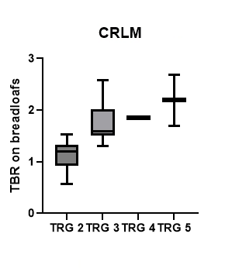
Supplementary figure 3: Treatment effect on fluorescence signal intensity
Box plot showing tumor-to-background ratios (TBR) of colorectal liver metastases (CRLM) stratified by tumor regression grade (TRG, score of Mandard). Higher TRG-scores are associated with increased fluorescence intensity, indicating improved detectability of lesions with lower treatment response. TRG1=Complete regression (= fibrosis without detectable tissue of tumor), TRG2=Fibrosis with scattered tumor cells, TRG3=Fibrosis and tumor cells with preponderance of fibrosis, TRG4=Fibrosis and tumor cells with preponderance of tumor cells, TRG5=Tissue of tumor without changes of regression.

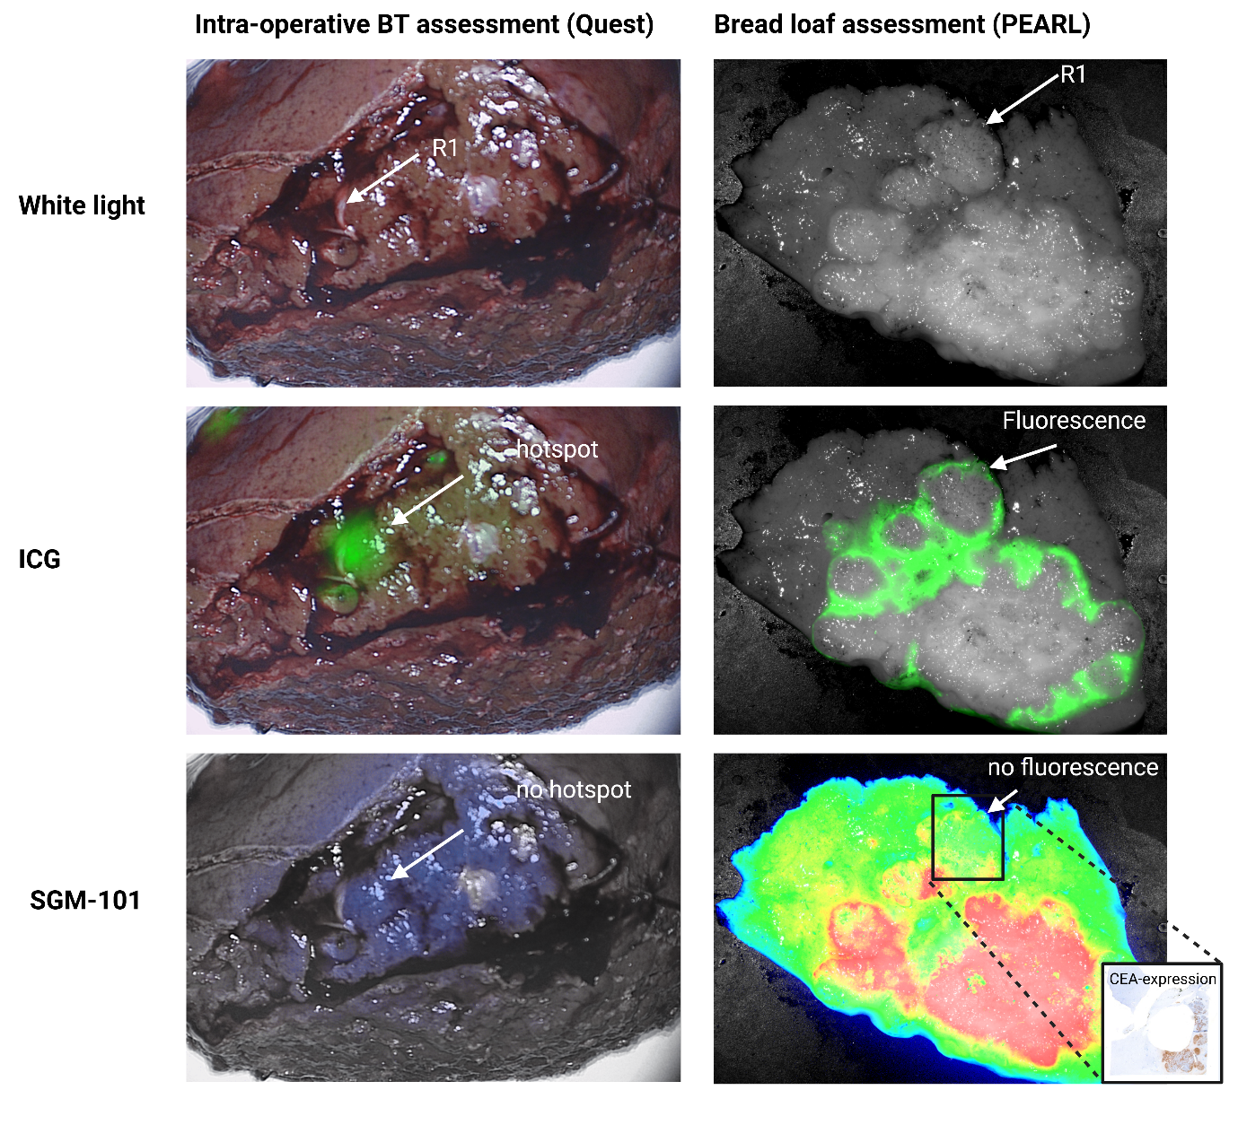
Supplementary figure 4: illustration of R1-resection site not detected by SGM-101.
Among the three R1-lesions in the cohort, one was not identified by SGM-101 fluorescence, illustrated above. In this case, ICG correctly showed a true-positive hotspot at the resection margin, whereas SGM-101 did not. The reason of the absence of signal with SGM-101 is unknown, CEA expression was 8/12, although with heterogeneous tissue expression.
ICG=indocyanine green, R1 = microscopically positive resection margin <1mm, CEA = carcinoembryonic antigen.
Supplementary table 2: Diagnostic accuracy of SGM-101 for intraoperative visualization of liver lesions located within 5 mm of the capsule, based on subjective scoring
SGM-101 | Malignant | Benign | Total
SGM-101 positive | 15 | 0 | 15
SGM-101 negative | 3 | 9 | 12
Total | 18 | 9 | 27
Sensitivity  Specificity  Positive predictive value  Negative predictive value | 83%  100%  100%  75%
ICG | Malignant | Benign | Total
ICG positive | 17 | 6 | 23
ICG negative | 1 | 3 | 4
Total | 18 | 9 | 27
Sensitivity  Specificity  Positive predictive value  Negative predictive value | 94%  33%  74%  75%

The intraoperative performance of SGM-101 and ICG in distinguishing malignant from benign lesions within 5mm of the liver capsule evaluated based on subjective assessment of fluorescence positivity. SGM-101 correctly identified 15 of 18 malignant lesions and all 9 benign lesions, resulting in a sensitivity of 83%, specificity of 100%, positive predictive value (PPV) of 100%, and negative predictive value (NPV) of 75%.
PPV = positive predictive value, NPV = negative predictive value.

Supplementary table 3: Potential intraoperative impact of SGM-101 on surgical decision-making
A) Potential positive influence SGM-101
Patient ID | Lesion | Treatment | Histopathology | Potential positive influence SGM-101
1 | 1 | Resection | Adenocarcinoma | R1-resection: Ex-vivo, ICG identified three hotspots suggesting R1, one of which was also fluorescent by SGM-101. Pathology confirmed only the SGM-101–positive site as true R1. As re-resection was not feasible intraoperatively, additional coagulation of the wound bed was performed. No local recurrence was observed at 6 months
2 | 7 | Resection | Adenocarcinoma | R1 resection: Confirmed by both ICG and SGM-101, not detected under normal light inspection.
4 | 3 | Resection | Adenocarcinoma | R0-resection: ICG FP, SGM-101 TN
4 | 7 | Resection | Benign | Benign lesion: ICG FP, SGM-101 TN
4 | 8 | No resection, (cyst) | N.A. | Benign lesion: ICG FP, SGM-101 TN
5 | 1 | Resection | Adenocarcinoma | R0-resection: ICG FP, SGM-101 TN
6 | 2 | Irresectable | Adenocarcinoma | SGM-101 confirmed the white-light impression of diaphragmatic invasion and tumor transection during surgical mobilization, while ICG did not. The case was deemed irresectable (R2).
7 | 1 | Resection | Adenocarcinoma | R0-resection: ICG FP, SGM-101 TN
7 | 2 | Resection | Adenocarcinoma | R0-resection: ICG FP, SGM-101 TN
8 | 2 | Resection | Benign | Benign lesion: ICG FP, SGM-101 TN
9 | 2 | Resection | Benign | Benign lesion: ICG FP, SGM-101 TN
9 | 4 | Resection | Benign | Benign lesion: ICG FP, SGM-101 TN
9 | 5 | Resection | Benign | Benign lesion: ICG FP, SGM-101 TN
10 | 1 | Resection | Adenocarcinoma | R0-resection: ICG FP, SGM-101 TN

Potential negative influence SGM-101
Patient ID | Lesion | Treatment | Histopathology | Potential negative impact SGM-101
4 | 3 | Resection | Adenocarcinoma | Malignant lesion: SGM-101 FN intraoperatively despite superficial location, likely due to excessive camera-to-lesion distance, as the lesion was TP on the back table. ICG TP.
5 | 2 | Resection | Adenocarcinoma | R1 resection: SGM-101 was FN, while ICG was TP. Despite an overall SGM-101 TBR of 1.7, heterogeneous CEA expression—with a CEA score of 4 at the R1 margin—led to near-absence of fluorescence in the R1-area.
7 | 1 | Resection | Adenocarcinoma | Malignant lesion: SGM-101 FN intraoperatively despite superficial location, likely due to near-complete response (TRG2); ICG was TP.
8 | 3 | Resection | Adenocarcinoma | Malignant lesion: SGM-101 FN intraoperatively despite superficial location, likely due to near-complete response (TRG2); ICG was TP.
8 | 4 | Resection | Adenocarcinoma | Malignant lesion: SGM-101 FN intraoperatively despite superficial location, likely due to near-complete response (TRG2); ICG was TP.
9 | 1 | Resection | Benign | Benign extrahepatic lesion detected by SGM-101 (FP)
10 | 2 | Resection | Benign | Benign extrahepatic lesion detected by SGM-101 (FP)
This table summarizes cases in which SGM-101 (potentially) influenced surgical management, categorized as either potentially positive (part A) or negative (part B).
ICG=indocyanine green, FP=false positive, TN=true negative, TP=true positive, FN=false negative, R0=resection with negative margins, R1=microscopic residual tumor in resection margins <1mm, TBR=tumor-to-background ratio, TRG=tumor regression grade (Mandard score), CEA=carcinoembryonic antigen.

