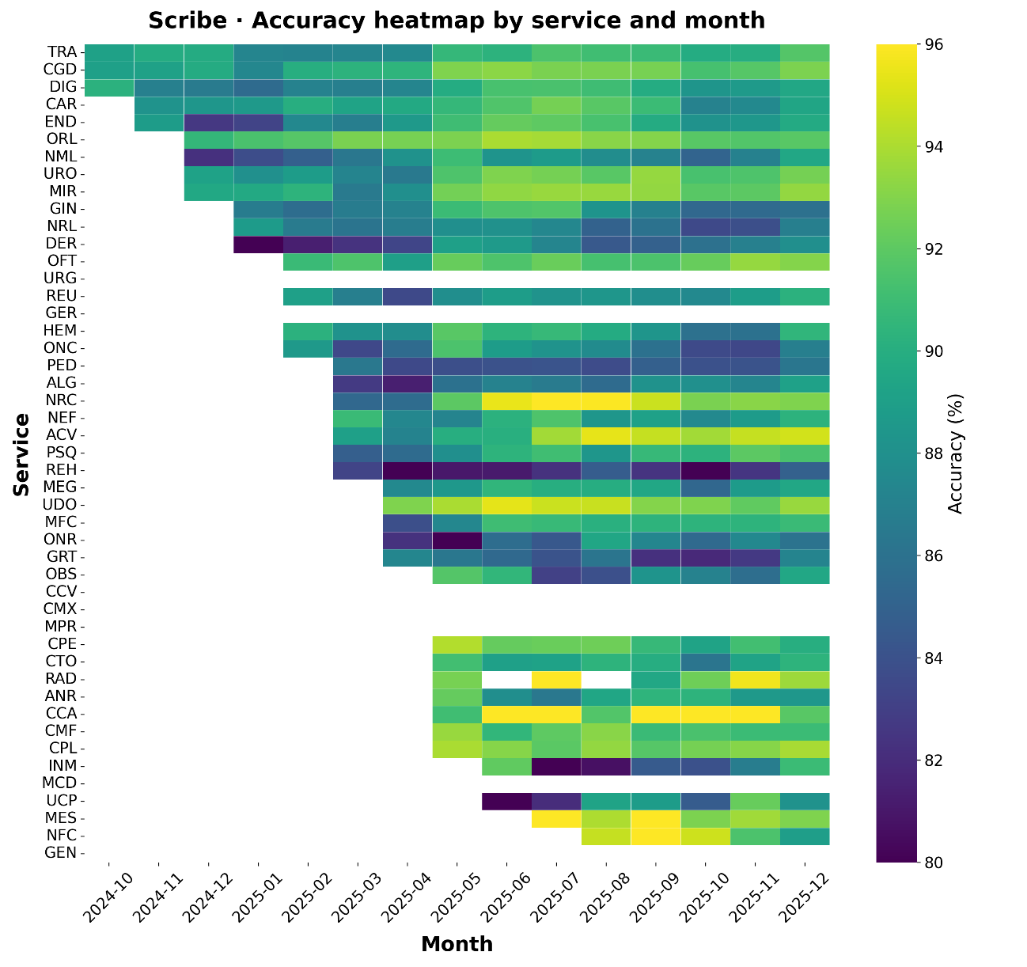
Figure S1. Monthly Semantic Agreement Heatmap by Specialty. Heatmap showing Scribe’s mean textual similarity (%) by specialty (rows) and month (columns) from October 2024 to December 2025. Color intensity reflects similarity levels (80% to 96%), highlighting both consistently high-performing specialties and those with greater variability over time.
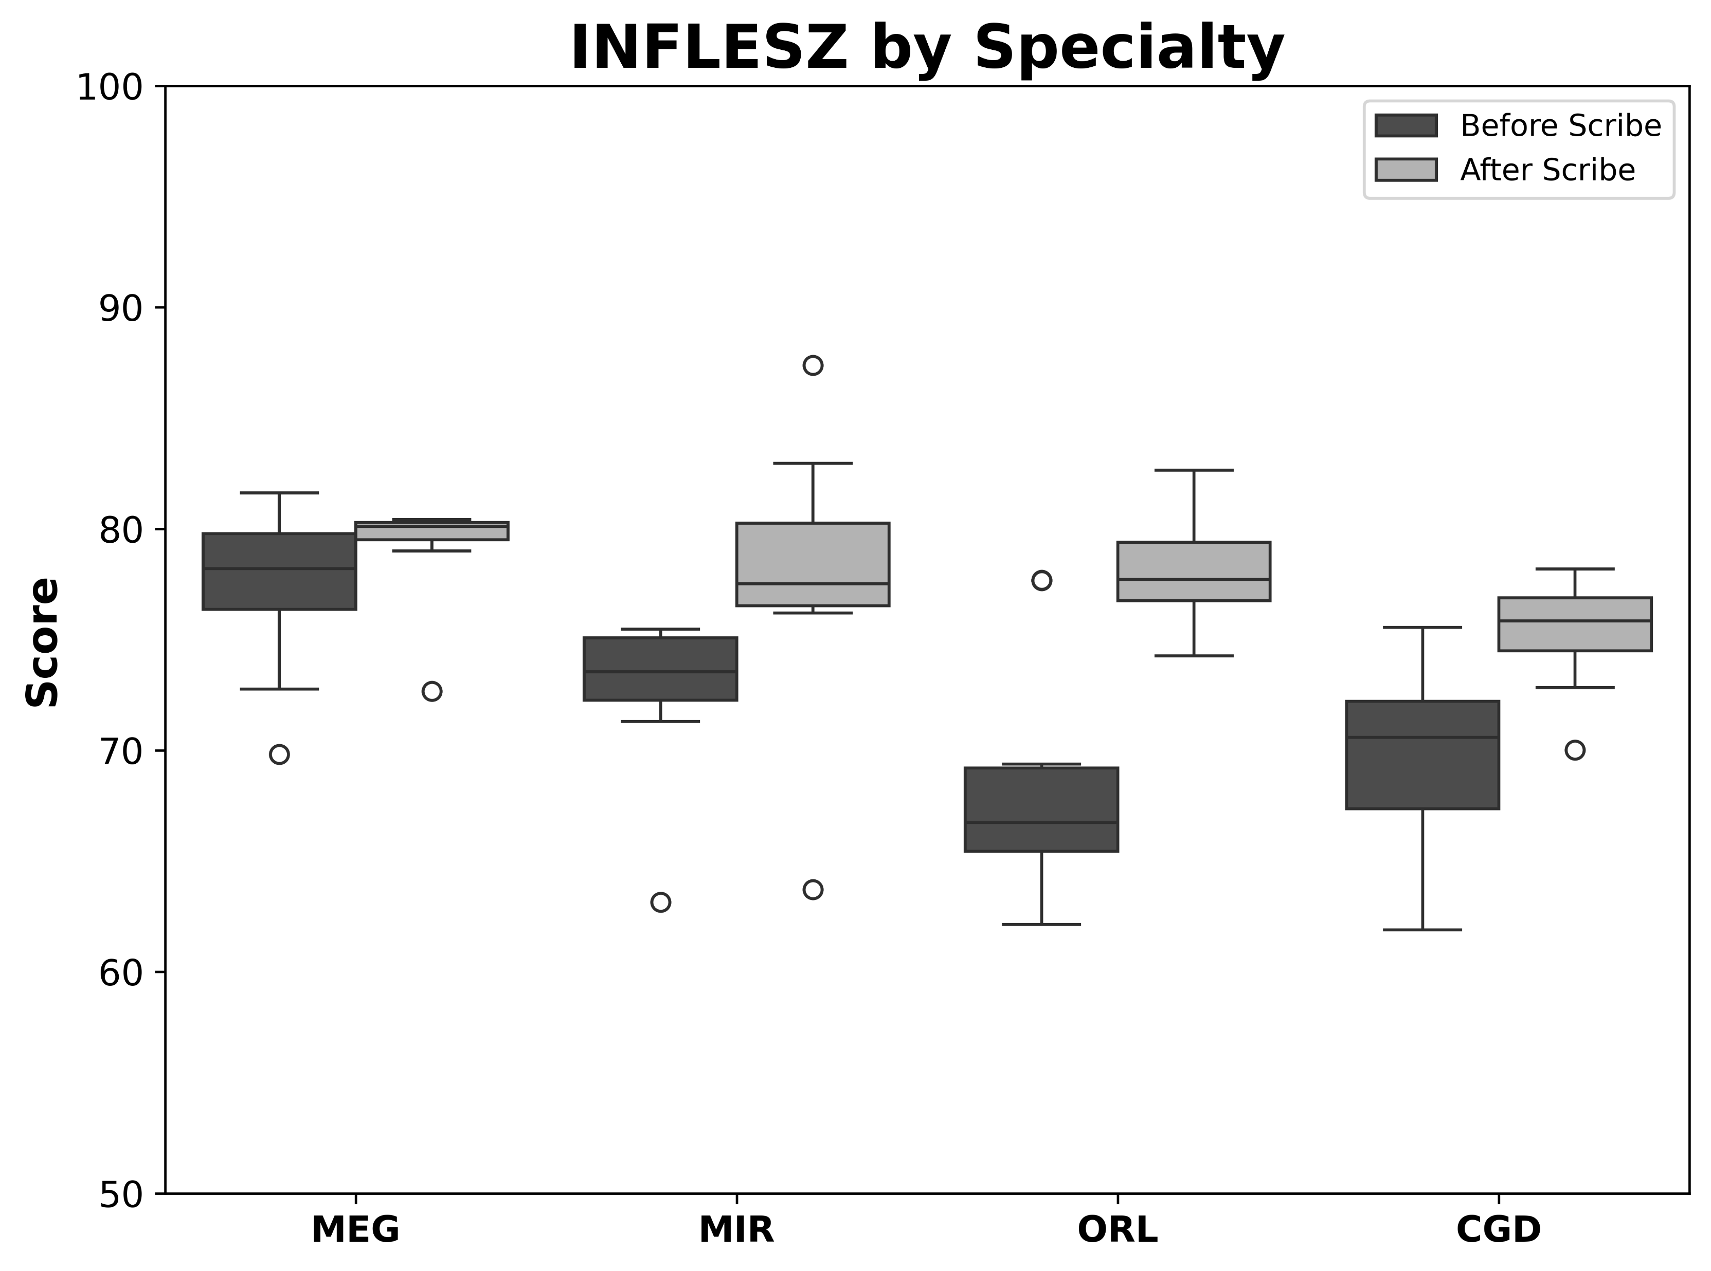
Figure S2. Distribution of INFLESZ readability scores by specialty before and after Scribe implementation.

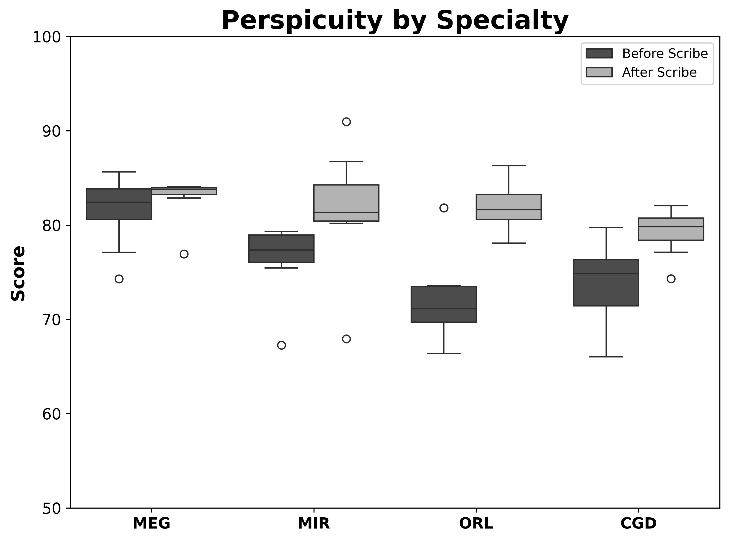
Figure S3. Distribution of perspicuity scores by specialty before and after Scribe implementation.

Table S1. List of quality assessment items evaluated to determine the overall quality of medical reports generated through conventional vs. Scribe consultations.
 | Quality Assessment Item
1 | Physician’s full name, surname, and professional registration number
2 | Concordance between report date and signature date
3 | Main headings are presented in the correct order
4 | No headings are duplicated
5 | Presence of a Personal Medical History heading
6 | Presence of a Regular Medication or Chronic Treatment section (if applicable)
7 | Specification of dates for Surgical History (if applicable)
8 | Clear statement of the Reason for Consultation
9 | Clear documentation of clinical assessment, physical examination, and complementary tests
10 | Previous consultations documented in chronological order
11 | Presence of a Diagnosis section
12 | Absence of acronyms or abbreviations in the Diagnosis section
13 | Presence of a Treatment section
14 | Absence of acronyms or abbreviations in the Treatment section
15 | Specification of prescribed medication, including dose, regimen, and duration
16 | Presence of Management Plan and Recommendations section
17 | Absence of acronyms or abbreviations in the Management Plan section
18 | Documentation of encounter outcome (discharge: yes/no)

Table S2. Items assessed in the manual audit of clinical reports.
Item Assessed | Description
Proper Completion of Past Medical History | Verification that the patient’s past medical history is appropriately documented in the clinical report
Correct Allergy Documentation | Confirmation that allergy status is clearly documented, including absence of allergies when applicable

Table S3. Global readability outcomes before and after Scribe implementation.
Mean INFLESZ and perspicuity scores across all 40 paired clinical reports, including pre- and post-Scribe values, mean paired differences, and corresponding p-values.
 | Scribe implementation
Metric | Before | After | Difference | p
INFLESZ | 72.05 | 77.61 | 5.56 | <0.001
Perspicuity | 76.19 | 81.49 | 5.30 | <0.001

Table S4. Analysis by Specialty for Past Medical History (PMH) and Allergy Documentation. Scores are reported on a 0–10 scale derived from the proportion of reports meeting the audited criterion. A score of 10 indicates that all evaluated reports fulfilled the criterion.
 |  | Conventional |  | Scribe
 |  | Mean | 95% CI | Mean | 95% CI | p-value | Cohens´dz
Traumatology | PMH | 4.00 | 0.31-7.69 | 8.00 | 4.98-11.02 | 0.037 | 0.78
 | Allergy | 9.00 | 6.74-11.26 | 9.00 | 6.74-11.26 | 1.000 | 0.00
Family Medicine | PMH | 1.00 | -1.26-3.26 | 10 | - | <0.001 | 2.85
 | Allergy | 10 | - | 10 | - | N/A | N/A
Urology | PMH | 0 | - | 6.00 | 2.31-9.69 | 0.005 | 1.16
 | Allergy | 2.00 | -1.02-5.02 | 10 | - | <0.001 | 1.90
Otorhinolaryngology | PMH | 2.00 | -1.02-5.06 | 7.00 | 3.54-10.46 | 0.052 | 0.71
 | Allergy | 10 | - | 10 | - | N/A | N/A

Supplementary Material. STROBE checklist.
Section/Topic | Item No. | Recommendation | Reported on Page No. / Section
Title and Abstract | 1a | Indicate the study’s design with a commonly used term in the title or abstract | Title; Abstract
 | 1b | Provide an informative and balanced summary of what was done and what was found | Abstract
Introduction | 2 | Explain the scientific background and rationale for the investigation | Introduction
 | 3 | State specific objectives, including any prespecified hypotheses | Introduction (final paragraph)
Methods | 4 | Present key elements of study design early in the paper | Study Design
 | 5 | Describe the setting, locations, and relevant dates, including periods of recruitment, exposure, follow-up, and data collection | Study Design
 | 6a | Give the eligibility criteria and the sources and methods of selection of participants | Readability Evaluation; Assessment of Report Quality
 | 6b | For matched studies, give matching criteria and the number of exposed and unexposed participants | Readability Evaluation; Assessment of Report Quality
 | 7 | Clearly define all outcomes, exposures, predictors, potential confounders, and effect modifiers | Evaluation of Semantic Agreement; Readability Evaluation; Assessment of Report Quality
 | 8 | For each variable of interest, give sources of data and details of methods of assessment | Methods
 | 9 | Describe any efforts to address potential sources of bias | Methods; Discussion (Limitations)
 | 10 | Explain how the study size was arrived at | Methods
 | 11 | Explain how quantitative variables were handled in the analyses | Assessment of Report Quality; Statistical Analysis
 | 12a | Describe all statistical methods, including those used to control for confounding | Statistical Analysis
 | 12b | Describe any methods used to examine subgroups and interactions | Statistical Analysis; Results
 | 12c | Explain how missing data were addressed | Not applicable
 | 12d | If applicable, explain how matching was addressed | Readability Evaluation; Assessment of Report Quality
 | 12e | Describe any sensitivity analyses | Not performed
Results | 13a | Report numbers of individuals/reports at each stage of the study | Results
 | 13b | Give reasons for non-participation at each stage | Not applicable
 | 13c | Consider use of a flow diagram | Not applicable
 | 14a | Give characteristics of study participants/reports and information on exposures and potential confounders | Methods; Results
 | 14b | Indicate number of participants with missing data for each variable of interest | Not applicable
 | 15 | Report numbers of outcome events or summary measures | Results; Tables 1–3; Tables S3–S4
 | 16a | Give unadjusted estimates and, if applicable, confounder-adjusted estimates and their precision | Results; Tables 1–3
 | 16b | Report category boundaries when continuous variables were categorized | Not applicable
 | 16c | If relevant, translate estimates of relative risk into absolute risk | Not applicable
 | 17 | Report other analyses performed, including subgroup and stratified analyses | Results; Tables 1–3; Table S4
Discussion | 18 | Summarize key results with reference to study objectives | Discussion
 | 19 | Discuss limitations of the study, considering potential bias or imprecision | Discussion (Limitations)
 | 20 | Give a cautious overall interpretation of results considering objectives, limitations, multiplicity of analyses, and evidence from similar studies | Discussion
 | 21 | Discuss the generalizability of the results | Discussion (Limitations)
Other Information | 22 | Give the source of funding and the role of the funders | Funding Statement
 | 23 | Provide information on ethical approval and consent procedures | Ethics and Reporting Standards

