Supplementary
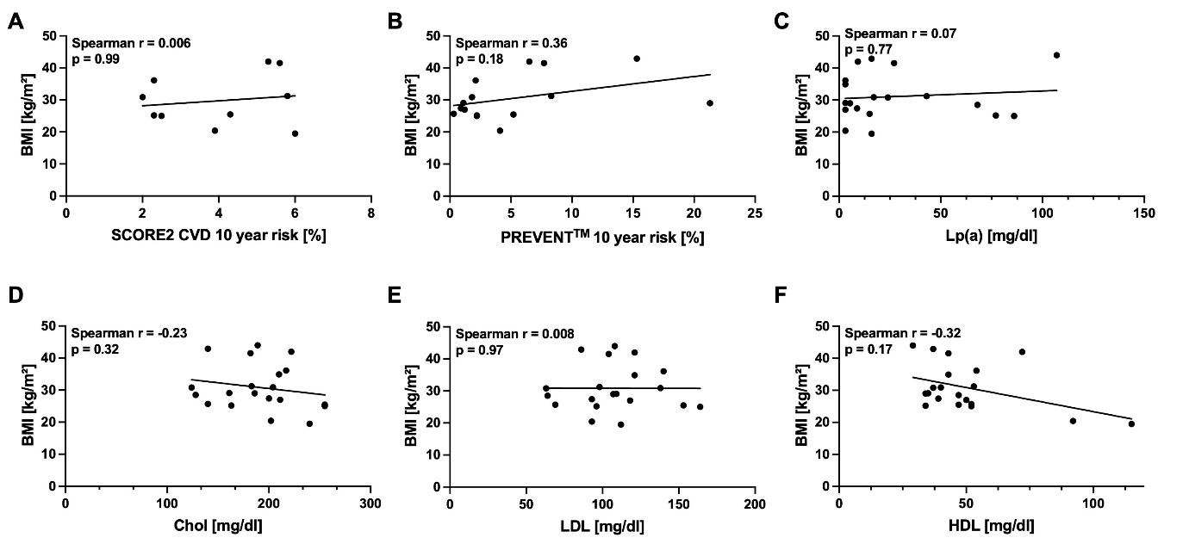
Supplemental Figure S1: Correlation of body mass index (BMI) with (A) 10-year (10-y) non-fatal and fatal cardiovascular disease (CVD) risk calculated using the Systematic Coronary Risk Estimation 2 – score (SCORE2) by the 2021 Guidelines on cardiovascular disease prevention in clinical practice (European Society of Cardiology (ESC)), (B) Predicting Risk of cardiovascular disease EVENTs (PREVENTTM) by the American Heart Association, (C) Lipoprotein A (Lp(a)), (D) total cholesterol (Chol), (E) low density lipoprotein (LDL) and (F) high density lipoprotein (HDL).

