Supplementary Table S1. Antibiotic and phage sensitivity of clinical isolate
Bacterial strain | P10 | Cocktail | Ciprofloxacin | Imipenem or Meropenem | entamicin or Amikacin | Piperacillin-Tazobactam
C1 | + | + | + | + | + | +
C2 | - | - | + | + | + | +
C3 | + | + | + | + | + | +
C4 | + | + | + | + | + | +
C5 | - | - | - | - | - | -
C6 | + | + | + | + | + | +
C7 | - | - | + | + | + | +
C8 | + | + | + | + | + | -
C9 | + | + | + | - | + | +
C10 | - | - | - | - | - | -
C11 | - | - | - | - | + | -
C12 | + | + | + | - | + | +
C13 | + | + | + | + | + | +
C14 | + | + | + | + | + | -
C15 | + | + | + | - | + | +
C16 | + | + | + | + | + | -
C17 | - | - | - | - | - | -
C18 | - | - | - | - | - | -
C19 | - | - | - | - | - | -
C20 | - | - | + | + | + | +
C21 | + | + | + | + | + | +
C22 | + | + | + | - | +
C23 | - | - | + | - | - | +
C24 | - | - | - | - | + | -
C25 | - | - | + | + | + | -
C26 | - | - | - | - | - | -
C27 | - | + | - | - | - | -
C28 | - | + | - | - | - | -
C29 | - | + | + | - | + | +
C30 | - | + | + | - | + | +
C31 | - | - | + | - | + | +
C32 | - | - | + | + | + | -
C33 | + | + | + | + | + | -
C34 | + | + | + | + | + | +
C35 | - | - | - | - | + | -
C36 | - | - | + | + | + | -
C37 | - | - | + | + | - | +
C38 | - | + | + | + | + | +
C39 | - | + | + | + | + | -
C40 | - | + | - | - | - | -
C41 | - | + | + | + | + | +
C42 | + | + | + | + | + | +
C43 | - | - | - | + | + | +
C44 | - | - | + | + | + | +
C45 | + | + | + | + | + | +
C46 | - | - | + | + | + | +
C47 | - | + | + | + | + | +
C48 | - | + | + | + | + | +
C49 | + | + | - | - | - | +
C50 | - | - | - | - | - | -
C51 | + | + | + | - | - | +
C52 | - | - | + | - | + | +
C53 | - | + | + | + | + | -
C54 | - | + | + | + | + | +
C55 | - | + | - | - | - | -
C56 | - | + | + | + | + | +
C57 | - | - | - | - | + | +
C58 | - | - | + | + | - | +
C59 | - | - | + | + | + | +
C60 | - | + | - | I | - | +
C61 | - | + | I | + | - | I
C62 | - | - | + | + | + | +
C63 | + | + | + | + | + | +
C64 | + | + | + | + | + | +
C65 | + | + | + | + | + | +
C66 | - | - | + | + | + | +
C67 | + | + | + | + | + | +
C68 | + | + | + | + | + | +
C69 | - | - | - | I | - | +
C70 | - | + | - | - | - | -
C71 | - | + | - | - | - | -
C72 | - | + | - | - | -
C73 | - | + | + | + | + | +
C74 | - | - | + | + | + | +
C75 | + | + | + | + | + | +
C76 | + | + | + | + | + | +
C77 | - | - | + | + | + | +
C78 | + | + | + | + | + | +
C79 | - | - | + | + | + | +
C80 | - | - | - | - | - | -
C81 | - | - | - | - | - | -
C82 | + | + | + | + | + | +
C83 | - | - | + | + | + | +
Supplementary Figure S1. Heat map showing whole genome comparison of P10 with 34 other phages, generated using VIRIDIC server with the threshold set to 95% for species differentiation. P10 is highlighted in green.
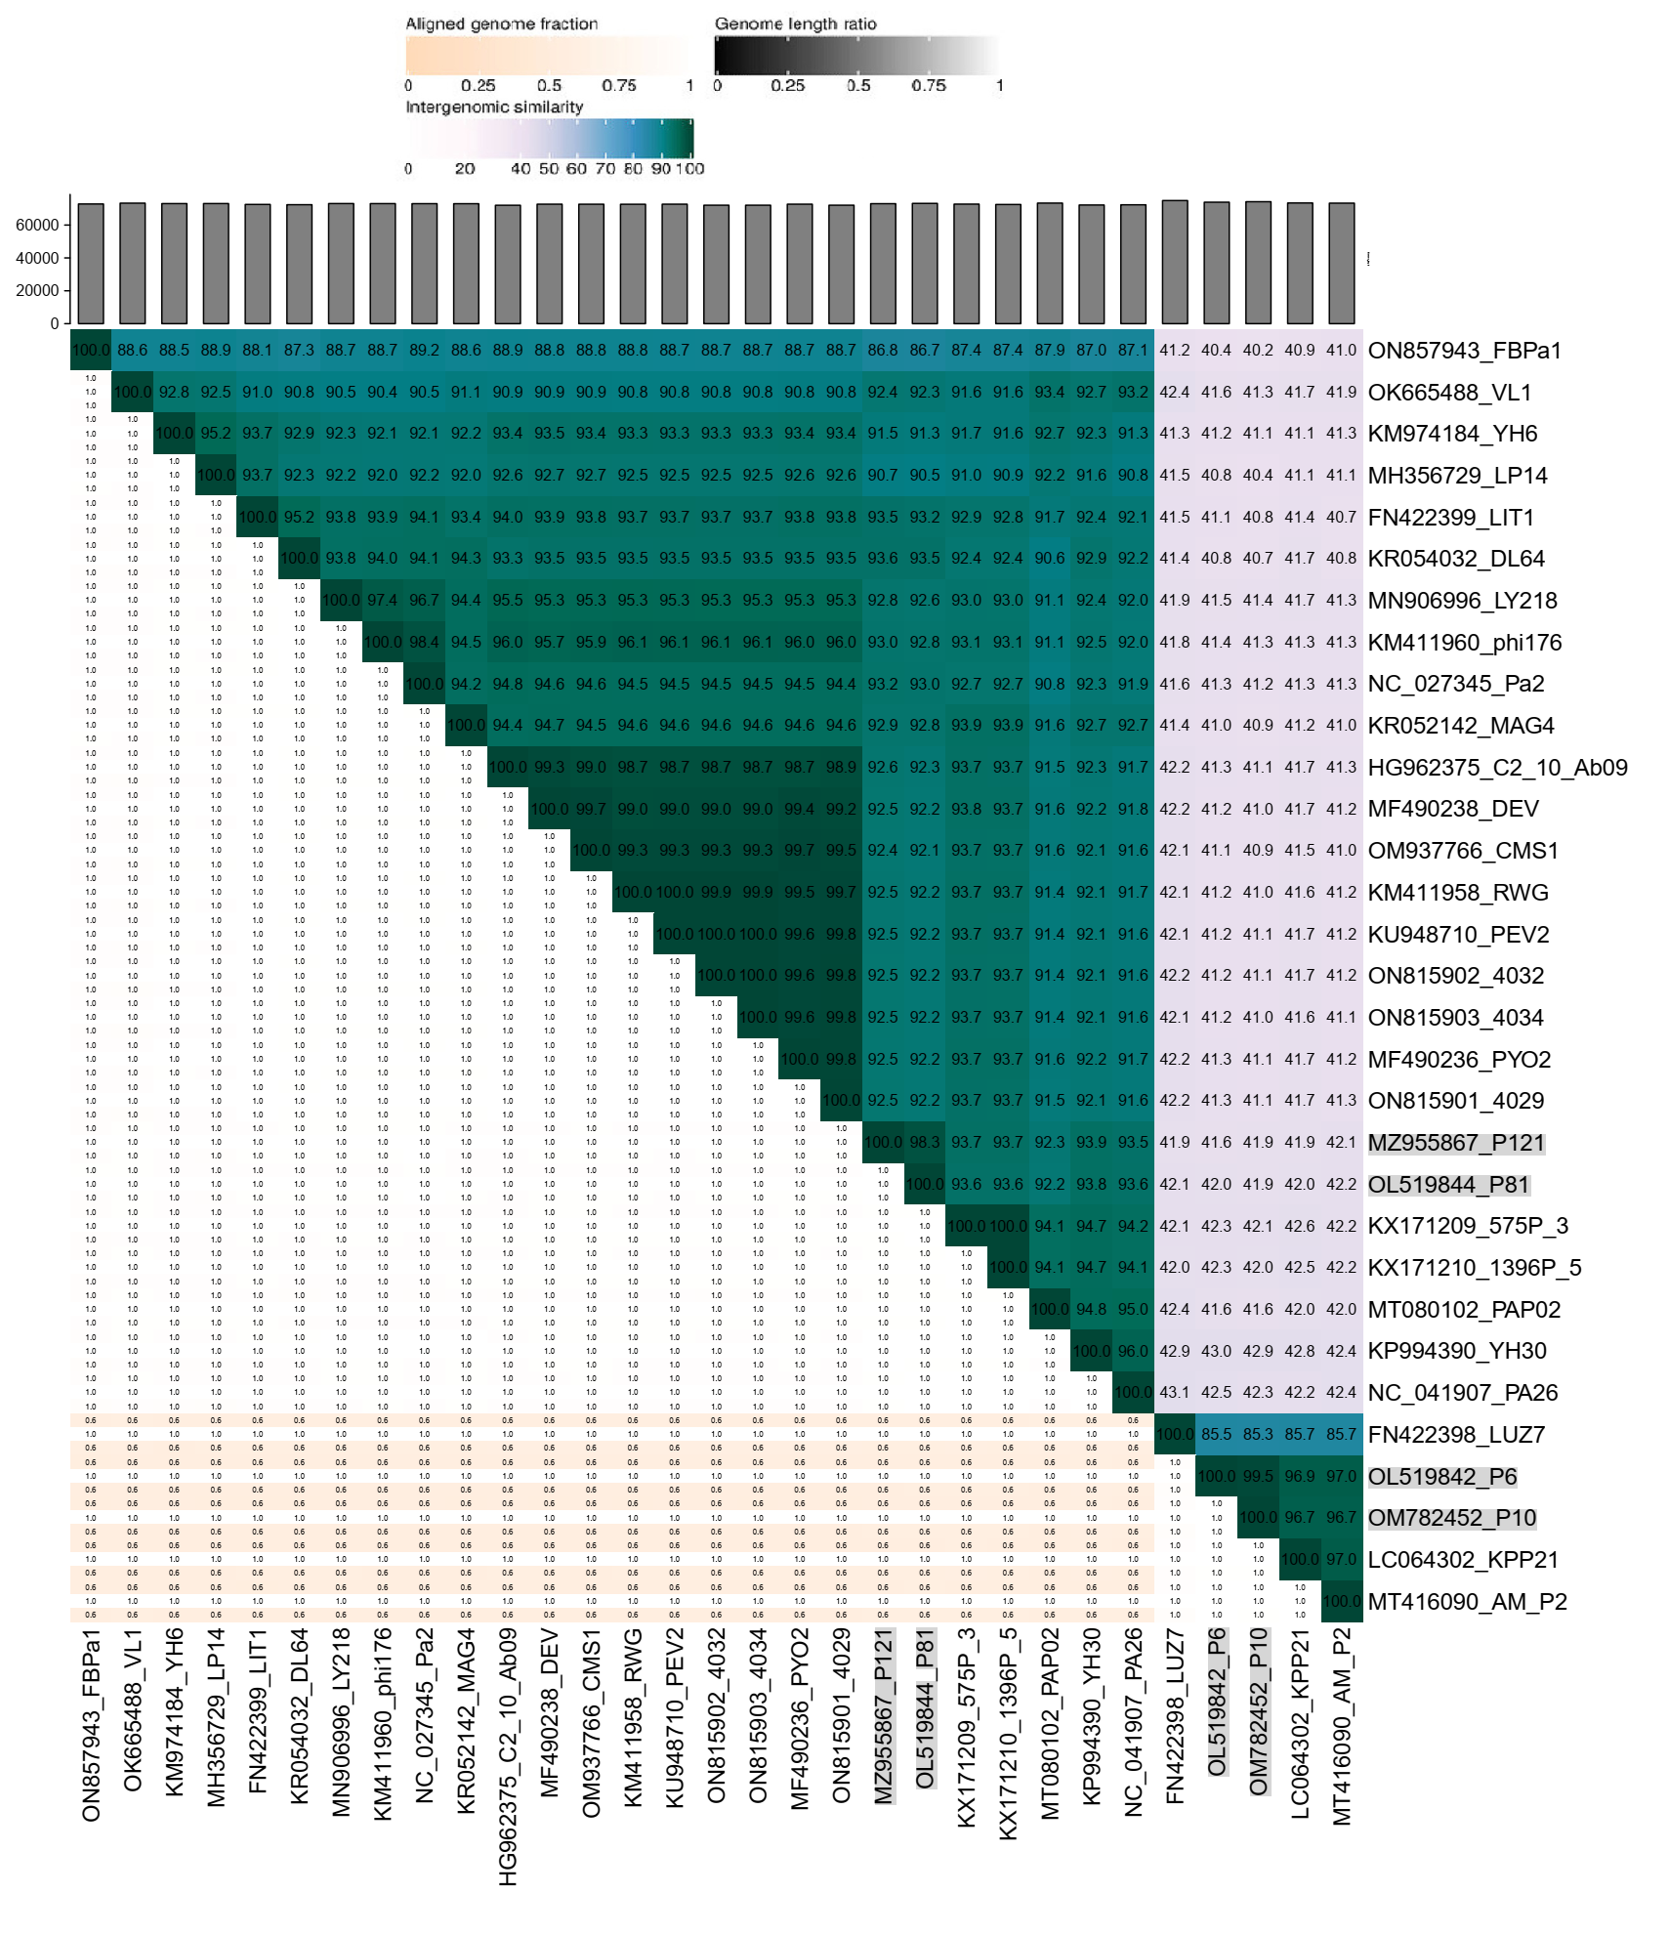

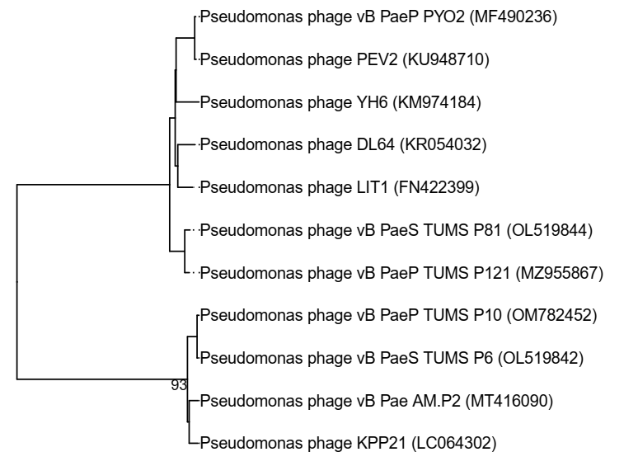
Supplementary Figure S2. Phylogeny tree drawn based on complete genome sequences

Supplementary Figure S3. Colony morphology of bacterial survivors after 40h incubation

