Table SA1. Shapiro-Wilk and Levene's tests — Germination, growth, and chlorophyll parameters (n = 192; full factorial: 2 Varieties × 2 Salinity levels × 4 Proline doses × 4 SA doses × 3 replicates)
Parameter | n | Shapiro-Wilk W | Shapiro-Wilk P | Levene's F | Levene's P
Germination (%) | 192 | 0.977 | 0.003 | 0.302 | 1.000
Germination index | 192 | 0.980 | 0.007 | 0.286 | 1.000
Plumule length (cm) | 192 | 0.986 | 0.061 | 0.588 | 0.990
Radicle length (cm) | 192 | 0.970 | <0.001 | 0.839 | 0.780
Plumule fresh weight (g) | 192 | 0.979 | 0.006 | 0.320 | 1.000
Plumule dry weight (g) | 192 | 0.977 | 0.003 | 0.313 | 1.000
Radicle fresh weight (g) | 192 | 0.840 | <0.001 | 1.029 | 0.438
Radicle dry weight (g) | 192 | 0.969 | <0.001 | 0.675 | 0.958
Vigour index | 192 | 0.984 | 0.028 | 0.669 | 0.961
Stress tolerance index | 192 | 0.893 | <0.001 | 1.881 | 0.001
Chlorophyll a | 192 | 0.855 | <0.001 | 0.686 | 0.952
Chlorophyll b | 192 | 0.534 | <0.001 | 0.892 | 0.690
Total chlorophyll | 192 | 0.575 | <0.001 | 0.817 | 0.814
Carotenoids | 192 | 0.992 | 0.393 | 0.442 | 1.000
The Shapiro–Wilk test was used to assess the normality of residuals from the full ANOVA model, including Variety, Salinity, Proline, Salicylic Acid, and their interactions. Levene’s test (median-centered) was used to assess homogeneity of variances across the 64 Variety × Salinity × Proline × Salicylic Acid treatment combinations. Some parameters showed significant deviations from normality; however, the ANOVA was retained because the factorial design was balanced and the analysis was applied consistently across all treatment combinations.
Table SA2. Shapiro-Wilk and Levene's tests — Mineral content, antioxidant and oxidative-stress parameters (n = 30; 2 Varieties × 5 Treatments × 3 replicates)
Parameter | n | Shapiro-Wilk W | Shapiro-Wilk P | Levene's F | Levene's P
Iron (Fe) | 30 | 0.957 | 0.264 | 0.383 | 0.929
Copper (Cu) | 30 | 0.952 | 0.189 | 0.304 | 0.965
Zinc (Zn) | 30 | 0.962 | 0.350 | 0.231 | 0.986
Manganese (Mn) | 30 | 0.958 | 0.270 | 0.404 | 0.918
Sodium (Na) | 30 | 0.968 | 0.492 | 0.496 | 0.860
Calcium (Ca) | 30 | 0.965 | 0.406 | 0.239 | 0.984
Magnesium (Mg) | 30 | 0.961 | 0.330 | 0.789 | 0.630
Potassium (K) | 30 | 0.964 | 0.401 | 0.190 | 0.993
Catalase (CAT) | 30 | 0.936 | 0.073 | 0.059 | 1.000
Peroxidase (POD) | 30 | 0.972 | 0.588 | 0.235 | 0.985
Superoxide dismutase (SOD) | 30 | 0.946 | 0.134 | 0.983 | 0.483
Hydrogen peroxide (H2O2) | 30 | 0.966 | 0.432 | 0.313 | 0.961
Malondialdehyde (MDA) | 30 | 0.940 | 0.093 | 0.351 | 0.945
The Shapiro–Wilk test was applied to the residuals of the two-way ANOVA (Variety × Treatment; Control, Salt, P₂, SA₁, and P₂SA₂) for each parameter. Levene’s test (median-centered) was used to assess homogeneity of variances across the 10 Variety × Treatment groups. All parameters met the assumptions of normality and homogeneity of variance (P ≥ 0.05).
Table SB1. ANOVA F-values, P-values, and partial eta-squared (effect sizes) — Germination, growth, and chlorophyll parameters (n = 192)
Parameter | Variety (V) | Salinity (S) | Proline (P) | SA
Germination (%) | F=6.51, P=0.012, η²=0.048 | F=285.21, P=<0.001, η²=0.690 | F=77.05, P=<0.001, η²=0.644 | F=144.95, P=<0.001, η²=0.773
Germination index | F=5.57, P=0.020, η²=0.042 | F=280.21, P=<0.001, η²=0.686 | F=102.65, P=<0.001, η²=0.706 | F=167.29, P=<0.001, η²=0.797
Plumule length (cm) | F=2.42, P=0.122, η²=0.019 | F=16502.16, P=<0.001, η²=0.992 | F=742.77, P=<0.001, η²=0.946 | F=602.90, P=<0.001, η²=0.934
Radicle length (cm) | F=7988.14, P=<0.001, η²=0.984 | F=42629.56, P=<0.001, η²=0.997 | F=1876.44, P=<0.001, η²=0.978 | F=1683.52, P=<0.001, η²=0.975
Plumule fresh weight (g) | F=7.93, P=0.006, η²=0.058 | F=90155.18, P=<0.001, η²=0.999 | F=1489.48, P=<0.001, η²=0.972 | F=1758.02, P=<0.001, η²=0.976
Plumule dry weight (g) | F=137.24, P=<0.001, η²=0.517 | F=59.94, P=<0.001, η²=0.319 | F=449.02, P=<0.001, η²=0.913 | F=186.60, P=<0.001, η²=0.814
Radicle fresh weight (g) | F=2499.63, P=<0.001, η²=0.951 | F=1070.40, P=<0.001, η²=0.893 | F=126.23, P=<0.001, η²=0.747 | F=18.50, P=<0.001, η²=0.302
Radicle dry weight (g) | F=92.08, P=<0.001, η²=0.418 | F=83.25, P=<0.001, η²=0.394 | F=395.99, P=<0.001, η²=0.903 | F=208.94, P=<0.001, η²=0.830
Vigour index | F=55.89, P=<0.001, η²=0.304 | F=2430.17, P=<0.001, η²=0.950 | F=62.01, P=<0.001, η²=0.592 | F=155.31, P=<0.001, η²=0.784
Stress tolerance index | F=0.90, P=0.345, η²=0.007 | F=822.95, P=<0.001, η²=0.865 | F=78.14, P=<0.001, η²=0.647 | F=20.17, P=<0.001, η²=0.321
Chlorophyll a | F=571.12, P=<0.001, η²=0.817 | F=1344.19, P=<0.001, η²=0.913 | F=830.22, P=<0.001, η²=0.951 | F=211.00, P=<0.001, η²=0.832
Chlorophyll b | F=551.60, P=<0.001, η²=0.812 | F=480.57, P=<0.001, η²=0.790 | F=184.69, P=<0.001, η²=0.812 | F=133.35, P=<0.001, η²=0.758
Total chlorophyll | F=3.39, P=0.068, η²=0.026 | F=1575.83, P=<0.001, η²=0.925 | F=450.36, P=<0.001, η²=0.913 | F=231.67, P=<0.001, η²=0.844
Carotenoids | F=1430.38, P=<0.001, η²=0.918 | F=7092.01, P=<0.001, η²=0.982 | F=8193.43, P=<0.001, η²=0.995 | F=3500.19, P=<0.001, η²=0.988

Supplementary Table SB1 (continued) — Interaction terms
Parameter | V×S | V×S×P | V×S×SA | V×S×P×SA
Germination (%) | F=3.96, P=0.049, η²=0.030 | F=13.80, P=<0.001, η²=0.492 | F=6.08, P=<0.001, η²=0.300 | F=19.75, P=<0.001, η²=0.847
Germination index | F=4.56, P=0.035, η²=0.034 | F=20.39, P=<0.001, η²=0.589 | F=5.13, P=<0.001, η²=0.265 | F=27.46, P=<0.001, η²=0.885
Plumule length (cm) | F=58.47, P=<0.001, η²=0.314 | F=77.84, P=<0.001, η²=0.846 | F=77.14, P=<0.001, η²=0.844 | F=170.11, P=<0.001, η²=0.980
Radicle length (cm) | F=482.45, P=<0.001, η²=0.790 | F=384.85, P=<0.001, η²=0.964 | F=357.69, P=<0.001, η²=0.962 | F=278.37, P=<0.001, η²=0.987
Plumule fresh weight (g) | F=9.72, P=0.002, η²=0.071 | F=259.72, P=<0.001, η²=0.948 | F=279.50, P=<0.001, η²=0.952 | F=313.82, P=<0.001, η²=0.989
Plumule dry weight (g) | F=506.61, P=<0.001, η²=0.798 | F=12.69, P=<0.001, η²=0.472 | F=106.65, P=<0.001, η²=0.882 | F=74.47, P=<0.001, η²=0.954
Radicle fresh weight (g) | F=215.13, P=<0.001, η²=0.627 | F=19.09, P=<0.001, η²=0.573 | F=18.30, P=<0.001, η²=0.563 | F=19.63, P=<0.001, η²=0.847
Radicle dry weight (g) | F=13.84, P=<0.001, η²=0.098 | F=31.35, P=<0.001, η²=0.688 | F=45.33, P=<0.001, η²=0.761 | F=65.14, P=<0.001, η²=0.948
Vigour index | F=1.10, P=0.297, η²=0.008 | F=6.44, P=<0.001, η²=0.312 | F=12.45, P=<0.001, η²=0.467 | F=15.75, P=<0.001, η²=0.816
Stress tolerance index | F=2.03, P=0.157, η²=0.016 | F=26.64, P=<0.001, η²=0.652 | F=5.97, P=<0.001, η²=0.296 | F=6.21, P=<0.001, η²=0.636
Chlorophyll a | F=110.34, P=<0.001, η²=0.463 | F=354.46, P=<0.001, η²=0.961 | F=198.44, P=<0.001, η²=0.933 | F=377.87, P=<0.001, η²=0.991
Chlorophyll b | F=0.65, P=0.423, η²=0.005 | F=43.84, P=<0.001, η²=0.755 | F=127.40, P=<0.001, η²=0.900 | F=63.26, P=<0.001, η²=0.947
Total chlorophyll | F=32.97, P=<0.001, η²=0.205 | F=102.99, P=<0.001, η²=0.879 | F=95.62, P=<0.001, η²=0.871 | F=134.68, P=<0.001, η²=0.974
Carotenoids | F=1418.69, P=<0.001, η²=0.917 | F=957.59, P=<0.001, η²=0.985 | F=947.50, P=<0.001, η²=0.985 | F=1166.05, P=<0.001, η²=0.997
Partial eta squared (η²) = SS_effect / (SS_effect + SS_error), calculated from the ANOVA model matching Table 2 (error df = 128). Values ≈ 0.01, 0.06, and 0.14 are conventionally interpreted as small, medium, and large effects (Cohen, 1988).
Table SB2. ANOVA F-values, P-values, and partial eta-squared (effect sizes) — Mineral content, antioxidant and oxidative-stress parameters (n = 30)
Parameter | Variety (V) | Treatment (T) | V×T
Iron (Fe) | F=93.04, P=<0.001, η²=0.823 | F=101.95, P=<0.001, η²=0.953 | F=4.28, P=0.012, η²=0.461
Copper (Cu) | F=10.76, P=0.004, η²=0.350 | F=108.23, P=<0.001, η²=0.956 | F=1.39, P=0.272, η²=0.218
Zinc (Zn) | F=96.45, P=<0.001, η²=0.828 | F=73.51, P=<0.001, η²=0.936 | F=3.54, P=0.024, η²=0.414
Manganese (Mn) | F=162.70, P=<0.001, η²=0.891 | F=126.79, P=<0.001, η²=0.962 | F=4.55, P=0.009, η²=0.477
Sodium (Na) | F=1723.21, P=<0.001, η²=0.989 | F=7598.12, P=<0.001, η²=0.999 | F=130.33, P=<0.001, η²=0.963
Calcium (Ca) | F=159.87, P=<0.001, η²=0.889 | F=684.41, P=<0.001, η²=0.993 | F=11.97, P=<0.001, η²=0.705
Magnesium (Mg) | F=1219.72, P=<0.001, η²=0.984 | F=520.78, P=<0.001, η²=0.990 | F=26.07, P=<0.001, η²=0.839
Potassium (K) | F=407.46, P=<0.001, η²=0.953 | F=1967.10, P=<0.001, η²=0.997 | F=1.09, P=0.388, η²=0.179
Catalase (CAT) | F=0.61, P=0.445, η²=0.029 | F=13.72, P=<0.001, η²=0.733 | F=1.23, P=0.330, η²=0.197
Peroxidase (POD) | F=20.44, P=<0.001, η²=0.505 | F=23.60, P=<0.001, η²=0.825 | F=0.48, P=0.750, η²=0.088
Superoxide dismutase (SOD) | F=25.71, P=<0.001, η²=0.562 | F=27.52, P=<0.001, η²=0.846 | F=1.05, P=0.407, η²=0.174
Hydrogen peroxide (H2O2) | F=2063.36, P=<0.001, η²=0.990 | F=4920.34, P=<0.001, η²=0.999 | F=253.79, P=<0.001, η²=0.981
Malondialdehyde (MDA) | F=0.30, P=0.589, η²=0.015 | F=6402.21, P=<0.001, η²=0.999 | F=296.80, P=<0.001, η²=0.983
Partial eta squared (η²) = SS_effect / (SS_effect + SS_error), calculated from the two-way ANOVA (Variety × Treatment) for each parameter (error df = 20)
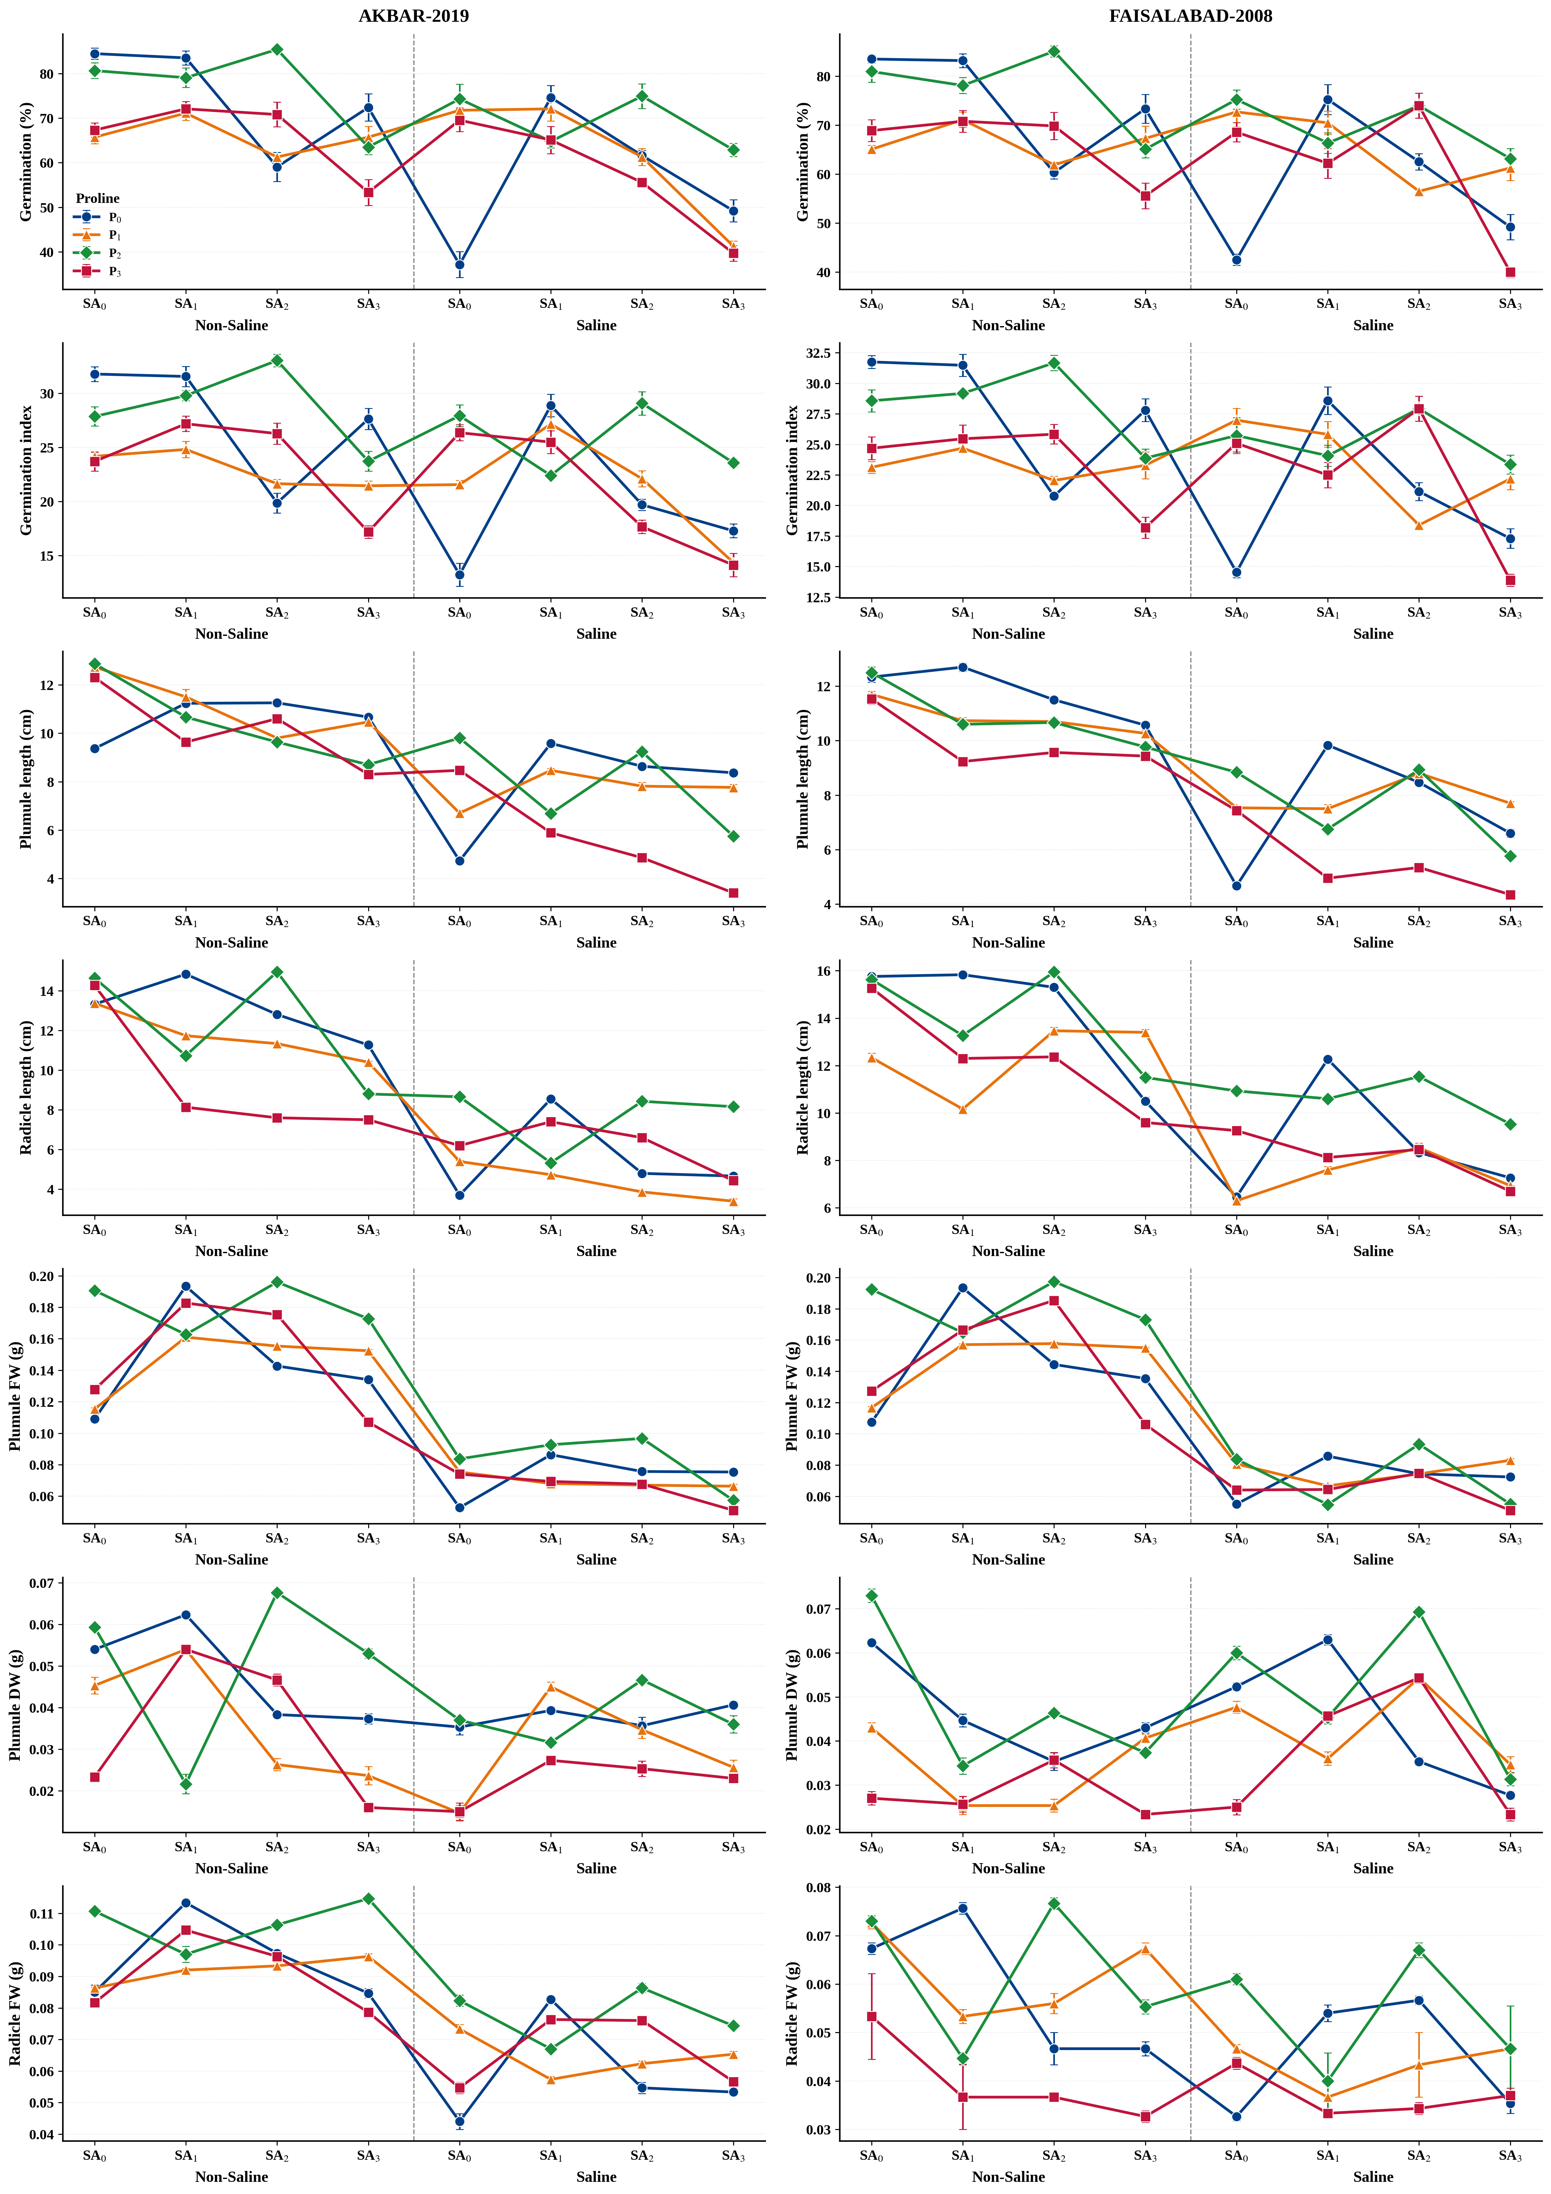
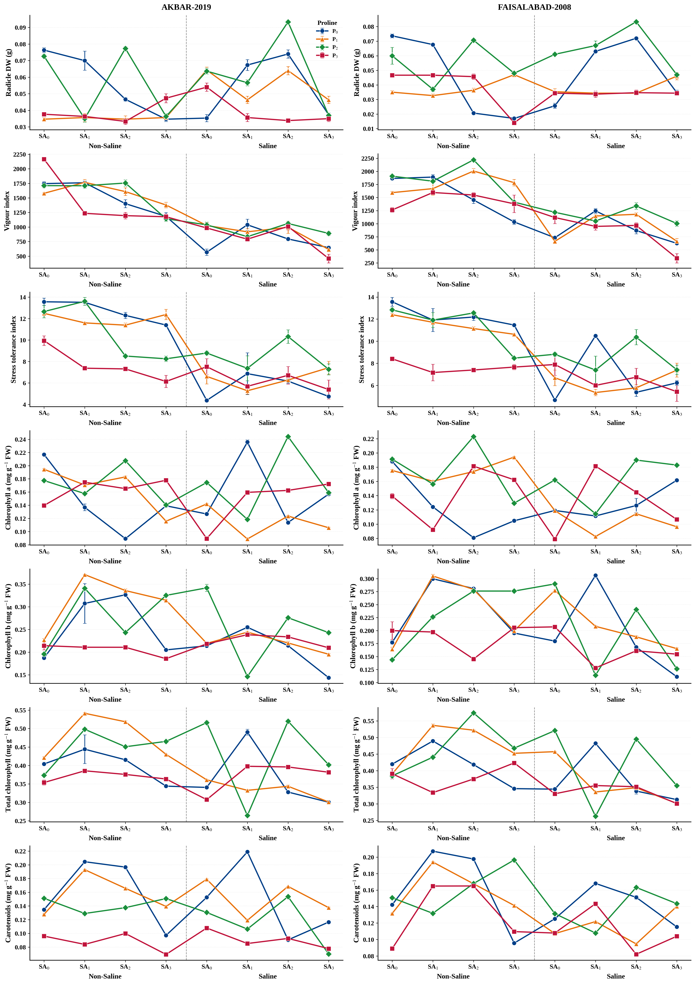
Fig S1: Interaction plots showing the effects of salinity (0 and 160 mM NaCl), salicylic acid dose (SA₀–SA₃: 0, 1, 5, 10 mM), and proline dose (P₀–P₃: 0, 1, 5, 10 mM) on germination, growth and pigment parameters in AKBAR-2019 and FAISALABAD-2008 (n = 3). Data are means ± SE. Non-parallel or crossing lines indicate an interaction between factors.
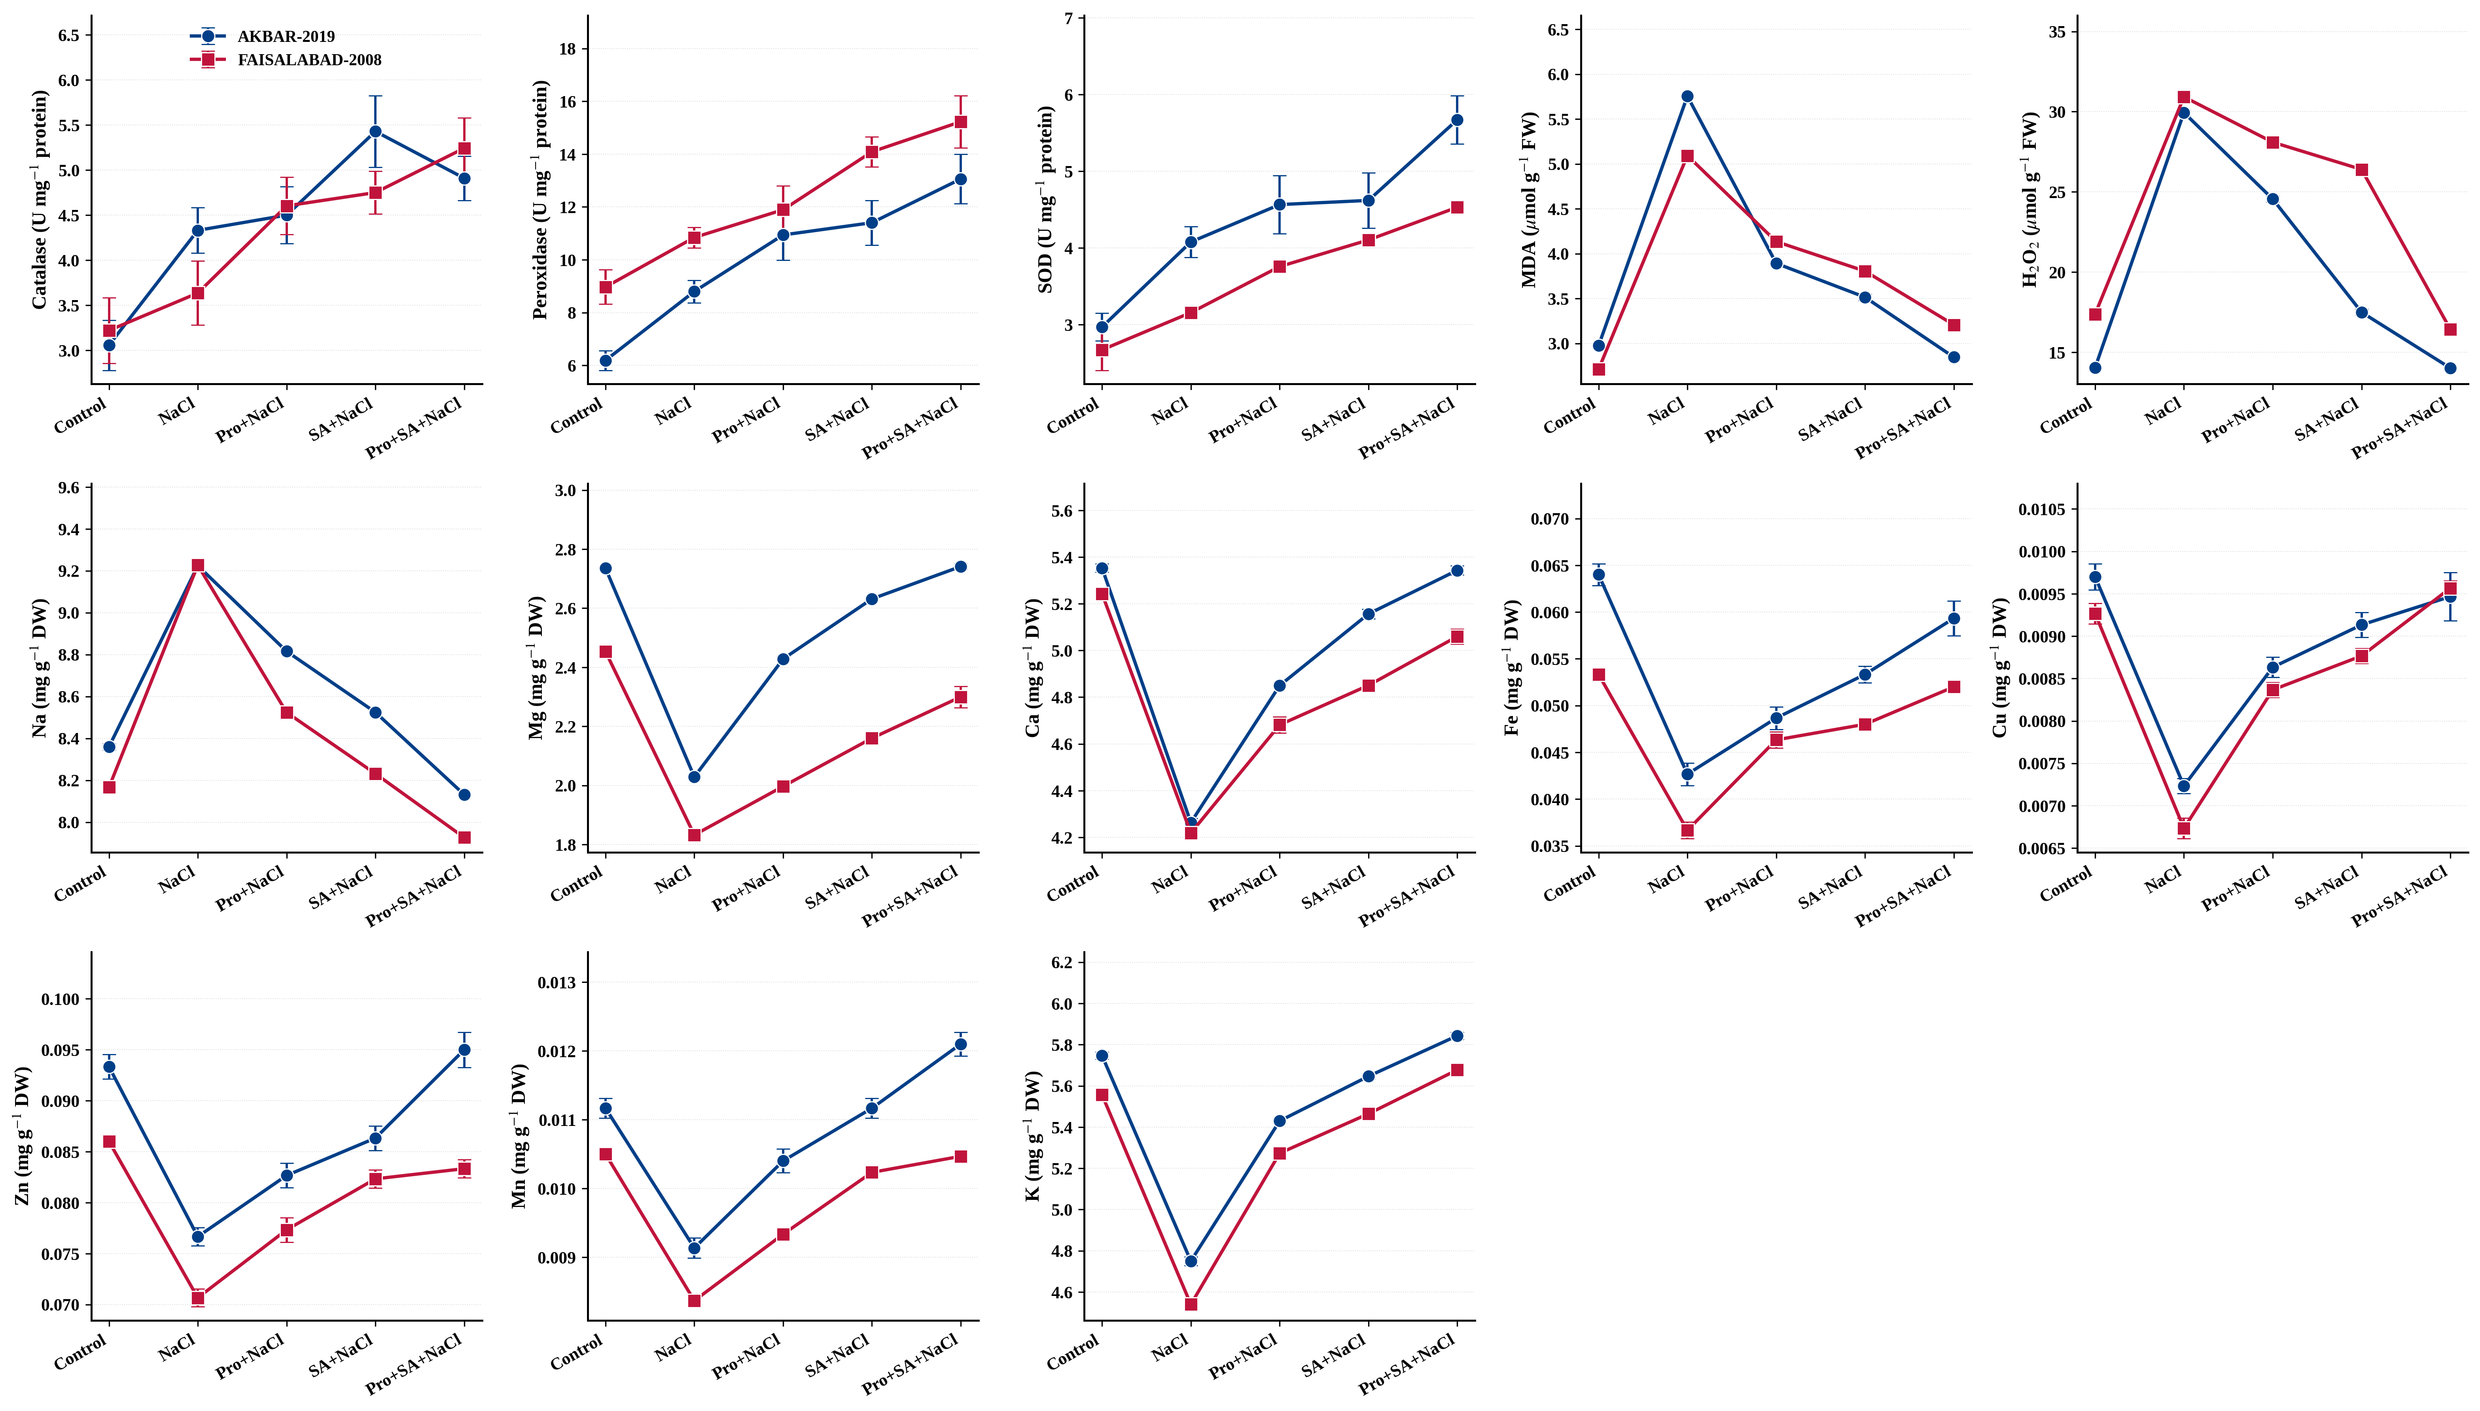
Figure S2. Interaction plots (Variety × Treatment) for mineral contents, antioxidant assays, and oxidative-stress parameters (n = 3). Data are means ± SE. Non-parallel or crossing lines indicate an interaction between Variety and Treatment.

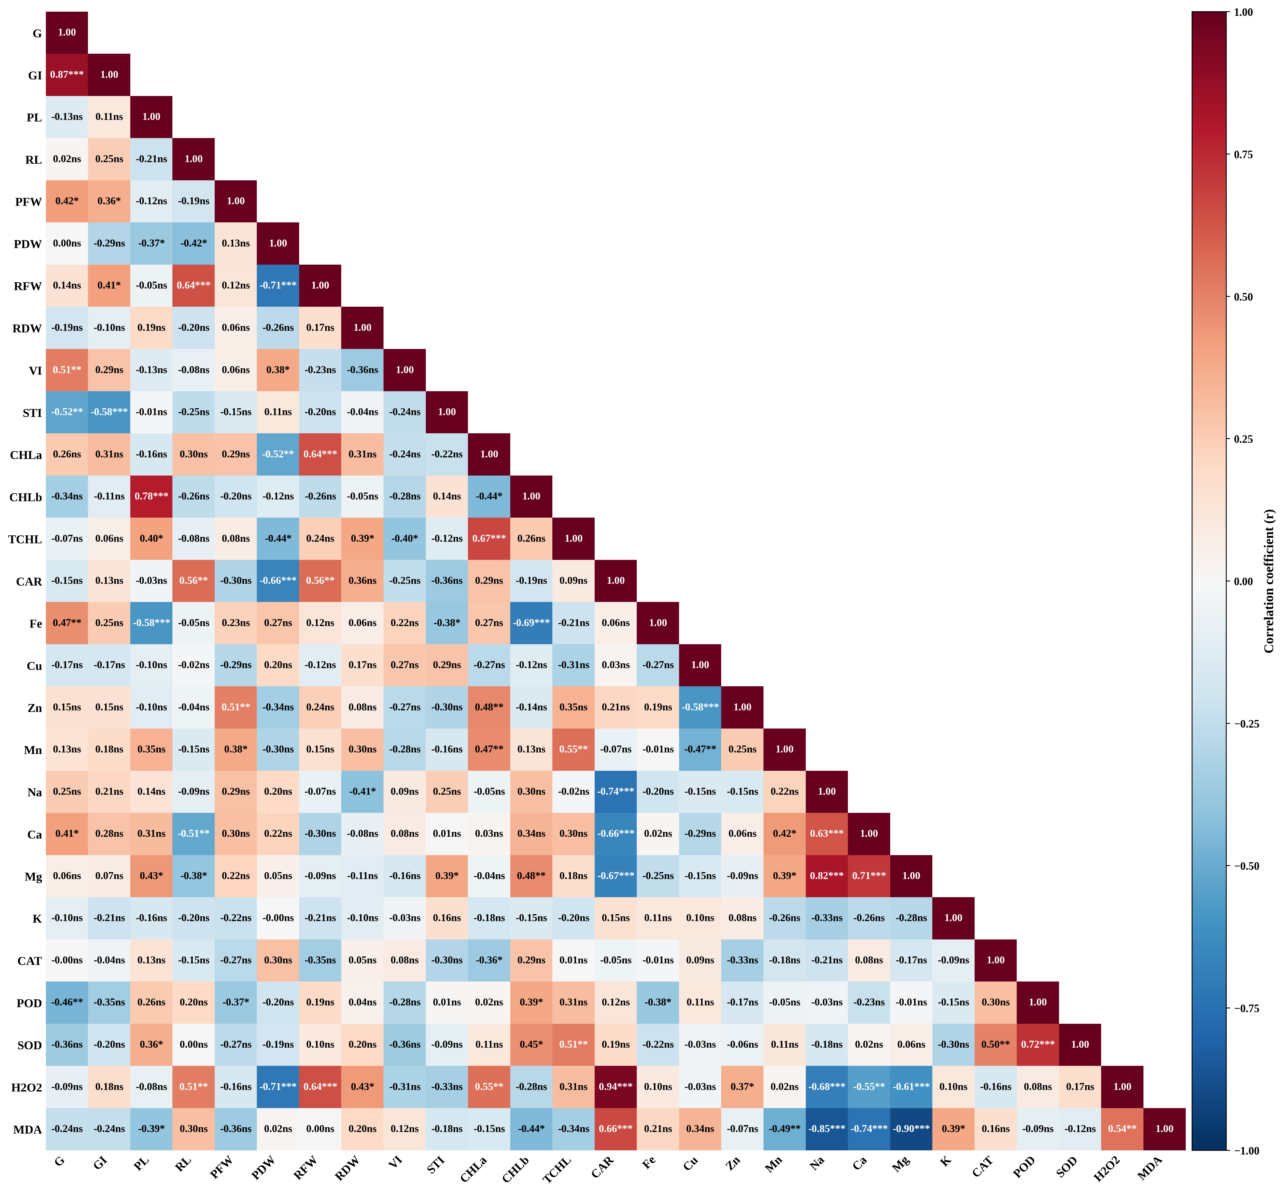
Fig S3: Partial Pearson correlation matrix among growth, pigment, mineral, and antioxidant parameters in wheat seedlings, controlling for the effects of Variety and Treatment (n = 30). Correlation coefficients were calculated on the residuals of each parameter after removing the additive effects of Variety and Treatment (linear model: Value ~ Variety + Treatment), to avoid spurious correlations arising from the treatment structure of the experiment. Colour intensity represents the strength and direction of the correlation coefficient (r), with dark red indicating strong positive correlations and dark blue indicating strong negative correlations. *, **, *** indicate significance at P < 0.05, P < 0.01, and P < 0.001, respectively; ns = not significant. Parameter abbreviations: G, germination percentage; GI, germination index; PL, plumule length; RL, radicle length; PFW, plumule fresh weight; PDW, plumule dry weight; RFW, radicle fresh weight; RDW, radicle dry weight; VI, vigour index; STI, stress tolerance index; CHLa, chlorophyll a; CHLb, chlorophyll b; TCHL, total chlorophyll; CAR, carotenoids; Fe, iron; Cu, copper; Zn, zinc; Mn, manganese; Na, sodium; Ca, calcium; Mg, magnesium; K, potassium; CAT, catalase; POD, peroxidase; SOD, superoxide dismutase; H₂O₂, hydrogen peroxide; MDA, malondialdehyde.

