Supplemental Figure S1. Flowchart of the study population.
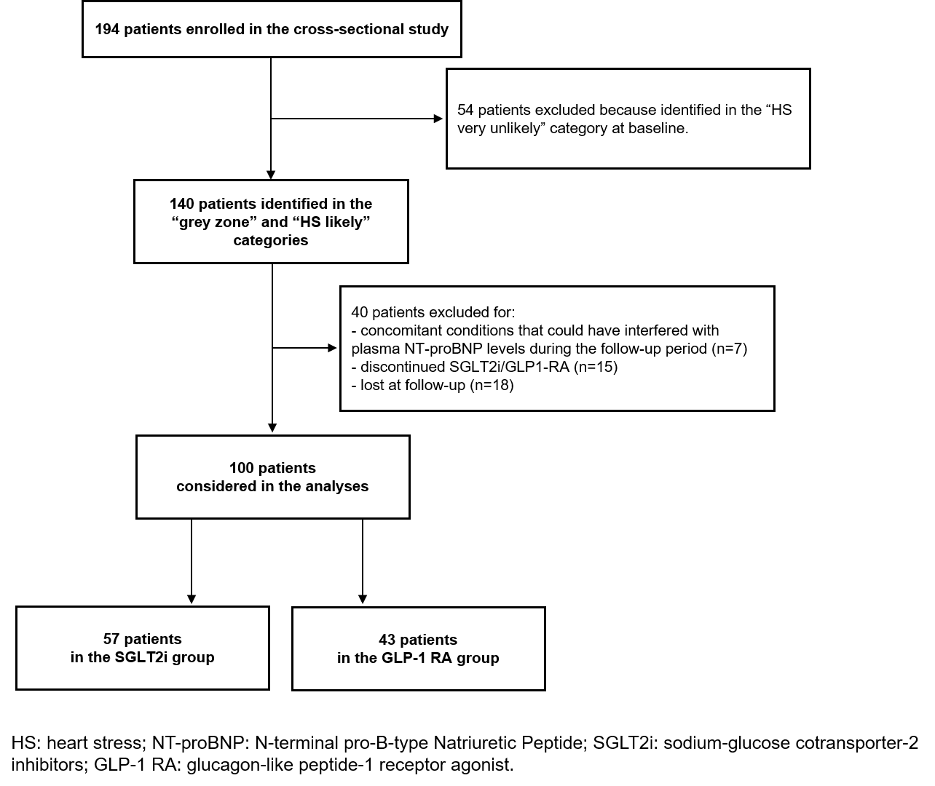

Supplemental Table S1. General characteristics of the study population at baseline according to NT-proBNP tertiles.
 | Tertile 1  NT-proBNP  <116 pg/mL  (n=33) | Tertile 2  NT-proBNP  116-229 pg/mL  (n=33) | Tertile 3  NT-proBNP  >229 pg/mL  (n=34) |  | p-values
Demographics and anthropometrics
Age (years) | 68.0±7.3 | 73.1±6.5 | 76.3±7.1 |  | <0.001
Sex (male) | 50% | 81.3% | 68.8% |  | 0.028
BMI (Kg/m²) | 33.3±7.0 | 31.1±5.1 | 31.4±4.5 |  | 0.227
Waist circumference (cm) | 114.7±14.0 | 109.5±13.5 | 106.6±9.8 |  | 0.225
CKD (eGFR <60 ml/min/1.73m²) | 18.8% | 28.1% | 62.5% |  | 0.001
Obesity (BMI ≥30 Kg/m²) | 59.4% | 50.0% | 58.1% |  | 0.717
Systolic BP (mmHg) | 137.1±15.2 | 139.5±15.1 | 137.7±17.4 |  | 0.822
Diastolic BP (mmHg) | 74.8±9.7 | 74.8±9.3 | 74.1±8.6 |  | 0.937
Smoking habit | 32.1% | 23.1% | 38.5% |  | 0.485
Dyslipidemia | 96.9% | 84.4% | 100.0% |  | 0.629
Atrial fibrillation | 3.1% | 10.0% | 34.4% |  | 0.002
Peripheral artery disease | 55.6% | 65.0% | 70.6% |  | 0.644
Cerebrovascular disease | 6.3% | 3.3% | 6.3% |  | 0.842
Laboratory parameters
eGFR (mL/min/1.73m²) | 75.6±23.8 | 72.9±18.9 | 60.4±23.4 |  | 0.016
NT-proBNP (pg/mL) | 79.5 (62.3-107.8) | 168.5 (132.5-186.0) | 731.0 (385.8-1528.8) |  | <0.001
Total cholesterol (mg/dL) | 153.3±35.6 | 139.4±33.5 | 151.4±29.2 |  | 0.269
HDL-C (mg/dL) | 46.1±17.2 | 46.3±11.8 | 47.1±14.7 |  | 0.972
LDL-C (mg/dL) | 73.1±24.8 | 67.6±33.4 | 79.8±26.3 |  | 0.328
Triglycerides (mg/dL) | 142.0 (103.5-257.0) | 116.0 (93.0-166.0) | 109.0 (79.0-148.0) |  | 0.096
Fasting glycaemia (mg/dL) | 145.0 (116.0-181.0) | 149.5 (124.3-183.8) | 142.0 (115.8-157.0) |  | 0.603
HbA1c (mmol/mol) | 61.3 (52.0-68.0) | 58.5 (52.0-63.7) | 58.0 (50.0-63.0) |  | 0.469
Albuminuria (≥30 mg/g creatinine) | 33.3% | 16.7% | 33.3% |  | 0.878
Pharmacological therapy
LLT | 78.1% | 74.2% | 90.6% |  | 0.219
Metformin | 81.3% | 65.6% | 59.4% |  | 0.151
Insulin therapy | 9.4% | 21.9% | 21.9% |  | 0.319
Other antidiabetic drugs * | 21.9% | 25.0% | 28.1% |  | 0.846
ACEi/ARBs | 71.9% | 75.0% | 87.5% |  | 0.278
Diuretics | 53.1% | 31.3% | 65.6% |  | 0.021
Calcium channel blockers | 25.0% | 59.4% | 50.0% |  | 0.017
MRAs | 9.4% | 6.3% | 18.8% |  | 0.242
Beta-blockers | 53.1% | 50.0% | 46.9% |  | 0.882
Peripheral artery disease includes the presence of atherosclerotic plaques in the carotid artery and lower and upper extremity arteries. * Sulfonylureas, Meglitinides, Thiazolidinediones, Alpha-Glucosidase Inhibitors, DPP-4 Inhibitors. BMI: Body Mass Index; CKD: Chronic Kidney Disease; BP: blood pressure; eGFR: estimated glomerular filtration rate; NT-proBNP: N-terminal pro-B-type Natriuretic Peptide; HDL-C: high-density lipoprotein cholesterol; LDL-C: low-density lipoprotein cholesterol; HbA1c: glycated haemoglobin; LLT: lipid-lowering therapy; ACEi: angiotensin-converting enzyme inhibitor; ARB: angiotensin-receptor blocker; MRA: mineralocorticoid receptor antagonist.

Supplemental Figure S2. Prevalence of «HS likely» and «grey zone» in the two studied groups.
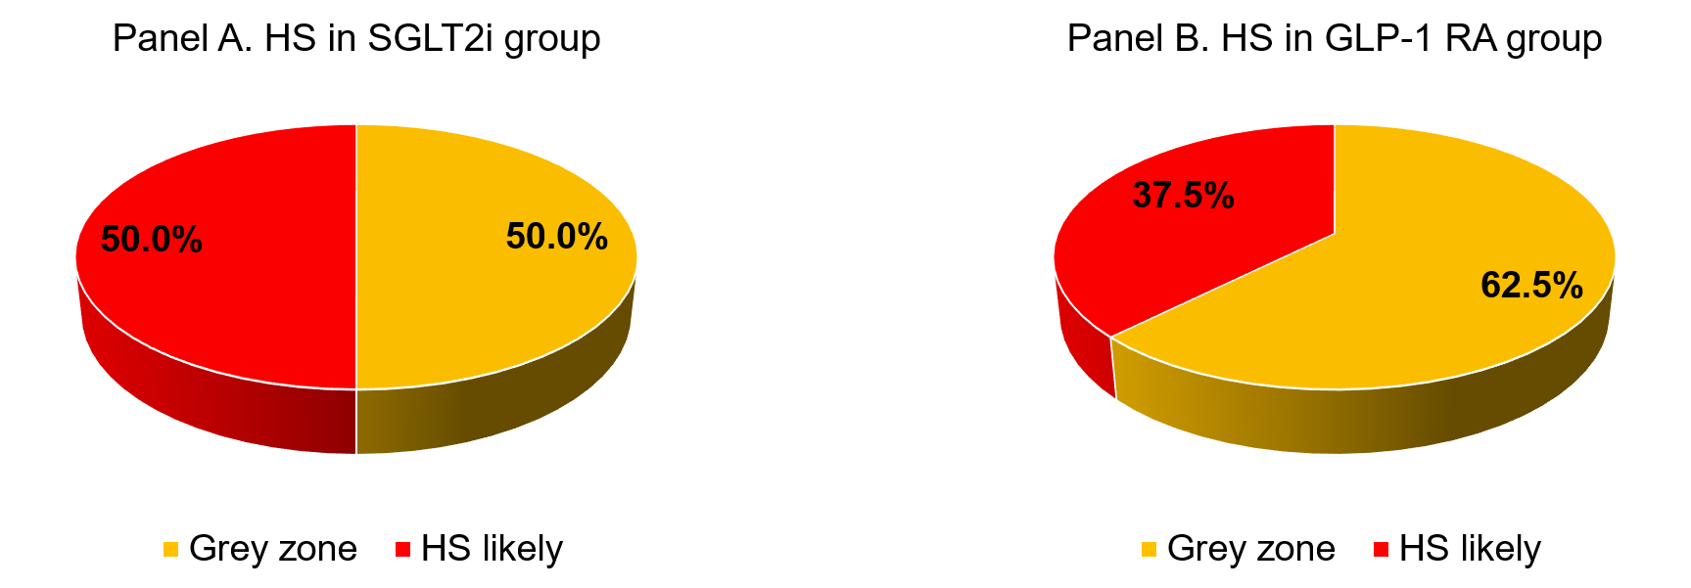
“HS likely” is defined by NT-proBNP levels ≥75 pg/mL for patients aged <50 years, ≥150 pg/mL for patients aged 50-74 years and ≥300 pg/mL for patients aged ≥75 years.

Supplemental Table S2. Change in CKD stages between baseline and follow-up in the SGLT2i group (p<0.001).
 | At follow-up
At baseline |  | eGFR > 60 ml/min/1.73 m² | 45 ≤ eGFR < 60 ml/min/1.73 m² | 30 ≤ eGFR < 45 ml/min/1.73 m² | eGFR <30 ml/min/1.73 m²
At baseline | eGFR > 60 ml/min/1.73 m² | 17 (29.8%) | 13 (22.8%) | 2 (3.5%) | 0 (0.0%)
At baseline | 45 ≤ eGFR ≤ 60 ml/min/1.73 m² | 1 (1.8%) | 4 (7.0%) | 10 (17.5%) | 3 (5.3%)
At baseline | 30 ≤ eGFR < 45 ml/min/1.73 m² | 0 (0.0%) | 1 (1.8%) | 4 (7.0%) | 1 (1.8%)
At baseline | eGFR <30 ml/min/1.73 m² | 0 (0.0%) | 0 (0.0%) | 0 (0.0%) | 1 (1.8%)
McNemar test was used. eGFR: estimated glomerular filtration rate.

Supplemental Table S3. Change in BMI (body mass index) categories between baseline and follow-up in the GLP-1 RA group (p=0.075).

 | At follow-up
At baseline |  | BMI<30 kg/m² | 30 ≤ BMI < 35 kg/m² | 35 ≤ BMI < 40 kg/m² | BMI ≥ 40 kg/m²
At baseline | BMI<30 kg/m² | 16 (37.2%) | 0 (0.0%) | 0 (0.0%) | 0 (0.0%)
At baseline | 30 ≤ BMI < 35 kg/m² | 2 (4.7%) | 9 (20.9%) | 0 (0.0%) | 0 (0.0%)
At baseline | 35 ≤ BMI < 40 kg/m² | 1 (2.3%) | 3 (7.0%) | 6 (14.0%) | 1 (2.3%)
At baseline | BMI ≥ 40 kg/m² | 0 (0.0%) | 3 (7.0%) | 0 (0.0%) | 2 (4.7%)
McNemar test was used. BMI: Body Mass Index.

