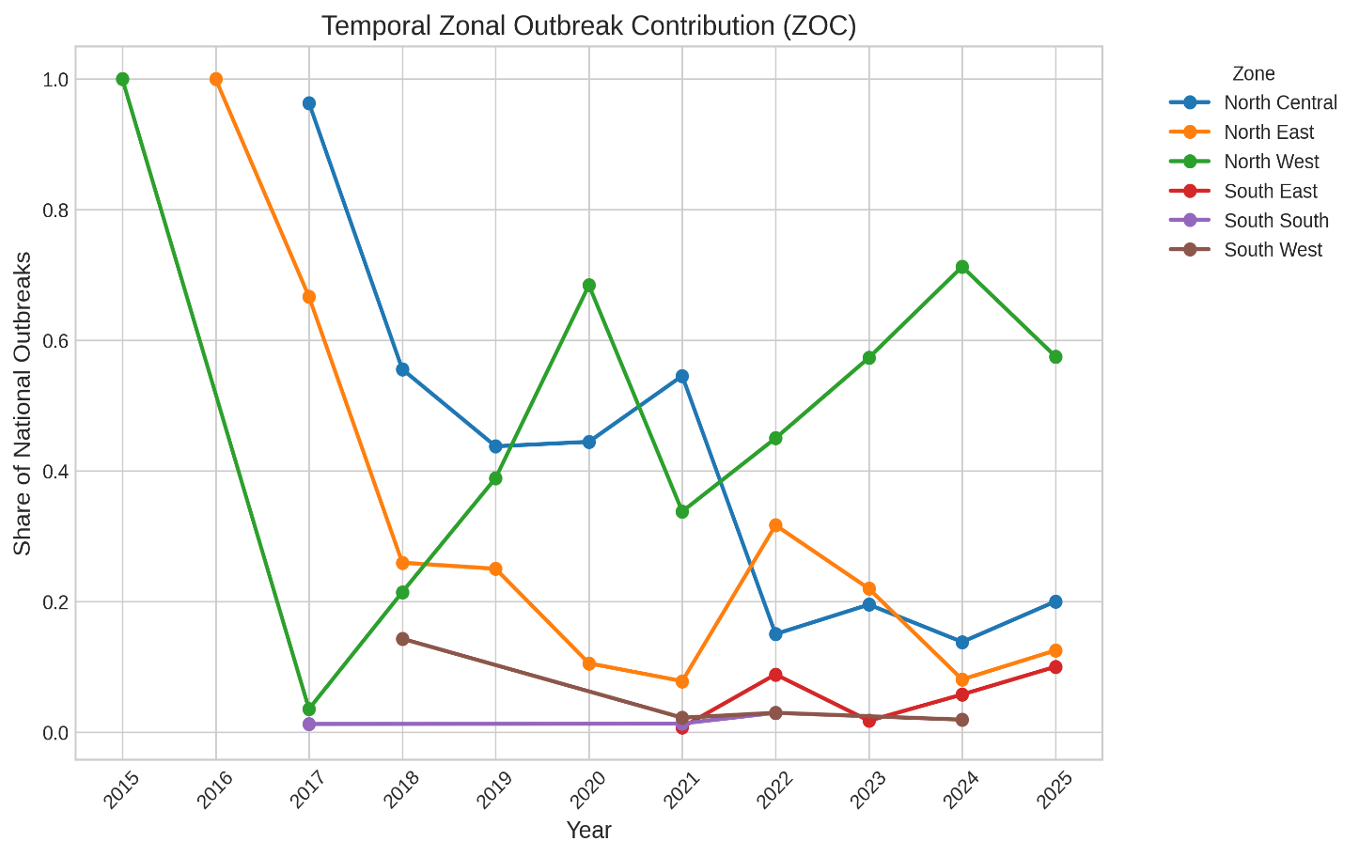
Figure S1: Zonal outbreak contribution to national reported FMD burden in Nigeria, 2015 to 2025

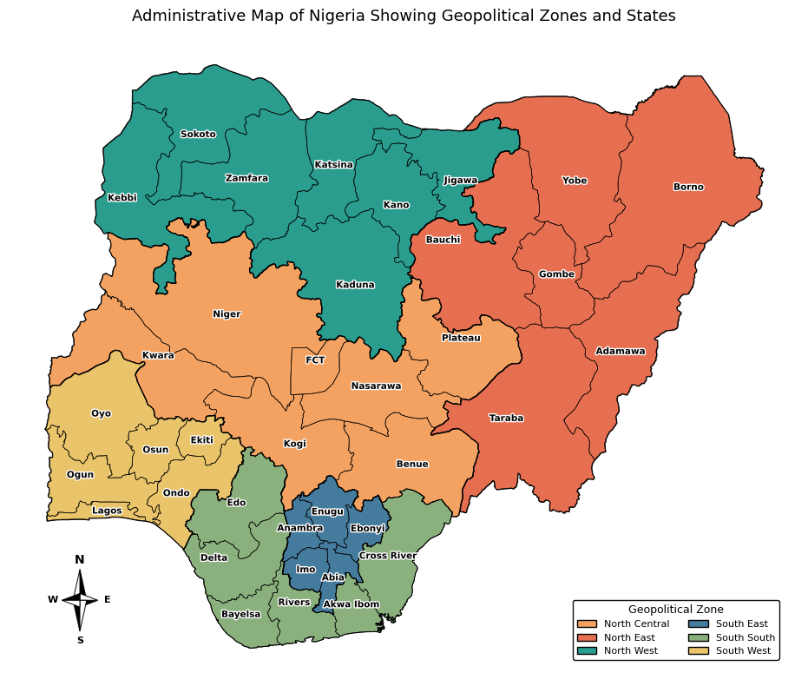
Figure S2: Administrative map of Nigeria showing the 36 states, the Federal Capital Territory, and the six geopolitical zones

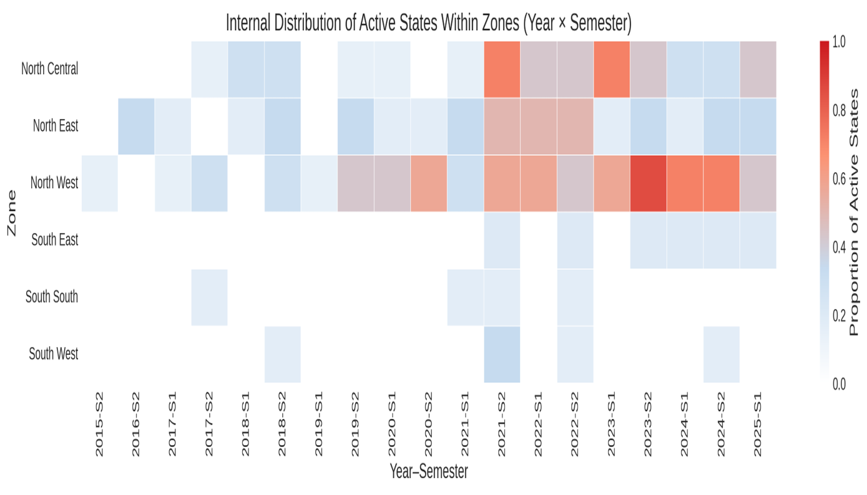
Figure S3: Semester-level internal state participation heatmap
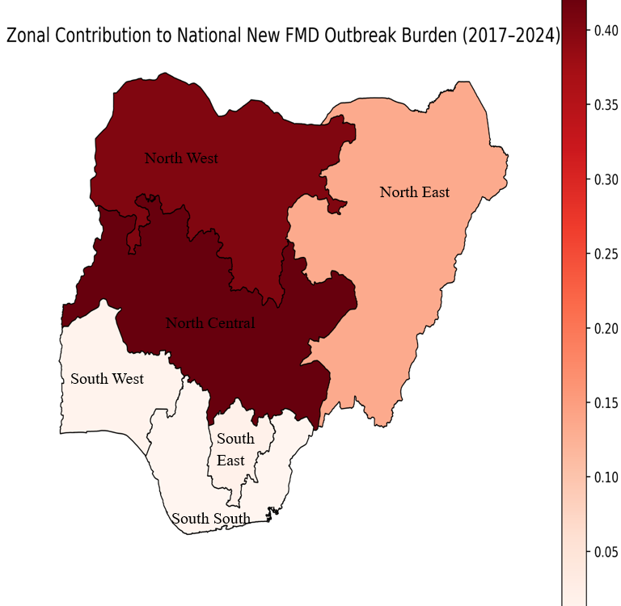
Figure S4: Zonal contribution to cumulative reported FMD outbreak burden in Nigeria

Table S1: Queen Contiguity Neighbour Structure for Nigeria’s 36 States and the FCT.
S/N | State | Queen neighbours | Queen neighbour count
1 | Abia | Akwa Ibom, Anambra, Cross River, Ebonyi, Enugu, Imo, Rivers | 7
2 | Adamawa | Borno, Gombe, Taraba | 3
3 | Akwa Ibom | Abia, Cross River, Rivers | 3
4 | Anambra | Abia, Delta, Edo, Enugu, Imo, Kogi | 6
5 | Bauchi | Gombe, Jigawa, Kaduna, Kano, Plateau, Taraba, Yobe | 7
6 | Bayelsa | Delta, Rivers | 2
7 | Benue | Cross River, Ebonyi, Enugu, Kogi, Nasarawa, Taraba | 6
8 | Borno | Adamawa, Gombe, Yobe | 3
9 | Cross River | Abia, Akwa Ibom, Benue, Ebonyi, Taraba | 5
10 | Delta | Anambra, Bayelsa, Edo, Rivers | 4
11 | Ebonyi | Abia, Benue, Cross River, Enugu | 4
12 | Edo | Anambra, Delta, Kogi, Ondo | 4
13 | Ekiti | Kogi, Kwara, Ondo, Osun | 4
14 | Enugu | Abia, Anambra, Benue, Ebonyi, Kogi | 5
15 | FCT | Kaduna, Kogi, Nasarawa, Niger | 4
16 | Gombe | Adamawa, Bauchi, Borno, Taraba, Yobe | 5
17 | Imo | Abia, Anambra, Delta, Rivers | 4
18 | Jigawa | Bauchi, Kano, Katsina, Yobe | 4
19 | Kaduna | Bauchi, FCT, Kano, Katsina, Nasarawa, Niger, Plateau, Zamfara | 8
20 | Kano | Bauchi, Jigawa, Kaduna, Katsina | 4
21 | Katsina | Jigawa, Kaduna, Kano, Zamfara | 4
22 | Kebbi | Niger, Sokoto, Zamfara | 3
23 | Kogi | Anambra, Benue, Edo, Ekiti, Enugu, FCT, Kwara, Nasarawa, Niger, Ondo | 10
24 | Kwara | Ekiti, Kogi, Niger, Osun, Oyo | 5
25 | Lagos | Ogun | 1
26 | Nasarawa | Benue, FCT, Kaduna, Kogi, Plateau, Taraba | 6
27 | Niger | FCT, Kaduna, Kebbi, Kogi, Kwara, Zamfara | 6
28 | Ogun | Lagos, Ondo, Osun, Oyo | 4
29 | Ondo | Edo, Ekiti, Kogi, Ogun, Osun | 5
30 | Osun | Ekiti, Kwara, Ogun, Ondo, Oyo | 5
31 | Oyo | Kwara, Ogun, Osun | 3
32 | Plateau | Bauchi, Kaduna, Nasarawa, Taraba | 4
33 | Rivers | Abia, Akwa Ibom, Bayelsa, Delta, Imo | 5
34 | Sokoto | Kebbi, Zamfara | 2
35 | Taraba | Adamawa, Bauchi, Benue, Cross River, Gombe, Nasarawa, Plateau | 7
36 | Yobe | Bauchi, Borno, Gombe, Jigawa | 4
37 | Zamfara | Kaduna, Katsina, Kebbi, Niger, Sokoto | 5

Table S2: Workflow Summary and Material Availability
Workflow Stage | Description | Output | Availability
Data Source | Raw WAHIS FMD Dataset | WAHIS FMD data on Nigeria | https://wahis.woah.org
Data Cleaning | WAHIS records cleaned and harmonised | Python code and cleaned analytical table | Available on reasonable request
Temporal aggregation | Annual and semester summaries | Python code and temporal tables | Available on reasonable request
Spatial weights | Queen contiguity matrix | Python code, Neighbour list, and weights object | Available on reasonable request
ESDA | Moran’s I, LISA, Gi* | ESDA Python code, statistics, and maps | Available on reasonable request

Table S3: Internal Zonal State Participation Across Study Window (2015–2025)
Zone | No of States in Zone | Min Active States | Max Active States | Min Proportion | Max Proportion
North Central (NC) | 7 | 1 | 5 | 0.17 | 0.83
North East (NE) | 6 | 1 | 4 | 0.17 | 0.67
North West  (NW) | 7 | 1 | 7 | 0.14 | 1.00
South East  (SE) | 5 | 1 | 1 | 0.20 | 0.20
South South  (SS) | 6 | 1 | 2 | 0.17 | 0.33
South West  (SW) | 6 | 1 | 2 | 0.17 | 0.33

Table S4: WAHIS FMD dataset record distribution and data quality assessment for Nigeria, 2005 to 2025.
Variables |  | 2005-2025 |  | 2005-2014 |  |  | 2015-2025
Category | Field Name | Total Records | Missing (%) | Records | Missing  % | Quality Remark | Records | Missing  % | Quality Remark
Administrative | Country (Nigeria) | 414 | 0.0 | 82 | 0.0 | Very High | 332 | 0.0 | Very High
Administrative | Divisions (States) | 414 | 6.3 | 82 | 14.6 | Very High | 332 | 4.2 | Very High
Temporal | Semester | 414 | 0.0 | 82 | 0.0 | Very High | 332 | 0.0 | Very High
Temporal | Year | 414 | 0.0 | 82 | 0.0 | Very High | 332 | 0.0 | Very High
Epidemiological | Disease | 414 | 0.0 | 82 | 0.0 | Very High | 332 | 0.0 | Very High
Epidemiological | Serotype/Genotype | 414 | 31.4 | 82 | 48.8 | Low | 332 | 27.1 | High
Epidemiological | Species | 414 | 51.5 | 82 | 53.7 | Low | 332 | 50.9 | Low
Epidemiological | New Outbreaks | 414 | 36.5 | 82 | 86.6 | Unusable | 332 | 24.1 | High
Epidemiological | Cases/Deaths | 414 | 39.1 | 82 | 92.7 | Unusable | 332 | 31.3 | Moderate

