T-cell responses to ancestral SARS-CoV-2 and Omicron in unvaccinated hospitalised adults living with and without HIV in South Africa

William C. McMahon¹, Gaurav Kwatra^{1,2,3}, Alane Izu^{1,4}, Natali Serafin¹, Farzanah Laher¹, Sharon Shalekoff^{5,6}, Caroline T. Tiemessen^{5,6}, Shabir A. Madhi^{1,4,*}, Marta C. Nunes^{1,7,*}

SUPPLEMENTARY INFORMATION
Supplementary Fig. S1: Flow cytometry gating strategy and representative
staining profiles.

Supplementary Fig. S2: T-cell subset proportions and CD4⁺/CD8⁺ T-cell ratios.

Supplementary Fig. S3: Polyfunctionality of CD4⁺CD8⁺ T cells to ancestral SARS-
CoV-2 and Omicron variant.

Supplementary Fig. S4: Comparative polyfunctionality of CD4⁺ and CD8⁺ T cells in
response to ancestral SARS-CoV-2.

Supplementary Fig. S5: T-cell activation after stimulation with the full-length spike
and nucleocapsid proteins of ancestral SARS-CoV-2.

Supplementary Table S1: Definition of statistical comparison families used for
Benjamini–Hochberg false discovery rate correction.

Fig. S1
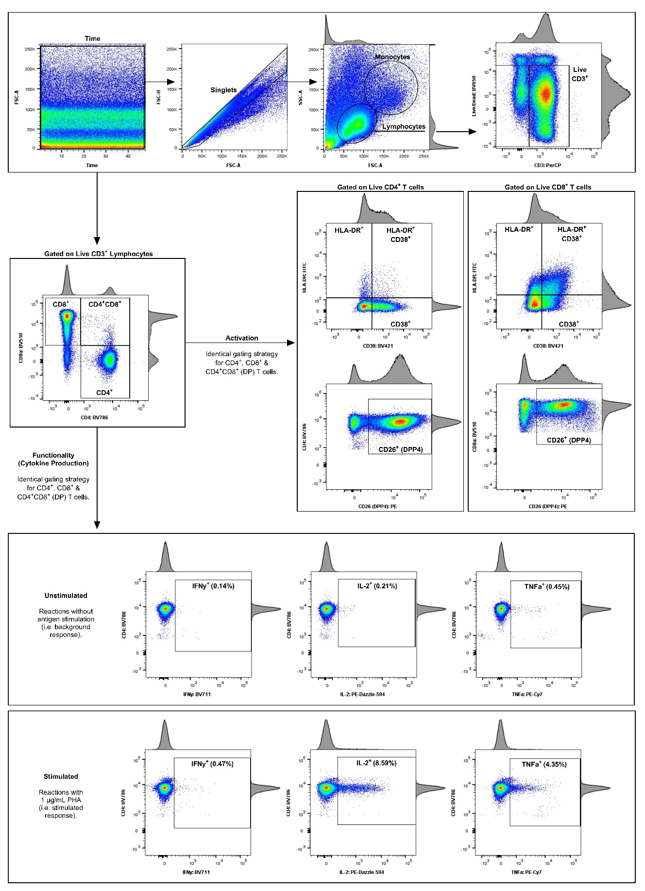
Fig. S1. Flow cytometry gating strategy and representative staining profiles.
The flow cytometry gating strategy is depicted using pseudocolour plots with accompanying histograms from a COVID-19-vaccinated donor (the plate control). (a) A time gate was applied to include only data acquired at a consistent flow rate. Doublets were excluded by gating on FSC-A vs. FSC-H, followed by the selection of lymphocytes based on FSC-A and SSC-A properties. Live CD3⁺ lymphocytes were selected as the final gating population to ensure the acquisition of approximately 100,000 events (cells) for each reaction. (b) CD4⁺, CD8⁺, and CD4⁺CD8⁺ (double positive, DP) T cells were individually gated and analysed for activation and functional responses. (c) T-cell activation was characterised by the extracellular expression of CD26 (DPP4), CD38, and HLA-DR. (d) Functional responses were assessed by the intracellular expression of IFN-γ, IL-2, and TNF-α. T-cell responses for an unstimulated control and a PHA-stimulated control are shown, with response frequencies indicated in each plot.

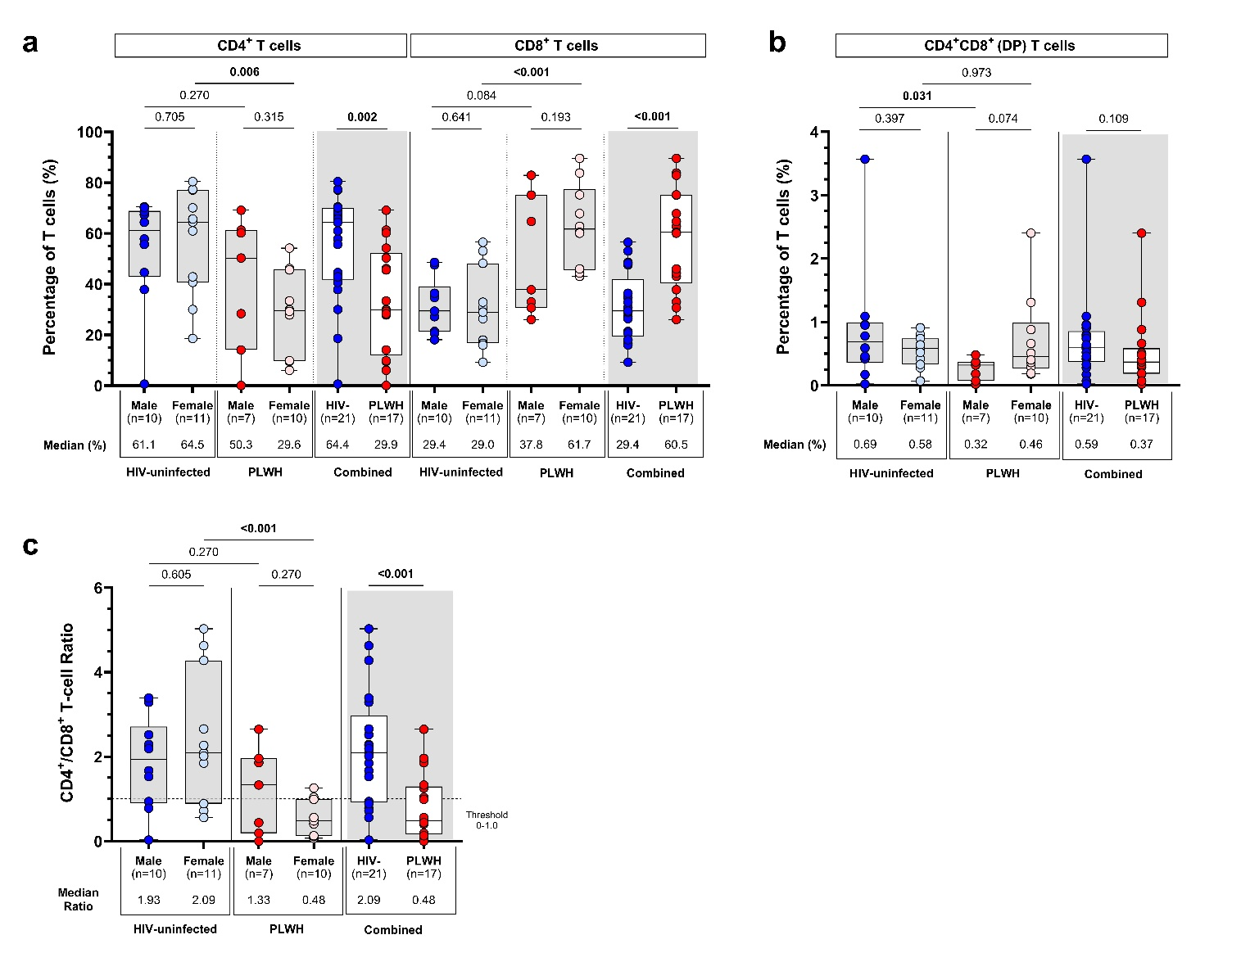
Fig. S2

Fig. S2. T-cell subset proportions and CD4⁺/CD8⁺ T-cell ratios.
(a, b) Proportion of live CD3⁺ T-lymphocytes expressing CD4 and CD8 among participants living with (n=17) and without HIV (n=21), with additional stratification by biological sex (male and female). (c) CD4⁺/CD8⁺ T-cell ratios. Each participant is represented by an individual point, with median proportions displayed below each axis. Box-and-whisker plots show medians (horizontal black lines), interquartile ranges (boxes), and minimum/maximum values (whiskers). Statistical comparisons between unpaired groups (HIV-uninfected vs. PLWH; male vs. female) were performed using the Mann–Whitney U-test. Denotations: Combined: participants living with and without HIV; PLWH: participants living with HIV.

Fig. S3
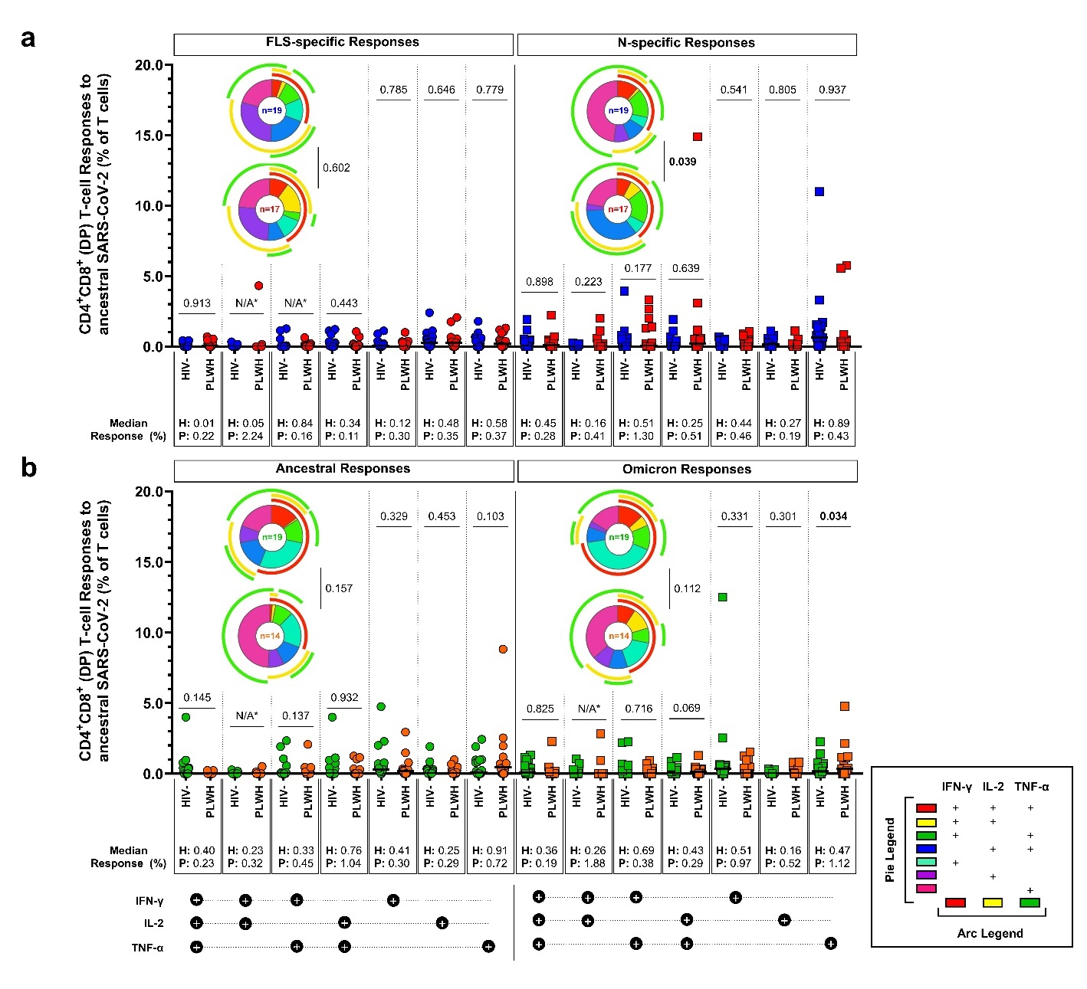

Fig. S3. Polyfunctionality of CD4⁺CD8⁺ T cells to ancestral SARS-CoV-2 and Omicron variant.
Polyfunctionality profiles of CD4⁺CD8⁺ (double positive, DP) T cells in response to (a) full-length spike (FLS) and nucleocapsid (N) proteins of ancestral SARS-CoV-2, as well as (b) partial ancestral SARS-CoV-2 and Omicron (BA.4/BA.5) spike proteins. Each participant is represented by an individual point, with median responses displayed below each axis. Polyfunctional response patterns are colour-coded and summarised in pie charts with overarching legend denoting cytokine production. Statistical comparisons between HIV-uninfected participants and PLWH were performed using multivariable linear regression on log-transformed data. Differences in overall polyfunctional T-cell response profiles were assessed using a permutation test (10,000 iterations). Raw P-values and Benjamini–Hochberg-adjusted P-values (q-values) are presented as P | q, with q-values indicated in orange. Denotations: HIV-: HIV-uninfected participants; N/A*: not applicable – P/q-values could not be determined due to only two participants having polyfunctional response values >0.00%; PLWH: participants living with HIV.

Fig. S4
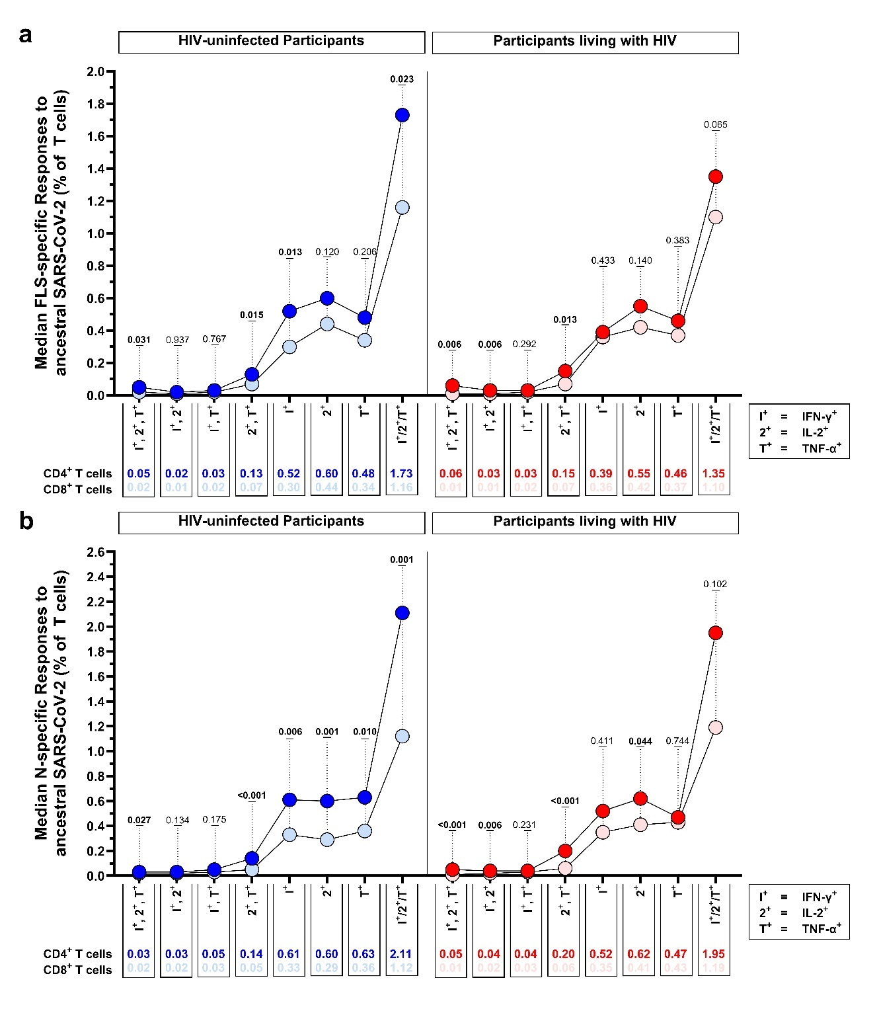Fig. S4. Comparative polyfunctionality of CD4⁺ and CD8⁺ T cells in response to ancestral SARS-CoV-2.
(a, b) Direct median comparisons of CD4⁺ and CD8⁺ T-cell polyfunctionality in response to the full-length spike (FLS) and nucleocapsid (N) proteins of ancestral SARS-CoV-2, stratified by HIV status. Each data point represents the median T-cell response (displayed below the axis) of positive responders for each cytokine combination. The Wilcoxon signed-rank test was used for paired comparisons (CD4⁺ vs. CD8⁺). Significant P-values are indicated in bold. Denotations: FLS: full-length spike glycoprotein; IFN-γ: interferon gamma; IL-2: interleukin 2; N: nucleocapsid protein; PLWH: participants living with HIV; TNF-α: tumor necrosis factor alpha.

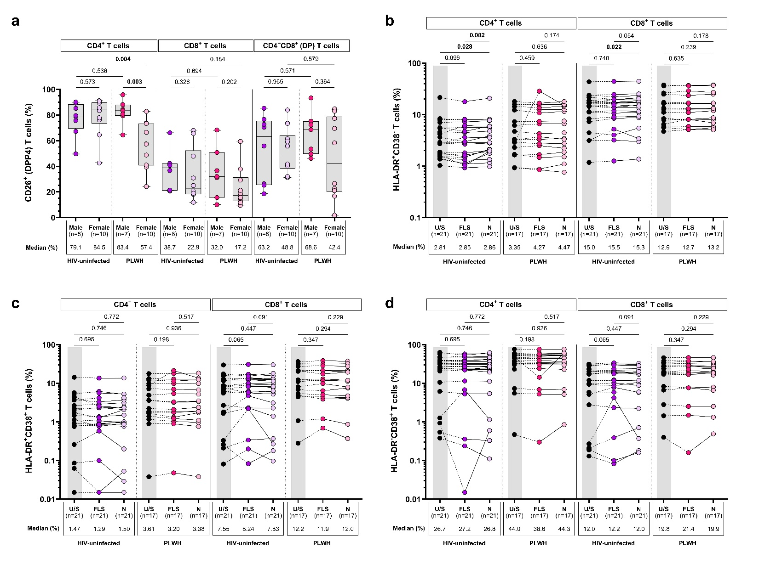
Fig. S5

Fig. S5. T-cell activation after stimulation with the full-length spike and nucleocapsid proteins of ancestral SARS-CoV-2.
(a) Proportion of CD4⁺, CD8⁺, and CD4⁺CD8⁺ (double positive, DP) T cells expressing CD26 (DPP4) among participants living with (n=17) and without HIV (n=18), further stratified by biological sex (male vs. female). Box-and-whisker plots show medians (horizontal black lines), interquartile ranges (boxes), and minimum/maximum values (whiskers). CD4⁺ and CD8⁺ T-cell activation following stimulation with the full-length spike (FLS) and nucleocapsid (N) proteins of ancestral SARS-CoV-2, as measured by the proportion of cells expressing (b) HLA-DR⁺CD38⁻, (c) HLA-DR⁺CD38⁺, or (d) HLA-DR⁻CD38⁺. Each participant is represented by an individual point, with median proportions displayed below each axis. Statistical comparisons between unpaired (HIV-uninfected vs. PLWH; male vs. female) and paired (U/S vs. FLS; U/S vs. N; FLS vs. N) groups were performed using adjusted multivariate log-linear regression and the Wilcoxon signed-rank test, respectively. Denotations: FLS: full-length spike glycoprotein; N: nucleocapsid protein; PLWH: participants living with HIV; U/S: unstimulated.

Table S1
Table S1: Definition of statistical comparison families used for Benjamini–Hochberg false discovery rate correction
Family | Figure | Comparison / hypothesis family | No. of tests
F1 | Fig. 1a | PLWH vs. HIV-uninfected: FLS and N responses across CD4⁺, CD8⁺, and DP T cells | 6
F2 | Fig. 1a | HIV-uninfected: Paired FLS vs. N responses within CD4⁺, CD8+, and DP T cells | 3
F3 | Fig. 1a | PLWH: Paired FLS vs. N responses within CD4⁺, CD8⁺, and DP T cells | 3
F4 | Fig. 1b | PLWH vs. HIV-uninfected: seven CD4⁺ T-cell polyfunctional cytokine patterns following FLS stimulation | 7
F5 | Fig. 1b | PLWH vs. HIV-uninfected: seven CD8⁺ T-cell polyfunctional cytokine patterns following FLS stimulation | 7
F6 | Fig. 1c | PLWH vs. HIV-uninfected: seven CD4⁺ T-cell polyfunctional cytokine patterns following N stimulation | 7
F7 | Fig. 1c | PLWH vs. HIV-uninfected: seven CD8⁺ T-cell polyfunctional cytokine patterns following N stimulation | 7
F8 | Fig. 1d | Correlations between total FLS- and N-specific T-cell responses | 9
F9 | Fig. 1e | Correlations between total FLS- and N-specific T-cell responses of individual cytokines | 27
F10 | Fig. 2a | PLWH vs. HIV-uninfected: CD26 expression across CD4⁺, CD8⁺, and DP T cells | 3
F11 | Fig. 2a | HIV-uninfected: Paired comparisons of CD26 expression between CD4⁺, CD8⁺, and DP T cells | 3
F12 | Fig. 2a | PLWH: Paired comparisons of CD26 expression between CD4⁺, CD8⁺, and DP T cells | 3
F13 | Fig. 2b | PLWH vs. HIV-uninfected: three T-cell activation phenotypes (HLA-DR⁺CD38⁻, HLA-DR⁺CD38⁺, HLA-DR⁻CD38⁺) | 6
F14 | Fig. 2b | HIV-uninfected: Paired CD4⁺ vs. CD8⁺ comparisons across the three activation phenotypes | 3
F15 | Fig. 2b | PLWH: Paired CD4⁺ vs. CD8⁺ comparisons across the three activation phenotypes | 3
F16 | Fig. 2c | Correlations between CD26 expression and T-cell activation phenotypes | 27
F17 | Fig. 2d | Correlations between total FLS- and N-specific T-cell responses and CD26/HLA-DR/CD38 expression | 72
F18 | Fig. 3a | PLWH vs. HIV-uninfected: ancestral/Omicron spike-specific responses across CD4⁺, CD8⁺, and DP T cells | 6
F19 | Fig. 3a | HIV-uninfected: Paired ancestral vs Omicron responses across CD4⁺, CD8⁺, and DP T cells | 3
F20 | Fig. 3a | PLWH: Paired ancestral vs. Omicron responses across CD4⁺, CD8⁺, and DP T cells | 3
F21 | Fig. 3b | PLWH vs. HIV-uninfected: fold change in CD4⁺ and CD8⁺ T-cell responses | 2
F22 | Fig. 3b | Paired ancestral vs. Omicron fold-change comparisons for CD4⁺ and CD8⁺ T cells | 2
F23 | Fig. 3c | PLWH vs. HIV-uninfected: CD4⁺ T-cell polyfunctional cytokine patterns following ancestral spike stimulation | 7
F24 | Fig. 3c | PLWH vs. HIV-uninfected: CD4⁺ T-cell polyfunctional cytokine patterns following Omicron spike stimulation | 7
F25 | Fig. 3d | PLWH vs. HIV-uninfected: CD8⁺ T-cell polyfunctional cytokine patterns following ancestral spike stimulation | 7
F26 | Fig. 3d | PLWH vs. HIV-uninfected: CD8⁺ T-cell polyfunctional cytokine patterns following Omicron spike stimulation | 7
F27 | Fig. 3e | Correlations between ancestral and Omicron responses across CD4⁺, CD8⁺, and DP T cells | 9
F28 | Fig. S3a | PLWH vs. HIV-uninfected: seven DP T-cell polyfunctional cytokine patterns following FLS stimulation | 7
F29 | Fig. S3a | PLWH vs. HIV-uninfected: seven DP T-cell polyfunctional cytokine patterns following N stimulation | 7
F30 | Fig. S3b | PLWH vs. HIV-uninfected: seven DP T-cell polyfunctional cytokine patterns following ancestral spike stimulation | 7
F31 | Fig. S3b | PLWH vs. HIV-uninfected: seven DP T-cell polyfunctional cytokine patterns following Omicron spike stimulation | 7

