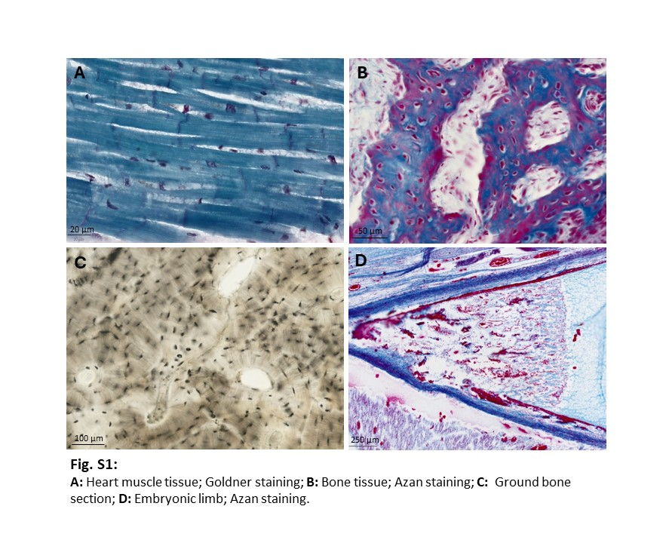
S1
S2
Questions related to the teaching methods:
Q1.
Identifying anatomical regions (e.g., epiphyseal plate, special lamellae…) within a histological section/digital slides was easy for me.
Q2.
Identifying specific cell types (e.g., osteoblasts, cardiac muscle cells) or cellular substructures (e.g., A or I bands) within a histological section/digital slides was easy for me.
Q3.
Switching from one specimen to the next was easy for me.
Q4.
When using high magnification (e.g., a 40x objective in classical microscopy), I always had a clear sense of which part of the specimen I was viewing at high resolution.
Q5.
I believe that working with a conventional light microscope/digital slides is time well spent when it comes to exam preparation.
Q6.
In my view, working with a conventional light microscope/ digital slides represents a valuable investment of time for acquiring in-depth histological knowledge.
Q7.
With conventional light microscope/digital slides, I found it easy to interact with the lecturer.
Q8.
With conventional light microscope/digital slides, I found it easy to interact with my classmates.
Q9.
I enjoyed using the conventional light microscope/digital slides.
Q10.
I believe it is important to learn the technical fundamentals of conventional light microscope /digital microscopy.

Questions related to the technical affinity of the students:
Q1.
I am very curious about technological innovations.
Q2.
I am always interested in using the latest technical devices.
Q3.
I quickly take an interest in technological innovations.
Q4.
If I had the opportunity, I would use the latest technical products much more frequently than I currently do.

