Supplementary materials

List of Supplementary Tables
Table S1: Performance of the risk scores at different cut-off points. 2
Table S2: Baseline demographic, obstetric, and clinical characteristics of eligible women who consented to participate, by induction outcome, at the University of Gondar Hospital, Ethiopia, from 10 October 2021 to March 2023 (n = 628) 4

List of Supplementary Figures
Figure S1: Screenshot from “Risk of cesarean delivery among women undergoing induction of labour: (https://eskedar.shinyapps.io/R_script/). A case example of this calculator is demonstrated, which shows that a nulliparous woman with a Bishop score of less than six and a history of stillbirth will have a 94% risk of CS…………………………………………………….2
Figure S2: QR code for the web calculator for risk of CS after IoL. 3

Table S1: Performance of the risk scores at different cut-off points.
Cutoff point | Sensitivity  (95% CI) | Specificity  (95% CI) | PPV  (95% CI) | NPV  (95% CI) | LR+  (95% CI) | LR-  (95% CI)
0 | 1(0.98- NA) | 0.00(NA-0.01) | 0.51(NA- NA) | NA (0.00- 1.0) | 1.0(1.0- 1.0) | NA
>1 | 0.92 (0.89- 0.95) | 0.51(0.45- 0.57) | 0.66(0.61- 0.76) | 0.87(0.81-0.89) | 1.89(1.67-2.13) | 0.13(0.09- 0.2)
>2 | 0.89(0.85- 0.92) | 0.64(0.59- 0.70) | 0.72(0.67- 0.79) | 0.85(0.79-0.87) | 2.53(2.16- 2.97) | 0.16(0.12- 0.23)
>3 | 0.88(0.84-0.92) | 0.67(0.62- 0.73) | 0.74(0.69- 0.80) | 0.84(0.79- 0.87) | 2.72(2.3-3.22) | 0.17(0.12- 0.23)
>5 | 0.88(0.84-0.92) | 0.68(0.62- 0.73) | 0.74(0.69-0.80) | 0.85(0.79- 0.87) | 2.78(2.34- 3.30) | 0.16(0.12- 0.23)
>6 | 0.42(0.36- 0.47) | 0.91(0.87- 0.94) | 0.84(0.77- 0.86) | 0.60(0.54- 0.70) | 5.04(3.39- 7.5) | 0.63(0.57- 0.69)
>7 | 0.11(0.08- 0.15) | 0.99(0.98- 0.99) | 0.97(0.86- 0.98) | 0.51(0.42- 0.97) | 35.3(4.84- 255) | 0.88(0.84- 0.92)
8 | 0.02(0.01-0.04) | 1.0(0.98- NA) | 1.0(0.61- 1.0) | 0.49(0.26- NA) | Inf(NA-inf) | 0.98(0.96-0.99)
*PPV: Positive Predictive Value; NPV: Negative Predictive Value; LR+: Positive Likelihood Ratio; LR-: Negative Likelihood Ratio; CI: Confidence Interval.
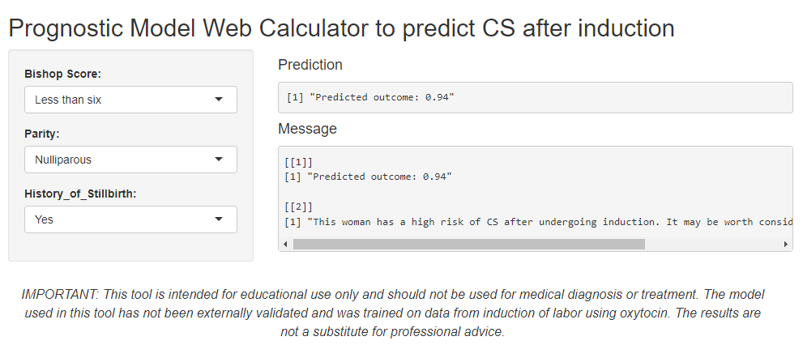
Figure S1: Screenshot from “Risk of cesarean delivery among women undergoing induction of labour: (https://eskedar.shinyapps.io/R_script/). A case example of this calculator is demonstrated, which shows that a nulliparous woman with a Bishop score of less than six and a history of stillbirth will have a 94% risk of CS.
Figure S2: QR code for the web calculator of CS risk.

Table S2: Baseline demographic, obstetric, and clinical characteristics of eligible women who consented to participate, by induction outcome, at the University of Gondar Hospital, Ethiopia, from 10 October 2021 to March 2023 (n = 628).
Variables | Outcome of Induction
Variables | C-Section  (n=321) | Vaginal delivery  (n=307) |  | OR  (95% CI)
Age | --- | --- | 0.99(0.96-1.02)
BMI | --- | --- | 1.05(0.99-1.11)
History of abortion
Yes | 48 (15%) | 42 (13.7%) |  | 1.11 (0.71-1.74)
No | 273 (85%) | 265 (86.3%) |  | Ref
History of stillbirth
Yes | 39 (12.1%) | 11 (3.6%) |  | 3.72 (1.93-7.76)
No | 282 (87.9%) | 296 (96.4%) |  | Ref
History of neonatal mortality
Yes | 26 (8.1%) | 26 (8.5%) |  | 0.95 (0.54-1.69)
No | 295 (91.9%) | 281 (91.5%) |  | Ref
ANC visit
Yes | 305 (95%) | 288 (93.8%) |  | 1.26 (0.63-2.52)
No | 16 (5%) | 19 (6.2%) |  | Ref
History of antepartum complication
Yes | 237 (73.8%) | 242 (78.8%) |  | 0.76 (0.52-1.10)
No | 84 (26.2%) | 65 (21.2%) |  | Ref
Parity
Nulliparous | 113 (35.2%) | 68 (22.1%) |  | 1.92 (1.35-2.74)
Parous | 207 (64.5%) | 239 (77.9%) |  | Ref
Gravidity
Primigravida | 179 (55.8%) | 133 (43.3%) |  | 1.66 (1.21-2.28)
Multigravida | 142 (44.2%) | 174 (56.7%) |  | Ref
Gestational age
Preterm | 6 (1.9%) | 10 (3.3%) |  | 0.52(0.17-1.41)
Term | 293 (91.3%) | 252 (82.1%) |  | Ref
Post-term | 16 (5%) | 40 (13.3) |  | 0.34(0.18-0.62)
Bishop score
<6 | 285 (88.8%) | 97 (31.6%) |  | 17.1 (11.4-26.5)
≥6 | 36 (11.2%) | 210 (68.4%) |  | Ref
Type of induction
Elective | 242 (75.4%) | 232 (75.6%) |  | 0.99 (0.69-1.42)
Emergency | 79 (24.6%) | 75 (24.4%) |  | Ref
Cervical ripening
Yes | 205 (63.9%) | 203 (66.1%) |  | 0.91 (0.65-1.26)
No | 116 (36.1%) | 104 (33.9%) |  | Ref
Membrane status
Ruptured | 79 (24.6%) | 59 (19.2%) |  | Ref
Intact | 242 (75.4%) | 248 (80.8%) |  | 0.73 (0.50-1.16)
Infant sex
Female | 201 (62.6%) | 191 (62.2%) |  | Ref
Male | 120 (39.1%) | 116 (37.8%) |  | 0.98 (0.71-1.36)
Birthweight (g) | --- | --- |  | 1.03(0.91-1.25)
Indication for Induction
APH | 9 (2.8%) | 14 (4.6%) |  | Ref
GDM | 33 (10.3%) | 18 (5.9%) |  | 2.85 (1.05-8.12)
HDP | 100 (31.2%) | 84 (27.4%) |  | 1.85 (0.77-4.65)
IUGR | 43 (13.4%) | 17 (5.5%) |  | 3.93 (1.46-11.1)
Oligohydramnios | 41 (12.8%) | 76 (24.6%) |  | 0.84 (0.34-2.17)
Post-term | 22 (6.9%) | 41 (13.4%) |  | 0.83 (0.31-2.29)
PROM | 73 (22.7%) | 57 (18.7%) |  | 1.99 (0.82-5.09)

