Supplementary Information for
Denoising of deep-tow magnetic anomalies based on discrete wavelet transform
Mingming Wang^{1,*}, Qiang Li², Zhipeng Cao¹
1 School of Resources and Civil Engineering, Suzhou University, Suzhou, China
2 Wuhan Kedao Geographical Information Engineering CO., LTD, Wuhan, China
*Corresponding author: Mingming Wang, Email: wmm@ahszu.edu.cn

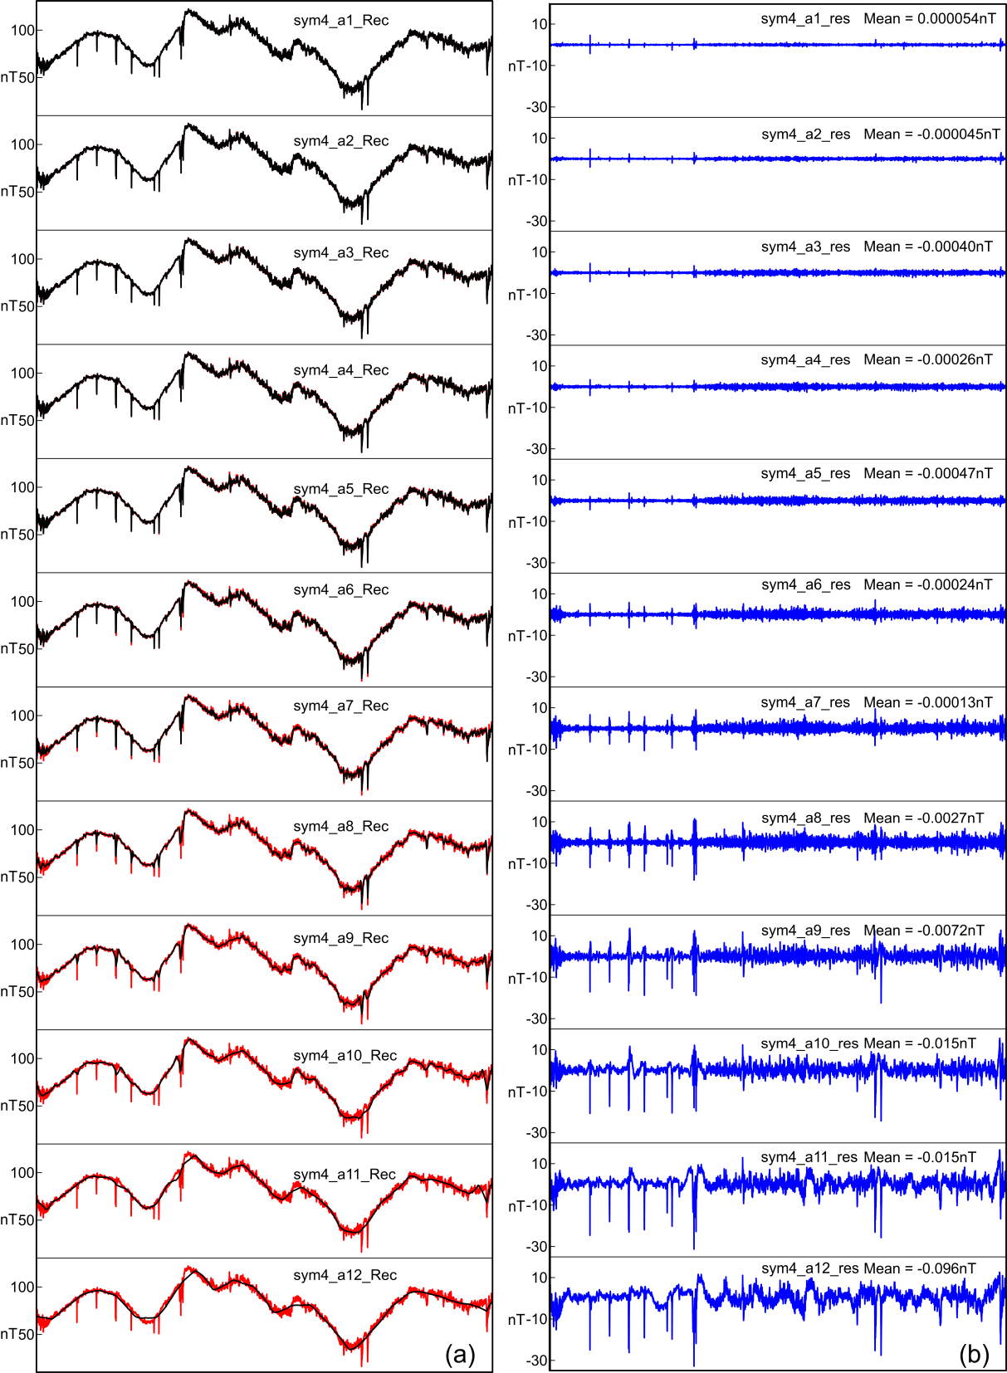
Figure S1. Denoising performance of the sym4 wavelet at decomposition levels 1–12 for deep‑tow magnetic anomalies along Segment A. (a) Superposition of raw and denoised profiles for Segment A; black solid lines represent denoised magnetic anomalies, and red solid lines represent the original raw deep‑tow magnetic anomalies. (b) Residual anomalies calculated by subtracting filtered signals from raw observations; the mean value of each residual sequence is marked correspondingly.
Figure S2. Denoising performance of the sym4 wavelet at decomposition levels 1–12 for deep‑tow magnetic anomalies along Segment B. (a) Superposition of raw and denoised profiles for Segment B; black solid lines represent denoised magnetic anomalies, and red solid lines represent the original raw deep‑tow magnetic anomalies. (b) Residual anomalies calculated by subtracting filtered signals from raw observations; the mean value of each residual sequence is marked correspondingly.
Figure S3. Denoising performance of the db5 wavelet at decomposition levels 1–12 for deep‑tow magnetic anomalies along Segment A. (a) Superposition of raw and denoised profiles for Segment A; black solid lines represent denoised magnetic anomalies, and red solid lines represent the original raw deep‑tow magnetic anomalies. (b) Residual anomalies calculated by subtracting filtered signals from raw observations; the mean value of each residual sequence is marked correspondingly.
Figure S4. Denoising performance of the db5 wavelet at decomposition levels 1–12 for deep‑tow magnetic anomalies along Segment B. (a) Superposition of raw and denoised profiles for Segment B; black solid lines represent denoised magnetic anomalies, and red solid lines represent the original raw deep‑tow magnetic anomalies. (b) Residual anomalies calculated by subtracting filtered signals from raw observations; the mean value of each residual sequence is marked correspondingly.
Figure S5. Denoising performance of the db8 wavelet at decomposition levels 1–12 for deep‑tow magnetic anomalies along Segment A. (a) Superposition of raw and denoised profiles for Segment A; black solid lines represent denoised magnetic anomalies, and red solid lines represent the original raw deep‑tow magnetic anomalies. (b) Residual anomalies calculated by subtracting filtered signals from raw observations; the mean value of each residual sequence is marked correspondingly.
Figure S6. Denoising performance of the db8 wavelet at decomposition levels 1–12 for deep‑tow magnetic anomalies along Segment B. (a) Superposition of raw and denoised profiles for Segment B; black solid lines represent denoised magnetic anomalies, and red solid lines represent the original raw deep‑tow magnetic anomalies. (b) Residual anomalies calculated by subtracting filtered signals from raw observations; the mean value of each residual sequence is marked correspondingly.
Figure S7. Denoising performance of the coif5 wavelet at decomposition levels 1–12 for deep‑tow magnetic anomalies along Segment A. (a) Superposition of raw and denoised profiles for Segment A; black solid lines represent denoised magnetic anomalies, and red solid lines represent the original raw deep‑tow magnetic anomalies. (b) Residual anomalies calculated by subtracting filtered signals from raw observations; the mean value of each residual sequence is marked correspondingly.
Figure S8. Denoising performance of the coif5 wavelet at decomposition levels 1–12 for deep‑tow magnetic anomalies along Segment B. (a) Superposition of raw and denoised profiles for Segment B; black solid lines represent denoised magnetic anomalies, and red solid lines represent the original raw deep‑tow magnetic anomalies. (b) Residual anomalies calculated by subtracting filtered signals from raw observations; the mean value of each residual sequence is marked correspondingly.

