Supplementary Information for
No detectable association of APOE ε4 with spatial navigation and broader cognition in healthy young adults
Luise P. Graichen^{1,}*, Lea Schenk¹, Christian Gausterer², Isabella C. Wagner^{1,3}*

¹ Department of Cognition, Emotion, and Methods in Psychology, Faculty of Psychology, University of Vienna, Vienna, Austria
² DNA Central Laboratory, Center for Forensic Medicine, Medical University of Vienna, Vienna, Austria
³ Division of Microbial Ecology, Centre for Microbiology and Environmental Systems Science, University of Vienna, Vienna, Austria

* Shared correspondence: Isabella C. Wagner, University of Vienna, Faculty of Psychology, Liebiggasse 5, 1010 Vienna, Austria, Phone: +43 (0)1 4277 47151, Email: isabella.wagner@univie.ac.at; Luise P. Graichen, University of Vienna, Faculty of Psychology, Liebiggasse 5, 1010, Vienna, Austria, Phone: +43 (0)1 4277 47133; Email: luise.philine.graichen@univie.ac.at

This PDF file includes:
Supplementary Results

Supplementary Methods
Supplementary Figures
Supplementary Table
Supplementary References

Supplementary Results
S1: Outlier exclusion does not change results for wayfinding distance and duration
To assess the robustness of the two primary wayfinding outcomes (wayfinding distance and duration), we recomputed group comparisons after excluding extreme outliers (± 3 × median absolute deviation, MAD). Results remained virtually identical to the main analysis (wayfinding distance: n_{ε3ε3} = 308 [19 excluded], n_{ε3ε4} = 87 [1 excluded], wayfinding duration: n_{ε3ε3} = 313 [14 excluded], n_{ε3ε4} = 88 [0 excluded], all p > .05).

S2: Joint wayfinding performance confirms no significant APOE genotype effect on goal-directed navigation
Although wayfinding distance and duration are closely related measures (i.e., individuals who take shorter paths are also generally faster), they may reflect partially distinct aspects of navigation performance in individual cases. For example, participants may take relatively short routes while requiring more time to navigate, or move quickly while following less direct paths. To capture goal-directed spatial navigation ability in a single composite score accounting for such cases, we created a joint measure combining both variables (see Methods), with higher values indicating better performance (i.e., shorter, faster routes). In line with the substantial correlation between wayfinding distance and duration (Pearson’s r = 0.87, p < .0001; Figure 2C), joint wayfinding performance did not significantly differ between APOE genotype groups (n_{ε3ε3} = 327, n_{ε3ε4} = 88; Wilcoxon rank-sum test, W = 15048, p = .75, r = 0.032; Supplementary Fig. S1). Overall, these results suggest that goal-directed spatial navigation in healthy young adults did not vary by APOE genotype.

S3: APOE genotype does not affect SHQ performance differently in biologically female and male participants
Biological sex showed a clear main effect on goal-directed spatial navigation performance, whereas APOE genotype did not. This is consistent with previous findings of biological sex differences in wayfinding duration, with men completing wayfinding levels faster than women [1]. Moreover, this raises the question of whether a genotype-related effect might differ across biological sexes, which would not be captured by a model estimating main effects alone. To test this possibility, and in line with our preregistered analysis plan, we fitted linear regression models that included an APOE × biological sex interaction term. Across the three main wayfinding outcomes (wayfinding distance, wayfinding duration, and mean distance-to-border), there was no evidence for a significant APOE × biological sex interaction (all p > .05). In other words, the association between APOE genotype and the three main wayfinding outcomes did not differ significantly between biological females and males. We next examined whether including demographic and cognitive covariates altered this pattern by fitting covariate-adjusted interaction models that included biological sex, age, gaming experience, self-reported navigation ability, and map view duration. The APOE × biological sex interaction remained non-significant across wayfinding outcomes (all p > .05), and covariate adjustment did not change the magnitude or direction of the interaction term. A simulation-based sensitivity analysis showed, however, that only relatively large interaction effects could be reliably detected in our sample (Supplementary Results S5). Thus, although we found no significant APOE genotype × biological sex interactions, our data cannot rule out smaller effects, particularly given the small number of male ε3ε4 carriers (n = 26).

S4: Equivalence testing and Bayes factors corroborate null effects in the SHQ game
Across all SHQ outcomes, we did not observe significant performance differences between the two APOE genotype groups. However, the absence of a significant effect is difficult to interpret, as a null result may reflect either a true absence of a group effect (meaning that APOE genotype did not affect spatial navigation in healthy young adults) or a lack of statistical power (meaning that any effect of APOE genotype was too small to be detected in our data [2]). We, therefore, next tested whether the observed null effects reflected statistical equivalence between APOE genotype groups. To address this within the frequentist framework, we adopted an equivalence testing approach, which allows researchers to evaluate whether an effect is small enough to be considered statistically equivalent [3]. To do so, we conducted two one-sided tests (TOST) for each outcome, using standardised equivalence bounds of ± 0.3 Cohen’s d [2,4]. If the two genotype groups were truly equivalent in their performance, the confidence intervals for the group differences would fall entirely within the specified bounds. For wayfinding distance, wayfinding duration, and mean distance-to-border, the 90% confidence intervals were fully contained within these bounds, and both one-sided tests were significant (all p < .05; Figure 3C). In other words, and in line with our results so far, the two genotype groups performed within a statistically equivalent range.
To complement our analysis, we next used Bayes factors to quantify the strength of evidence for the absence of APOE genotype performance differences. While the frequentist analyses showed no significant group differences and equivalence testing indicated that the null results reflected statistical equivalence, Bayes factors allow a direct evaluation of whether the data provide stronger support for the null model or for the alternative [5]. We used the default medium prior from the ttestBF function of the BayesFactor package, which is a Cauchy prior on the standardised effect size, centred at zero with a width of r = 0.707. This distribution favours small over large effect sizes [5], consistent with our expectation that potential effects of APOE genotype on spatial navigation in healthy young adults may be subtle [6]. Across all three main wayfinding outcomes, Bayes factors supported the null model over the alternative, with BF₀₁ values indicating moderate evidence for the absence of APOE genotype differences (wayfinding distance: 6.34, wayfinding duration: 7.58, and mean distance to border: 6.88, Figure 3C). Altogether, these results suggest that goal-directed spatial navigation did not differ between ε3ε3 and ε3ε4 carriers.
S5: Sensitivity analyses for APOE group differences and APOE × biological sex interactions
To determine the effect sizes that our sample could reliably detect at 80% and 90% power, we conducted simulation-based sensitivity analyses for wayfinding distance, wayfinding duration, and mean distance-to-border. For each outcome, we sampled with replacement from the combined ε3ε3 and ε3ε4 data to generate ε3ε3 and ε3ε4 groups matching the study sample (n_{ε3ε3} = 327; n_{ε3ε4} = 88), thereby preserving the skewness of the outcome distributions. We introduced group differences ranging from d = 0.10 to 0.60 in increments of 0.01, with ε3ε4 performance shifted in the hypothesised direction, and applied the same one-tailed Wilcoxon rank-sum test as in the main analysis. For each outcome and effect size, we repeated this procedure 10,000 times and calculated power as the proportion of simulations yielding a significant group difference. Thresholds for 80% and 90% power were estimated by interpolation. At α = .05, 80% power was reached at d = 0.22 for wayfinding distance, d = 0.25 for wayfinding duration, and d = 0.31 for mean distance-to-border. The corresponding thresholds for 90% power were d = 0.25, d = 0.29, and d = 0.37. Thus, the analyses were sensitive to small-to-moderate differences in wayfinding distance and duration and moderate differences in mean distance-to-border, although subtler genotype effects could have escaped detection.
We also assessed power to detect APOE genotype × biological sex interactions using 10,000 simulations that preserved the sizes and variability of the four genotype-by-sex groups (ε3ε3 female, ε3ε3 male, ε3ε4 female, and ε3ε4 male). Interaction effects describe the extent to which the difference between ε3ε3 and ε3ε4 carriers varied by biological sex, expressed in outcome standard-deviation units. An interaction effect of 0.70 would mean that the performance difference between genotype groups was 0.70 standard deviations larger in one biological sex than in the other. The smallest interaction effects reaching 80% power were 0.70 standard deviations for wayfinding distance, 0.66 for wayfinding duration, and 0.70 for mean distance-to-border; the corresponding effects at 90% power were 0.80, 0.76, and 0.80 standard deviations, respectively. In the covariate-adjusted models, the smallest effects reaching 80% power ranged from 0.63 to 0.69 standard deviations, compared with 0.72 to 0.79 at 90% power. We conclude that the study had sufficient power to detect relatively large interactions, but not necessarily smaller ones.

S6: Equivalence testing and Bayes factors corroborate null effects in tasks assessing working memory, processing speed, executive function, and face recognition
Across all cognitive tasks assessing working memory, processing speed, executive function, and face recognition, the two APOE genotype groups did not differ significantly in their performance. To determine whether these null effects reflected a true absence of group differences rather than insufficient statistical power to detect small effects, we conducted equivalence tests. Following established procedures, we applied two one-sided tests (TOST) for each task measure, using standardised equivalence bounds of ± 0.3 Cohen’s d [2,3]. For SSTM, TMT B, and CFMT, the 90% confidence intervals of the mean differences fell entirely within the specified bounds, and both one-sided tests were significant (all p < .05; Figure 4C). This suggests that any group differences in these tasks were smaller than the predefined equivalence range and can therefore be considered statistically equivalent. Scores of the MU task and the TMT A slightly exceeded the equivalence bounds, allowing for two different interpretations. Either APOE genotype groups performed similarly on these tasks, though not statistically equivalent by our criteria, or any true performance differences were minimal (and thus too small for us to detect with sufficient power). Together, these findings support the notion of equivalent performance on SSTM, TMT B, and CFMT across APOE genotype groups, while the evidence for MU and TMT A is less conclusive. We speculate that if any differences in MU and TMT A performance truly exist, they are likely very small.
We next turned to Bayesian statistics to examine how strongly the data supported the absence of APOE genotype differences in performance across the cognitive tasks. Specifically, we compared a null model assuming no difference between APOE genotype groups to an alternative model estimating a possible difference in standardised effect size. As above, we used the default medium prior implemented in the ttestBF function of the BayesFactor package, corresponding to a Cauchy prior on the standardised effect size centred at zero with a width of r = 0.707. We calculated Bayes factors for each task. Across all task measures, the resulting BF₀₁ values indicated a preference for the null model over the alternative (that is, the data were more likely under the assumption of no group differences), providing moderate evidence for the absence of APOE-related performance differences (MU: 4.72, SSTM: 7.37, TMT A: 3.14, TMT B: 6.26, CFMT: 6.32; Figure 4C). Overall, these results indicate no APOE genotype differences in working memory, executive function, or face recognition.

Supplementary Methods

S1: Preregistration and deviations
The study was preregistered on OSF on July 11, 2023 (https://doi.org/10.17605/OSF.IO/ZMDBF). We deviated from the preregistered analysis plan in six aspects.
First, the preregistration specified that APOE ε3ε4 and ε4ε4 carriers would be analysed as a single APOE ε4 carrier group and compared with ε3ε3 carriers, to test for potential ε4-related effects on cognition in a healthy young cohort. In the analyses reported here, we opted for keeping these genotype groups separate. Although both groups included at least one ε4 allele, ε3ε4 and ε4ε4 carriers are known to differ in their associated Alzheimer's disease risk, with ε4ε4 carriers showing markedly higher risk than ε3ε4 carriers [7]. Treating these genotypes as a single group could therefore obscure dose-dependent or genotype-specific effects in two distinct ways: an effect driven mainly by ε4ε4 carriers could appear diluted (and statistically weaker) when pooled with ε3ε4 carriers, or, conversely, an effect specific to ε4ε4 carriers could be misattributed to the ε4 carrier group as a whole, falsely suggesting generalisation to ε3ε4 carriers. We therefore focused the main analyses on the comparison between ε3ε4 and ε3ε3 carriers, in line with previous studies investigating the effect of APOE ε4 on cognition [8,9]. As a sensitivity check, we repeated the analysis using the preregistered ε4 carrier grouping. This yielded virtually unchanged results, with no significant performance differences between ε3ε3 carriers and the combined ε4 carrier group (n_{ε3ε3} = 327, n_{ε4} = 99; wayfinding distance: p = .17, wayfinding duration: p = .29, mean distance-to-border: p = .28).
Second, we used linear regression models rather than the preregistered linear mixed-effects models for the follow-up analyses of the APOE × biological sex interaction. Linear mixed-effects models were originally planned to account for repeated observations within participants across SHQ levels. Here, we tested the APOE × biological sex interaction on outcomes aggregated across levels, following directly from our primary genotype comparisons (Wilcoxon rank-sum tests), which were likewise conducted on aggregated data. The same approach was used for the covariate-adjusted interaction models, which included biological sex, age, gaming experience, self-reported navigation ability, and map viewing duration. To separately assess whether any APOE-related differences were tied to a specific SHQ level, which is a question that the aggregated models could not address, we additionally fitted linear mixed-effects models. Game level, APOE genotype, and their interaction were treated as fixed effects, for each of the three main wayfinding outcomes (wayfinding distance, wayfinding duration, and mean distance-to-border), as originally planned. Across all three outcomes, we observed no significant APOE genotype × game level interaction (all p > .05), suggesting that APOE-related differences did not vary by game level.
Third, we had planned to examine the interaction between APOE genotype and biological sex for wayfinding distance, wayfinding duration, and flare accuracy. During flare accuracy levels, participants had to indicate their starting position after navigating to a target location, allowing us to assess path integration ability. Since prior work had linked path integration to APOE ε4-related differences in spatial navigation, we expected ε4 carriers to show early behavioural effects on flare accuracy specifically [8,9]. However, flare accuracy scores were discrete and strongly skewed toward the maximum, with 80% of participants performing at ceiling. We therefore retained flare accuracy in the primary group comparison but did not carry it forward into the follow-up regression models, as the restricted range left too little interindividual variability to meaningfully test effects of APOE genotype, biological sex, or their interaction.
Fourth, we deviated from our preregistered plan when deciding which demographic, cognitive, and questionnaire-based variables to include in the follow-up models. The preregistered procedure was exploratory and would have involved adding and removing predictors based on model fit in a stepwise fashion. In the final analyses, we instead decided to use a fixed set of covariates selected for their theoretical or task-related relevance to navigation performance. Biological sex and age have been consistently linked to individual differences in spatial navigation [10–12], alongside self-reported navigation ability (Santa Barbara Sense Of Direction Scale, SBSOD [13]) and computer- and smartphone-based gaming experience involving virtual navigation. We also included map viewing duration, as longer inspection times may have helped participants memorise checkpoint locations. This fixed-covariate approach allowed us to test whether the APOE ε4 result changed after accounting for these variables. The results were consistent with the primary analyses: APOE ε4 status was not associated with any of the three main wayfinding outcomes (wayfinding distance, wayfinding duration, mean distance-to-border).
Fifth, we used Wilcoxon rank-sum tests instead of the preregistered independent-samples t-tests for the main group comparisons of wayfinding distance, wayfinding duration, and mean distance-to-border. Wayfinding distance and wayfinding duration significantly deviated from the normal distribution (Shapiro-Wilk tests, both p < .05, consistent across APOE subgroups) and were therefore analysed nonparametrically. Mean distance-to-border met the normality assumption, both in the pooled sample and within each APOE subgroup, but we applied the same nonparametric test for comparability and consistency across the three main wayfinding outcomes. Given our directional hypotheses that ε3ε4 carriers would show poorer navigation performance, reflected in longer wayfinding distances and durations as well as navigation at closer distances to borders of the virtual environment, we applied one-tailed tests to these outcomes. Nevertheless, no group differences emerged. Notably, using t-tests did not change the results (n_{ε3ε3} = 327, n_{ε4} = 88; wayfinding distance: p = .27, wayfinding duration: p = .49, mean distance-to-border: p = .33).
Sixth, for the main group comparison of flare accuracy specifically, we conducted Fisher's exact test rather than the Wilcoxon rank-sum test. Flare accuracy scores were calculated as the sum of three per-level scores (1-3 points each, range 3-9) and were strongly skewed toward the maximum (s. deviation 3). This left little variability for a rank-based test to discriminate between groups, so we instead chose Fisher's exact test, which is well-suited to a small number of discrete score categories.

S2: Model assumptions
Model assumptions for the linear regression and linear mixed-effects models reported in the main text were assessed using graphical diagnostics. For each model, we inspected residual Q-Q plots to assess residual normality and plotted residuals against fitted values to evaluate homoscedasticity and linearity. We report diagnostics separately for four models: the linear regression model testing effects of APOE genotype and covariates on SHQ performance, the linear regression model testing the APOE genotype × biological sex interaction, the covariate-adjusted linear regression model testing the APOE genotype × biological sex interaction, and the linear mixed-effects model testing the APOE genotype × game level interaction. For each model, diagnostics are shown separately for the three main wayfinding outcomes (wayfinding distance, wayfinding duration, and mean distance-to-border; Supplementary Fig. 2-5).
We first examined residual normality using Q-Q plots. Across the three regression models (Supplementary Fig. 2-4), wayfinding distance and wayfinding duration deviated from normality, with a heavier upper tail than expected, consistent with the non-normal distribution of these two outcomes (Shapiro-Wilk test; see Supplementary Methods S1). Mean distance-to-border did not deviate from normality (Shapiro-Wilk test; see Supplementary Methods S1). In the linear mixed-effects model (Supplementary Fig. 5), the upper-tail deviation from normality was more pronounced for wayfinding distance and duration than in the other three models, potentially reflecting the use of level-wise rather than aggregated data. Mean distance-to-border, which had not deviated from normality in the regression models, showed a mild deviation at both tails in this model.
We next examined plots of residuals against fitted values to assess homoscedasticity and linearity. Plots did not raise homoscedasticity concerns for mean distance-to-border, whereas for wayfinding distance and duration, residual spread increased slightly at higher fitted values across models. In the linear regression model testing the APOE genotype × biological sex interaction (Supplementary Fig. 3), which included only categorical predictors, fitted values formed discrete clusters rather than a continuous range. Mean distance-to-border in the linear mixed-effects model (Supplementary Fig. 5) showed a similar pattern, with fitted values clustering by game level. The residual variance for this outcome was comparatively low, suggesting that game level may have been the main driver of the fitted values. Residual spread was comparable across clusters in the biological sex interaction model, but varied between game-level clusters in the mixed-effects model.
Diagnostics for the covariate model (Supplementary Fig. 2) and the covariate-adjusted interaction model (Supplementary Fig. 4) were nearly identical across outcomes, since the two models differed only in the small, non-significant APOE × biological sex interaction term. Accordingly, fitted values from the two models differed only marginally (e.g., for wayfinding distance: mean relative difference between the two models' fitted values < 1%). Overall, the diagnostics revealed some deviations, mainly for wayfinding distance and duration. These outcomes showed a heavier upper tail than expected and a slight increase in residual spread at higher fitted values across all four models, both most pronounced in the mixed-effects model. Mean distance-to-border met assumptions closely in the three regression models, departing only in the clustering of fitted values by game level in the mixed-effects model.

Supplementary Figures
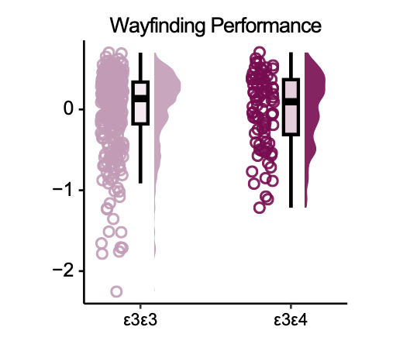

Fig. S1: No difference in joint wayfinding performance between genotype groups. Data points show individual joint wayfinding performance scores (combined z-standardised wayfinding distance and duration, multiplied by -0.5, such that higher values indicate better performance) for APOE ε3ε3 carriers (in rose) and ε3ε4 carriers (in dark red). Boxplots mark the median, the interquartile range, and whiskers indicate the minimum and maximum outlier values. Group differences were assessed using a Wilcoxon rank-sum test (p = .75).

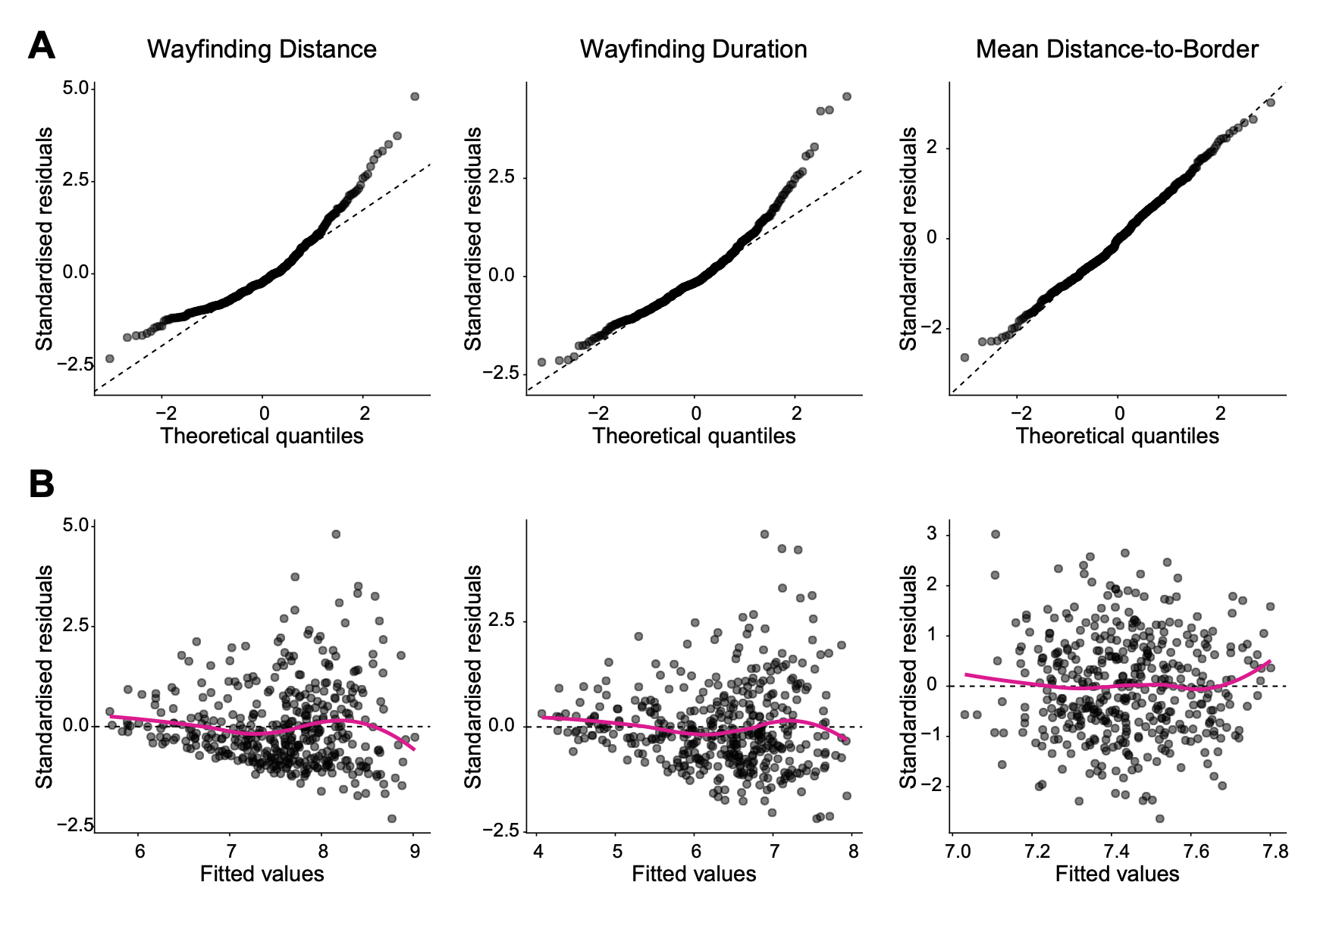
Fig. S2: Model assumptions for the linear regression model testing effects of APOE genotype and covariates on SHQ performance. A. Residual Q-Q plots for wayfinding distance (left), wayfinding duration (middle), and mean distance-to-border (right), from linear regression models including APOE genotype, biological sex, age, gaming experience, self-reported navigation ability, and map viewing duration as fixed effects. B. Standardised residuals plotted against fitted values for wayfinding distance (left), wayfinding duration (middle), and mean distance-to-border (right). Dashed lines indicate the Q-Q reference line and the zero line for residuals; solid lines show a smoothed trend through the residuals.
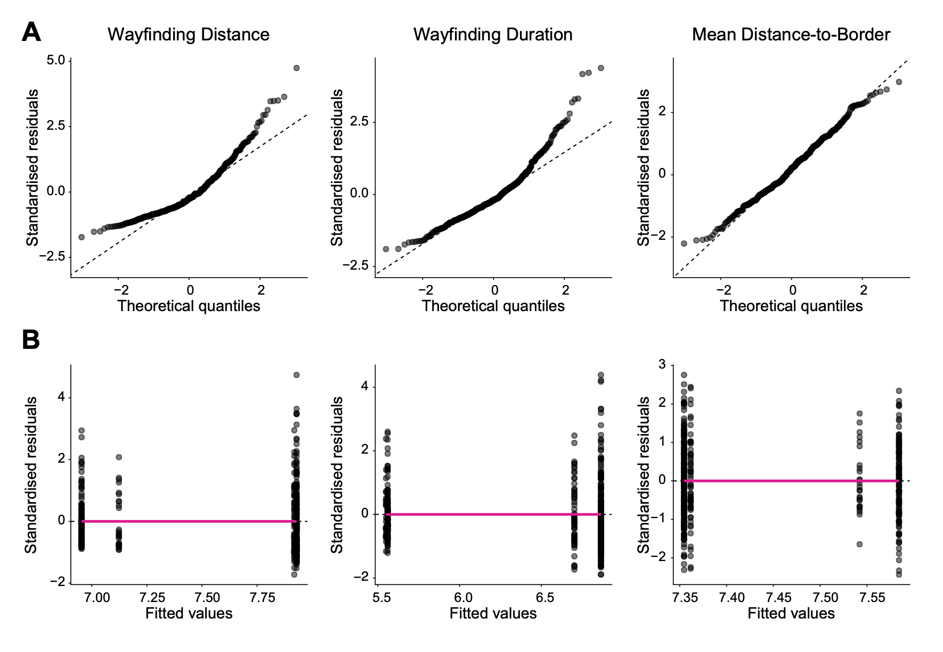
Fig. S3: Model assumptions for the linear regression model testing the APOE genotype × biological sex interaction on SHQ performance. A. Residual Q-Q plots for wayfinding distance (left), wayfinding duration (middle), and mean distance-to-border (right). B. Standardised residuals plotted against fitted values for wayfinding distance (left), wayfinding duration (middle), and mean distance-to-border (right). Dashed lines indicate the Q-Q reference line and the zero line for residuals; solid lines show a smoothed trend through the residuals.
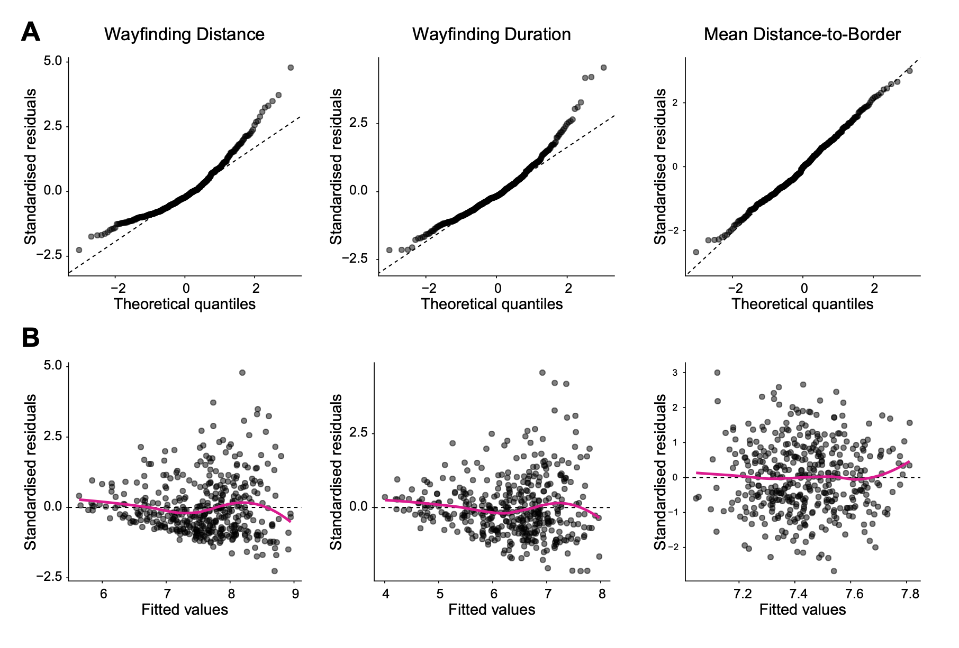
Fig. S4: Model assumptions for the covariate-adjusted linear regression model testing the APOE genotype × biological sex interaction on SHQ performance. A. Residual Q-Q plots for wayfinding distance (left), wayfinding duration (middle), and mean distance-to-border (right), from models including biological sex, age, gaming experience, self-reported navigation ability, and map viewing duration as covariates. B. Standardised residuals plotted against fitted values for wayfinding distance (left), wayfinding duration (middle), and mean distance-to-border (right). Dashed lines indicate the Q-Q reference line and the zero line for residuals; solid lines show a smoothed trend through the residuals.
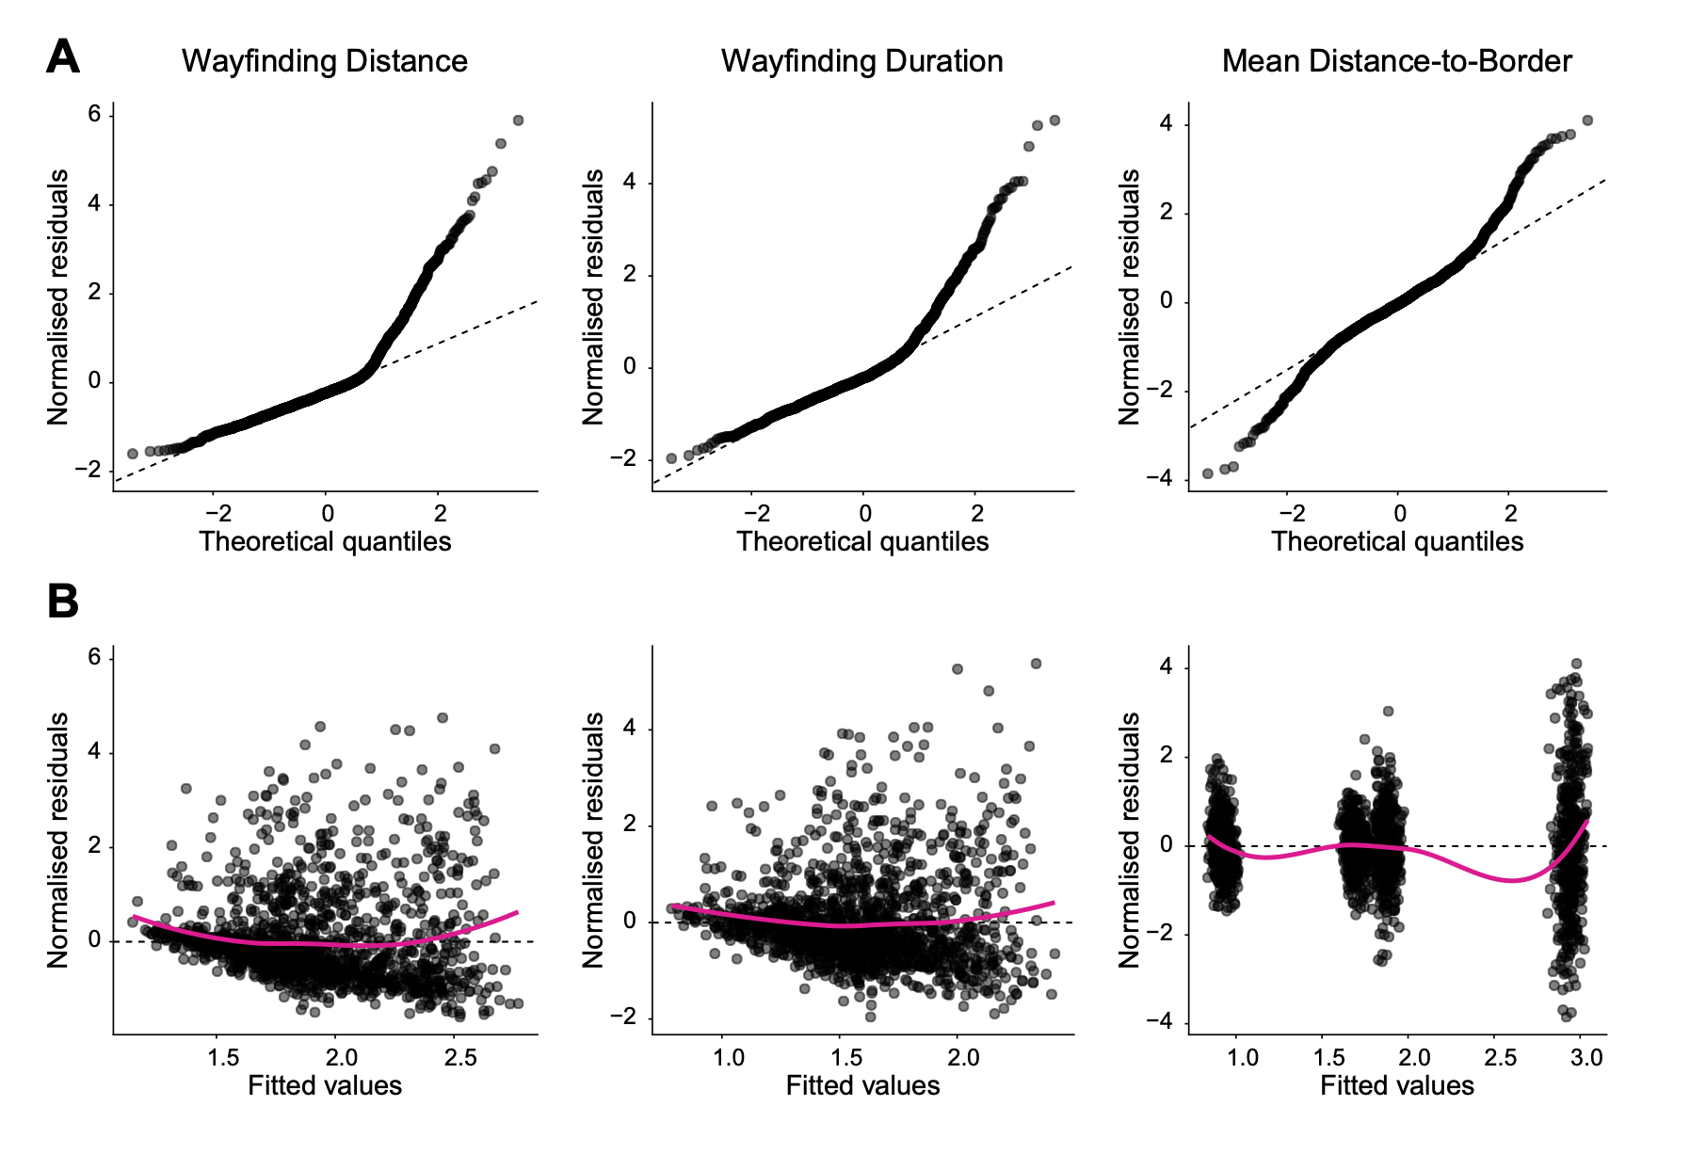
Fig. S5: Model assumptions for the linear mixed-effects model testing the APOE genotype × game level interaction on SHQ performance. A. Residual Q-Q plots for wayfinding distance (left), wayfinding duration (middle), and mean distance-to-border (right), from models including game level, APOE genotype, and their interaction as fixed effects, together with biological sex, age, gaming experience, self-reported navigation ability, and map viewing duration as covariates, and random intercepts for participants. B. Normalised residuals plotted against fitted values for wayfinding distance (left), wayfinding duration (middle), and mean distance-to-border (right). Dashed lines indicate the Q-Q reference line and the zero line for residuals; solid lines show a smoothed trend through the residuals.

Supplementary Tables
Table 1. Demographics of all APOE genotype groups in the SHQ game.
 |  | APOE ε2ε2  (n = 6) | APOE ε2ε3  (n = 51) | APOE ε2ε4  (n = 6) | APOE ε3ε3  (n = 327) | APOE ε3ε4  (n = 88) | APOE ε4ε4  (n = 11)
Age | Mean (SD) | 22.8 (2.8) | 22.8 (3.3) | 23.2 (2.8) | 23.2 (3.6) | 23.5 (3.6) | 20.7 (2.0)
 | Range | 19-26 | 19-32 | 20-27 | 18-34 | 18-35 | 18-25
Biological sex | Female | 4  (66.7%) | 32 (62.7%) | 2  (33.3%) | 200 (61.2%) | 62 (70.5%) | 10 (90.9%)
 | Male | 2  (33.3%) | 19 (37.3%) | 4  (66.7%) | 127 (38.8%) | 26 (29.5%) | 1  (9.1%)
Education | High school | 1  (16.7%) | 7  (13.7%) | 0  (0.0%) | 37 (11.3%) | 11 (12.5%) | 2  (18.2%)
 | College | 3  (50.0%) | 23 (45.1%) | 1  (16.7%) | 133 (40.7%) | 36 (40.9%) | 7  (63.6%)
 | University | 2  (33.3%) | 21 (41.2%) | 5  (83.3%) | 150 (45.9%) | 41 (46.6%) | 2  (18.2%)
Ethnicity | White | 6 (100.0%) | 47 (92.2%) | 6 (100.0%) | 300 (91.7%) | 85 (96.6%) | 10 (90.9%)
 | Hispanic/Latino | 0 (0.0%) | 1 (2.0%) | 0 (0.0%) | 4 (1.2%) | 2 (2.3%) | 0 (0.0%)
 | Black/African American | 0 (0.0%) | 0 (0.0%) | 0 (0.0%) | 2 (0.6%) | 0 (0.0%) | 0 (0.0%)
 | Asian | 0 (0.0%) | 2 (3.9%) | 0 (0.0%) | 8 (2.4%) | 0 (0.0%) | 0 (0.0%)
 | Middle-Eastern  /North African | 0 (0.0%) | 1 (2.0%) | 0 (0.0%) | 9 (2.8%) | 0 (0.0%) | 0 (0.0%)
 | Other/mixed | 0 (0.0%) | 0 (0.0%) | 0 (0.0%) | 4 (1.2%) | 1 (1.1%) | 1 (9.1%)
Note. These participants completed the SHQ game. Education reflects the highest qualification obtained according to German education levels, with high school = Realschulabschluss and college = Gymnasialabschluss. Seven APOE ε3ε3 carriers with unspecified education are not shown.

Table 2. Demographics of all APOE genotype groups in the MU task.
 |  | APOE  ε2ε2  (n = 5) | APOE  ε2ε3  (n = 49) | APOE  ε2ε4  (n = 6) | APOE  ε3ε3  (n = 308) | APOE  ε3ε4  (n = 84) | APOE  ε4ε4  (n = 10)
Age | Mean (SD) | 24.4  (4.4) | 23.2  (3.2) | 22.2  (2.1) | 23.4  (3.7) | 23.2  (3.7) | 21.0  (1.9)
 | Range | 19-30 | 19-32 | 20-25 | 18-34 | 17-35 | 18-25
Biological sex | Female | 2  (40.0%) | 32  (65.3%) | 2  (33.3%) | 189  (61.4%) | 63  (75.0%) | 9  (90.0%)
 | Male | 3  (60.0%) | 17  (34.7%) | 4  (66.7%) | 119  (38.6%) | 21  (25.0%) | 1  (10.0%)
Education | High school | 1  (20.0%) | 7  (15.6%) | 0  (0.0%) | 34  (11.4%) | 11  (13.3%) | 2  (20.0%)
 | College | 3  (60.0%) | 19  (42.2%) | 2  (33.3%) | 117  (39.1%) | 33  (39.8%) | 6  (60.0%)
 | University | 1  (20.0%) | 19  (42.2%) | 4  (66.7%) | 148  (49.5%) | 39  (47.0%) | 2  (20.0%)
Ethnicity | White | 4  (80.0%) | 45  (91.8%) | 6  (100.0%) | 283  (91.9%) | 80  (95.2%) | 9  (90.0%)
 | Hispanic/Latino | 0  (0.0%) | 1  (2.0%) | 0  (0.0%) | 3  (1.0%) | 2  (2.4%) | 0  (0.0%)
 | Black/African American | 0  (0.0%) | 0  (0.0%) | 0  (0.0%) | 2  (0.6%) | 0  (0.0%) | 0  (0.0%)
 | Asian | 1  (20.0%) | 1  (2.0%) | 0  (0.0%) | 7  (2.3%) | 0  (0.0%) | 0  (0.0%)
 | Middle Eastern/North African | 0  (0.0%) | 1  (2.0%) | 0  (0.0%) | 9  (2.9%) | 0  (0.0%) | 0  (0.0%)
 | Other/mixed | 0  (0.0%) | 1  (2.0%) | 0  (0.0%) | 4  (1.3%) | 2  (2.4%) | 1  (10.0%)
Note. These participants completed the MU task. Education reflects the highest qualification obtained according to German education levels, with high school = Realschulabschluss and college = Gymnasialabschluss. Education percentages are based on available specified responses.

Table 3. Demographics of all APOE genotype groups in the SSTM task.
 |  | APOE  ε2ε2  (n = 5) | APOE  ε2ε3  (n = 50) | APOE  ε2ε4  (n = 6) | APOE  ε3ε3  (n = 311) | APOE  ε3ε4  (n = 83) | APOE  ε4ε4  (n = 10)
Age | Mean (SD) | 24.4  (4.4) | 23.0  (3.2) | 22.2  (2.1) | 23.4  (3.7) | 23.3  (3.7) | 21.0  (1.9)
 | Range | 19-30 | 19-32 | 20-25 | 18-34 | 17-35 | 18-25
Biological sex | Female | 2  (40.0%) | 33  (66.0%) | 2  (33.3%) | 190  (61.1%) | 62  (74.7%) | 9  (90.0%)
 | Male | 3  (60.0%) | 17  (34.0%) | 4  (66.7%) | 121  (38.9%) | 21  (25.3%) | 1  (10.0%)
Education | High school | 1  (20.0%) | 7  (15.2%) | 0  (0.0%) | 35  (11.6%) | 12  (14.6%) | 2  (20.0%)
 | College | 3  (60.0%) | 20  (43.5%) | 2  (33.3%) | 121  (40.1%) | 32  (39.0%) | 6  (60.0%)
 | University | 1  (20.0%) | 19  (41.3%) | 4  (66.7%) | 146  (48.3%) | 38  (46.3%) | 2  (20.0%)
Ethnicity | White | 4  (80.0%) | 46  (92.0%) | 6  (100.0%) | 285  (91.6%) | 80  (96.4%) | 9  (90.0%)
 | Hispanic/Latino | 0  (0.0%) | 1  (2.0%) | 0  (0.0%) | 4  (1.3%) | 2  (2.4%) | 0  (0.0%)
 | Black/African American | 0  (0.0%) | 0  (0.0%) | 0  (0.0%) | 2  (0.6%) | 0  (0.0%) | 0  (0.0%)
 | Asian | 1  (20.0%) | 1  (2.0%) | 0  (0.0%) | 7  (2.3%) | 0  (0.0%) | 0  (0.0%)
 | Middle Eastern/North African | 0  (0.0%) | 1  (2.0%) | 0  (0.0%) | 9  (2.9%) | 0  (0.0%) | 0  (0.0%)
 | Other/mixed | 0  (0.0%) | 1  (2.0%) | 0  (0.0%) | 4  (1.3%) | 1  (1.2%) | 1  (10.0%)
Note. These participants completed the SSTM task. Education reflects the highest qualification obtained according to German education levels, with high school = Realschulabschluss and college = Gymnasialabschluss. Education percentages are based on available specified responses.
Table 4. Demographics of all APOE genotype groups in the CFMT task.
 |  | APOE  ε2ε2  (n = 5) | APOE  ε2ε3  (n = 49) | APOE  ε2ε4  (n = 5) | APOE  ε3ε3  (n = 318) | APOE  ε3ε4  (n = 88) | APOE  ε4ε4  (n = 10)
Age | Mean (SD) | 24.4  (4.4) | 23.1  (3.1) | 22.6  (2.1) | 23.4  (3.7) | 23.1  (3.7) | 21.0  (1.9)
 | Range | 19-30 | 19-32 | 20-25 | 18-34 | 17-35 | 18-25
Biological sex | Female | 2  (40.0%) | 33  (67.3%) | 2  (40.0%) | 195  (61.3%) | 65  (73.9%) | 9  (90.0%)
 | Male | 3  (60.0%) | 16  (32.7%) | 3  (60.0%) | 123  (38.7%) | 23  (26.1%) | 1  (10.0%)
Education | High school | 1  (20.0%) | 7  (15.6%) | 0  (0.0%) | 35  (11.4%) | 12  (13.8%) | 2  (20.0%)
 | College | 3  (60.0%) | 19  (42.2%) | 2  (40.0%) | 123  (39.9%) | 35  (40.2%) | 6  (60.0%)
 | University | 1  (20.0%) | 19  (42.2%) | 3  (60.0%) | 150  (48.7%) | 40  (46.0%) | 2  (20.0%)
Ethnicity | White | 4  (80.0%) | 45  (91.8%) | 5  (100.0%) | 292  (91.8%) | 84  (95.5%) | 9  (90.0%)
 | Hispanic/Latino | 0  (0.0%) | 1  (2.0%) | 0  (0.0%) | 4  (1.3%) | 2  (2.3%) | 0  (0.0%)
 | Black/African American | 0  (0.0%) | 0  (0.0%) | 0  (0.0%) | 2  (0.6%) | 0  (0.0%) | 0  (0.0%)
 | Asian | 1  (20.0%) | 1  (2.0%) | 0  (0.0%) | 7  (2.2%) | 0  (0.0%) | 0  (0.0%)
 | Middle Eastern/North African | 0  (0.0%) | 1  (2.0%) | 0  (0.0%) | 9  (2.8%) | 0  (0.0%) | 0  (0.0%)
 | Other/mixed | 0  (0.0%) | 1  (2.0%) | 0  (0.0%) | 4  (1.3%) | 2  (2.3%) | 1  (10.0%)
Note. These participants completed the CFMT task. Education reflects the highest qualification obtained according to German education levels, with high school = Realschulabschluss and college = Gymnasialabschluss. Education percentages are based on available specified responses.
Table 5. Demographics of all APOE genotype groups in the TMT A & B.
 |  | APOE  ε2ε2  (n = 7) | APOE  ε2ε3  (n = 55) | APOE  ε2ε4  (n = 7) | APOE  ε3ε3  (n = 335) | APOE  ε3ε4  (n = 92) | APOE  ε4ε4  (n = 11)
Age | Mean (SD) | 23.9  (3.7) | 22.9  (3.2) | 22.9  (2.7) | 23.3  (3.7) | 23.2  (3.7) | 20.7  (2.0)
 | Range | 19-30 | 19-32 | 20-27 | 12-34 | 17-35 | 18-25
Biological sex | Female | 4  (57.1%) | 35  (63.6%) | 3  (42.9%) | 205  (61.2%) | 67  (72.8%) | 10  (90.9%)
 | Male | 3  (42.9%) | 20  (36.4%) | 4  (57.1%) | 130  (38.8%) | 25  (27.2%) | 1  (9.1%)
Education | High school | 1  (14.3%) | 7  (13.7%) | 0  (0.0%) | 38  (11.7%) | 12  (13.2%) | 2  (18.2%)
 | College | 4  (57.1%) | 23  (45.1%) | 2  (28.6%) | 133  (40.9%) | 37  (40.7%) | 7  (63.6%)
 | University | 2  (28.6%) | 21  (41.2%) | 5  (71.4%) | 154  (47.4%) | 42  (46.2%) | 2  (18.2%)
Ethnicity | White | 6  (85.7%) | 50  (90.9%) | 7  (100.0%) | 308  (91.9%) | 88  (95.7%) | 10  (90.9%)
 | Hispanic/Latino | 0  (0.0%) | 1  (1.8%) | 0  (0.0%) | 4  (1.2%) | 2  (2.2%) | 0  (0.0%)
 | Black/African American | 0  (0.0%) | 0  (0.0%) | 0  (0.0%) | 2  (0.6%) | 0  (0.0%) | 0  (0.0%)
 | Asian | 1  (14.3%) | 2  (3.6%) | 0  (0.0%) | 8  (2.4%) | 0  (0.0%) | 0  (0.0%)
 | Middle Eastern/North African | 0  (0.0%) | 1  (1.8%) | 0  (0.0%) | 9  (2.7%) | 0  (0.0%) | 0  (0.0%)
 | Other/mixed | 0  (0.0%) | 1  (1.8%) | 0  (0.0%) | 4  (1.2%) | 2  (2.2%) | 1  (9.1%)
Note. These participants completed the TMT A & B. Education reflects the highest qualification obtained according to German education levels, with high school = Realschulabschluss and college = Gymnasialabschluss. Education percentages are based on available specified responses.
Table 6. Sequences of primers and probes for APOE genotyping.
Gene | Primers / Probes | Sequence (5’−3’)
APOE | APOE Probe | FAM−CAGCTCCTCGGTGCTCTGGC−BHQ1
 | ε2-Forward | GCGGACATGGAGGACGTGT
 | ε2-Reverse | CCTGGTACACTGCCAGGCA
 | ε3-Forward | CGGACATGGAGGACGTGT
 | ε4-Forward | CGGACATGGAGGACGTGC
 | ε3ε4-Reverse | CTGGTACACTGCCAGGCG
 | ACTB Probe | TAMRA−TGCTGTCTGGCGGCACCACCATGTACC−BHQ2
 | ACTB-Forward | GACGTGGACATCCGCAAAGAC
 | ACTB-Reverse | CAGGTCAGCTCAGGCAGGAA
Note. The table lists primer and probe sequences used to detect the ε2, ε3, and ε4 alleles of the APOE gene.

Supplementary References
1. Coughlan G, Coutrot A, Khondoker M, Minihane A-M, Spiers H, Hornberger M. Toward personalized cognitive diagnostics of at-genetic-risk Alzheimer’s disease. Proc Natl Acad Sci. Proceedings of the National Academy of Sciences; 2019;116:9285–92. https://doi.org/10.1073/pnas.1901600116
2. Lakens D. Equivalence Tests: A Practical Primer for t Tests, Correlations, and Meta-Analyses. Soc Psychol Personal Sci. SAGE Publications Inc; 2017;8:355–62. https://doi.org/10.1177/1948550617697177
3. Hauck WW, Anderson S. A new statistical procedure for testing equivalence in two-group comparative bioavailability trials. J Pharmacokinet Biopharm. 1984;12:83–91. https://doi.org/10.1007/BF01063612
4. Schuirmann DJ. A comparison of the Two One-Sided Tests Procedure and the Power Approach for assessing the equivalence of average bioavailability. J Pharmacokinet Biopharm. 1987;15:657–80. https://doi.org/10.1007/BF01068419
5. Keysers C, Gazzola V, Wagenmakers E-J. Using Bayes factor hypothesis testing in neuroscience to establish evidence of absence. Nat Neurosci. 2020;23:788–99. https://doi.org/10.1038/s41593-020-0660-4
6. Daly J, De Luca F, Berens SC, Field AP, Rusted JM, Bird CM. The effect of apolipoprotein E genotype on spatial processing in humans: A meta-analysis and systematic review. Cortex. 2024;177:268–84. https://doi.org/10.1016/j.cortex.2024.05.006
7. Corder EH, Saunders AM, Strittmatter WJ, Schmechel DE, Gaskell PC, Small Gw, u. a. Gene dose of apolipoprotein E type 4 allele and the risk of Alzheimer’s disease in late onset families. Science. American Association for the Advancement of Science; 1993;261:921–3.
8. Bierbrauer A, Kunz L, Gomes Carlos A, Luhmann M, Deuker L, Getzmann S, u. a. Unmasking selective path integration deficits in Alzheimer’s disease risk carriers. Sci Adv. American Association for the Advancement of Science; 2020;6:eaba1394. https://doi.org/10.1126/sciadv.aba1394
9. Kunz L, Schröder TN, Lee H, Montag C, Lachmann B, Sariyska R, u. a. Reduced grid-cell-like representations in adults at genetic risk for Alzheimer’s disease. Science. 2015;350:430–3. https://doi.org/10.1126/science.aac8128
10. Lester AW, Moffat SD, Wiener JM, Barnes CA, Wolbers T. The Aging Navigational System. Neuron. 2017;95:1019–35. https://doi.org/10.1016/j.neuron.2017.06.037
11. Moffat SD. Aging and Spatial Navigation: What Do We Know and Where Do We Go? Neuropsychol Rev. 2009;19:478–89. https://doi.org/10.1007/s11065-009-9120-3
12. Nazareth A, Huang X, Voyer D, Newcombe N. A meta-analysis of sex differences in human navigation skills. Psychon Bull Rev. 2019;26:1503–28. https://doi.org/10.3758/s13423-019-01633-6
13. Hegarty M, E. Richardson A, R. Montello D, Lovelace K, Subbiah I. Development of a self-report measure of environmental spatial ability. Intelligence. 2002;30:425–47. https://doi.org/10.1016/j.jhydrol.2006.03.022

