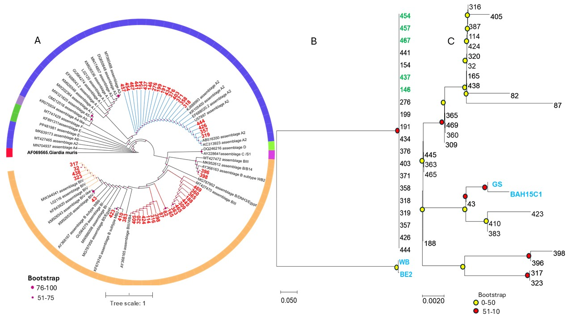

Figure supplementary 1: Maximum likelihood phylogenetic analysis of the tpi locus for Giardia duodenalis assemblages A and B. Maximum likelihood phylogenetic trees were constructed from partial tpi gene sequences to infer evolutionary relationships among Giardia duodenalis isolates. (A) Circular phylogenetic tree showing overall clustering patterns of assemblages A and B. (B) Linear phylogenetic tree of assemblage A, including reference strains WB and BE2. (C) Linear phylogenetic tree of assemblage B, with GS and BAH15C1 included as reference strains. Sample identifiers are shown at terminal branches. Bootstrap support values are indicated by colored circles, with yellow representing lower support (0–50), pink representing moderate support (51–75), and red representing high support (76–100). Scale bars denote the number of nucleotide substitutions per site. All trees were inferred using the maximum likelihood method with 1,000 bootstrap replicates.

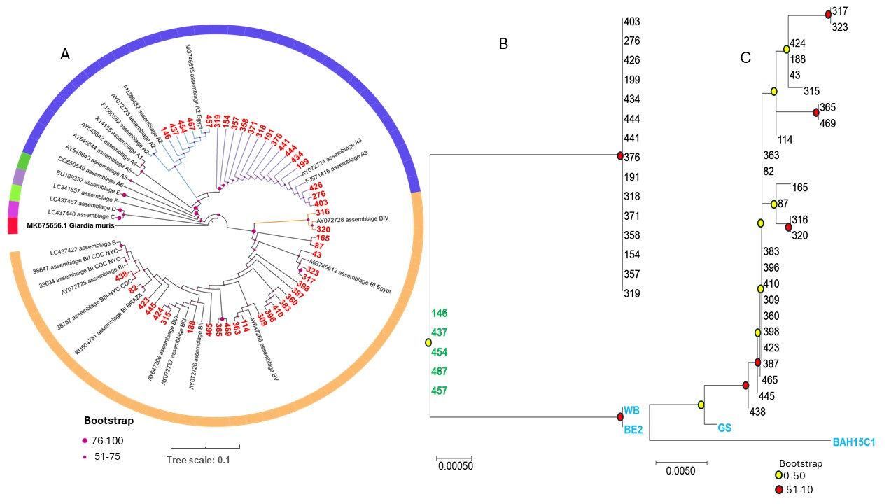

Figure supplementary 2: Maximum likelihood phylogenetic analysis of the bg locus for Giardia duodenalis assemblages A and B. Maximum likelihood phylogenetic trees were constructed from partial β-giardin (bg) gene sequences to examine evolutionary relationships among Giardia duodenalis isolates. (A) Circular phylogenetic tree showing the overall placement of assemblage A and assemblage B sequences relative to published reference sequences. (B) Linear phylogenetic tree of assemblage A, including reference strains WB and BE2. (C) Linear phylogenetic tree of assemblage B, including reference strains GS and BAH15C1. Sample identifiers are shown at terminal branches. Bootstrap support values are indicated by colored circles, with yellow representing lower support (0-50) and red representing higher support (51-100). Scale bars indicate the number of nucleotide substitutions per site. All trees were inferred using the maximum likelihood method with 1,000 bootstrap replicates.

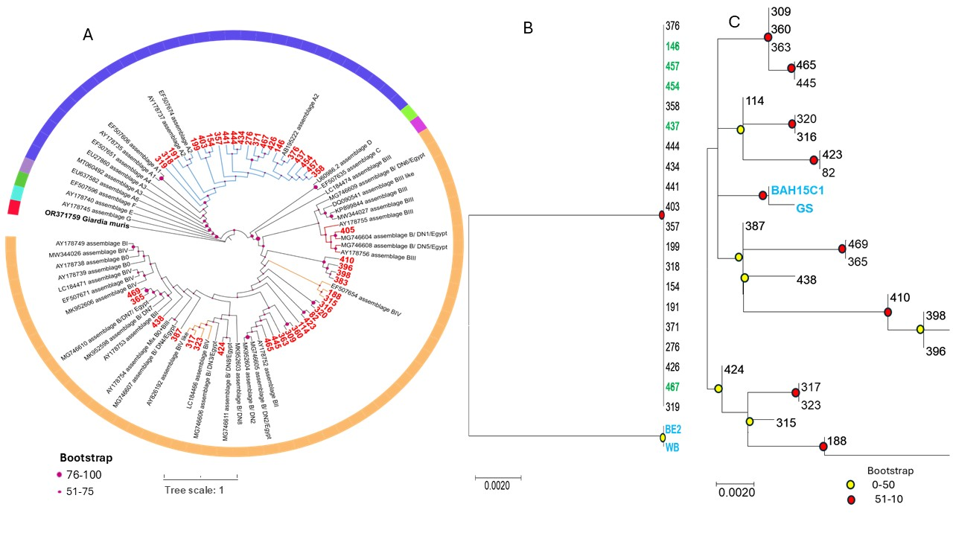

Figure supplementary 3: Maximum likelihood phylogenetic analysis of the gdh locus for Giardia duodenalis assemblages A and B. Maximum likelihood phylogenetic trees were constructed from partial gdh gene sequences to examine evolutionary relationships among Giardia duodenalis isolates. (A) Circular phylogenetic tree showing the overall placement of assemblage A and assemblage B sequences relative to published reference sequences. (B) Linear phylogenetic tree of assemblage A, including reference strains WB and BE2 (C) Linear phylogenetic tree of assemblage B, including reference strains GS and BAH15C1. Sample identifiers are shown at terminal branches. Bootstrap support values are indicated by colored circles, with yellow representing lower support (0–50) and red representing higher support (51–100). Scale bars denote the number of nucleotide substitutions per site. All trees were inferred using the maximum likelihood method with 1,000 bootstrap replicates.

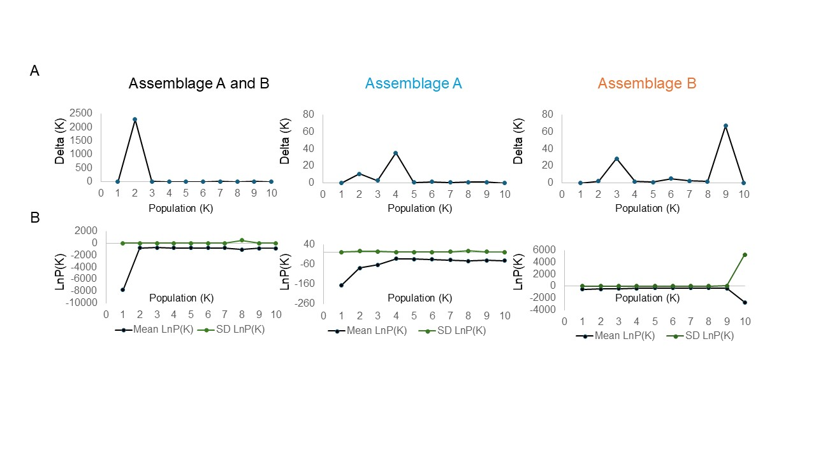

Figure supplementary 4. Determination of the optimal number of genetic clusters (K) for Giardia duodenalis assemblages using STRUCTURE analysis. (A) ΔK plots for the combined dataset (assemblages A and B), assemblage A only, and assemblage B only, showing the rate of change in the log probability of the data across K = 1–10. Peaks in ΔK indicate the most likely number of genetic clusters, with K = 2 for the combined dataset, K = 4 for assemblage A, and K = 9 for assemblage B. (B) Mean LnP(K) and standard deviation (SD) LnP(K) values across K = 1–10 for the same datasets. Black lines represent mean LnP(K), and green lines represent SD LnP(K). These plots illustrate the stability and variance of likelihood estimates across K values and support the ΔK‑based identification of optimal clustering levels. These analyses identify the most probable population structure within G. duodenalis assemblages A and B and highlight the greater genetic complexity observed in assemblage B.

