Systematic review and meta-regression analysis of the prevalence of Crimean-Congo hemorrhagic fever in humans, ticks and animals in Sub-Saharan Africa from 1980 to 2025

Auther Tamale Wasswa¹, Karla Rascón-García², Harriet Abizera ¹, Solomon Ainebyoona¹, Wilson Amanyire¹, Joseph Nkamwesiga¹, Phillip Magambo Kimuda¹, Maureen Nanziri Mayanja³ & Dennis Muhanguzi¹*

*Correspondence: dennis.muhanguzi@mak.ac.ug

Contents

PRISMA 2020 Checklist

PRISMA 2020 for Abstracts Checklist
- API Search Terms and Metadata
- Study Quality Assessment

Supplementary Tables

Supplementary Figures
- Sensitivity Analyses

1. PRISMA 2020 Checklist

Section and Topic | Item # | Checklist item | Location where item is reported
TITLE
Title | 1 | Identify the report as a systematic review. | Page 01
ABSTRACT
Abstract | 2 | See the PRISMA 2020 for Abstracts checklist. | Supplementary information
INTRODUCTION
Rationale | 3 | Describe the rationale for the review in the context of existing knowledge. | Page 02-05
Objectives | 4 | Provide an explicit statement of the objective(s) or question(s) the review addresses. | Page 05
METHODS
Eligibility criteria | 5 | Specify the inclusion and exclusion criteria for the review and how studies were grouped for the syntheses. | Page 07
Information sources | 6 | Specify all databases, registers, websites, organisations, reference lists and other sources searched or consulted to identify studies. Specify the date when each source was last searched or consulted. | Page 06
Search strategy | 7 | Present the full search strategies for all databases, registers, and websites, including any filters and limits used. | Page 06
Selection process | 8 | Specify the methods used to decide whether a study met the inclusion criteria of the review, including how many reviewers screened each record and each report retrieved, whether they worked independently, and if applicable, details of automation tools used in the process. | Page 06 - 08
Data collection process | 9 | Specify the methods used to collect data from reports, including how many reviewers collected data from each report, whether they worked independently, any processes for obtaining or confirming data from study investigators, and if applicable, details of automation tools used in the process. | Page 06
Data items | 10a | List and define all outcomes for which data were sought. Specify whether all results that were compatible with each outcome domain in each study were sought (e.g., for all measures, time points, analyses), and if not, the methods used to decide which results to collect. | Page 08
Data items | 10b | List and define all other variables for which data were sought (e.g., participant and intervention characteristics, funding sources). Describe any assumptions made about any missing or unclear information. | Page 06
Study risk of bias assessment | 11 | Specify the methods used to assess risk of bias in the included studies, including details of the tool(s) used, how many reviewers assessed each study and whether they worked independently, and if applicable, details of automation tools used in the process. | Page 09
Effect measures | 12 | Specify for each outcome the effect measure(s) (e.g., risk ratio, mean difference) used in the synthesis or presentation of results. | Page 09 - 10
Synthesis methods | 13a | Describe the processes used to decide which studies were eligible for each synthesis (e.g., tabulating the study intervention characteristics and comparing against the planned groups for each synthesis (item #5)). | Page 07
Synthesis methods | 13b | Describe any methods required to prepare the data for presentation or synthesis, such as handling of missing summary statistics, or data conversions. | Page 07 - 09
Synthesis methods | 13c | Describe any methods used to tabulate or visually display results of individual studies and syntheses. | Page 07 - 09
Synthesis methods | 13d | Describe any methods used to synthesize results and provide a rationale for the choice(s). If meta-analysis was performed, describe the model(s), method(s) to identify the presence and extent of statistical heterogeneity, and software package(s) used. | Page 07 - 09
Synthesis methods | 13e | Describe any methods used to explore possible causes of heterogeneity among study results (e.g., subgroup analysis, meta-regression). | Page 08 - 09
Synthesis methods | 13f | Describe any sensitivity analyses conducted to assess robustness of the synthesized results. | NA
Reporting bias assessment | 14 | Describe any methods used to assess risk of bias due to missing results in a synthesis (arising from reporting biases). | Page 09
Certainty assessment | 15 | Describe any methods used to assess certainty (or confidence) in the body of evidence for an outcome. | Page 08-09
RESULTS
Study selection | 16a | Describe the results of the search and selection process, from the number of records identified in the search to the number of studies included in the review, ideally using a flow diagram. | Page 08 - 09
Study selection | 16b | Cite studies that might appear to meet the inclusion criteria, but which were excluded, and explain why they were excluded. | Page 09
Study characteristics | 17 | Cite each included study and present its characteristics. | Supplementary information
Risk of bias in studies | 18 | Present assessments of risk of bias for each included study. | Supplementary information  Figure S1
Results of individual studies | 19 | For all outcomes, present, for each study: (a) summary statistics for each group (where appropriate) and (b) an effect estimate and its precision (e.g., confidence/credible interval), ideally using structured tables or plots. | Supplementary Information  Table S2-S5
Results of syntheses | 20a | For each synthesis, briefly summarise the characteristics and risk of bias among contributing studies. | Page 18
Results of syntheses | 20b | Present results of all statistical syntheses conducted. If meta-analysis was done, present for each the summary estimate and its precision (e.g., confidence/credible interval) and measures of statistical heterogeneity. If comparing groups, describe the direction of the effect. | Page 18 - 19
Results of syntheses | 20c | Present results of all investigations of possible causes of heterogeneity among study results. | Page 18 - 19
Results of syntheses | 20d | Present results of all sensitivity analyses conducted to assess the robustness of the synthesized results. | Page 20
Reporting biases | 21 | Present assessments of risk of bias due to missing results (arising from reporting biases) for each synthesis assessed. | Page 19
Certainty of evidence | 22 | Present assessments of certainty (or confidence) in the body of evidence for each outcome assessed. | Page 18
DISCUSSION
Discussion | 23a | Provide a general interpretation of the results in the context of other evidence. | Page 19- 21
Discussion | 23b | Discuss any limitations of the evidence included in the review. | Page 22
Discussion | 23c | Discuss any limitations of the review processes used. | Page 22
Discussion | 23d | Discuss implications of the results for practice, policy, and future research. | Page 21-22
OTHER INFORMATION
Registration and protocol | 24a | Provide registration information for the review, including register name and registration number, or state that the review was not registered. | NA
Registration and protocol | 24b | Indicate where the review protocol can be accessed, or state that a protocol was not prepared. | NA
Registration and protocol | 24c | Describe and explain any amendments to information provided at registration or in the protocol. | NA
Support | 25 | Describe sources of financial or non-financial support for the review, and the role of the funders or sponsors in the review. | Page 23
Competing interests | 26 | Declare any competing interests of review authors. | Page 23
Availability of data, code and other materials | 27 | Report which of the following are publicly available and where they can be found template data collection forms; data extracted from included studies; data used for all analyses; analytic code; any other materials used in the review. | Page 23

2. PRISMA 2020 for Abstracts Checklist
Section and Topic | Item # | Checklist item | Reported (Yes/No)
TITLE
Title | 1 | Identify the report as a systematic review. | Yes
BACKGROUND
Objectives | 2 | Provide an explicit statement of the main objective(s) or question(s) the review addresses. | Yes
METHODS
Eligibility criteria | 3 | Specify the inclusion and exclusion criteria for the review. | Yes
Information sources | 4 | Specify the information sources (e.g., databases, registers) used to identify studies and the date when each was last searched. | Yes
Risk of bias | 5 | Specify the methods used to assess risk of bias in the included studies. | Yes
Synthesis of results | 6 | Specify the methods used to present and synthesise results. | Yes
RESULTS
Included studies | 7 | Give the total number of included studies and participants and summarise relevant characteristics of studies. | Yes
Synthesis of results | 8 | Present results for main outcomes, preferably indicating the number of included studies and participants for each. If meta-analysis was done, report the summary estimate and confidence/credible interval. If comparing groups, indicate the direction of the effect (i.e. which group is favoured). | Yes
DISCUSSION
Limitations of evidence | 9 | Provide a brief summary of the limitations of the evidence included in the review (e.g. study risk of bias, inconsistency and imprecision). | Yes
Interpretation | 10 | Provide a general interpretation of the results and important implications. | Yes
OTHER
Funding | 11 | Specify the primary source of funding for the review. | Yes
Registration | 12 | Provide the register name and registration number. | NA

3. API Search Terms and Metadata

Search Date: September 1, 2025

The following convention was used to generate search queries:

[Country Name] + “congo hemorrhagic fever”

EXAMPLE:

Kenya + congo hemorrhagic fever

Complete list of countries included in search queries:

Angola, Benin, Botswana, Burkina Faso, Burundi, Cameroon, Cape Verde, Central African Republic, Chad, Cote d'Ivoire, Democratic Republic of Congo, Djibouti, Equatorial Guinea, Eritrea, Ethiopia, Gabon, Gambia, Ghana, Greece, Guinea, Guinea-Bissau, Kenya, Lesotho, Liberia, Madagascar, Malawi, Mali, Mauritania, Mozambique, Namibia,Niger, Nigeria, Puntland, Republic of Congo, Rwanda, São Tomé and Príncipe ,Senegal, Sierra Leone, Somalia, Somaliland, South Africa, South Sudan, Swaziland, Tanzania, Togo, Uganda, Zambia, Zanzibar, Zimbabwe

4. Study Quality Assessment

Authors | 1) Was the sample frame appropriate to address target population? | 2) Were study population sampled in an appropriate way? | 3) Was the sample size adequate | 4) Were the subjects and/or study setting described? | 5) Was the data analysis conducted with sufficient coverage of the identified sample? | 6) Were valid methods used for the identification of the condition? | 7) Was the condition measured in a standard, reliable way for all study population? | 8) Was there appropriate statistical analysis? | Total (where ‘Yes’=2, ‘Unclear’=1, ‘No’=0) | Mean Score
Adamu et al.,2024 | Unclear | Unclear | Unclear | Yes | Yes | Yes | Yes | Yes | 13 | 1.625
Addo et al.,2024 | Unclear | Unclear | Unclear | Yes | Unclear | Yes | Yes | Unclear | 11 | 1.375
Adjogoua et al.,2021 | Unclear | Unclear | Unclear | Yes | Yes | Yes | Yes | Yes | 13 | 1.625
Akuffo et al.,2016 | Unclear | Unclear | Unclear | Yes | Unclear | Yes | Yes | Unclear | 11 | 1.375
Amoah et al.,2024 | Unclear | Unclear | Unclear | Yes | Yes | Yes | Yes | Yes | 13 | 1.625
Andriamandimby et al.,2011 | Yes | Yes | Yes | Yes | Unclear | Yes | Yes | Yes | 15 | 1.875
Atim et al.,2022 | Yes | Yes | Unclear | Yes | Yes | Yes | Yes | Yes | 15 | 1.875
Atim et al.,2023 | Unclear | Unclear | Unclear | Yes | Yes | Yes | Yes | Yes | 13 | 1.625
Badji et al., 2023 | Unclear | Unclear | Unclear | Yes | Yes | Yes | Yes | Yes | 13 | 1.625
Balinandi et al.,2021 | Yes | Unclear | Unclear | Yes | Yes | Yes | Yes | Yes | 14 | 1.750
Balinandi et al.,2024 | Unclear | Unclear | Unclear | Yes | Unclear | Yes | Yes | Unclear | 11 | 1.375
Balindandi et al., 2018 | Unclear | Unclear | Unclear | Yes | Unclear | Yes | Yes | Unclear | 11 | 1.375
Baumann et al.,2019 | Unclear | Unclear | Unclear | Yes | Unclear | Yes | Yes | Unclear | 11 | 1.375
Bentil et al.,2023 | Unclear | Unclear | Unclear | Yes | Unclear | Yes | Yes | Unclear | 11 | 1.375
Blackburn et al.,1982 | Unclear | Unclear | Unclear | Yes | Unclear | Yes | Yes | Unclear | 11 | 1.375
Blanco-Penedo et al.,2021 | Yes | Unclear | Unclear | Yes | Yes | Yes | Yes | Yes | 14 | 1.750
Bonney et al.,2013 | Unclear | Unclear | Unclear | Yes | Yes | Yes | Yes | Yes | 13 | 1.625
Boushab et al.,2022 | Unclear | Unclear | Unclear | Yes | Yes | Yes | Yes | Unclear | 12 | 1.500
Bower et al.,2019 | Unclear | Unclear | Unclear | Yes | Yes | Yes | Yes | Yes | 13 | 1.625
Bukbuk et al.,2016 | Yes | Yes | Unclear | Yes | Yes | Yes | Yes | Yes | 15 | 1.875
Burt et al.,1996 | Yes | Yes | Unclear | Yes | Yes | Yes | Yes | Yes | 15 | 1.875
Chapman et al.,1991 | Unclear | Unclear | Unclear | Yes | Yes | Yes | Yes | Yes | 13 | 1.625
Chinyere et al.,2025 | Unclear | Unclear | Yes | Yes | Unclear | Yes | Yes | Unclear | 12 | 1.500
Chiuya et al.,2020 | Unclear | Yes | Unclear | Yes | Yes | Yes | Yes | Yes | 14 | 1.750
Dahourou et al.,2023 | Yes | Yes | Yes | Yes | Yes | Yes | Yes | Yes | 16 | 2.00
Dahourou et al.,2024 | Yes | Yes | Yes | Yes | Yes | Yes | Yes | Yes | 16 | 2.00
Daodu et al.,2024 | Unclear | Unclear | Unclear | Yes | Yes | Yes | Yes | Yes | 13 | 1.625
Daodu et al.,2025 | Unclear | Unclear | Unclear | Yes | Yes | Yes | Yes | Yes | 13 | 1.625
Diakite et al.,2024 | Unclear | Unclear | Unclear | Yes | Yes | Yes | Yes | Yes | 13 | 1.625
Dzikwi-Emennaa et al.,2022 | Unclear | Unclear | Unclear | Yes | Yes | Yes | Yes | Yes | 13 | 1.625
Fafetine et al.,2025 | Unclear | Unclear | Unclear | Yes | Yes | Yes | Yes | Yes | 13 | 1.625
Folster et al.,2014 | Unclear | Unclear | Unclear | Yes | Unclear | Yes | Yes | Unclear | 11 | 1.375
Gahn et al.,2024 | Yes | Yes | Unclear | Yes | Yes | Yes | Yes | Yes | 15 | 1.875
Gasparine et al.,2025 | Unclear | Yes | Unclear | Yes | Yes | Yes | Yes | Yes | 14 | 1.750
Ghassem et al.,2023 | Yes | Unclear | Unclear | Yes | Yes | Yes | Yes | Yes | 14 | 1.750
Gonzalez & Georges,1986 | Yes | Unclear | Unclear | Yes | Unclear | Yes | Yes | Unclear | 12 | 1.500
Gonzalez et al.,1989 | Yes | Unclear | Unclear | Yes | Unclear | Yes | Yes | Unclear | 12 | 1.500
Gonzalez et al.,1990 | Yes | Unclear | Unclear | Yes | Unclear | Yes | Yes | Unclear | 12 | 1.500
Gordon et al.,2022 | Yes | Yes | Unclear | Yes | Yes | Yes | Yes | Yes | 15 | 1.875
Guilherme et al.,1996 | Yes | Unclear | Unclear | Yes | Unclear | Yes | Yes | Yes | 13 | 1.625
Horton et al.,2016 | Yes | Yes | Unclear | Yes | Unclear | Yes | Yes | Unclear | 13 | 1.625
Hughes et al.,2024 | Yes | Yes | Yes | Yes | Yes | Yes | Yes | Yes | 16 | 2.000
Ibrahim et al.,2015 | Yes | Yes | Unclear | Yes | Unclear | Yes | Yes | Yes | 14 | 1.750
Igah et al.,2025 | Yes | Yes | Unclear | Yes | Yes | Yes | Yes | Yes | 15 | 1.875
Johnson et al.,1983 | Yes | Yes | Unclear | Yes | Unclear | Yes | Yes | Unclear | 13 | 1.625
Johnson et al.,1993 | Yes | Unclear | Unclear | Yes | Yes | Yes | Yes | Yes | 14 | 1.750
Kajihara et al.,2021 | Unclear | Unclear | Unclear | Yes | Unclear | Yes | Yes | Unclear | 11 | 1.375
Khoule et al.,2025 | Yes | Yes | Unclear | Yes | Yes | Yes | Yes | Yes | 15 | 1.875
Kizito et al., 2018 | Unclear | Yes | Unclear | Yes | Unclear | Yes | Yes | Unclear | 11 | 1.375
Lule et al.,2022 | Yes | Yes | Unclear | Yes | Yes | Yes | Yes | Yes | 15 | 1.875
Lutomiah et al.,2014 | Yes | Yes | Unclear | Yes | Unclear | Yes | Yes | Unclear | 13 | 1.625
Lwande et al.,2012 | Yes | Yes | Unclear | Yes | Yes | Yes | Yes | Yes | 15 | 1.875
Lysholm et al., 2022 | Yes | Yes | Yes | Yes | Yes | Yes | Yes | Yes | 16 | 2.000
Maiga et al.,2017 | Yes | Yes | Unclear | Yes | Unclear | Yes | Yes | Unclear | 13 | 1.625
Malonga et al.,2024 | Unclear | Yes | Unclear | Yes | Yes | Yes | Yes | Yes | 14 | 1.750
Mangombi et al.,2020 | Unclear | Unclear | Unclear | Yes | Unclear | Yes | Yes | Yes | 12 | 1.500
Mathiot et al.,1988 | Yes | Unclear | Unclear | Yes | Unclear | Yes | Yes | Unclear | 12 | 1.500
Mathiot et al.,1989 | Yes | Yes | Unclear | Yes | Unclear | Yes | Yes | Unclear | 13 | 1.625
Mathiot et al.,1990 | Unclear | Yes | Unclear | Yes | Unclear | Yes | Yes | Unclear | 12 | 1.500
Matthews et al.,2023 | Yes | Yes | Unclear | Yes | Yes | Yes | Yes | Yes | 15 | 1.875
Mhamadi et al.,2022 | Yes | Yes | Unclear | Yes | Yes | Yes | Yes | Yes | 15 | 1.875
Mihalakakos et al.,2025 | Yes | Yes | Unclear | Yes | Yes | Yes | Yes | Yes | 15 | 1.875
Mohamed et al.,2024 | Yes | Unclear | Unclear | Yes | Yes | Yes | Yes | Yes | 14 | 1.750
Msimang et al.,2021 | Yes | Yes | Yes | Yes | Yes | Yes | Yes | Yes | 16 | 2.000
Muianga et al.,2017 | Unclear | Unclear | Unclear | Yes | Yes | Yes | Yes | Yes | 13 | 1.625
Mukhaye et al.,2024 | Yes | Yes | Yes | Yes | Yes | Yes | Yes | Yes | 16 | 2.000
Naidenova et al.,2020 | Yes | Yes | Unclear | Yes | Yes | Yes | Yes | Yes | 15 | 1.875
Naidenova et al.,2021 | Yes | Yes | Unclear | Yes | Yes | Yes | Yes | Yes | 15 | 1.875
Naydenova et al.,2019 | Yes | Yes | Unclear | Yes | Yes | Yes | Yes | Yes | 15 | 1.875
Ngom et al., 2024 | Yes | Yes | Unclear | Yes | Yes | Yes | Yes | Yes | 15 | 1.875
Nimo-Paintsil et al.,2022 | Yes | Yes | Unclear | Yes | Yes | Yes | Yes | Yes | 15 | 1.875
Nyakarahuka et al., 2022 | Unclear | Yes | Unclear | Yes | Unclear | Yes | Yes | Unclear | 13 | 1.625
Nyakarahuka et al.,2023 | Yes | Yes | Yes | Yes | Yes | Yes | Yes | Yes | 16 | 2.00
Nyataya et al.,2019 | Yes | Yes | Unclear | Yes | Yes | Yes | Yes | Yes | 15 | 1.875
O’Hearn et al.,2016 | Yes | Yes | Unclear | Yes | Yes | Yes | Yes | Unclear | 13 | 1.625
Obanda et al.,2021 | Unclear | Yes | Unclear | Yes | Yes | Yes | Yes | Yes | 14 | 1.750
Olk et al.,2025 | Unclear | Yes | Unclear | Yes | Yes | Yes | Yes | Unclear | 13 | 1.625
Oludele et al.,2023 | Yes | Yes | Unclear | Yes | Yes | Yes | Yes | Unclear | 14 | 1.750
Oluwayelu et al.,2020 | Yes | Yes | Unclear | Yes | Unclear | Yes | Yes | Unclear | 13 | 1.625
Omoga et al.,2023 | Yes | Yes | Unclear | Yes | Yes | Yes | Yes | Yes | 15 | 1.875
Phonera et al.,2021 | Yes | Yes | Unclear | Yes | Yes | Yes | Yes | Yes | 15 | 1.875
Rahden et al.,2019 | Unclear | Yes | Unclear | Yes | Yes | Yes | Yes | Yes | 14 | 1.750
Rodhain et al.,1989 | Unclear | Yes | Unclear | Yes | Unclear | Yes | Yes | Unclear | 13 | 1.625
Rollin et al., 1987 | Unclear | Unclear | Unclear | Yes | Unclear | Yes | Yes | Unclear | 11 | 1.375
Rugarabamu et al., 2021 | Yes | Yes | Yes | Yes | Yes | Yes | Yes | Yes | 16 | 2.00
Rugarabamu et al.,2022 | Yes | Yes | Unclear | Yes | Yes | Yes | Yes | Yes | 15 | 1.875
Rusanganwa et al., 2024 | Yes | Yes | Unclear | Yes | Yes | Yes | Yes | Yes | 15 | 1.875
Sadeuh-Mba et al.,2018 | Yes | Yes | Unclear | Yes | Unclear | Yes | Yes | Unclear | 13 | 1.625
Sadio et al., 2025 | Yes | Yes | Unclear | Yes | Yes | Yes | Yes | Yes | 15 | 1.875
Salah et al., 1988 | Yes | Yes | Unclear | Yes | Unclear | Yes | Yes | Unclear | 13 | 1.625
Saluzzo et al.,1985 | Yes | Yes | Unclear | Yes | Unclear | Yes | Yes | Unclear | 13 | 1.625
Samkange et al.,2024 | Yes | Yes | Unclear | Yes | Unclear | Yes | Yes | Unclear | 13 | 1.625
sang et al., 2011 | Yes | Yes | Unclear | Yes | Yes | Yes | Yes | Yes | 15 | 1.875
Sang et al.,2006 | Yes | Yes | Unclear | Yes | Yes | Yes | Yes | Yes | 15 | 1.875
Sankhe et al.,2023 | Yes | Yes | Unclear | Yes | Yes | Yes | Yes | Yes | 15 | 1.875
Sas et al., 2017 | Yes | Yes | Unclear | Yes | Unclear | Yes | Yes | Unclear | 13 | 1.625
Schoepp et al.,2014 | Yes | Yes | Unclear | Yes | Unclear | Yes | Yes | Unclear | 13 | 1.625
Schulz et al., 2021 | Yes | Yes | Unclear | Yes | Yes | Yes | Yes | Yes | 15 | 1.875
Schulz et al.,2021 | Yes | Yes | Unclear | Yes | Yes | Yes | Yes | Yes | 15 | 1.875
Sene et al., 2025 | Yes | Yes | Unclear | Yes | Yes | Yes | Yes | Unclear | 14 | 1.750
Sene et al.,2024 | Yes | Yes | Unclear | Yes | Unclear | Yes | Yes | Unclear | 13 | 1.625
Shao et al.,2025 | Unclear | Yes | Unclear | Yes | Yes | Yes | Yes | Yes | 14 | 1.750
Shepherd et al.,1987 | Yes | Yes | Unclear | Yes | Yes | Yes | Yes | Yes | 15 | 1.875
Shuaib et al.,2020 | Yes | Yes | Unclear | Yes | Yes | Yes | Yes | Yes | 15 | 1.875
Stukolova et al., 2019 | Unclear | Yes | Unclear | Yes | Unclear | Yes | Yes | Unclear | 12 | 1.500
Swanepoel et al.,1985 | Unclear | Yes | Unclear | Yes | Unclear | Yes | Yes | Unclear | 12 | 1.500
Tchetgna et al.,2023 | Yes | Yes | Yes | Yes | Yes | Yes | Yes | Yes | 16 | 2.000
Tigoi et al.,2015 | Yes | Yes | Unclear | Yes | Yes | Yes | Yes | Yes | 15 | 1.875
Vawda et al.,2018 | Yes | Yes | Unclear | Yes | Unclear | Yes | Yes | Unclear | 13 | 1.625
Villiers et al., 2025 | Yes | Yes | Unclear | Yes | Yes | Yes | Yes | Unclear | 14 | 1.750
Wampande et al.,2021 | Yes | Yes | Unclear | Yes | Unclear | Yes | Yes | Unclear | 13 | 1.625
Wilson et al.,1990 | Yes | Yes | Unclear | Yes | Yes | Yes | Yes | Unclear | 14 | 1.750
Yessinou et al.,2025 | Yes | Yes | Unclear | Yes | Yes | Yes | Yes | Yes | 15 | 1.875
Zeller et al.,1994 | Yes | Yes | Unclear | Yes | Unclear | Yes | Yes | Unclear | 13 | 1.625

5. Supplementary tables

Supplementary Table S1. General attributes of the studies included in the meta-analyses
Host | Country | Publication Year | Diagnostic Method | Diagnostic  Test | Positive | Sample Size | Apparent  prevalence (%) | Author
Cattle | Benin | 2025 | Serological | ELISA | 34 | 81 | 41.98 | Yessinou et al.,2025¹⁴³
 | Burkina Faso | 2024 | Serological | ELISA | 268 | 371 | 72.24 | Dahourou et al.,2024³²
 | Cameroon | 2022 | Serological | ELISA | 807 | 1498 | 53.87 | Gordon et al.,2022¹⁴²
 | Cameroon | 2023 | Serological | ELISA | 433 | 441 | 98.19 | Tchetgna et al.,2023⁹⁷
 | Cameroon | 2025 | Molecular | qRT-PCR | 0 | 386 | 0.00 | Gasparine et al.,2025⁹⁷
 | Cameroon | 2025 | Serological | ELISA | 273 | 386 | 70.73 | Gasparine et al.,2025⁹⁷
 | Central African Republic | 1996 | Serological | ELISA | 157 | 389 | 40.36 | Guilherme et al.,1996⁴⁰
 | Democratic Republic of Congo | 2017 | Serological | ELISA | 2 | 514 | 0.39 | Sas et al., 2017¹²⁷
 | Gambia | 2023 | Serological | ELISA | 239 | 399 | 59.9 | Matthews et al.,2023¹²⁹
 | Kenya | 2021 | Serological | ELISA | 46 | 148 | 31.08 | Blanco-Penedo et al.,2021¹¹³
 | Kenya | 2021 | Serological | ELISA | 39 | 139 | 28.06 | Obanda et al.,2021¹⁶⁰
 | Kenya | 2023 | Serological | ELISA | 44 | 310 | 14.19 | Omoga et al.,2023¹⁶³
 | Kenya | 2024 | Molecular | qRT-PCR | 6 | 42 | 14.29 | Mukhaye et al.,2024⁸⁵
 | Kenya | 2024 | Serological | ELISA | 100 | 160 | 62.5 | Mukhaye et al.,2024⁸⁵
 | Malawi | 2021 | Serological | ELISA | 195 | 416 | 46.88 | Phonera et al.,2021¹²⁸
 | Mali | 2017 | Serological | ELISA | 706 | 1075 | 65.67 | Maiga et al., 2017¹³⁰
 | Mali | 2024 | Serological | ELISA | 58 | 99 | 58.59 | Diakite et al.,2024³⁵
 | Mauritania | 1985 | Serological | IFAT | 8 | 25 | 32.00 | Saluzzo et al.,1985¹⁵⁰
 | Mauritania | 2021 | Serological | ELISA | 138 | 201 | 68.66 | Schulz et al., 2021⁸
 | Mauritania | 2023 | Molecular | qRT-PCR | 0 | 240 | 0.00 | Ghassem et al.,2023⁴³
 | Mauritania | 2023 | Serological | ELISA | 179 | 240 | 74.58 | Ghassem et al.,2023⁴³
 | Mozambique | 2025 | Serological | ELISA | 230 | 460 | 50.00 | Fafetine et al.,2025³¹
 | Namibia | 2024 | Serological | ELISA | 36 | 100 | 36.00 | Samkange et al.,2024⁹³
 | Nigeria | 2020 | Serological | ELISA | 12 | 50 | 24.00 | Oluwayelu et al.,2020¹⁵¹
 | Nigeria | 2020 | Serological | IFAT | 14 | 50 | 28.00 | Oluwayelu et al.,2020¹⁵¹
 | Nigeria | 2022 | Serological | ELISA | 56 | 184 | 30.43 | Dzikwi-Emennaa et al.,2022⁹⁹
 | Nigeria | 2025 | Serological | ELISA | 22 | 105 | 20.95 | Chinyere et al.,2025¹⁰⁰
 | Nigeria | 2025 | Molecular | qRT-PCR | 0 | 318 | 0.00 | Daodu et al.,2025¹²
 | Nigeria | 2025 | Serological | ELISA | 223 | 333 | 66.97 | Igah et al.,2025¹⁷
 | Senegal | 2020 | Serological | ELISA | 8 | 14 | 57.14 | Mangombi et al.,2020¹⁰¹
 | Senegal | 2024 | Serological | ELISA | 50 | 57 | 87.72 | Ngom et al., 2024¹¹
 | Senegal | 2025 | Serological | ELISA | 7 | 15 | 46.67 | Sadio et al., 2025⁹¹
 | Senegal | 2025 | Molecular | qRT-PCR | 0 | 61 | 0.00 | Sene et al., 2025¹¹⁷
 | Senegal | 2025 | Serological | ELISA | 50 | 61 | 81.97 | Sene et al., 2025¹¹⁷
 | South Africa | 1985 | Serological | IFT | 1624 | 6128 | 26.50 | Swanepoel et al.,1985¹²⁶
 | South Africa | 1996 | Serological | ELISA | 905 | 2116 | 42.77 | Burt et al.,1996³⁴
 | South Africa | 2021 | Serological | ELISA | 515 | 700 | 73.57 | Msimang et al.,2021⁸⁰
 | Sudan | 2015 | Serological | ELISA | 54 | 282 | 19.15 | Ibrahim et al.,2015¹⁴⁰
 | Tanzania | 2024 | Serological | ELISA | 1495 | 3015 | 49.59 | Hughes et al.,2024³⁰
 | Uganda | 2018 | Serological | ELISA | 37 | 62 | 59.68 | Kizito et al., 2018²⁴
 | Uganda | 2021 | Molecular | qRT-PCR | 0 | 500 | 0.00 | Balinandi et al.,2021¹⁶²
 | Uganda | 2021 | Serological | ELISA | 375 | 500 | 75.00 | Balinandi et al.,2021¹⁶²
 | Uganda | 2022 | Serological | ELISA | 612 | 666 | 91.89 | Atim et al.,2022⁴²
 | Uganda | 2022 | Serological | ELISA | 292 | 419 | 69.69 | Lule et al.,2022¹⁵
 | Uganda | 2023 | Molecular | qRT-PCR | 0 | 117 | 0.00 | Atim et al.,2023⁴¹
 | Uganda | 2023 | Serological | ELISA | 110 | 117 | 94.02 | Atim et al.,2023⁴¹
 | Uganda | 2023 | Serological | ELISA | 292 | 1732 | 16.86 | Nyakarahuka et al.,2023¹
 | Zambia | 2021 | Serological | IFAT | 88 | 1047 | 8.40 | Kajihara et al.,2021¹²⁵
Humans | Benin | 2025 | Molecular | RT-PCR | 0 | 650 | 0.00 | Olk et al.,2025⁸⁷
 | Benin | 2025 | Serological | ELISA | 2 | 650 | 0.31
 | Brazaville, Republic of Congo | 2024 | Serological | ELISA | 2 | 352 | 0.57 | Malonga et al.,2024²²
 | Cameroon | 1989 | Serological | IFAT | 2 | 1152 | 0.17 | Gonzalez et al.,1989⁴⁵
 | Cameroon | 2018 | Serological | ELISA | 6 | 137 | 4.38 | Sadeuh-Mba et al.,2018
 | Cameroon | 2025 | Molecular | qRT-PCR | 2 | 465 | 0.43 | Gasparine et al.,2025⁹⁷
 | Cameroon | 2025 | Serological | ELISA | 9 | 465 | 1.94 | Gasparine et al.,2025⁹⁷
 | Central African Republic | 1986 | Serological | IFAT | 17 | 2672 | 0.64 | Gonzalez & Georges,1986¹³³
 | Central African Republic | 1989 | Serological | IFAT | 0 | 327 | 0.00 | Gonzalez et al.,1989⁴⁵
 | Central African Republic | 1993 | Serological | IFAT | 4 | 4295 | 0.09 | Johnson et al.,1993⁴⁶
 | Chad | 1989 | Serological | IFAT | 0 | 334 | 0.00 | Gonzalez et al.,1989⁴⁵
 | Congo brazeville | 1989 | Serological | IFAT | 4 | 728 | 0.55 | Gonzalez et al.,1989⁴⁵
 | Djibouti | 1988 | Serological | IFT | 0 | 160 | 0.00 | Salah et al., 1988²⁷
 | Equatorial Guinea | 1989 | Serological | IFAT | 5 | 688 | 0.73 | Gonzalez et al.,1989⁴⁵
 | Gabon | 1989 | Serological | IFAT | 0 | 1841 | 0.00 | Gonzalez et al.,1989⁴⁵
 | Ghana | 2013 | Molecular | RT-PCR | 0 | 258 | 0.00 | Bonney et al.,2013¹¹²
 | Ghana | 2016 | Serological | ELISA | 6 | 108 | 5.56 | Akuffo et al.,2016¹⁰³
 | Guinea | 2019 | Molecular | RT-PCR | 0 | 200 | 0.00 | Stukolova et al., 2019¹¹⁶
 | Guinea | 2019 | Serological | ELISA | 14 | 200 | 7.00 | Stukolova et al., 2019¹¹⁶
 | Guinea | 2020 | Serological | ELISA | 67 | 2207 | 3.04 | Naidenova et al.,2021⁸⁴
 | Guinea | 2021 | Serological | ELISA | 58 | 2620 | 2.21 | Naidenova et al.,2021⁸⁴
 | Kenya | 1983 | Serological | IFT | 4 | 1822 | 0.22 | Johnson et al.,1983¹²²
 | Kenya | 2012 | Serological | ELISA | 96 | 517 | 18.57 | Lwande et al.,2012²
 | Kenya | 2015 | Serological | ELISA | 97 | 379 | 25.59 | Tigoi et al.,2015⁹⁴
 | Kenya | 2019 | Serological | ELISA | 20 | 1033 | 1.940 | Nyataya et al.,2019⁸⁶
 | Kenya | 2023 | Molecular | RT-PCR | 0 | 493 | 0.00 | Omoga et al.,2023¹⁶³
 | Kenya | 2023 | Serological | ELISA | 29 | 493 | 5.88 | Omoga et al.,2023¹⁶³
 | Kenya | 2024 | Molecular | qRT-PCR | 0 | 16 | 0.00 | Mukhaye et al.,2024⁸⁵
 | Kenya | 2024 | Serological | ELISA | 42 | 580 | 7.24 | Mukhaye et al.,2024⁸⁵
 | Madagascar | 1989 | Serological | IFT | 2 | 381 | 0.52 | Mathiot et al.,1989²⁶
 | Madagascar | 2011 | Serological | ELISA | 15 | 1995 | 0.75 | Andriamandimby et al.,2011⁴⁴
 | Mali | 2019 | Molecular | qRT-PCR | 2 | 489 | 0.41 | Baumann et al.,2019³⁸
 | Mali | 2024 | Serological | ELISA | 4 | 229 | 1.75 | Malonga et al.,2024²²
 | Mauritania | 1985 | Serological | IFAT | 1 | 59 | 1.69 | Saluzzo et al.,1985¹⁵⁰
 | Mauritania | 1987 | Serological | IFAT | 1 | 1305 | 0.08 | Rollin et al., 1987¹³⁶
 | Mauritania | 1990 | Serological | ELISA | 36 | 99 | 36.36 | Gonzalez et al.,1990¹³⁵
 | Mauritania | 2022 | Molecular | RT-PCR | 7 | 88 | 7.95 | Boushab et al.,2022³⁶
 | Mauritania | 2023 | Molecular | qRT-PCR | 2 | 263 | 0.76 | Ghassem et al.,2023⁴³
 | Mauritania | 2023 | Serological | ELISA | 31 | 263 | 11.79 | Ghassem et al.,2023⁴³
 | Mozambique | 2017 | Serological | ELISA | 8 | 300 | 2.67 | Muianga et al.,2017¹⁰⁹
 | Mozambique | 2023 | Serological | ELISA | 9 | 218 | 4.13 | Oludele et al.,2023⁷⁸
 | Nigeria | 1991 | Serological | ELISA | 37 | 283 | 13.07 | Chapman et al.,1991³³
 | Nigeria | 2016 | Molecular | qRT-PCR | 1 | 380 | 0.26 | Bukbuk et al.,2016¹¹⁵
 | Nigeria | 2016 | Serological | ELISA | 126 | 1189 | 10.60 | Bukbuk et al.,2016¹¹⁵
 | Nigeria | 2024 | Molecular | RT-PCR | 0 | 737 | 0.00 | Daodu et al.,2024¹²
 | Nigeria | 2024 | Serological | ELISA | 130 | 737 | 17.64 | Daodu et al.,2024¹²
 | Rwanda | 2024 | Molecular | RT-PCR | 0 | 2294 | 0.00 | Rusanganwa et al., 2024⁸⁸
 | Senegal | 1990 | Serological | ELISA | 61 | 1017 | 6.00 | Wilson et al.,1990¹³⁷
 | Senegal | 2022 | Molecular | qRT-PCR | 0 | 364 | 0.00 | Mhamadi et al.,2022¹¹⁰
 | Senegal | 2022 | Serological | ELISA | 37 | 364 | 10.16 | Mhamadi et al.,2022¹¹⁰
 | Senegal | 2023 | Serological | ELISA | 10 | 1421 | 0.70 | Sankhe et al.,2023⁴
 | Senegal | 2025 | Serological | ELISA | 7 | 903 | 0.78 | Sadio et al., 2025¹¹
 | Senegal | 2025 | Molecular | qRT-PCR | 0 | 225 | 0.00 | Sene et al., 2025¹¹⁷
 | Senegal | 2025 | Serological | ELISA | 10 | 225 | 4.44 | Sene et al., 2025¹¹⁷
 | Sierra leone | 2014 | Serological | ELISA | 0 | 253 | 0.00 | Schoepp et al.,2014¹⁰⁶
 | Sierra leone | 2016 | Serological | MAGPIX® assay | 13 | 641 | 2.03 | O’Hearn et al.,2016⁷⁹
 | South Africa | 1985 | Serological | IFT | 18 | 1818 | 0.99 | Swanepoel et al.,1985¹²⁶
 | South Africa | 2018 | Serological | ELISA | 2 | 374 | 0.53 | Vawda et al.,2018¹⁰⁵
 | South Africa | 2021 | Serological | ELISA | 21 | 1040 | 2.02 | Msimang et al.,2021⁸⁰
 | Sudan | 2019 | Molecular | RT-PCR | 7 | 65 | 10.77 | Bower et al.,2019¹¹⁴
 | Sudan | 2019 | Serological | ELISA | 7 | 65 | 10.77 | Bower et al.,2019¹¹⁴
 | Sudan | 2019 | Serological | ELISA | 12 | 464 | 2.59 | Rahden et al.,2019⁸⁹
 | Sudan | 2024 | Serological | ELISA | 0 | 152 | 0.00 | Mohamed et al.,2024⁸¹
 | Tanzania | 2021 | Serological | ELISA | 10 | 500 | 2.00 | Rugarabamu et al., 2021⁹⁰
 | Tanzania | 2022 | Serological | ELISA | 2 | 308 | 0.65 | Rugarabamu et al., 2021⁹⁰
 | Tanzania | 2024 | Serological | ELISA | 53 | 351 | 15.1 | Hughes et al.,2024³⁰
 | Tanzania | 2024 | Serological | MAGPIX® assay | 23 | 735 | 3.13 | Shao et al.,2025³
 | Uganda | 1989 | Serological | IFT | 2 | 132 | 1.52 | Rodhain et al.,1989¹³⁸
 | Uganda | 2022 | Serological | ELISA | 221 | 800 | 27.62 | Atim et al.,2022⁴²
 | Uganda | 2022 | Serological | ELISA | 49 | 478 | 10.25 | Lule et al.,2022¹⁵
 | Uganda | 2024 | Molecular | qRT-PCR | 13 | 2626 | 0.50 | Balinandi et al.,2024¹²¹
 | Uganda | 2025 | Serological | ELISA | 51 | 1199 | 4.25 | Mihalakakos et al.,2025⁸²
 | Zimbabwe | 1982 | Serological | IFAT | 18 | 486 | 3.70 | Blackburn et al.,1982³⁷
Ticks | Cameroon | 2023 | Molecular | qRT-PCR | 2 | 300 | 0.67 | Tchetgna et al.,2023⁹⁵
 | Cameroon | 2025 | Molecular | qRT-PCR | 0 | 235 | 0.00 | Gasparine et al.,2025⁹⁷
 | Djibouti | 2016 | Molecular | qRT-PCR | 141 | 546 | 25.82 | Horton et al.,2016¹⁵⁴
 | Ghana | 2022 | Molecular | qRT-PCR | 0 | 912 | 0.00 | Nimo-Paintsil et al.,2022¹⁴⁹
 | Ghana | 2023 | Molecular | qRT-PCR | 4 | 705 | 0.57 | Bentil et al.,2023¹⁸
 | Ghana | 2024 | Molecular | RT-PCR | 2 | 491 | 0.41 | Addo et al.,2024¹⁴
 | Ghana | 2024 | Molecular | RT-PCR | 2 | 52 | 3.85 | Amoah et al.,2024¹⁰²
 | Guinea | 2019 | Molecular | RT-PCR | 37 | 1406 | 2.63 | Naydenova et al.,2019¹⁵⁵
 | Guinea | 2019 | Serological | ELISA | 21 | 1406 | 1.49 | Naydenova et al.,2019¹⁵⁵
 | Guinea | 2020 | Molecular | qRT-PCR | 27 | 882 | 3.06 | Naidenova et al.,2020⁸³
 | Guinea | 2020 | Serological | ELISA | 11 | 882 | 1.25 | Naidenova et al.,2020⁸³
 | Ivorycoast | 2021 | Molecular | qRT-PCR | 16 | 4088 | 0.39 | Adjogoua et al.,2021⁶
 | Kenya | 2006 | Molecular | RT-PCR | 0 | 1071 | 0.00 | Sang et al.,2006¹⁴⁶
 | Kenya | 2011 | Molecular | RT-PCR | 23 | 1144 | 2.01 | Sang et al., 2011¹⁴⁷
 | Kenya | 2014 | Molecular | RT-PCR | 0 | 6760 | 0.00 | Lutomiah et al.,2014¹⁵⁶
 | Kenya | 2020 | Molecular | RT-PCR | 2 | 333 | 0.6 | Chiuya et al.,2020¹⁹
 | Madagascar | 1988 | Serological | CFT | 5 | 248 | 2.02 | Mathiot et al.,1988²⁶
 | Mali | 2014 | Molecular | RT-PCR | 1 | 23 | 4.35 | Zivcec et al.,2014²⁰
 | Mauritania | 1985 | Serological | CFT | 12 | 172 | 6.98 | Saluzzo et al.,1985¹⁵⁰
 | Mauritania | 2021 | Molecular | qRT-PCR | 39 | 1517 | 2.57 | Schulz et al.,2021⁸
 | Mauritania | 2023 | Molecular | qRT-PCR | 32 | 282 | 11.35 | Ghassem et al.,2023⁴³
 | Nigeria | 2025 | Molecular | qRT-PCR | 2 | 319 | 0.63 | Daodu et al.,2025¹²
 | Nigeria | 2025 | Molecular | qRT-PCR | 1 | 41 | 2.44 | Igah et al.,2025¹⁷
 | Senegal | 2022 | Molecular | qRT-PCR | 3 | 808 | 0.37 | Mhamadi et al.,2022¹¹⁰
 | Senegal | 2023 | Molecular | qRT-PCR | 33 | 1956 | 1.69 | Badji et al., 2023¹⁶
 | Senegal | 2024 | Molecular | qRT-PCR | 5 | 319 | 1.57 | Ngom et al., 2024¹¹
 | Senegal | 2024 | Molecular | RT-PCR | 1 | 427 | 0.23 | Sene et al.,2024¹⁰
 | Senegal | 2025 | Molecular | qRT-PCR | 6 | 1709 | 0.35 | Khoule et al.,2025¹⁴⁸
 | Senegal | 2025 | Molecular | qRT-PCR | 11 | 360 | 3.06 | Sene et al., 2025¹¹⁷
 | Sudan | 2020 | Molecular | qRT-PCR | 0 | 561 | 0.00 | Shuaib et al.,2020¹⁵²
 | Uganda | 2018 | Molecular | qRT-PCR | 1 | 53 | 1.89 | Balinandi et al., 2018¹¹¹
 | Uganda | 2021 | Molecular | RT-PCR | 8 | 70 | 11.43 | Wampande et al.,2021¹⁵³
 | Uganda | 2022 | Molecular | NGS | 4 | 121 | 3.31 | Atim et al.,2022⁴²
 | Uganda | 2022 | Serological | ELISA | 32 | 523 | 6.12 | Lule et al.,2022¹⁵
 | Uganda | 2022 | Molecular | qRT-PCR | 0 | 14 | 0.00 | Nyakarahuka et al., 2022¹²⁴
 | Zambia | 2021 | Molecular | RT-PCR | 11 | 290 | 3.79 | Kajihara et al.,2021¹²⁵
Goats | Cameroon | 2023 | Serological | ELISA | 11 | 168 | 6.55 | Tchetgna et al.,2023⁹⁵
 | Cameroon | 2025 | Molecular | qRT-PCR | 0 | 148 | 0.00 | Gasparine et al.,2025⁹⁷
 | Cameroon | 2025 | Serological | ELISA | 116 | 148 | 78.38 | Gasparine et al.,2025⁹⁷
 | Democratic Republic of Congo | 2017 | Serological | ELISA | 11 | 186 | 5.91 | Sas et al., 2017¹²⁷
 | Gambia | 2023 | Serological | ELISA | 49 | 544 | 9.01 | Matthews et al.,2023¹²⁹
 | Kenya | 2023 | Serological | ELISA | 24 | 295 | 8.14 | Omoga et al.,2023¹⁶³
 | Kenya | 2024 | Molecular | qRT-PCR | 1 | 26 | 3.85 | Mukhaye et al.,2024⁸⁵
 | Kenya | 2024 | Serological | ELISA | 96 | 841 | 11.41 | Mukhaye et al.,2024⁸⁵
 | Mauritania | 2021 | Serological | ELISA | 35 | 233 | 15.02 | Schulz et al., 2021⁸
 | Mauritania | 2023 | Molecular | qRT-PCR | 0 | 477 | 0.00 | Ghassem et al.,2023⁴³
 | Mauritania | 2023 | Serological | ELISA | 43 | 477 | 9.01 | Ghassem et al.,2023⁴³
 | Nigeria | 2020 | Serological | ELISA | 1 | 50 | 2.00 | Oluwayelu et al.,2020¹⁵¹
 | Nigeria | 2020 | Serological | IFAT | 1 | 50 | 2.00 | Oluwayelu et al.,2020¹⁵¹
 | Nigeria | 2025 | Serological | ELISA | 12 | 111 | 10.81 | Chinyere et al.,2025¹⁰⁰
 | Senegal | 2020 | Serological | ELISA | 2 | 9 | 22.22 | Mangombi et al.,2020¹⁰¹
 | Senegal | 2024 | Serological | ELISA | 16 | 80 | 20.00 | Ngom et al., 2024¹¹
 | Senegal | 2024 | Serological | ELISA | 18 | 79 | 22.78 | Sene et al.,2024¹⁰
 | Senegal | 2024 | Serological | ELISA | 114 | 997 | 11.43 | Gahn et al.,2024⁹⁸
 | Senegal | 2025 | Serological | ELISA | 4 | 35 | 11.43 | Sadio et al., 2025⁹¹
 | Senegal | 2025 | Molecular | qRT-PCR | 0 | 90 | 0.00 | Sene et al., 2025¹¹⁷
 | Senegal | 2025 | Serological | ELISA | 29 | 90 | 32.22 | Sene et al., 2025¹¹⁷
 | Tanzania | 2024 | Serological | ELISA | 805 | 2382 | 33.80 | Hughes et al.,2024³⁰
 | Uganda | 2018 | Serological | ELISA | 5 | 21 | 23.81 | Kizito et al., 2018²⁴
 | Uganda | 2022 | Serological | ELISA | 413 | 549 | 75.23 | Atim et al.,2022⁴²
 | Uganda | 2022 | Serological | ELISA | 37 | 52 | 71.15 | Nyakarahuka et al., 2022¹²⁴
 | Uganda | 2023 | Molecular | qRT-PCR | 0 | 93 | 0.00 | Atim et al.,2023⁴¹
 | Uganda | 2023 | Serological | ELISA | 83 | 93 | 89.25 | Atim et al.,2023⁴¹
 | Uganda | 2023 | Serological | ELISA | 531 | 1091 | 48.67 | Nyakarahuka et al.,2023¹
 | Zambia | 2022 | Serological | ELISA | 33 | 962 | 3.43 | Lysholm et al., 2022³⁹
Sheep | Burkina Faso | 2023 | Serological | ELISA | 54 | 364 | 14.84 | Dahourou et al.,2023²³
 | Cameroon | 2023 | Serological | ELISA | 23 | 147 | 15.65 | Tchetgna et al.,2023⁹⁵
 | Democratic Republic of Congo | 2017 | Serological | ELISA | 0 | 138 | 0.00 | Sas et al., 2017¹²⁷
 | Gambia | 2023 | Serological | ELISA | 89 | 470 | 18.94 | Matthews et al.,2023¹²⁹
 | Kenya | 2023 | Serological | ELISA | 19 | 295 | 6.44 | Omoga et al.,2023¹⁶³
 | Kenya | 2024 | Molecular | qRT-PCR | 0 | 16 | 0.00 | Mukhaye et al.,2024⁸⁵
 | Kenya | 2024 | Serological | ELISA | 66 | 750 | 8.8 | Mukhaye et al.,2024⁸⁵
 | Mali | 2024 | Serological | ELISA | 27 | 100 | 27 | Diakite et al.,2024³⁵
 | Mauritania | 1990 | Serological | ELISA | 246 | 1219 | 20.18 | Gonzalez et al.,1990¹³⁵
 | Mauritania | 2021 | Serological | ELISA | 39 | 247 | 15.79 | Schulz et al., 2021⁸
 | Mauritania | 2023 | Molecular | qRT-PCR | 0 | 502 | 0.00 | Ghassem et al.,2023⁴³
 | Mauritania | 2023 | Serological | ELISA | 91 | 502 | 18.13 | Ghassem et al.,2023⁴³
 | Namibia | 2024 | Serological | ELISA | 22 | 100 | 22.00 | Samkange et al.,2024⁹³
 | Nigeria | 2020 | Serological | ELISA | 0 | 50 | 0.00 | Oluwayelu et al.,2020¹⁵¹
 | Nigeria | 2020 | Serological | IFAT | 0 | 50 | 0.00 | Oluwayelu et al.,2020¹⁵¹
 | Nigeria | 2025 | Serological | ELISA | 7 | 91 | 7.69 | Chinyere et al.,2025¹⁰⁰
 | Senegal | 1990 | Serological | ELISA | 98 | 942 | 10.4 | Wilson et al.,1990¹³⁷
 | Senegal | 2020 | Serological | ELISA | 30 | 136 | 22.06 | Mangombi et al.,2020¹⁰¹
 | Senegal | 2022 | Molecular | qRT-PCR | 0 | 34 | 0.00 | Mhamadi et al.,2022¹¹⁰
 | Senegal | 2022 | Serological | ELISA | 13 | 34 | 38.24 | Mhamadi et al.,2022¹¹⁰
 | Senegal | 2024 | Serological | ELISA | 57 | 99 | 57.58 | Ngom et al., 2024¹¹
 | Senegal | 2024 | Serological | ELISA | 29 | 91 | 31.87 | Sene et al.,2024¹⁰
 | Senegal | 2024 | Serological | ELISA | 183 | 1130 | 16.19 | Gahn et al.,2024⁹⁸
 | Senegal | 2025 | Serological | ELISA | 1 | 35 | 2.86 | Sadio et al., 2025⁹¹
 | Senegal | 2025 | Molecular | qRT-PCR | 0 | 76 | 0.00 | Sene et al., 2025¹¹⁷
 | Senegal | 2025 | Serological | ELISA | 17 | 76 | 22.37 | Sene et al., 2025¹¹⁷
 | Tanzania | 2024 | Serological | ELISA | 572 | 2059 | 27.78 | Hughes et al.,2024³⁰
 | Uganda | 2023 | Serological | ELISA | 176 | 358 | 49.16 | Nyakarahuka et al.,2023¹
Dogs | Namibia | 2025 | Serological | ELISA | 43 | 374 | 11.5 | Villiers et al., 2025¹¹⁸
 | Senegal | 2020 | Serological | ELISA | 2 | 11 | 18.18 | Mangombi et al.,2020¹⁰¹
 | Uganda | 2022 | Serological | ELISA | 18 | 32 | 56.25 | Atim et al.,2022⁴²
Cats | Namibia | 2025 | Serological | ELISA | 4 | 238 | 1.68 | Villiers et al., 2025¹¹⁸
Camels | Kenya | 2024 | Molecular | qRT-PCR | 24 | 80 | 30.00 | Mukhaye et al.,2024⁸⁵
 | Kenya | 2024 | Serological | ELISA | 87 | 97 | 89.69 | Mukhaye et al.,2024⁸⁵
 | Mauritania | 2021 | Serological | ELISA | 199 | 247 | 80.57 | Schulz et al., 2021⁸
 | Mauritania | 2023 | Molecular | qRT-PCR | 0 | 161 | 0.00 | Ghassem et al.,2023⁴³
 | Mauritania | 2023 | Serological | ELISA | 144 | 161 | 89.44 | Ghassem et al.,2023⁴³
 | Nigeria | 2024 | Serological | ELISA | 179 | 184 | 97.28 | Adamu et al.,2024¹⁰⁴
 | Nigeria | 2025 | Serological | ELISA | 135 | 160 | 84.38 | Chinyere et al.,2025¹⁰⁰
Donkey | Kenya | 2023 | Serological | ELISA | 16 | 51 | 31.37 | Omoga et al.,2023¹⁶³
 | Senegal | 2020 | Serological | ELISA | 5 | 29 | 17.24 | Mangombi et al.,2020¹⁰¹
Horses | Benin | 2025 | Serological | ELISA | 4 | 24 | 16.67 | Yessinou et al.,2025¹⁴³
 | Senegal | 2020 | Serological | ELISA | 45 | 64 | 70.31 | Mangombi et al.,2020¹⁰¹
Monkey | Central African Republic | 1990 | Serological | IFT | 6 | 178 | 3.37 | Mathiot et al.,1990¹⁶¹
Buffalo | Kenya | 2021 | Serological | ELISA | 144 | 191 | 75.39 | Obanda et al.,2021¹⁶⁰
Buffalo | Kenya | 2024 | Serological | ELISA | 10 | 16 | 62.5 | Mukhaye et al.,2024⁸⁵
Birds | Benin | 2025 | Serological | ELISA | 0 | 7 | 0.00 | Yessinou et al.,2025¹⁴³
 | Senegal | 1994 | Serological | ELISA | 9 | 175 | 5.14 | Zeller et al.,1994¹³²
 | South Africa | 1987 | Serological | RPHA | 22 | 552 | 3.99 | Shepherd et al.,1987⁴⁹
Rodents | Kenya | 2023 | Molecular | RT-PCR | 4 | 480 | 0.83 | Omoga et al.,2023¹⁶³
 | Kenya | 2023 | Serological | ELISA | 6 | 93 | 6.45 | Omoga et al.,2023¹⁶³
Giraffes | Kenya | 2024 | Serological | ELISA | 9 | 12 | 75.00 | Mukhaye et al.,2024⁸⁵
Zebra | Kenya | 2024 | Serological | ELISA | 6 | 15 | 40.00 | Mukhaye et al.,2024⁸⁵
Bats | Benin | 2025 | Serological | ELISA | 0 | 30 | 0.00 | Yessinou et al.,2025¹⁴³
Warthogs | Kenya | 2024 | Serological | ELISA | 3 | 15 | 20.00 | Mukhaye et al.,2024⁸⁵
Waterbuck | Kenya | 2024 | Serological | ELISA | 1 | 6 | 16.67 | Mukhaye et al.,2024⁸⁵
Orynx | Kenya | 2024 | Serological | ELISA | 6 | 18 | 33.33 | Mukhaye et al.,2024⁸⁵
Hare | Benin | 2025 | Serological | ELISA | 1 | 17 | 5.88 | Yessinou et al.,2025¹⁴³
Impala | Kenya | 2024 | Serological | ELISA | 0 | 3 | 0.00 | Mukhaye et al.,2024⁸⁵
Diagnostic Test: PCR = Polymerase chain reaction, ELISA = Enzyme-linked immunosorbent assay, IFT = Immunofluorescent test, MAGPIX® = Magnetic bead-based assay, CFT = Complement fixation test, RPHA = Reverse phase passive hemagglutination, IFAT = Immunofluorescent Antibody test, qRT-PCR = Quantitative reverse transcriptase polymerase chain reaction, RT-PCR = Reverse transcriptase polymerase chain reaction, NGS = Next generation sequencing

Supplementary Table S2: Prevalence of CCHFV in humans, by study attributes

Attribute | Subgroup | No. of studies | Positive | Sample  size | % Prevalence  (95% CI) | τ² | I²
Diagnostic method | Molecular | 16 | 34 | 9613 | 0.1 (0.02 - 0.6) | 6.708 | 93.1
Diagnostic method | Serological | 51 | 1511 | 44544 | 1.86 (1.17 - 2.95) | 2.995 | 98.5
Publication year | 1980 - 2015 | 24 | 420 | 23001 | 0.59 (0.21 - 1.68) | 5.669 | 98.7
Publication year | 2016 - 2020 | 15 | 291 | 7852 | 2.48 (1.34 - 4.52) | 1.284 | 95
Publication year | 2021 - 2025 | 34 | 834 | 23304 | 1.26 (0.61 - 2.57) | 3.935 | 98.7
Region | Central Africa | 5 | 34 | 12541 | 0.19 (0.08 - 0.46) | 0.96 | 73.5
Region | East Africa | 19 | 733 | 16472 | 2.21 (0.91 - 5.25) | 4.06 | 99
Region | Southern Africa | 7 | 105 | 4498 | 2.26 (0.73–6.8) | 2.23 | 96.4
Region | West Africa | 26 | 673 | 20646 | 1.22 (0.62 - 2.35) | 3.284 | 98.2
Sample size | 1000+ | 17 | 488 | 33546 | 0.64 (0.28 - 1.5) | 3.113 | 98.7
Sample size | 501 - 999 | 9 | 543 | 8366 | 1.54 (0.42 - 5.51) | 4.901 | 99.3
Sample size | <=500 | 34 | 514 | 12245 | 1.42 (0.75 - 2.69) | 3.699 | 97.3

Supplementary Table S3: Prevalence of CCHFV in cattle, by study attributes
Attribute | Subgroup | No. of studies | Positive | Sample size | Prevalence (95% CI) | τ² | I²
Diagnostic method | Molecular | 7 | 6 | 1664 | 0.0 (0.0 - 99.9) | 97.633 | 98.7
Diagnostic method | Serological | 40 | 10819 | 25055 | 51.05 (39.56 - 62.44) | 2.207 | 99.6
Publication year | 1980 - 2015 | 5 | 2748 | 8940 | 31.55 (23.59 - 40.77) | 0.18 | 97.7
Publication year | 2016 - 2020 | 5 | 779 | 1765 | 26.24 (6.22 - 65.64) | 4.247 | 98.4
Publication year | 2021 - 2025 | 31 | 7312 | 16064 | 30.95 (14.91 - 53.42) | 8.019 | 99.8
Region | Central Africa | 3 | 389 | 1363 | 12.31 (0.77 - 71.88) | 6.404 | 99.7
Region | East Africa | 13 | 3528 | 8309 | 29.66 (11.82 -57.01) | 5.565 | 99.7
Region | Southern Africa | 6 | 3363 | 10507 | 36.28 (19.97 - 56.51) | 1.051 | 99.6
Region | West Africa | 19 | 3559 | 6590 | 32.99 (11.92 - 64.17) | 8.919 | 99.8
Sample size | 1000+ | 7 | 5917 | 16611 | 34.47 (20.14 - 52.31) | 0.981 | 99.8
Sample size | 501 - 999 | 3 | 1129 | 1880 | 33.03 (0.89 - 96.44) | 12.354 | 99.8
Sample size | <=500 | 31 | 3793 | 8278 | 29.75 (14.98 - 50.43) | 7.164 | 99.6

Supplementary Table S4: Prevalence of CCHFV in goats, by study attributes
Attribute | Subgroup | No. of studies | Positive | Sample size | Prevalence  (95% CI) | τ² | I²
Diagnostic method | Molecular | 5 | 1 | 834 | 0.03 (0.0 - 11.82) | 7.34 | 80.9
Diagnostic method | Serological | 23 | 2488 | 9493 | 20.8 (12.37 - 32.84) | 2.199 | 99.1
Publication year | 2017 - 2019 | 2 | 16 | 207 | 10.56 (3.69 - 26.64) | 0.429 | 70.5
Publication year | 2020 - 2022 | 6 | 522 | 1905 | 15.1 (3.66 - 45.45) | 3.972 | 98.6
Publication year | 2023 - 2025 | 15 | 1952 | 8265 | 8.85 (3.16 - 22.42) | 5.53 | 99.6
Region | Central Africa | 1 | 11 | 186 | 5.91 (2.99 - 10.34) | - | -
Region | East Africa | 9 | 1997 | 5543 | 17.39 (5.17 - 44.86) | 5.216 | 99.7
Region | Southern Africa | 1 | 33 | 962 | 3.43 (2.37 - 4.78) | - | -
Region | West Africa | 12 | 449 | 3686 | 7.85 (2.78 - 20.28) | 4.139 | 98.7
Sample size | 1000+ | 2 | 1336 | 3473 | 40.95 (31.11 - 51.59) | 0.093 | 97.1
Sample size | 501 - 999 | 5 | 705 | 3893 | 15.07 (4.54 - 39.84) | 2.241 | 99.4
Sample size | <=500 | 17 | 449 | 3011 | 7.79 (2.83 - 19.68) | 5.721 | 98.2

Supplementary Table S5: Prevalence of CCHFV in sheep, by study attributes
Attribute | Subgroup | No. of studies | Positive | Sample size | Prevalence (95% CI) | τ² | I²
Diagnostic method | Serological | 23 | 1859 | 9433 | 15.81 (10.69 - 22.74) | 1.096 | 98.4
Diagnostic method | Molecular | 4 | 0 | 628 | 0.00 (0.00 – 0.00) | 0 | 0
Publication year | 1990 - 2019 | 3 | 344 | 2299 | 3.97 (10.69 - 22.74) | 4.63 | 99.6
Publication year | 2020 - 2022 | 4 | 82 | 551 | 2.8 (0.17 - 32.25) | 7.182 | 98.3
Publication year | 2023 - 2025 | 16 | 1433 | 7261 | 11.81 (6.02 - 21.88) | 2.379 | 99.1
Region | Central Africa | 1 | 0 | 138 | 0.0 (0.0 - 2.64) | - | -
Region | East Africa | 5 | 833 | 3578 | 4.49 (0.63 - 25.78) | 4.734 | 99.5
Region | Southern Africa | 2 | 268 | 1319 | 20.32 (18.23 - 22.58) | 0 | 0
Region | West Africa | 15 | 758 | 5076 | 11.22 (5.51 - 21.52) | 2.469 | 98.7
Sample size | 1000+ | 3 | 1001 | 4408 | 21.08 (16.2 - 26.95) | 0.077 | 94.6
Sample size | 501 - 999 | 3 | 255 | 2696 | 3.6 (0.33 - 29.78) | 5.365 | 99.6
Sample size | <=500 | 18 | 603 | 3007 | 8.49 (3.67 - 18.43) | 3.386 | 98.4

Supplementary Table S6: Prevalence of CCHFV in ticks, by study attributes
Attribute | Subgroup | No. of studies | Positive | Sample size | Prevalence  (95% CI) | τ² | I²
Diagnostic method | Molecular | 31 | 414 | 27795 | 0.85 (0.42 - 1.72) | 3.351 | 97.3
Diagnostic method | Serological | 5 | 81 | 3231 | 2.73 (1.41 - 5.23) | 0.505 | 87.8
Publication  year | 1980 - 2015 | 6 | 41 | 9418 | 0.34 (0.02 - 5.55) | 10.228 | 98
Publication  year | 2016 - 2020 | 6 | 240 | 6069 | 1.64 (1.33 - 2.01) | 2.445 | 97.9
Publication  year | 2021 - 2025 | 22 | 214 | 15539 | 1.13 (0.6 - 2.11) | 1.839 | 94.1
Region | East Africa | 11 | 211 | 11196 | 0.53 (0.06 - 4.17) | 9.627 | 99
Region | Southern Africa | 2 | 16 | 538 | 2.97 (1.83 - 4.8) | 0 | 0
Region | West Africa | 21 | 268 | 19292 | 1.1 (0.65 - 1.87) | 1.367 | 93.6
Sample size | 1000+ | 8 | 175 | 21057 | 0.48 (0.12 - 1.89) | 3.932 | 98.6
Sample size | 501 - 999 | 7 | 218 | 5819 | 0.82 (0.14 - 4.58) | 5.491 | 98.8
Sample size | <=500 | 19 | 102 | 4150 | 1.75 (0.96 - 3.17) | 1.29 | 85.6

Supplementary Table S7: CCHFV prevalence in cattle by country and diagnostic method

Country | Diagnostic  Method | No. of studies | Positive | Sample size | Prevalence (95% CI) | τ² | I²
Benin | Serological | 1 | 34 | 81 | 41.98 (31.09 - 53.46) | - | -
Burkina Faso | Serological | 1 | 268 | 371 | 72.24 ( 67.38 - 76.74) | - | -
Cameroon | Molecular | 1 | 0 | 386 | 0.0 (0.0 - 0.95) | - | -
Cameroon | Serological | 3 | 1513 | 2325 | 84.06 (44.42 - 97.21) | 2.735 | 99.5
Central African Republic | Serological | 1 | 157 | 389 | 40.36 (35.45 - 45.42) | - | -
Democratic Republic of Congo | Serological | 1 | 2 | 514 | 0.39 (0.05 - 1.4) | - | -
Gambia | Serological | 1 | 239 | 399 | 59.9 (54.91 - 64.74) | - | -
Kenya | Molecular | 1 | 6 | 42 | 14.29 (5.43 - 28.54) | - | -
Kenya | Serological | 4 | 229 | 757 | 31.85 (17.1 - 51.43) | 0.667 | 95.7
Malawi | Serological | 1 | 195 | 416 | 46.88 (42 - 51.8) | - | -
Mali | Serological | 2 | 764 | 1174 | 65.08 (62.3 - 67.75) | 0 | 0
Mauritania | Molecular | 1 | 0 | 240 | 0.0 (0.0 - 1.53) | - | -
Mauritania | Serological | 3 | 325 | 466 | 61.39 (40.59 - 78.73) | 0.474 | 92.5
Mozambique | Serological | 1 | 230 | 460 | 50.0 (45.33 - 54.67) | - | -
Namibia | Serological | 1 | 36 | 100 | 36.0 (26.64 - 46.21) | - | -
Nigeria | Molecular | 1 | 0 | 318 | 0.0 (0.0 - 1.15) | - | -
Nigeria | Serological | 4 | 313 | 672 | 34.72 (19.0 - 54.67) | 0.647 | 94.9
Senegal | Molecular | 1 | 0 | 61 | 0.0 (0.0 - 5.87) | - | -
Senegal | Serological | 4 | 115 | 147 | 73.4 (53.99 - 86.64) | 0.543 | 74.1
South Africa | Serological | 3 | 3044 | 8944 | 47.54 (25.83 - 70.22) | 0.711 | 99.7
Sudan | Serological | 1 | 54 | 282 | 19.15 (14.73 - 24.23) | - | -
Tanzania | Serological | 1 | 1495 | 3015 | 49.59 (47.79 - 51.39) | - | -
Uganda | Molecular | 2 | 0 | 617 | 0.0 (0.0 - 0.0) | - | -
Uganda | Serological | 6 | 1718 | 3496 | 72.69 (45.64 - 89.4) | 2.036 | 99.3
Zambia | Serological | 1 | 88 | 1047 | 8.4 (6.8 - 10.25) | - | -

Supplementary Table S8: Prevalence of CCHFV in goats by country and diagnostic method
Country | Diagnostic  Method | No. of studies | Positive | Sample size | Prevalence (95% CI) | τ² | I²
Cameroon | Molecular | 1 | 0 | 148 | 0.0 (0.0 - 2.46) | - | -
Cameroon | Serological | 2 | 127 | 316 | 33.5 (3.06 - 88.94) | 3.928 | 98.3
Democratic Republic of Congo | Serological | 1 | 11 | 186 | 5.91 (2.99 - 10.34) | - | -
Gambia | Serological | 1 | 49 | 544 | 9.01 (6.74 - 11.73) | - | -
Kenya | Molecular | 1 | 1 | 26 | 3.85 (0.1 - 19.64) | - | -
Kenya | Serological | 2 | 120 | 1136 | 10.56 (8.9 - 12.49) | 0.0 | 0.0
Mauritania | Molecular | 1 | 0 | 477 | 0.0 (0.0 - 0.77) | - | -
Mauritania | Serological | 2 | 78 | 710 | 11.43 (7.95 - 16.17) | 0.054 | 64.4
Nigeria | Serological | 2 | 13 | 161 | 6.49 (2.04–18.77) | 0.274 | 32.9
Senegal | Molecular | 1 | 0 | 90 | 0.0 (0.0 - 4.02) | - | -
Senegal | Serological | 6 | 183 | 1290 | 18.69 (12.92 - 26.25) | 0.19 | 75.4
Tanzania | Serological | 1 | 805 | 2382 | 33.8 (31.9 - 35.73) | - | -
Uganda | Molecular | 1 | 0 | 93 | 0.0 (0.0 - 3.89) | - | -
Uganda | Serological | 5 | 1069 | 1806 | 65.04 (42.17 - 82.61) | 1.057 | 98
Zambia | Serological | 1 | 33 | 962 | 3.43 (2.37 - 4.78) | - | -

Supplementary Table S9: Prevalence of CCHFV in ticks by country and diagnostic method
Country | Diagnostic  Method | No. of studies | Positive | Sample size | Prevalence (95% CI) | τ² | I²
Cameroon | Molecular | 2 | 2 | 535 | 0.37 (0.09 - 1.48) | 0.0 | 0.0
Djibouti | Molecular | 1 | 141 | 546 | 25.82 (22.2 - 29.71) | - | -
Ghana | Molecular | 4 | 8 | 2160 | 0.38 (0.08 - 1.83) | 1.796 | 76.9
Guinea | Molecular | 2 | 64 | 2288 | 2.8 (2.2 - 3.56) | 0.0 | 0.0
Guinea | Serological | 2 | 32 | 2288 | 1.4 (0.99 - 1.97) | 0.0 | 0.0
Ivorycoast | Molecular | 1 | 16 | 4088 | 0.39 (0.22 - 0.63) | - | -
Kenya | Molecular | 4 | 25 | 9308 | 0.04 (0.0 - 2.96) | 11.812 | 95.5
Madagascar | Serological | 1 | 5 | 248 | 2.02 (0.66 - 4.64) | - | -
Mali | Molecular | 1 | 1 | 23 | 4.35 (0.11 - 21.95) | - | -
Mauritania | Molecular | 2 | 71 | 1799 | 5.4 (1.87 - 14.55) | 0.592 | 95.1
Mauritania | Serological | 1 | 12 | 172 | 6.98 (3.66 - 11.87) | - | -
Nigeria | Molecular | 2 | 3 | 360 | 0.83 (0.27 - 2.55) | 0.0 | 0.0
Senegal | Molecular | 6 | 59 | 5579 | 0.85 (0.39 - 1.83) | 0.725 | 84.2
Sudan | Molecular | 1 | 0 | 561 | 0.0 (0.0 - 0.66) | - | -
Uganda | Molecular | 4 | 13 | 258 | 4.22 (1.6 - 10.67) | 0.384 | 47.5
Uganda | Serological | 1 | 32 | 523 | 6.12 (4.22 - 8.53) | - | -
Zambia | Molecular | 1 | 11 | 290 | 3.79 (1.91 - 6.69) | - | -

Supplementary Table S10: Prevalence of CCHFV in sheep by country and diagnostic method

Country | Diagnostic  Method | No. of studies | Positive |  | Sample  size | Prevalence (95% CI) | τ² | I²
Burkina Faso | Serological | 1 |  | 54 | 364 | 14.84 (11.35 -18.91) | - | -
Cameroon | Serological | 1 |  | 23 | 147 | 15.65 (10.18 - 22.5) | - | -
Democratic Republic of Congo | Serological | 1 |  | 0 | 138 | 0.0 (0 - 2.64) | - | -
Gambia | Serological | 1 |  | 89 | 470 | 18.94 (15.49 - 22.78) | - | -
Kenya | Molecular | 1 |  | 0 | 16 | 0.0 (0.0 - 20.59) | - | -
Kenya | Serological | 2 |  | 85 | 1045 | 8.13 (6.62 - 9.95) | 0 | 0
Mali | Serological | 1 |  | 27 | 100 | 27 (18.61 - 36.8) | - | -
Mauritania | Molecular | 1 |  | 0 | 502 | 0.0 (0.0 - 0.73) | - | -
Mauritania | Serological | 3 |  | 376 | 1968 | 19.11 (17.43 - 20.9) | 0 | 0
Namibia | Serological | 1 |  | 22 | 100 | 22.0 (14.33 - 31.39) | - | -
Nigeria | Serological | 2 |  | 7 | 141 | 2.55 (0.16 - 29.53) | 1.432 | 56.8
Senegal | Molecular | 2 |  | 0 | 110 | 0.0 (0.0 - 0.0) | 0 | -
Senegal | Serological | 8 |  | 428 | 2543 | 22.09 (12.99 - 35.01) | 0.768 | 96.2
Tanzania | Serological | 1 |  | 572 | 2059 | 27.78 (25.85 - 29.77) | - | -
Uganda | Serological | 1 |  | 176 | 358 | 49.16 (43.87 - 54.47) | - | -

Supplementary Table S11: Prevalence of CCHFV in other animal species by country and diagnostic method
Host | Country | Diagnostic  Method | No. of Studies | Positive | Sample  Size | % Prevalence  (95% CI) | τ² | I²
Bats | Benin | Serological | 1 | 0 | 30 | 0 (0-5.65) | - | -
Buffalo | Kenya | Serological | 2 | 154 | 207 | 73.8 (63.37-83.1) | 0.0 | 0.0
Camels | Kenya | Serological | 1 | 87 | 97 | 89.69 (82.75-95.07) |  | -
Camels | Mauritania | Serological | 2 | 343 | 408 | 85.11 (75.5-92.69) | 0.0 | 0.0
Camels | Nigeria | Serological | 2 | 314 | 344 | 92.02 (75.27-99.88) | 0.0 | 0.0
Cats | Namibia | Serological | 1 | 4 | 238 | 1.68 (0.36-3.79) | - | -
Dogs | Namibia | Serological | 1 | 43 | 374 | 11.5 (8.45-14.94) | - | -
Dogs | Senegal | Serological | 1 | 2 | 11 | 18.18 (0.47-47.35) | - | -
Dogs | Uganda | Serological | 1 | 18 | 32 | 56.25 (38.64-73.13) | - | -
Donkeys | Kenya | Serological | 1 | 16 | 51 | 31.37 (19.27-44.86) | - | -
Donkeys | Senegal | Serological | 1 | 5 | 29 | 17.24 (5.3-33.46) | - | -
Giraffe | Kenya | Serological | 1 | 9 | 12 | 75 (46.08-96.07) | - | -
Hare | Benin | Serological | 1 | 1 | 17 | 5.88 (0-23.54) | - | -
Horses | Benin | Serological | 1 | 4 | 24 | 16.67 (3.96-34.64) | - | -
Horses | Senegal | Serological | 1 | 45 | 64 | 70.31 (58.47-80.95) | - | -
Impala | Kenya | Serological | 1 | 0 | 3 | 0 (0-50.03) | - | -
Orynx | Kenya | Serological | 1 | 6 | 18 | 33.33 (13.08-57.03) | - | -
Rodents | Kenya | Serological | 1 | 6 | 93 | 6.45 (2.2-12.5) | - | -
Rodents | Kenya | Molecular | 1 | 4 | 480 | 0.83 (0.18-1.89) | - | -
Warthog | Kenya | Serological | 1 | 3 | 15 | 20 (2.98-44.6) | - | -
Waterbuck | Kenya | Serological | 1 | 1 | 6 | 16.67 (0-58.6) | - | -
Zebra | Kenya | Serological | 1 | 6 | 15 | 40 (16.29-66.18) | - | -

Supplementary Table S12: Univariable meta-regression analyses
Host | Variable | P-value | R² (%)
Humans | Diagnostic Method | 0.002 | 10.07
 | Region | 0.001 | 18.79
 | Study Year | 0.2564 | 0.5
 | Sample size | 0.0654 | 6.82
 | Country | 0.1462 | 10.84
Cattle | Diagnostic Method | < 0.0001 | 48.01
 | Region | 0.70 | 0.00
 | Study Year | 0.84 | 0.00
 | Sample size | 0.99 | 0.00
 | Country | 0.99 | 0.00
Ticks | Diagnostic Method | 0.2593 | 0.00
 | Region | 0.64 | 0.00
 | Study Year | 0.7119 | 0.00
 | Sample size | 0.251 | 0.52
 | Country | < 0.0001 | 55.31
Goats | Diagnostic Method | < 0.0001 | 32.8
 | Sample size | 0.4530 | 0.00
 | Region | 0.5104 | 0.00
 | Study Year | 0.9110 | 0.00
 | Country | 0.2570 | 11.4
Sheep | Diagnostic Method | <0.0001 | 41.21
 | Region | 0.1389 | 1.57
 | Country | 0.2586 | 0.00
 | Study Year | 0.5958 | 0.00
 | Sample size | 0.3552 | 0.00

6. Supplementary figures

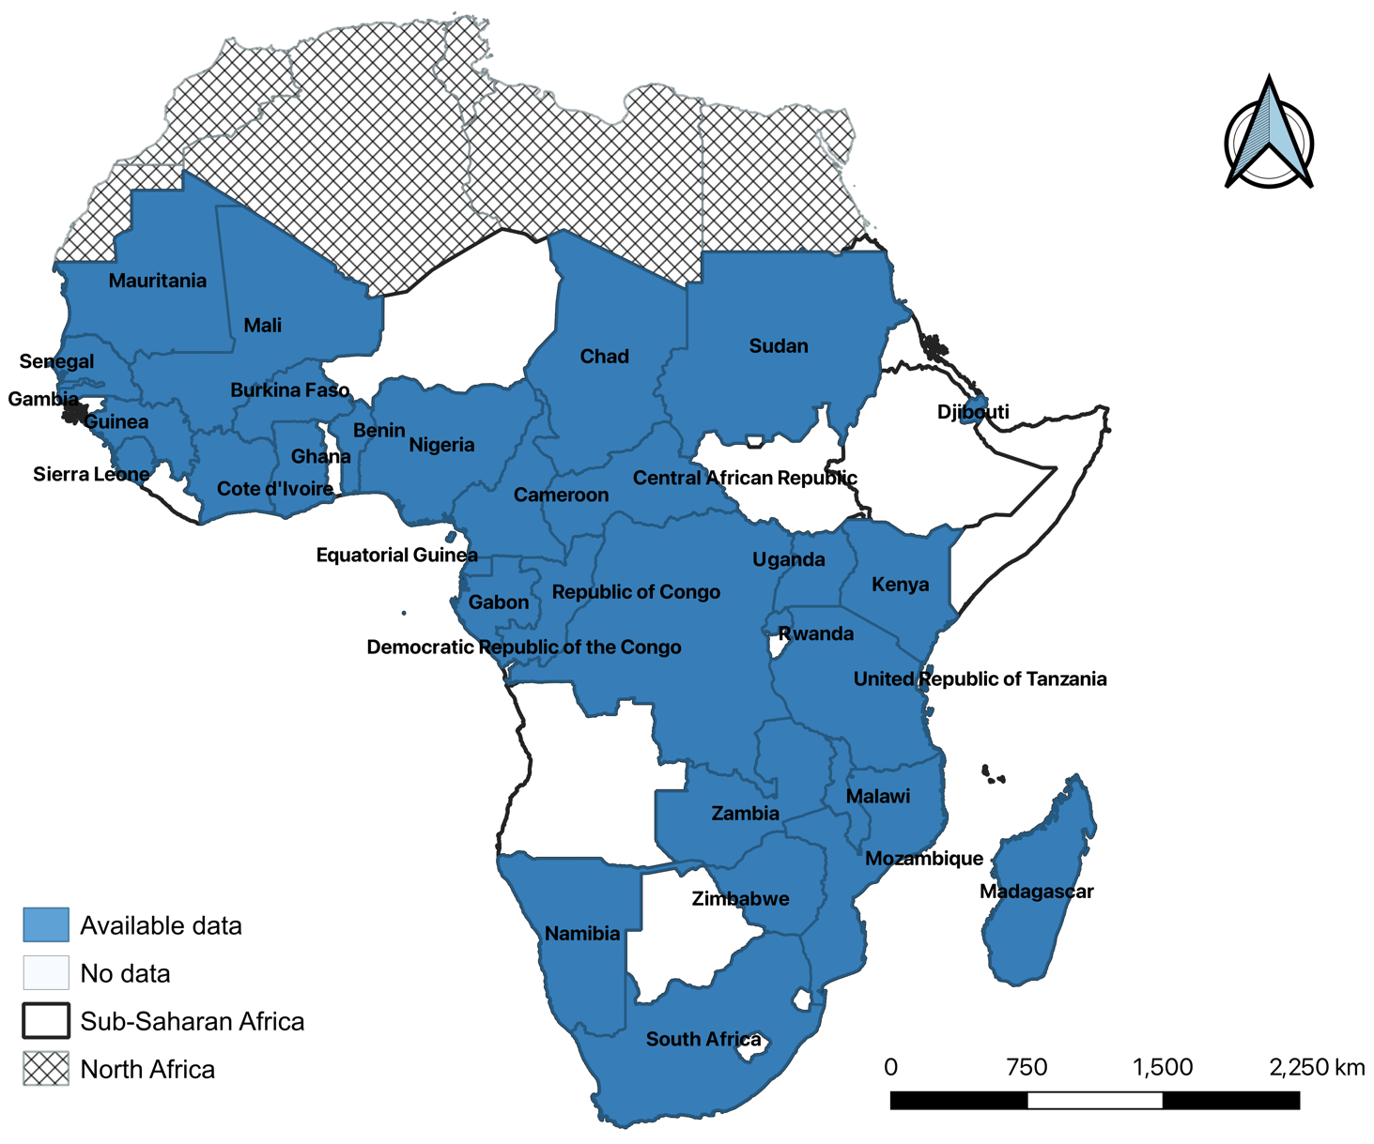

Supplementary Figure S1. Sub-Saharan African countries with published data on prevalence of CCHFV among humans, animals and ticks (1980 - 2025).

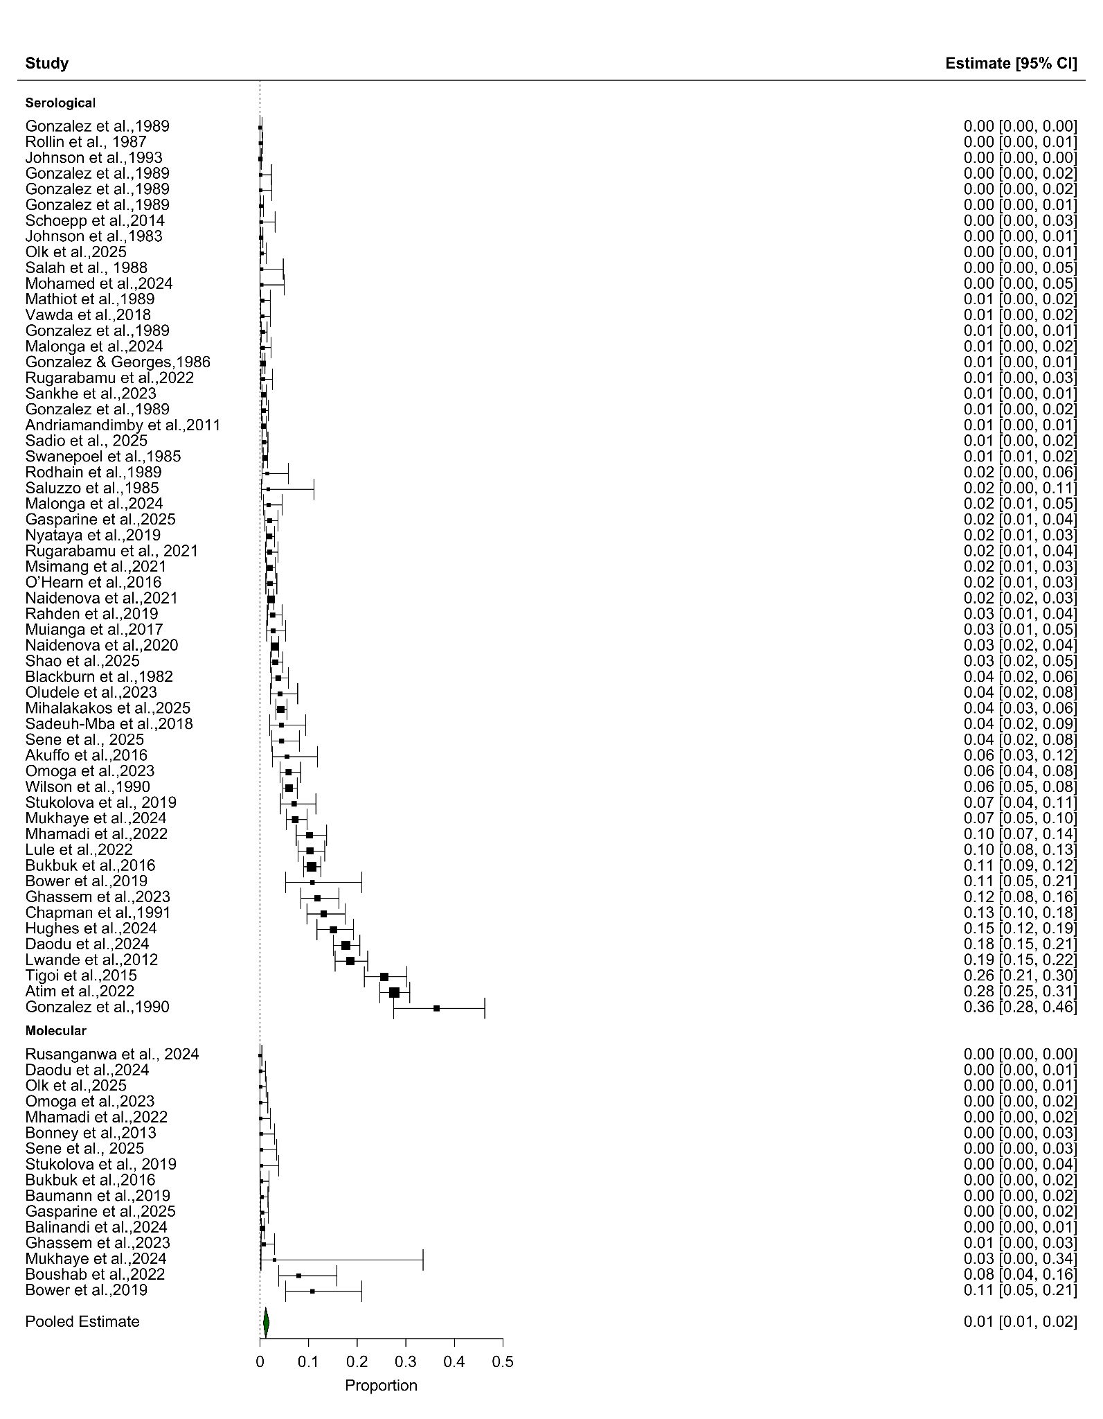
a) Forest plot for prevalence of CCHFV in humans in SSA

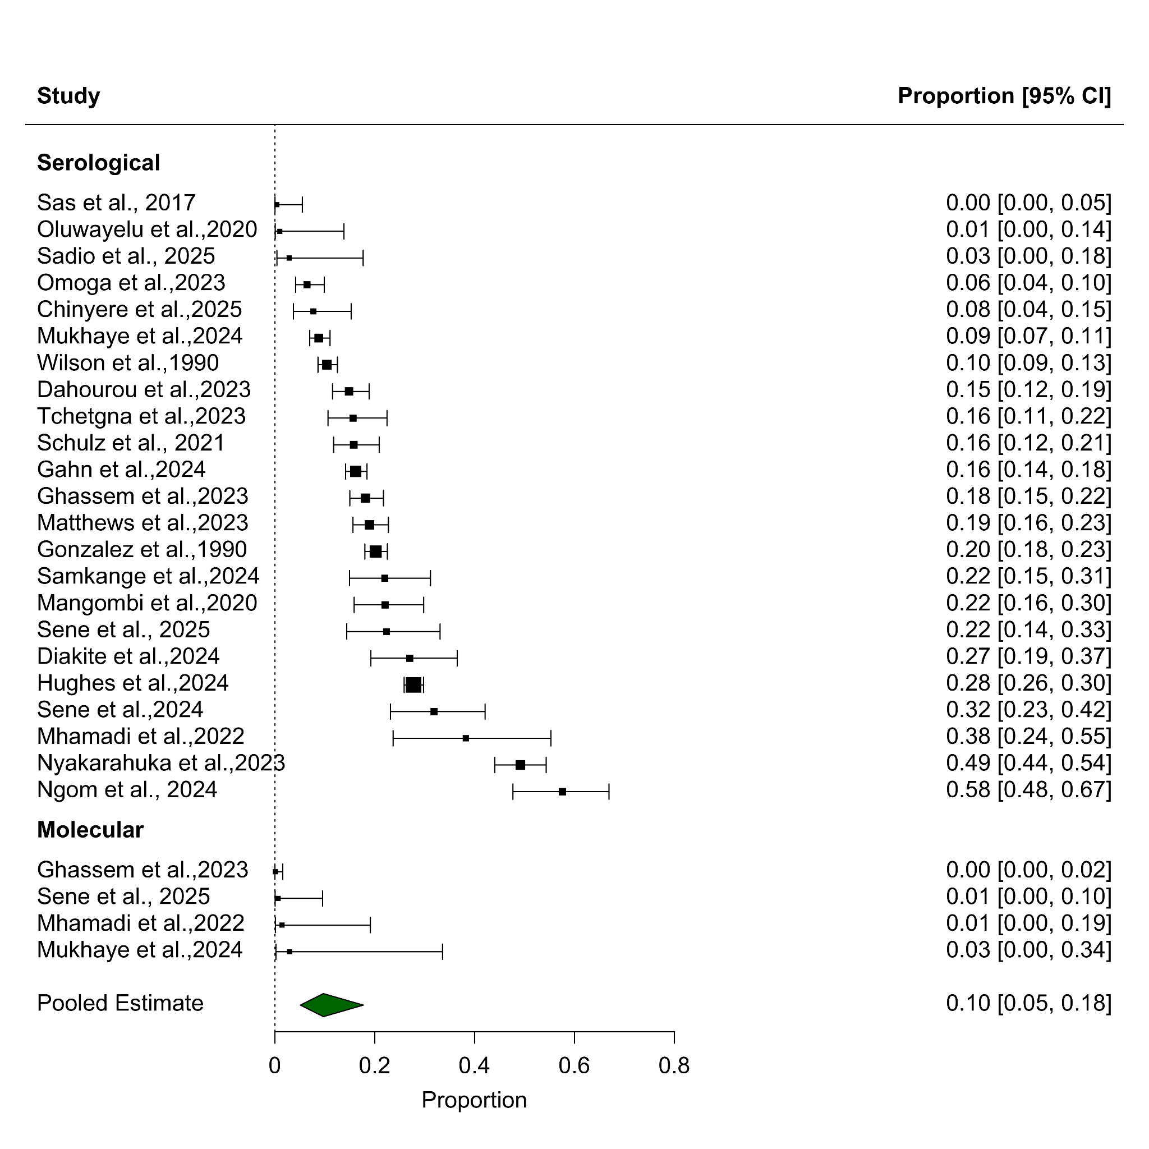
b) Forest plot for prevalence of CCHFV in sheep in SSA

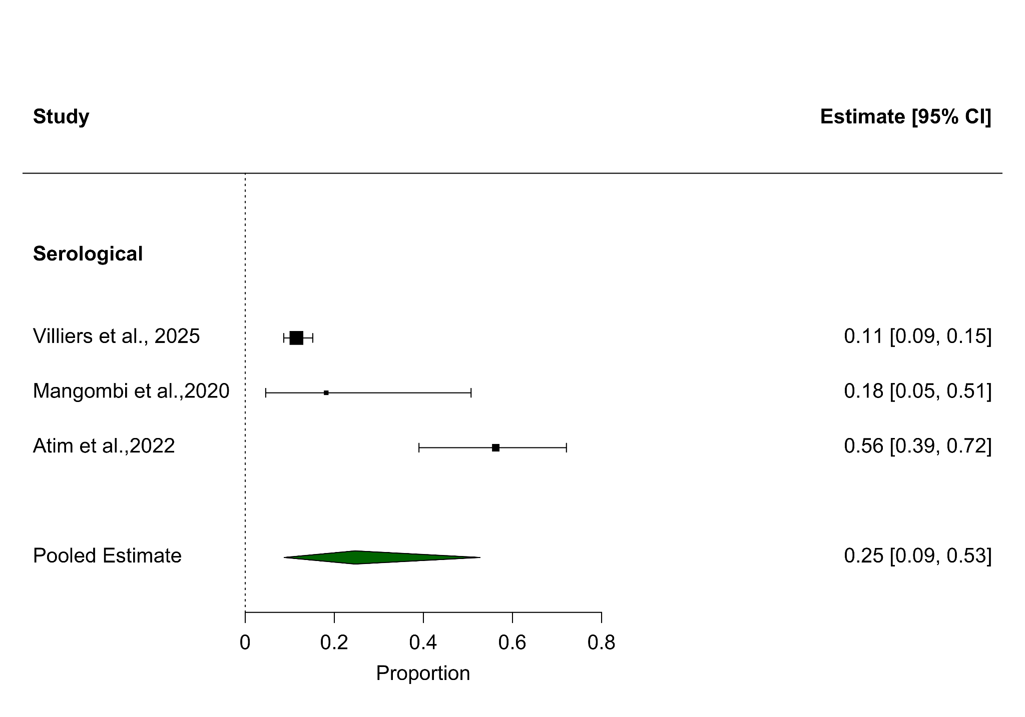

c) Forest plot for prevalence of CCHFV in dogs in SSA

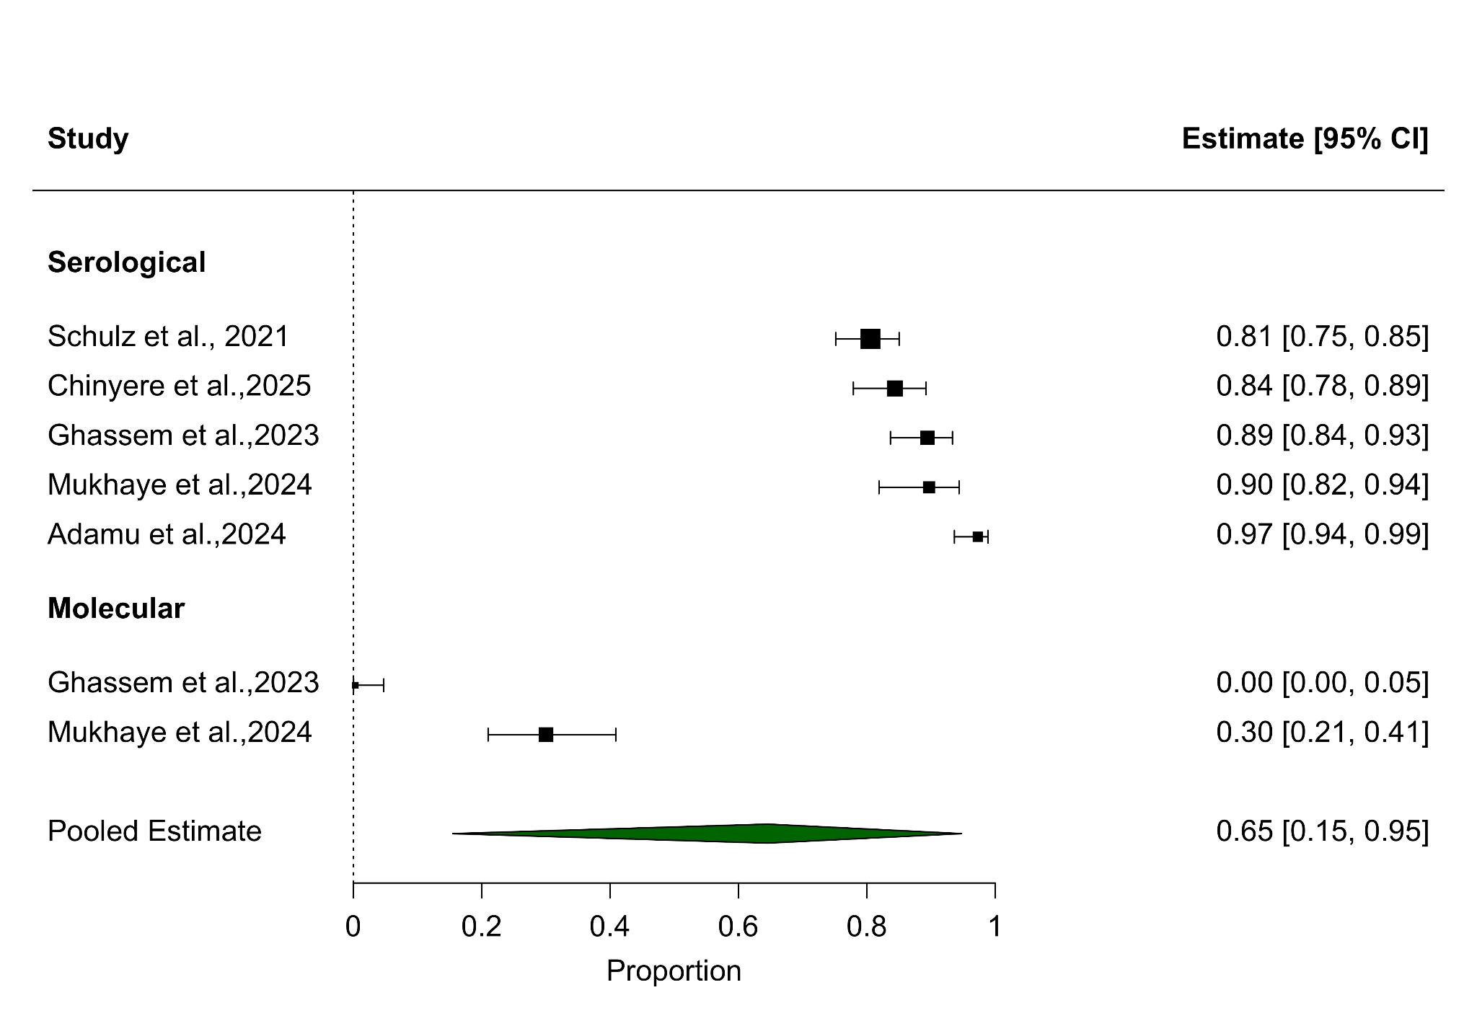
d) Forest plot for prevalence of CCHFV in camels

Supplementary Figure S2. Prevalence of CCHFV forest plots for (a) humans, (b) sheep, (c) dogs (d) camels,. NOTE: Forest plots in these figures report propotions as a value between 0.0 – 1.0.

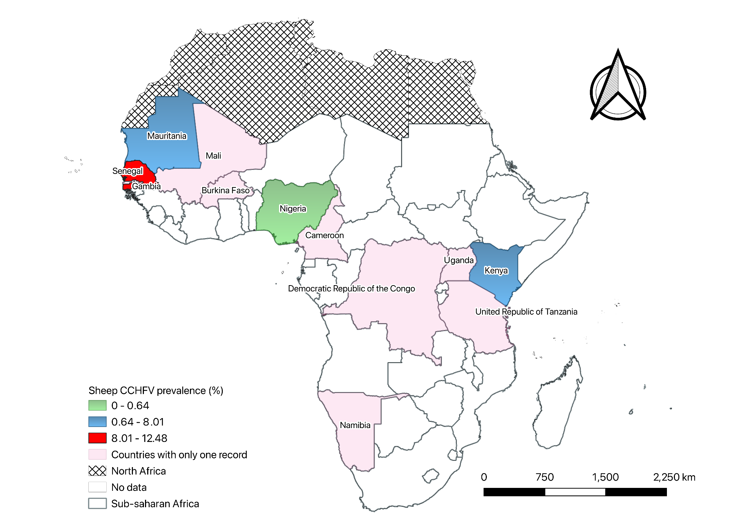
Supplementary Figure S3. Prevalence of CCHFV in sheep by country estimated by all diagnostic methods among countries with two or more records. Country-level prevalence maps were produced using Jenks natural breaks with four classes

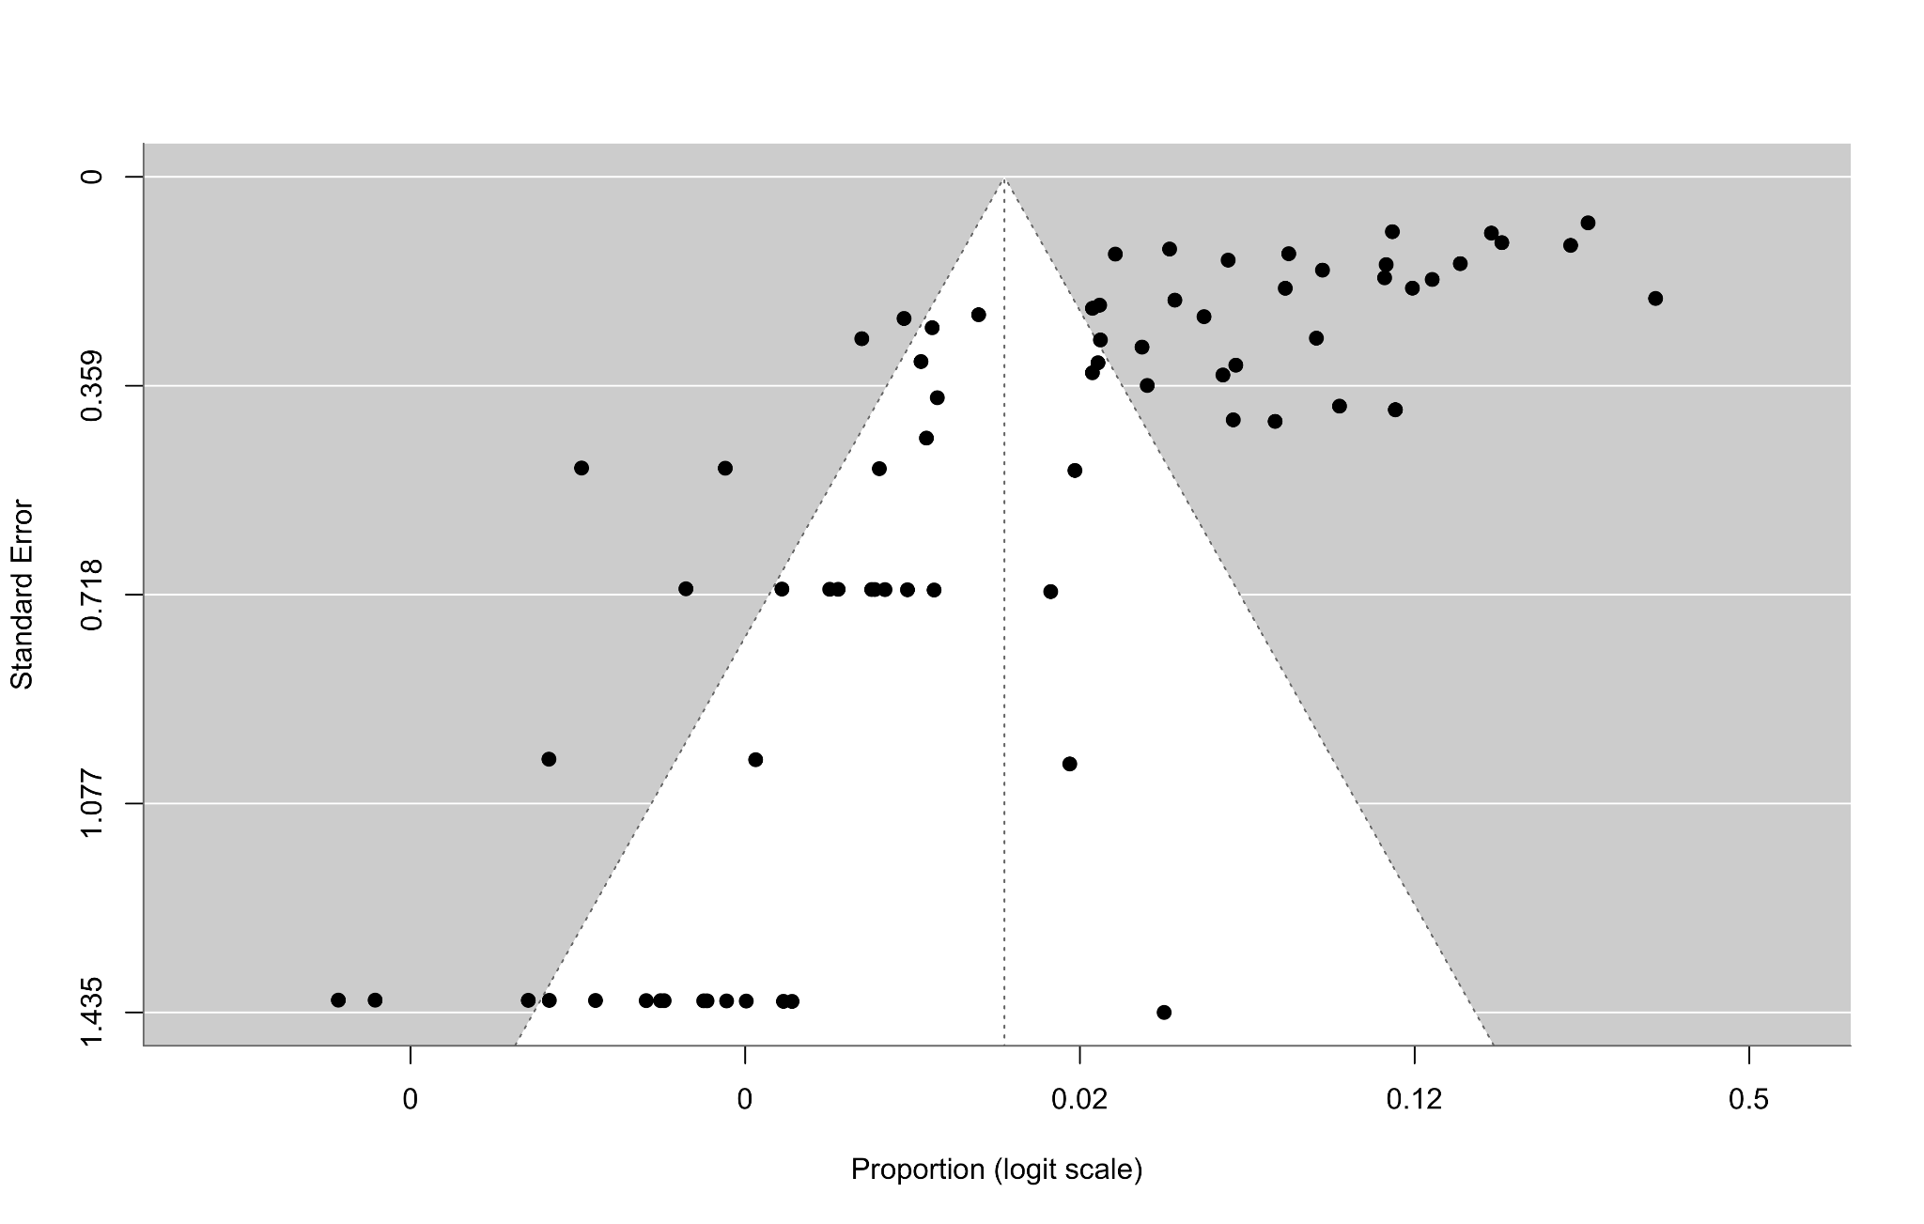
a) Funnel plots for prevalence of CCHFV in humans LFK index for funnel plot asymmetry -7.09 (major asymmetry)

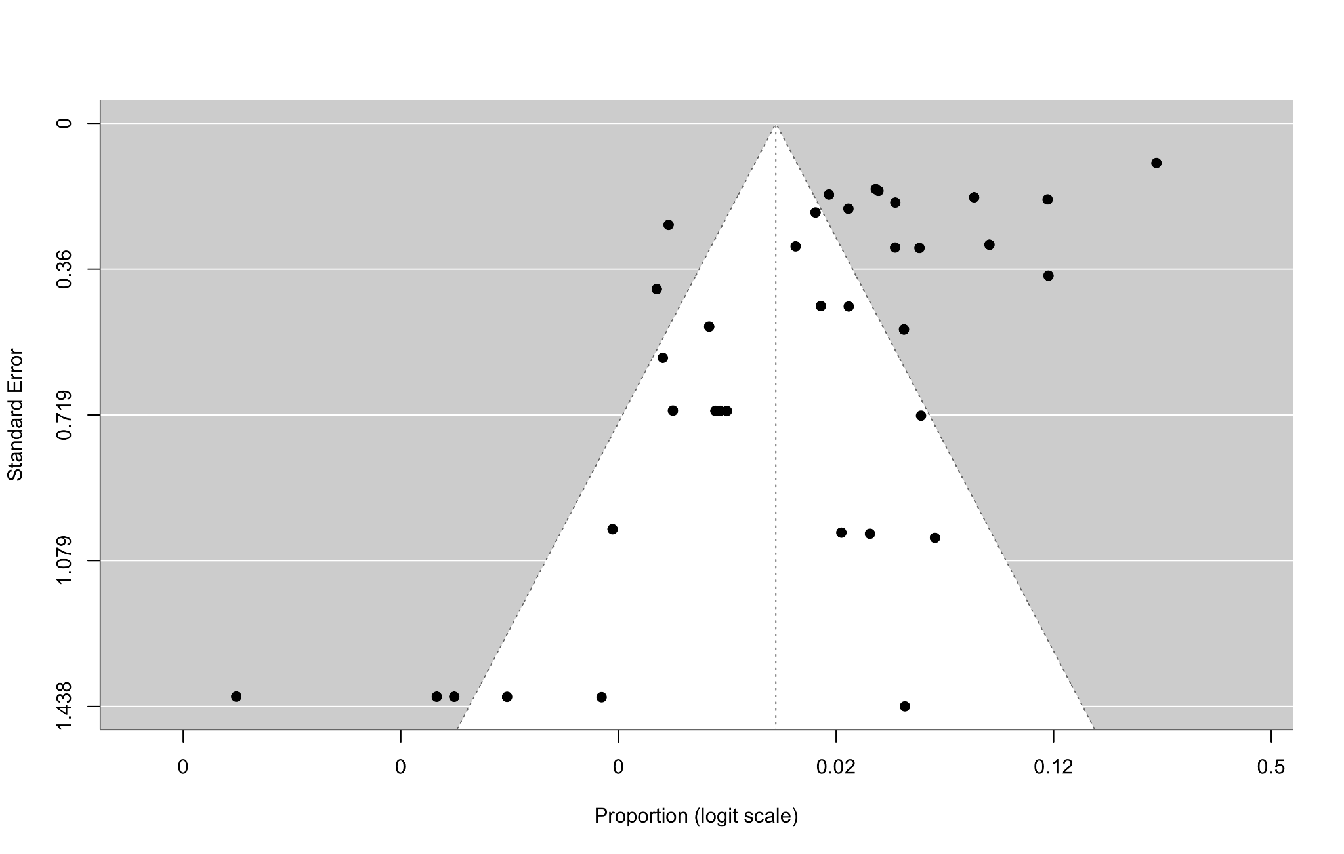
b) Funnel plot for pool-positivity of CCHFV in ticks LFK index: -3.54 (major asymmetry)

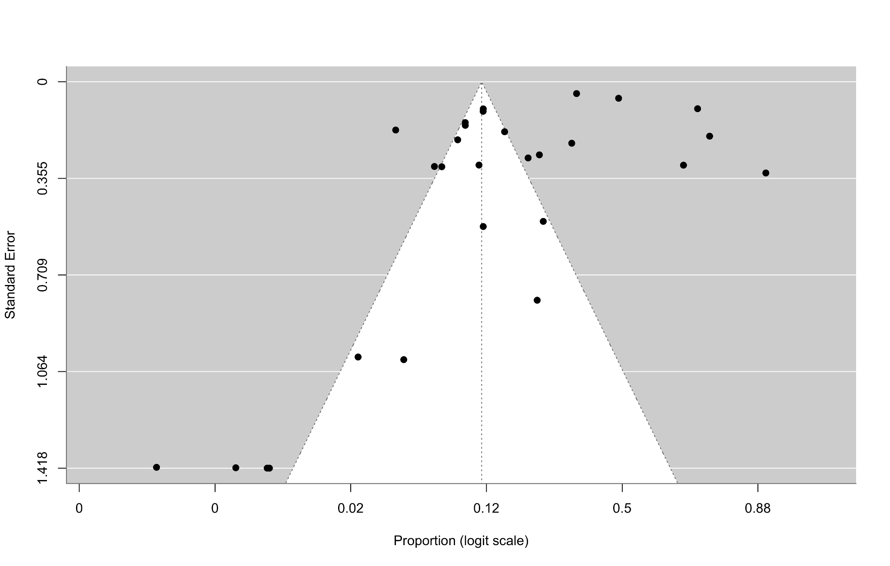
c) Funnel plot for prevalence of CCHFV in goats - LFK index: -4.77 (major asymmetry)

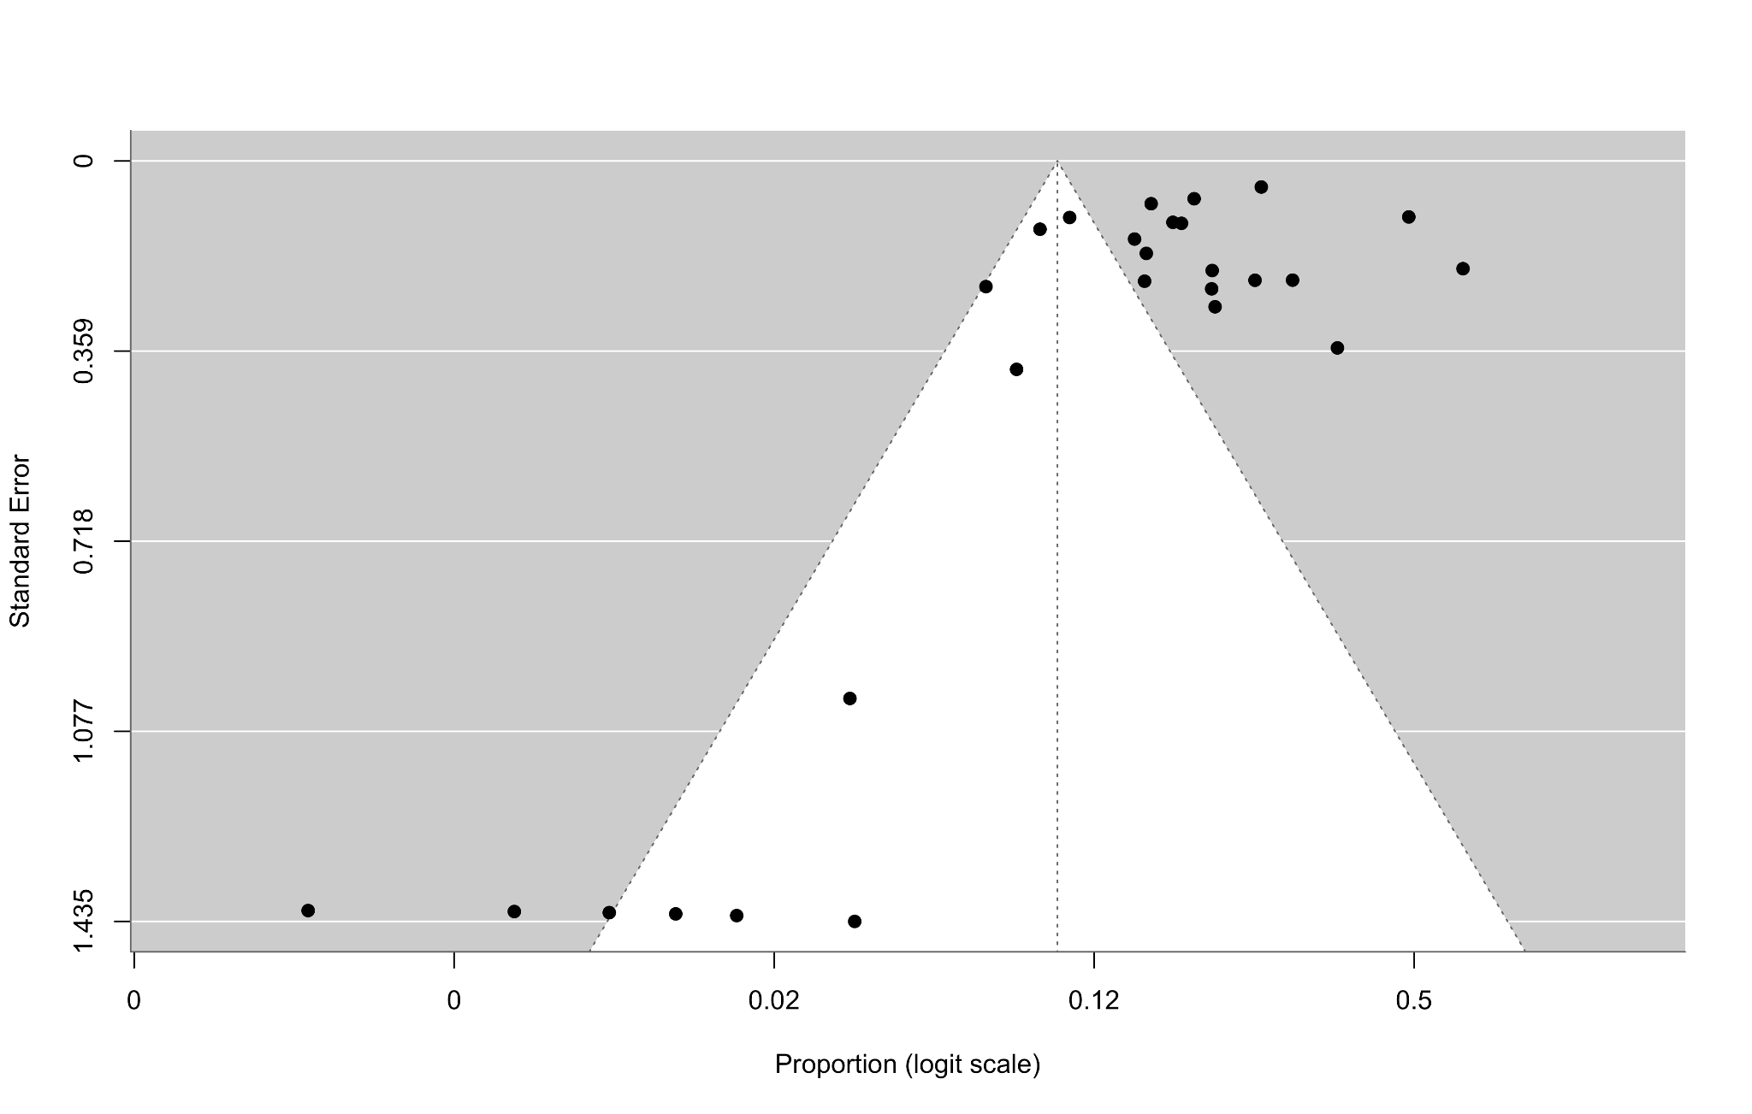
d) Funnel plot for prevalence of CCHFV in sheep- LFK index: -4.16 (major asymmetry)

Supplementary Figure S4. funnel plots for prevalence of CCHFV in (a) humans, (b) ticks, (c) goats , (d) sheep. LFK values refer to the Luis Furuya-Kanamori index⁶⁴. LFK index values < -2 and > +2 indicate major asymmetry, indicating a funnel plot asymmetry.

7. Sensitivity analyses

Leave-one-out analyses
Supplementary Table S13: Leave-one-out analysis of cattle pooled prevalence estimates

Omitted study | Diagnostic method | Logit Prevalence | % Prevalence
Atim et al.,2022 | Serological | -0.86544 | 29.62049
Atim et al.,2023 | Serological | -0.87063 | 29.51229
Balinandi et al.,2021 | Serological | -0.84064 | 30.14007
Blanco-Penedo et al.,2021 | Serological | -0.80011 | 31.00011
Burt et al.,1996 | Serological | -0.81157 | 30.75553
Chinyere et al.,2025 | Serological | -0.78758 | 31.26882
Dahourou et al.,2024 | Serological | -0.83779 | 30.19996
Diakite et al.,2024 | Serological | -0.8252 | 30.46603
Dzikwi-Emennaa et al.,2022 | Serological | -0.79946 | 31.01414
Fafetine et al.,2025 | Serological | -0.8179 | 30.62096
Gasparine et al.,2025 | Serological | -0.83631 | 30.23132
Ghassem et al.,2023 | Serological | -0.84018 | 30.14967
Gordon et al.,2022 | Serological | -0.82126 | 30.5497
Guilherme et al.,1996 | Serological | -0.80935 | 30.80293
Hughes et al.,2024 | Serological | -0.81758 | 30.62774
Ibrahim et al.,2015 | Serological | -0.78511 | 31.32192
Igah et al.,2025 | Serological | -0.83274 | 30.30653
Kajihara et al.,2021 | Serological | -0.76184 | 31.82462
Kizito et al., 2018 | Serological | -0.82609 | 30.44725
Lule et al.,2022 | Serological | -0.83531 | 30.25243
Maiga et al.,2017 | Serological | -0.83158 | 30.33117
Mangombi et al.,2020 | Serological | -0.82321 | 30.50823
Matthews et al.,2023 | Serological | -0.82644 | 30.43988
Msimang et al.,2021 | Serological | -0.83916 | 30.17127
Mukhaye et al.,2024 | Serological | -0.82868 | 30.39251
Ngom et al., 2024 | Serological | -0.85687 | 29.79934
Nyakarahuka et al.,2023 | Serological | -0.7815 | 31.39965
Obanda et al.,2021 | Serological | -0.79675 | 31.07212
Oluwayelu et al.,2020 | Serological | -0.79143 | 31.1862
Omoga et al.,2023 | Serological | -0.77644 | 31.50881
Phonera et al.,2021 | Serological | -0.81519 | 30.67855
Sadio et al., 2025 | Serological | -0.81404 | 30.70309
Saluzzo et al.,1985 | Serological | -0.80033 | 30.99558
Samkange et al.,2024 | Serological | -0.80508 | 30.89407
Sas et al., 2017 | Serological | -0.67736 | 33.68498
Schulz et al., 2021 | Serological | -0.83431 | 30.27349
Sene et al., 2025 | Serological | -0.84854 | 29.97393
Swanepoel et al.,1985 | Serological | -0.79512 | 31.107
Tchetgna et al.,2023 | Serological | -0.88994 | 29.11232
Yessinou et al.,2025 | Serological | -0.81065 | 30.7751
Atim et al.,2023 | Molecular | -0.67355 | 33.7702
Balinandi et al.,2021 | Molecular | -0.63867 | 34.55466
Daodu et al.,2025 | Molecular | -0.64996 | 34.29981
Gasparine et al.,2025 | Molecular | -0.64517 | 34.40777
Ghassem et al.,2023 | Molecular | -0.6568 | 34.14593
Mukhaye et al.,2024 | Molecular | -0.77572 | 31.52422
Sene et al., 2025 | Molecular | -0.68794 | 33.44913

HUMANS:
Leave- one- out analysis demonstrated that the pooled prevalence estimate of humans was highly stable and robust. Removal of each individual resulted in pooled prevalence estimates ranging from 1.10% to 1.25%, compared with the overall pooled estimate of 1.1% (Supplementary table S14). The highest estimate was observed following removal of Rusanganwa et al., 2024, which increased the pooled estimate to 1.25%. Overall, removal of individual studies produced only minor changes in the pooled prevalence, indicating that the overall human prevalence estimate was not disproportionately influenced by an individual study.
Supplementary Table S14: Leave one out analysis of human pooled prevalence estimates
omitted study | Diagnostic method | logit prevalence | % Prevalence
Akuffo et al.,2016 | Serological | -4.477324484 | 1.123609
Andriamandimby et al.,2011 | Serological | -4.448712072 | 1.155846
Atim et al.,2022 | Serological | -4.495666879 | 1.103413
Blackburn et al.,1982 | Serological | -4.47350895 | 1.127856
Bower et al.,2019 | Serological | -4.485154699 | 1.114943
Bukbuk et al.,2016 | Serological | -4.486683418 | 1.113259
Chapman et al.,1991 | Serological | -4.488650125 | 1.111096
Daodu et al.,2024 | Serological | -4.49177638 | 1.107666
Gasparine et al.,2025 | Serological | -4.463695872 | 1.138852
Ghassem et al.,2023 | Serological | -4.48752845 | 1.112329
Gonzalez & Georges,1986 | Serological | -4.445785797 | 1.159194
Gonzalez et al.,1989 | Serological | -4.419739126 | 1.18942
Gonzalez et al.,1989 | Serological | -4.406513934 | 1.205064
Gonzalez et al.,1989 | Serological | -4.406204868 | 1.205432
Gonzalez et al.,1989 | Serological | -4.441910485 | 1.163642
Gonzalez et al.,1989 | Serological | -4.447120764 | 1.157665
Gonzalez et al.,1989 | Serological | -4.37727849 | 1.240371
Gonzalez et al.,1990 | Serological | -4.497441633 | 1.101478
Hughes et al.,2024 | Serological | -4.49015984 | 1.109438
Johnson et al.,1993 | Serological | -4.405936387 | 1.205751
Johnson et al.,1983 | Serological | -4.424439223 | 1.183908
Lule et al.,2022 | Serological | -4.486195595 | 1.113796
Lwande et al.,2012 | Serological | -4.492208236 | 1.107193
Malonga et al.,2024 | Serological | -4.441340777 | 1.164298
Malonga et al.,2024 | Serological | -4.460765357 | 1.142156
Mathiot et al.,1989 | Serological | -4.440008323 | 1.165832
Mhamadi et al.,2022 | Serological | -4.486013358 | 1.113997
Mihalakakos et al.,2025 | Serological | -4.475746972 | 1.125363
Mohamed et al.,2024 | Serological | -4.416784811 | 1.192897
Msimang et al.,2021 | Serological | -4.464998539 | 1.137386
Muianga et al.,2017 | Serological | -4.468200539 | 1.133791
Mukhaye et al.,2024 | Serological | -4.482262059 | 1.118137
Naidenova et al.,2020 | Serological | -4.471254715 | 1.130373
Naidenova et al.,2021 | Serological | -4.466704094 | 1.13547
Nyataya et al.,2019 | Serological | -4.464340408 | 1.138126
O’Hearn et al.,2016 | Serological | -4.464744863 | 1.137671
Olk et al.,2025 | Serological | -4.430611969 | 1.176709
Oludele et al.,2023 | Serological | -4.474266135 | 1.127012
Omoga et al.,2023 | Serological | -4.479658058 | 1.12102
Rahden et al.,2019 | Serological | -4.468215499 | 1.133774
Rodhain et al.,1989 | Serological | -4.456555307 | 1.146919
Rollin et al., 1987 | Serological | -4.405034483 | 1.206826
Rugarabamu et al., 2021 | Serological | -4.464294859 | 1.138177
Rugarabamu et al.,2022 | Serological | -4.443540966 | 1.161769
Sadeuh-Mba et al.,2018 | Serological | -4.474353685 | 1.126915
Sadio et al., 2025 | Serological | -4.448646602 | 1.155921
Salah et al., 1988 | Serological | -4.416148143 | 1.193648
Saluzzo et al.,1985 | Serological | -4.454993644 | 1.148691
Sankhe et al.,2023 | Serological | -4.447290872 | 1.157471
Schoepp et al.,2014 | Serological | -4.410135968 | 1.200759
Sene et al., 2025 | Serological | -4.475356803 | 1.125797
Shao et al.,2025 | Serological | -4.471344109 | 1.130273
Stukolova et al., 2019 | Serological | -4.481265703 | 1.119239
Swanepoel et al.,1985 | Serological | -4.453569024 | 1.15031
Tigoi et al.,2015 | Serological | -4.494991474 | 1.10415
Vawda et al.,2018 | Serological | -4.440319626 | 1.165473
Wilson et al.,1990 | Serological | -4.480121335 | 1.120506
Balinandi et al.,2024 | Molecular | -4.441016676 | 1.164671
Baumann et al.,2019 | Molecular | -4.435717304 | 1.170787
Bonney et al.,2013 | Molecular | -4.409861965 | 1.201084
Boushab et al.,2022 | Molecular | -4.481834884 | 1.118609
Bower et al.,2019 | Molecular | -4.485154694 | 1.114943
Bukbuk et al.,2016 | Molecular | -4.427776427 | 1.180011
Daodu et al.,2024 | Molecular | -4.393835769 | 1.220251
Gasparine et al.,2025 | Molecular | -4.436589918 | 1.169777
Ghassem et al.,2023 | Molecular | -4.446106594 | 1.158826
Mhamadi et al.,2022 | Molecular | -4.404942561 | 1.206936
Mukhaye et al.,2024 | Molecular | -4.438013448 | 1.168133
Olk et al.,2025 | Molecular | -4.395925214 | 1.217735
Omoga et al.,2023 | Molecular | -4.400343136 | 1.212432
Rusanganwa et al., 2024 | Molecular | -4.372930088 | 1.245709
Sene et al., 2025 | Molecular | -4.411733995 | 1.198865
Stukolova et al., 2019 | Molecular | -4.413297436 | 1.197014

GOATS:

Leave one out analysis demonstrated that the pooled prevalence estimate of goats was stable and robust. Removal of each individual resulted in pooled prevalence estimates ranging from 9.92% to 13.51% compared with the overall pooled estimate of 11.20% (Supplementary table S15). The lowest estimate was observed by removal of Atim et al., 2023 while the highest estimate was observed following removal of Ghassem et al., 2023, Overall, removal of individual studies produced only minor changes in the pooled prevalence, indicating that the overall goat prevalence estimate was not disproportionately influenced by an individual study.

Supplementary Table S15: Leave one out analysis of goat pooled prevalence estimates
omitted study | Diagnostic method | logit Prevalence | % Prevalence
Atim et al.,2023 | Serological | -2.20654 | 9.916467325
Gasparine et al.,2025 | Serological | -2.19021 | 10.063282
Atim et al.,2022 | Serological | -2.18635 | 10.09833894
Nyakarahuka et al., 2022 | Serological | -2.17976 | 10.1582551
Nyakarahuka et al.,2023 | Serological | -2.15363 | 10.3992735
Hughes et al.,2024 | Serological | -2.1334 | 10.589312
Sene et al., 2025 | Serological | -2.13005 | 10.6210019
Sene et al.,2024 | Serological | -2.11262 | 10.78767352
Kizito et al., 2018 | Serological | -2.11118 | 10.80147218
Ngom et al., 2024 | Serological | -2.10634 | 10.84821343
Mangombi et al.,2020 | Serological | -2.10149 | 10.8952312
Schulz et al., 2021 | Serological | -2.09393 | 10.96883532
Gahn et al.,2024 | Serological | -2.08188 | 11.08707689
Mukhaye et al.,2024 | Serological | -2.08176 | 11.08818614
Chinyere et al.,2025 | Serological | -2.07783 | 11.12703811
Sadio et al., 2025 | Serological | -2.07723 | 11.13294459
Matthews et al.,2023 | Serological | -2.07075 | 11.19727026
Ghassem et al.,2023 | Serological | -2.07072 | 11.19750717
Omoga et al.,2023 | Serological | -2.0657 | 11.24759018
Tchetgna et al.,2023 | Serological | -2.05495 | 11.35536131
Sas et al., 2017 | Serological | -2.05028 | 11.40242166
Mukhaye et al.,2024 | Molecular | -2.02564 | 11.65373153
Lysholm et al., 2022 | Serological | -2.02549 | 11.65523972
Oluwayelu et al.,2020 | Serological | -1.99911 | 11.92964327
Sene et al., 2025 | Molecular | -1.925 | 12.73053629
Atim et al.,2023 | Molecular | -1.92378 | 12.74401896
Gasparine et al.,2025 | Molecular | -1.90599 | 12.94319199
Ghassem et al.,2023 | Molecular | -1.85631 | 13.51336747

SHEEP:
Leave one out analysis demonstrated that the pooled prevalence estimate of sheep was stable and robust. Removal of each individual resulted in pooled prevalence estimates ranging from 8.95 % to 12.26% compared with the overall pooled estimate of 9.71% (Supplementary table S16). The lowest estimate was observed by removal of Ngom et al., 2024 while the highest estimate was observed following removal of Ghassem et al., 2023, Overall, removal of individual studies produced only minor changes in the pooled prevalence, indicating that the overall sheep prevalence estimate was not disproportionately influenced by an individual study.

Supplementary Table S16: Leave one out analysis of sheep pooled prevalence estimates
omitted study | Diagnostic method | logit Prevalence | % Prevalence
Ngom et al., 2024 | Serological | -2.31919 | 8.95459
Nyakarahuka et al.,2023 | Serological | -2.31572 | 8.982941
Mhamadi et al.,2022 | Serological | -2.3049 | 9.071821
Sene et al.,2024 | Serological | -2.29982 | 9.113787
Hughes et al.,2024 | Serological | -2.29567 | 9.148223
Diakite et al.,2024 | Serological | -2.29329 | 9.168041
Mangombi et al.,2020 | Serological | -2.28513 | 9.236236
Sene et al., 2025 | Serological | -2.28484 | 9.238619
Samkange et al.,2024 | Serological | -2.2846 | 9.240633
Gonzalez et al.,1990 | Serological | -2.28234 | 9.259634
Matthews et al.,2023 | Serological | -2.27934 | 9.284825
Ghassem et al.,2023 | Serological | -2.27743 | 9.300951
Gahn et al.,2024 | Serological | -2.27259 | 9.34189
Schulz et al., 2021 | Serological | -2.27079 | 9.35711
Tchetgna et al.,2023 | Serological | -2.2698 | 9.365507
Dahourou et al.,2023 | Serological | -2.26818 | 9.379317
Wilson et al.,1990 | Serological | -2.25147 | 9.522284
Mukhaye et al.,2024 | Serological | -2.24288 | 9.596505
Chinyere et al.,2025 | Serological | -2.23293 | 9.683249
Omoga et al.,2023 | Serological | -2.22549 | 9.748514
Sadio et al., 2025 | Serological | -2.17922 | 10.16317
Mukhaye et al.,2024 | Molecular | -2.15312 | 10.40399
Mhamadi et al.,2022 | Molecular | -2.12448 | 10.67401
Oluwayelu et al.,2020 | Serological | -2.10771 | 10.835
Sene et al., 2025 | Molecular | -2.08769 | 11.02986
Sas et al., 2017 | Serological | -2.05564 | 11.34833
Ghassem et al.,2023 | Molecular | -1.96775 | 12.26309

TICKS:
Leave one out analysis demonstrated that the pooled pool-positivity estimate of ticks was stable and robust. Removal of each individual resulted in pooled pool-positivity estimates ranging from 0.95 % to 1.25% compared with the overall pooled estimate of 1.04 % (Supplementary table S17). The lowest estimate was observed by removal of Horton et al.,2016 while the highest estimate was observed following removal of Lutomiah et al.,2014, Overall, removal of individual studies produced only minor changes in the pooled prevalence, indicating that the overall tick pool positivity estimate was not disproportionately influenced by an individual study.

Supplementary Table S17: Leave one out analysis of tick pooled pool-positivity estimates
omitted study | Diagnostic method | logit Prevalence | % Prevalence
Horton et al.,2016 | Molecular | -4.64333 | 0.953386
Ghassem et al.,2023 | Molecular | -4.62784 | 0.968124
Wampande et al.,2021 | Molecular | -4.62489 | 0.970957
Saluzzo et al.,1985 | Serological | -4.61522 | 0.980297
Lule et al.,2022 | Serological | -4.61365 | 0.981818
Kajihara et al.,2021 | Molecular | -4.59949 | 0.995683
Naidenova et al.,2020 | Molecular | -4.59504 | 1.000078
Sene et al., 2025 | Molecular | -4.59351 | 1.001593
Atim et al.,2022 | Molecular | -4.59141 | 1.003681
Naydenova et al.,2019 | Molecular | -4.59092 | 1.004163
Schulz et al.,2021 | Molecular | -4.59027 | 1.004816
Amoah et al.,2024 | Molecular | -4.58898 | 1.006096
sang et al., 2011 | Molecular | -4.58239 | 1.012678
Folster et al.,2014 | Molecular | -4.5818 | 1.013271
Mathiot et al.,1988 | Serological | -4.57874 | 1.016344
Badji et al., 2023 | Molecular | -4.57723 | 1.017862
Naydenova et al.,2019 | Serological | -4.57292 | 1.022221
Ngom et al., 2024 | Molecular | -4.57114 | 1.024021
Igah et al.,2025 | Molecular | -4.57008 | 1.025094
Naidenova et al.,2020 | Serological | -4.56609 | 1.029156
Balindandi et al., 2018 | Molecular | -4.56437 | 1.03091
Tchetgna et al.,2023 | Molecular | -4.54013 | 1.055937
Daodu et al.,2025 | Molecular | -4.53815 | 1.058002
Chiuya et al.,2020 | Molecular | -4.53675 | 1.059469
Bentil et al.,2023 | Molecular | -4.53663 | 1.059595
Nyakarahuka et al., 2022 | Molecular | -4.53572 | 1.06055
Adjogoua et al.,2021 | Molecular | -4.52417 | 1.072741
Addo et al.,2024 | Molecular | -4.52369 | 1.073253
Mhamadi et al.,2022 | Molecular | -4.52074 | 1.076386
Khoule et al.,2025 | Molecular | -4.51919 | 1.078041
Sene et al.,2024 | Molecular | -4.50614 | 1.092037
Gasparine et al.,2025 | Molecular | -4.48556 | 1.114492
Shuaib et al.,2020 | Molecular | -4.46137 | 1.141473
Nimo-Paintsil et al.,2022 | Molecular | -4.44593 | 1.159032
Sang et al.,2006 | Molecular | -4.4405 | 1.165263
Lutomiah et al.,2014 | Molecular | -4.36534 | 1.255086

